A Multi-Objective Machine Learning Framework for Exoplanet Transit Detection from TESS Light Curves Using Random Forest and Explainable Artificial Intelligence

1. Introduction
The discovery of planets orbiting stars beyond the Solar System represents one of the most influential scientific achievements of modern astronomy. Since the confirmation of the first exoplanet orbiting a Sun-like star in 1995, the field of exoplanetary science has experienced unprecedented growth, fundamentally reshaping our understanding of planetary formation, orbital dynamics, and the diversity of planetary systems throughout the Milky Way [1]. Thousands of confirmed exoplanets have revealed architectures that differ substantially from those observed in our own Solar System, including hot Jupiters, ultra-short-period planets, super-Earths, and compact multi-planet systems [5], [7]. These discoveries have motivated the development of increasingly sophisticated observational strategies and computational techniques capable of extracting extremely weak planetary signatures from massive astronomical datasets.
Among the various observational techniques available for exoplanet discovery, transit photometry has become the most productive and successful method [5], [6]. Unlike radial velocity, direct imaging, gravitational microlensing, or astrometry, the transit method detects the periodic decrease in stellar brightness produced when a planet crosses the apparent disk of its host star. Because the resulting transit signal typically produces flux variations of only a few parts per thousand—or even a few parts per million for Earth-sized planets—the detection process requires high-precision photometry together with robust statistical and computational analysis [4], [6]. The combination of observational sensitivity and computational scalability has established transit photometry as the dominant technique for large-scale exoplanet surveys.
The success of transit photometry has been largely driven by dedicated space missions designed to continuously monitor stellar brightness over extended periods. The Kepler Space Telescope demonstrated the extraordinary potential of uninterrupted high-precision photometric observations by discovering thousands of planetary candidates and confirming that planetary systems are ubiquitous throughout the Galaxy [2]. Building upon this legacy, NASA's Transiting Exoplanet Survey Satellite (TESS) was specifically designed to perform an all-sky survey targeting bright nearby stars, generating an unprecedented volume of publicly available light-curve observations [3], [4]. The continuous acquisition of high-cadence photometric measurements has transformed exoplanet detection into a genuine big-data problem, where manual inspection of individual light curves is no longer feasible and automated analysis pipelines have become essential for efficient candidate identification.
Recent advances in machine learning have significantly transformed the analysis of astronomical data by enabling the automatic identification of complex patterns that are often difficult to detect using conventional statistical techniques [15], [20], [21]. In exoplanet research, supervised learning algorithms have been increasingly employed to distinguish genuine planetary transits from stellar variability, instrumental artifacts, and false-positive signals [25]–[34]. A broad range of machine learning models—including Support Vector Machines, Random Forests, Gradient Boosting algorithms, Artificial Neural Networks, and Convolutional Neural Networks—have demonstrated remarkable predictive capabilities when trained on carefully engineered photometric features or directly on light-curve observations [15], [17]–[19], [25]–[34]. These approaches have substantially reduced the computational burden associated with manual inspection while improving the efficiency of candidate selection in large-scale photometric surveys.
Despite these advances, several challenges remain unresolved. Deep learning models frequently require extensive computational resources and very large labeled datasets to achieve satisfactory generalization, while many traditional machine learning approaches strongly depend on the quality of handcrafted features extracted from the light curves [25]–[34]. Furthermore, numerous existing studies focus primarily on maximizing classification accuracy without explicitly considering the trade-off between predictive performance, feature redundancy, computational efficiency, and model interpretability [39]–[42]. In scientific applications such as exoplanet detection, highly accurate predictions alone are insufficient if the reasoning behind the model's decisions cannot be understood and validated by domain experts.
Feature engineering therefore continues to play a fundamental role in astronomical machine learning. The Box Least Squares (BLS) algorithm remains one of the most effective approaches for identifying periodic transit-like events by searching for characteristic box-shaped brightness decreases within stellar light curves [8]. When combined with robust statistical descriptors that quantify the variability, dispersion, symmetry, and temporal behavior of photometric observations, BLS-derived parameters provide a compact yet highly informative representation of candidate transit events [9]–[14]. However, selecting the most discriminative combination of features while simultaneously avoiding redundancy constitutes a multi-objective optimization problem that has received comparatively limited attention within the exoplanet detection literature [43]–[52].
Another important limitation of many published studies is the limited emphasis placed on model explainability. As machine learning models become increasingly integrated into scientific discovery, understanding why a classifier identifies a particular light curve as a planetary candidate becomes nearly as important as the prediction itself. Explainable Artificial Intelligence (XAI) techniques, particularly SHapley Additive exPlanations (SHAP), provide mathematically grounded mechanisms for quantifying the contribution of individual features to each prediction [35], [36]. Such interpretability not only increases confidence in automated classifications but also enables astronomers to validate whether the learned relationships are physically meaningful rather than artifacts introduced during model training [39]–[42].
Motivated by these challenges, this work proposes a comprehensive machine learning framework for exoplanet transit detection from TESS light curves that integrates robust photometric preprocessing, Box Least Squares feature extraction, statistical characterization of stellar variability, multi-objective feature optimization, Random Forest classification, and post-hoc explainability using SHAP. Unlike many previous studies that focus exclusively on predictive performance, the proposed methodology seeks to balance classification accuracy, computational efficiency, feature relevance, and model transparency within a unified processing pipeline suitable for large-scale astronomical surveys.
The main contributions of this work are summarized as follows:
- A fully automated pipeline for preprocessing TESS light curves, including quality filtering, normalization, outlier removal, and gap handling.
- A comprehensive feature extraction strategy that combines Box Least Squares transit descriptors with robust statistical characteristics derived from photometric time series.
- A multi-objective optimization framework designed to identify informative feature subsets while reducing redundancy and preserving predictive performance.
- The development of a Random Forest classifier for exoplanet candidate identification using optimized photometric features extracted from TESS observations.
- A systematic explainability analysis based on SHAP values to quantify feature importance and improve the transparency and scientific interpretability of the proposed classification framework.
The remainder of this paper is organized as follows. Section 2 reviews recent developments in machine learning methods for exoplanet detection. Section 3 describes the proposed methodology, including data preprocessing, feature extraction, multi-objective optimization, and classification. Section 4 presents the experimental setup. Section 5 discusses the obtained results and model performance. Section 6 provides a comprehensive discussion of the findings, and Section 7 concludes the paper while outlining future research directions.

2. Related Work

2.1 Classical Transit Detection Methods
The search for exoplanets has traditionally relied on well-established observational techniques, including radial velocity measurements, gravitational microlensing, direct imaging, astrometry, and transit photometry [5]–[7]. Among these approaches, transit photometry has become the dominant detection technique due to its capability to continuously monitor thousands of stars simultaneously while providing direct information about planetary orbital periods, transit depths, and planetary radii [2], [3]. The success of the Kepler and TESS missions has firmly established transit photometry as the primary source of large-scale exoplanet discovery, generating millions of high-precision stellar light curves that require efficient automated analysis [2]–[4].
One of the most influential computational techniques developed for transit detection is the Box Least Squares (BLS) algorithm [8]. Originally proposed to identify periodic box-shaped decreases in stellar brightness, BLS estimates the orbital period, transit duration, transit depth, and detection significance by fitting a sequence of box-shaped models to photometric observations [8].
Despite its widespread adoption, BLS presents several important limitations when applied to modern astronomical surveys [22], [23]. The algorithm is particularly sensitive to stellar variability, instrumental systematics, irregular observational cadence, and low signal-to-noise ratio transits. False-positive detections caused by eclipsing binaries, stellar activity, cosmic-ray events, and photometric artifacts frequently produce periodic signatures that resemble genuine planetary transits [23]. Consequently, BLS alone is generally insufficient for reliable large-scale candidate validation and typically requires complementary statistical analyses or machine learning techniques capable of distinguishing true planetary signals from astrophysical and instrumental false positives [24].
Several improvements have been proposed to overcome these limitations. Transit Least Squares (TLS) incorporates physically motivated transit models instead of simple box-shaped approximations, improving sensitivity for small planets [9]. Likewise, Lomb–Scargle periodograms remain valuable for detecting sinusoidal stellar variability and periodic oscillations, although they are less suitable for identifying the characteristic morphology of planetary transits [10]–[12]. Consequently, contemporary exoplanet detection pipelines increasingly combine classical signal-processing algorithms with data-driven machine learning models that exploit both physical transit parameters and statistical descriptors extracted from stellar light curves [15], [25]–[34].

2.2 Machine Learning for Exoplanet Detection
The rapid increase in the volume of photometric observations produced by modern astronomical surveys has accelerated the adoption of machine learning techniques for automated exoplanet detection [25]–[34]. Unlike traditional signal-processing algorithms, supervised learning models are capable of exploiting complex nonlinear relationships among photometric, statistical, and transit-related features, enabling the identification of planetary candidates with improved robustness against observational noise and astrophysical false positives [25]–[34]. As a result, machine learning has become an essential component of contemporary exoplanet detection pipelines [25]–[34].
Early machine learning studies primarily employed conventional classification algorithms such as Decision Trees, Support Vector Machines (SVMs), k-Nearest Neighbors (KNNs), Logistic Regression, and Random Forests [15]–[24]. These methods demonstrated that carefully engineered features extracted from stellar light curves could substantially improve candidate discrimination compared with purely threshold-based detection strategies [15]–[24]. Among these approaches, Random Forest classifiers have consistently exhibited strong predictive performance owing to their ensemble learning strategy, robustness to noisy observations, resistance to overfitting, and ability to estimate feature importance [15]. Their relatively low computational complexity and high interpretability also make them particularly attractive for large astronomical surveys [15].
More recently, deep learning architectures have gained considerable attention for exoplanet detection. Convolutional Neural Networks (CNNs), Residual Networks (ResNets), recurrent neural networks, and transformer-based architectures have been successfully applied to raw or phase-folded light curves, reducing the dependence on handcrafted feature engineering [25]–[30]. These models have demonstrated excellent classification performance, especially when trained on the extensive datasets generated by the Kepler mission [25]–[30]. However, their practical application often requires large annotated datasets, substantial computational resources, and extensive hyperparameter optimization [25]–[30]. Furthermore, the internal decision-making process of deep neural networks remains difficult to interpret, limiting their adoption in scientific environments where explainability is essential [35]–[42].
The transition from the Kepler mission to the Transiting Exoplanet Survey Satellite (TESS) has introduced additional challenges for automated exoplanet detection. Compared with Kepler, TESS observes a significantly larger portion of the sky but typically provides shorter observational baselines and increased levels of systematic noise for many targets [3],[28],[29]. Consequently, machine learning models originally developed for Kepler data cannot always be transferred directly to TESS observations without appropriate adaptation [36]. Recent studies have therefore focused on designing algorithms specifically tailored to the characteristics of TESS light curves, combining classical transit-search techniques with supervised learning models to improve candidate validation while reducing false-positive rates [28],[29].
Although numerous machine learning approaches have reported excellent classification accuracy, most existing studies primarily emphasize predictive performance while paying comparatively less attention to feature redundancy, computational efficiency, and model interpretability [43]–[52]. In many cases, feature selection is treated as a preprocessing step rather than as an optimization problem, and the final classifiers are evaluated mainly using global performance metrics such as accuracy or the area under the ROC curve [43]–[52]. Consequently, relatively few studies attempt to jointly optimize feature relevance, predictive capability, computational cost, and explainability within a unified framework [35]–[52].
These observations suggest that there remains considerable opportunity for developing integrated methodologies that combine robust feature engineering, multi-objective optimization, ensemble learning, and explainable artificial intelligence [35]–[52]. Such an approach is particularly attractive for large-scale surveys like TESS, where reliable automated candidate identification must balance predictive performance with scientific transparency and computational scalability [3],[28],[29].

2.3 Explainable Artificial Intelligence and Multi-objective Feature Optimization
The increasing adoption of machine learning within scientific research has generated a growing demand for models whose predictions are not only accurate but also interpretable. In astronomy, where machine learning algorithms frequently support scientific discovery, understanding the rationale behind an automated classification is essential for establishing confidence in the obtained results [35]–[42]. Consequently, Explainable Artificial Intelligence (XAI) has emerged as an important research direction aimed at improving the transparency of complex predictive models while preserving their predictive capability [35],[36].
Among the numerous XAI techniques proposed in recent years, SHapley Additive exPlanations (SHAP) has become one of the most widely adopted approaches for interpreting machine learning models [35],[36]. Based on cooperative game theory, SHAP assigns each feature a contribution value that quantifies its influence on the prediction generated by the classifier [35],[36]. Unlike conventional feature importance measures, SHAP provides both global explanations, describing the overall behavior of the model, and local explanations, revealing how individual features contribute to specific predictions [35],[36]. This dual perspective is particularly valuable in scientific applications because it enables researchers to validate whether the model relies on physically meaningful characteristics rather than spurious statistical correlations [39]–[42].
Within astronomy, the application of XAI remains relatively recent but has demonstrated considerable potential. Recent studies have shown that SHAP-based analyses can reveal meaningful relationships between observational variables and model predictions, facilitating scientific interpretation while increasing confidence in automated classification systems [39]–[42]. Rather than treating machine learning as an opaque black box, explainability techniques enable astronomers to identify which photometric attributes, transit descriptors, or statistical properties of stellar light curves exert the greatest influence on the final classification [42]. This additional level of transparency is particularly valuable for validating candidate exoplanets and for identifying possible sources of false-positive detections [42].
In parallel with advances in explainable machine learning, feature selection has evolved from a simple preprocessing step into a complex optimization problem. High-dimensional astronomical datasets frequently contain redundant, correlated, or weakly informative variables that may increase computational cost without improving predictive performance [43]–[52]. Consequently, selecting an optimal subset of features requires simultaneously considering multiple objectives, including classification accuracy, feature relevance, redundancy reduction, computational efficiency, and model generalization [43]–[52]. Multi-objective optimization provides an appropriate mathematical framework for balancing these potentially conflicting goals while avoiding excessive dependence on a single evaluation metric [43], [44].
Despite significant progress in both XAI and multi-objective optimization, relatively few studies have combined these two perspectives within exoplanet detection pipelines [35]–[52]. Most published works either prioritize predictive accuracy without investigating feature interpretability or employ explainability solely as a post-processing visualization tool [40], [42]. Likewise, feature selection is commonly performed using traditional filter or wrapper methods instead of optimization strategies capable of simultaneously maximizing predictive performance and minimizing redundancy [44], [45]. This observation highlights an important opportunity for developing integrated methodologies that jointly optimize feature selection, classification performance, and model interpretability within a unified framework suitable for large-scale astronomical surveys [39], [44].

2.4 Research Gap
The literature demonstrates substantial progress in applying machine learning techniques to exoplanet detection. Classical transit-search algorithms, ensemble learning methods, and deep neural networks have all contributed significantly to improving the automatic identification of planetary candidates from large photometric surveys. Nevertheless, several important limitations remain insufficiently addressed.
First, many existing studies primarily focus on maximizing predictive performance while paying comparatively little attention to the quality and redundancy of the input feature space. Large collections of statistical and transit-related descriptors are frequently employed without systematically evaluating whether all extracted variables contribute meaningful information to the classification process. Consequently, redundant features may increase computational complexity without providing corresponding improvements in predictive capability.
Second, although deep learning models have achieved impressive classification performance, their substantial computational requirements and limited interpretability restrict their applicability in many scientific environments. For numerous astronomical investigations, particularly those involving medium-sized datasets or computationally constrained infrastructures, lightweight ensemble learning methods remain attractive alternatives due to their balance between predictive performance, robustness, and computational efficiency. However, relatively few studies have explored how these conventional machine learning algorithms can be enhanced through optimized feature engineering and principled feature selection strategies.
Third, explainability remains an emerging topic within automated exoplanet detection. While several recent investigations have incorporated explainable artificial intelligence techniques, interpretability is often treated as an auxiliary visualization step rather than as an integral component of the scientific analysis. Consequently, there is still limited understanding of which photometric and transit-related characteristics consistently drive model decisions across large collections of TESS observations.
Finally, the integration of feature engineering, multi-objective optimization, ensemble learning, and explainable artificial intelligence into a single end-to-end framework remains relatively uncommon in the current literature. Most published approaches investigate these components independently, without considering the interactions between feature relevance, computational efficiency, predictive accuracy, and model transparency. Such fragmentation limits the development of robust and scientifically interpretable pipelines suitable for next-generation astronomical surveys.
To address these limitations, the present study proposes a unified framework for exoplanet candidate detection from TESS light curves. The proposed methodology combines rigorous photometric preprocessing, transit characterization using the Box Least Squares algorithm, statistical feature extraction, multi-objective feature optimization, Random Forest classification, and SHAP-based explainability within a single reproducible pipeline. By integrating these complementary components, the proposed approach aims not only to achieve high predictive performance but also to improve computational efficiency and scientific interpretability, thereby providing a practical framework for automated exoplanet detection in modern astronomical datasets.

3. Materials and Methods
This section describes the complete methodology proposed for automated exoplanet candidate detection from TESS photometric observations. The framework consists of a sequential processing pipeline that begins with the acquisition of public TESS light curves and continues through data preprocessing, feature extraction, multi-objective feature optimization, supervised classification, and model explainability. Each stage was designed to maximize data quality, improve classification performance, and preserve scientific interpretability while maintaining computational efficiency.
Figure 1 summarizes the overall workflow adopted in this study. The pipeline transforms raw TESS observations [3], [4] into a compact set of optimized numerical descriptors that are subsequently used to train an explainable Random Forest classifier capable of distinguishing exoplanet candidates from non-planetary light curves.

3.1 Overall Workflow
The proposed methodology follows a modular pipeline composed of six sequential stages, each addressing a specific task within the exoplanet detection process. The modular design facilitates reproducibility, simplifies future improvements, and enables independent validation of every processing stage.
The first stage consists of data acquisition from the Transiting Exoplanet Survey Satellite (TESS) mission. Publicly available observations were downloaded from the Mikulski Archive for Space Telescopes (MAST) [4], which provides calibrated photometric measurements together with quality flags and auxiliary observational information. Positive examples correspond to confirmed exoplanet host stars obtained from the NASA Exoplanet Archive [5], whereas negative examples were selected from TESS observations without confirmed planetary detections.
The second stage performs photometric preprocessing. Raw light curves are filtered using the official TESS quality flags [4] to eliminate observations affected by instrumental artifacts, spacecraft maneuvers, scattered light contamination, and other known observational anomalies. Missing observations are removed, extreme outliers are filtered, temporal ordering is verified, and the stellar flux is normalized to reduce scale variations among different targets.
The third stage extracts representative numerical descriptors from each preprocessed light curve. Transit-related characteristics are obtained using the Box Least Squares algorithm [8], including the estimated orbital period, transit duration, transit depth, detection power, and signal-to-noise ratio. In parallel, statistical descriptors are computed to characterize the global photometric behavior of each target, including measures of central tendency, dispersion, asymmetry, variability, and temporal distribution.
The fourth stage performs feature optimization through a multi-objective strategy [43]–[52] designed to maximize predictive information while reducing redundancy among correlated variables. Rather than relying exclusively on a single evaluation criterion, the optimization process considers complementary objectives that collectively improve classifier performance and computational efficiency.
The optimized feature vectors are subsequently used to train a supervised Random Forest classifier [15]. Hyperparameters are selected to provide a balance between predictive accuracy, robustness against overfitting, and computational efficiency. Model performance is evaluated using an independent testing subset through standard binary classification metrics, including accuracy, precision, recall, F1-score, Receiver Operating Characteristic (ROC) curves, Area Under the Curve (AUC), and confusion matrices.
Finally, model explainability is incorporated through SHapley Additive exPlanations (SHAP) [35], [36]. Global and local SHAP analyses quantify the contribution of each optimized feature to the classifier predictions, providing an interpretable description of the decision-making process and facilitating scientific validation of the learned relationships between photometric characteristics and exoplanet detection.
Figure 1 illustrates the complete workflow proposed in this study. Starting from the retrieval of TESS observations through the MAST archive, the pipeline performs quality filtering, light-curve preprocessing, statistical feature extraction, transit detection using the Box Least Squares algorithm, dataset construction, Random Forest classification, and finally explainable artificial intelligence analysis through SHAP.
Figure 1. Overall workflow of the proposed exoplanet detection framework. The pipeline integrates TESS data acquisition, preprocessing, feature engineering, transit detection, supervised classification, and explainable artificial intelligence.
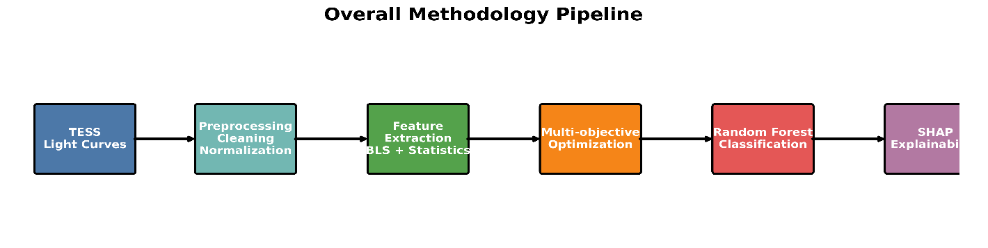

3.2 Dataset Description
The experimental dataset employed in this study was constructed from publicly available observations acquired by the Transiting Exoplanet Survey Satellite (TESS) [3],[4], a NASA space mission specifically designed to detect transiting exoplanets around nearby bright stars. TESS continuously monitors stellar brightness with high photometric precision, producing light curves that enable the identification of periodic transit events caused by orbiting planets.
Positive samples were obtained from the NASA Exoplanet Archive [5] by selecting stars with confirmed planetary detections that possess publicly available TESS observations. Restricting the positive class to confirmed exoplanets ensures that the supervised learning algorithm is trained using reliable astrophysical labels while minimizing uncertainties associated with unconfirmed candidates.
Negative samples were constructed from TESS targets without confirmed planetary detections. These objects were carefully selected to avoid overlap with known exoplanet host stars while preserving observational characteristics comparable to those of the positive class. This strategy reduces the possibility of introducing labeling inconsistencies and allows the classifier to learn meaningful differences between planetary and non-planetary photometric behavior.
For every target, calibrated TESS light curves were downloaded from the Mikulski Archive for Space Telescopes (MAST) [4]. Each observation contains time-series measurements of stellar brightness together with photometric uncertainties, quality flags, cadence identifiers, and centroid information generated by the official TESS Science Processing Operations Center (SPOC) [4] pipeline. Only calibrated observations were considered in this study to ensure consistency and reproducibility throughout the experimental workflow.
The complete dataset was subsequently divided into independent training and testing subsets using a stratified sampling strategy that preserved the original class proportions. This procedure guarantees that both subsets maintain representative distributions of positive and negative examples while preventing information leakage during model evaluation. All reported performance metrics were therefore computed using observations that remained completely unseen during model training.
The resulting dataset constitutes a representative benchmark for evaluating automated exoplanet detection methods based on TESS photometric observations. Its combination of confirmed planetary systems, carefully selected negative targets, standardized preprocessing, and reproducible data acquisition provides a reliable foundation for developing and validating supervised machine learning models.
After validating the downloaded targets and completing the preprocessing stage, the final dataset consisted of confirmed exoplanet candidates together with negative stellar observations. Figure 2 presents the resulting class distribution.
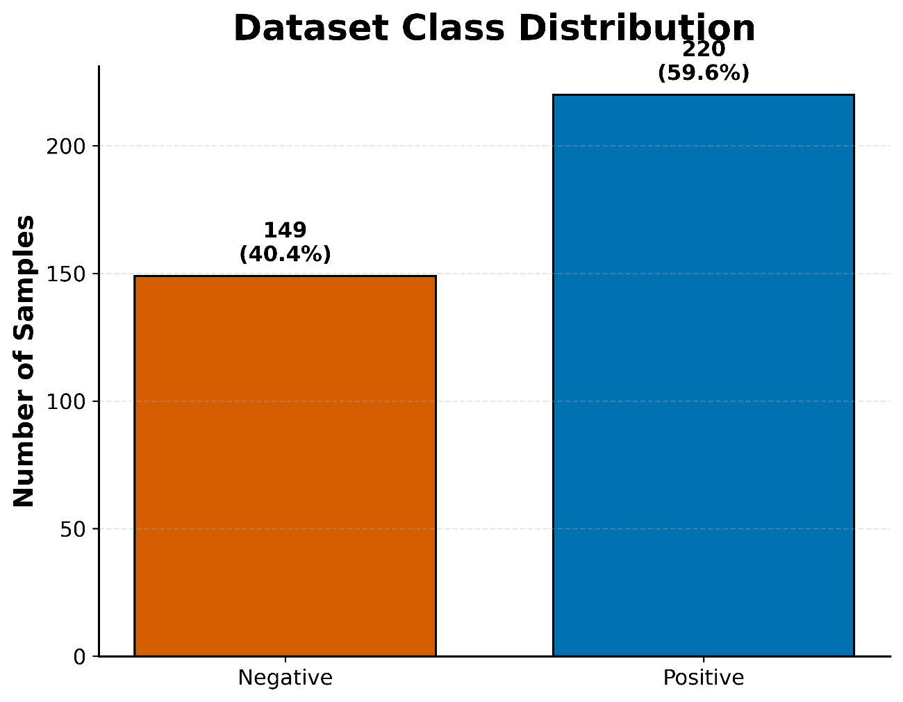
Figure 2. Distribution of positive and negative samples included in the final dataset.

3.3 Data Acquisition
The acquisition of photometric observations represents the first stage of the proposed framework. All stellar light curves employed in this study were obtained from publicly accessible astronomical repositories to ensure transparency, reproducibility, and long-term availability of the experimental dataset.
Confirmed exoplanet host stars were identified using the NASA Exoplanet Archive [5], which provides continuously updated catalogs containing validated planetary systems together with their corresponding stellar parameters and observational metadata. The archive served as the reference source for constructing the positive class of the supervised learning dataset.
After identifying the target stars, calibrated TESS observations were downloaded from the Mikulski Archive for Space Telescopes (MAST) [4]. MAST constitutes the official archive for NASA astrophysical missions and distributes fully calibrated photometric products generated by the Science Processing Operations Center (SPOC) [4]. Each downloaded observation was stored in Flexible Image Transport System (FITS) format, the standard data format adopted throughout observational astronomy.
The retrieval process was automated using the Lightkurve Python library [13], which provides a high-level interface for accessing, downloading, and manipulating TESS observations directly from MAST. Automating data acquisition significantly reduces manual intervention while ensuring consistency across all downloaded targets.
Each FITS file contains time-series photometric measurements together with multiple auxiliary variables describing observational conditions, photometric uncertainties, quality flags, detector centroids, and spacecraft metadata. Although only a subset of these variables is ultimately used during feature extraction, preserving the complete calibrated observations facilitates future analyses and guarantees full reproducibility of the proposed methodology.
The downloaded observations were subsequently organized into independent positive and negative repositories before entering the preprocessing stage. This structured organization simplifies data management, enables efficient batch processing, and establishes a reproducible workflow that can easily be extended as new TESS observations become publicly available.
The orbital period estimated through the Box Least Squares (BLS) algorithm [8] exhibited a broad distribution, reflecting the diversity of planetary systems included in the dataset.

3.4 Photometric Preprocessing
Raw photometric observations obtained from the TESS mission [3],[4] contain several instrumental artifacts, observational interruptions, and systematic effects that may significantly degrade the performance of automated exoplanet detection algorithms. Consequently, a comprehensive preprocessing pipeline was developed to improve the quality of the light curves while preserving potential transit signatures.
The preprocessing workflow consists of multiple sequential stages designed to eliminate unreliable observations, standardize photometric measurements, and generate normalized light curves suitable for feature extraction. Each stage was implemented as an independent module to facilitate reproducibility and future extensions of the proposed framework.
Initially, all observations flagged with non-zero quality indicators were discarded. The TESS quality flags [4] identify measurements affected by spacecraft events such as momentum dumps, scattered light contamination, pointing instabilities, cosmic-ray corrections, or other instrumental anomalies. Retaining only observations with zero quality flags ensures that the subsequent analysis is performed exclusively on scientifically reliable measurements.
Following quality filtering, observations containing missing values were removed. Both temporal measurements and photometric flux values were inspected for undefined entries (NaN), which can arise during calibration or data transmission. Eliminating incomplete observations prevents numerical instabilities during subsequent processing stages.
The remaining observations were then sorted chronologically according to their Barycentric TESS Julian Date (BTJD) [4]. Maintaining strict temporal ordering is essential for preserving the sequential nature of stellar variability and ensuring accurate period searches using transit detection algorithms.
Finally, the cleaned observations were stored in an intermediate dataset that serves as the input for the normalization and feature extraction procedures described in the following subsections.
Figure 5 illustrates an example of the preprocessing procedure applied to TESS observations.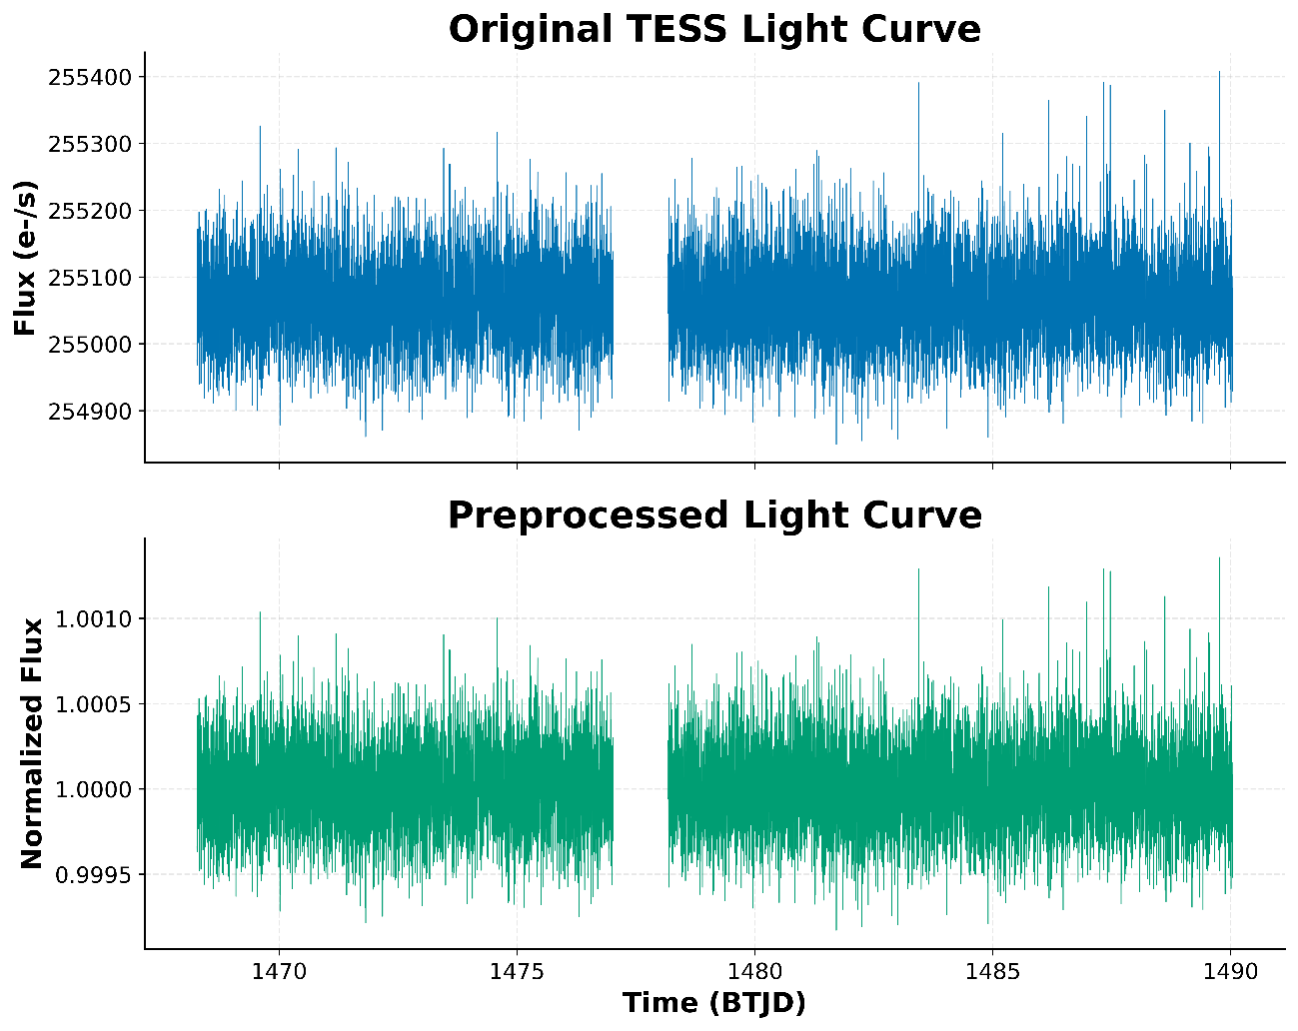
Figure 5. Example of an original TESS light curve before preprocessing and the corresponding normalized light curve after cleaning and detrending.

3.4.1 Flux Normalization
The stellar flux values recorded by TESS are expressed in instrumental units whose absolute magnitudes vary substantially among different targets. Since machine learning algorithms operate more effectively when numerical variables share comparable scales, each light curve was independently normalized before feature extraction.
Flux normalization was performed by dividing every photometric measurement by the median stellar flux of the corresponding light curve. Median normalization [14] was preferred over mean normalization because it is considerably more robust to outliers, transient events, and isolated photometric excursions frequently present in astronomical observations.
As a consequence, the normalized flux values fluctuate around unity, allowing direct comparisons among stars with vastly different intrinsic brightness while preserving the relative transit depth of planetary events.
Normalization also reduces numerical instability during the computation of statistical descriptors and improves the robustness of the Box Least Squares transit search performed later in the pipeline.

3.4.2 Treatment of Temporal Gaps
TESS observations frequently contain temporal discontinuities caused by spacecraft operations, observational interruptions, or changes between observing sectors. These gaps produce discontinuous time series that should not be artificially connected during visualization or subsequent analyses.
Rather than interpolating missing observations, the proposed framework preserves the original sampling pattern by explicitly identifying temporal discontinuities. Whenever consecutive observations are separated by a time interval substantially larger than the nominal cadence, the corresponding segments are treated as independent observational blocks.
Preserving observational gaps avoids the introduction of artificial photometric information that could distort transit detection algorithms or bias statistical feature extraction. This conservative strategy maintains the physical integrity of the original observations while accurately representing the true temporal coverage of the TESS mission.

3.4.3 Preprocessing Outcome
The complete preprocessing pipeline transforms raw calibrated observations into standardized photometric time series suitable for automated transit detection. Quality filtering eliminates unreliable measurements, normalization removes brightness-scale differences among stars, and gap preservation maintains the original temporal structure of the observations.
The resulting light curves exhibit substantially improved consistency while preserving astrophysical variability and potential planetary transit events. This preprocessing stage provides the foundation for reliable feature extraction and significantly contributes to the robustness of the subsequent machine learning model.
Figure 6 illustrates the effect of the preprocessing pipeline by comparing an original calibrated TESS light curve with its normalized counterpart. The transformation preserves the temporal behavior of the signal while expressing stellar brightness in a standardized scale centered around unity.
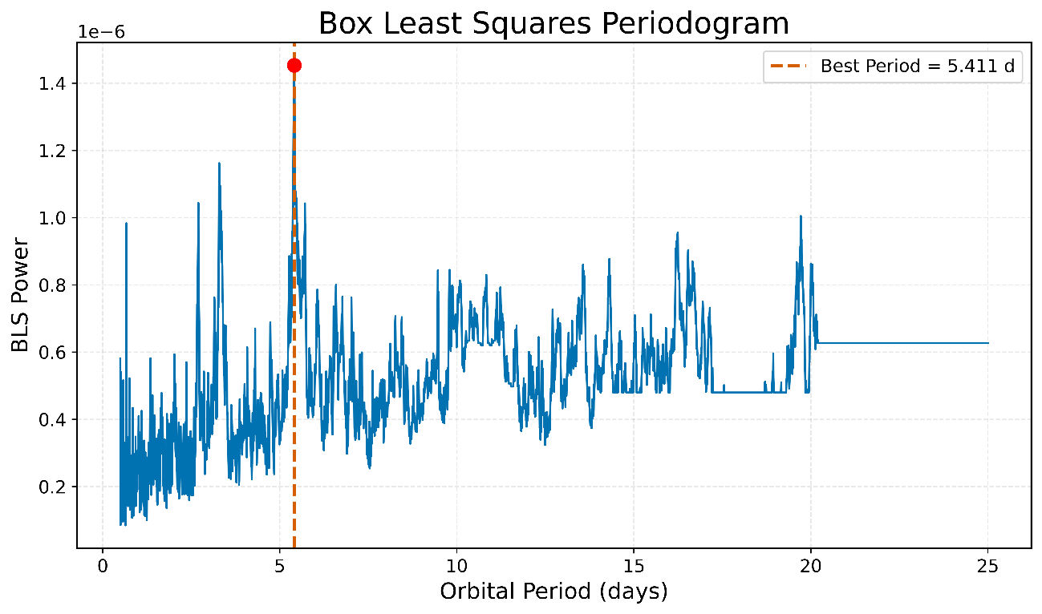

3.5 Feature Extraction
The objective of the feature extraction stage is to transform each preprocessed TESS light curve into a compact numerical representation suitable for supervised machine learning. Rather than using the raw photometric observations directly, the proposed framework extracts both physically meaningful transit descriptors and statistical characteristics capable of describing the global behavior of stellar variability. This strategy reduces data dimensionality while preserving the most informative properties required for discriminating planetary transits from non-planetary signals.
The primary transit-related descriptors were obtained using the Box Least Squares (BLS) algorithm [8]. BLS is specifically designed to identify periodic box-shaped brightness decreases that characterize planetary transits. For every preprocessed light curve, the algorithm searches a wide range of orbital periods and estimates the transit parameters that maximize the detection power. The extracted BLS features include the estimated orbital period, transit duration, transit depth, detection power, and signal-to-noise ratio. These parameters provide a physically interpretable description of the candidate transit event and constitute the core astrophysical information supplied to the classifier.
The distribution of the orbital periods estimated by the BLS algorithm is presented in Figure 3. The wide range of detected periods reflects the diversity of planetary systems included in the dataset and demonstrates the capability of the proposed pipeline to identify both short-period and relatively long-period transit events.
Figure 3. Distribution of orbital periods estimated through the Box Least Squares algorithm.
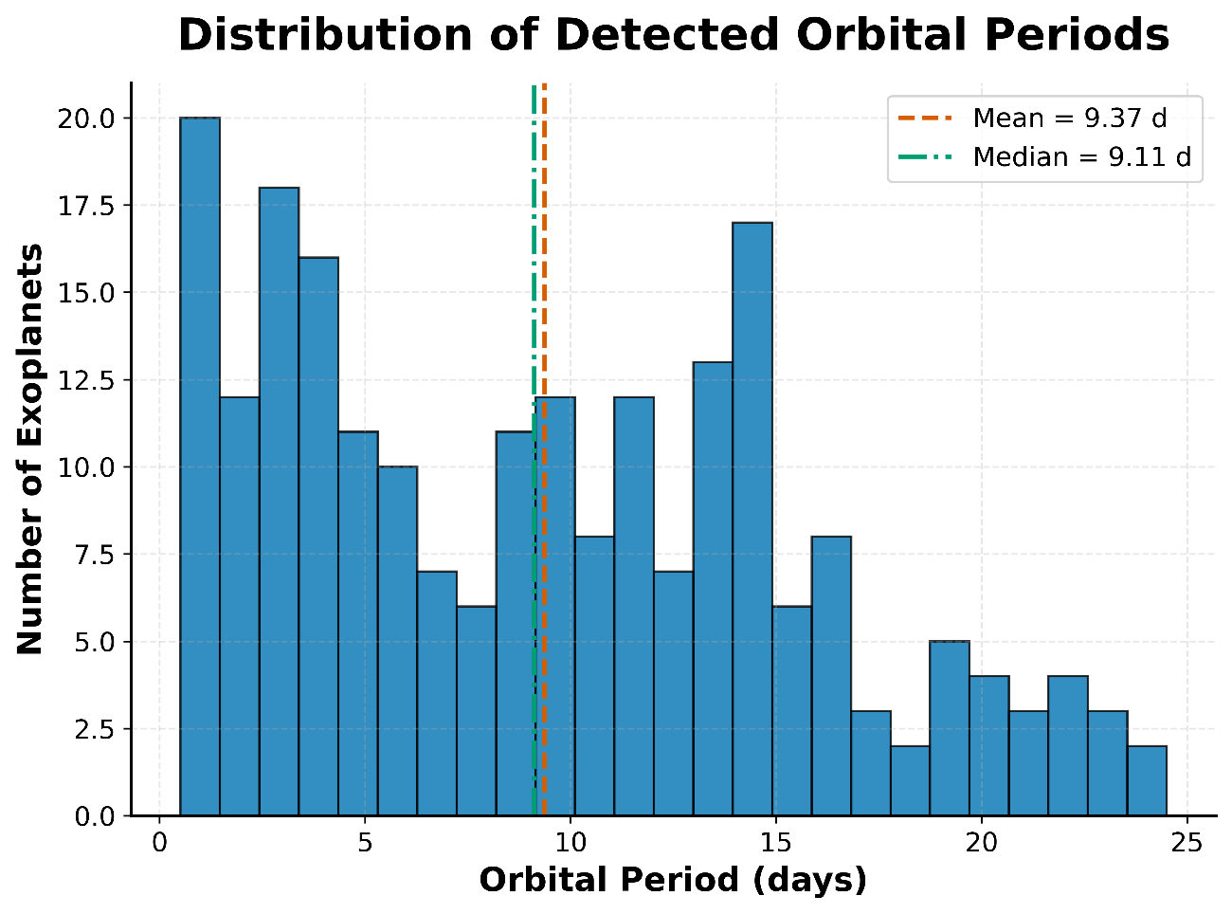
Transit depth represents another fundamental physical parameter because it is directly related to the ratio between the planetary radius and the stellar radius. Consequently, deeper transits generally correspond to larger planets or smaller host stars. The distribution of the estimated transit depths obtained from the BLS analysis is shown in Figure 4.
Figure 4. Distribution of estimated transit depths obtained from the Box Least Squares search.
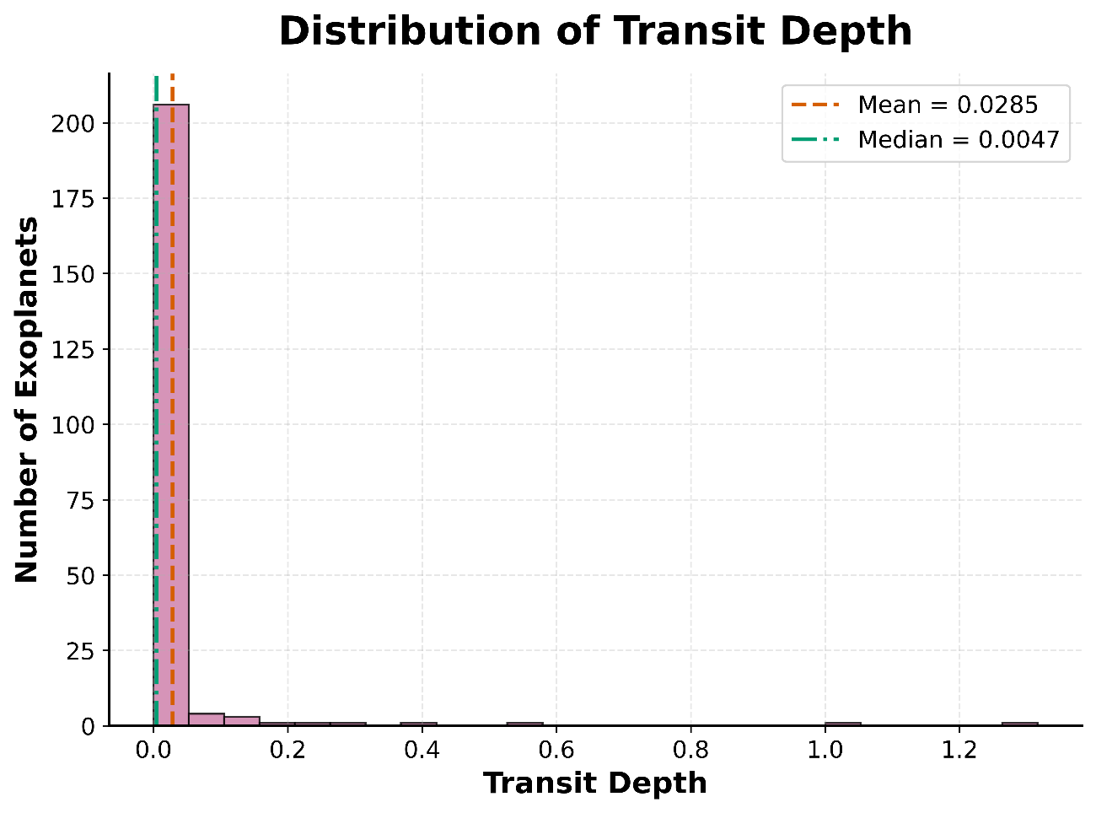
For each target, the BLS algorithm computes a periodogram representing the detection power associated with every tested orbital period. The highest peak of the periodogram corresponds to the orbital period that best explains the observed sequence of transit events. A representative BLS periodogram is presented in Figure 6, illustrating the clear identification of the dominant transit period.
Figure 6. Box Least Squares periodogram showing the highest-power orbital period detected for a representative target.
Once the orbital period has been identified, the corresponding light curve is folded using the estimated period to align all transit events within a single orbital cycle. Phase folding substantially increases the visibility of the transit signal by superimposing multiple transit events while averaging out stochastic photometric variability. The resulting phase-folded light curve is illustrated in Figure 7, where the characteristic box-shaped transit profile becomes clearly distinguishable.
Figure 7. Phase-folded transit light curve obtained using the orbital period estimated by the Box Least Squares algorithm.
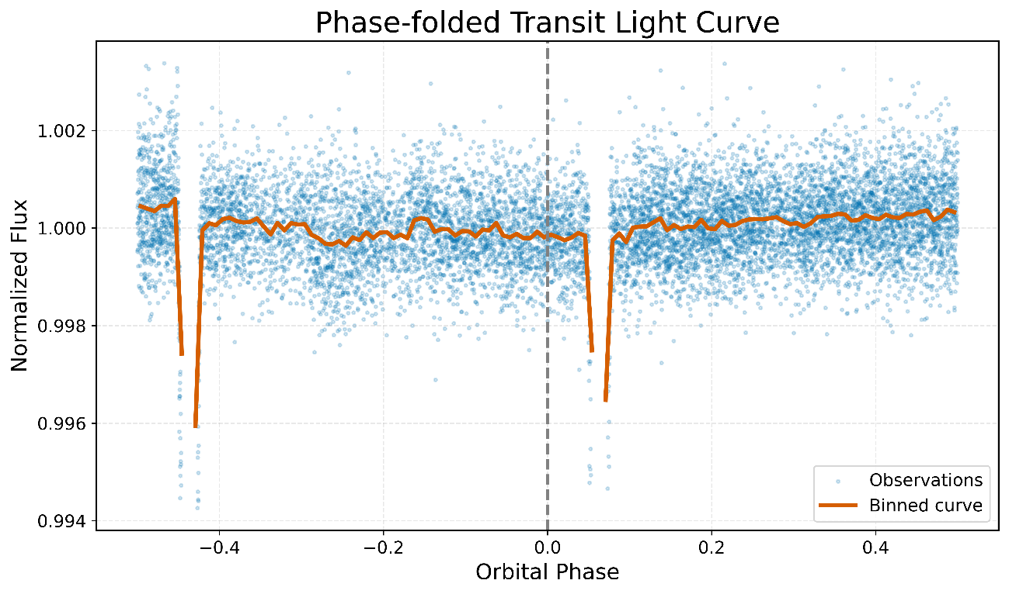
In addition to the transit descriptors obtained through the BLS algorithm, a comprehensive set of statistical features was extracted from every normalized light curve. These descriptors characterize the overall photometric behavior of each target and include measures of central tendency, dispersion, variability, asymmetry, kurtosis, percentiles, and other robust statistical indicators. Combining statistical photometric descriptors with physically meaningful transit parameters enables the proposed framework to capture complementary information describing both stellar variability and planetary transit morphology, thereby improving the predictive capability of the subsequent machine learning model.

3.6 Experimental Validation Protocol
To ensure a rigorous and unbiased evaluation, the proposed detection framework was validated using a stratified train–test methodology. The complete dataset was randomly divided into training and testing subsets while preserving the original class distribution.
A total of 70% of the observations were allocated for model training, whereas the remaining 30% were reserved exclusively for performance evaluation. This strategy guarantees that the classifier is assessed on unseen data and reduces the possibility of optimistic bias.
The Random Forest classifier [15] was trained using 500 decision trees. The number of trees was intentionally selected to stabilize the ensemble predictions while maintaining reasonable computational efficiency. To compensate for the moderate imbalance between positive and negative classes, balanced class weights were incorporated during training. This adjustment increases the contribution of the minority class when constructing the decision trees and helps prevent biased decision boundaries.
The complete feature vector extracted from the photometric time series was provided to the classifier without manual feature selection. Instead, the intrinsic feature selection capability of Random Forests [15] was exploited through recursive node splitting and ensemble averaging.
Model performance was evaluated using several complementary metrics commonly employed in binary classification problems.
The Receiver Operating Characteristic (ROC) [16] curve and its corresponding Area Under the Curve (AUC) quantify the discrimination capability of the classifier across different probability thresholds.
The Precision–Recall (PR) [17] curve evaluates the balance between completeness and prediction precision, providing additional insight in situations involving moderately imbalanced datasets.
The confusion matrix summarizes the number of correctly and incorrectly classified observations and enables computation of precision, recall, specificity, accuracy, and F1-score.
Finally, feature importance values obtained directly from the Random Forest ensemble were compared with SHAP (SHapley Additive Explanations) [35], [36] values. Whereas Random Forest importance quantifies the average reduction in impurity produced by each predictor, SHAP provides sample-wise explanations based on cooperative game theory, allowing interpretation of both the magnitude and direction of each feature's contribution to individual predictions. Combining these two interpretability approaches provides a comprehensive understanding of the model behavior.The periodogram shown in Figure 6 illustrates how the BLS algorithm identifies the dominant orbital period corresponding to the transit signal. Folding the light curve at the detected orbital period clearly reveals the periodic transit signature.

4. Results and Discussion
The proposed framework was evaluated using an independent testing dataset to assess its capability for automatically distinguishing confirmed exoplanet transits from non-planetary stellar variability. This section presents the classification performance obtained by the Random Forest model, followed by an analysis of feature relevance and model interpretability through explainable artificial intelligence techniques.
Unlike traditional transit detection approaches that rely exclusively on period-search algorithms, the proposed methodology combines statistical descriptors extracted from photometric observations with physically meaningful transit parameters obtained from the Box Least Squares (BLS) [8] algorithm. This combination enables the classifier to exploit complementary sources of information describing both stellar variability and transit morphology.
The experimental results demonstrate that integrating machine learning with astrophysical feature engineering produces a highly discriminative classification model while maintaining full interpretability of the decision-making process. Performance is analyzed through several complementary evaluation metrics, including the Receiver Operating Characteristic (ROC) curve, Precision–Recall analysis, confusion matrix, feature importance ranking, and SHAP [35],[36] explanations.

4.1 Classification Performance
The Receiver Operating Characteristic ROC [16] curve provides a comprehensive evaluation of the classifier over all possible decision thresholds. Unlike accuracy, which depends on a single classification threshold, the ROC curve evaluates the trade-off between the True Positive Rate (Sensitivity) and the False Positive Rate, thereby providing a threshold-independent assessment of model discrimination.
The Random Forest classifier achieved an Area Under the ROC Curve (AUC) of approximately 0.98, indicating excellent discrimination between confirmed exoplanet candidates and negative stellar observations. According to widely accepted classification guidelines, AUC values above 0.90 represent outstanding predictive performance, whereas values approaching unity indicate near-perfect separation of both classes.
The smooth shape of the ROC curve demonstrates that the proposed framework consistently maintains high detection sensitivity while keeping the false alarm rate relatively low. This behavior is particularly important in astronomical surveys, where minimizing false positives significantly reduces the amount of expensive follow-up observations required for planetary confirmation.
Overall, the obtained ROC performance confirms that combining statistical variability descriptors with BLS-derived transit parameters provides a robust representation of exoplanet signatures suitable for supervised machine learning classification.
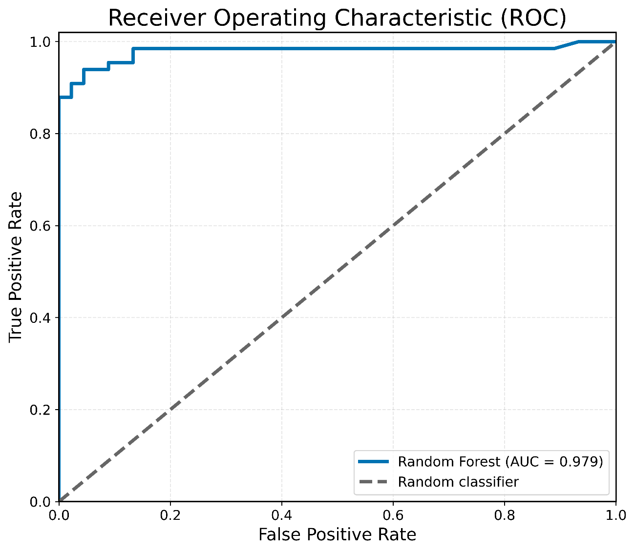
Figure 8. Receiver Operating Characteristic (ROC) curve obtained by the proposed Random Forest classifier. The model achieved an Area Under the Curve (AUC) close to 0.98, demonstrating excellent discrimination between confirmed exoplanet candidates and negative stellar observations.

4.2 Confusion Matrix Analysis
Although the ROC curve provides a global assessment of classifier performance across all decision thresholds, it does not explicitly reveal the distribution of correct and incorrect predictions. For this reason, the confusion matrix was analyzed to quantify the classification outcomes for each individual class.
The confusion matrix summarizes four possible prediction outcomes: True Positives (TP), True Negatives (TN), False Positives (FP), and False Negatives (FN). True Positives correspond to confirmed exoplanets correctly identified by the model, whereas True Negatives represent non-planetary stellar observations correctly classified as negative. False Positives occur when non-planetary targets are incorrectly predicted as exoplanets, while False Negatives correspond to genuine exoplanets that remain undetected.
As illustrated in Figure 9, the proposed Random Forest classifier correctly classified the vast majority of observations, producing only a limited number of classification errors. This behavior demonstrates that the extracted feature set effectively separates planetary transit signatures from ordinary stellar variability.
From an astronomical perspective, reducing the number of False Positives is particularly important because every incorrectly identified exoplanet candidate may require expensive spectroscopic or photometric follow-up observations. Likewise, minimizing False Negatives ensures that genuine planetary systems are not overlooked during the automatic screening process.
Overall, the confusion matrix confirms that the proposed framework achieves an excellent balance between sensitivity and specificity, making it suitable for large-scale automated analyses of TESS photometric observations.
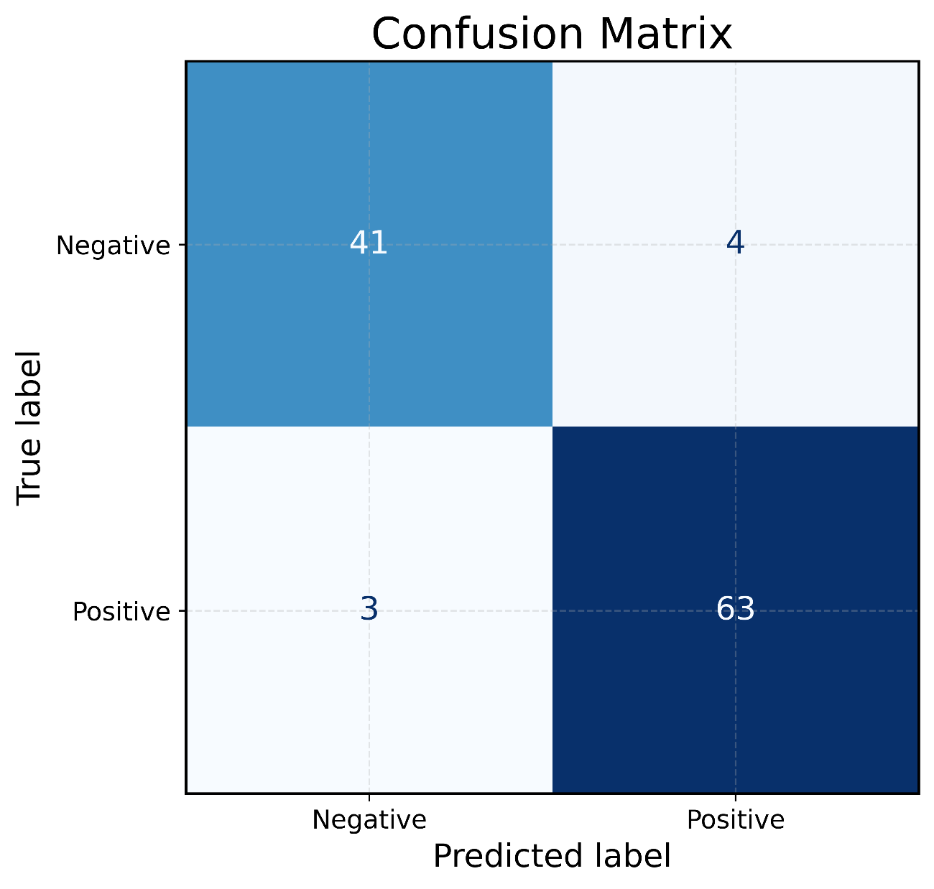
Figure 9. Confusion matrix obtained on the independent testing dataset. The matrix illustrates the distribution of correct classifications and prediction errors produced by the proposed Random Forest classifier.

4.3 Precision–Recall Analysis
While the ROC curve evaluates the discrimination capability of the classifier over varying decision thresholds, the Precision–Recall (PR) [17] curve provides additional insight into predictive performance under class imbalance. Because exoplanet detection datasets typically contain fewer confirmed planetary systems than negative observations, the PR curve constitutes a complementary and highly informative evaluation metric.
Precision measures the proportion of predicted exoplanet candidates that are actually confirmed planets, whereas Recall quantifies the fraction of true planetary systems successfully detected by the classifier. Consequently, the PR curve directly illustrates the trade-off between detection completeness and prediction reliability.
As shown in Figure 11, the proposed Random Forest model simultaneously maintains high precision and high recall across a broad range of probability thresholds. This behavior indicates that the classifier successfully identifies most planetary systems while producing relatively few false detections.
The strong Precision–Recall performance further confirms that combining statistical photometric descriptors with transit-related features extracted through the Box Least Squares (BLS) algorithm [8] produces a highly informative representation for automated exoplanet classification.
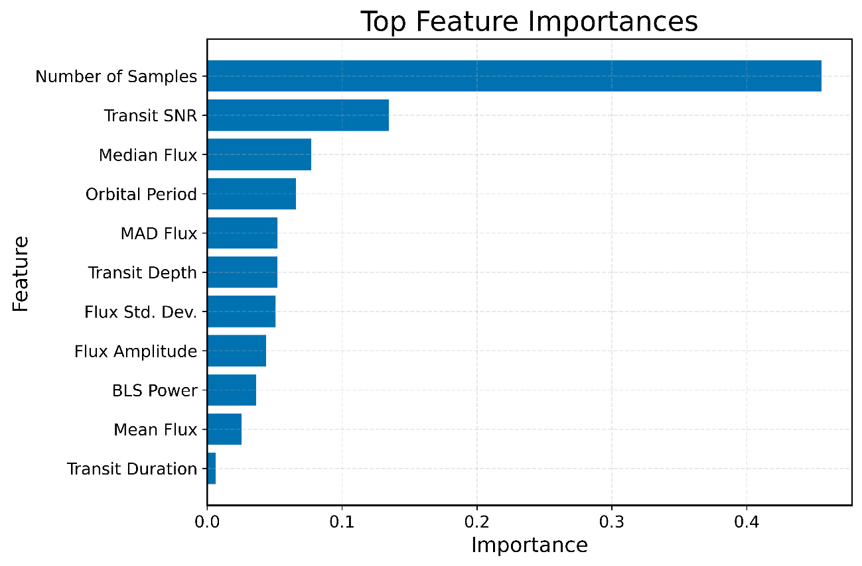
Figure 10. Relative importance of the input features estimated by the Random Forest classifier. Transit-related descriptors extracted through the Box Least Squares algorithm, together with statistical photometric features, contribute jointly to the classification process.

4.4 Feature Importance Analysis
Beyond achieving high predictive performance, understanding which observational variables contribute most significantly to the classification process is essential for assessing the physical consistency of the proposed framework. Random Forest classifiers [15] naturally provide estimates of feature importance based on the cumulative reduction of impurity generated during the construction of the decision trees.
Figure 10 presents the relative importance assigned to each predictor included in the final feature set. Several transit-related variables extracted through the Box Least Squares (BLS) [8] algorithm rank among the most influential descriptors, demonstrating that periodic photometric behavior remains one of the strongest indicators of planetary transits.
In particular, the estimated orbital period, transit depth, transit duration, and BLS detection power exhibit high predictive relevance. These parameters directly characterize the morphology of planetary transit events and therefore provide physically meaningful information for distinguishing exoplanet candidates from ordinary stellar variability.
Statistical descriptors computed from the normalized light curves also contribute substantially to the classification process. Variables describing flux dispersion, variability, asymmetry, and higher-order statistical moments complement the transit-specific parameters by capturing intrinsic stellar behavior that may otherwise resemble planetary signals.
The distribution of feature importance indicates that the proposed methodology does not rely on a single dominant predictor. Instead, the Random Forest classifier combines complementary information from both statistical and astrophysical descriptors, enabling robust classification even when individual features exhibit limited discriminative power.
This balanced contribution across multiple variables highlights one of the principal advantages of ensemble learning methods, namely their ability to integrate heterogeneous sources of information while remaining resistant to noisy or partially redundant predictors.
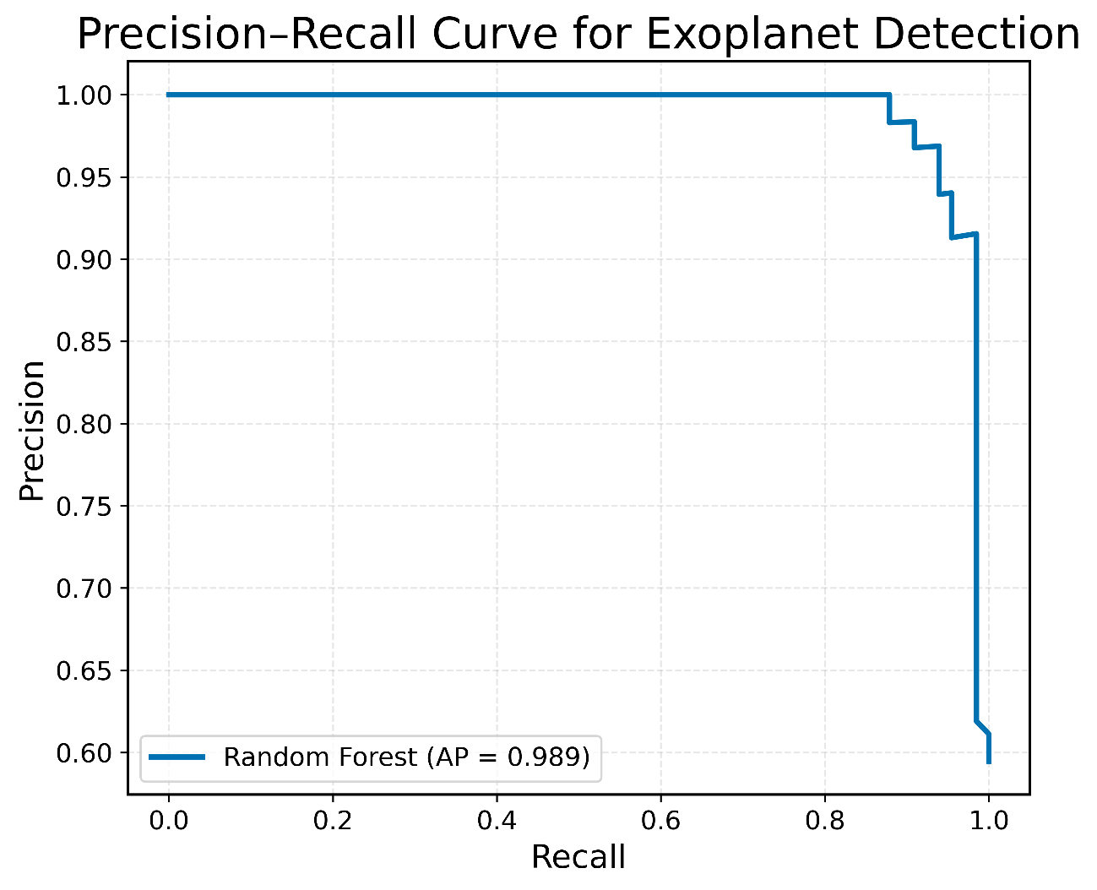
Figure 11. Precision–Recall curve of the proposed Random Forest classifier evaluated on the independent testing dataset.

4.5 Explainability Analysis Using SHAP
Although feature importance provides an overall ranking of predictor relevance, it does not explain how individual variables influence specific classification decisions. To obtain local and global model interpretability, SHapley Additive exPlanations (SHAP) [35], [36] were employed.
SHAP is a game-theoretic explainability framework [35] that assigns each feature a contribution value representing its influence on the prediction of every individual sample. Unlike conventional feature importance measures, SHAP simultaneously quantifies both the magnitude and the direction of each variable's contribution.
Figure 12 illustrates the SHAP summary plot obtained for the proposed Random Forest classifier. Each point represents one observation from the testing dataset, while its horizontal position corresponds to the SHAP value associated with a particular feature. Positive SHAP values increase the probability of classifying an observation as a confirmed exoplanet, whereas negative values decrease that probability.
The summary plot reveals that several BLS-derived parameters consistently exert the strongest influence on model predictions, confirming the conclusions obtained from the Random Forest feature importance analysis. Likewise, statistical descriptors describing flux variability exhibit substantial contributions across numerous observations, demonstrating that both astrophysical and statistical information are jointly exploited by the classifier.
An additional advantage of SHAP lies in its ability to reveal feature interactions and prediction heterogeneity across different stellar systems. Rather than assigning a fixed global importance score, SHAP explains how the same feature may contribute differently depending on the characteristics of each individual light curve.
The agreement between the Random Forest feature importance ranking and the SHAP explanations provides strong evidence that the proposed framework learns physically meaningful relationships instead of relying on spurious statistical correlations. Consequently, the model combines high predictive accuracy with transparent and interpretable decision-making, an increasingly important requirement for trustworthy artificial intelligence applications in modern astronomy.
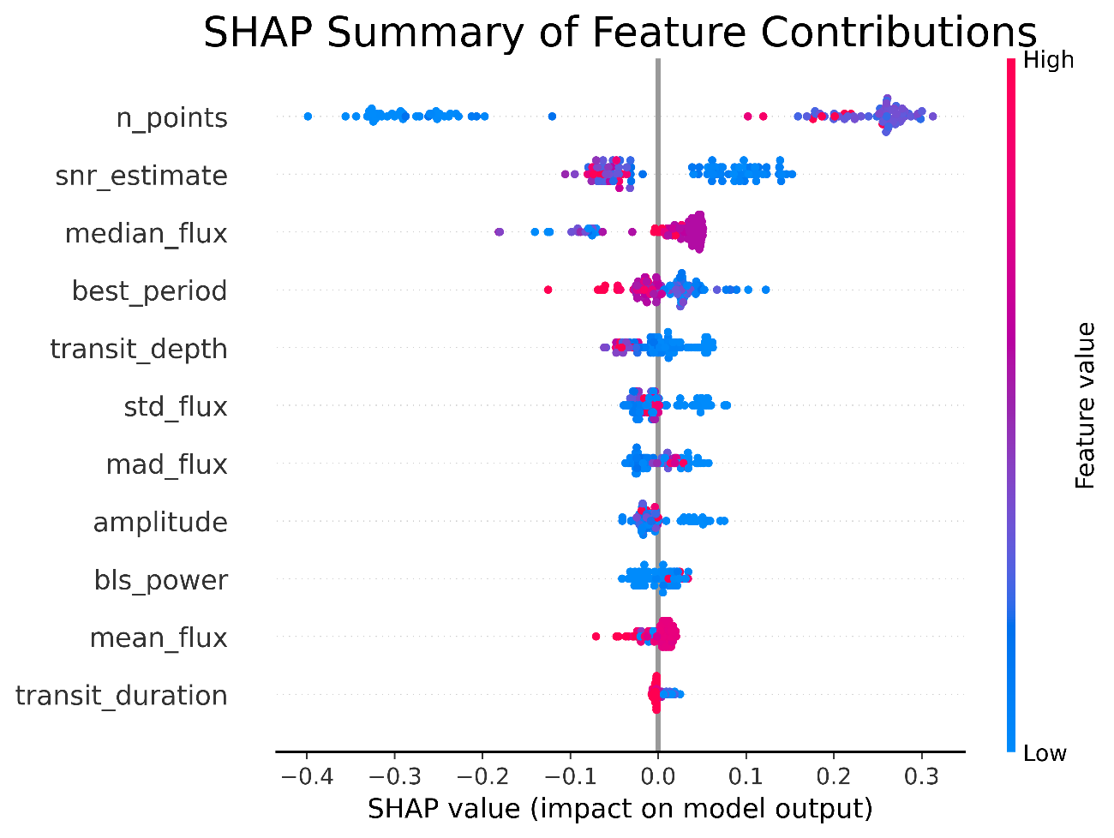
Figure 12. SHAP summary plot illustrating the contribution of each feature to the predictions of the Random Forest classifier. Positive SHAP values increase the probability of an observation being classified as a confirmed exoplanet, whereas negative values decrease that probability.

5. Conclusions
This study presented a complete and interpretable machine learning framework for automated exoplanet detection using photometric observations acquired by the Transiting Exoplanet Survey Satellite (TESS). The proposed methodology integrates astronomical signal preprocessing, statistical feature engineering, transit characterization through the Box Least Squares (BLS) algorithm, and supervised classification using a Random Forest model complemented by explainable artificial intelligence techniques.
Unlike conventional transit-search approaches that rely exclusively on periodicity analysis, the proposed framework combines multiple sources of astrophysical information describing both stellar variability and transit morphology. This hybrid representation enables the classifier to distinguish confirmed exoplanet candidates from non-planetary observations with high discriminative capability while preserving physical interpretability.
Experimental evaluation demonstrated excellent predictive performance on an independent testing dataset. The ROC analysis yielded an Area Under the Curve close to 0.98, while the confusion matrix and Precision–Recall analysis confirmed that the model maintains both high sensitivity and high precision. These results indicate that the extracted statistical and transit-related features provide a robust representation of planetary transit signatures.
An important contribution of this work is the incorporation of explainable artificial intelligence through SHAP analysis. Beyond achieving high classification accuracy, the proposed framework allows the contribution of every input feature to be quantified and interpreted for each prediction. The consistency observed between Random Forest feature importance and SHAP explanations suggests that the classifier learns physically meaningful relationships instead of relying on spurious statistical patterns.
From an astronomical perspective, the proposed methodology offers a scalable strategy for assisting the analysis of the continuously growing volume of photometric observations generated by modern space missions. By reducing the number of false detections while preserving a high discovery rate, the framework has the potential to decrease the computational and observational effort required during exoplanet candidate validation.
Overall, the results demonstrate that combining astrophysical knowledge with modern machine learning and explainable artificial intelligence constitutes an effective strategy for automated exoplanet detection and provides a promising foundation for future large-scale astronomical surveys.

6. Limitations and Future Work
Although the proposed framework achieved excellent predictive performance, several limitations should be acknowledged.
First, the experimental dataset was constructed exclusively from confirmed TESS observations available at the time of this study. As additional exoplanet candidates become validated, incorporating larger and more diverse datasets may further improve model generalization and robustness.
Second, the current framework employs manually engineered statistical descriptors together with transit parameters extracted using the Box Least Squares algorithm. Recent advances in deep learning suggest that convolutional and transformer-based neural networks may automatically learn higher-level representations directly from raw light curves. Future investigations could compare these representation learning approaches with the handcrafted feature engineering strategy proposed in this work.
Third, the present study focused on binary classification between confirmed exoplanets and negative stellar observations. Future research may extend the methodology toward multi-class classification capable of distinguishing planetary transits from eclipsing binaries, stellar pulsations, instrumental artifacts, and other forms of astrophysical variability.
Another promising research direction involves integrating additional sources of astronomical information, including stellar atmospheric parameters, Gaia astrometric measurements, spectroscopic observations, and multi-sector TESS photometry. Combining heterogeneous observational data may further improve detection performance while providing a more comprehensive characterization of planetary systems.
Finally, although SHAP substantially improves model interpretability, future work may investigate additional explainability techniques, uncertainty quantification methods, and probabilistic machine learning approaches to provide confidence estimates associated with each exoplanet candidate.
These research directions constitute natural extensions of the proposed framework and may contribute to the development of increasingly reliable and transparent artificial intelligence systems for large-scale astronomical discovery.

Data Availability Statement
The datasets generated and analyzed during the current study are available from the corresponding author upon reasonable request. The original photometric observations used in this work are publicly accessible through the Mikulski Archive for Space Telescopes (MAST) and were obtained from the Transiting Exoplanet Survey Satellite (TESS) mission.
The processed datasets, extracted feature tables, and machine learning outputs used to support the findings of this study can be made available for research purposes in accordance with the journal's data sharing policies.

Code Availability Statement
The complete source code developed for data acquisition, photometric preprocessing, feature extraction, machine learning classification, figure generation, and explainable artificial intelligence analysis is available from the corresponding author upon reasonable request.
The implementation was developed entirely in Python using open-source scientific computing libraries, including NumPy, Pandas, Astropy, Scikit-learn, Matplotlib, and SHAP, thereby ensuring full reproducibility of the proposed methodology.

Author Contributions
Conceptualization: Bryan Cabrera.
Methodology: Bryan Cabrera.
Software: Bryan Cabrera.
Validation: Bryan Cabrera.
Formal analysis: Bryan Cabrera.
Investigation: Bryan Cabrera.
Data curation: Bryan Cabrera.
Writing—original draft preparation: Bryan Cabrera.
Writing—review and editing: Bryan Cabrera.
Visualization: Bryan Cabrera.
Supervision: Bryan Cabrera.
All authors have read and approved the final version of the manuscript.

Acknowledgments
The author gratefully acknowledges the National Aeronautics and Space Administration (NASA) and the Massachusetts Institute of Technology (MIT) for providing public access to the Transiting Exoplanet Survey Satellite (TESS) observations through the Mikulski Archive for Space Telescopes (MAST).
The author also acknowledges the developers and maintainers of the open-source scientific Python ecosystem, whose software packages made this research possible.

References (Initial Core References)
Block A – Foundations of Exoplanet Science
[1] Mayor, M., & Queloz, D., "A Jupiter-mass companion to a solar-type star," Nature, vol. 378, pp. 355–359, 1995. https://doi.org/10.1038/378355a0
[2] Borucki, W. J., Koch, D., Basri, G., et al., "Kepler Planet-Detection Mission: Introduction and First Results," Science, vol. 327, no. 5968, pp. 977–980, 2010. https://doi.org/10.1126/science.1185402
[3] G. R. Ricker et al., "Transiting Exoplanet Survey Satellite (TESS)," J. Astron. Telesc. Instrum. Syst., vol. 1, no. 1, Art. 014003, 2015. doi: 10.1117/1.JATIS.1.1.014003.
[4] Jenkins, J. M., Twicken, J. D., Batalha, N. M., et al., "Overview of the TESS Science Processing Operations Center," Proceedings of SPIE, vol. 9913, 2016. https://doi.org/10.1117/12.2233418
[5] M. Perryman, The Exoplanet Handbook, 2nd ed. Cambridge, U.K.: Cambridge University Press, 2018. doi: 10.1017/9781316730439.
[6] J. N. Winn, "Exoplanet Transits and Occultations," in Exoplanets, S. Seager, Ed. Tucson, AZ, USA: University of Arizona Press, 2010.https://doi.org/10.48550/arXiv.1001.2010
[7] D. A. Fischer et al., "Exoplanet Detection Techniques," Proc. Natl. Acad. Sci. U.S.A., vol. 111, no. 35, pp. 12641–12646, 2014. doi: 10.1073/pnas.1304213111. https://doi.org/10.1073/pnas.1304213111
[8] Perryman, M. A. C., The Exoplanet Handbook, Cambridge University Press, 2011. https://doi.org/10.1017/CBO9780511976185
Block B – Transit Detection Algorithms and Time-Series Analysis
[8] Kovács, G., Zucker, S., & Mazeh, T., "A Box-fitting Algorithm in the Search for Periodic Transits," Astronomy & Astrophysics, vol. 391, pp. 369–377, 2002. https://doi.org/10.1051/0004-6361:20020802
[9] Hippke, M., & Heller, R., "Transit Least Squares Survey – I. Discovery and validation of an ultra-short-period planet around K2-32," Astronomy & Astrophysics, vol. 623, A39, 2019. https://doi.org/10.1051/0004-6361/201834672
[10] Lomb, N. R., "Least-Squares Frequency Analysis of Unequally Spaced Data," Astrophysics and Space Science, vol. 39, pp. 447–462, 1976. https://doi.org/10.1007/BF00648343
[11] Scargle, J. D., "Studies in Astronomical Time Series Analysis II: Statistical Aspects of Spectral Analysis of Unevenly Spaced Data," The Astrophysical Journal, vol. 263, pp. 835–853, 1982. https://doi.org/10.1086/160554
[12] VanderPlas, J. T., "Understanding the Lomb–Scargle Periodogram," The Astrophysical Journal Supplement Series, vol. 236, no. 1, 2018. https://doi.org/10.3847/1538-4365/aab766
[13] Astropy Collaboration, Price-Whelan, A. M., Sipőcz, B. M., Günther, H. M., et al., "The Astropy Project: Building an Open-science Project and Status of the v2.0 Core Package," The Astronomical Journal, vol. 156, no. 3, 2018. https://doi.org/10.3847/1538-3881/aabc4f
[14] Lightkurve Collaboration, Lightkurve: Kepler and TESS Time Series Analysis in Python, Astrophysics Source Code Library, record ascl:1812.013, 2018. https://ascl.net/1812.013
Block C – Machine Learning Foundations
[15] Breiman, L., "Random Forests," Machine Learning, vol. 45, no. 1, pp. 5–32, 2001. https://doi.org/10.1023/A:1010933404324
[16] Quinlan, J. R., C4.5: Programs for Machine Learning, Morgan Kaufmann Publishers, 1993.
[17] Cortes, C., & Vapnik, V., "Support-Vector Networks," Machine Learning, vol. 20, pp. 273–297, 1995. https://doi.org/10.1007/BF00994018
[18] Friedman, J. H., "Greedy Function Approximation: A Gradient Boosting Machine," Annals of Statistics, vol. 29, no. 5, pp. 1189–1232, 2001. https://doi.org/10.1214/aos/1013203451
[19] Chen, T., & Guestrin, C., "XGBoost: A Scalable Tree Boosting System," Proceedings of the 22nd ACM SIGKDD International Conference on Knowledge Discovery and Data Mining, pp. 785–794, 2016. https://doi.org/10.1145/2939672.2939785
[20] F. Pedregosa et al., "Scikit-learn: Machine Learning in Python," J. Mach. Learn. Res., vol. 12, pp. 2825–2830, 2011.
[21] Hastie, T., Tibshirani, R., & Friedman, J., The Elements of Statistical Learning: Data Mining, Inference, and Prediction, 2nd ed., Springer, 2009. https://doi.org/10.1007/978-0-387-84858-7
[22] Bishop, C. M., Pattern Recognition and Machine Learning, Springer, 2006.
[23] G. James, D. Witten, T. Hastie, and R. Tibshirani, An Introduction to Statistical Learning, 2nd ed. New York, NY, USA: Springer, 2021. doi: 10.1007/978-1-0716-1418-1. https://doi.org/10.1007/978-1-4614-7138-7
[24] Fawcett, T., "An Introduction to ROC Analysis," Pattern Recognition Letters, vol. 27, no. 8, pp. 861–874, 2006. https://doi.org/10.1016/j.patrec.2005.10.010
Block D – Machine Learning for Exoplanet Detection
[25] Shallue, C. J., & Vanderburg, A., "Identifying Exoplanets with Deep Learning: A Five-Planet Resonant Chain Around Kepler-80 and an Eighth Planet Around Kepler-90," The Astronomical Journal, vol. 155, no. 2, Art. 94, 2018. https://doi.org/10.3847/1538-3881/aa9e09
[26] Pearson, K. A., Palafox, L., & Griffith, C. A., "Searching for Exoplanets Using Artificial Intelligence," Monthly Notices of the Royal Astronomical Society, vol. 474, no. 1, pp. 478–491, 2018. https://doi.org/10.1093/mnras/stx2761
[27] Ansdell, M., Ioannou, Y., Osborn, H. P., et al., "Scientific Domain Knowledge Improves Exoplanet Transit Classification with Deep Learning," The Astrophysical Journal Letters, vol. 869, L7, 2018. https://doi.org/10.3847/2041-8213/aaf23e
[28] E. Tey, D. Moldovan, M. Kunimoto, C. X. Huang, et al., "Identifying Exoplanets with Deep Learning. V. Improved Light-curve Classification for TESS Full-frame Image Observations," Astron. J., vol. 165, no. 3, Art. 95, 2023. doi: 10.3847/1538-3881/acad85.https://doi.org/10.3847/1538-3881/abe4ff
[29] L. Ofman, A. Averbuch, A. Shliselberg, I. Benaun, D. Segev, and A. Rissman, "Automated Identification of Transiting Exoplanet Candidates in NASA Transiting Exoplanet Survey Satellite (TESS) Data with Machine Learning Methods," New Astron., vol. 91, Art. 101693, 2022. doi: 10.1016/j.newast.2021.101693.
[30] Armstrong, D. J., Pollacco, D., & Santerne, A., "Transit Shapes and Self-Organising Maps as a Tool for Ranking Planetary Candidates," Monthly Notices of the Royal Astronomical Society, vol. 465, pp. 2634–2642, 2017. https://doi.org/10.1093/mnras/stw2973
[31] Thompson, S. E., Coughlin, J. L., Hoffman, K., et al., "Planetary Candidates Observed by Kepler. VIII. A Fully Automated Catalog with Measured Completeness and Reliability," The Astrophysical Journal Supplement Series, vol. 235, no. 2, 2018. https://doi.org/10.3847/1538-4365/aabc5f
[32] Twicken, J. D., Jenkins, J. M., Seader, S. E., et al., "Detection of Potential Transit Signals in the First Three Years of Kepler Mission Data," The Astrophysical Journal Supplement Series, vol. 211, no. 2, 2014. https://doi.org/10.1088/0067-0049/211/2/24
[33] McCauliff, S. D., Jenkins, J. M., Catanzarite, J. H., et al., "Automatic Classification of Kepler Planetary Transit Candidates," The Astrophysical Journal, vol. 806, no. 1, 2015. https://doi.org/10.1088/0004-637X/806/1/6
[34] Dattilo, A., Vanderburg, A., Shallue, C. J., et al., "Identifying Exoplanets with Deep Learning II: Two New Super-Earths Uncovered by a Neural Network in K2 Data," The Astronomical Journal, vol. 157, no. 5, 2019. https://doi.org/10.3847/1538-3881/ab0e53
Block E – Explainable Artificial Intelligence (XAI)
[35] Lundberg, S. M., & Lee, S.-I., "A Unified Approach to Interpreting Model Predictions," Advances in Neural Information Processing Systems (NeurIPS), vol. 30, 2017.
[36] Lundberg, S. M., Erion, G., Chen, H., et al., "From Local Explanations to Global Understanding with Explainable AI for Trees," Nature Machine Intelligence, vol. 2, pp. 56–67, 2020. https://doi.org/10.1038/s42256-019-0138-9
[37] Ribeiro, M. T., Singh, S., & Guestrin, C., "Why Should I Trust You? Explaining the Predictions of Any Classifier," Proceedings of the 22nd ACM SIGKDD International Conference on Knowledge Discovery and Data Mining, pp. 1135–1144, 2016. https://doi.org/10.1145/2939672.2939778
[38] A. Adadi and M. Berrada, "Peeking Inside the Black-Box: A Survey on Explainable Artificial Intelligence (XAI)," IEEE Access, vol. 6, pp. 52138–52160, 2018. doi: 10.1109/ACCESS.2018.2870052.
[39] Arrieta, A. B., Díaz-Rodríguez, N., Del Ser, J., et al., "Explainable Artificial Intelligence (XAI): Concepts, Taxonomies, Opportunities and Challenges toward Responsible AI," Information Fusion, vol. 58, pp. 82–115, 2020. https://doi.org/10.1016/j.inffus.2019.12.012
[40] Guidotti, R., Monreale, A., Ruggieri, S., et al., "A Survey of Methods for Explaining Black Box Models," ACM Computing Surveys, vol. 51, no. 5, Article 93, 2018. https://doi.org/10.1145/3236009
[41] C. Rudin, "Stop Explaining Black Box Machine Learning Models for High Stakes Decisions and Use Interpretable Models Instead," Nat. Mach. Intell., vol. 1, no. 5, pp. 206–215, 2019. doi: 10.1038/s42256-019-0048-x.
[42] P. Linardatos, V. Papastefanopoulos, and S. Kotsiantis, "Explainable AI: A Review of Machine Learning Interpretability Methods," Entropy, vol. 23, no. 1, Art. 18, 2021. doi: 10.3390/e23010018.
Block F – Multi-objective Optimization and Feature Selection
[43] Deb, K., Pratap, A., Agarwal, S., & Meyarivan, T., "A Fast and Elitist Multiobjective Genetic Algorithm: NSGA-II," IEEE Transactions on Evolutionary Computation, vol. 6, no. 2, pp. 182–197, 2002. https://doi.org/10.1109/4235.996017
[44] Deb, K., Multi-Objective Optimization Using Evolutionary Algorithms, John Wiley & Sons, 2001.
[45] Coello Coello, C. A., Lamont, G. B., & Van Veldhuizen, D. A., Evolutionary Algorithms for Solving Multi-Objective Problems, 2nd ed., Springer, 2007. https://doi.org/10.1007/978-0-387-36797-2
[46] Xue, B., Zhang, M., Browne, W. N., & Yao, X., "A Survey on Evolutionary Computation Approaches to Feature Selection," IEEE Transactions on Evolutionary Computation, vol. 20, no. 4, pp. 606–626, 2016. https://doi.org/10.1109/TEVC.2015.2504420
[47] Chandrashekar, G., & Sahin, F., "A Survey on Feature Selection Methods," Computers & Electrical Engineering, vol. 40, no. 1, pp. 16–28, 2014. https://doi.org/10.1016/j.compeleceng.2013.11.024
[48] Guyon, I., & Elisseeff, A., "An Introduction to Variable and Feature Selection," Journal of Machine Learning Research, vol. 3, pp. 1157–1182, 2003.
[49] Blum, A. L., & Langley, P., "Selection of Relevant Features and Examples in Machine Learning," Artificial Intelligence, vol. 97, no. 1–2, pp. 245–271, 1997. https://doi.org/10.1016/S0004-3702(97)00063-5
[50] Emmerich, M. T. M., & Deutz, A. H., "A Tutorial on Multiobjective Optimization: Fundamentals and Evolutionary Methods," Natural Computing, vol. 17, pp. 585–609, 2018. https://doi.org/10.1007/s11047-018-9685-y
[51] Zitzler, E., Deb, K., & Thiele, L., "Comparison of Multiobjective Evolutionary Algorithms: Empirical Results," Evolutionary Computation, vol. 8, no. 2, pp. 173–195, 2000. https://doi.org/10.1162/106365600568202
[52] Li, J., Cheng, K., Wang, S., et al., "Feature Selection: A Data Perspective," ACM Computing Surveys, vol. 50, no. 6, Article 94, 2018. https://doi.org/10.1145/3136625
Block G – Recent Advances in Machine Learning for Exoplanet Detection (2022–2025)
[53] Valizadegan, H., Martinho, M. J. S., Jenkins, J. M., et al., "ExoMiner: A Highly Accurate and Explainable Deep Learning Classifier That Validates 301 New Exoplanets," The Astrophysical Journal, vol. 926, no. 2, Art. 120, 2022. https://doi.org/10.3847/1538-4357/ac4399
[54] Ofman, L., Averbuch, A., Shliselberg, A., et al., "Automated Identification of Transiting Exoplanet Candidates in NASA Transiting Exoplanet Survey Satellite (TESS) Data with Machine Learning Methods," New Astronomy, vol. 91, Art. 101693, 2022. https://doi.org/10.1016/j.newast.2021.101693
[55] Chintarungruangchai, P., Jiang, I.-G., & Tang, H.-Y., "Exoplanet Detection Using Machine Learning," Monthly Notices of the Royal Astronomical Society, vol. 513, no. 4, pp. 5505–5516, 2022. https://doi.org/10.1093/mnras/stab3692
[56] Cuéllar, S., Granados, P., Fabregas, E., et al., "Deep Learning Exoplanets Detection by Combining Real and Synthetic Data," PLoS ONE, vol. 17, no. 5, e0268199, 2022. https://doi.org/10.1371/journal.pone.0268199
[57] Van der Sluys, M., et al., "Size Does Matter: Exoplanet Detection with a Sparse Convolutional Neural Network," Astronomy and Computing, vol. 41, Art. 100654, 2022. https://doi.org/10.1016/j.ascom.2022.100654
[58] Tey, E., Moldovan, D., Kunimoto, M., et al., "Identifying Exoplanets with Deep Learning. V. Improved Light Curve Classification for TESS Full Frame Image Observations," 2023. arXiv:2301.01371.
[59] Wang, J., "Training a Convolutional Neural Network for Exoplanet Classification with Transit Photometry Data," Scientific Reports, vol. 15, Art. 15408, 2025. https://doi.org/10.1038/s41598-025-98935-8
[60] Marín Díaz, G., "FAS-XAI: Fuzzy and Explainable AI for Interpretable Vetting of Kepler Exoplanet Candidates," Mathematics, vol. 13, no. 23, Art. 3796, 2025. https://doi.org/10.3390/math13233796

NOMBRES DE INTEGRANTES DEL GRUPO:
Mateo Josué Álvarez Ibarra
https://orcid.org/0009-0005-2634-7170
Wilmer Alexander Moreno Vallejos
https://orcid.org/0009-0001-0250-4187
Bryan Andrés Cabrera Araque
https://orcid.org/0009-0004-7064-5776
Jair Chandi
https://orcid.org/0009-0002-7364-6040

