California Dealer Logistics Solutions (CDLS)
Adaptive Route & Charge Optimization Module
Technical Architecture Proposal — Statistical Routing Engine with Behavioral Equilibrium Modeling

1. Purpose & Scope
This document specifies an upgrade to the CDLS technology platform that adds a statistically grounded, behavior-aware routing and charging engine. It combines two methodologies into one system:
- A Bayesian (MCMC) regression layer over 10 years of historical haul, dwell, and congestion data to produce stable, noise-filtered cost estimates for every corridor in the dealer network.
- A behavioral equilibrium layer, modeled on the agent-based approach used in the National Renewable Energy Laboratory / Lawrence Berkeley National Laboratory GEMINI co-simulation framework, which captures how drivers and dealers actually behave — not just the theoretical shortest path.
The combined output is a “path-of-least-resistance” router: the route and charging plan most likely to be followed in practice, continuously validated and re-calibrated through live A/B testing.

2. Why Combine These Two Approaches
A purely statistical router optimizes for cost or time but assumes drivers behave like cost-minimizing robots. A purely behavioral model captures realistic choices but drifts without a stable, denoised cost backbone. The GEMINI research (Panossian et al., 2023, Energies) demonstrates the value of merging these: their co-simulation of an agent-based transportation model (BEAM) with a grid simulation (PyDSS) showed that grid and routing impacts are not evenly distributed — they concentrate geographically and temporally around real driver behavior, such as home charging before the morning commute. The same concentration effect applies to CDLS hauls and charging stops, which is why the router needs both layers.

3. System Architecture
The diagram below shows the six-layer data flow, from historical inputs through to live feedback.
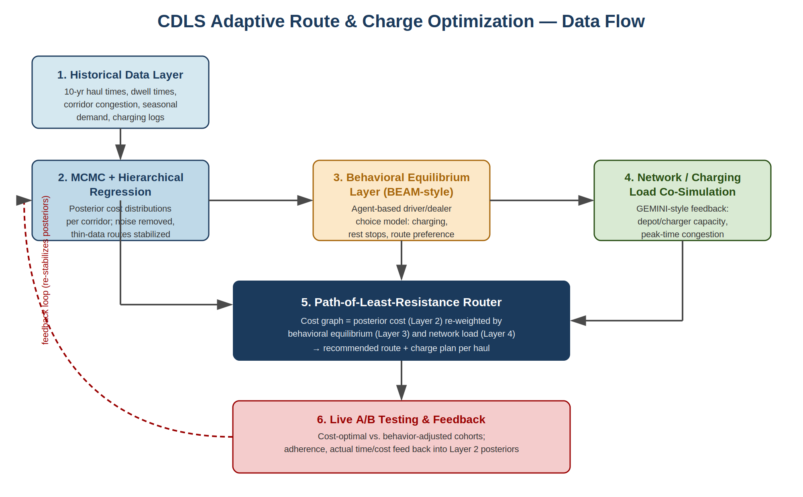

3.1 Layer 1 — Historical Data
Ten years of CDLS-relevant data: dealer-to-dealer haul times, driver check-in/check-out logs, charging dwell times, corridor congestion, and seasonal demand patterns (tied to the existing CDLS load economics: 9 vehicles per haul, 350-mile reference routes).

3.2 Layer 2 — MCMC + Hierarchical Regression
Bayesian regression sampled via Markov Chain Monte Carlo (e.g., Hamiltonian Monte Carlo through Stan or PyMC) produces a full posterior distribution of travel cost per corridor rather than a single point estimate.
- Noise removal: one-off disruptions (accidents, single bad pickups, weather events) are modeled as outliers in the likelihood rather than allowed to distort the trend.
- Stabilization: a hierarchical / partial-pooling structure lets thin-data routes borrow statistical strength from the network average, preventing low-volume corridors from producing volatile estimates.

3.3 Layer 3 — Behavioral Equilibrium Layer
Modeled on BEAM’s agent-based approach, this layer simulates driver and dealer choices — preferred charging locations, rest-stop habits, route familiarity — as an equilibrium outcome rather than a fixed schedule, the same way BEAM captures daily activity patterns, mode choice, and charging behavior for millions of simulated travelers.

3.4 Layer 4 — Network / Charging Load Co-Simulation
A lightweight co-simulation, inspired directly by the GEMINI HELICS framework, tracks depot and charger capacity constraints so the router is aware of where charging infrastructure will actually bottleneck, not just where it exists on paper.

3.5 Layer 5 — Path-of-Least-Resistance Router
The router builds its cost graph from Layer 2’s posterior estimates, then re-weights edges using the behavioral equilibrium (Layer 3) and network load awareness (Layer 4). The output is the route and charging plan that minimizes friction in practice — the path drivers will actually take and succeed on, not just the theoretical optimum.

3.6 Layer 6 — Live A/B Testing & Feedback
Matched driver/lane cohorts are split between a pure cost-optimal policy and the behavior-adjusted policy. Adherence rates, actual vs. predicted time, and charging-stop choices are tracked and fed back into Layer 2, continuously re-stabilizing the posteriors as real outcomes accumulate.

4. Mapping to GEMINI's Validated Findings
GEMINI Finding | CDLS Parallel | Routing Implication
Grid impacts concentrate near urban centers during morning home-charging before commute | Haul and charging demand concentrate around specific dealer hubs at predictable times | Router should pre-emptively shift load away from known peak windows/corridors
Geographic concentration implies upgrades can be focused on specific areas | A small number of corridors likely drive most network friction | Prioritize MCMC data quality and A/B testing on high-impact corridors first
Future work will test charging control strategies using metrics like wait times and traveler costs | CDLS already tracks dealer satisfaction and capacity utilization metrics | Reuse the same metric families as A/B test success criteria

5. Fit with Existing CDLS Financial Model
This module is the operational mechanism behind network-effect assumptions already in the CDLS plan:
- Route density optimization is projected to reduce per-mile transportation costs 18–25% as dealer density doubles — the MCMC layer is what actually measures and exploits that density in real time.
- A 50-dealer network is projected to generate 300–450 monthly dealer-to-dealer transfer opportunities — the behavioral equilibrium layer is what identifies which of those opportunities drivers will realistically take.
- Network-scale data is projected to enable 25–35% more accurate demand forecasting and route optimization — this module is the concrete implementation of that projection.

6. Suggested Build Sequence
- Stand up the historical data pipeline (Layer 1) using existing DMS integrations already planned for Reynolds, CDK, and Dealertrack.
- Fit the hierarchical MCMC regression (Layer 2) on whatever historical window is available at launch; backfill toward 10 years as data accumulates.
- Prototype the behavioral equilibrium layer (Layer 3) with a simplified agent model before attempting full BEAM-scale simulation.
- Layer in charging/depot capacity awareness (Layer 4) once CDLS's own charging partner network is defined.
- Launch the router (Layer 5) in shadow mode alongside the existing dispatch process before going live.
- Begin A/B testing (Layer 6) during the pilot program described in the existing CDLS rollout plan, reusing planned usability-testing infrastructure.

7. Carbon Accounting Rigor: Stress-Testing the CDLS Credit Model
CDLS’s financial model assumes a fixed carbon savings figure per haul (0.29 MT CO₂ and a $24.68 carbon credit value). A 2025 lifecycle assessment (Malik et al., World Electric Vehicle Journal) shows that this kind of fixed assumption can break down badly depending on two variables CDLS does not yet model explicitly: where the EV fleet's batteries were produced, and what generation mix charges them.
- Battery production location: the same battery pack produced in Tianjin emits 258.7% more CO₂ than one produced in Norway, due to differences in grid mix and manufacturing efficiency at the factory location.
- Charging source: charging an EV with a coal-dominated grid can increase emissions by 17.98% compared to the least emissive ICE vehicle in the study — meaning a CDLS haul charged on the wrong grid mix could lose its carbon-credit justification entirely.
- Combined effect: for a single vehicle model in that study, switching both battery origin (Norway → Tianjin) and charging source (nuclear/hydro → coal) moved total lifecycle emissions from about 5,553 kg CO₂-eq to 46,805 kg CO₂-eq for the same 200,000 km of driving — more than an 8x swing.
Recommendation: CDLS’s carbon credit calculation should not use a single static factor. Instead, the MCMC layer (Section 3.2) should carry a battery-provenance and charging-grid-mix term for each truck and lane, so the $24.68/haul credit value is computed per-haul from actual conditions rather than assumed network-wide. This also gives CDLS a defensible, auditable number if its carbon credits are ever scrutinized by a registry like Verra or Gold Standard, and it turns the fleet's actual charging behavior into a lever CDLS can manage rather than a fixed assumption it hopes holds.

8. Local Energy Market Integration for Charging Cost and Carbon Optimization
A 2023 comprehensive review of microgrid local energy markets (Zahraoui et al., Energies) describes how distributed energy resources, demand response, and peer-to-peer energy trading let consumers shift consumption to cheaper, cleaner windows and even sell flexibility back to the grid. This maps directly onto Layer 4 of the CDLS architecture (network/charging load co-simulation) and gives CDLS a second lever beyond routing: when and from whom its trucks buy power.
- Demand response participation: CDLS's charging depots could enroll as a demand response asset, shifting truck charging to off-peak or renewable-heavy hours and earning revenue or rate reductions — the literature reports renewable curtailment reductions of 35–77% and demand-side savings up to 20% in comparable programs.
- Local/P2P energy markets: where CDLS depots are sited near solar or storage-rich microgrids, depots could buy directly from local prosumers at below-retail rates instead of the standard utility tariff, lowering both cost per haul and the depot's grid-mix carbon factor used in Section 7.
- Pricing mechanism choice: the review's comparison of day-ahead, intraday, and real-time markets suggests CDLS depots should pre-commit predictable overnight charging on day-ahead contracts (lowest, fixed pricing) while reserving smaller real-time or intraday purchases for unplanned en-route charging — mirroring how CDLS's own routing layer already distinguishes scheduled vs. en-route charging.
Recommendation: as CDLS selects depot locations, prioritize sites with existing or planned local energy market infrastructure (community microgrids, aggregator participation, or utility demand-response programs). This turns charging cost and the Section 7 carbon factor into something CDLS can actively manage through market participation, not just something it absorbs passively from whatever grid happens to serve a given depot.

9. Deadhead-Mile Calibration Layer
CDLS trucks accrue empty repositioning miles between drop-offs and next pickups, the same dynamic documented in TNC ride-hailing studies as “open phase” and “fetch phase” deadheading (Martin, Shaheen & Wolfe, 2024, Sustainability). Without explicit calibration, the routing engine risks overstating fuel and carbon savings by ignoring repositioning costs, and underbuilding EV charging-stop logic for unloaded legs, which still consume energy and time.
Source / Study | Deadhead Estimate | Vehicle Type
SF County Transportation Authority (SFCTA) | 20% | TNC
SFCTA | 40% | Taxi
California Public Utilities Commission, statewide | ~40% | TNC
11-month CA TNC emissions dataset | 30% of CO₂ emissions | TNC (Uber)
Systematic literature review (multi-study) | 28%–59% | TNC
Henao (Denver field study, driver-conducted) | ~40% (61% with passenger) | TNC

9.1 Integration Into the Six-Layer Architecture
- Layer 4 (Network/Charging Load Awareness): add a deadhead-ratio variable, with a 20–40% baseline range, into the MCMC priors from Section 3.2. Empty-repositioning EV legs still require charging-stop planning, not just loaded legs.
- Layer 6 (A/B Testing): add a second validation metric — realized deadhead % reduction, benchmarked against the 20–40% industry range — rather than relying on assumed savings alone.
- New Sensitivity Module: publish a sensitivity table (deadhead % × empty-leg-avoidance %) alongside any headline savings estimate, since the source study found that a roughly 13% change in one parameter, or an ~80% change in baseline mileage, was enough to flip the sign of net mileage impact in a given market. CDLS's carbon and cost savings claims (Sections 6 and 7) should carry the same kind of defensible range rather than a single optimistic figure.

9.2 Recommended Next Step
- Instrument current truck telemetry to measure actual loaded vs. unloaded miles per route, establishing a CDLS-specific deadhead baseline.
- Feed that baseline into the MCMC stabilization layer as an informed prior, replacing the generic 20–40% range once enough data exists.
- Publish the sensitivity table as part of investor materials (CalPERS-style) to pre-empt due-diligence questions about savings assumptions.

10. Sources
Panossian, N.V., Laarabi, H., Moffat, K., Chang, H., Palmintier, B., Meintz, A., Lipman, T.E., Waraich, R.A. “Architecture for Co-Simulation of Transportation and Distribution Systems with Electric Vehicle Charging at Scale in the San Francisco Bay Area.” Energies, 2023, 16, 2189.
CDLS internal planning materials: Private Placement Memorandum; Bibliography and Sources (Appendix B); Chapters 11–13.
Malik, F.H., Ayadi, W., Hussain, G.A., Haider, Z.M., Alkhatib, F., Lehtonen, M. “Evaluating Carbon Emissions: A Lifecycle Comparison Between Electric and Conventional Vehicles.” World Electric Vehicle Journal, 2025, 16, 287.
Zahraoui, Y., Korõtko, T., Rosin, A., Agabus, H. “Market Mechanisms and Trading in Microgrid Local Electricity Markets: A Comprehensive Review.” Energies, 2023, 16, 2145.
Martin, E., Shaheen, S., Wolfe, R. “TNC Ride-Hailing VMT and GHG Emissions Study.” Sustainability, 2024, 16(17), 7454.

