Cyclistic Case Study – Final Report
GOOGLE DATA ANALYTICS CERTIFICATE -
Behavioral Analysis of Casual vs. Annual Members
JUlio Rodrigues
2026
Table of Contents
Introduction 1
Ask Phase 2
Prepare Phase 3
Process Phase 4
Additional Contextual Data 6
Analyze Phase 7
1. User Distribution 7
2. Weekly Usage Patterns 8
3. Hourly Usage Patterns 10
4. Ride Duration 12
5. Monthly Trends 14
6. Geographic Patterns and Tourist Areas 16
7. Vehicle Type Usage (Additional Insight) 17
Summary of Key Findings 18
Share Phase 19
Act Phase 20
1. Promote Membership as a Better Option for Frequent Riders 20
2. Target Marketing in Tourist and Recreational Areas 20
3. Weekday Use Through Commuting Campaigns 21
Conclusion 21
Data Source and License 21

Introduction
Cyclistic is a bike-share program operating in Chicago since 2016, with a fleet of 5,824 bicycles distributed across 692 docking stations. The program offers flexible pricing plans, including single-ride passes, full-day passes, and annual memberships. Customers who purchase single-ride or day passes are classified as casual riders, while those with annual subscriptions are classified as Cyclistic members.
Financial analysis shows that annual members generate significantly higher lifetime value compared to casual riders. While flexible pricing has successfully attracted a broad customer base, Cyclistic’s long-term growth depends on increasing the proportion of annual members. Casual riders represent a key opportunity for conversion, as they are already familiar with the service and demonstrate consistent demand.
This project presents a comprehensive analysis of Cyclistic trips from 2024 and 2025, capturing seasonal fluctuations, ride frequency, duration, and spatial usage across Chicago.
The analysis aims to:
- Identify behavioral differences between casual riders and annual members
- Explore factors that may drive casual riders to convert to memberships
- Highlight trends in ride patterns, peak usage periods, and high-demand areas
- Translate insights into actionable marketing strategies to support membership growth
By leveraging current data and advanced exploratory techniques, this project provides evidence-based recommendations to guide strategic marketing decisions, enhance customer retention, and drive long-term revenue growth.

Ask Phase
The starting point of the project is to clearly define the business task and the guiding questions that will drive the analysis. Cyclistic’s challenge is not only to understand current usage patterns but also to generate actionable insights that can support targeted marketing campaigns aimed at converting casual riders into annual members.
The business task is defined as follows:
- Use Cyclistic’s 2024–2025 bike trip data to identify differences in service usage between annual members and casual riders.
- Determine factors that could motivate casual riders to purchase annual memberships.
- Explore how digital media can be leveraged to encourage this conversion.
From this task, three guiding questions emerge to direct the analysis:
- How do annual members and casual riders differ in terms of trip frequency, duration, and usage patterns?
- What factors could prompt casual riders to purchase annual memberships (e.g., convenience, time of day, day of the week, trip duration, popular stations)?
- How can Cyclistic leverage digital media to influence casual riders to become members?
Answering these questions provides a framework for designing data-driven marketing strategies aligned with Cyclistic’s goals for increasing membership and profitability.

Prepare Phase
To address the business question, the first step was to collect, understand, and evaluate the dataset supporting Cyclistic’s bike-sharing operations. The analysis uses ride records from 2024 to 2025, sourced from the official Cyclistic bike-share data repository. The files were downloaded in CSV format, ensuring accessibility, reproducibility, and compatibility with analytical tools.
The raw dataset contains 11,413,562 rides and 13 columns, capturing key attributes of each trip:
- ride_id – unique identifier for each trip
- rideable_type – type of bike used (Classic Bike, Electric Bike, or Electric Scooter)
- started_at / ended_at – timestamps for ride start and end
- start_station_name / start_station_id – station where the ride began
- end_station_name / end_station_id – station where the ride ended
- start_lat / start_lng / end_lat / end_lng – geographic coordinates of start and end stations
- member_casual – rider classification (Member or Casual)
Initial Data Assessment
Before any transformations, the dataset was evaluated for completeness, consistency, and integrity. Key observations included:
- Missing values – Some rides were missing station names or IDs (2,258,624 start stations; 2,347,958 end stations), and 12,767 rides lacked end coordinates. These gaps were documented and considered for potential filtering in spatial analyses, but they were preserved in the raw dataset at this stage.
- Duplicate trips – 211 duplicate ride IDs were detected. Their presence was noted, ensuring that later steps could remove them to maintain uniqueness.
- Format standardization – The raw dataset includes categorical labels such as "member" and "casual", which were later standardized in formatting for analytical clarity.
Dataset Overview After Cleaning
At this stage, the dataset is raw, complete, and anonymized, providing a reliable starting point for subsequent data processing and analysis. It broadly aligns with the ROCCC data quality criteria:
- Reliable – sourced directly from the official Cyclistic system
- Objective – contains raw trip records without interpretation
- Complete – includes all rides recorded between January 2024 and December 2025
- Consistent – structure and column types documented, though not yet harmonized
- Current – reflects recent usage, enabling timely insights
This Prepare Phase establishes a solid foundation for the subsequent Process Phase, where data cleaning, filtering of invalid rides, standardization of columns, and feature engineering are applied.

Process Phase
With the dataset collected and assessed, the next step was to prepare the data for analysis through cleaning, standardization, and feature engineering. All transformations were performed in R using the tidyverse package, ensuring transparency, reproducibility, and consistency throughout the data preparation process.
- Duplicate Removal
Duplicate records were identified based on the ride_id, which serves as the unique identifier for each trip. A total of 211 duplicate records were detected and removed to ensure that each row represented a single ride.
- Column Standardization and Recoding
Column names were harmonized and renamed for clarity (member_casual → user_type, rideable_type → vehicle_type). User type labels were standardized (member → Member, casual → Casual). Bike types were also recoded (classic_bike → Classic Bike, electric_bike → Electric Bike, electric_scooter → Electric Scooter)
Additionally, column types were adjusted: user_type and vehicle_type were converted to factors with consistent levels, timestamp columns were preserved as datetime objects, and numeric fields (coordinates, durations) were ensured to be numeric. These transformations ensure consistent behavior in calculations, aggregations, and visualizations.
- Temporal Feature Engineering
New temporal features were created to support behavioral analysis:
- ride_length_min – ride duration in minutes, derived from ended_at - started_at
- ride_date – the date of the ride
- day_of_week – the weekday corresponding to the ride date
- month – month of the ride
- hour – hour of the day when the ride started
- is_weekend – flag indicating whether the ride occurred on a weekend
- part_of_day – categorization into Morning, Afternoon, Evening, or Night
- lat_round / lng_round – rounded latitude and longitude to ~100 meters for spatial aggregation
These features enable the analysis of temporal usage patterns, including daily, weekly, and hourly trends, as well as behavioral differences between member and casual riders.
- Ride Duration Calculation and Filtering
Rides with negative or zero durations, as well as rides shorter than 1 minute or longer than 24 hours, were considered unrealistic for typical bike-share usage and excluded from descriptive calculations, removing 292,069 records. This step ensures that statistical summaries and visualizations are not biased by invalid trip data.
- Geographic Filtering
Latitude and longitude values were validated against the expected geographic bounds of the Chicago service area, and rides with coordinates outside the expected range were excluded (333 rides removed). This step prevents distortions in spatial analyses and maps.
- Dataset Consolidation
After cleaning, standardization, feature engineering, and geographic filtering, the dataset contains 11,120,949 rides and 22 variables, including identifiers, timestamps, station data, ride metrics, user classification, and temporal/geographic features.
At this stage, the dataset is structured, validated, and enriched with analytical features, enabling reliable exploration of usage patterns, rider behavior, and spatial trends.
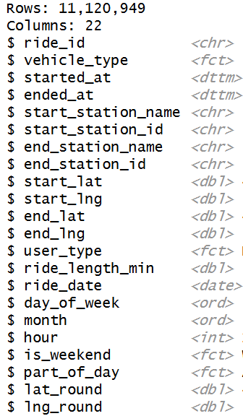
Figure 1: Dataset Structure (Glimpse Output)

Additional Contextual Data
A complementary dataset containing major tourist attractions in Chicago was incorporated into Tableau, including geographic coordinates collected from Wikipedia, LatLong.net, and CoordinatesFinder. This contextual data enables the analysis of potential overlaps between casual rider activity and popular tourist destinations, supporting tourism-oriented marketing insights.

Analyze Phase
With the dataset prepared and structured, the next step involved analyzing usage patterns to identify meaningful behavioral differences between casual riders and annual members. Rather than focusing solely on descriptive metrics, this phase aims to interpret patterns in a way that directly supports the business objective: understanding how each segment uses Cyclistic and identifying opportunities to encourage membership conversion.
To ensure a logical and strategic progression, the analysis was structured across key behavioral dimensions: user distribution, weekly and hourly usage patterns, ride duration behavior, monthly trends, and geographic concentration. Together, these dimensions provide a comprehensive view of when, how, and where each user group interacts with the service, forming the foundation for data-driven strategic recommendations.

User Distribution
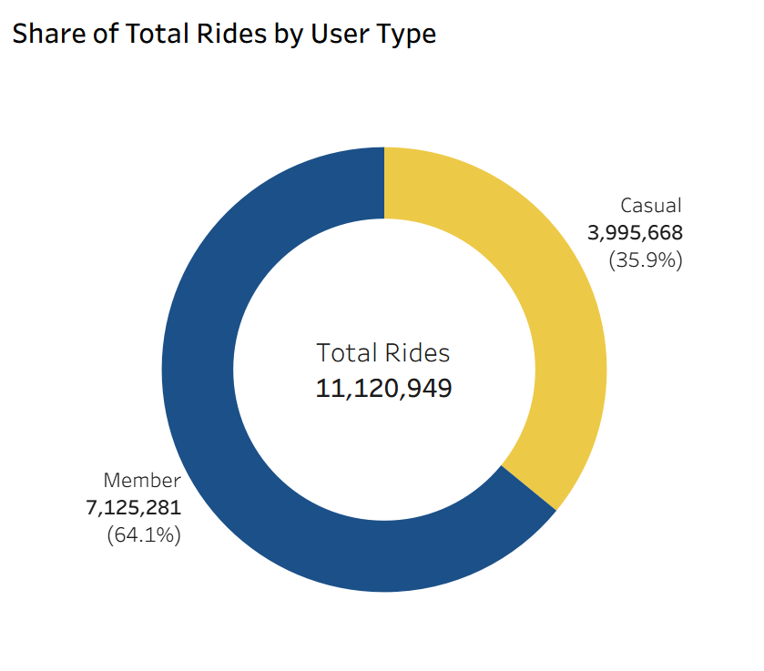
Figure 2: Composition of Cyclistic Riders

Key Insight
Annual members represent the majority of total rides, making up 64.1% of all trips, while casual riders account for 35.9%. This shows that subscription users form the core of Cyclistic’s recurring demand, whereas casual riders contribute a smaller but still meaningful share of rides.
Evidence
- Members: 7,125,281 rides (64.1%)
- Casuals: 3,995,668 rides (35.9%)
- Total rides: 11,120,949
Interpretation
Members appear to rely on Cyclistic for routine transportation, likely commuting or frequent trips. Casual riders engage less consistently but still represent a significant portion of overall usage, indicating a meaningful casual user base.
Business Implication
Targeted strategies to convert casual riders into annual members could yield a noticeable increase in recurring revenue. Even small improvements in conversion rates may significantly impact total rides and customer loyalty. Understanding behavioral differences is key for designing promotions, pricing, and service improvements aimed at this group.

Weekly Usage Patterns
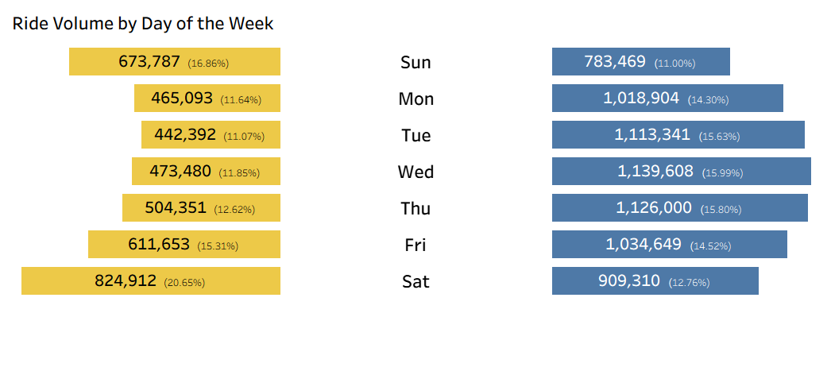
Figure 3: Usage Across the Week

Key Insight
Casual riders show strong weekend usage, with ride activity peaking on Saturdays and Sundays. In contrast, members display more consistent usage throughout weekdays, suggesting commuting or routine transportation patterns.
Evidence
Casual Riders
- Saturday: 824,912 rides (20.6% of total trips)
- Sunday: 673,787 rides (16.9% of total trips)
- Weekdays (Mon–Fri): 442,392 – 611,653 rides per day
Members
- Weekdays (Mon-Fri): consistently above 1M rides per day
- Weekend usage decreases compared to weekdays levels
Interpretation
The distribution indicates that casual riders primarily use Cyclistic bikes for leisure or recreational activities, which are more common on weekends. Members, on the other hand, show a more stable weekday pattern, suggesting that bikes are integrated into their daily routines, such as commuting or regular transportation.
Business Implication
Marketing strategies aimed at converting casual riders into members could focus on highlighting the convenience and cost advantages of membership for frequent usage. Additionally, promotional campaigns targeting casual riders may perform better when scheduled around weekends, when their engagement is highest.

Hourly Usage Patterns
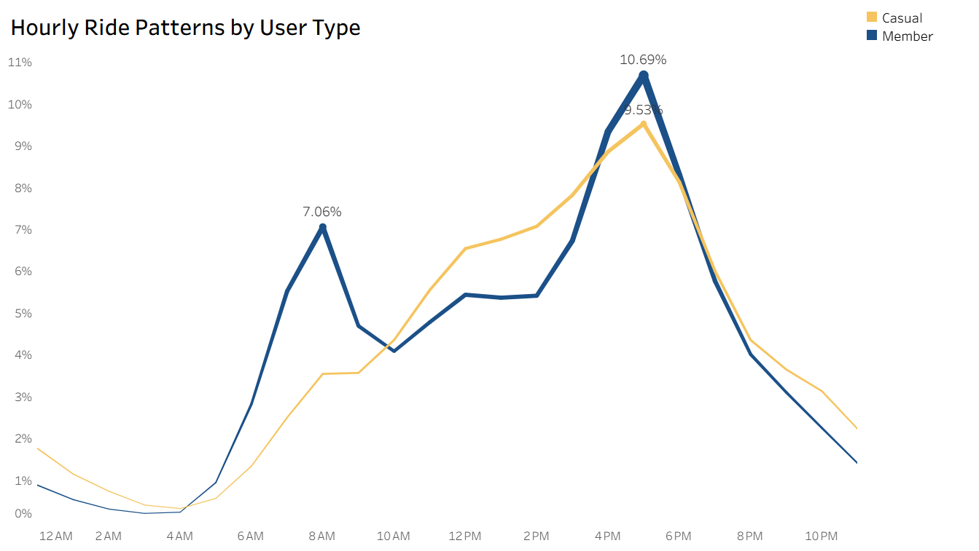
Figure 4.1: Usage Across the Day

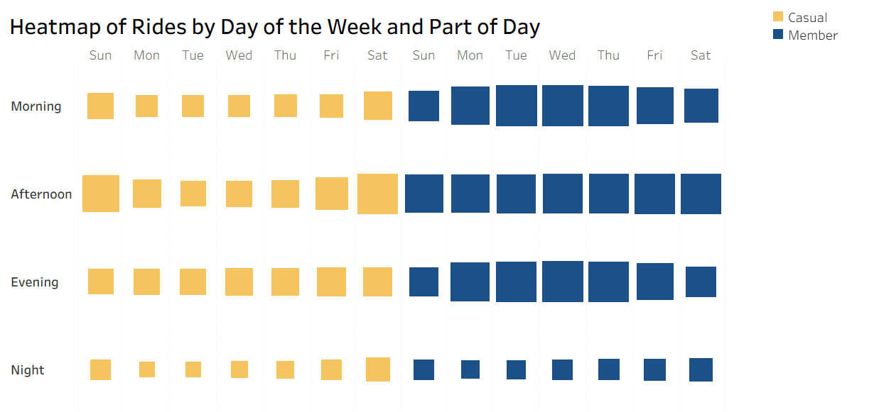
Figure 4.2: Day-of-Week × Part-of-Day Heatmap

Key Insight
Members show clear peaks during typical commuting hours, while casual riders gradually increase their activity throughout the day, with the highest usage occurring in the late afternoon.
Evidence
Members
- 8 AM: 503,371 rides (7.06% of total – morning commuting peak)
- 4 PM: 665,963 rides (9.35% of total)
- 5 PM: 761,887 rides (10.69% of total – highest peak)
Casual Riders
- 4 AM: 354,204 rides (8.86% of total)
- 5 PM: 380,926 rides (9.53% of total - peak)
- 6 PM: 325,104 rides (8.14% of total)
Additional patterns observed in the day-of-week × part-of-day heatmap:
- Saturday Afternoon (Casual): 345,097 rides
- Sunday Afternoon (Casual): 291,824 rides
- Weekday Mornings (Members): average 337,876 rides
Interpretation
Members display a clear commuting pattern, with strong activity during morning and late-afternoon hours on weekdays. This suggests that annual members rely on Cyclistic bikes as part of their daily transportation routine.
Casual riders, however, show a more gradual increase in usage throughout the day, with the highest activity during the afternoon and early evening. Their activity also intensifies during weekends, reinforcing a leisure-oriented usage pattern rather than routine transportation.
Business Implication
These differences suggest that conversion strategies should focus on integrating casual riders into weekday mobility routines. Marketing initiatives could position Cyclistic as a convenient transportation option for commuting, highlighting benefits such as flexible access, competitive pricing, and time savings compared to other transportation modes.

Ride Duration
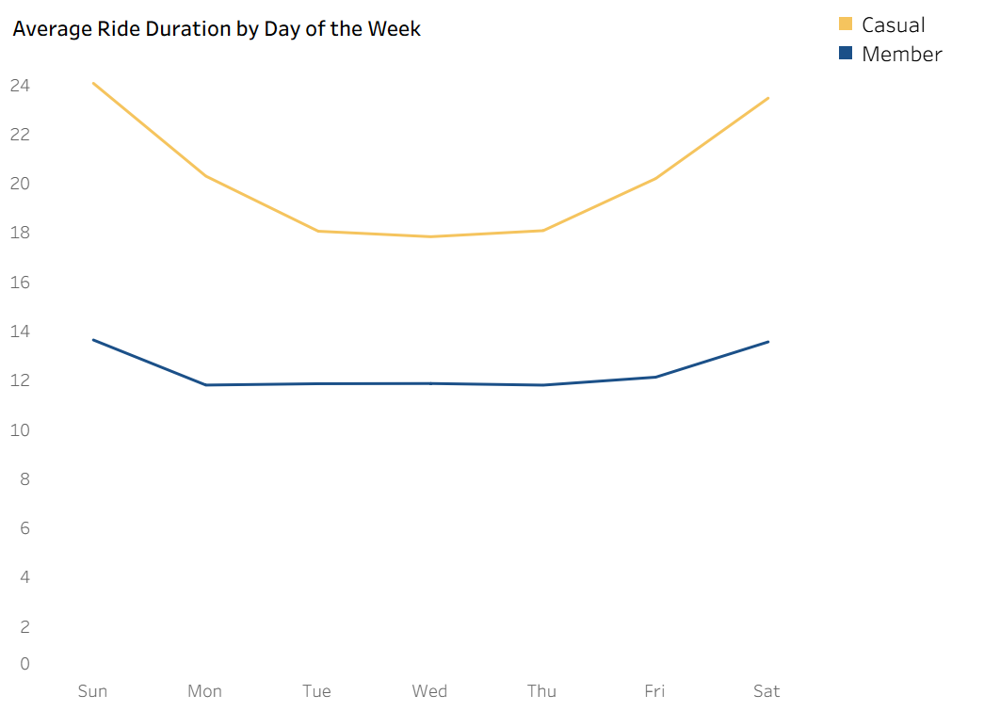
Figure 5.1: Average Distribution by Weekday

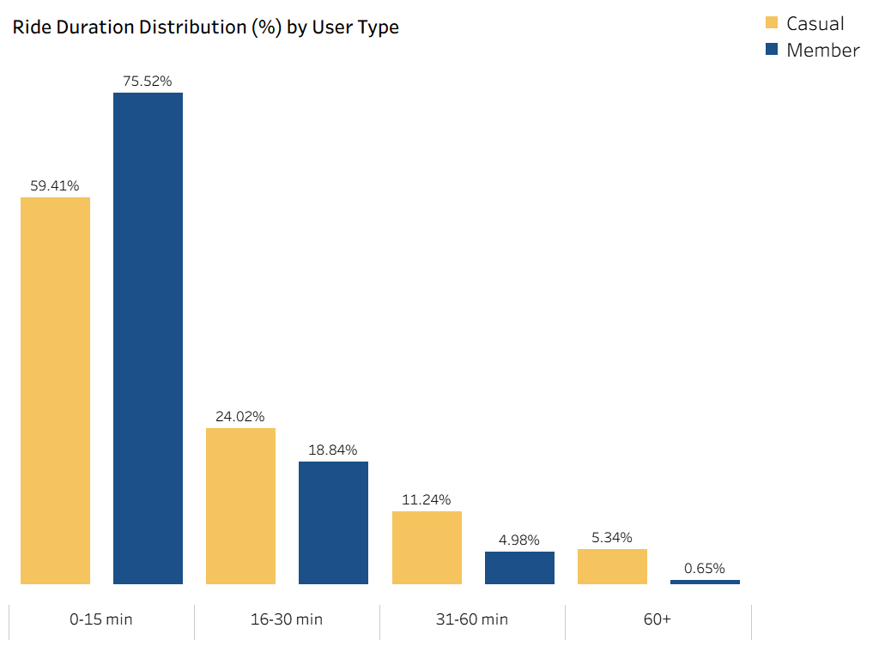
Figure 5.2: Ride Duration Distribution

Key Insight
Casual riders tend to take longer trips on average, with trip duration increasing noticeably during weekends, suggesting a more leisure-oriented usage pattern. Members, on the other hand, maintain shorter and more consistent trip durations throughout the week, reflecting typical commuting behavior.
Evidence
Average Ride Duration by Day
Members
- Weekday averages remain stable around ~11.8 minutes (Mon-Thu)
- Weekend averages increase slightly to 13.56 min (Sat) and 13.63 min (Sun)
Casual Riders
- Weekday averages range between 17.83 min and 20.29 min
- Weekend averages increase significantly to 23.46 min (Sat) and 24.06 min (Sun)
Ride Duration Distribution
Members
- 75.52% of rides last 0-15 minutes
- Only 0.65% exceed 60 minutes
Casual Riders
- 59.41% of rides last 0-15 minutes
- 5.34% last more than 60 minutes
Interpretation
The longer average trip durations and higher share of extended rides among casual riders suggests that this group primarily uses the bikes for leisure and recreational activities, particularly during weekends.
In contrast, members tend to take shorter and more consistent trips throughout the week, which aligns with utilitarian usage patterns such as commuting or short-distance transportation.
Business Implication
Given the established usage patterns of casual riders, Cyclistic could explore strategies that highlight the value of membership for longer or recreational trips.
Promotions or targeted campaigns during weekends and high-leisure periods may help encourage casual riders to consider membership plans that better support their riding habits.

Monthly Trends
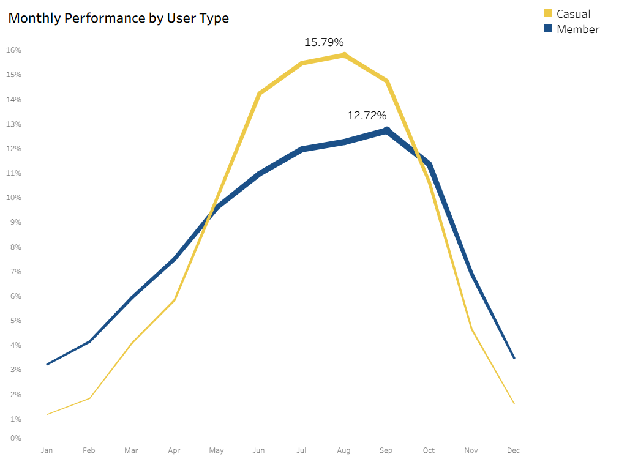
Figure 6: Monthly Performance Trends

Key Insight
Bike usage follows a clear seasonal pattern, increasing from spring and reaching its peak during the summer months. This trend is much more pronounced among casual riders, whose activity rises sharply during warmer periods and drops significantly in winter, while members maintain more consistent usage throughout the year, suggesting a stronger reliance on bikes for regular transportation.
Evidence
Members
- Activity increases gradually from 3.21% in January to a peak of 12.72% in September
- Summer months show the highest activity: Jun (10.97%), Jul (11.96%), Aug (12.26%), Sep (12.72%)
- Winter months show lower activity but still consistent usage: Jan (3.21%) and Dec (3.47%)
Casual Riders
- Activity rises sharply from 1.18% in January to a peak of 15.79% in August
- Summer months concentrate the majority of rides: Jun (14.23%), Jul (15.46%), Aug (15.79%), Sep (14.74%)
- Winter activity is very low compared to members: Jan (1.18%) and Dec (1.61%)
Interpretation
The seasonal pattern in bike usage indicates that both groups take more trips during warmer months. However, this concentration is much stronger among casual riders, whose winter activity is very low, reinforcing that they primarily use Cyclistic bikes for recreational purposes.
Despite showing similar seasonal trends, members remain active during low-season months, suggesting they rely on bikes for additional purposes, such as regular transportation.
Business Implication
Given the strong seasonal increase in ridership, particularly among casual riders, Cyclistic could prioritize marketing and promotional strategies during spring and summer months, when demand is highest. These periods present a key opportunity to target casual riders and encourage them to transition to membership plans while engagement with the service is at its peak.

Geographic Patterns and Tourist Areas
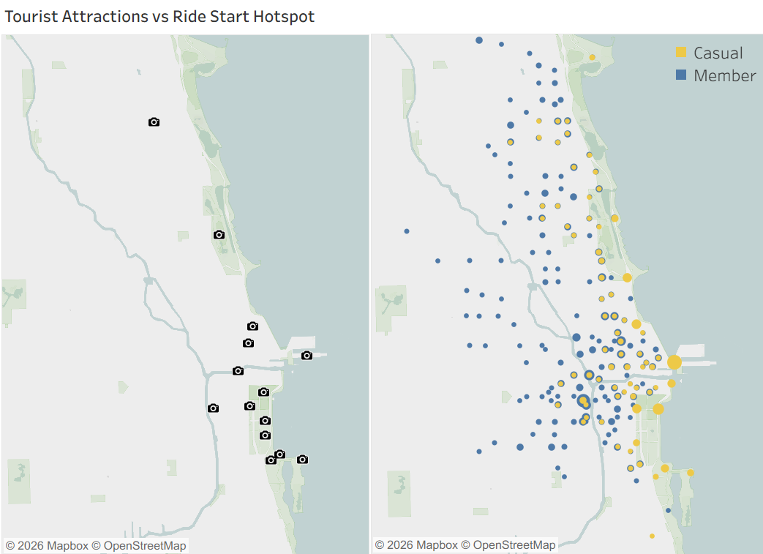
Figure 7: Tourist Attractions vs Ride Origins

Key Insight
Casual ride hotspots are concentrated near major tourist attractions and lakefront recreational areas, while member rides appear more widely distributed across the city. This spatial pattern suggests that casual riders are more associated with leisure-oriented locations, whereas members use Cyclistic bikes across a broader set of urban areas.
Evidence
- Casual ride hotspots cluster near major tourist attractions and lakefront areas.
- Member ride origins are more widely distributed across the city.
- Tourist attractions are primarily located near the lakefront and central recreational areas.
Interpretation
The spatial concentration of casual rides near major tourist attractions and lakefront recreational areas reinforces the leisure-oriented usage pattern observed in previous analyses. These areas are popular destinations for visitors and recreational activities, which likely attracts casual riders seeking short-term or occasional bike usage.
In contrast, the broader distribution of member ride origins across the city suggests that members rely on Cyclistic bikes for a wider range of purposes, including commuting and regular transportation, rather than concentrating usage in specific recreational locations.
Business Implication
Given the strong presence of casual rides around tourist and recreational areas, Cyclistic could focus conversion strategies in these locations to encourage casual riders to become members. Targeted initiatives such as promotional signage at nearby stations, partnerships with tourist attractions, or limited-time membership offers could help capture leisure riders who already demonstrate interest in using the service.
By focusing marketing efforts in these high-traffic leisure areas, Cyclistic may increase the likelihood of converting occasional riders into long-term members.

Vehicle Type Usage (Additional Insight)
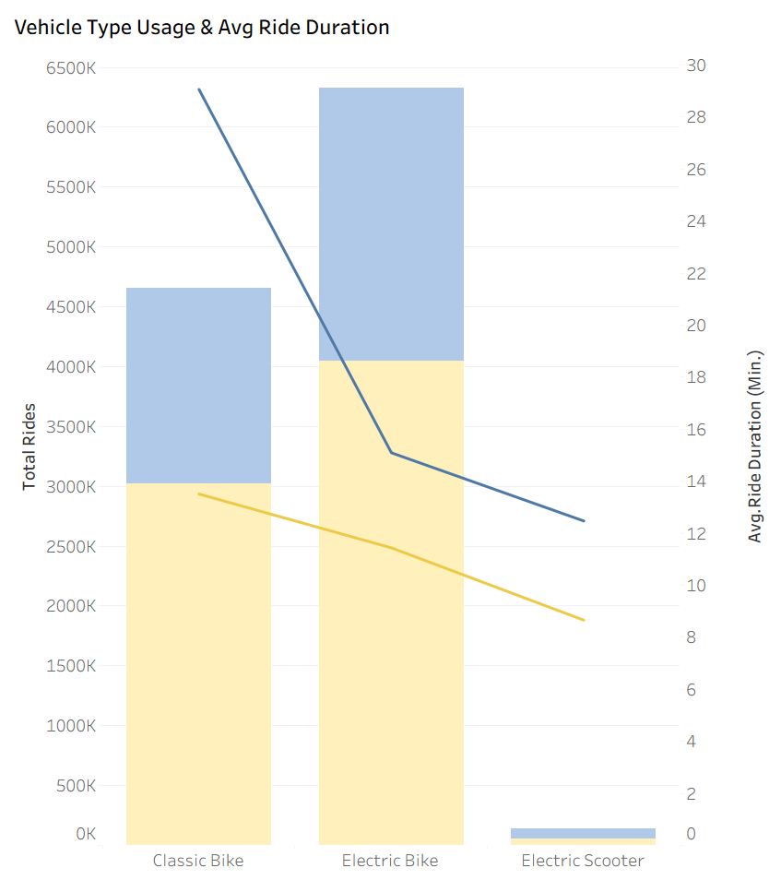
Figure 8: Vehicle Type Preference (Volume and Average Duration)

Key Insight
Ride distribution across vehicle types is similar for both user groups, with electric bikes representing the majority of trips, followed by classic bikes and electric scooters. While average ride duration varies by vehicle type, casual riders consistently maintain longer trips across all vehicle categories.
Evidence
- Electric bikes account for the largest share of rides for both user types (4.0M member rides and 2.28M casual rides).
- Classic bikes represent the second most used vehicle type for both groups.
- Electric scooters account for a relatively small portion of total rides.
- Across all vehicle types, casual riders present longer average ride durations than members.
Interpretation
The similar distribution of vehicle types across both groups suggests that vehicle preference is not a major behavioral differentiator between casual riders and members. Instead, the main distinction remains how the bikes are used, with casual riders consistently taking longer trips regardless of vehicle type.
Business Implication
Since vehicle type preference is similar across both groups, conversion strategies should focus primarily on behavioral patterns such as leisure usage, seasonality, and location rather than specific vehicle categories.

Summary of Key Findings
The analysis reveals consistent behavioral differences between casual riders and members. Casual riders show strong patterns associated with leisure activities, including longer ride durations, higher activity during weekends, and a significant increase in usage during warmer months. Additionally, their rides tend to concentrate near tourist attractions and recreational areas.
Members, on the other hand, demonstrate more consistent usage patterns throughout the week and across the year. Their rides are typically shorter and more evenly distributed across the city, suggesting that Cyclistic bikes are commonly used as part of regular transportation or commuting routines.
These differences indicate that casual riders primarily use the service for occasional or recreational purposes, while members rely on Cyclistic bikes as part of their daily mobility.

Share Phase
The Share Phase focused on clearly and effectively communicating the insights from the Analyze Phase to Cyclistic’s stakeholders. The findings were consolidated into an interactive Tableau dashboard, designed to highlight the main differences between casual riders and members.
The dashboard presents multiple perspectives of user behavior, including:
- Ride patterns by hour and day of the week
- Average ride duration
- Monthly and seasonal trends
- Geographic patterns, showing ride origins and their relation to tourist attractions
This setup allows decision-makers to explore user dynamics, identify opportunities for increasing engagement, and design marketing strategies to convert casual riders into members.
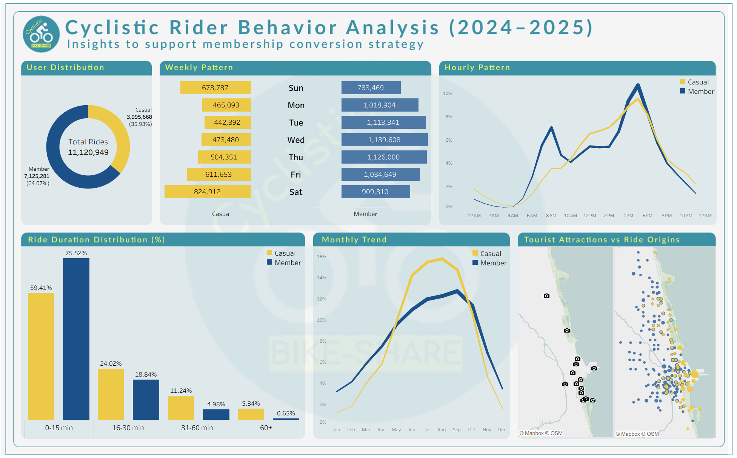
Figure 9: Final Dashboard

Act Phase
The analysis revealed clear behavioral differences between casual riders and annual members. Casual riders tend to use bikes for leisure activities, showing longer rides, stronger weekend usage, and higher concentration near tourist attractions. Members, on the other hand, demonstrate more consistent usage patterns throughout the week and across the city, suggesting regular transportation or commuting.
Based on these findings, the following recommendations aim to encourage casual riders to transition to annual memberships.

Promote Membership as a Better Option for Frequent Riders
Cyclistic could develop marketing campaigns highlighting the financial and practical benefits of annual memberships compared to single rides or short-term usage.
Supporting Insight
Casual riders take longer rides and show strong activity during weekends and warmer months, suggesting repeated use for leisure purposes.
Expected Impact
By emphasizing the long-term value of memberships, Cyclistic could encourage frequent casual riders to switch to annual plans.

Target Marketing in Tourist and Recreational Areas
Cyclistic could promote membership options in areas where casual rides are more concentrated, especially near tourist attractions and popular recreational zones.
Supporting Insight
Geographic analysis shows that casual ride origins are strongly concentrated around tourist attractions and leisure areas.
Expected Impact
Increasing marketing presence in these locations could improve visibility among casual riders who already use the service.

Weekday Use Through Commuting Campaigns
Cyclistic could highlight the benefits of using bikes for daily transportation, such as convenience, flexibility, and cost savings.
Supporting Insight
Members show consistent weekday usage and clear commuting patterns, while casual riders show lower activity during weekdays.
Expected Impact
Encouraging casual riders to use bikes for everyday transportation could increase ride frequency and make membership more attractive.

Conclusion
The analysis highlighted clear differences between casual riders and annual members. Casual riders mainly use bikes for leisure, with longer rides on weekends and near tourist attractions, while members ride more consistently throughout the city and week, suggesting regular transportation.
The three recommendations — promoting membership benefits for frequent riders, targeting marketing in tourist and recreational areas, and encouraging weekday use through commuting campaigns — provide actionable ways to increase casual-to-member conversions and strengthen Cyclistic’s role as a reliable and accessible mobility service.

Data Source and License
This analysis uses publicly available Divvy Bike Share data, provided by the City of Chicago and operated by Lyft Bikes and Scooters, LLC. Data is used under the Divvy Data License Agreement for non-commercial, educational, and analytical purposes.
Official source: https://www.divvybikes.com/system-data

