In Class Exercise 2 – Julio Tain Sueiras

Student ID:991327201

1.Truth Tables

|  |  |  |  |  |
| --- | --- | --- | --- | --- |
| x | y | y | y+x | x(y+x) |
| 1 | 1 | 0 | 1 | 1 |
| 1 | 0 | 1 | 1 | 1 |
| 0 | 1 | 0 | 0 | 0 |
| 0 | 0 | 1 | 1 | 0 |

2.Truth Tables

|  |  |  |  |  |  |
| --- | --- | --- | --- | --- | --- |
| a | b | c | b | bc | a+(bc) |
| 1 | 1 | 1 | 0 | 0 | 1 |
| 1 | 1 | 0 | 0 | 0 | 1 |
| 1 | 0 | 1 | 1 | 1 | 1 |
| 1 | 0 | 0 | 1 | 0 | 1 |
| 0 | 1 | 1 | 0 | 0 | 0 |
| 0 | 1 | 0 | 0 | 0 | 0 |
| 0 | 0 | 1 | 1 | 1 | 1 |
| 0 | 0 | 0 | 1 | 0 | 0 |

3.Truth Tables

|  |  |  |  |  |  |
| --- | --- | --- | --- | --- | --- |
| a | b | c | b+c | a+(b+c) | b(a+(b+c)) |
| 1 | 1 | 1 | 1 | 1 | 1 |
| 1 | 1 | 0 | 1 | 1 | 1 |
| 1 | 0 | 1 | 1 | 1 | 0 |
| 1 | 0 | 0 | 0 | 1 | 0 |
| 0 | 1 | 1 | 1 | 1 | 1 |
| 0 | 1 | 0 | 1 | 1 | 1 |
| 0 | 0 | 1 | 1 | 1 | 0 |
| 0 | 0 | 0 | 0 | 0 | 0 |

4.Truth Tables

|  |  |  |  |  |  |
| --- | --- | --- | --- | --- | --- |
| A | B | C | AB | AB+C | AB+C |
| 1 | 1 | 1 | 1 | 1 | 0 |
| 1 | 1 | 0 | 1 | 1 | 0 |
| 1 | 0 | 1 | 0 | 1 | 0 |
| 1 | 0 | 0 | 0 | 0 | 1 |
| 0 | 1 | 1 | 0 | 1 | 0 |
| 0 | 1 | 0 | 0 | 0 | 1 |
| 0 | 0 | 1 | 0 | 1 | 0 |
| 0 | 0 | 0 | 0 | 0 | 1 |

5.Truth Tables

|  |  |  |  |  |  |
| --- | --- | --- | --- | --- | --- |
| A | B | C | AB | C | AB+C |
| 1 | 1 | 1 | 1 | 0 | 1 |
| 1 | 1 | 0 | 1 | 1 | 1 |
| 1 | 0 | 1 | 0 | 0 | 0 |
| 1 | 0 | 0 | 0 | 1 | 1 |
| 0 | 1 | 1 | 0 | 0 | 0 |
| 0 | 1 | 0 | 0 | 1 | 1 |
| 0 | 0 | 1 | 0 | 0 | 0 |
| 0 | 0 | 0 | 0 | 1 | 1 |

5.Truth Tables

|  |  |  |  |  |  |  |  |
| --- | --- | --- | --- | --- | --- | --- | --- |
| A | B | C | C | AB | AB | AB+AB | C(AB+AB) |
| 1 | 1 | 1 | 0 | 1 | 0 | 1 | 0 |
| 1 | 1 | 0 | 1 | 1 | 0 | 1 | 1 |
| 1 | 0 | 1 | 0 | 0 | 1 | 1 | 0 |
| 1 | 0 | 0 | 1 | 0 | 1 | 1 | 1 |
| 0 | 1 | 1 | 0 | 0 | 1 | 1 | 0 |
| 0 | 1 | 0 | 1 | 0 | 1 | 1 | 1 |
| 0 | 0 | 1 | 0 | 0 | 1 | 1 | 0 |
| 0 | 0 | 0 | 1 | 0 | 1 | 1 | 1 |

Logic Gates

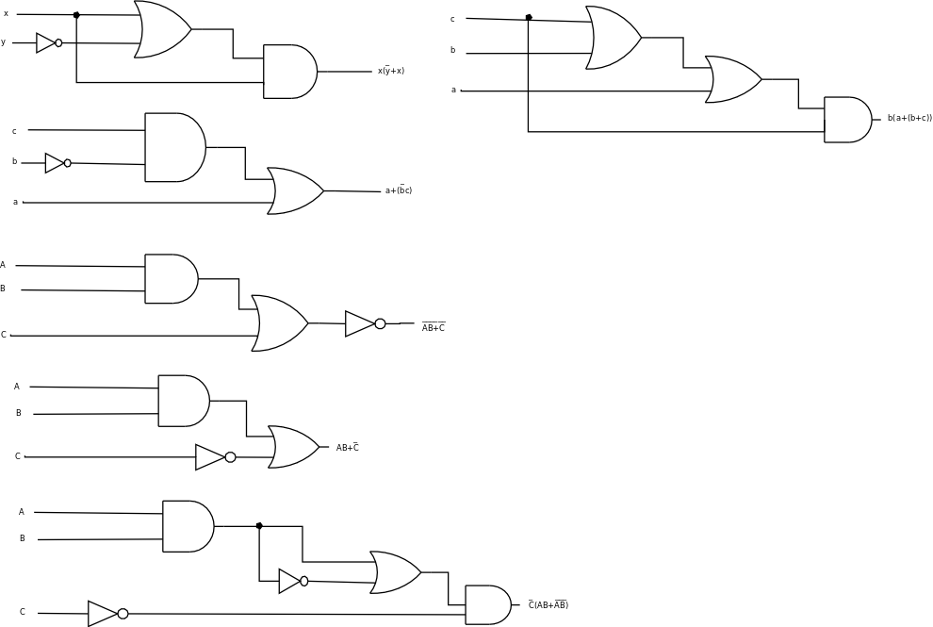

Part 2.

1. c+(ab) 2. r(pq+rp) 3. r(p+q) 4. qr+p

5. q+(p(q+r))