Computer Architecture – Fall 2014

Assignment Two

**Name:** ________________________________________

**Due Dates:** FRI OCT 10 at MIDNIGHT, in the dropbox in your section in SLATE

**Instructions:**  This assignment is to complete individually (This means by yourself).

Show our work in the space provided where appropriate.

**NOTE: If you print this document from SLATE, you**

**MUST leave the page breaks in the correct place!**

1. Given the following diagram taken from the notes

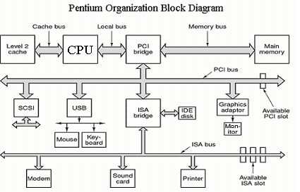

**Define PCI __________________________________________________________________**

**ISA ___________________________________________________________________**

**SCSI __________________________________________________________________**

**USB ___________________________________________________________________**

**IDE ___________________________________________________________________**

**ISA ___________________________________________________________________**

In each of the above simply state the meaning of the acronym.

1. Briefly explain the difference between a half adder and a full adder

How many bits are added together in a half adder? ________________________

How many output bits in a half adder? _________________________________

How many bits are added together in a full adder? ________________________

How many output bits in a full adder? _________________________________

1. In the following diagram

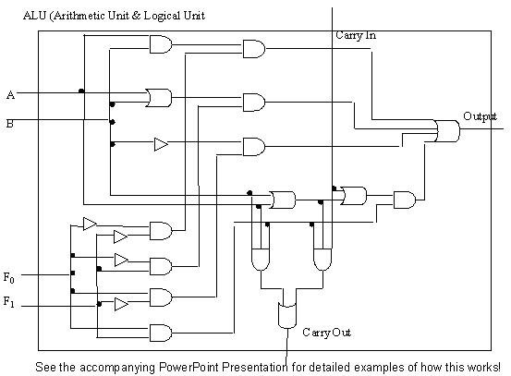

How many control bits are present? ____________

How many input bits are present? ______________

How many different functions can the unit complete?

____________________

1. Consider the following diagram.

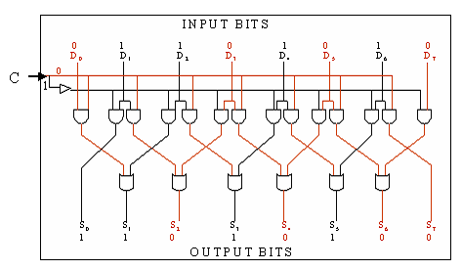

The circuit is called a(n) ____________________________

Given above input bits (the D’s), did a shift right or left occur? ______________

1. How many 16 bit registers exist on the Intel 8086 processor? ________________
2. Give the three classifications of the 8086 registers.
   1. ­­­­­­­­­­­­­­­­­­­­­­­­­_______________________________________________________

* 1. ______________________________________________________

* 1. _______________________________________________________

1. Give the names of the accumulator registers. _____________________________
2. Give the names of the segment registers._________________________________
3. Which two registers combine to give the effective address of an instruction that is stored in memory? ___________ ___________________
4. Give the effective address if the segment register is AB02 and the offset register is 0100.

_________________

1. a) How many bits are contained in the flags register? _________________

b) How many bits of the flags register are used? _________________

1. How many different ‘types’ of instructions exist on the 8086? ______________
2. The 32-bit value 30A79847 is stored starting at memory location 1000. Fill in the following tables.

|  |  |  |  |  |
| --- | --- | --- | --- | --- |
| Address | 10000 | 10001 | 10002 | 10003 |
| contents |  |  |  |  |

Little Endian

|  |  |  |  |  |
| --- | --- | --- | --- | --- |
| Address | 10000 | 10001 | 10002 | 10003 |
| contents |  |  |  |  |

Big Endian

1. In class (and in the notes) we discussed a 6 step procedure in executing programs on a Von Neumann computer. List the steps.
   * _______________________________________________
   * _______________________________________________
   * _______________________________________________
   * _______________________________________________
   * _______________________________________________
   * _______________________________________________
2. Give the four ‘types’ of instructions that are required in assembler programming.
   * _______________________________________________
   * _______________________________________________
   * _______________________________________________
   * _______________________________________________
3. Write an 8086 assembler program (using the emulator) that will perform the following calculations. You should attach a printed copy of your code to this assignment.

a) 3 + ( 4 + 100) + ( 4 -5) Place the answer in the AX register

b) 1001 * ( 1111 * 2) Where (in which registers) is the answer?

_________

1. a) How many software interrupts are possible? ________________________

b) How many are currently supported by the emulator? __________

1. Consider the following program:

org 100h

mov bx,0005h

mov ax,bx

back:

sub bx,01h

add ax,bx

cmp bx,00

jne back

hlt

Single step through the program and answer the following:

1. Complete the following table:



1. Give the contents of the AX, BX and IP registers just before each execution of the JNE instruction: **For example:**  The first time the JNE instruction is highlighted the registers look like the following. You fill in the table:

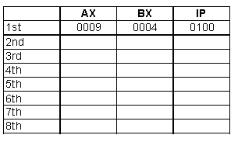

1. How many times did the instruction JNE get executed? _________________
2. Using the emulator write a program that displays your name on the screen.

(Attach a printed copy of your source code to this assignment)