In Class Exercise 2 – Julio Tain Sueiras
Student ID:991327201

1.Truth Tables
x | y | y | y+x | x(y+x)
1 | 1 | 0 | 1 | 1
1 | 0 | 1 | 1 | 1
0 | 1 | 0 | 0 | 0
0 | 0 | 1 | 1 | 0

2.Truth Tables
a | b | c | b | bc | a+(bc)
1 | 1 | 1 | 0 | 0 | 1
1 | 1 | 0 | 0 | 0 | 1
1 | 0 | 1 | 1 | 1 | 1
1 | 0 | 0 | 1 | 0 | 1
0 | 1 | 1 | 0 | 0 | 0
0 | 1 | 0 | 0 | 0 | 0
0 | 0 | 1 | 1 | 1 | 1
0 | 0 | 0 | 1 | 0 | 0

3.Truth Tables
a | b | c | b+c | a+(b+c) | b(a+(b+c))
1 | 1 | 1 | 1 | 1 | 1
1 | 1 | 0 | 1 | 1 | 1
1 | 0 | 1 | 1 | 1 | 0
1 | 0 | 0 | 0 | 1 | 0
0 | 1 | 1 | 1 | 1 | 1
0 | 1 | 0 | 1 | 1 | 1
0 | 0 | 1 | 1 | 1 | 0
0 | 0 | 0 | 0 | 0 | 0

4.Truth Tables
A | B | C | AB | AB+C | AB+C
1 | 1 | 1 | 1 | 1 | 0
1 | 1 | 0 | 1 | 1 | 0
1 | 0 | 1 | 0 | 1 | 0
1 | 0 | 0 | 0 | 0 | 1
0 | 1 | 1 | 0 | 1 | 0
0 | 1 | 0 | 0 | 0 | 1
0 | 0 | 1 | 0 | 1 | 0
0 | 0 | 0 | 0 | 0 | 1

5.Truth Tables
A | B | C | AB | C | AB+C
1 | 1 | 1 | 1 | 0 | 1
1 | 1 | 0 | 1 | 1 | 1
1 | 0 | 1 | 0 | 0 | 0
1 | 0 | 0 | 0 | 1 | 1
0 | 1 | 1 | 0 | 0 | 0
0 | 1 | 0 | 0 | 1 | 1
0 | 0 | 1 | 0 | 0 | 0
0 | 0 | 0 | 0 | 1 | 1
5.Truth Tables
A | B | C | C | AB | AB | AB+AB | C(AB+AB)
1 | 1 | 1 | 0 | 1 | 0 | 1 | 0
1 | 1 | 0 | 1 | 1 | 0 | 1 | 1
1 | 0 | 1 | 0 | 0 | 1 | 1 | 0
1 | 0 | 0 | 1 | 0 | 1 | 1 | 1
0 | 1 | 1 | 0 | 0 | 1 | 1 | 0
0 | 1 | 0 | 1 | 0 | 1 | 1 | 1
0 | 0 | 1 | 0 | 0 | 1 | 1 | 0
0 | 0 | 0 | 1 | 0 | 1 | 1 | 1

Logic Gates
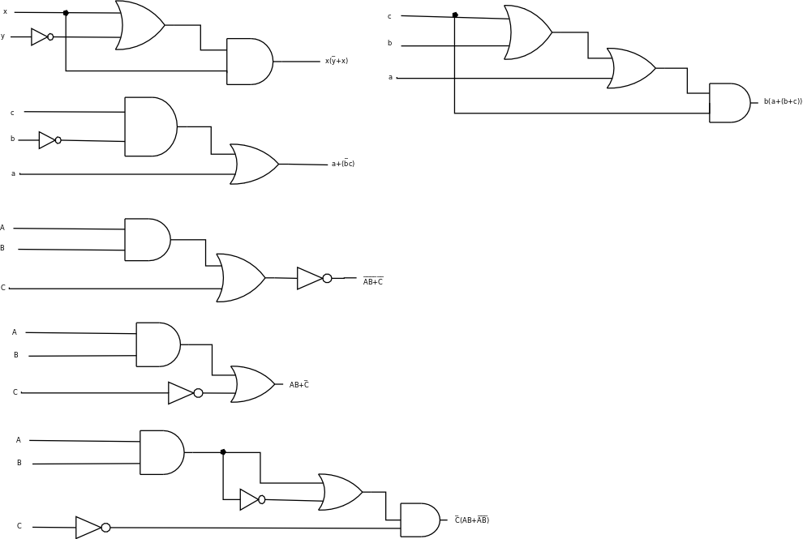

Part 2.
1. c+(ab) 2. r(pq+rp) 3. r(p+q) 4. qr+p
5. q+(p(q+r))

