Parallel Study Walkthrough: USFLI vs. Gold Standard Transient Elastography in NHANES
This document provides a comparative analysis of two parallel NHANES studies evaluating Metabolic Dysfunction-Associated Steatotic Liver Disease (MASLD), Metabolic Dysfunction-Associated Steatohepatitis (MASH), and advanced liver fibrosis/cirrhosis:
1. Primary Study (NHANES 1999–2023): Employs non-invasive blood-based indexes—the U.S. Fatty Liver Index (USFLI > 30) for steatosis [1], FIB-4 > 2.67 for high-risk MASH [2], and APRI thresholds for fibrosis/cirrhosis [3].
2. Gold Standard Study (NHANES 2017–2023): Employs Vibration-Controlled Transient Elastography (FibroScan) measurements—CAP) 285 dB/m for steatosis [4,5], the FibroScan-AST (FAST) score 0.35 for MASH (surrogate for histological NAS ) 4 + F2 [6], and Median Liver Stiffness Measurement (LSM > 13.6 kPa) for cirrhosis [7].

Study Design Flowcharts (Carousel)
Flip through the slides below to compare the design and raw sample sizes of the two parallel studies:
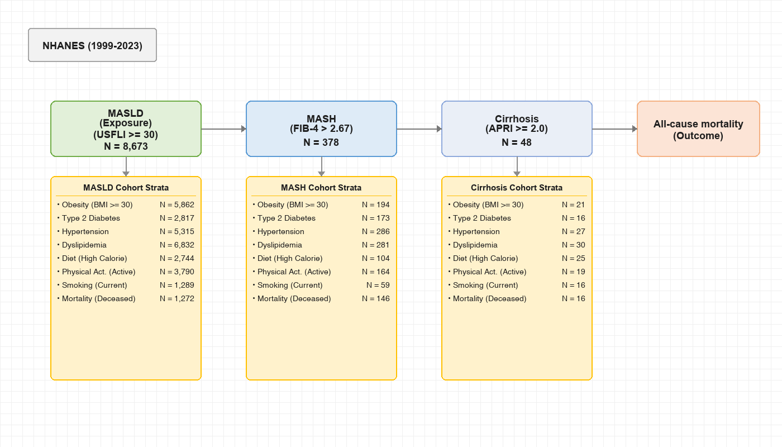
Figure: masld_study_flowchart.png

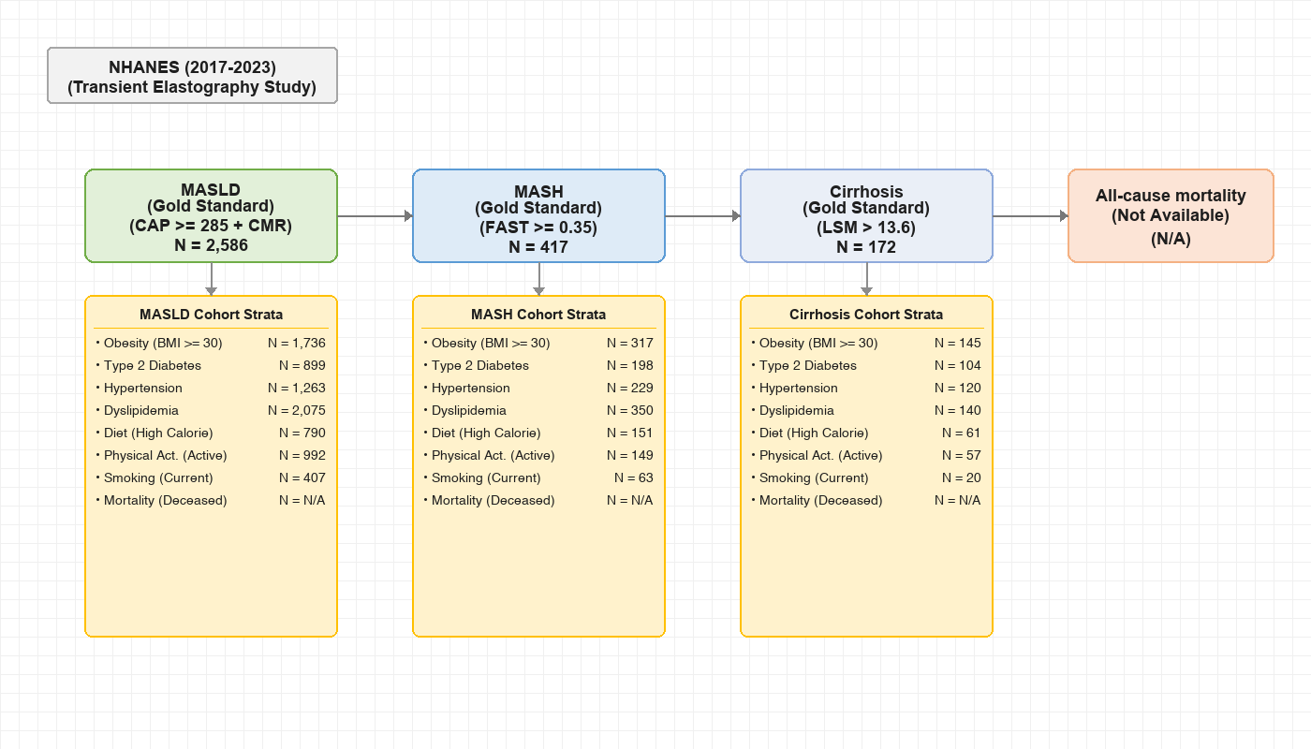
Figure: gold_standard_flowchart.png

PART A: Primary Study (NHANES 1999–2023)

A.1. Longitudinal Prevalence Results (NHANES 1999–2023)
Below is the summary table of positive cases (USFLI > 30) and survey-weighted estimates for adults aged >20 years:
NHANES Cycle | Raw USFLI > 30 N | Raw Prevalence (%) | Weighted Prevalence (%) | Weighted Population Size N
**1999-2000** | 616 | 34.39% | 27.88% | 54,046,125
**2001-2002** | 701 | 33.65% | 30.25% | 59,380,012
**2003-2004** | 539 | 28.73% | 26.96% | 52,620,852
**2005-2006** | 556 | 29.56% | 28.56% | 57,287,665
**2007-2008** | 786 | 35.07% | 30.76% | 63,044,528
**2009-2010** | 960 | 38.43% | 34.83% | 73,016,619
**2011-2012** | 725 | 33.89% | 33.78% | 70,991,388
**2013-2014** | 688 | 30.67% | 30.57% | 66,190,995
**2015-2016** | 745 | 34.91% | 33.31% | 74,182,474
**2017-2018** | 821 | 38.22% | 35.63% | 80,795,840
**2017-2020 (Pre-Pandemic)\*** | 1,366 | 38.21% | 36.07% | 82,704,779
**2021-2023 (Post-Pandemic)** | 991 | 36.91% | 35.16% | 78,587,877

NOTE: - **2017-2020 Combined Cycle:** The CDC combined the partial 2019–2020 data (interrupted by COVID-19) with 2017–2018 to create a representative 4-year cycle. This is marked with an asterisk (*) above.

A.2. Visualizing MASLD, MASH, & Fibrosis Prevalence Trends
The chart below shows the survey-weighted prevalence trends for MASLD (USFLI > 30), MASH (FIB-4 > 2.67), and Significant Fibrosis (APRI > 0.5) in U.S. adults over time with 95% confidence intervals:

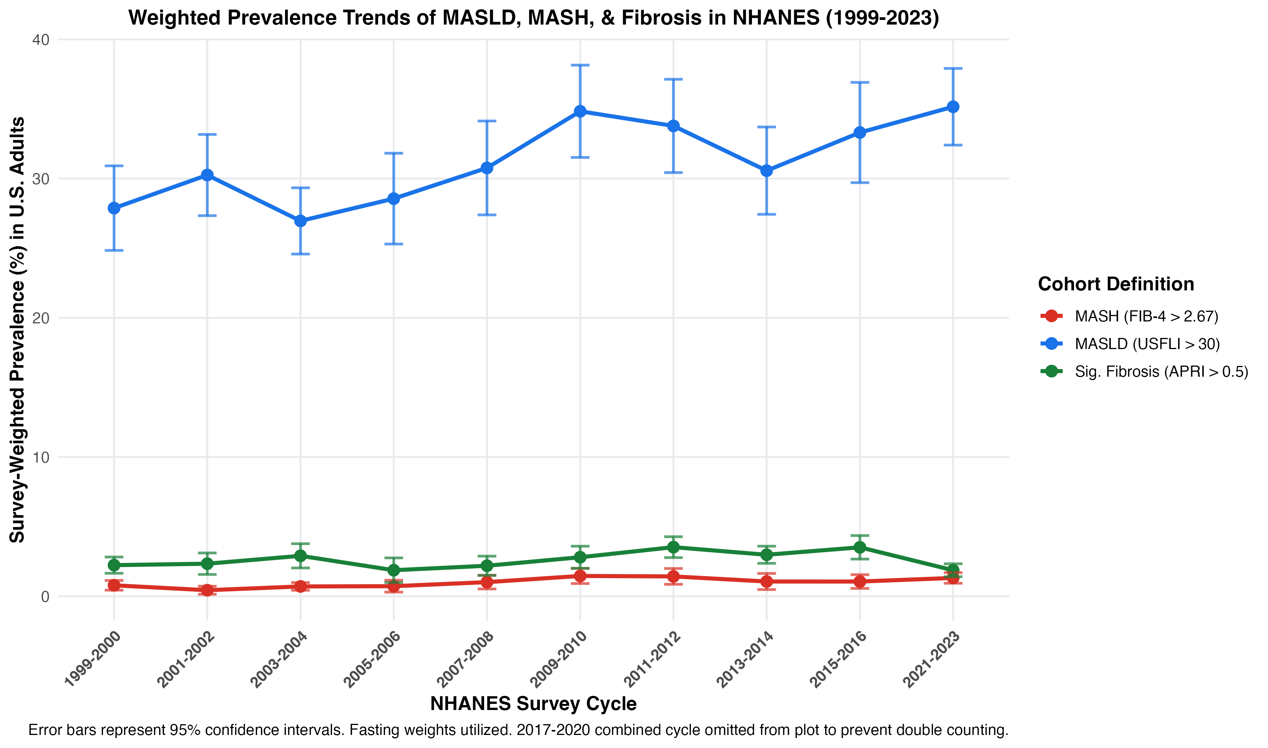
Figure: usfli_prevalence_trend.png

A.3. Primary Cohort Comorbidity & Lifestyle Stratification
Below is the integrated comorbidity stratification table for the primary study, presenting the general MASLD cohort ((N = 8,673)), the MASH cohort (N = 378), the Significant Fibrosis cohort ((N = 760)), and the Cirrhosis cohort ((N = 48)) side-by-side:
Category | Stratum / Subgroup | MASLD Raw N | MASLD Weighted % | MASH Raw N | MASH Weighted % | Fibrosis Raw N | Fibrosis Weighted % | Cirrhosis Raw N | Cirrhosis Weighted %
**Obesity/BMI** | Normal (18.5–24.9) | 409 | 4.00% | 47 | 15.76% | 71 | 9.67% | 5 | 17.96%
 | Overweight (25.0–29.9) | 2350 | 24.66% | 131 | 34.25% | 246 | 30.09% | 21 | 39.54%
 | Obese (\(\ge 30.0\)) | 5862 | 71.30% | 194 | 50.00% | 438 | 60.16% | 21 | 42.50%
 | Underweight (<18.5) | 4 | 0.04% | 0 | 0.00% | 1 | 0.08% | 0 | 0.00%
 | *Missing / Unknown* | 48 | -- | 6 | -- | 4 | -- | 1 | --
**Type 2 DM** | Diabetes | 2817 | 26.97% | 173 | 37.98% | 296 | 33.99% | 16 | 27.32%
 | No Diabetes | 5856 | 73.03% | 205 | 62.02% | 464 | 66.01% | 32 | 72.68%
 | *Missing / Unknown* | 0 | -- | 0 | -- | 0 | -- | 0 | --
**Hypertension** | Hypertension | 5315 | 59.31% | 286 | 75.06% | 485 | 62.67% | 27 | 58.20%
 | No Hypertension | 3354 | 40.69% | 92 | 24.94% | 275 | 37.33% | 21 | 41.80%
 | *Missing / Unknown* | 4 | -- | 0 | -- | 0 | -- | 0 | --
**Dyslipidemia** | Dyslipidemia | 6832 | 79.56% | 281 | 75.00% | 586 | 78.83% | 30 | 62.32%
 | No Dyslipidemia | 1841 | 20.44% | 97 | 25.00% | 174 | 21.17% | 18 | 37.68%
 | *Missing / Unknown* | 0 | -- | 0 | -- | 0 | -- | 0 | --
**Diet (Calorie)** | Low Calorie (Tertile 1) | 2744 | 28.02% | 147 | 37.55% | 226 | 28.55% | 10 | 23.63%
 | Medium Calorie (Tertile 2) | 2743 | 33.50% | 108 | 30.37% | 214 | 29.37% | 11 | 18.22%
 | High Calorie (Tertile 3) | 2744 | 38.47% | 104 | 32.08% | 273 | 42.08% | 25 | 58.15%
 | *Missing / Unknown* | 442 | -- | 19 | -- | 47 | -- | 2 | --
**Physical Activity** | Active | 3790 | 51.55% | 164 | 46.21% | 377 | 52.53% | 19 | 32.32%
 | Inactive | 3892 | 48.45% | 170 | 53.79% | 326 | 47.47% | 25 | 67.68%
 | *Missing / Unknown* | 991 | -- | 44 | -- | 57 | -- | 4 | --
**Smoking Status** | Never Smoker | 4427 | 54.98% | 147 | 38.88% | 332 | 46.30% | 14 | 42.85%
 | Former Smoker | 2263 | 28.77% | 147 | 44.84% | 216 | 33.74% | 13 | 24.26%
 | Current Smoker | 1289 | 16.25% | 59 | 16.28% | 151 | 19.96% | 16 | 32.89%
 | *Missing / Unknown* | 694 | -- | 25 | -- | 61 | -- | 5 | --
**Mortality (1999–2018)** | Alive | 5040 | 84.38% | 129 | 49.32% | 442 | 78.00% | 23 | 50.36%
 | Deceased | 1272 | **15.62%** | 146 | **50.68%** | 154 | **22.00%** | 16 | **49.64%**
 | *Missing / Unknown* | 0 | -- | 103 | -- | 0 | -- | 9 | --

PART B: Gold Standard Study (NHANES 2017–2023)
The gold standard study restricted the sample to the 5,699 adults aged \(\ge\) 20 years in the morning fasting subsample who had valid transient elastography (FibroScan) measurements in the 2017–2020 pre-pandemic and 2021–2023 cycles.
Survey weights were combined to represent the 6-year period:
- 2017–2020 Fasting weights were scaled by \(2/3\).
- 2021–2023 Fasting weights were scaled by \(1/3\).

B.1. Gold Standard Cohort Sizes
- MASLD (CAP \(\ge\) 285 dB/m + CMR): Raw \(N = 2,586\)
- MASH (MASLD + FAST \(\ge\) 0.35): Raw \(N = 417\)
- Cirrhosis (MASLD + LSM > 13.6 kPa): Raw \(N = 172\)

B.2. Gold Standard Comorbidity & Lifestyle Stratification
Below is the summary stratification table of the three gold-standard cohorts, styled with matching layout (Raw N followed by survey-weighted percentage side-by-side for each cohort):
Category | Stratum / Subgroup | MASLD Raw N | MASLD Weighted % | MASH Raw N | MASH Weighted % | Cirrhosis Raw N | Cirrhosis Weighted %
**Obesity/BMI** | Normal (18.5–24.9) | 139 | 4.42% | 18 | 2.69% | 3 | 1.28%
 | Overweight (25.0–29.9) | 688 | 26.29% | 77 | 17.09% | 22 | 11.50%
 | Obese (\(\ge 30.0\)) | 1736 | 69.25% | 317 | 79.97% | 145 | 87.21%
 | Underweight (<18.5) | 2 | 0.04% | 1 | 0.25% | 0 | 0.00%
 | *Missing / Unknown* | 23 | -- | 4 | -- | 2 | --
**Type 2 DM** | Diabetes | 899 | 29.41% | 198 | 40.51% | 104 | 62.38%
 | No Diabetes | 1687 | 70.59% | 219 | 59.49% | 68 | 37.62%
 | *Missing / Unknown* | 2 | -- | 0 | -- | 0 | --
**Hypertension** | Hypertension | 1265 | 43.07% | 229 | 46.53% | 120 | 65.81%
 | No Hypertension | 1321 | 56.93% | 188 | 53.47% | 52 | 34.19%
 | *Missing / Unknown* | 2 | -- | 0 | -- | 0 | --
**Dyslipidemia** | Dyslipidemia | 2075 | 81.41% | 350 | 86.47% | 140 | 83.50%
 | No Dyslipidemia | 512 | 18.59% | 67 | 13.53% | 32 | 16.50%
 | *Missing / Unknown* | 1 | -- | 0 | -- | 0 | --
**Diet (Calorie)** | Low Calorie (Tertile 1) | 727 | 28.06% | 96 | 22.30% | 43 | 33.66%
 | Medium Calorie (Tertile 2) | 750 | 31.76% | 113 | 27.98% | 51 | 24.66%
 | High Calorie (Tertile 3) | 790 | 40.18% | 151 | 49.72% | 61 | 41.68%
 | *Missing / Unknown* | 321 | -- | 57 | -- | 17 | --
**Physical Activity** | Active | 992 | 50.30% | 149 | 45.83% | 57 | 44.42%
 | Inactive | 1596 | 49.70% | 268 | 54.17% | 115 | 55.58%
 | *Missing / Unknown* | 0 | -- | 0 | -- | 0 | --
**Smoking Status** | Never Smoker | 1446 | 56.70% | 226 | 50.82% | 98 | 55.78%
 | Former Smoker | 734 | 28.52% | 128 | 32.39% | 54 | 33.87%
 | Current Smoker | 407 | 14.78% | 63 | 16.79% | 20 | 10.35%
 | *Missing / Unknown* | 1 | -- | 0 | -- | 0 | --
**Mortality** | Deceased / Alive | N/A | N/A | N/A | N/A | N/A | N/A

References
1. Ruhl CE, Everhart JE. Fatty liver indices in the multiethnic United States National Health and Nutrition Examination Survey. *Alimentary Pharmacology & Therapeutics*. Jan 2015;41(1):65-76. doi:10.1111/apt.13012
2. Targher G, Valenti L, Byrne CD. Metabolic Dysfunction–Associated Steatotic Liver Disease. *The New England Journal of Medicine*. 2025.
3. Dreytser E, Blyuss O, Mudrova A, et al. Aspartate Aminotransferase-to-Platelet Ratio Index (APRI) for Staging of Fibrosis in Adults With Chronic Hepatitis C. *The Cochrane Database of Systematic Reviews*. 2025.
4. Lee BP, Dodge JL, Terrault NA. National prevalence estimates for steatotic liver disease and subclassifications using consensus nomenclature. *Hepatology*. Mar 1 2024;79(3):666-673. doi:10.1097/HEP.0000000000000604
5. Rinella ME, Lazarus JV, Ratziu V, et al. A multisociety Delphi consensus statement on new fatty liver disease nomenclature. *Hepatology*. Dec 1 2023;78(6):1966-1986. doi:10.1097/HEP.0000000000000520
6. Ravaioli F, Dajti E, Mantovani A, et al. Diagnostic Accuracy of FibroScan-AST (FAST) Score for the Non-Invasive Identification of Patients With Fibrotic Non-Alcoholic Steatohepatitis: A Systematic Review and Meta-Analysis. *Gut*. 2023.
7. Sterling RK, Duarte-Rojo A, Patel K, et al. AASLD Practice Guideline on Imaging-Based Noninvasive Liver Disease Assessment of Hepatic Fibrosis and Steatosis. *Hepatology*. 2025.

