# Problem

Teachers often find the process of creating, storing, and managing weekly plans at the "Mamá Cigüeña" Child Development Center tedious, repetitive, and inefficient. They must manually generate documents, organize their storage, and keep accurate records of updates. This workflow often results in misplaced files, version control issues, and a significant loss of time from other important tasks.

This administrative burden distracts from the teachers' primary goal: providing high-quality education and supporting children's development.

# Overview

We propose the development of a software product that streamlines the creation, storage, and management of weekly educational activity plans.

The system will enable teachers to create, edit, and organize their plans through an intuitive user interface, automatically store them within a structured directory, and ensure secure access through authentication mechanisms.

By automating document generation and facilitating the retrieval and modification of plans, the software will significantly reduce administrative burden, minimize errors, and allow teachers to focus more on delivering high-quality education and supporting the children's development.

# Background

Think of a share of stock as a piece of a company, albeit typically a very small piece. The value of a share is loosely related to the value of the company divide by the number of outstanding shares (i.e., total shares owned by shareholders.) For example, if a company was worth $10M and there was a total of 1M shares owned by shareholders, then each share would be worth $10.

In a stock market, all companies and their stock are identified by symbols, which are short character strings. For example, Amazon’s symbol is AMZN, Apple’s is AAPL, and Microsoft’s is MSFT.

An investor will buy some number of shares at a specific purchase price and pay a small fee to a broker to complete that transaction. Then, at late time, the investor will sell all or some of those shares at a sales price and pay another small fee to a broker. Obviously, if an investor sells at a price higher than the purchase price (adjusting for the fees), the investor will make money. For example, if an investor buy 10 shares of AMZN at $800/share for a $10 fee, then sell those 10 shares at

$850/share for $10 fee, that investor will make a profit of $480

(850*10 – 10 – 800*10 – 10).

For taxes purpose and asset management, investors correlate the sale of a block of stocks to specific purchases. For example, consider an investor who buy 100 shares of ABC at $10/share and a little while later another 100 shares at $11/share. Then, image that the investor sell 125 shares. In making that sale, the investor will say how many of the 125 shares come from the first block of shares purchase and how many come from the second block, because it will impact how many profit the investor makes.

An investor does not actually make or loss money until shares are sold. Shares that an investor is holding onto only represent potential profits or losses. So, to rank an analyst perform, we need to know about completed purchase/sales cycles. Therefore, a history will contain records with following data:

Stock symbol A short string that identifies the company Quantity (Q) A integer that represent the number of shares purchase and sold Purchase Date/time (PT) A number that represents time of purchase in minutes since Jan 1, 2016 Purchase Price (PP) An integer represents the purchase price in cents. For example, 1234 would be a purchase price of $12.34.

Purchase Trans. Fee (PF) An integer represents the purchase transaction fee in cents. Sale Date/time (ST) A number that represents time of purchase in minutes since Jan 1, 2016 Sale Price (SP) An integer represents the purchase price in cents. For example, 1234 would be a purchase price of $12.34. Sale Trans. Fee (SF) An integer represents the purchase transaction fee in cents. Q, PT, PP, PF, ST, SP, SF

See Table 1 for an example of a small history for an investor who purchased and sold stock for four companies: Amazon (AMZN), Apple (AAPL), Microsoft (MSFT), and Google (GOOGL).

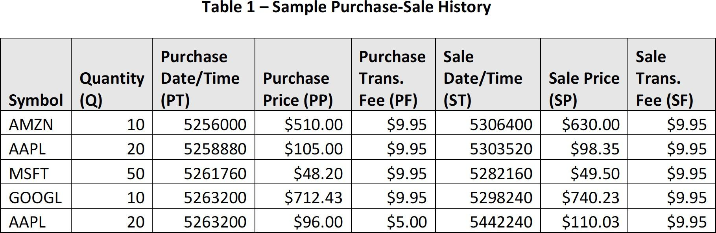

The amount of money invested (INV) in a purchase/sale is the cost of the shared adjust plus both the purchase fee and the

sales fees INV = Q*PP + PF + SF

So, the profit/loss (PL) for each purchase/sale can be computed as PL = Q*SP – INV

Table 2 shows INV and PL for each of the row, identified by the symbol and ST, of Table 1.

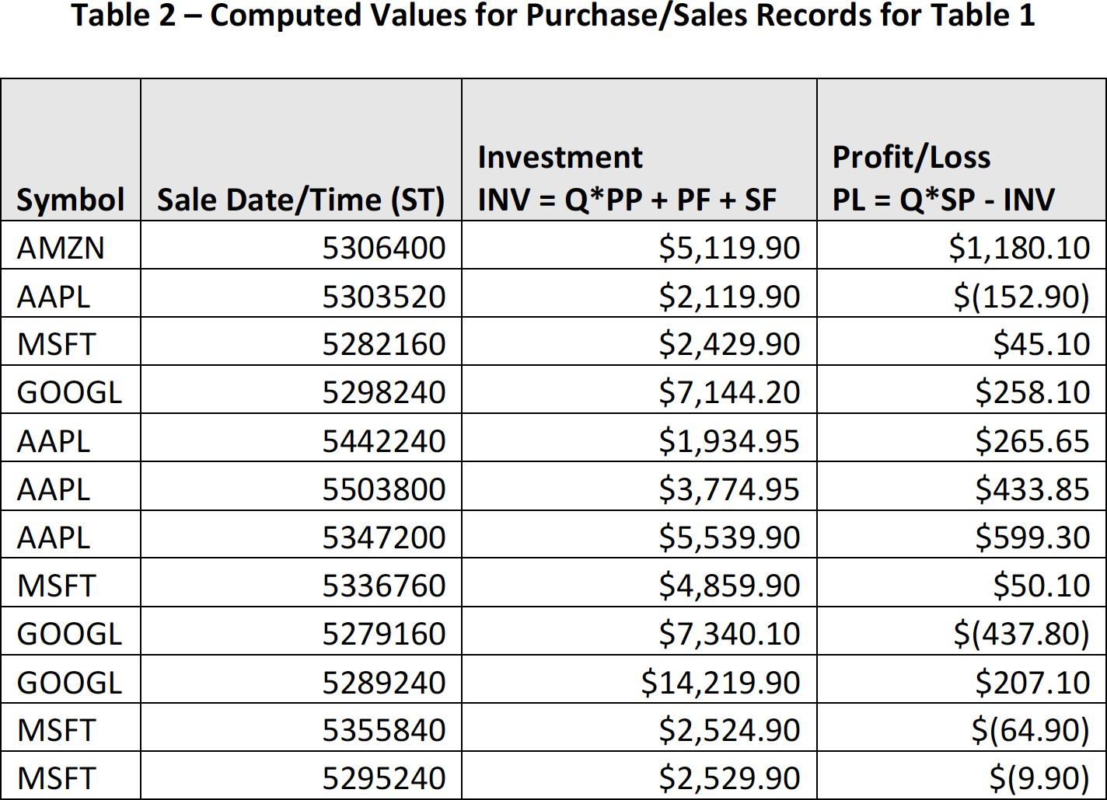

# Analyst Comparison

To compare analysts, we give each analyst “play” money (called the seed amount) and let them make whatever purchases and sales they desire, using simulated transaction. We record the purchase-sales for each investor in a separate purchase-sale histories file. Each investor starts off with same seed money, but they can start and end their simulation at different times. The number of days between the start and end of an analyst’s simulation is called the Simulation Days (D).

One measure of overall investor performance is total of all PL’s computed for each purchasesale in that investor’s history. We’ll call this Total Profit-Loss (TPL). Another measure of overall investor performance is TPL divided by the D. We’ll call this Profit/Loss per Day (PLPD).

Another measure is an investor’s performance for an individual stock. This is the sum of PL for that stock, divided by the total days invested in that stock. See Table 3 for an example.

