VCFcache reduces redundant computation in repeated variant annotation
  - Technical Note
[AUTHOR LIST TO COMPLETE]
2026-09-09
Running title: Reusing variant annotations with VCFcache
Affiliations: [AFFILIATIONS TO COMPLETE]
Corresponding author: [NAME, POSTAL ADDRESS, EMAIL, AND ORCID TO COMPLETE]
Article type: Technical Note

Abstract
Background: Variant annotators repeatedly compute the same consequences when alleles recur across samples. VCFcache stores INFO annotation payloads from a fixed annotation recipe and sends only cache misses to the original annotator.
Findings: In 12 independent GRCh38 genomes using a bundled gnomAD allele-frequency (AF) ≥1% cache, median whole-genome sequencing speedups were 9.50-fold for Ensembl VEP --everything, 2.54-fold for clinical fastVEP and 10.78-fold for clinical SnpEff. Corresponding exome speedups were 2.29-, 0.93- and 2.66-fold, showing that very short workflows may not recover fixed cache costs. Across 52 held-out genomes, bundled AF ≥10%, bundled AF ≥1% and disjoint three-genome cohort caches accelerated VEP 4.75-, 9.21- and 4.59-fold and fastVEP 1.84-, 2.05- and 1.81-fold. Controlled VEP pipelines spanning 4.2–22.7 hours returned 3.3–20.5 hours per genome as annotation work increased. Three-genome cohort caches broke even after two subsequent genomes; at 1,000 genomes, measured VEP rates corresponded to 39.1–86.7 compute days returned. All 176 evaluable direct/cached comparisons in the final clinical campaign were semantically concordant, with no cache-attributable annotation mismatch.
Conclusions: Relative acceleration is governed by cache coverage and recoverable per-variant work, whereas absolute time saved increases with pipeline cost. VCFcache therefore benefits annotation-rich cohorts most while retaining the configured annotator as the authority for every cache miss.

Keywords
variant annotation; VCF; BCF; caching; Ensembl VEP; fastVEP; workflow acceleration; reproducible bioinformatics

Findings

VCFcache turns repeated annotation into incremental computation
Across separately annotated samples, the same alleles recur, yet conventional annotation recomputes the requested annotations on every run. VEP and SnpEff use local reference data to avoid repeated remote database access, but still evaluate each input allele [1,2]. Lookup-based tools such as vcfanno and echtvar efficiently retrieve pre-existing annotation fields from reference files or indexed archives, but do not themselves invoke a user-defined annotation workflow for variants absent from those resources [3,4]. VCFcache combines reuse with automatic fallback: it retrieves allele-level INFO annotation payloads produced by a fixed annotation recipe—defined by the annotator version, command-line options, plugins and supplementary resources—and sends cache misses through that same recipe. Cached and newly annotated records are then merged into a sorted, indexed BCF (Figure 1). This makes an existing recipe reusable across incoming samples: laboratories can retain their configured annotator while avoiding computation already performed for recurring alleles. Reuse requires consistent allele representation and a fixed reference assembly [5].
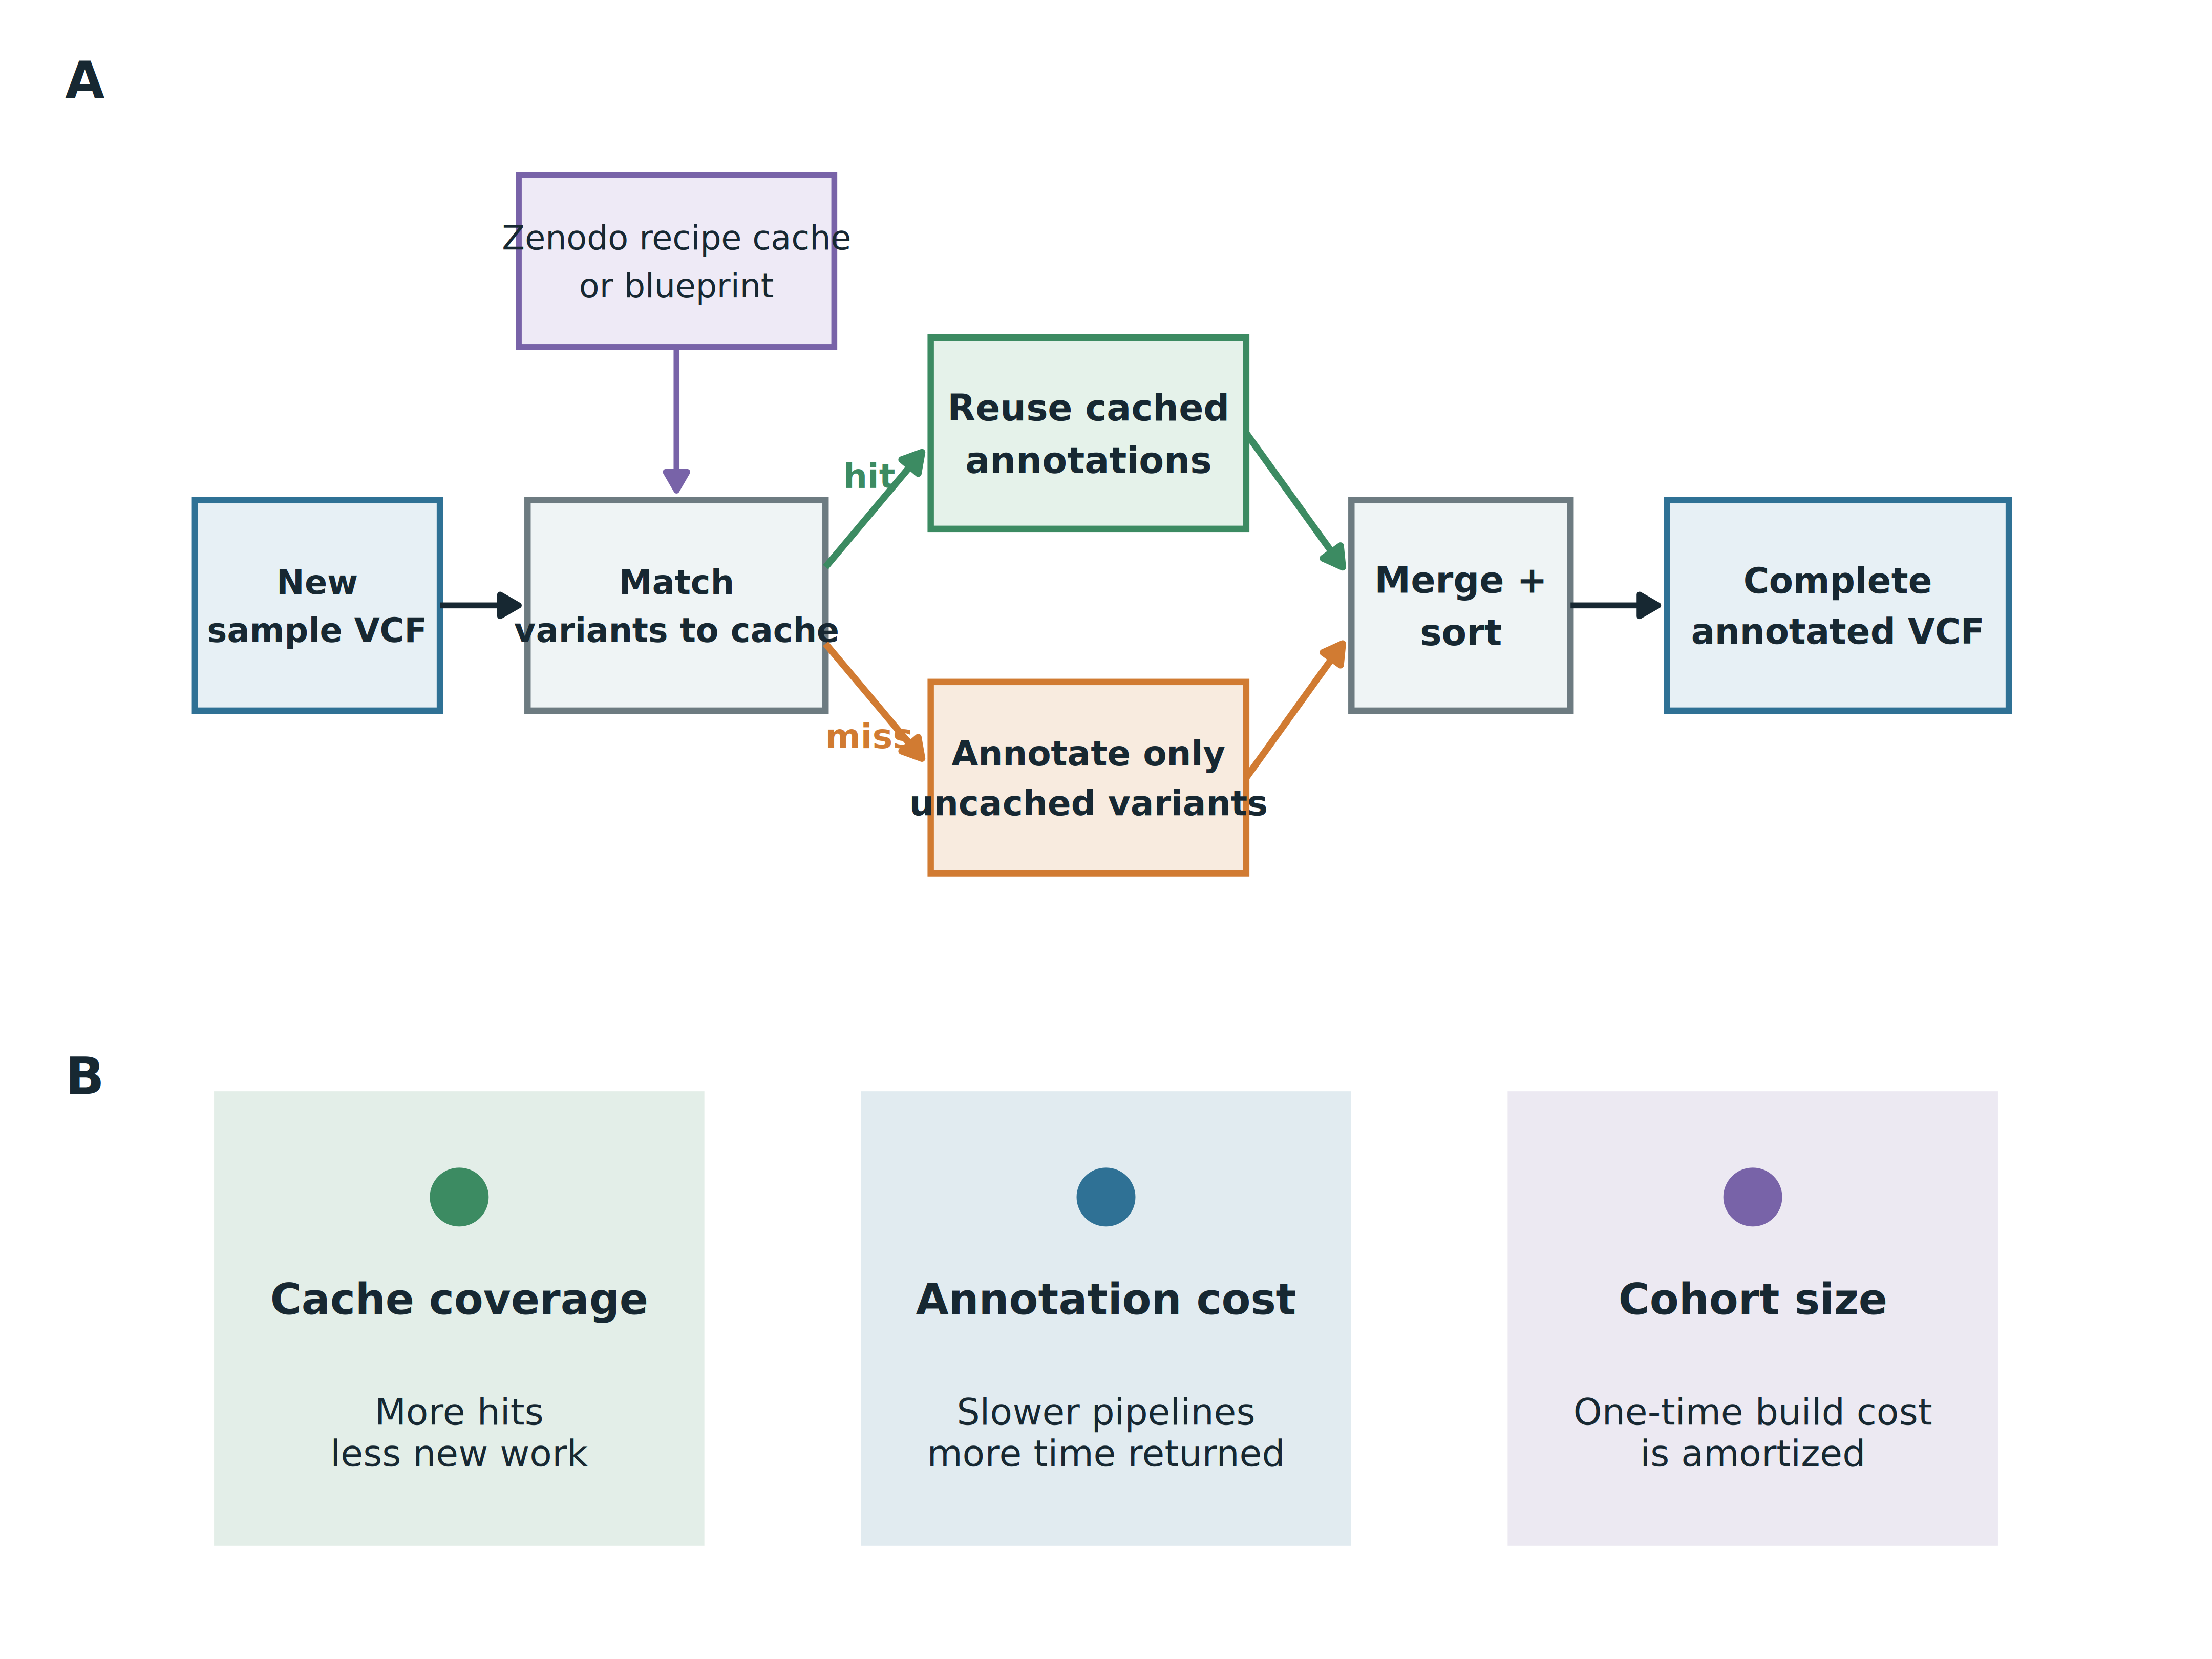
Figure 1: VCFcache reuses annotation work without changing the completed record set. (A) Each input VCF is matched against a recipe-specific cache. Existing annotations are retrieved, only cache misses are sent to the configured annotator, and both streams are merged into a sorted, indexed output BCF. Users may download a ready-to-use recipe cache or a blueprint from Zenodo. (B) Benefit is governed by cache coverage, the cost of the underlying annotation recipe and the number of samples over which any local cache build is amortized. BCF, binary variant call format; VCF, variant call format.
For $N$ input alleles, hit fraction $f$ and $M=N(1−f)$ misses, let $A_{0}$ denote annotator start-up and $A_{1}$ average per-allele annotation cost. Let $B_{d}(N)$ and $B_{c}(N)$ denote the non-annotation costs of the direct and cached paths, respectively, including preprocessing and output processing.
$$T_{direct}≈B_{d}(N)+A_{0}+A_{1}N,$$
$$T_{cached}≈B_{c}(N)+1_{M>0}(A_{0}+A_{1}M).$$
The indicator is one when misses remain and zero otherwise: a perfect hit rate also avoids annotator start-up. With any miss, caching breaks even when $A_{1}fN>B_{c}(N)−B_{d}(N)$; at perfect coverage, the saving additionally includes $A_{0}$. This approximation assumes comparable average annotation cost for hits and misses; variant and transcript composition can change that cost. High coverage alone therefore need not accelerate small inputs or minimal recipes. A custom cache’s one-time build cost is amortized as $T_{effective}≈T_{cached}+T_{build}/S$ after $S$ uses.

Assay scale and annotation cost determine practical benefit
Twelve independent GRCh38 genomes (six KPGP and six SGDP) were represented as matched ACMG panel, WES and WGS inputs and evaluated with the bundled gnomAD AF ≥1% cache. Each native annotator configuration was compared only with its own direct baseline. VEP --everything produced median speedups of 0.71-, 2.29- and 9.50-fold for Panel, WES and WGS, respectively. The corresponding values were 0.46-, 0.93- and 2.54-fold for clinical fastVEP and 1.06-, 2.66- and 10.78-fold for clinical SnpEff (Figure 2). Thus fixed lookup and output costs can outweigh saved work for small inputs, whereas WGS contained enough recoverable work to accelerate all three configurations.
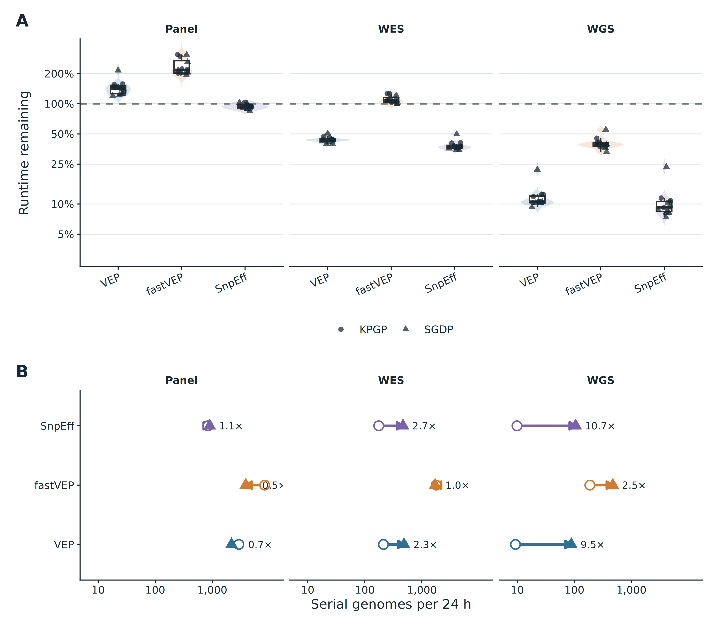
Figure 2: VCFcache returns most WGS annotation time across three native annotator configurations. Twelve independent GRCh38 genomes were tested as ACMG SF v3.3 Panel, Twist Human Core Exome WES and WGS inputs with the bundled gnomAD AF ≥1% strategy. VEP used --everything; fastVEP and SnpEff used their clinical recipes. Configurations are compared only against their own direct baseline. (A) Distribution of end-to-end runtime remaining after caching; the dashed line marks equal runtime. (B) Median serial throughput calculated as 86,400 seconds divided by median per-sample wall time; open circles denote direct annotation and arrowheads denote VCFcache. Cohort shapes identify independent biological samples. AF, allele frequency; KPGP, Korean Personal Genome Project; SGDP, Simons Genome Diversity Project; VEP, Variant Effect Predictor; WES, whole-exome sequencing; WGS, whole-genome sequencing.
For WGS, median serial throughput increased from 9.3 to 88.4 genomes per day for VEP, from 186.3 to 471.2 for fastVEP and from 9.9 to 105.4 for SnpEff under the benchmark allocations. These values show the operational effect of reuse within each recipe; they are not a ranking of annotators because the native recipes intentionally differ in annotation scope.

Cache coverage defines opportunity; pipeline cost determines time returned
Across the 108 matched GRCh38 sample-tool-assay pairs, runtime remaining approached the annotation-dominated approximation, $1−f$, as direct annotation became more expensive (Figure 3A). The deviation for Panel and some WES cells shows the extra processing cost $B_{c}(N)−B_{d}(N)$; hit rate alone is insufficient to predict benefit for short jobs.
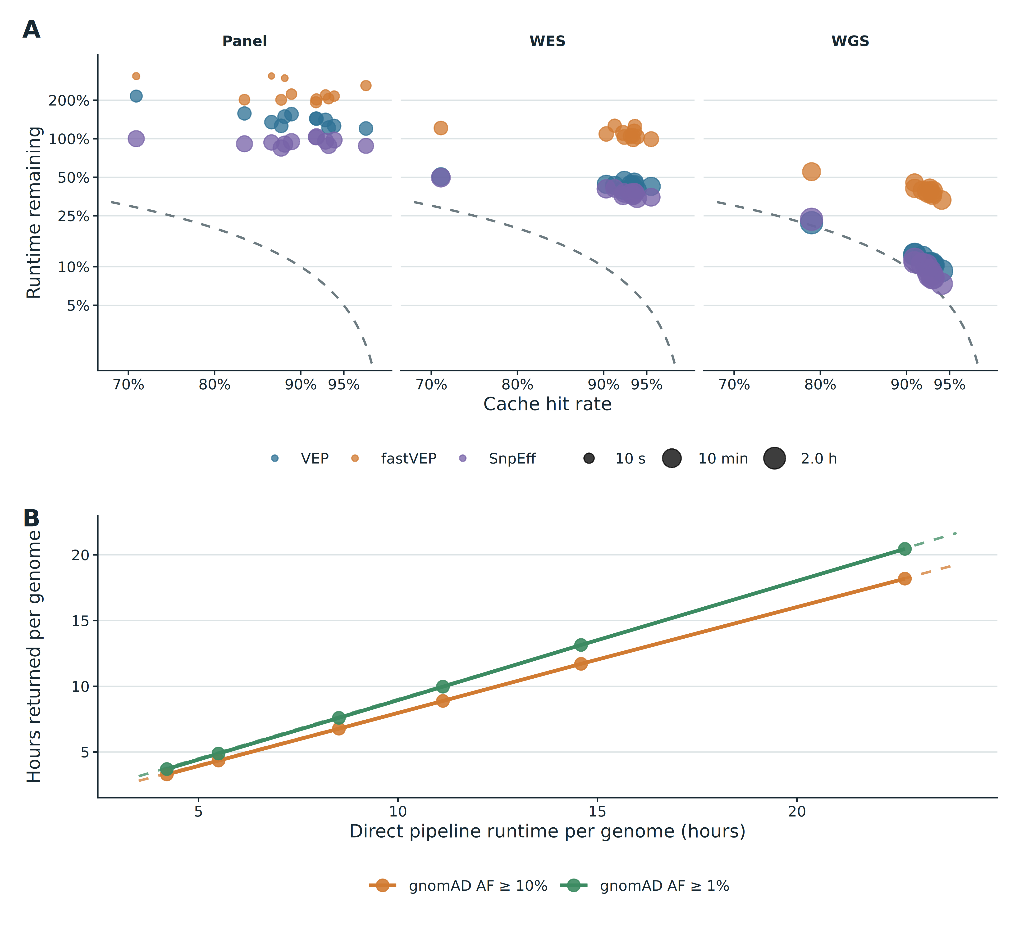
Figure 3: Cache coverage defines the theoretical opportunity, while annotation cost determines how much time is returned. (A) Observed runtime remaining for 108 matched GRCh38 sample-tool-assay pairs. Dashed curves show the annotation-dominated, negligible-overhead approximation, $1−f$, for hit rate $f$; point area represents direct annotation time. Fixed lookup, preprocessing and output costs dominate very short Panel jobs but become small relative to WGS annotation. (B) One 4.80-million-variant KPGP genome was processed with six controlled VEP loads and bundled gnomAD AF ≥10% and AF ≥1% caches. Solid lines show observed hours returned as pipeline cost increases; dashed lines show the cache-coverage approximation, $f×$ direct runtime, valid when per-allele annotation dominates runtime. All 12 outputs passed semantic comparison. AF, allele frequency; KPGP, Korean Personal Genome Project; VEP, Variant Effect Predictor; WGS, whole-genome sequencing.
The controlled VEP recipes spanned 4.2–22.7 hours without changing their annotation content. At 80.23% cache coverage, 19.7–21.7% of direct wall time remained (4.62–5.07-fold speedup); at 90.26% coverage, 9.9–11.9% remained (8.39–10.10-fold). For the longest recipe, VCFcache returned 18.19 and 20.45 hours per genome at the two cache depths. Measured and coverage-predicted relative runtimes differed by at most 0.56 percentage points. Relative speedup therefore approaches a hit-rate ceiling even while the absolute time returned continues to grow with pipeline cost.

Public and cohort caches support different deployment models
We next evaluated 20 KPGP, 20 SGDP and 12 Harvard PGP genomes [6–8]. KPGP and SGDP remained in GRCh38 and PGP in GRCh37. Three additional, disjoint genomes from each provider formed cohort caches; relatedness screening prevented a second-degree-or-closer training/evaluation pair. The public alternatives were bundled, assembly-matched gnomAD v4.1 caches containing alleles reaching AF ≥10% or AF ≥1% in any reported frequency stratum [9]. gnomAD supplies a broad public allele universe [10]; the coverage measured here remains specific to these cohorts, filters and variant representations, rather than a general clinical hit-rate estimate.
Across these 52 held-out genomes, VEP median end-to-end speedups were 4.75-fold (AF ≥10%), 9.21-fold (AF ≥1%) and 4.59-fold (cohort cache). With the core fastVEP recipe, they were 1.84-, 2.05- and 1.81-fold. Median AF ≥1% coverage was 91.95–93.04% across providers, whereas three-genome cohort coverage was 77.45–82.88% (Supplementary Figure 1).
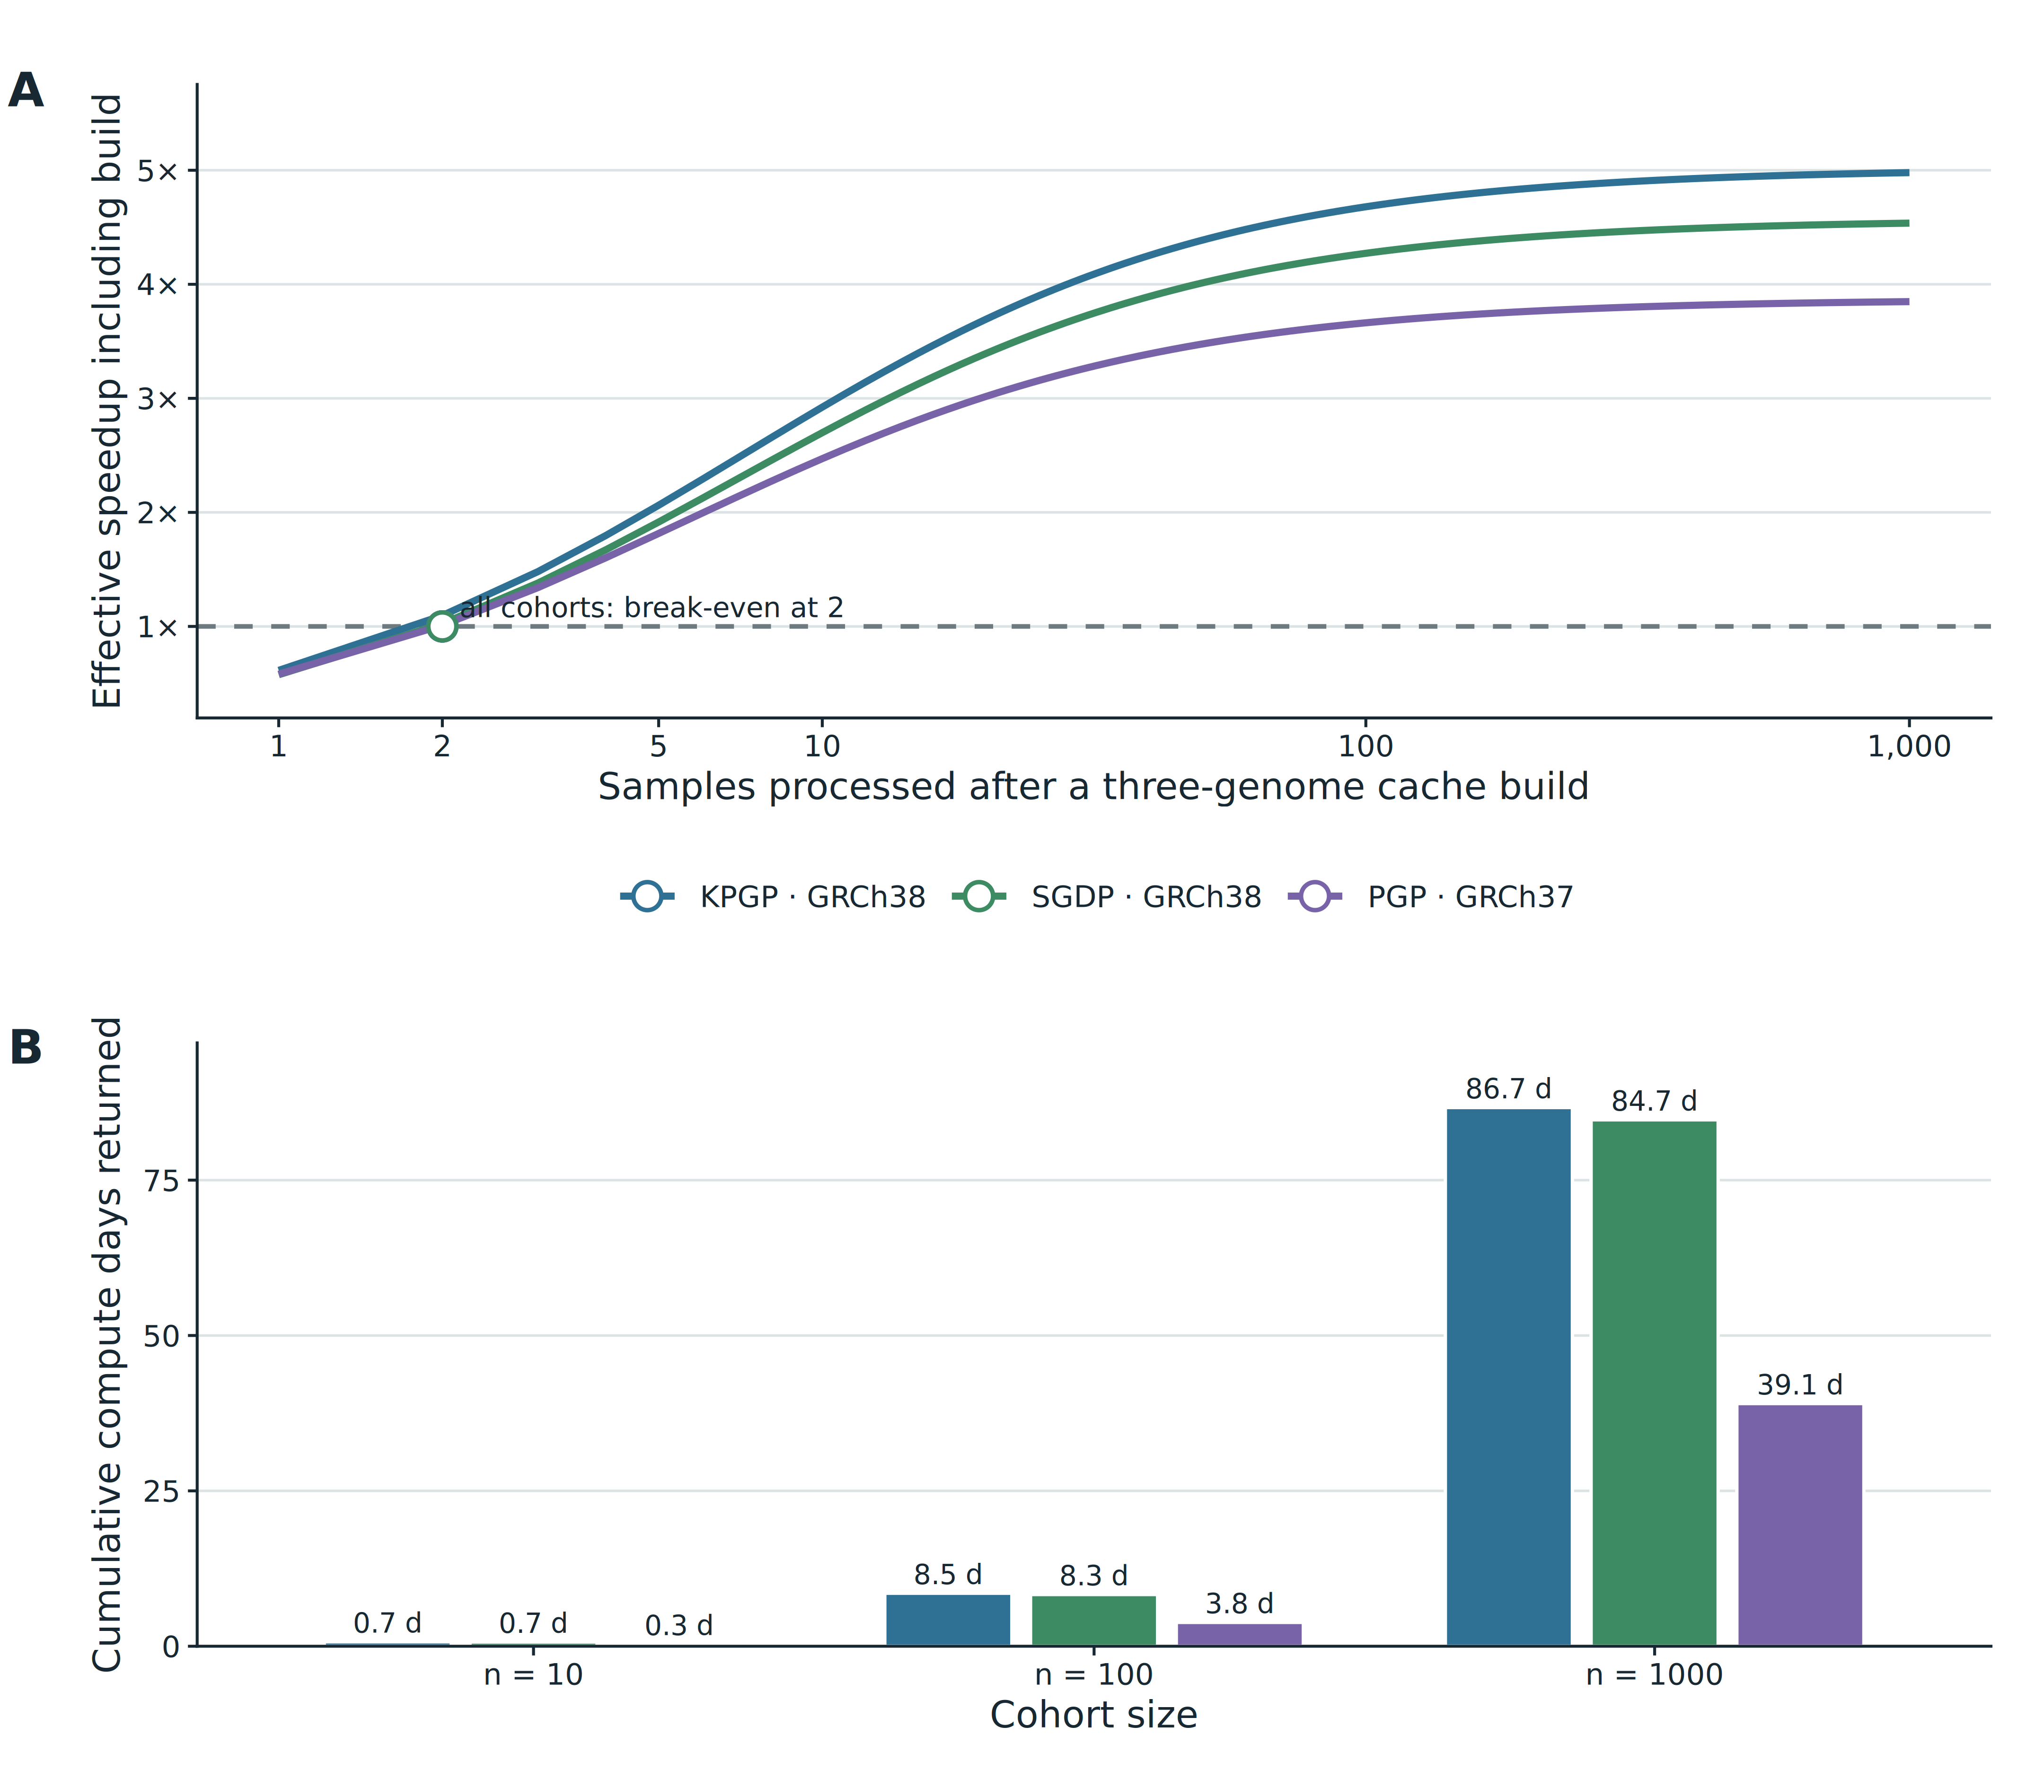
Figure 4: A cohort-derived cache repays its build cost rapidly and returns cumulative compute time. Three held-out real-world cohorts were evaluated with caches built from three disjoint genomes. (A) Effective speedup includes the complete one-time cache-build duration divided across the indicated cohort size; circles mark empirical break-even. (B) Compute days returned after build cost for cohorts of 10, 100 and 1,000 samples, using measured cohort-specific median direct and cached VEP WGS runtimes. KPGP, Korean Personal Genome Project; PGP, Personal Genome Project; SGDP, Simons Genome Diversity Project; VEP, Variant Effect Predictor; WGS, whole-genome sequencing.
All three cohort caches repaid their measured build cost after two subsequent genomes; downloaded bundled caches require no local annotation build. At 100 genomes, the observed VEP rates corresponded to 8.5, 8.3 and 3.8 compute days returned for KPGP, SGDP and PGP, respectively. At 1,000 genomes, these values were 86.7, 84.7 and 39.1 days. The calculation includes the complete local cache-build time and therefore distinguishes immediate public-cache use from cohort-specific amortization.

Caching complements efficient and parallel annotators
Increasing annotation load strengthened benefit without changing cache membership. On the same GRCh37 genomes, extending SnpEff from core consequence annotation to a clinical ClinVar and gnomAD recipe increased median speedup from 1.16- to 3.62-fold for WES and from 4.46- to 12.31-fold for WGS (Supplementary Figure 3 and Supplementary Table 1).
An independent engineering experiment asked whether more CPUs eliminate reuse benefit for fast native annotation. A dense ten-database fastVEP recipe saturated between process-wide limits of 10 and 32 CPUs (706.2 versus 691.4 s direct) but retained 3.07- and 3.37-fold speedups at approximately 90% cache hits. At 10 CPUs, caching returned 7.9 minutes per genome (Supplementary Figure 2). Parallelism and reuse therefore reduce different components of runtime.

Correctness was assessed outside timed cells
All 156 VEP and 156 fastVEP whole-genome pairs passed annotator-specific semantic comparison. For VEP, 8,898 of 734,582,949 records (0.0012%) differed only in HGNC_ID, a documented VEP 115.2 batching effect [11]; the field was reported but excluded from pass/fail. fastVEP comparison covered all INFO, FORMAT and relevant header values, canonicalizing order only.
In the final clinical campaign, all 176 eligible direct/cached pairs were semantically concordant (Supplementary Figure 3). Four of 180 SnpEff pairs were excluded before inference because one GRCh37 allele differed only by WARNING_TRANSCRIPT_MULTIPLE_STOP_CODONS; consequence, transcript, HGVS, ClinVar, gnomAD, genotype and record counts agreed. A direct-SnpEff reproducer showed that the warning changed when two adjacent input records were reversed, without VCFcache involvement. We therefore documented the annotator-order effect rather than adding warning-specific normalization. These results support equivalence under a fixed tool, version, reference and recipe, not byte identity or equivalence between annotators.

Scope and relationship to existing approaches
The contribution is recipe-specific incremental execution: an indexed payload cache, automatic execution of the same recipe for misses, and assembly of one sample-level result. vcfanno and echtvar address efficient joins of supplied annotation fields, and VarNote accelerates access to large functional resources [3,4,12]. GEMINI persists cohort variants, genotypes and annotations for downstream query [13]. These approaches establish that annotation reuse and fast lookup are not new in themselves; VCFcache makes reuse part of executing an existing recipe on successive samples. Faster lookup can further reduce its processing cost.
Reuse is appropriate for allele-local INFO annotations stable under the frozen recipe. Genotype-dependent, haplotype-dependent or processing-order-dependent output requires separate validation; arbitrary FORMAT changes and changes to the record set are outside the demonstrated contract. The observed VEP and SnpEff differences therefore delimit the equivalence claim. Within the tested scope, reusable public and cohort caches turn recurrent alleles into saved annotation work, including around a fast parallel annotator.

Methods

Software and cache design
VCFcache is implemented in Python and delegates normalized BCF processing and indexing to bcftools/htslib [14]. A blueprint is a genotype-free set of normalized alleles. Cache construction applies one frozen annotation command to the blueprint and stores its output with immutable recipe and parameter snapshots. Sample annotation splits records into cache hits and misses, applies the same command to misses, and produces a coordinate-sorted, indexed BCF. Semantic comparison was performed afterward and was never timed.
Cache matching uses CHROM, POS, REF and ALT within an assembly-specific namespace, rather than a position-only or genotype key. Equivalent alleles can have different VCF encodings [5]. Sample preprocessing decomposes multiallelic records with bcftools norm -m- and removes spanning-deletion ALT=* alleles; it does not recombine the split records. This command does not perform reference-based left alignment. Input and cache must share allele representation and contig naming for matching; reference-based left alignment and minimal representation can establish consistent keys and, when applied, must use the same reference sequence upstream. Assembly and contig-name compatibility checks do not establish biological equivalence between differently represented indels. Tested inputs contained biallelic autosomal SNPs and short indels; this study does not validate arbitrary structural variants or record-changing recipes.
The cache stores INFO payloads, while sample genotypes remain attached to the input records. The recipe’s required INFO tag identifies annotated records and must be populated for records intended to count as annotated hits. By default, records still lacking that tag after annotation are filtered; the --preserve-unannotated option retains them. Recipe and parameter snapshots record the command and resource paths; a YAML checksum alone cannot detect a changed binary or database at an unchanged path. The benchmark adds tool versions, binary/reference/database hashes and frozen wrapper scripts in its provenance manifests. Annotator, option, plugin, reference, resource or output-schema changes require a separately built cache. The archived resource checksums, rather than automatic hashing of every external dependency by the CLI, define the benchmark’s frozen execution environment.

Samples and cache strategies
The external WGS benchmark used open KPGP and SGDP GRCh38 genomes and Harvard PGP GRCh37 genomes. Inputs were restricted to carried, biallelic autosomal SNPs and short indels and checked for compression, index readability, coordinate order, contigs, sample identity and completeness. Three genomes per provider were reserved for cache construction; evaluation comprised 20 KPGP, 20 SGDP and 12 PGP genomes. PLINK2 KING screening at kinship 0.0884 excluded a second-degree-or-closer relationship across the construction/evaluation boundary.
Matched-assay experiments used six KPGP and six SGDP GRCh38 evaluation genomes, subset to Twist Human Core Exome intervals padded by 125 bp and ACMG SF v3.3 MANE Select coding intervals padded by 20 bp. The principal matched comparison combined VEP --everything, clinical fastVEP and clinical SnpEff measurements on these identical 12 inputs and the same gnomAD AF ≥1% cache membership, yielding 108 direct/cached sample-tool-assay pairs. The wider final clinical campaign used 12 genomes per assembly across Panel, WES and WGS; frozen sample membership is provided with its reproducer.
Public strategies were assembly-matched VCFcache gnomAD v4.1 joint exome/genome caches containing sites reaching AF ≥10% or AF ≥1% in any frequency stratum. Production Zenodo archives were checksum-verified before use. Provider-specific cohort blueprints contained alleles from the three reserved genomes; annotations were built independently for every tool and recipe. No documented overlap between evaluation cohorts and gnomAD was identified, although undisclosed sample-level overlap cannot be excluded. The gnomAD resource citation and v4.1 release identify the source population data; the AF ≥10% and AF ≥1% GRCh38 VEP cache DOIs identify the downloadable artifacts [9,10,15,16]. fastVEP and SnpEff caches were annotated locally from the corresponding allele sets.

Annotation recipes and execution
VEP 115.2 ran offline with the assembly-matched Ensembl cache, --everything, --hgvsg, buffer size 500,000 and eight forks. fastVEP 0.3.0 used frozen release binaries, assembly-matched FASTA and transcript caches. Its core recipe reported consequences and HGVS; clinical and engineering recipes added the specified supplementary databases. SnpEff 5.4c used GRCh38.115 or GRCh37.75; the core recipe emitted ANN consequences, whereas the clinical recipe subsequently used SnpSift to add ClinVar and gnomAD exome AF/AC/AN fields [2]. Binary, reference, database and recipe hashes are archived. These native configurations intentionally represent realistic within-tool loads; they do not produce identical annotation fields and were not used for cross-tool performance ranking.
Each unique sample, annotator, recipe, assay and cache condition contributed one direct and one cached observation; samples, not technical repeats, were the inferential units. Direct and cached arms used identical inputs, recipes, databases, storage and CPU allocations and ran in separate Slurm job steps. End-to-end wall time included normalization, lookup, annotation, output assembly, compression and indexing, but excluded cache construction and semantic comparison. Short Panel/WES tasks used an untimed, separate calibration input before either retained condition to standardize warm state.

Correctness comparison
The VEP comparator checked variant keys, retained input fields, genotype, the CSQ definition and all CSQ entries; it canonicalized CSQ and same-locus record ordering. HGNC_ID-only differences were counted but excluded from pass/fail because VEP 115.2 varies this field with batching [11]. The fastVEP comparator checked every INFO and FORMAT value and relevant header, canonicalizing only representational ordering. The SnpEff comparator checked the complete tested annotation level, including ANN, ClinVar and gnomAD fields, while canonicalizing same-position record and ANN-entry order.
Four SnpEff cells with one warning-only difference were excluded before summary statistics. Diagnosis used direct SnpEff 5.4c outside all timing: the target alone, an adjacent insertion followed by the target, and the reversed pair. No VCFcache process was involved. Exact inputs, outputs and checksums are archived with the final campaign. These four cells failed the original equivalence gate and remain reported as such; their upstream explanation does not turn them into concordant results. Likewise, the VEP pass criterion does not establish equality of HGNC_ID.

Controlled annotation-load experiments
Pipeline scaling used held-out GRCh38 sample KPGP-00319 (4,795,706 variants) and bundled caches with observed hit rates of 80.23% and 90.26%. Six VEP --everything recipes added 0.5, 1, 2, 4, 7 or 10 ms per transcript consequence through a plugin that emitted no field. Each load had one direct observation and one cached observation per cache depth.
A separate fastVEP experiment compared core and dense ten-database recipes on the same held-out WGS under taskset limits of 1, 10 or 32 CPUs. The dense one-CPU exploratory cell was stopped for impractically low throughput and was not analysed. This controlled cache fixed coverage near 90% to isolate the interaction between CPU availability and annotation load rather than estimate biological coverage.

Cache construction and amortization
Cache construction was excluded from per-sample timing and recorded separately. For each cohort cache, the measured build duration was divided by paired median time saved to obtain the number of subsequent genomes required for break-even. Effective per-sample time after $S$ uses was calculated as $T_{cached}+T_{build}/S$. Public Zenodo caches have no local annotation-build cost. Cache allele counts, archive and extracted sizes, peak resident memory and transient disk use were taken from indexed artefacts and instrumented builds rather than inferred from input size.

Outcomes and analysis
The primary outcome was speedup $T_{direct}/T_{cached}$; secondary outcomes were relative runtime, paired time saved, hit rate and cache-build amortization. Serial throughput was reported descriptively as 86,400 s divided by median wall time. Cumulative cohort time returned was $S(T_{direct}−T_{cached})−T_{build}$ and was converted to compute days. Medians were calculated across genomes. Pooled confidence intervals used 10,000 sample-level bootstrap resamples stratified by provider cohort while preserving paired conditions. Modelled and measured values were labelled separately. Figures were generated in R with ggplot2, assembled with patchwork, and exported as SVG, PDF and 600-dpi PNG with frozen source tables and session information.

Availability of supporting source code and requirements
- Project name: VCFcache
- Project home page: https://github.com/julius-muller/vcfcache
- Archived version: v0.5.5, https://doi.org/10.5281/zenodo.22019326 (concept DOI https://doi.org/10.5281/zenodo.17943997 resolves to the most recent release)
- Operating systems: Linux; container images are provided for portable execution
- Programming language: Python 3.11 or later
- Other requirements: bcftools 1.20 or later; an external annotation command and its reference assets are required to build or use an annotation cache
- License: GNU General Public License v3.0 only
- RRID: [RRID TO COMPLETE, IF APPLICABLE]
- bio.tools identifier: [BIO.TOOLS IDENTIFIER TO COMPLETE]
The source repository includes automated tests, example configurations, Docker definitions, cache manifests and the complete benchmark preparation and analysis workflow. Public cache aliases resolve to archives distributed through Zenodo.

Data availability
The datasets supporting the benchmark results are available from https://doi.org/10.5281/zenodo.22018995. The deposit will include frozen source tables, cohort-selection and QC manifests, commands, semantic-comparison summaries, figure-rendering code, R session records, and a compact test input with expected cached and direct outputs.
A self-contained executable example is distributed with the software itself and requires no download, no reference data and no external annotation tool. The command vcfcache demo runs the complete workflow — blueprint creation, blueprint extension, cache construction and cached annotation — against bundled test data using a self-describing annotation recipe, then asserts that the cached and directly annotated outputs are identical. It completes in approximately one second and its peak resident memory is 42.6 MB, so editors, reviewers and users can verify the central correctness claim on any machine that satisfies the stated requirements. This example is the recommended entry point for reproducing the workflow; the archived benchmark deposit reproduces the measurements. Raw public human genomic inputs will be referenced through their provider accessions and terms rather than redistributed when redistribution is not appropriate.
The bundled GRCh38 VEP cache with any-stratum AF ≥10% is archived at https://doi.org/10.5281/zenodo.18189447, and the AF ≥1% cache at https://doi.org/10.5281/zenodo.18190046. The corresponding GRCh37 caches are archived at https://doi.org/10.5281/zenodo.18189051 and https://doi.org/10.5281/zenodo.18189348. Source software will be cited by release and persistent archive identifier in the final manuscript.

List of abbreviations
AF: allele frequency; BCF: binary variant call format; BGZF: blocked GNU Zip Format; CSQ: consequence annotation field; GRCh: Genome Reference Consortium human assembly; KPGP: Korean Personal Genome Project; PGP: Personal Genome Project; SGDP: Simons Genome Diversity Project; VCF: variant call format; VEP: Ensembl Variant Effect Predictor; WGS: whole-genome sequencing.

Declarations

Ethics approval and consent to participate
This study used only openly accessible, de-identified public genomic resources and did not recruit participants or attempt re-identification. [INSTITUTIONAL ETHICS DETERMINATION OR WAIVER WORDING TO COMPLETE]

Consent for publication
Not applicable; the manuscript contains no directly identifying participant information.

Competing interests
[COMPETING-INTEREST DECLARATION TO COMPLETE]

Funding
[FUNDING SOURCES, GRANT NUMBERS AND FUNDER ROLES TO COMPLETE]

Authors’ contributions
[CRediT AUTHOR CONTRIBUTIONS TO COMPLETE]

Acknowledgements
[ACKNOWLEDGEMENTS TO COMPLETE]

Disclosure of use of AI-assisted tools
OpenAI Codex using a GPT-5-family model was used on 17 August 2026 to organize the manuscript workspace and to generate and edit an initial prose draft under the direction of [DIRECTING AUTHOR NAME TO COMPLETE]. Quantitative statements were checked against frozen repository tables and figure records. The authors reviewed the scientific interpretation and remain responsible for all content.

References
1. McLaren, W, Gil, L, Hunt, SE, Riat, HS, Ritchie, GRS, Thormann, A, et al. The ensembl variant effect predictor. Genome Biology 2016; 17:122. doi:10.1186/s13059-016-0974-4.
2. Cingolani, P, Platts, A, Wang, LL, Coon, M, Nguyen, T, Wang, L, et al. A program for annotating and predicting the effects of single nucleotide polymorphisms, SnpEff. Fly 2012; 6:80–92. doi:10.4161/fly.19695.
3. Pedersen, BS, Layer, RM, Quinlan, AR. Vcfanno: Fast, flexible annotation of genetic variants. Genome Biology 2016; 17:118. doi:10.1186/s13059-016-0973-5.
4. Pedersen, BS, Ridder, J de. Echtvar: Compressed variant representation for rapid annotation and filtering of SNPs and indels. Nucleic Acids Research 2023; 51:e3. doi:10.1093/nar/gkac931.
5. Tan, A, Abecasis, GR, Kang, HM. Unified representation of genetic variants. Bioinformatics 2015; 31:2202–2204. doi:10.1093/bioinformatics/btv112.
6. Korean Genome Project. Korean personal genome project. 2026; https://koreangenome.org/Korean_Personal_Genome_Project. Accessed 17 August 2026.
7. Mallick, S, Li, H, Lipson, M, et al. The simons genome diversity project: 300 genomes from 142 diverse populations. Nature 2016; 538:201–206. doi:10.1038/nature18964.
8. Ball, MP, Thakuria, JV, Zaranek, AW, et al. A public resource facilitating clinical use of genomes. Proceedings of the National Academy of Sciences of the United States of America 2012; 109:11920–11927. doi:10.1073/pnas.1201904109.
9. gnomAD Production Team. gnomAD v4.1: Joint frequency data and updated resources. 2024; https://gnomad.broadinstitute.org/news/2024-04-gnomad-v4-1. Accessed 17 August 2026.
10. Karczewski, KJ, Francioli, LC, Tiao, G, et al. The mutational constraint spectrum quantified from variation in 141,456 humans. Nature 2020; 581:434–443. doi:10.1038/s41586-020-2308-7.
11. Ensembl VEP developers. HGNC ID in VEP output is affected by buffering and batching. 2025; https://github.com/Ensembl/ensembl-vep/issues/1959. GitHub issue 1959; accessed 17 August 2026.
12. Huang, D, Yi, X, Zhou, Y, et al. Ultrafast and scalable variant annotation and prioritization with big functional genomics data. Genome Research 2020; 30:1789–1801. doi:10.1101/gr.267997.120.
13. Paila, U, Chapman, BA, Kirchner, R, Quinlan, AR. GEMINI: Integrative exploration of genetic variation and genome annotations. PLoS Computational Biology 2013; 9:e1003153. doi:10.1371/journal.pcbi.1003153.
14. Danecek, P, Bonfield, JK, Liddle, J, Marshall, J, Ohan, V, Pollard, MO, et al. Twelve years of SAMtools and BCFtools. GigaScience 2021; 10. doi:10.1093/gigascience/giab008.
15. Müller, J. VCFcache gnomAD v4.1 GRCh38 any-stratum AF at least 10 percent VEP 115.2 cache. 2026; doi:10.5281/zenodo.18189447.
16. Müller, J. VCFcache gnomAD v4.1 GRCh38 any-stratum AF at least 1 percent VEP 115.2 cache. 2026; doi:10.5281/zenodo.18190046.

Supplementary Information
This document contains the supplementary methods, results and figures for the VCFcache GigaScience Technical Note.

Supplementary Methods

External WGS selection and quality control
KPGP and SGDP inputs were selected from the DDBJ/NIG public-human-genomes autosomal reanalysis, and PGP inputs from participant-contributed public VCFs. Candidate catalogues recorded provider identifier, source URL, assembly, declared sample identifier and file metadata before download. All preparation steps were resumable and emitted machine-readable manifests.
Selection was deterministic and performed before timing results were examined. Three provider-specific genomes were assigned to cache construction. The evaluation sets contained 20 KPGP, 20 SGDP and 12 PGP genomes. Training and evaluation membership did not overlap. KPGP and SGDP remained in GRCh38; PGP remained in GRCh37. No liftover was applied.
Prepared inputs were single-sample, carried-allele VCFs restricted to biallelic autosomal SNPs and short indels. Quality control tested compression, index readability, coordinate order, contigs, sample identity, record count and file integrity. Stable provider identifiers were retained separately from potentially non-unique VCF sample labels.
Relatedness screening was stratified by assembly. Common SNPs were pruned and PLINK2 KING robust kinship was evaluated at 0.0884. The design prohibited a second-degree-or-closer relationship across the cache-training/evaluation boundary. One related KPGP pair within the evaluation set was retained and reported because such structure is realistic in an applied cohort.

Matched assay extension
The assay-by-annotator extension used 12 genomes selected deterministically from the independent GRCh38 evaluation set before assay timing: six KPGP and six SGDP. PGP was not included because its GRCh37 configuration would prevent a matched assembly comparison. Each selected WGS was subset to Twist Human Core Exome capture intervals padded by 125 bp and to ACMG SF v3.3 MANE Select coding intervals padded by 20 bp. The resulting WES and Panel inputs therefore retained the providers and variant-calling pipelines of the independent WGS cohorts and did not introduce 1000 Genomes-derived performance samples.
Each input was processed once with VEP 115.2 --everything, clinical fastVEP 0.3.0 and clinical SnpEff 5.4c, directly and through recipe-specific caches built on the same gnomAD AF ≥1% blueprint. The VEP observations came from the matched assay extension and the clinical fastVEP/SnpEff observations from the final native annotation campaign; sample identity, assay definition and cache membership were held fixed. All cached outputs were subjected to their annotator-specific external semantic comparators. The 108 paired observations were designed to identify where fixed cache-workflow costs are recovered, not to imply that every assay benefits or that the three native recipes have equal annotation content.

Public-cache provenance
Only VCFcache caches distributed from production Zenodo were used for the ready-made public-cache comparison. The GRCh38 VEP 115.2 AF ≥10% and AF ≥1% archives had DOIs 10.5281/zenodo.18189447 and 10.5281/zenodo.18190046. Their GRCh37 counterparts had DOIs 10.5281/zenodo.18189051 and 10.5281/zenodo.18189348. Downloads were checked against frozen archive MD5 values before extraction.
The frequency thresholds are any-stratum thresholds: a site entered the blueprint when at least one reported gnomAD frequency stratum met the cutoff. The labels therefore do not mean combined-population AF thresholds.

Benchmark execution and statistical analysis
The Slurm cluster comprised one head node and six workers with identical software and worker-local benchmark inputs, caches and annotator assets. A shared results export was mounted read-only or append-only as appropriate. Each sample task executed its direct and cached conditions in separate Slurm job steps. This prevented an earlier condition’s cgroup memory peak from being reported for a later condition.
The final campaigns used one observation for each unique sample/annotator/cache combination. Samples provide biological and pipeline heterogeneity; repeated executions of the same technical cell were not treated as independent observations. A small repeatability control showed sub-percent differences and was not pooled with the 52-genome analysis.
The external semantic comparator ran after timing and was excluded from all reported wall times. No observation was calibrated or rescaled.
For the short matched Panel/WES extension, one separate KPGP-00319 assay subset was processed before either timed condition in every task. This untimed step loaded annotator, transcript and cache-lookup assets consistently; it was not an evaluation-sample replicate and was excluded from all summaries. The need for this control was established before retaining extension timings, when a discarded pilot showed that cold-state condition order dominated short cells.
The final clinical campaign used 12 independent genomes per assembly and five tool/recipe/assembly arms: clinical fastVEP on GRCh38 and GRCh37, clinical SnpEff on both assemblies, and core SnpEff on GRCh37. Panel, WES and WGS cells each contained one direct and one cached run. The gnomAD AF ≥1% blueprint set cache membership; every cache was annotated locally with its own frozen recipe. No cache annotation was transferred between tools.
Medians summarize sample-level speedups. Stratified bootstrap intervals used 10,000 resamples within KPGP, SGDP and PGP while preserving a sampled genome’s paired conditions. This respects the deliberately heterogeneous 20/20/12 cohort allocation.
Relative speedup was interpreted within each assembly and annotator recipe. In particular, the GRCh37 PGP configuration had a substantially faster direct fastVEP baseline than the two GRCh38 configurations, whereas parsing, lookup and output construction did not decrease in the same proportion. Its smaller relative fastVEP speedup therefore reflects the larger fixed-cost fraction and must not be interpreted as evidence of poorer biological cache coverage.

Runtime model and limiting cases
The main-text model separates non-annotation work in direct and cached paths and starts the native annotator only if $M=N(1−f)>0$. Its general break-even condition is
$$A_{1}fN+(1−1_{M>0})A_{0}>B_{c}(N)−B_{d}(N).$$
Here $A_{0}$ is native startup, $A_{1}$ is average per-allele annotation time and $B_{c}−B_{d}$ is additional processing cost. Perfect coverage removes startup as well as per-allele work. With at least one miss and dominant annotation cost, relative runtime approaches $1−f$ and speedup approaches $1/(1−f)$. At $f=1$, the remaining $B_{c}(N)$ prevents infinite throughput.
The common $A_{1}$ is an approximation. If hits and misses differ in their transcript overlap, variant types or supplementary-database matches, the recoverable work is the sum of annotation costs over hits, not necessarily $f$ times the total. Similarly, processing costs can depend on cache size, output payload, storage and thread allocation as well as input count. The curves in Figure 3 are explanatory approximations; they do not estimate every model parameter from independently timed stages.

Observed stage timings from an existing real-WGS run
The archived measured VEP run for SGDP genome LP6005519-DNA_B04 with the gnomAD AF ≥1% cache contains 4,876,494 input alleles and 342,007 misses (92.99% hits). Its command durations provide the following breakdown without rerunning the sample.
Operation | Wall time (s)
Multiallelic splitting and input filtering | 34.409
Cache annotation lookup | 102.368
Miss extraction | 44.556
VEP on misses, including input/output conversion | 911.632
Merge annotations | 52.822
Final filtering and output | 59.591
Other end-to-end overhead (difference) | 1.902
End-to-end cached runtime | 1,207.280
Each command includes its own output processing, compression and inline index creation where specified. The six sequential command durations sum to 1,205.378 s. The residual is calculated against the recorded end-to-end time, not attributed to a separately measured component. Direct annotation took 11,467.473 s; the retained pair passed its VEP semantic gate and achieved 9.499-fold speedup. Thus real-sample stage timing already exists; only separation of internal costs such as compression versus lookup would require additional instrumentation.
Evidence: figures/source_data/external_wgs_metrics.tsv, VEP/sample/AF ≥1% row, and the archived workflow.log under benchmarks/results/raw/campaigns/external-vep-light-full52-bbef41d7db8e/measured/tasks/task-23/runs/gnomad_af_0.01/pilot/LP6005519-DNA_B04/bbef41d7db8e/cached_r01/stats/LP6005519-DNA_B04_vcstats/. The final native campaign’s 180 cached cells contain no zero-miss observation; the perfect-hit case discussed in the model and early engineering pilot is a separate controlled condition.

Semantic validation details
Correctness was a gate, not a secondary timing outcome. A cached result could not contribute to a performance figure unless it passed the comparator defined for its annotator.
For VEP, variant keys, retained input INFO, genotype, CSQ header and all CSQ entries were compared. CSQ-entry order and complete-record order within a shared locus were canonicalized. HGNC_ID-only differences were counted but excluded from pass/fail because VEP 115.2 exhibits a documented batching dependency. This exception was not generalized to other fields or annotators.
For fastVEP, every INFO and FORMAT value and every relevant header definition was compared. INFO-tag order, CSQ-entry order and complete-record order within identical loci were canonicalized; no annotation field was ignored. This included fastVEP supplementary fields such as FV_CLINVAR, FV_GNOMAD, FV_1KG and FV_TOPMED when present.
For SnpEff, the comparator checked variant keys, genotype and the complete INFO content defining the tested recipe. ANN entries and same-position records were canonicalized for ordering; warning tokens, ClinVar and gnomAD values were not ignored. Of 180 final-campaign pairs, 176 passed. Four cells from GRCh37 sample hu6664F3 were excluded before inference because one allele carried a WARNING_TRANSCRIPT_MULTIPLE_STOP_CODONS token only in the cached arm. All consequence, transcript, HGVS, ClinVar, gnomAD, genotype and record-count values otherwise agreed.
A direct-SnpEff-only diagnostic reduced the difference to two input records. For chr2:11273459 C>T, the warning was absent when the allele was processed alone, present after chr2:11273458 A>AC, and absent when the same two records were reversed. The target’s warning-free ANN digest was identical in both controls. This demonstrates processing-order-dependent SnpEff 5.4c diagnostic state rather than a VCFcache lookup or merge error. The warning was neither suppressed nor added to a general exception; exact VCFs and output checksums are included in the archived diagnostic.
All 156 VEP and 156 fastVEP cached external-WGS outputs passed. The documented VEP exception comprised 8,898 HGNC_ID-only record differences among 734,582,949 compared records (0.0012%); the maximum was 495 records in one 4.84-million-variant comparison. A separate 89-output technical validation set contained 265 HGNC_ID-only differences and no unexpected annotation mismatch. The 12 cached pipeline-complexity outputs also passed their specified gates. These results support equivalence within a fixed annotator and recipe, not between annotators or arbitrary annotation configurations.

Supplementary Results

fastVEP engineering pilots
An exploratory pilot on one 4,329,621-variant WGS profiled the fixed work that remains when cache hits approach 100%. With the original core fastVEP recipe, VCFcache achieved 1.86-fold, 2.11-fold and 2.84-fold speedups at approximately 80%, 90% and 100% hits. Complete output comparison passed after canonicalizing only INFO-tag and CSQ-entry order. This engineering pilot is not combined with the primary external-WGS campaign.
A dense supplementary-database stress configuration used six custom fastSA sources, three population-style sources and ClinVar. It was rerun on the held-out KPGP-00319 genome under process-wide CPU affinity. At 10 CPUs, direct and 90%-cached annotation took 706.2 and 230.0 seconds (3.07-fold speedup); at 32 CPUs, they took 691.4 and 205.4 seconds (3.37-fold). Increasing the limit from 10 to 32 CPUs therefore changed direct runtime by only 2.1%, while caching returned approximately eight minutes per genome at both limits. All four retained outputs passed complete-record equality. This configuration demonstrates that cache reuse remains valuable after fastVEP saturates its CPU scaling, but its database density is deliberately an upper-bound stress test.
The matched core recipe took 868.4, 463.8 and 379.1 seconds directly at 1, 10 and 32 CPUs, and 576.5, 180.3 and 148.8 seconds with the controlled cache. The corresponding speedups were 1.51-fold, 2.57-fold and 2.55-fold. Thus ten CPUs made the dense direct recipe faster than the one-CPU core recipe (706.2 versus 868.4 seconds), but did not make complexity free: at the same 10-CPU allocation the dense recipe was 52.2% slower than the core recipe. VCFcache returned 7.9 minutes from the dense 10-CPU run and increased its speedup from 2.57-fold for the core recipe to 3.07-fold for the dense recipe. Additional CPUs and reuse therefore addressed different components of runtime.
Profiling at 100% hits attributed material wall time to cache lookup, the guaranteed-empty miss scan and final output construction; subprocess startup was negligible. The original heavy pilot’s diagnostic commands took 4.0 s for input filtering/BCF writing, 22.2 s for lookup with compressed output, 20.0 s for the empty-miss scan and 18.3 s for final filtering/compressed output. Standalone index construction took approximately 15 s; production commands built indexes inline. These are diagnostic timings from separate commands, not additive partitions of one end-to-end observation: compression and indexing overlap other work. The 100% condition was a deliberately constructed pilot cache, not an observed perfect hit rate in the final biological campaign. Archived runs with misses also contain stage timings, including the real-WGS example in the Supplementary runtime model. That command-level breakdown includes compression and indexing within each stage; it does not separately identify every internal operation or fit all model parameters.
In the affinity-controlled experiment, both direct fastVEP and VCFcache were restricted using taskset; the plotted axis therefore denotes CPUs available to the process rather than only a configured thread count. An exploratory dense one-CPU cell was stopped after sustained, impractically low throughput and was not treated as a completed observation. It was unnecessary for the prespecified comparison between the dense recipe at 10 CPUs and the core recipe at one CPU.
The pilots motivate a future streaming engine that performs lookup, miss selection and output construction with fewer complete-file passes. They do not alter the current publication claim that VCFcache already reduces end-to-end runtime around fastVEP.

Native clinical annotation campaign
The final campaign extended the assay-scale design to SnpEff and to clinical fastVEP recipes on both assemblies. Recipes were compared only with their own direct baseline because VEP --everything, fastVEP and SnpEff expose different annotation content. The clinical SnpEff recipe comprised SnpEff ANN consequence prediction followed by SnpSift ClinVar and gnomAD exome AF/AC/AN annotation. The core-to-clinical SnpEff comparison on GRCh37 held samples and cache membership fixed and therefore isolates additional per-variant annotation work.
Supplementary Table 1: End-to-end speedup in the final native annotation campaign. Values are medians across concordant sample pairs. The four warning-only SnpEff exclusions described above reduce two GRCh37 WES and two GRCh37 WGS rows from 12 to 11 genomes. AF, allele frequency; WES, whole-exome sequencing; WGS, whole-genome sequencing.
Tool | Recipe | Assembly | Assay | Genomes | Median hit rate | Median speedup
fastVEP | clinical | GRCh38 | Panel | 12 | 90.4% | 0.46-fold
fastVEP | clinical | GRCh38 | WES | 12 | 93.2% | 0.93-fold
fastVEP | clinical | GRCh38 | WGS | 12 | 92.6% | 2.54-fold
fastVEP | clinical | GRCh37 | Panel | 12 | 90.7% | 0.41-fold
fastVEP | clinical | GRCh37 | WES | 12 | 94.6% | 1.02-fold
fastVEP | clinical | GRCh37 | WGS | 12 | 95.8% | 1.70-fold
SnpEff | core | GRCh37 | Panel | 12 | 90.7% | 1.07-fold
SnpEff | core | GRCh37 | WES | 11 | 94.7% | 1.16-fold
SnpEff | core | GRCh37 | WGS | 11 | 95.9% | 4.46-fold
SnpEff | clinical | GRCh38 | Panel | 12 | 90.4% | 1.06-fold
SnpEff | clinical | GRCh38 | WES | 12 | 93.2% | 2.66-fold
SnpEff | clinical | GRCh38 | WGS | 12 | 92.6% | 10.78-fold
SnpEff | clinical | GRCh37 | Panel | 12 | 90.7% | 1.03-fold
SnpEff | clinical | GRCh37 | WES | 11 | 94.7% | 3.62-fold
SnpEff | clinical | GRCh37 | WGS | 11 | 95.9% | 12.31-fold
Panels were at or below practical break-even. Every whole-genome recipe benefited, while clinical SnpEff also benefited materially for exomes. On the same GRCh37 inputs, adding clinical lookups increased median speedup from 1.16- to 3.62-fold for WES and from 4.46- to 12.31-fold for WGS. This supports the runtime model’s central prediction: cache reuse becomes more valuable as the recoverable work performed for each variant increases.

Supplementary Figures
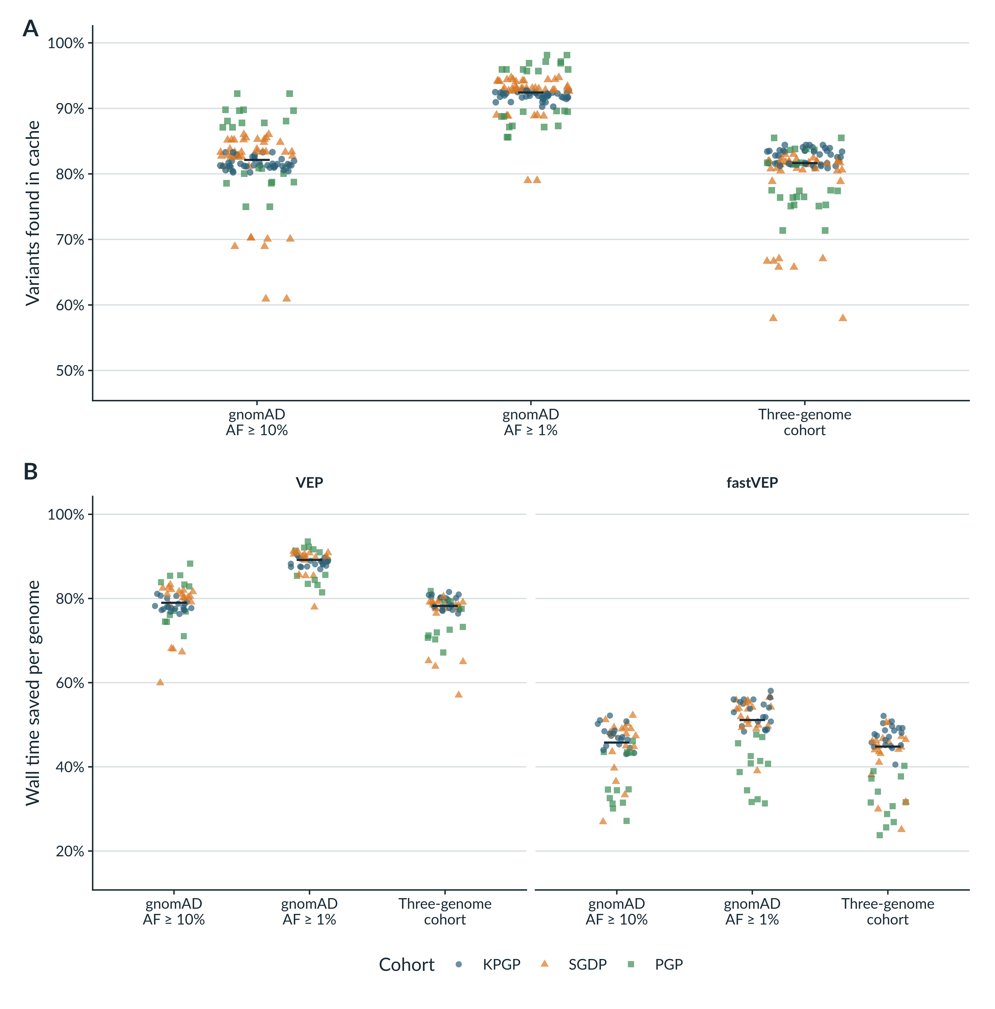
Supplementary Figure 1: Cache coverage and wall time returned across 52 independent WGS samples. Each symbol represents one evaluation genome; black horizontal marks denote medians. Colour and shape both identify the provider cohort. (A) Proportion of input variants found in each cache strategy. Cache membership is annotator-independent, so each genome is shown once. (B) Percentage of end-to-end wall time saved with VEP 115.2 and fastVEP 0.3.0. Public caches were downloaded from Zenodo. Cohort caches were constructed from three provider-specific genomes disjoint from evaluation. AF, allele frequency; KPGP, Korean Personal Genome Project; PGP, Harvard Personal Genome Project; SGDP, Simons Genome Diversity Project; VEP, Variant Effect Predictor; WGS, whole-genome sequencing.
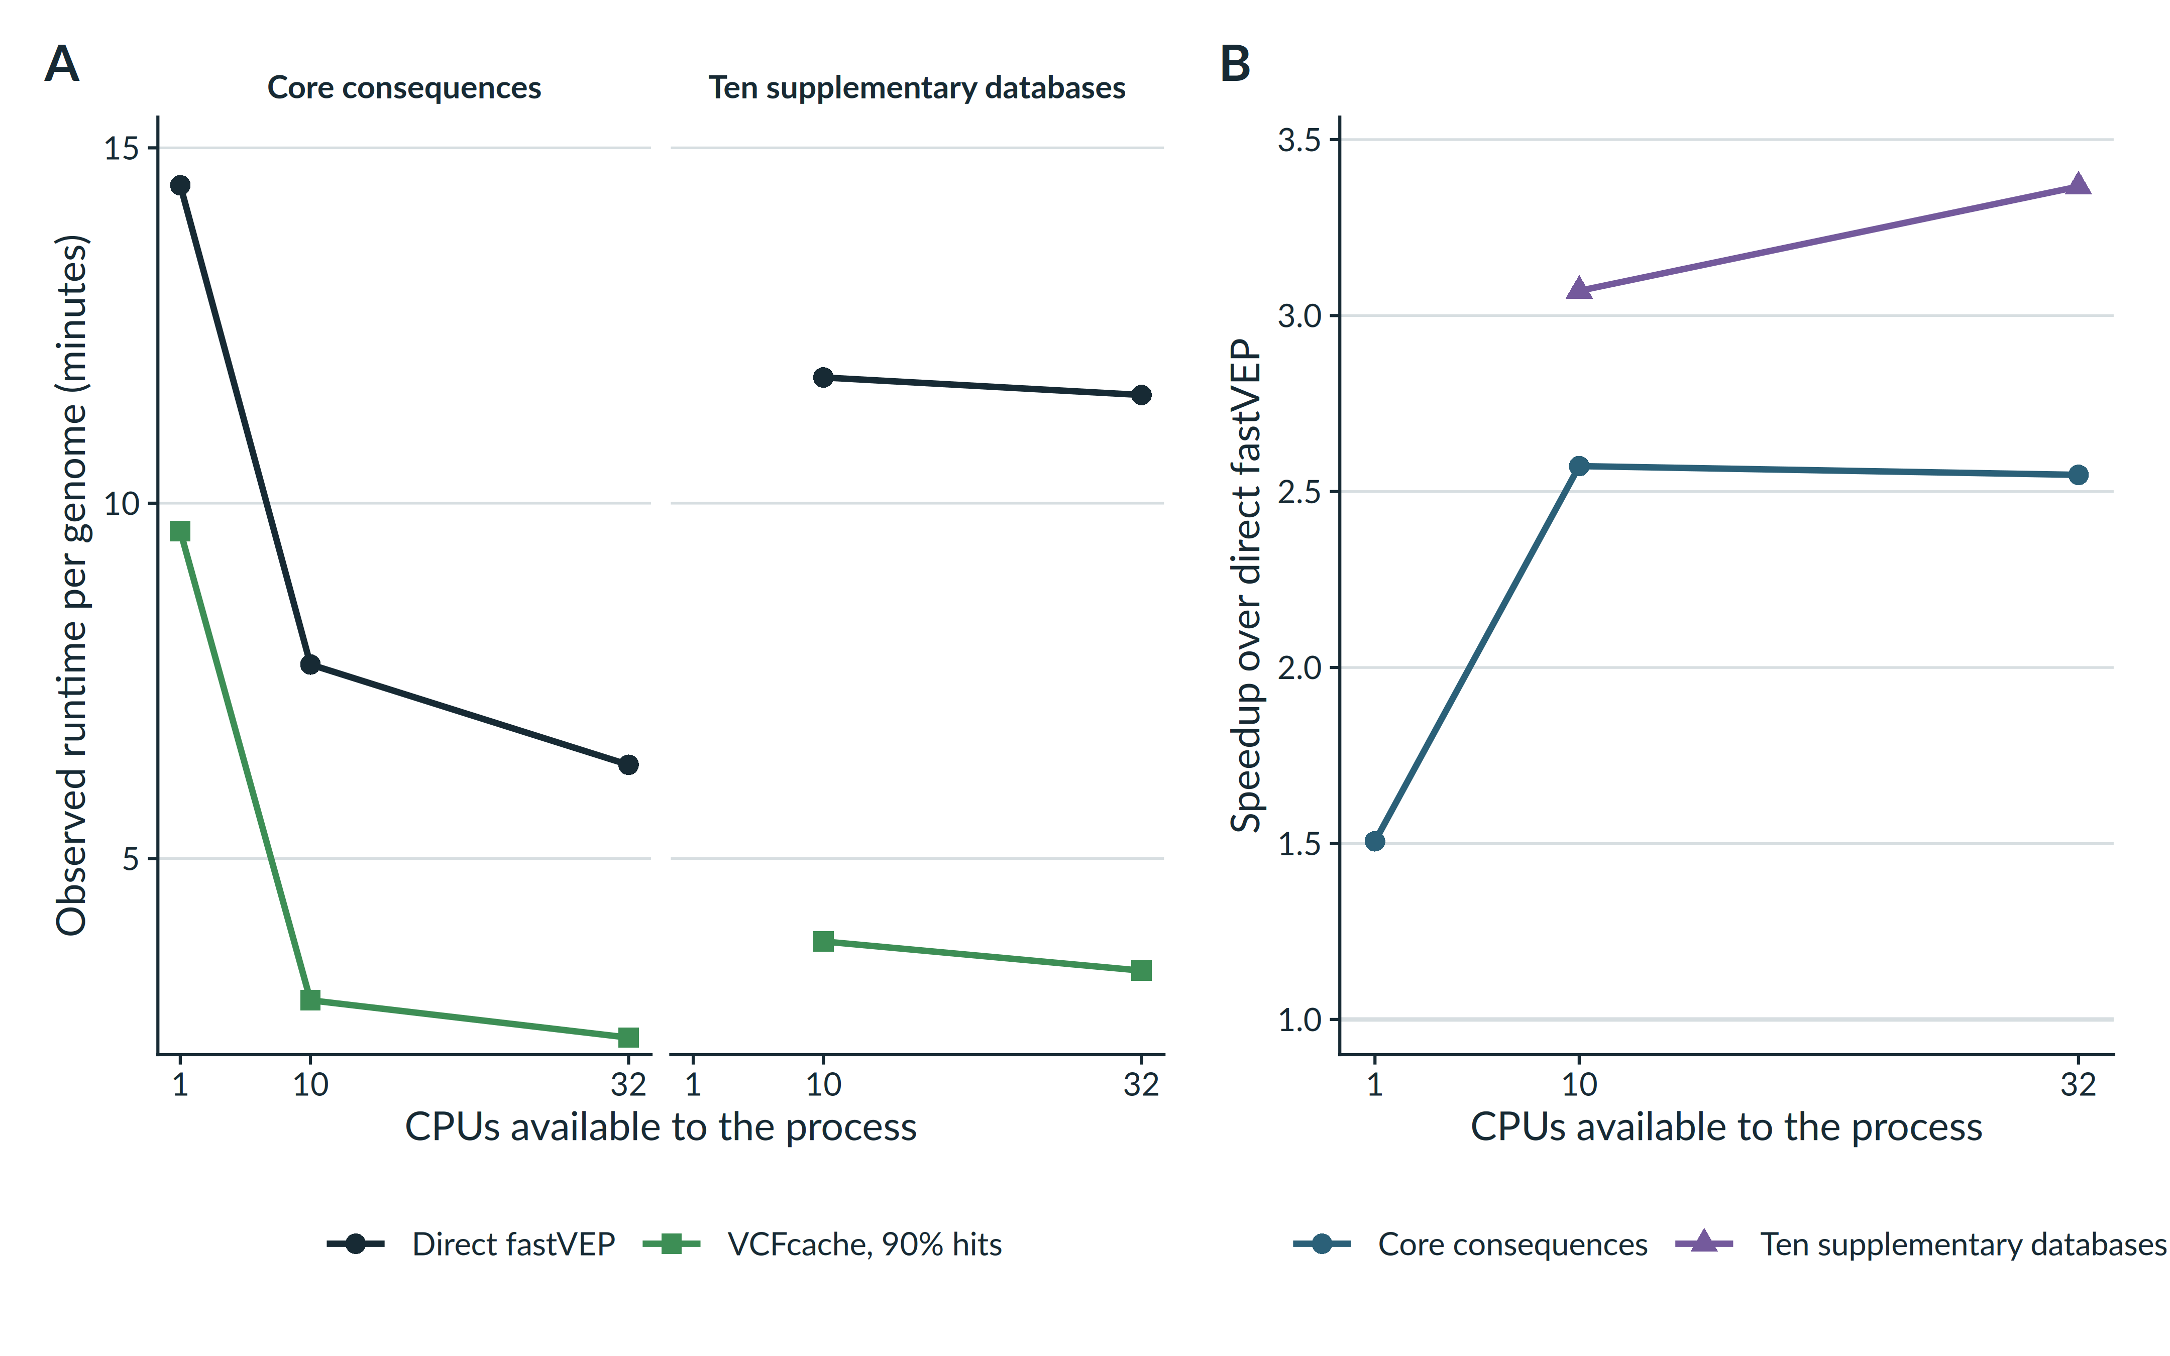
Supplementary Figure 2: CPU availability does not eliminate annotation-reuse benefit in fastVEP. The same held-out 4.80-million-variant KPGP genome was processed using the core consequence recipe and an engineering stress recipe containing ten supplementary databases. A controlled cache constructed only from the corresponding direct annotations fixed cache coverage at approximately 90%; it was used to isolate the interaction between annotation work and CPU availability, not to estimate biological cache coverage. Process-wide CPU affinity was restricted to 1, 10 or 32 CPUs for the core recipe and to 10 or 32 CPUs for the dense recipe, enabling direct comparison of dense fastVEP at 10 CPUs with core fastVEP at one CPU. (A) End-to-end runtime for direct fastVEP and VCFcache. (B) Speedup over direct fastVEP at the same CPU limit. Each retained cell was run once and each cached output passed strict complete-record comparison with its direct counterpart. KPGP, Korean Personal Genome Project; VCF, variant call format; VCFcache, cached annotation workflow; WGS, whole-genome sequencing.
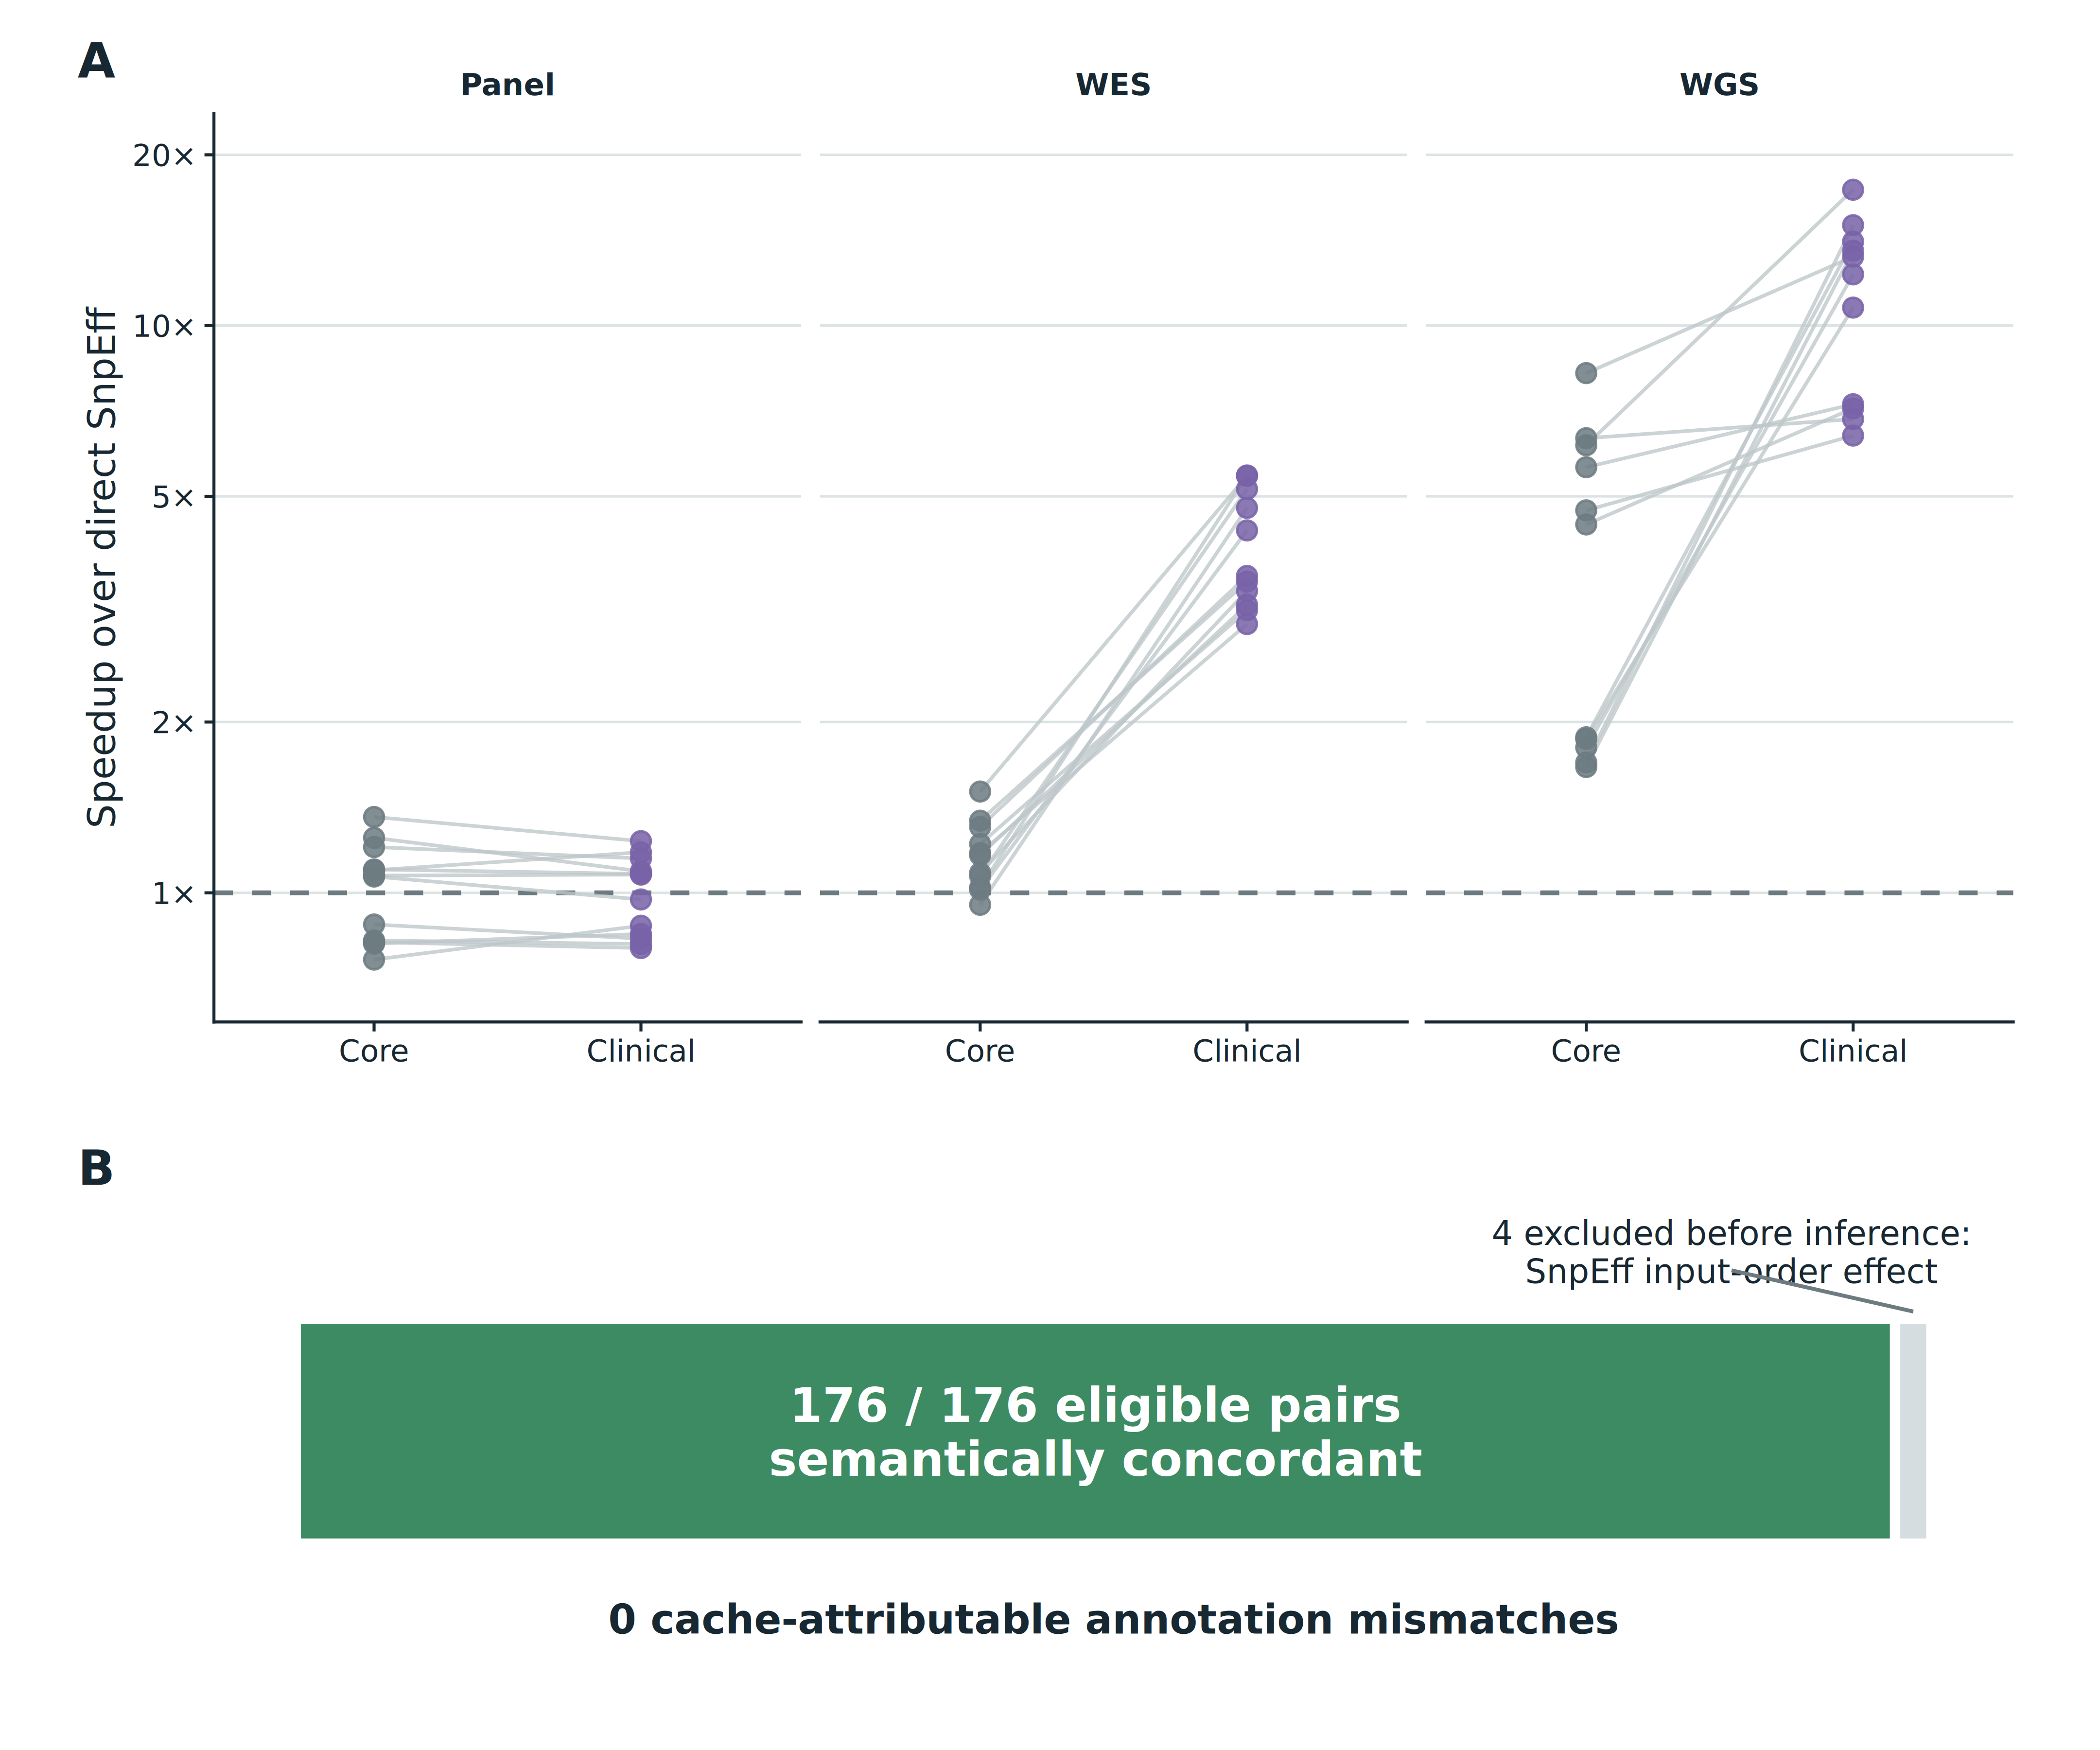
Supplementary Figure 3: Annotation load increases reuse benefit without a cache-attributable change in output. (A) Paired SnpEff speedups for core and clinical recipes on the same GRCh37 PGP samples. Lines connect identical samples; the dashed line marks equal runtime. The documented warning-only sample was excluded before inference for WES and WGS. (B) Of 180 direct/cached cells in the final clinical campaign, 176 were eligible and semantically concordant. Four SnpEff cells were excluded because direct SnpEff itself changed output with input order; these are not counted as evidence for or against VCFcache. No eligible pair contained a cache-attributable mismatch. PGP, Personal Genome Project; WES, whole-exome sequencing; WGS, whole-genome sequencing.

