Engine: OpenAI DALL-E

Prompt: Show me a picture of people in a group sitting in the park

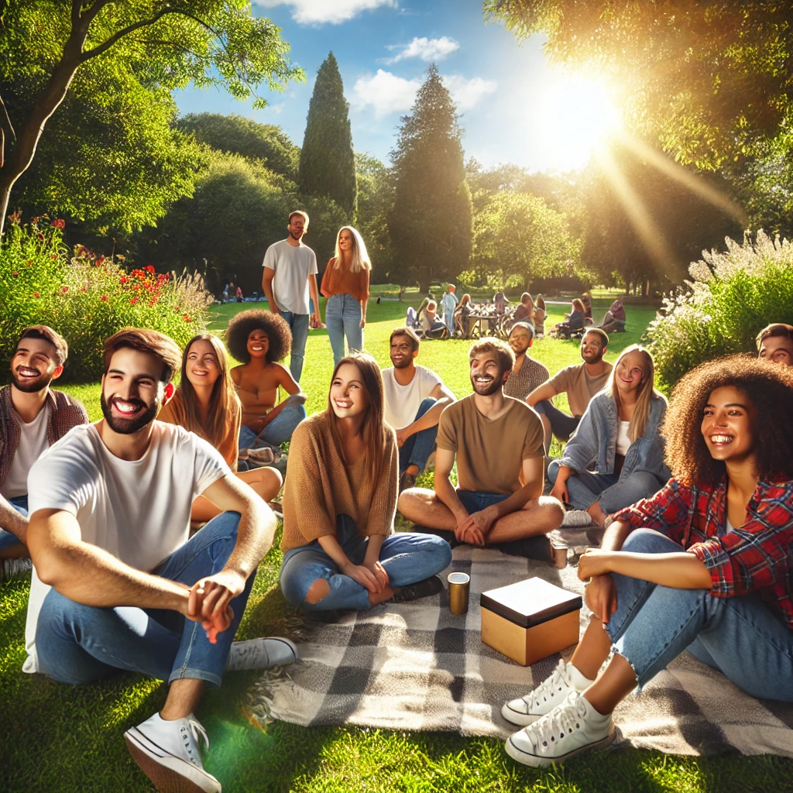
There are a lot of inconsistencies:
- Faces don’t look real (especially eyes, mouth)
- Guy in first row, right hand doesn’t look right
- Shadows don’t really look real
- Everyone has quite the same pose
- Fingers don’t look real

