Dataset, Methods, Observations
Problem Statement
To examine whether a sentiment classifier trained on generic YouTube comments can be adapted to a specific video.

Dataset
A generic YouTube comment dataset is used to train the model. The dataset contains 48,000 comments with three equally balanced, different labels – positive, negative and neutral. The dataset was split 90:10 to train and validate the model. A testing dataset of 250 comments from a single video was used.

Preprocessing
The preprocessing had a total of 5 preprocessing steps – normalizing urls and mentions, emoji handling, hashtag handling, casing, handling extra spaces and elongations. And with these 5 steps, we created 5 different variants of the dataset.
- Variant 1: Normalize URLs and mentions, retain hashtags, map emojis, preserve casing, remove extra spaces, detect elongation
- Variant 2: Normalize URLs and mentions, preserve casing, remove extra spaces
- Variant 3: Normalize URLs and mentions, retain hashtags, preserve casing, remove extra spaces, deal with elongation
- Variant 4: Normalize URLs and mentions, map emojis, preserve casing, remove extra spaces,
- Variant 5: Same as variant 1 but lowercased

Embeddings
- TF-IDF
- GloVe
- FastText
- Word2Vec
- BERT
- RoBERTa
- Sentence BERT

Models
- Naïve Bayes
- XGBoost
- Linear SVC
- MLP

Methodology
- Embedding: We applied seven different embedding techniques to the text, resulting in seven distinct versions of the dataset.
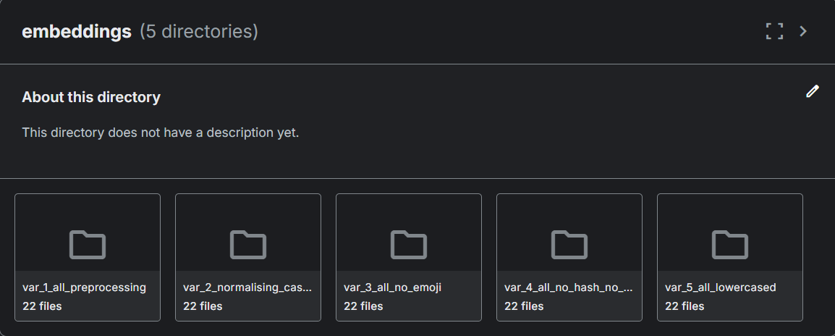

- Training: We paired each of these seven embedded datasets with four different classifiers, creating 28 unique model combinations.
- Scaling: We repeated this entire 28-pipeline process for all the five preprocessing variants of our training data.
- Testing: Finally, we processed the test dataset using the exact same steps and evaluated it against its matching trained model

Architecture Diagram
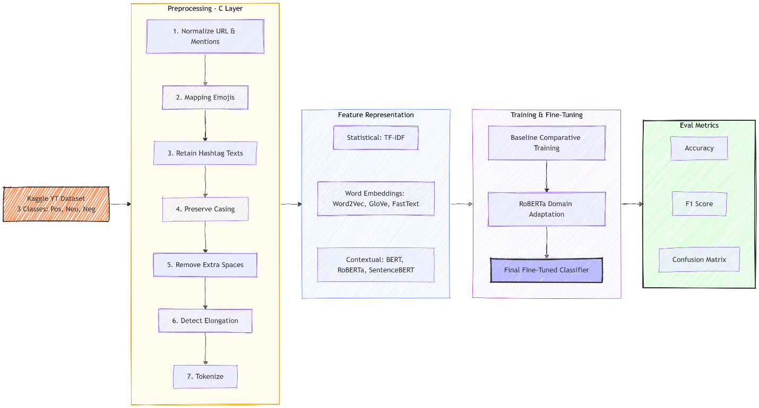

Observations
These are the observations seen from the different variants of preprocessing, embeddings and models after testing
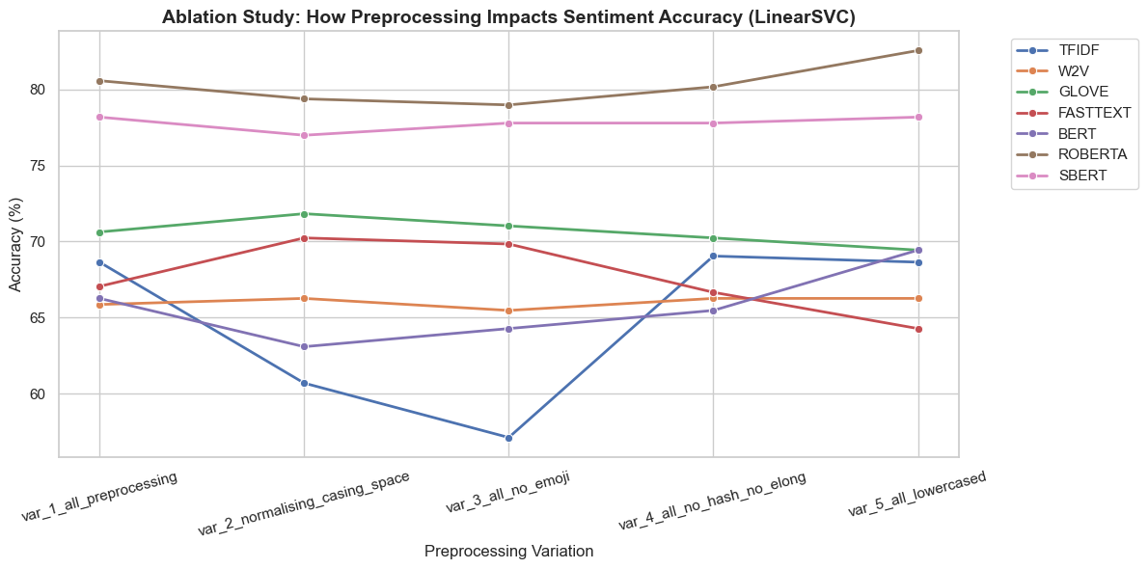
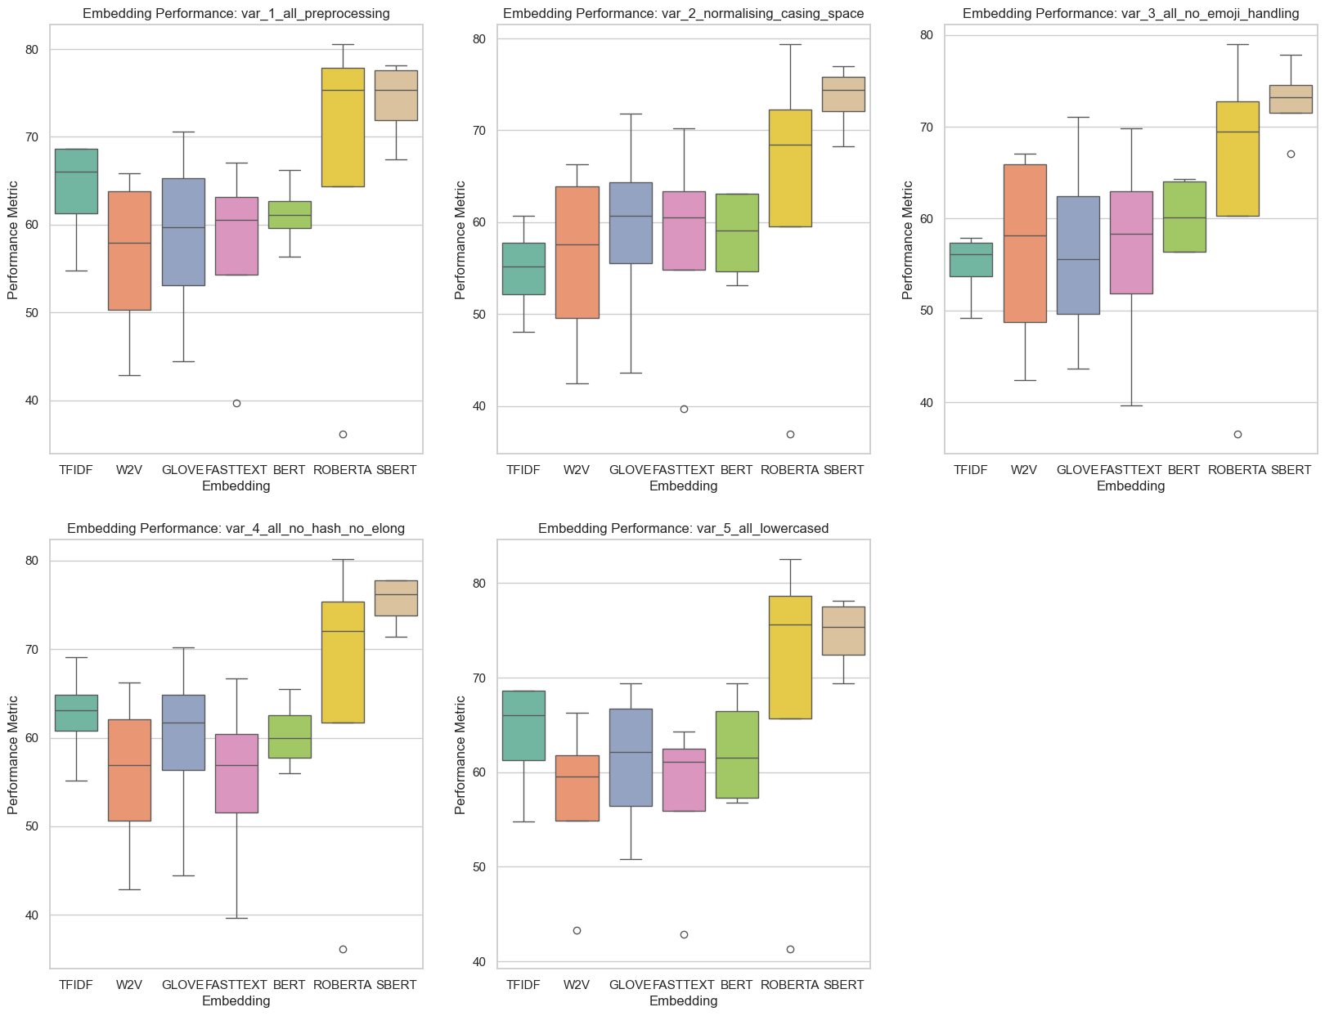
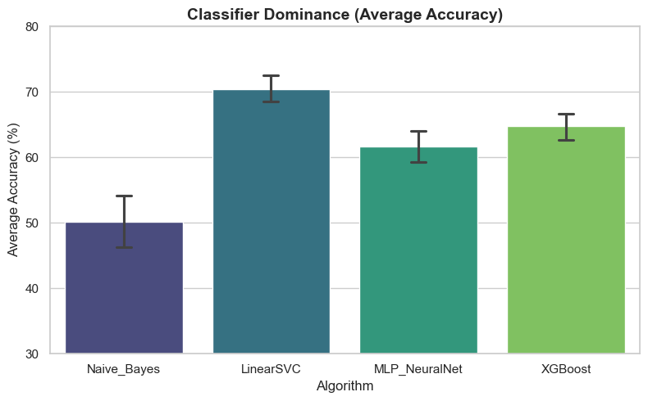

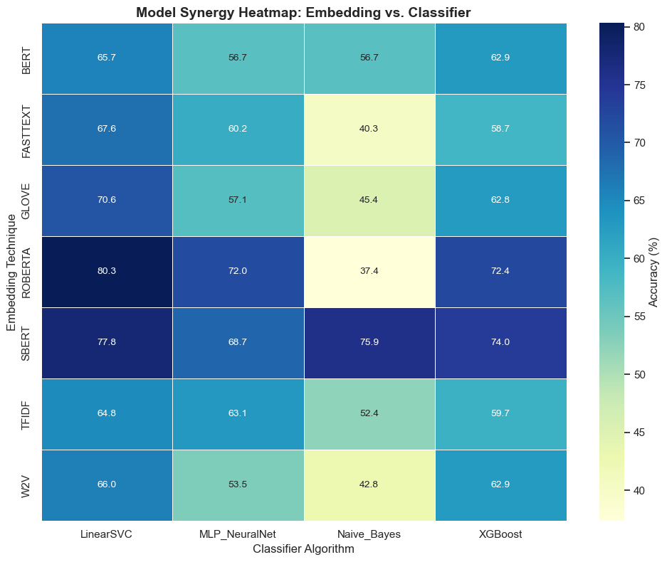

Result
RoBERTa with LinearSVC has performed the best out of all the embedding-classifier combinations with a test accuracy of 80.3%

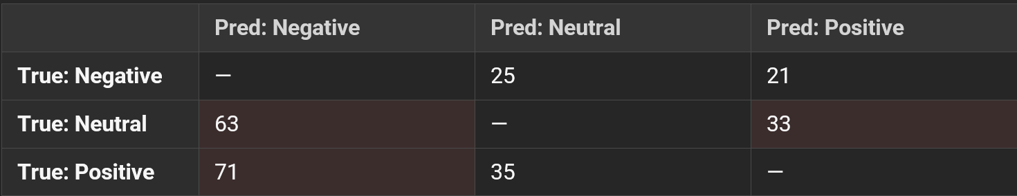
Post Processing
Even though RoBERTa had outperformed the models, there were still some misclassifications were present.
To address this, we tried ensembling the classifiers to see if there was any change in accuracy.
We used LinearSVC along with MLP and XGBoost for the ensemble classifier.
Method 1: We used a logistic regression head on top of the custom ensemble classifier to determine the weights that needed to be allocated to each of the internal classifiers during training.
Method 2: We assigned manual, fixed weights to the internal classifiers in the ratio 3:1:1 (3 – LinearSVC, 1-XGBoost and 1 – MLP) before training.
This is how the results looked.
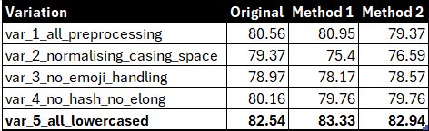
There wasn’t much difference between the original and the post processed methods. Hence, we decided to fine tune RoBERTa to improve performance.

Fine Tuning RoBERTa
To achieve domain adaptation for YouTube comment sentiment analysis, the pipeline transitioned from using a static feature extractor to fine-tuning of the pre-trained roberta-base model. The model's original Masked Language Modelling (MLM) head was discarded and replaced with a newly initialized, 3-neuron Sequence Classification head. The model was then fine-tuned across the five preprocessing variants, with each variant comprising a training dataset of 5,800 comments.
Unlike the baseline approach, full fine-tuning allows the classification error to backpropagate through the entire network. Rather than relying on static embeddings, RoBERTa actively updates the weights within its transformer layers during training. This mechanism fundamentally shifts the model's attention mapping away from formal grammar, allowing its internal representations to reshape and focus on the specific emotional intensity, slang, and structural irregularities that are seen in YouTube comments.
These were the results from fine-tuning RoBERTa
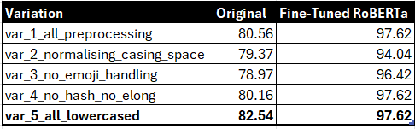

Confusion Matrix
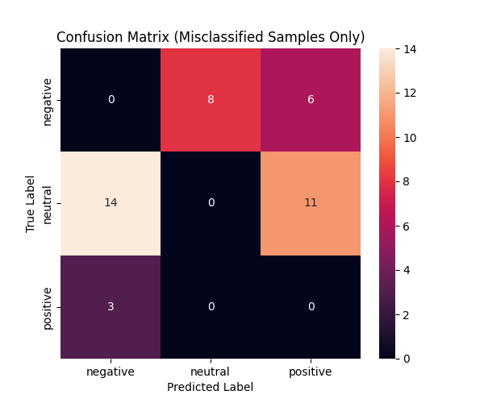

AFTER THRESHOLDING (0.85)
