# Install the Payment Module

1. Upload the content to the correct folder structure.
2. The Paydollar Payment Module for OpenCart contains ***\*** folder which has to be uploaded to the platforms root directory.
3. Originally, OpenCart has **<root-directory>/** for the front store and **<root-directory>/ /admin** for the admin site. However, if the folder name has changed, you will need to upload the content in ***\*** to the correct folder structure.

Eg: **<root-directory>/<new-folder-name>**

1. Check the payment module at the admin site. (Home -> Extensions -> Payment )
2. If you do not see **Paydollar** in the Payment List just as the below screenshot, please restart the server.

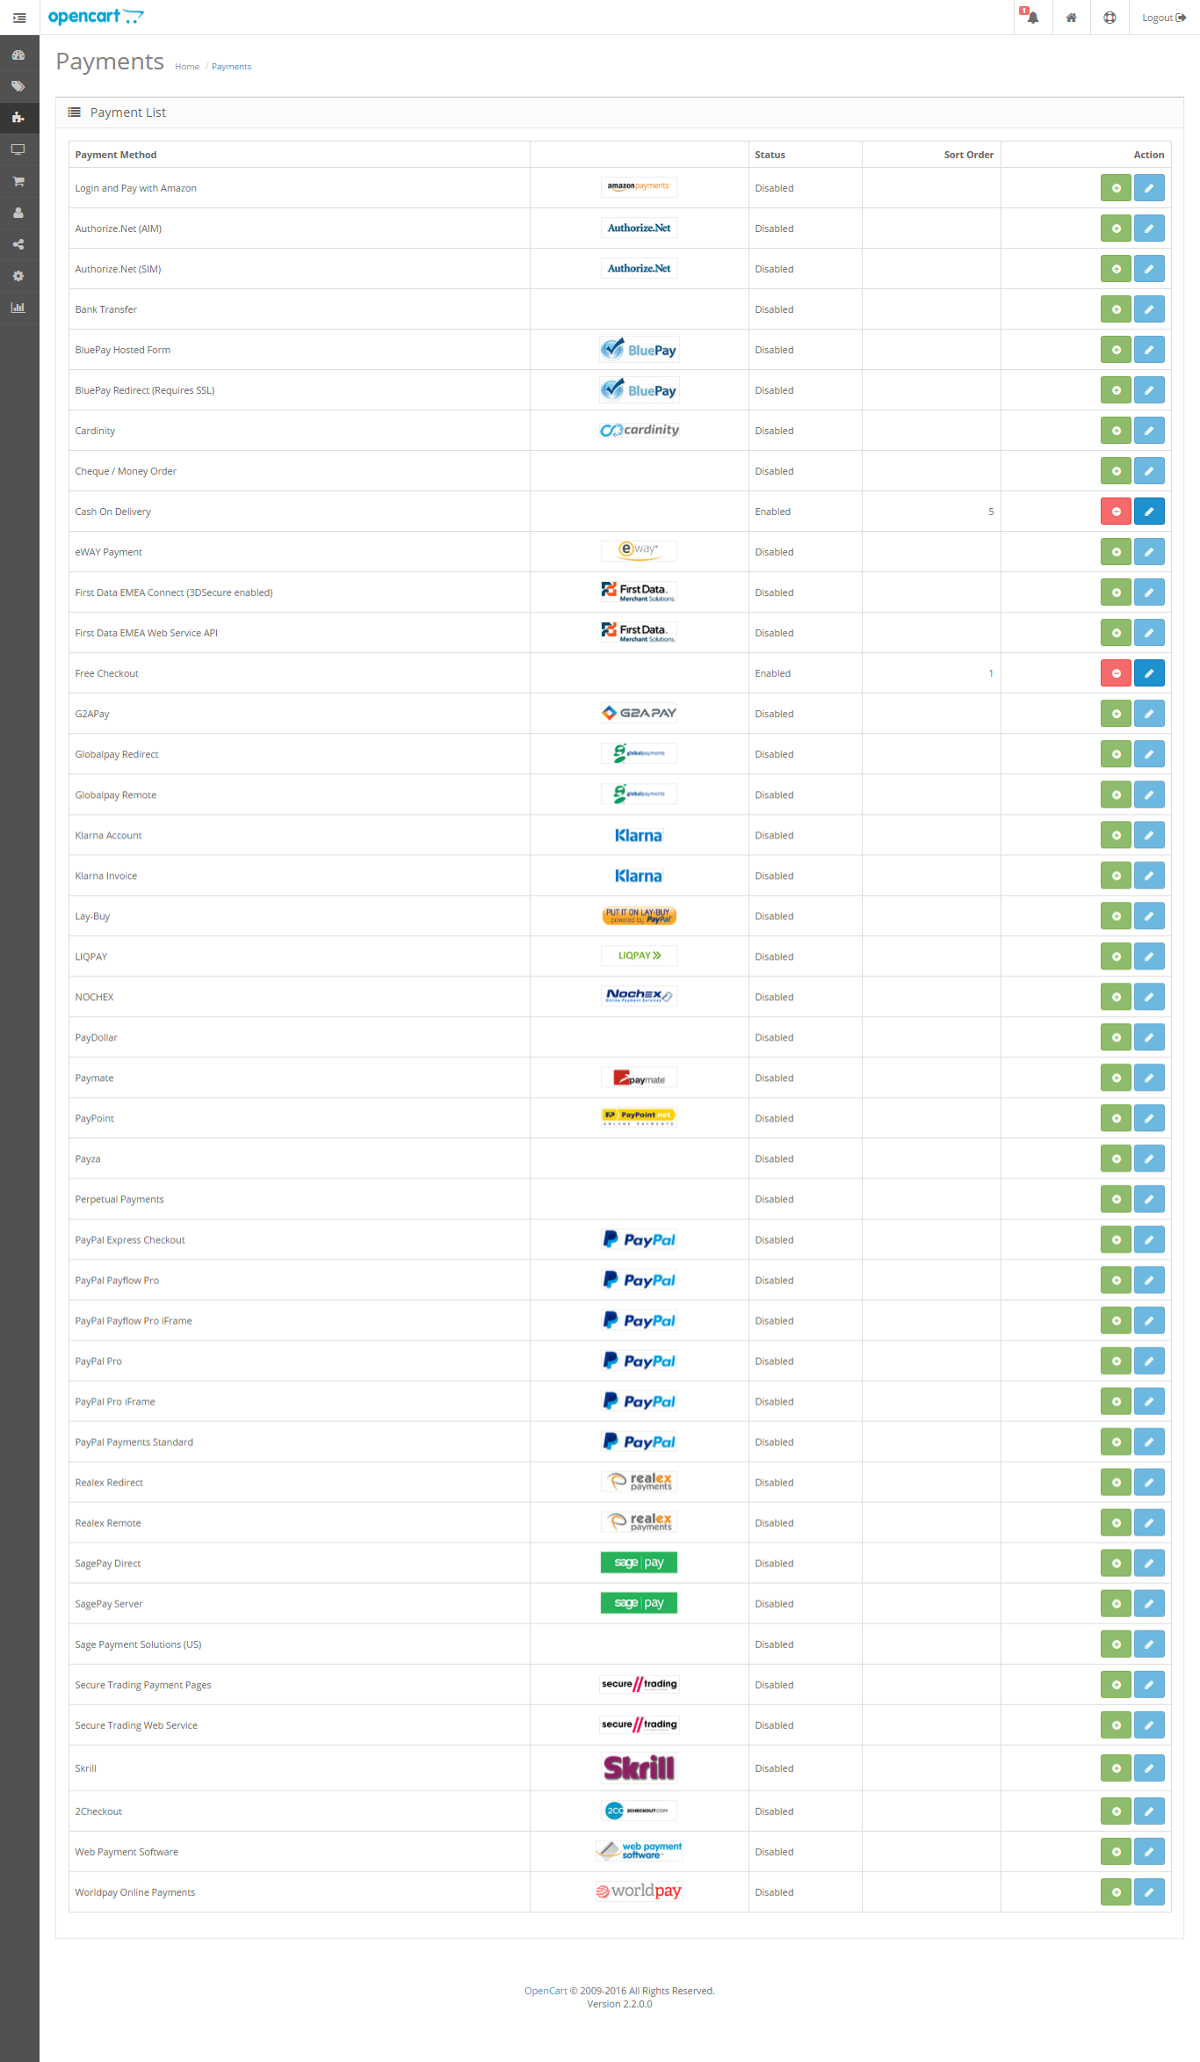

1. Install the module and configure the payment setting



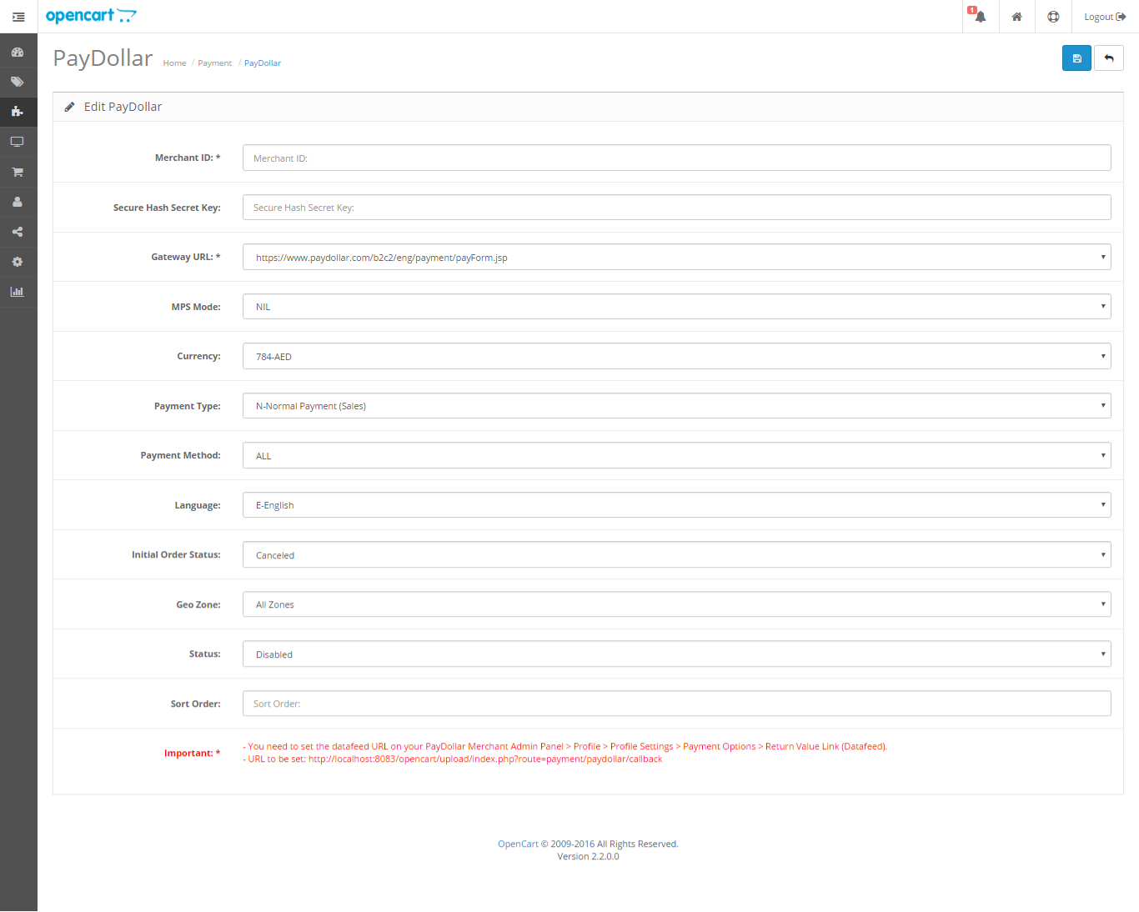

Field Description

1. **Merchant ID**: merchant ID issued to you by AsiaPay. Default: (none)
2. **Secure Hash Secret**: Optional, if secureHash function is enabled on your merchant account, set the secret word here. Default: blank
3. **Gateway URL**: URL to which the data from the merchant website is being passed to (use the test server indicated if the merchant is performing trials; use the live production server URL if the live account has been formally issued by AsiaPay)
4. MPS Mode
5. **Currency**: Select the currency
6. **Payment Type**: N for Normal/Sale, H for Hold/Authorize. Please check with PayDollar/PesoPay/SiamPay
7. **Payment Method**: Default: ALL
8. **Language**: The language that will be used by the gateway, type: C for Traditional Chinese, X for Simplified Chinese, E for English, K for Korean, J for Japanese, T for Thai, G for German, S for Spanish, F for French, R for Russian, V for Vietnamese; Default: E
9. **Initial Order Status**: refers to the status of the order upon checkout (Pending – default statuses for orders / Processing – refers to a paid approved transaction by the gateway; as much as possible, do not use this method as it may cause confusion for when the order transaction has been paid or not); Default: Pending – absolutely NOT advised to change to Processing
10. Geo Zone
11. **Status**: turns the module on or off (also affects visibility of the module on the front end)
12. **Sort Order**: Order of the module on the front end; Default: blank
13. **Transaction Type**: Suitable transaction type. Goods/ Service Purchase is the Default value if transaction type not provided.
14. **Challenge Preference**: Indicates whether a challenge is requested for the transactions in 3DS2.0. If “No challenge requested” options are selected, the chargeback liability shift to merchant.

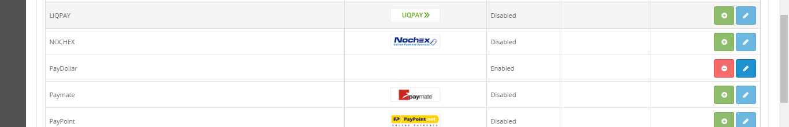

Above screenshot shows the enabled payment module. This means it will appear during customer checkout.

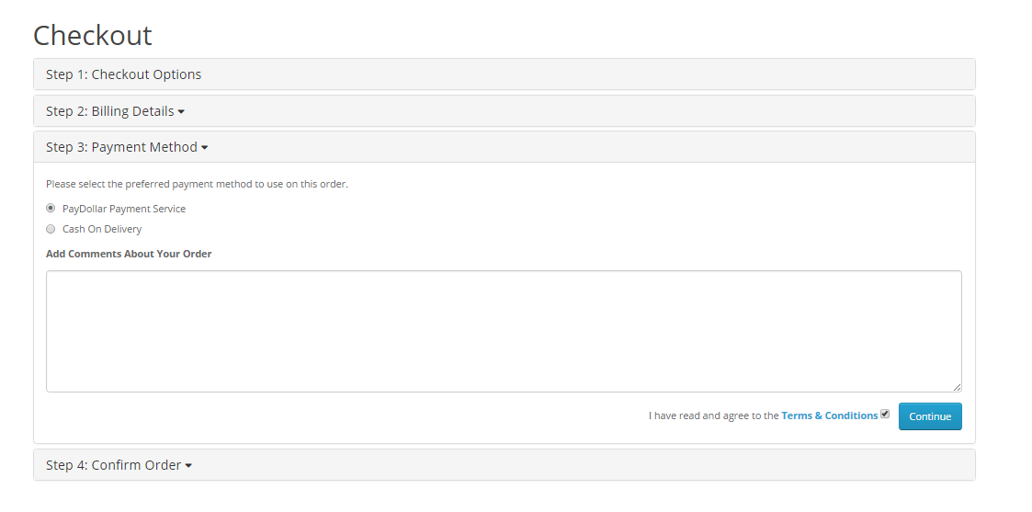

-End of Document-