Shockwave Studios

Project Codename: Waldo
Design Document

Saining Li
Quoc Huy Ta
Brandon Wong
Christopher Wong

COMP 361 - Software Engineering Project
School of Computer Science
McGill University

Fall 2011 - Winter 2012

SECTION 1. INTRODUCTION

1.1 Introduction

Our product, Project: Waldo, is a game created for the Sofware Engineering Project course offered by McGill University. The goal of this project is to provide users with a fun and challenging game experience that is available online. It is our intention to create a browser-based game that anyone can access provided they have a compatible browser and an Internet connection.

1.1.1 Purpose
This document provides a high-level description of the design for the implementation of our game. It also describes specific details of the design and structure of the software so that programmers may know how to create the system.The designs detailed in this document will be based on the requirements specified in the Software Requirements Document.

1.1.2 Audience
Its primary audience is the software engineering team that will use the designs as a guideline for the implementation the game. It is also meant for the perusal of Joseph Vybihal, our instructor, to fulfill one of the requirements for the course. Lastly, it is meant for anyone who wishes to understand the designs used in our game, for whatever purpose, good or evil.

1.1.3 References and terms definitions

1. Game Engine The brain that controls and mediates game functionalities such as rendering graphics, sounds, collision detection and AI.
2. Game Loop The updating of game information and rendering done at each frame.
3. Game Objects Objects newly converted from the database containing all data needed to specify a given game object. (referred to as gameObject)
4. Scene Objects Contains data required by the graphics engine to render a frame. The format required by THREE.js in order to render the object to the screen. (referred to as sceneObject)
5. Scene The collection of Scene Objects currently in play at any given point during the game.
6. Robot Ships controlled by the game’s AI.

1.2 Policies and Tactics

1.2.1 Goals And Guidelines
- We want this document to be clear and concise. Therefore, point form will be used for long sections.
- To facilitate references to sections and subsections, they will be numbered.
- Diagrams will be used when a textual description is insufficient or not as clear.
- This document assumes that some small portions of coding have already begun, and thus will serve to elaborate on more obscure sections.

1.2.2 Development method
Prior to the writing of this document, the different sections and contents were first discussed among team members to come to an agreement on an overall design. The sections were then assigned to different team members while allowing for consultations between team members during group meetings. As such, each member has had some input into each section.

SECTION 2. OVERALL DESIGN

2.1 Architecture Considerations

The specifications included in our requirements document influenced our choice for which technologies to employ. Since we decided on a browser-based game, Javascript was our language of choice. Also, we wanted the game to be 3D, and THREE.js was chosen to accomplish this. In a multiplayer game environment, fast client-sever communication is important, so we decided to use WebSockets. For the database, we decided to use SQL since it meets our requirements, which are minimal.

2.2 Design Considerations

The largest constraint for us is that this game is browser-based. This means that the technologies used cannot be too resource-intensive. Also, since there is a network component to our game, we have to make sure that the messages are passed reliably and quickly. This constrains the sizes of the messages.

We will assume that the user can support the technologies we use. Since we will be using WebGL, the minimum browser requirements are Mozilla Firefox 4.0, Google Chrome 9, Safari 5.1, or Opera 12. We will also assume that Javascript is supported and enabled. In addition, all users will be required to have an Internet connection to be able to play the game as having an account and logging in will be required to play both multi-player and single-player games.

2.3 High Level Design

2.3.1 System overview discussion
The overall game will be implemented in Javascript and therefore will be run entirely through the web browser on the client computer. This will include the Game and Graphics Engines which will be implemented in WebGL, and will therefore handle the game A.I. as well as model loading, manipulation and drawing. Various shaders will also be implemented to allow for certain effects and visuals for scene rendering. Thus specific desired effects would be handled by specific shaders depending on the scene and objects to be rendered.

2.3.2 Network Considerations
In terms of network considerations, the client will communicate with the server through WebSockets, where user information as well as game states will be stored onto a database server. In singleplayer mode, the client will only need to communicate with the server when loading and saving the game. In multiplayer mode, the server also handles chat messages and making sure the scenes are consistent across all clients.

2.4 Software organization

2.4.1 Client Overview
2.4.1.1 Overall System Structure Domain Model - Client

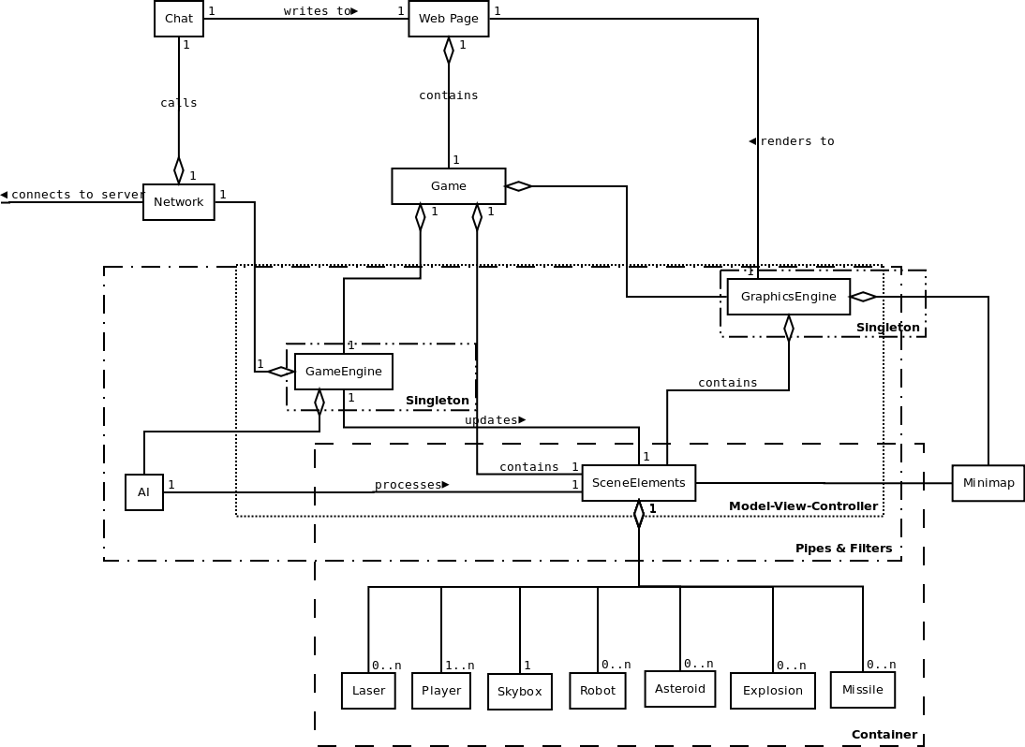

2.4.1.2 Diagram Description
- Web Page: The web page will serve as a container for the game. It consists of the game itself and a chat box.
- Chat: In multiplayer mode, text entered in the chat box will be sent to the server, which will subsequently sent to all players. Chat is disabled in singleplayer mode.
- Network: The network is responsible for relaying chat messages and game information between the clients and the server.
- Game: The Game class will serve as a central container for the client-side game classes.
- GraphicsEngine: The graphics engine class will be responsible for rendering all scene objects to the WebGL canvas (on the HTML web page) using the THREE.js graphics library. Objects to be rendered will be contained in a THREE.js Scene object, where the updating of object positions (both environmental and ships) will be handled by the Game Engine and AI. The graphics engine will also be responsible for rendering the Minimap based on the objects loaded into the scene. In addition, the graphics engine will also be responsible for handling any post-processing and shader effects.
- GameEngine: The game engine will be responsible for handling elements associated with the game state. This includes maintaining the values and attributes associated with each Solar System/Planet that is currently in play. In addition, the Game Engine communicates both with the Graphics Engine and game AI to evaluate and calculate object positions during gameplay. To do so, the scene containing the scene elements will be passed from class to class to carry out the necessary calculations. A connection to the Network will allow the GameEngine to save and load game states to the online database.
- AI: In singleplayer mode, the AI will process a scene and decide how the robot ships will act. In multiplayer mode, since there are no robot ships, AI is disabled.
- SceneElements: the SceneElements class will serve as a container for all the sceneObjects in a scene, including player and AI ships, environmental objects such as asteroids, projectiles (including lasers and missiles), explosions, as well as the skybox of the given scene.
- Minimap: The minimap shows all ships and planets in a planetary system.
- Player: The Player class represents ships that are controlled by game players and not AI.
- Skybox: The skybox represents a simple object containing the file information necessary to draw the background environment.
- Robot: The class represents an AI controlled ship that is stored within a given scene. Updating of this ship’s position and parameters will be handled by the AI class, and then be rendered by the Graphics Engine.
- Asteroid: The scenes in the game will usually contain many asteroids. They are mostly filler to make the landscape more interesting, though some might contain resources.
2.4.2 Server Overview
2.4.2.1 Overall System Structure Domain Model - Server
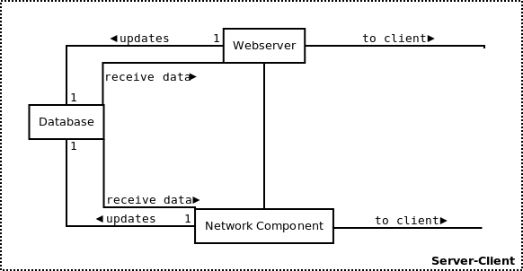

2.4.2.2 Diagram Description
- Webserver: The webserver, which will use Tornado (written in Python), will be responsible for serving up all game components. In multiplayer mode, it receives messages from clients and responds based on the request. The requests will be formatted in json, which can be parsed by the simplejson library in Python.
- Database: The database will be used to store all game states when a player decides to save their current game state.
- Network Component: The network component will use WebSockets to relay messages between clients and the webserver.

2.5 Design Patterns

The development and programming of a game involves several design patterns. Some of the more prominent and important ones within our game include:
2.5.1 Pipes & Filters (see Diagram 2.4.1.1)
The game elements demonstrating the Pipes & Filter design pattern include the object containing the THREE.js scene objects (data), the Game Engine (filter) and game AI (filter). Depending on the type of THREE.js scene object (whether it be a ship, projectile or environmental object), different objects will contain a set of different flags depending on its current state.
During the pipeline, these objects are first passed to the Game Engine which handles object collision detection and position updating of non-ship objects (eg. asteroids and other environmental objects). Depending on the results of the collision detection computations, different flags will be set to different values in accordance with the desired response.
The scene objects are then subsequently passed to the game AI which then computes and updates the positions of ship objects depending on the AI goals (eg. an enemy ship chasing and firing at the main player). Once updated, the scene objects are rendered by the graphics engine and drawn to the screen.
2.5.2 Server-Client (see Diagram 2.4.2.1)
The game demonstrates the network-client design pattern with respect to online multiplayer gameplay. Rather than being AI controlled (as in the case of single player) enemy ships are user controlled and thus ship positions must be obtained via a network. This is represented in the form of multiple clients (human players) connecting to a central server which both sends and receives data to all clients, containing information such as ship positions and related parameters, chat messages, as well as non-ship related scene information.
2.5.3 Model-View-Controller (see Diagram 2.4.1.1)
This design pattern is demonstrated through the interaction between the database data, graphics engine and game engine.
Representing the model in the design pattern is the database and its contained data. Once data is retrieved and the game object pipeline is running (see Pipes & Filters), the Game Engine serves as the controller, modifying the data as necessary according to the progression of the game and any user interaction/input. The role of the viewer is fulfilled by the Graphics Engine, which takes into account the changes made by the Game Engine and renders the newly modified objects to the screen.
2.5.4 Singleton (see Diagram 2.4.1.1)
The Graphics Engine and Game Engine within our application demonstrate the Singleton design pattern. Thus while the game is running there will be only one instance of each given class.
2.5.5 Container (see Diagram 2.4.1.1)
The Scene Elements object will be used to contain all scene objects to be rendered during each frame. In addition, this container will serve as a means of sharing data between the Graphics Engine, Game Engine and game AI.
2.6 Deployment

2.6.1 Deployment Diagram

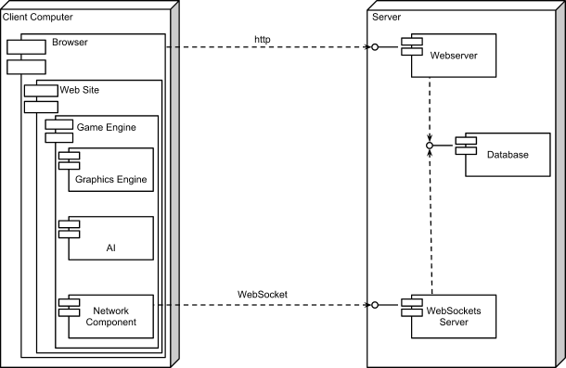

2.6.2.1 Deployment Analysis - Server
- Webserver
A program that serves web pages over the internet. Any such server that also provides cgi (for PHP and python) will suffice.
- Database
An SQL database. See Section 3.4.
- WebSockets Server
A server for continuous two-way communication between client and server. Written in Python and using the Tornado web server library.
2.6.2.2 Deployment Analysis - Client
- Browser
Typical modern web browser. See Section 4.6.2.
- Web Site
Front host page. Written in HTML. Login portions are implemented in PHP.
- Game Engine
Logic half of the core of the game. See Sections 3.2 and 3.2.2.1.
- Graphics Engine
Visuals half of the core of the game.
- AI
Integral component of the game engine. See Sections 3.2 and 3.2.2.2.
- Network Component
Client component that connects to the WebSockets Server. Written in javascript.

SECTION 3. SPECIFICATIONS

3.1 Subsystem Overview

3.1.1 Client-Side Subsystem Overview
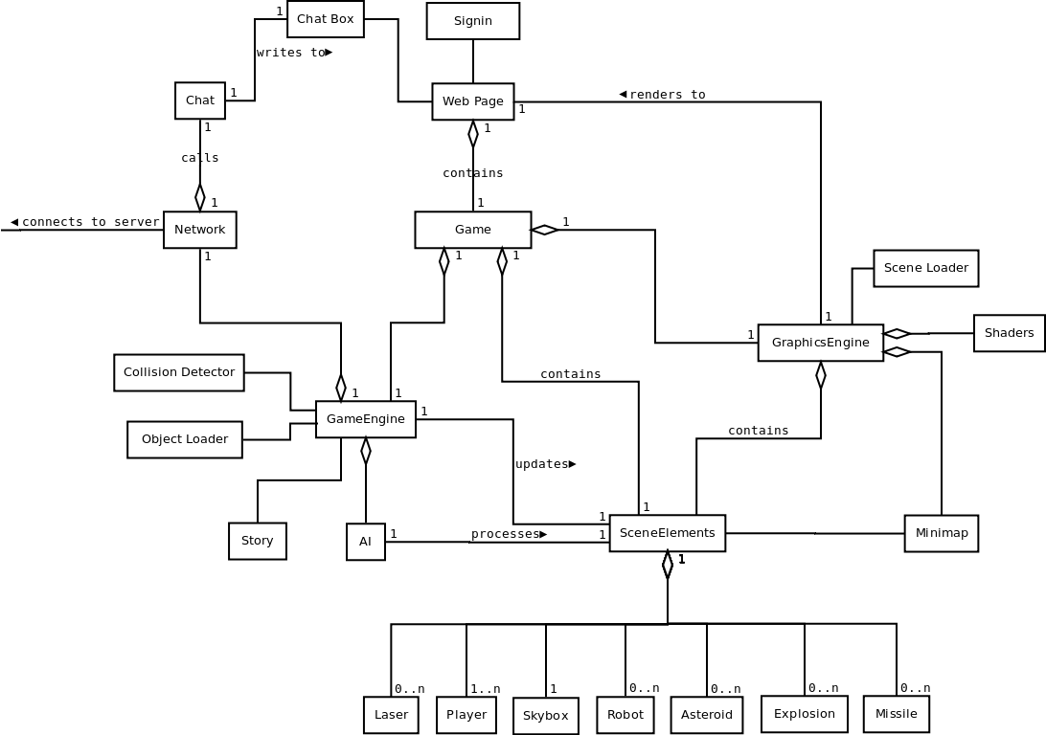

The main systems within the program include the graphics engine, game engine, web page components, scene elements, and network components. Various subcomponents are shown within the above diagram.
- Graphics Engine: The scene loader system within the graphics engine is responsible for taking the original game objects loaded from the database, and converting them into scene objects that THREE.js can recognize and render. Following this, sceneObjects are loaded into the SceneElements container to be passed to the game engine and AI.
Graphics shaders are used for various post-processing effects and rendering game components such as explosions.
- Game Engine: The game engine serves as a central communication point for processing data as well as loading data from the database and maintaining all game logic related tasks (such as the game storyline). In addition, the game engine contains the collision detection subsystem used by the game to compute all collisions that occur during the game. As such, the game engine also handles all collision resolution wherein the resulting consequence of a given collision is decided.
- Web Page Components: The main web page will contain a chat box element, as well as a sign-in/registration system where players can create new accounts or sign in to existing accounts in order to gain access to the game. Further, the web page will hold the WebGL canvas on which the game will be drawn and rendered.
- Scene Elements: Object containing all sceneObjects. This system serves as the central container for sharing scene data between the graphics engine, game engine and AI systems of the game. Furthermore, the minimap will also access this object in order to determine what elements need to be drawn to it during any given scene. This object itself will contain all types of scene objects including ships, environment objects, explosions, projectiles and the skybox for the given scene.
- Network Component: The networking component will allow communication with the servers for loading and saving game information, as well as allowing message passing for both the chat function and during multiplayer gameplay.

3.1.2 Server-Side Subsystem Overview
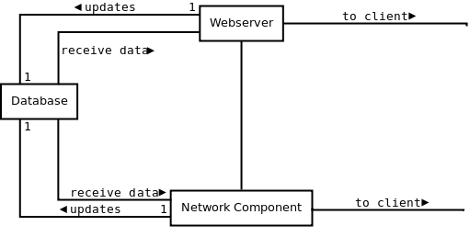
Refer to section 2.4.2.2 for diagram description
3.2 Module decomposition

3.2.1 Game Engine Class Diagram
NOTE: only methods directly relating to the GameEngine are mentionned in GraphicsEngine, UI, and Network

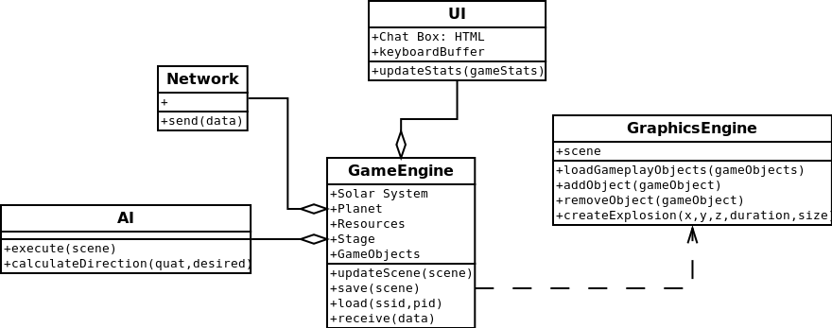

3.2.2 Game Engine Module (including AI) - Textual Description
3.2.2.1 GameEngine
variables:
- solarSystem - the solar system where the ship is currently located
- planet - the planet where the ship is near
- stage - a number indicating the progression of the player in the overall storyline
- resources - an array of the types of resources available on the planet for mining
- gameObjects - an array of game objects formatted to the graphics engine specifications
methods:
- save()
  - arguments: - none
  - description:
Called when a jump is initiated. Prior to loading a new planetary system, the game engine saves the state of the current environment (or rather, any changes to it) to the database. It pulls the game objects from the scene object, and passes them to the Network component.
  - return values: - none
- load(ssid, pid)
  - arguments:
    - ssid - ID of the destination solar system
    - pid - ID of the destination planet within the specified solar system
  - description:
Called when the player jumps into a new planetary system. Retrieves (via the Network component) data concerning the target location, loads it into the game environment, and calls the Graphics Engine to render everything and begin the primary loop
  - return values: - none
- update(scene)
  - arguments:
    - scene - array of objects within the planetary system
  - description:
Called by the Graphics Engine. At each iteration of the primary loop, this function is called. It parses through each object in the scene, updating values as needed. These values include resources
  - return values: - none
- receive(data)
  - arguments:
    - data: JSON object or string
  - description:
Called by Network component upon receipt of message from the server. Receives data from Network component and updates the scene data and environment accordingly.
  - return values: - none
3.2.2.2 AI
variables:
- scene - the scene object that contains all information about planets, ships, laser beam
methods:
- execute(scene)
  - arguments:
    - scene
  - description:
Decides the course of action for computer-controlled ships. If the player’s ship is in their range, they pursue it and shoot while avoiding collisions with asteroids. Otherwise, they just fly around in a predefined region.
  - return values: - none
- calculateDirection(ship1, ship2)
  - arguments:
    - computer’s ship and player’s ship
  - description:
compute the new direction vector of computer’s ship when it chases player’s ship.
  - return values: - none

NOTE: the following are only provided to inform of how GameEngine and AI connect to the rest of the program
3.2.2.3 GraphicsEngine
NOTE: only members directly pertaining to GameEngine or AI are mentionned here
variables:
- scene - THREE.js object containing the objects to be rendered to game screen
methods:
- loadGameplayObjects(gameObjects)
  - arguments:
    - gameObjects: array of initial gameObjects
  - description:
Called when an initial scene is to be loaded into the GraphicsEngine after having been properly formatted by the GameEngine. This method is only called during the initial scene creation using the data received from the database.
  - return values: - none
- addObject(gameObject)
  - arguments:
    - gameObject - single gameObject
  - description:
Called when a new object must be added to the scene to be rendered after the initial scene has been created.
  - return values: - none
- removeObject(gameObject)
  - arguments:
    - gameObject: single gameObject
  - description:
Called when a sceneObject must be removed from the scene.
  - return values: - none
- createExplosion(x, y, z, duration, size)
  - arguments:
    - x - a numeric value representing the x-coordinate in 3D space
    - y - a numeric value representing the y-coordinate in 3D space
    - z - a numeric value representing the z-coordinate in 3D space
    - duration - the amount of time in seconds that the explosion stays in play (ie is being rendered)
    - size - the radius of the explosion
  - description:
Creates and adds an explosion object to the scene to be rendered.
  - return value: - none
3.2.2.4 UI
NOTE: only members directly pertaining to GameEngine or AI are mentionned here
Variables:
- Chat Box - connection to formatted HTML divs where the chat feature is implemented
- keyboardBuffer - array of commands to be handled by GameEngine
methods:
- updateStats(gameStates)
  - arguments:
    - gameStats: object containing the values to update the current game stats such as health, armor, etc...
  - description:
Updates values in the HTML game interface informing the user of current available resources or statistics.
  - return values: - none

3.2.2.5 Network
NOTE: only members directly pertaining to GameEngine or AI are mentionned here
variables:
methods
- send(data)
  - arguments:
    - data - information to send to the server
  - description:
Network maintains a continuous connection to the server via WebSockets. This function allows components to send data to the server.
  - return values: - none
3.2.3 Sequence Diagram Relating to the Game Engine and AI
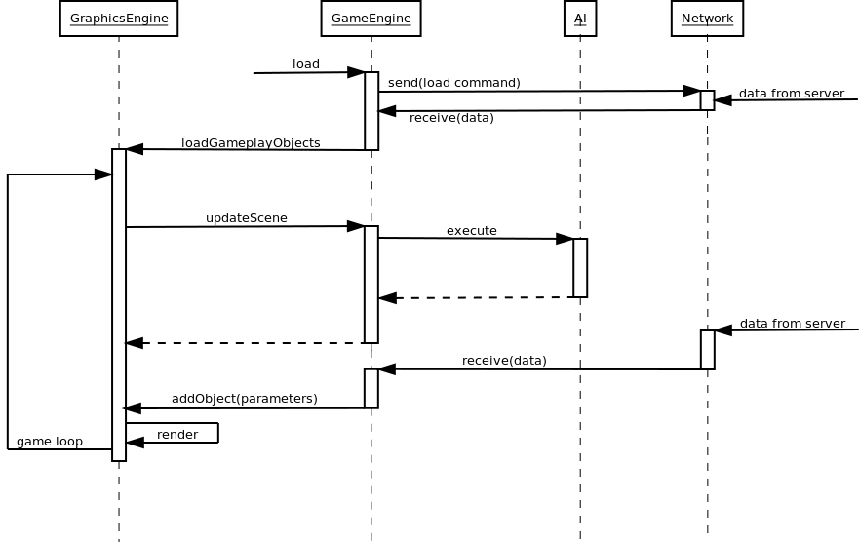

3.3 Critical Section

3.3.1 One critical section of the GameEngine module will be the collision detection sub-module. The functions provided by the THREE.js libraries are too taxing on the client computer, and so this must be written by the programming team. This consists of several functions that perform mathematical calculations, and will be custom-written for simplicity. It is very important to properly detect collisions, so that ships don’t fly through each other, solid objects don’t intersect, and that weapons (such as missiles or laser bolts) actually effect the intended damage.
3.3.1.1 A key algorithm within the sub-module is the implementation of the straight-line formula on two points in 3D space, given in non-consistent relative coordinates.
This is given by
d² = (x₂ - x₁)² + (y₂ - y₁)² + (z₂ - z₁)²
where d is the distance.
(x₁, y₁, z₁) and (x₂, y₂, z₂) must be converted to a common reference, preferably the absolute.
3.3.1.2 For a more detailed description of the algorithms involved, refer to Sections 5.2.1 and 5.2.2.
3.4 Database

3.4.1 Entity-Relationship Diagram

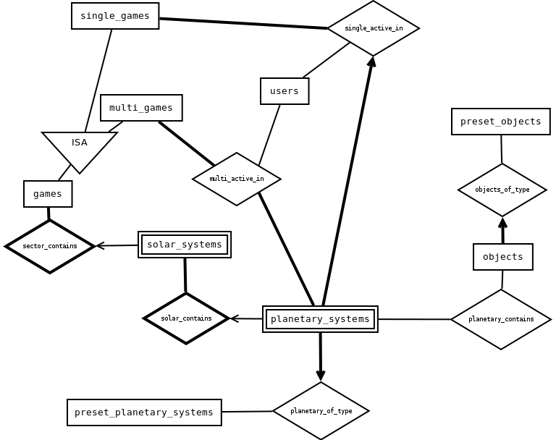

3.4.2 Data Dictionary
The following is a list of tables in the database, along with their columns. Primary keys are underlined.
- users
  - uid (int) - ID number
  - type (int) - account type
  - name (string) - user name
  - email (string) - email address
  - password (string) - user password
  - status (int) - current user status
- games
  - gid (int) - ID number
  - status (int) - current status of the game
  - owner (int) - ID number of the user who started the game
- single_games
  - gid (int) - game ID
  - uid (int) - participating user
  - ssid (int) - ID of solar system where the player is located
  - pid (int) - ID of planet where the player is located
- multi_games
  - gid (int) - game ID
  - uid (int) - participating user
  - ssid (int) - ID of solar system where the player is located
  - pid (int) - ID of planet where the player is located
- solar_systems
  - gid (int) - game ID
  - ssid (int) - ID number
  - x (int) - x-coordinate within sector
  - y (int) - y-coordinate within sector
  - name (string) - name of solar system
- planetary_systems
  - gid (int) - game ID
  - ssid (int) - solar system ID
  - pid (int) - ID number
  - type (int) - type of planet
  - name (string) - name of planet
- preset_planetary_systems
  - type (int) - ID number
  - top (string) - filename of image (for skybox)
  - bottom (string) - filename of image
  - front (string) - filename of image
  - back (string) - filename of image
  - left (string) - filename of image
  - right (string) - filename of image
- objects
  - oid (int) - ID number
  - type (int) - type of object
  - current_stats (JSON) - properties of object as of the last save
- preset_objects
  - type (int) - ID number
  - model (string) - filename of 3D model
  - texture (string) - filename of texture
  - initial_stats (JSON) - properties of object prior to the commencement of the game
- active_objects
  - gid (int) - game ID
  - ssid (int) - solar system ID
  - pid (int) - planetary system ID
  - oid (int) - ID of active object
  - x (int) - x-coordinate within planetary system
  - y (int) - y-coordinate within planetary system

SECTION 4: PROGRAMMING MANAGEMENT

4.1 Coding agreement

4.1.1 Code Styling and Syntax
With respect to code styling and syntax, the team will meet during the beginning stages of the programming phases to decide an agreed upon styling method (See Coding Convention for example style). Throughout the coding process, meetings will also be held to discuss the code content and to assign tasks and responsibilities with respect to each section.
4.1.2 Commenting
Code commenting will also be an important part of code styling when considering a team programming environment. Since collaboration is a part of our programming process, it is crucial that all members understand what existing code does. Thus, in the case of ambiguous sections of code, the author for that section will be responsible for adding in the necessary comments.
4.1.3 Error Correction Policy
In the event that an error is found by a given member, the severity of the error must first be evaluated. In the case of simple errors, such as semantic errors, the team member can attempt to correct it themselves, but must also inform the original author of the code of the change. For more serious errors that affect the functionality of the program, it is the responsibility of that member to inform the author and rest of the team of this error and not attempt to fix it themselves. It is then the responsibility of the author to try to resolve the issue and inform the rest of the team of any major changes that were necessary.
4.1.4 Code Merging
Conflicting segments of code or unintended side affects from code merging is also a possible concern. In such events, it is the responsibility of both authors to first identity the source of conflict, discuss the issue with the remaining team members and then come to an agreed upon solution. As with error handling, the team should then be informed of all the necessary changes that were made.

4.2 Code Styling

4.2.1 Policy
- Spaces are used instead of tabulators for indentation.
- Indentation width is four characters.
- Operators are padded with a space on each side.
- Statements end in semicolons.
- Names of variables and functions should be descriptive.
- Names of variables and functions are in camel case.
- Names of “class” objects are in camel case, with the first letter capitalized.
- Ambiguous code will be commented.
- Comments will explain the purpose of functions.
- Objects with multiple properties will be written on multiples lines.
4.2.2 Example
// fooBar - takes two arguments and adds values to them
// author: Brandon
function fooBar(arg1, arg2) {
var name1 = value1;
var name2 = value2;
var uselessObj = {
prop1: 1,
prop2: {
sub_prop1: 10,
sub_prop2: 2,
},
};
return [name1 + arg1, name2 + arg2];
}

4.3 Directory Structure

The following is a general outline of the directory of the files during the development as well as in operation.

4.3.1 In Development
Main Game folder
- .git/ - revision control folder
- dev/ - primary development fold
  - game/ - game client program, libraries, and media files
    - build/ - THREE.js sub-library files
    - js/ - THREE.js helper scripts
    - models/
    - textures/
    - sounds/
    - examples/ - sample programs for comparison/ideas
- pocs/ - Proofs of Concepts folder - sandbox testing and demonstration
4.3.2 In Operation
Main Game Folder
- game/ - game client program, libraries, and media files
  - build/ - THREE.js sub-library files
  - js/ - THREE.js helper scripts
  - models/
  - textures/
  - sounds/

4.4 Programming Tools, Libraries, and Coding Environment

The application will incorporate the usage of various tools and libraries for the different components of the program.
4.4.1 Sound
Collections/libraries of both sounds and music will be used and incorporated into the game. Such sources include freesound.org for game sounds and jamendo.com for music.
4.4.2 Code Sharing and Version Control
To maintain a working folder of latest versions, test cases, prototypes and proofs of concepts, a central Git repository will be used to store all team related files.
4.4.3 Text Editors
Such editors include Notepad++, Vim, Kate and gedit among others. As such, different team members will have different preferences with respect to text editors which is not a concern so long as the agreed upon coding conventions and styling are followed.
4.4.4 Web Browsers
Any of the web browsers mentioned in the installation procedure below will be sufficient for testing and developing. However, Google Chrome and Firefox have a javascript console that is useful for debugging and experimenting.
4.4.5 Graphics
The game will use the THREE.js rendering library to handle all game visuals and effects.
4.4.6 Webserver
We will be using the McGill University web host for demonstration.
We will be using Tornado, written in Python, as our WebSockets server and application framework.
The project environment will consist of the team members (serving as the designers and programmers), where actual programming will take place in a variety of workplaces. These include computer labs as well as home environments. Remote communication methods will also be used among team members

4.5 Software Building Method

- Given the overall design of the application, different modules will be assigned and coded by different team members.
- A central repository will be used to maintain the code of all team members, including a central folder to hold the latest version of the application.
- While coding each individual section, team members may wish to maintain their own separate folders for testing or prototyping purposes. However, before merging the latest/final versions of code, we will require that the programmer first test her own code to prevent potential errors that might emerge.
- After merging, all member will participate in intense final testing phase.
- If the program does not meet the requirements during this phase, two members will be assigned to fix the problems and the other two will keep testing. However, if the problems are major, all member will discuss and find a solution together.
- Meetings will be held regularly (weekly) to collaborate on new ideas, evaluate progress, discuss issues of concern, as well as any changes that would have to be made to the overall pre-established program design. A member can call extra meetings should they feel the need.

4.5.1 Flow chart view of software building method
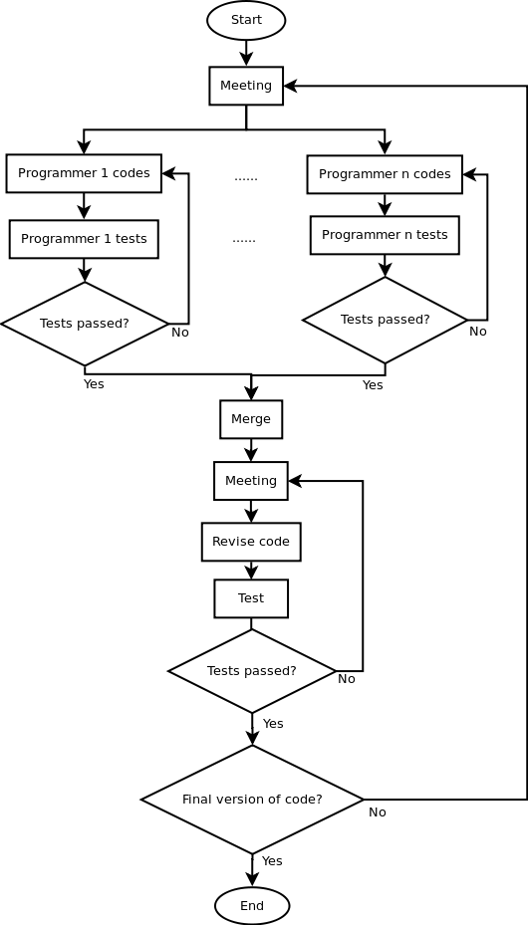
4.6 Installation Procedure

4.6.1 Server Side
On the server, a webserver is required. The game consists of a set of files and programs. These will be hosted by the webserver, and made available to users. Upon beginning the game, the user loads the client libraries, which in turn load the necessary media files. A database stores information for loading and playing the game, which is accessed by a server-side program. Another server-side program manages live network connections. All of these programs are stored on the server computer and are called by the webserver through client connection calls.
4.6.2 Client Side
Since it is browser-based game, installation is not necessary for clients. They only need a modern browsers that support WebGL and hardware acceleration such as Firefox 4.0+, Google Chrome 14.0+, IE 9.0+, safari 5 etc. Users can simply navigate to the web site and sign in, and the game will instantly be made available.
4.6.3 For further information, refer to diagram in Section 2.6.1.

SECTION 5: TEST CASES AND PROCEDURES

5.1 Testing Procedures

5.1.1 Testing Scope and Concerns
The development of a game incorporates a variety of different technologies related to areas in graphics, narrative/storytelling, game logic and AI, networking as well as database management. Consequently, a variety of different test cases and procedures are needed to fully test and minimize both the number and severity of errors within the application. With respect to each of the different technologies used within a game
5.1.1.1 Graphics
Computer graphics has a strong visual component in terms of proper functionality, and thus testing would involve procedures such as play testing where users would be given access to the game before release to identify any artifacts or unintended visual anomalies.
Additionally, elements such as collision detection are also important when considering game logic and graphics and thus play testing would be beneficial in this case as well. When considering collision detection, numerical testing methods will also play a role in terms of achieving proper functionality. This includes white box testing in which a variety of boundary values would be passed into the collision detection functions and the result would be analyzed to determine whether the correct (and intended) response is achieved. (see section 5.2 for further details on Collision Detection Testing)
5.1.1.2 Narrative/storytelling
Narratives and storytelling must be taken into account in game programming to avoid reaching non-sensical states during gameplay, as well as avoid situations where certain game triggers and events are unreachable and thus halt the game progression. Testing procedures would involve generating state diagrams to represent game progression and game states, and thus allow programmers to identity possible dead ends and areas of concern. Finally, player testing would again be beneficial in this regard to identity possible flaws in the story progression.
5.1.1.3 Game Logic/AI
AI testing would involve carrying out path analysis given different possible scenarios that may arise during game play. Analysis of the results and the resulting AI ship positions can then be compared to expected responses to verify correctness. Such testing methods would imply white box testing, where the programmers and testers are able to follow the different paths as well as adjust any bounds if necessary. Again, player and user testing would be used as well to ensure that although numerical values may be as expected, the resulting visuals should also appear somewhat realistic.

5.1.1.4 Networking
Two primary methods would be used for load testing a network connectivity and capacity. The first includes play testing allowing multiple users to play within a given game at once to ensure that the game is playable. The second would involve automated testing procedures in which scripts would be written to repeated connect/disconnect, pass messages, as well as request data.
5.1.1.5 Database testing
Data integrity is important when considering both maintaining user information as well as managing saving and loading game states.

5.1.2 Testing Methodology
5.1.2.1 Testing Flowchart
The following diagram outlines the overall testing phases that will take place during the development of the application.

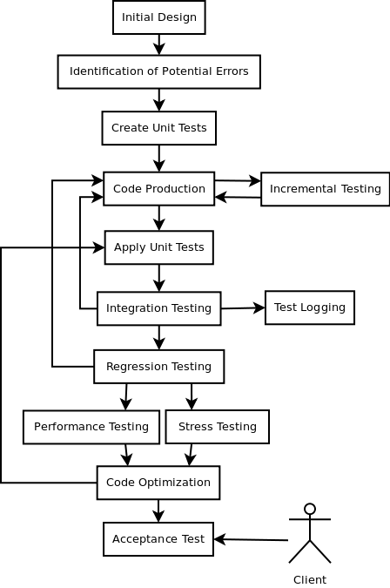

5.1.2.2 Description of Test Flow
The initial testing phases begin with the starting design of the application to identity potential sources of errors. Various test cases and units tests are then created before implementing the actual code. The members of programming team will be responsible for creating their own respective test cases for their respective sections, in addition to any incremental testing that they may wish to carry out during the writing of the code. The Javascript console will be a useful tool for both debugging and experimenting during the coding process. Upon the completion of code production, each member is then responsible for carrying out unit testing on their respective sections before integrating the code together.
Code integration testing will be carried by the team as a whole. Thus all members will be present during integration testing to ensure that any compatibility issues can be as efficiently resolved as possible. This includes finding the source of the errors among the different modules that are being merged together, as well as discussing possible solutions and alterations that need to be made to the code base. In such a case, regression testing is carried out to ensure that the changes made to the code do not fundamentally break any functionality or cause any unintended consequences.

5.2 Analysis of Module-Specific Testing

5.2.1 Collision Detection Testing Overview
This section will focus on the testing of the collision detection components of the game. These are responsible for generating collision events when two entities within the game hit each other. The THREE.js library has a built-in collision detection system that works based on ray projection and calculating the intersection of this ray with 3D faces of the models in the scene. This has proven (in initial tests) to be very expensive, however. A custom module will be built to implement a simpler version, based on simple bounding-sphere distance calculations. A suite of tests must be created to ensure its correctness - both during the production, as well as after its completion.
5.2.2 Brief Description of Module
Because the Collision Detection is not analyzed in detail in Section 3, a brief description is provided here, in text and in pseudocode.
5.2.2.1 Textual
This module accepts one object in the scene, and compares against all other objects in the scene. This is accomplished by projecting an imaginary “sphere” around the object, and using a simple distance calculation to detect if another object has entered it, or if it intersects with another object’s “sphere”.
Unusually shaped objects might have several small “spheres”, more closely conforming to its shape. To save on unnecessary checks, an all-encompassing perimeter “sphere” will determine if more detailed checks are necessary. Potentially, a large hierarchy of “spheres” can be implemented, going from the general to the more accurate, but only two levels are used here.
5.2.2.2 Pseudocode
// Simpler collision detection
// called only on moving objects
function detectCollision(testObject)
foreach missile in scene //missiles are calculated by a single point
//missile/laser must be active
if intersect(testObject.firstLevel, missile.point)
foreach sphere in testObject.secondLevel
if intersect(sphere, missile.point)
return missile
foreach other solid object in scene -> “candidate”
if intersect(testObject.firstLevel, candidate.firstLevel)
foreach sphere in testObject.secondLevel
foreach sphere2 in candidate.secondLevel
if intersect(sphere, sphere2)
return candidate
return NULL

// Intersection helper function
/* Before calling, spheres must be given in absolute coordinates
* if either of the two spheres are points,
* it will simply revert to a radius of zero.
* “distance” is simply the straight-line distance formula. */
function intersect(sphere1, sphere2)
actual -> distance(sphere1.center, sphere2.center)
min -> sphere1.radius + sphere2.radius
if actual <= min
return true
return false

5.2.3 Test Strategies
5.2.3.1 Potential Threats, Weaknesses, Breaking Points
- Input types can potentially be sensitive in this module.
  - detect must only accept scene objects
  - input objects must contain a spheres property containing points and radii
  - coordinates and radii must be numbers (javascript operations automatically convert between types of numbers)
- The loops might iterate over incompatible objects

5.2.4 Test Cases

5.2.4.1 Test Case 1
Name | Ship with Missile/Laser
Description | Verifies that missiles that impact with a ship are actually registered.
Preconditions | Both the ship and the missile are registered in the global entities container.
Inputs | a ship S1 - radius of 20, a missile S2 - radius of 4  1. S1 (x, y, z) - 10, 10, 10 ; S2 (x, y, z) - 40, 40, 40  2. S1 - 10, 10, 10 ; S2 - 34, 34, 34  3. S1 - 10, 10, 10 ; S2 - 32, 32, 32
Expected Outputs | 1. false - no collision  2. true - collision  3. true - collision

5.2.4.2 Test Case 2
Name | Ship with Ship
Description | Verifies that collision between two ships is detected.
Preconditions | Both ships are registered in the global entities container.
Input | a ship S1 - radius of 20, a ship S2 - radius of 20  1. S1 (x, y , z) - 10, 10, 10 ; S2 (x, y, z) - 80, 80, 80  2. S2 - 10, 10, 10; S2 - 50, 50, 50  3. S2 - 10, 10, 10; S2 - 40, 40, 40
Expected Output | 1. false - no collision  2. true - collision  3. true - collision

5.2.4.3 Test Case 3
Name | Multiple Objects
Description | Verifies that if collision occurs in a scene with multiple objects.
Preconditions | Ships and other objects are registered in the global entities container.
Input | a ship S1 - radius of 20, a missile - radius of 4,  an asteroid - radius of 40  1. S1 (x, y, z) - 10, 10, 10 ; S2 - 40, 40, 40 ; S3 - 100, 100, 100  2. S1 - 10, 10, 10 ; S2 - 50, 50, 50; S3 - 94, 94, 94  3. S1 - 10, 10, 10 ; S2 - 50, 50, 50; S3 - 60, 10, 10  4. S1 - 10, 10, 10 ; S2 - 24, 10, 10 - 70, 70, 70
Expected Output | 1. false - no collision  2. true - collision (S2 & S3)  3. true - collision (S1 & S3)  4. true - collision (S1 & S2)

