Shockwave Studios

Project Codename: Waldo
Design Document

Saining Li
Quoc Huy Ta
Brandon Wong
Christopher Wong

COMP 361 - Software Engineering Project
School of Computer Science
McGill University

Fall 2011 - Winter 2012

Section 1:

1.1 Introduction
Our product, Waldo, is a game created for the Sofware Engineering Project course offered by McGill University. The goal of this project is to provide users with a fun and challenging game experience that is available online. It is our intention to create a browser-based game that anyone can access provided they have a compatible browser and an Internet connection.

1.1.1 Purpose
This document provides a high-level description of the design for the implementation of our game. It also describes specific details of the design and structure of the software so that programmers may know how to create the system.The designs detailed in this document will be based on the requirements specified in the Software Requirements Document.

1.1.2 Audience
Its primary audience is the software engineering team that will use the designs as a guideline for the implementation the game. It is also meant for the perusal of Joseph Vybihal, our instructor, to fulfill one of the requirements for the course. Lastly, it is meant for anyone who wishes to understand the designs used in our game, for whatever purpose, good or evil.

1.1.3 References and terms definitions

Game Engine
Game Loop
Game Objects

1.2 Policies and Tactics:

1.2.1 Goals
- The game should run smoothly. Since it is browser-based, it cannot be resource intensive.

1.2.2 Guidelines
1.2.3 Development method

Section 2:

2.1 Architecture Considerations
The specifications included in our requirements document influenced our choice for which technologies to employ. Since we decided on a browser-based game, Javascript was our language of choice. Also, we wanted the game to be 3D, and Three.js was chosen to accomplish this. In a multiplayer game environment, fast client-sever communication is important, so we decided to use WebSockets. For the database, we decided to use SQL since it meets our requirements, which are minimal.

2.2 Design Considerations
The largest constraint for us is that this game is browser-based. This means that the technologies used cannot be too resource-intensive. Also, since there is a network component to our game, we have to make sure that the messages are passed reliably and quickly. This constrains the sizes of the messages.

We will assume that the user can support the technologies we use. Since we will be using WebGL, the minimum browser requirements are Mozilla Firefox 4.0, Google Chrome 9, Safari 5.1, or Opera 12. We will also assume that Javascript is supported and enabled. In addition, all users will be required to have an Internet connection to be able to play the game as having an account and logging in will be required to play both multi-player and single-player games.

2.3 High Level Design
2.3.1 System overview discussion
The overall game will be implemented in Javascript and therefore will be run entirely through the web browser on the client computer. This will include the Game and Graphics Engines which will be implemented in WebGL, and will therefore handle the game A.I. as well as model loading, manipulation and drawing. Various shaders will also be implemented to allow for certain effects and visuals for scene rendering. Thus specific desired effects would be handled by specific shaders depending on the scene and objects to be rendered.
2.3.2 Network Considerations
In terms of network considerations, the client will communicate with the server through WebSockets, where user information as well as game states will be stored onto a database server. In singleplayer mode, the client will only need to communicate with the server when loading and saving the game. In multiplayer mode, the server also handles chat messages and making sure the scenes are consistent across all clients.

Design pattern identification
final domain model (showing classes and design pattern)
final deployment diagram
Section 3: Specifications

3.1 Software organization
3.1.1.1 Overall System Structure Domain Model - Client

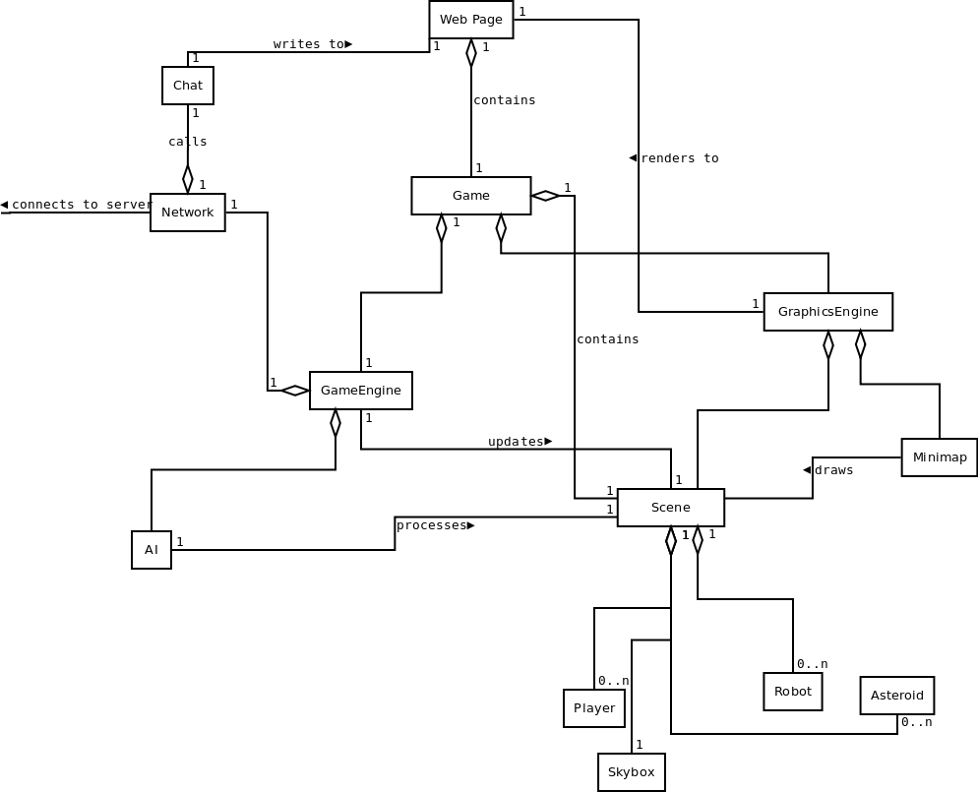

3.1.1.2 Diagram Description
- Web Page: The web page will serve as a container for the game. It consists of the game itself and a chat box.
- Chat: In multiplayer mode, text entered in the chat box will be sent to the server, which will subsequently sent to all players. Chat is disabled in singleplayer mode.
- Network: The network is responsible for relaying chat messages and game information between the clients and the server.
- Game: The Game class will serve as a central container for the client-side game classes.
- GraphicsEngine: The graphics engine class will be responsible for rendering all scene objects to the WebGL canvas (on the HTML web page) using the Three.js graphics library. Objects to be rendered will be contained in a Three.js Scene object, where the updating of object positions (both environmental and ships) will be handled by the Game Engine and AI. The graphics engine will also be responsible for rendering the Minimap based on the objects loaded into the scene. In addition, the graphics engine will also be responsible for handling any post-processing and shader effects.
- GameEngine: The game engine will be responsible for handling elements associated with the game state. This includes maintaining the values and attributes associated with each Solar System/Planet that is currently in play. In addition, the Game Engine communicates both with the Graphics Engine and game AI to evaluate and calculate object positions during gameplay. To do so, the scene containing the scene elements will be passed from class to class to carry out the necessary calculations. A connection to the Network will allow the GameEngine to save and load game states to the online database.
- AI: In singleplayer mode, the AI will process a scene and decide how the robot ships will act. In multiplayer mode, since there are no robot ships, AI is disabled.
- SceneElements: the SceneElements class will serve as a container for all the game objects in a scene.
- Minimap: The minimap shows all ships and planets in a planetary system.
- Player: The Player class represents ships that are controlled by game players and not AI.
- Skybox: The skybox represents a simple object containing the file information necessary to draw the background environment.
- Robot: The class represents an AI controlled ship that is stored within a given scene. Updating of this ship’s position and parameters will be handled by the AI class, and then be rendered by the Graphics Engine.
- Asteroid: The scenes in the game will usually contain many asteroids. They are mostly filler to make the landscape more interesting, though some might contain resources.
3.1.2.1 Overall System Structure Domain Model - Server
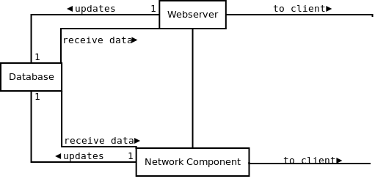
3.1.2.2 Diagram Description
- Webserver: The webserver, which will use Tornado (written in Python), will be responsible for serving up all game components. In multiplayer mode, it receives messages from clients and responds based on the request. The requests will be formatted in json, which can be parsed by the simplejson library in Python.
- Database: The database will be used to store all game states when a player decides to save their current game state.
- Network Component: The network component will use WebSockets to relay messages between clients and the webserver.

3.2 Module decomposition
3.2.1 Game Engine Class Diagram
NOTE: only methods directly relating to the GameEngine are mentionned in GraphicsEngine, UI, and Network

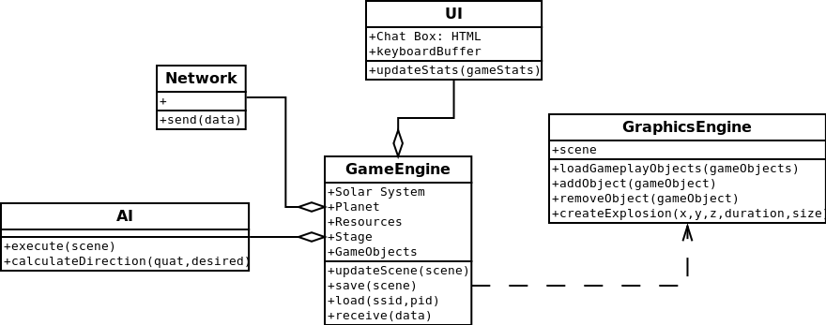

3.2.2 Game Engine Module (including AI) - Textual Description
3.2.2.1 GameEngine
variables:
- solarSystem - the solar system where the ship is currently located
- planet - the planet where the ship is near
- stage - a number indicating the progression of the player in the overall storyline
- resources - an array of the types of resources available on the planet for mining
- gameObjects - an array of game objects formatted to the graphics engine specifications
methods:
- save()
  - arguments - none
  - description
Called when a jump is initiated. Prior to loading a new planetary system, the game engine saves the state of the current environment (or rather, any changes to it) to the database. It pulls the game objects from the scene object, and passes them to the Network component.
  - return values - none
- load(ssid, pid)
  - arguments
    - ssid - ID of the destination solar system
    - pid - ID of the destination planet within the specified solar system
  - description
Called when the player jumps into a new planetary system. Retrieves (via the Network component) data concerning the target location, loads it into the game environment, and calls the Graphics Engine to render everything and begin the primary loop
  - return values - none
- update(scene)
  - arguments
    - scene - array of objects within the planetary system
  - description
Called by the Graphics Engine. At each iteration of the primary loop, this function is called. It parses through each object in the scene, updating values as needed. These values include resources
  - return values - none
- receive(data)
  - arguments
    - data: JSON object or string
  - description
Called by Network component upon receipt of message from the server. Receives data from Network component and updates the scene data and environment accordingly.
  - return values - none
3.2.2.2 AI
variables:
- scene - the scene object that contains all information about planets, ships, laser beam
methods:
execute(scene)
argument: scene
description: it decides the course of action for computer ships. If the player’s ship is in their range, they pursue it and shoot and avoid collision with planets. Otherwise, they just fly around in a predefined region.

calculateDirection(ship1, ship2)
argument: computer’s ship and player’s ship
description: compute the new direction of computer’s ship when it chases player’s ship.
3.2.2.3 GraphicsEngine
NOTE: only members directly pertaining to GameEngine or AI are mentionned here
variables:
- scene - Three.js object containing the objects to be rendered to game screen
methods:
- loadGameplayObjects(gameObjects)
  - argument:
    - gameObjects: array of initial gameObjects
  - description:
Called when an initial scene is to be loaded into the GraphicsEngine after having been properly formatted by the GameEngine. This method is only called during the initial scene creation using the data received from the database.
  - returns: N/A
- addObject(gameObject)
  - argument:
    - gameObject: single gameObject
  - description:
Called when a new object must be added to the scene to be rendered after the initial scene has been created.
  - returns: N/a
- removeObject(gameObject)
  - argument:
    - gameObject: single gameObject
  - description:
Called when a sceneObject must be removed from the scene.
  - returns: N/A
- createExplosion:
  - arguments:
    - x: a numeric value representing the x-coordinate in 3D space
    - y: a numeric value representing the y-coordinate in 3D space
    - z: a numeric value representing the z-coordinate in 3D space
    - duration: the amount of time in seconds that the explosion stays in play (ie is being rendered)
    - size: the radius of the explosion
3.2.2.4 UI
NOTE: only members directly pertaining to GameEngine or AI are mentionned here
Variables:
- Chat Box
- keyboardBuffer
methods:
- updateStats(gameStates)
  - argument:
    - gameStats: object containing the values to update the current game stats such as health, armor, etc...
  - description:
  - returns:

3.2.2.5 Network
NOTE: only members directly pertaining to GameEngine or AI are mentionned here
variables:
methods
- send(data)
  - arguments:
    - data
  - description
  - returns

3.2.3 Sequence Diagram Relating to the Game Engine and AI

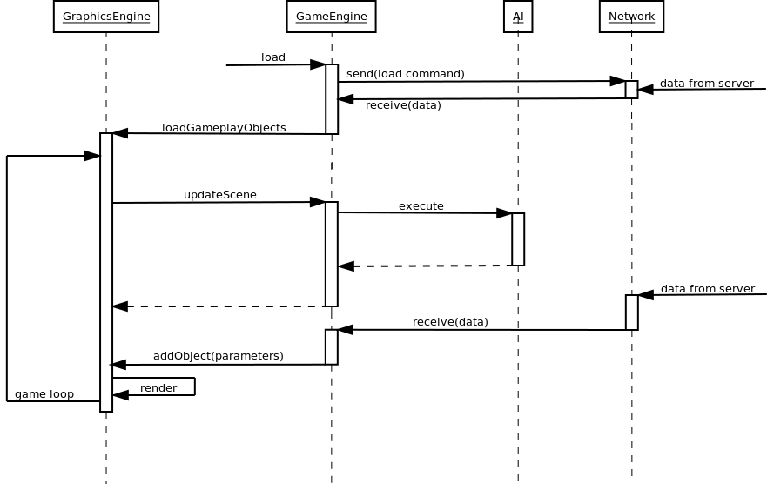

Critical section:
Algorithm selection:
critical code snippets
algorithm selection
state chart
calling sequence diagram

Entity relationship and data dictionary

Section 4: Programming management

4.1 Coding agreement
With respect to code styling and syntax, the team will meet during the beginning stages of the programming phases to decide an agreed upon styling method (See Coding Convention for example style). Throughout the coding process, meetings will also be held to discuss the code content and to assign tasks and responsibilities with respect to each section.
Code commenting will also be an important part of code styling when considering a team programming environment. Since collaboration is a part of our programming process, it is crucial that all members understand what existing code does. Thus, in the case of ambiguous sections of code, the author for that section will be responsible for adding in the necessary comments.
In the event that an error is found by a given member, the severity of the error must first be evaluated. In the case of simple errors, such as semantic errors, the team member can attempt to correct it themselves, but must also inform the original author of the code of the change. For more serious errors that affect the functionality of the program, it is the responsibility of that member to inform the author and rest of the team of this error and not attempt to fix it themselves. It is then the responsibility of the author to try to resolve the issue and inform the rest of the team of any major changes that were necessary.
Conflicting segments of code or unintended side affects from code merging is also a possible concern. In such events, it is the responsibility of both authors to first identity the source of conflict, discuss the issue with the remaining team members and then come to an agreed upon solution. As with error handling, the team should then be informed of all the necessary changes that were made.

4.2 Code Styling
  - Spaces are used instead of tabulators for indentation.
  - Indentation width is four characters.
example:
// fooBar - takes two arguments and adds values to them
// author: Brandon
function fooBar(arg1, arg2) {
var name1 = value1;
var name2 = value2;
return [name1 + arg1, name2 + arg2];
}

4.3 Directory Structure
The following is a general outline of the directory of the files during the development as well as in operation.

4.3.1 In Development
Main Game folder
- .git - revision control folder
- dev/ - primary development fold
  - game/ - game client program, libraries, and media files
    - build/ - THREE.js sub-library files
    - js/ - THREE.js helper scripts
    - models/
    - textures/
    - sounds/
    - examples/ - sample programs for comparison/ideas
- pocs/ - Proofs of Concepts folder - sandbox testing and demonstration
4.3.2 In Operation
Main Game Folder
- game/ - game client program, libraries, and media files
  - build/ - THREE.js sub-library files
  - js/ - THREE.js helper scripts
  - models/
  - textures/
  - sounds/

4.4 Programming Tools, Libraries, and Coding Environment
The application will incorporate the usage of various tools and libraries for the different components of the program.
- Sound: Collections/libraries of both sounds and music will be used and incorporated into the game. Such sources include freesound.org for game sounds and jamendo.com for music.
- Code Sharing and Version Control: To maintain a working folder of latest versions, test cases, prototypes and proofs of concepts, a central Git repository will be used to store all team related files.
- Text Editors: Such editors include Notepad++, Vim, Kate and gedit among others. As such, different team members will have different preferences with respect to text editors which is not a concern so long as the agreed upon coding conventions and styling are followed.
- Web Browsers: Any of the web browsers mentioned in the installation procedure below will be sufficient for testing and developing. However, Google Chrome and Firefox have a javascript console that is useful for debugging and experimenting.
- Graphics: The game will use the Three.js rendering library to handle all game visuals and effects.
- Webserver: We will be using Tornado, written in Python, as our webserver and application framework.
The project environment will consist of the team members (serving as the designers and programmers), where actual programming will take place in a variety of workplaces. These include computer labs as well as home environments. Remote communication methods will also be used among team members

4.5 Software Building Method
- Given the overall design of the application, different modules will be assigned and coded by different team members.
- A central repository will be used to maintain the code of all team members, including a central folder to hold the latest version of the application.
- While coding each individual section, team members may wish to maintain their own separate folders for testing or prototyping purposes. However, before merging the latest/final versions of code, we will require that the programmer first test her own code to prevent potential errors that might emerge.
- After merging, all member will participate in intense final testing phase.
- If the program does not meet the requirements during this phase, two members will be assigned to fix the problems and the other two will keep testing. However, if the problems are major, all member will discuss and find a solution together.
- Meetings will be held regularly (weekly) to collaborate on new ideas, evaluate progress, discuss issues of concern, as well as any changes that would have to be made to the overall pre-established program design. A member can call extra meetings should they feel the need.

4.6 Installation Procedure
4.6.1 Server Side
On the server, a webserver is required. The game consists of a set of files and programs. These will be hosted by the webserver, and made available to users. Upon beginning the game, the user loads the client libraries, which in turn load the necessary media files. A database stores information for loading and playing the game, which is accessed by a server-side program. Another server-side program manages live network connections. All of these programs are stored on the server computer and are called by the webserver through client connection calls.
4.6.2 Client Side
Since it is browser-based game, installation is not necessary for clients. They only need a modern browsers that support WebGL and hardware acceleration such as Firefox 4.0+, Google Chrome 14.0+, IE 9.0+, safari 5 etc. Users can simply navigate to the web site and sign in, and the game will instantly be made available.
Section 5: Test cases and procedure

5.1 Testing Procedures
5.1.1 Testing Scope
The development of a game incorporates a variety of different technologies related to areas in graphics, narrative/storytelling, game logic and AI, networking as well as database management. Consequently, a variety of different test cases and procedures are needed to fully test and minimize both the number and severity of errors within the application. With respect to each of the different technologies used within a game:
- Graphics: Computer graphics has a strong visual component in terms of proper functionality, and thus testing would involve procedures such as play testing where users would be given access to the game before release to identify any artifacts or unintended visual anomalies. Because of the important role that graphics play within a game, it is important to test different graphical elements in detail to ensure that visuals behave as intended to maximize the quality of the gaming experience.
Additionally, elements such as collision detection are also important when considering game logic and graphics and thus play testing would be beneficial in this case as well. When considering collision detection, numerical testing methods will also play a role in terms of achieving proper functionality. This includes white box testing in which a variety of boundary values would be passed into the collision detection functions and the result would be analyzed to determine whether the correct (and intended) response is achieved. (see section 5.2 for further details on Collision Detection Testing)
- Narrative/storytelling: Narratives and storytelling must be taken into account when

5.1.2 Testing Methodology

5.2.1 Collision Detection Testing Overview
This section will focus on the testing of the collision detection components of the game. These are responsible for generating collision events when two entities within the game hit each other. The THREE.js library has a built-in collision detection system that works based on calculating the intersection between 3D faces of the models in the scene. This has proven (in initial tests) to be very expensive, however. A custom module will be built to implement a simpler version, based on simple distance calculations. A suite of tests must be created to ensure its correctness - both during the production, as well as after its completion.
5.2.2.1 Brief Description of Module
Because the Collision Detection is not analyzed in detail in Section 3, a brief description is provided here, in text and in pseudocode.
5.2.2.2 Textual
This module accepts one object in the scene, and compares against all other objects in the scene. This is accomplished by projecting an imaginary “sphere” around the object, and using a simple distance calculation to detect if another object has entered it, or if it intersects with another object’s “sphere”.
Unusually shaped objects might have several small “spheres”, more closely conforming to its shape. To save on unnecessary checks, an all-encompassing perimeter “sphere” will determine if more detailed checks are necessary. Potentially, a large hierarchy of “spheres” can be implemented, going from the general to the more accurate, but only two levels are used here.
5.2.2.3 Pseudocode

// Simpler collision detection
// called only on moving objects
function detect(testObject)
foreach missile in scene //missiles are calculated by a single point
if intersect(testObject.firstLevel, missile.point)
foreach sphere in testObject.secondLevel
if intersect(sphere, missile.point)
return missile
foreach other solid object in scene -> “candidate”
if intersect(testObject.firstLevel, candidate.firstLevel)
foreach sphere in testObject.secondLevel
foreach sphere2 in candidate.secondLevel
if intersect(sphere, sphere2)
return candidate
return NULL

// Intersection helper function
/* if either of the two spheres are points,
* it will simply revert to a radius of zero.
* “distance” is simply the straight-line distance formula. */
function intersect(sphere1, sphere2)
actual -> distance(sphere1.center, sphere2.center)
min -> sphere1.radius + sphere2.radius
if actual <= min
return true
return false

Test driven development

Acceptance test driven development

Error logger
smart error logger

Building classes for auto testing
auto testing method
testing object calling all testable objects

Appendix

