Report: 04/25/2023

1. Initial File download with filter (Location, Count SKU with zero stock onhand and Categories) is done. Subcategory and brand is still in progress.

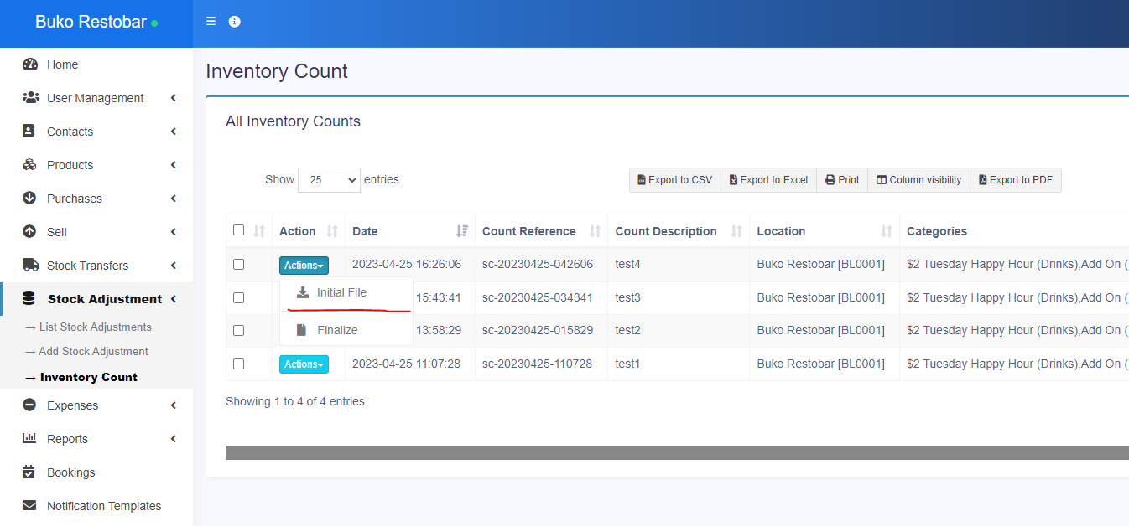

1. Finalize upload Final File and store in Count Details Table is done.  
   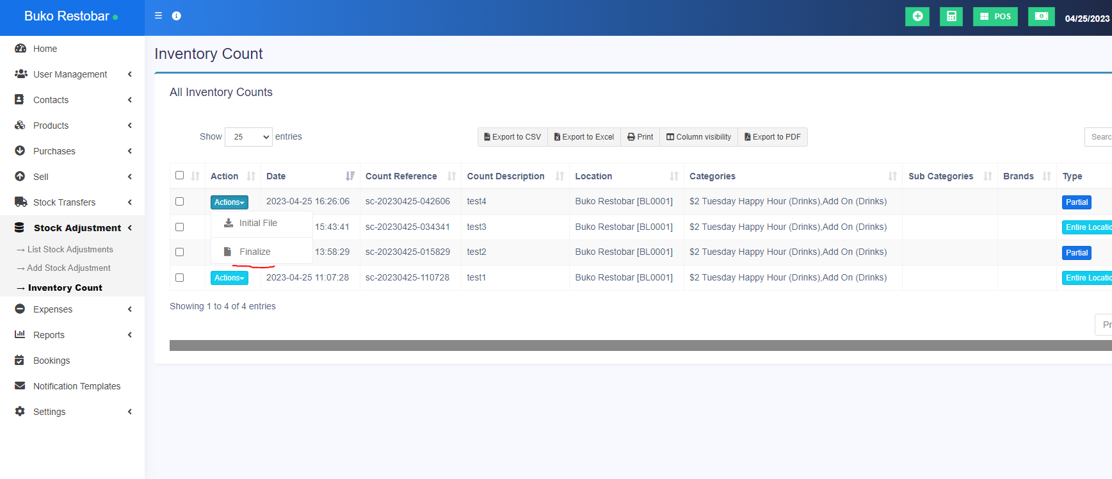

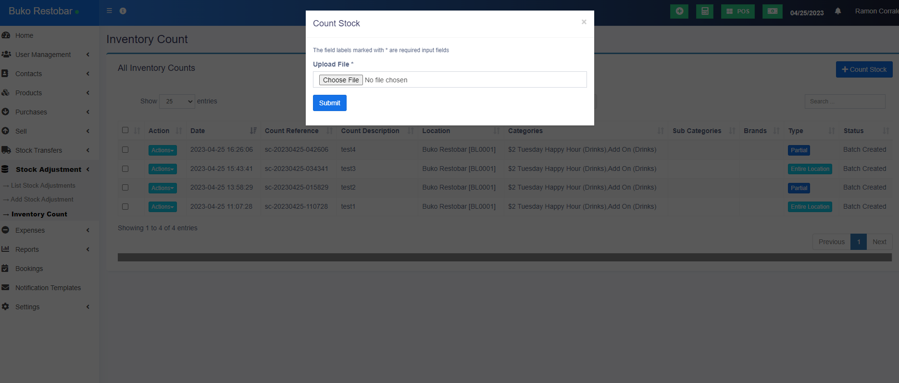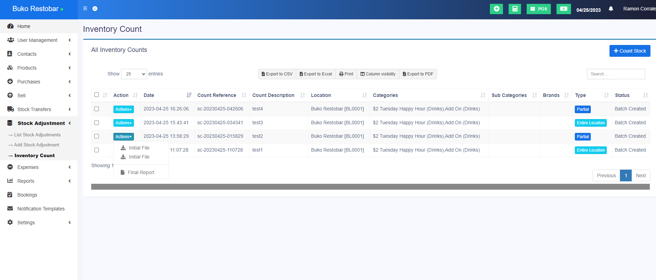

1. Study some functionalities of system like Booking System, Calendar and Business Settings.
2. Give assistance to our agent’s queries about the system.