Test Charter ID: А1

Charter name: Rain-out tour

Mission: testing login form

Areas: login form

Test Environment & URL: https://wildlife.by/

Start date & time: 20.10.2020 11:55

Tester name: Julia Nevar

Duration: super short (30 min)

Testing Notes: 1.open login form + ”X”

2.open login form, enter login +”X”

3.open login form, enter password + “X”

4.open login form, enter login and password + “X”

5.open login form, click to “Facebook” + “X”

6.open login form, click to “VK” + “X”

7.open login form, click to “Odnoklassniki” + “X”

8.open login form, click to “Google” + “X”

Bugs:

Issue1.1 : Login form : the fields remained filled in when open login form, enter login and password + “X” and open form again

Issue1.2: Login form: failed login when open login form and click to “Facebook”

Issue1.3: Login form: failed login when open login form and click to “VK”

Issue1.4: Login form: failed login when open login form and click to “Odnoklassniki”

Issue1.5: Login form: failed login when open login form and click to “Google”

Test Charter ID: А2

Charter name: Rain-out tour

Mission: testing photogallery

Areas: photogallery, login form

Test Environment & URL: https://wildlife.by/

Start date & time: 20.10.2020 11:55

Tester name: Julia Nevar

Duration: super short (30 min)

Testing Notes:

1. Click to “Share a photo” + “X”
2. Click to “Share a photo”, click to “VK” + “X”
3. Click to “Share a photo”, click to “VK”, enter login and password + “X”
4. Click to “Share a photo”, click to “VK”, authorize + “X”
5. Click to “Share a photo”, click to “VK”, authorize, select an audience + “X”
6. Click to “Share a photo”, click to “VK”, authorize, select an audience, write a message + “X”
7. Click to “Add a photo” + the back arrow
8. Click to “Add a photo”, enter login + the back arrow
9. Click to “Add a photo”, enter password + the back arrow
10. Click to “Add a photo”, enter login and password + the back arrow
11. Click to “Forgot your password?” + the back arrow
12. Click to “Forgot your password?”, enter login + “X”
13. Click to “Forgot your password?”, enter email + “X”
14. Click to “Forgot your password?”, enter email and login + “X”

Bugs:

Issue2.1: Page “Photogallery”: text moved out when open the page “Photogallery”

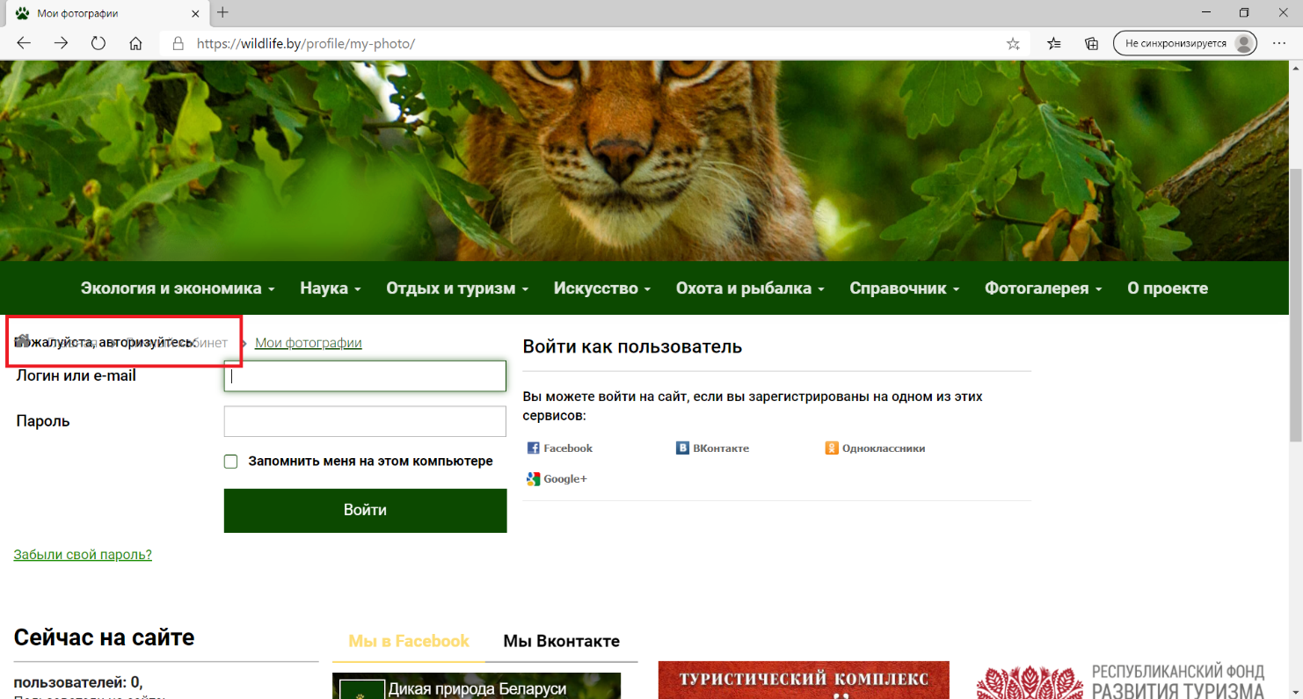

Issue2.2: Page “Photogallery”->”Forgot your password?”: text moved out when click to ”->”Forgot your password?” on the page “Photogallery”

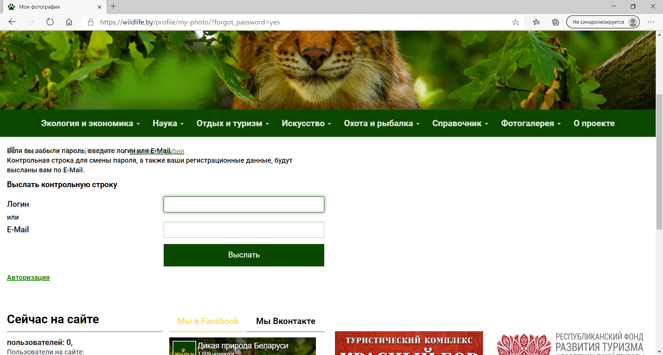

Test Charter ID: А3

Charter name: Rain-out tour

Mission: testing personal account

Areas: personal account, login form

Test Environment & URL: https://wildlife.by/

Start date & time: 20.10.2020 11:55

Tester name: Julia Nevar

Duration: super short (30 min)

Testing Notes:

1. Click to “Personal account” + the back arrow
2. Click to “Personal account””, enter login + the back arrow
3. Click to “Personal account”, enter password + the back arrow
4. Click to “Personal account”, enter login and password + the back arrow
5. Click to “Personal account”, enter login and password, click to “Remember me on this computer” + the back arrow

Bugs: