MOZAIKA- materiały

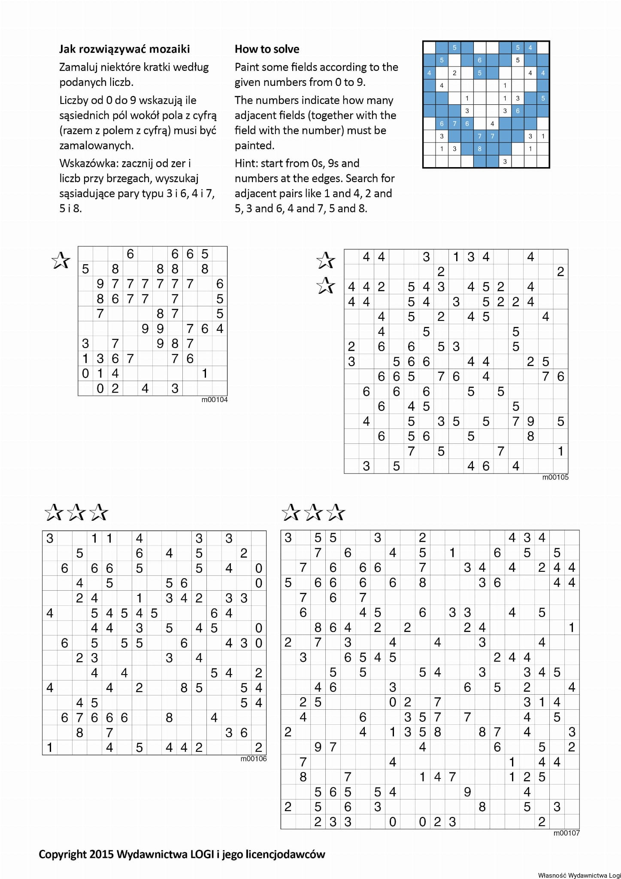

Rozwiązanie w javie: <https://github.com/mordechaim/Mosaic>

Wskazówki:

<http://www.graphilogic.net/howto/solve_m.html>

<http://www.puzzle-magazine.com/mosaic-puzzle-strategy.php>

<http://www.clarity-media.co.uk/puzzle-strategy/techniques-solving-mosaic-puzzles>