**Login application**

**What can you do?**

- As an user, you simply and easily login into the application.

- As an authenticated user, you are able to see a home page with different useful links like the weather.

- As an authenticated user, you can change your password.

- As an authenticated user, you can save your profile.

- As an authenticated user, you can change your profile.

We developed an application having login and registration system which connects to a database and also connects to a basic Weather application that allows you to parse JSON from google weather api and show the result.

JSON stands for JavaScript Object Notation.It is an independent data exchange format and is the best alternative for XML.

Android provides four differnet classes to manipulate JSON data. These classes are JSONArray, JSONObject, JSONStringer and JSONTokenizer.

## JSON - Elements

A JSON file consist of many components. Here is the table defining the compoents of an JSON file and their description:

|  |  |
| --- | --- |
| Sr.No | Component & description |
| 1 | Array([)  In a JSON file , square bracket ([) represents a JSON array |
| 2 | Objects({)  In a JSON file, curly bracket ({) represents a JSON object |
| 3 | Key  A JSON object contains a key that is just a string. Pairs of key/value make up a JSON object |
| 4 | Value  Each key has a value that could be string , integer or double e.t.c |

## 

## JSON - Parsing

For parsing a JSON object, we will create an object of class JSONObject and specify a string containing JSON data to it. Its syntax is:

String in;  
JSONObject reader = new JSONObject(in);

The last step is to parse the JSON. An JSON file consist of different object with different key/value pair e.t.c. So JSONObject has a seperate function for parsing each of the component of JSON file. Its syntax is given below:

JSONObject sys = reader.getJSONObject("sys");  
country = sys.getString("country");  
   
JSONObject main = reader.getJSONObject("main");  
temperature = main.getString("temp");

The method getJSONObject returns the JSON object. The method getString returns the string value of the specified key.

Apart from the these methods , there are other methods provided by this class for better parsing JSON files. These methods are listed below:

|  |  |
| --- | --- |
| Sr.No | Method & description |
| 1 | get(String name)  This method just Returns the value but in the form of Object type |
| 2 | getBoolean(String name)  This method returns the boolean value specified by the key |
| 3 | getDouble(String name)  This method returns the double value specified by the key |
| 4 | getInt(String name)  This method returns the integer value specified by the key |
| 5 | getLong(String name)  This method returns the long value specified by the key |
| 6 | length()  This method returns the number of name/value mappings in this object.. |
| 7 | names()  This method returns an array containing the string names in this object. |

**Testing the App**

1. How the app looks like in the phone menu (you can see it in the down right corner)

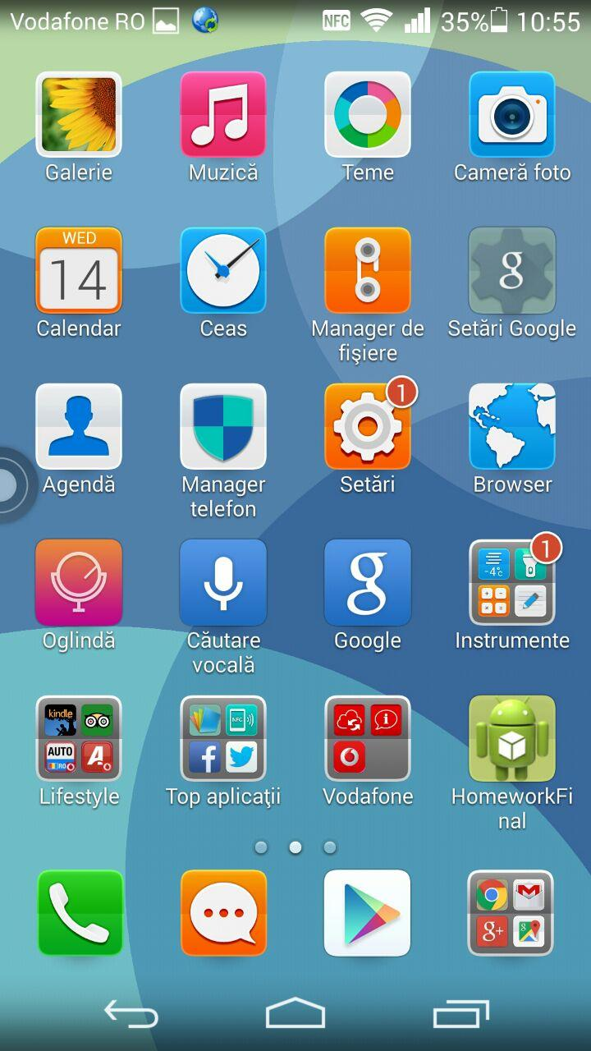

2. Login menu

Once you entered in the app, the below page will be shown. From this point, you have two options: the first one, if you already have a registered account, you type your username and your password and tap the login button. As a second option, if you do not have an account, just tap the register button, that will take you to a register form.

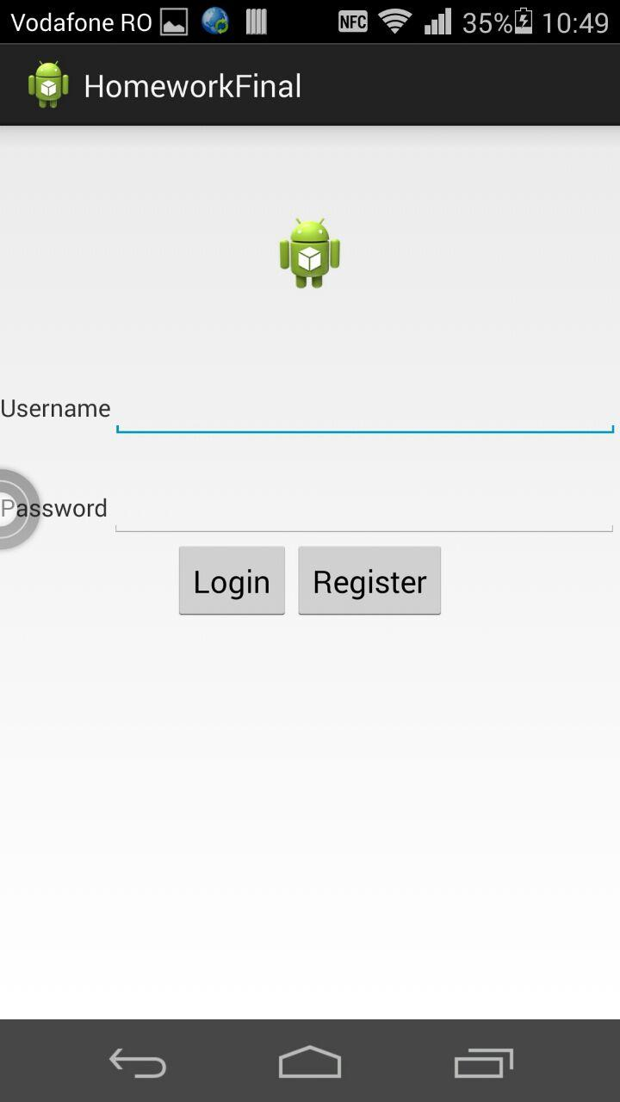

3. Registering our account

Once you tap the register button, you are going to see the register form page:

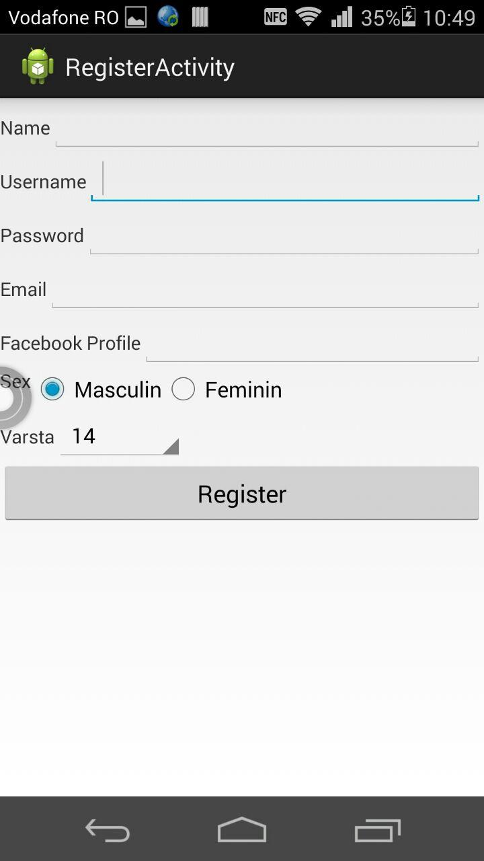

Fill in the form:

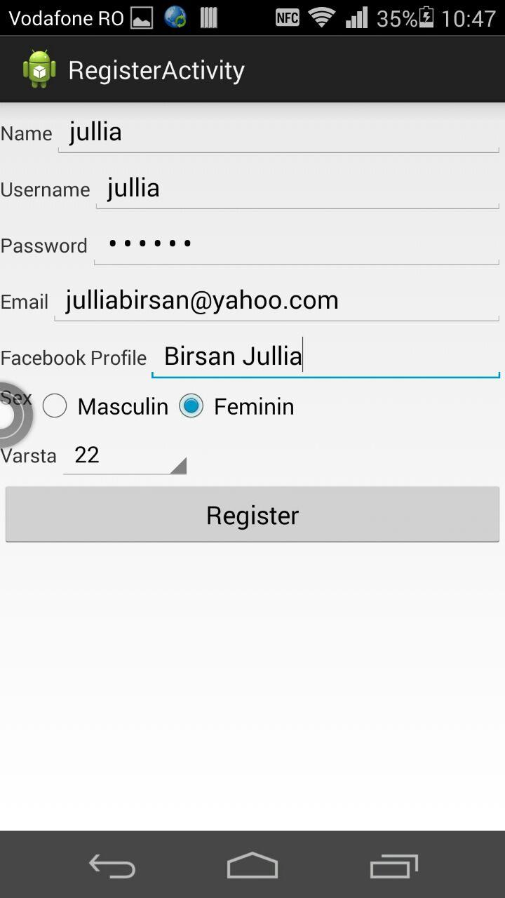

Once you filled in all the form, tap the register button and you're going to receive a message that will confirm your registration.

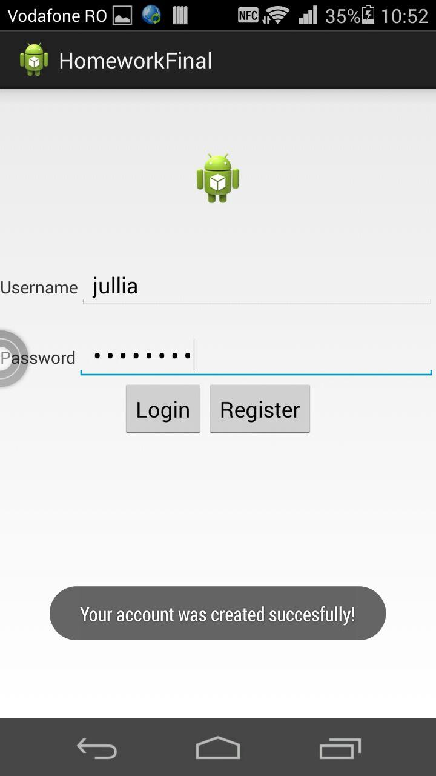

4. During registration…

When you fill in the registration form, be careful to use an username and a password with at least 6 characters; otherwise….

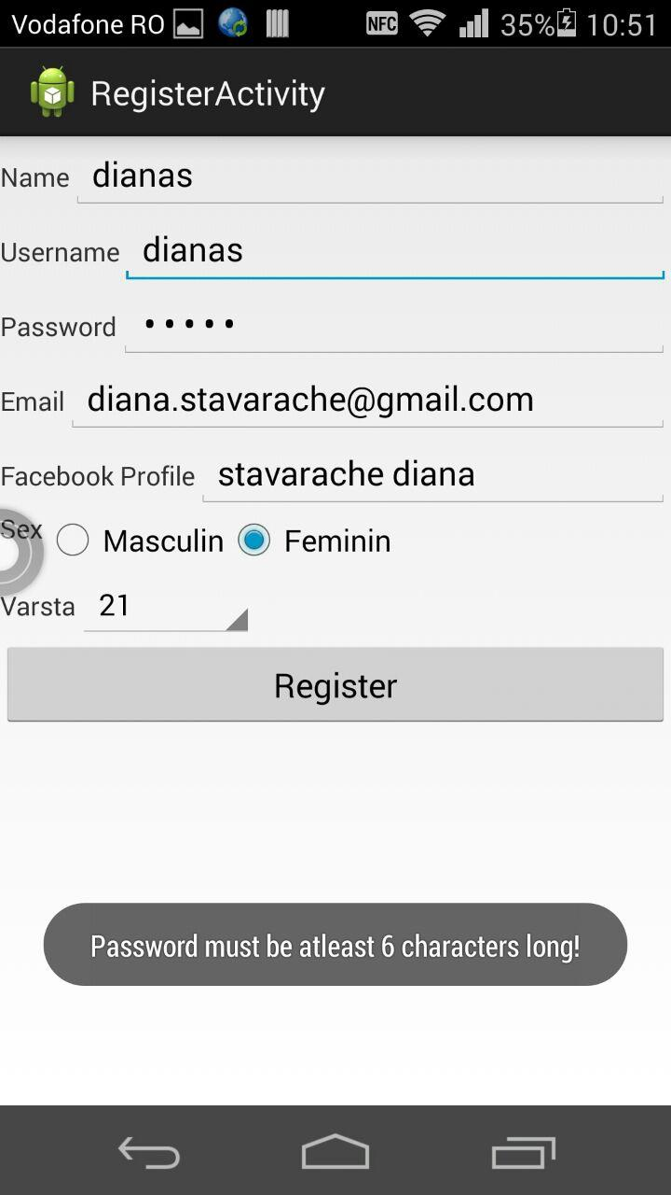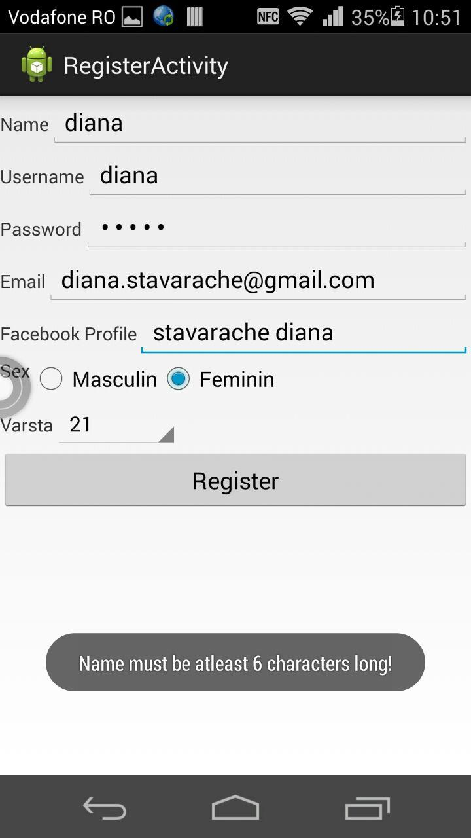

5. Back to our login main page and trying to login with our fresh new registered account

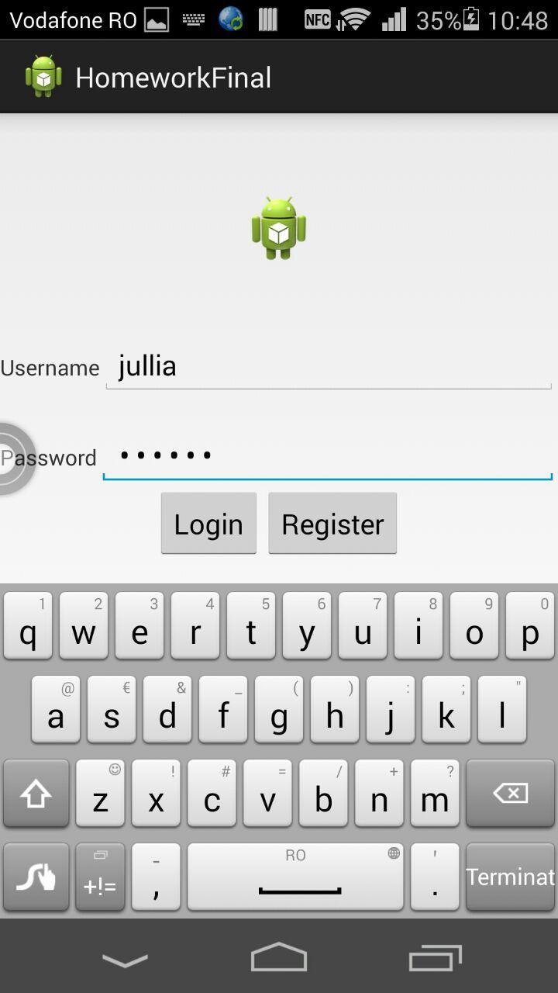

6. If you type your password wrong:

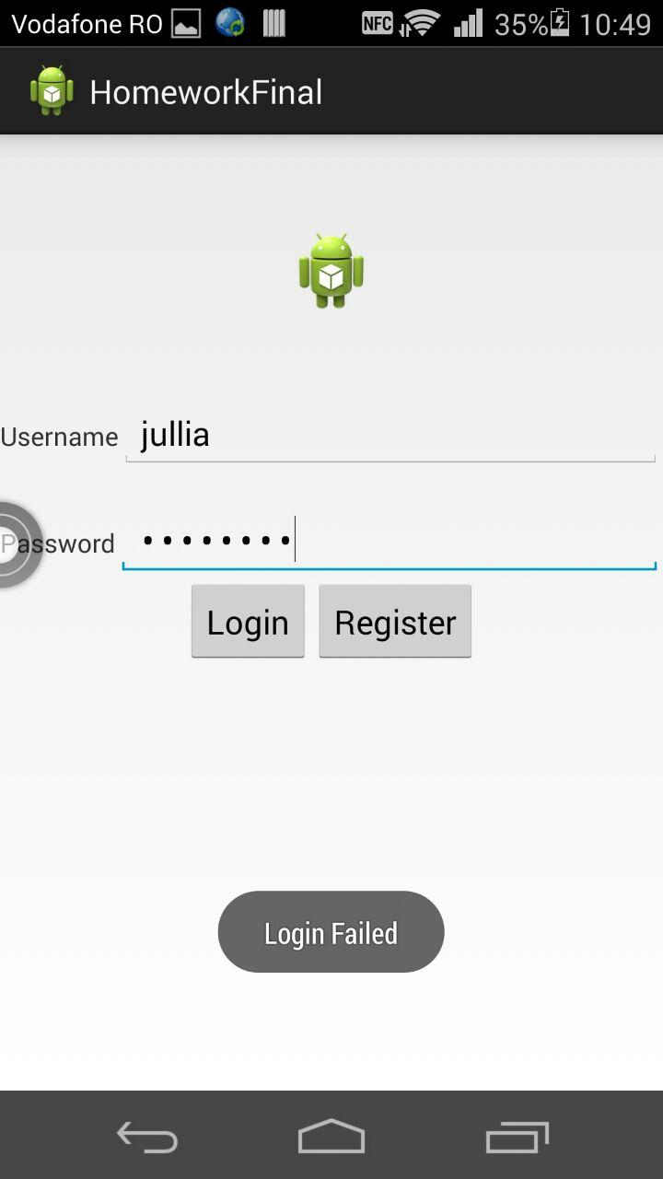

7. After writing your username and your password, tap the "magic" button called login that will lead you to the next page:

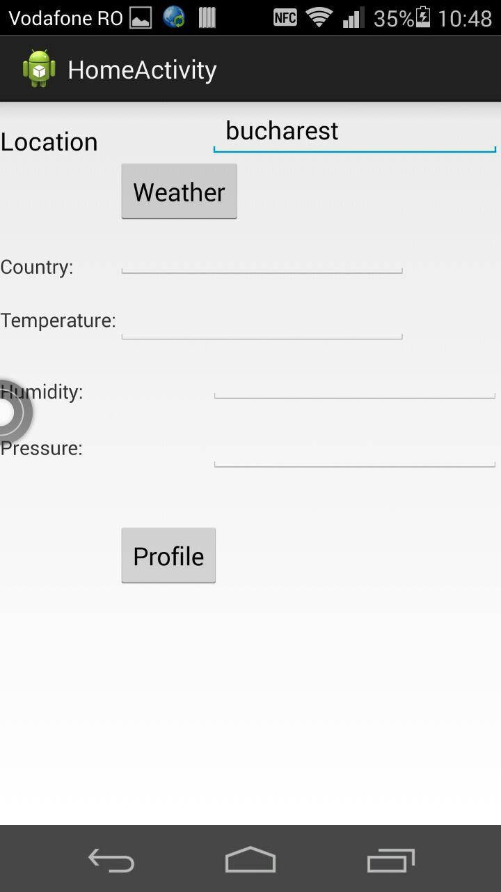

In order to get the temperature of a city/country, just type in the location field the desired place.

The temperature is in Celsius degrees, and in plus, you also receive data about the humidity and pressure.

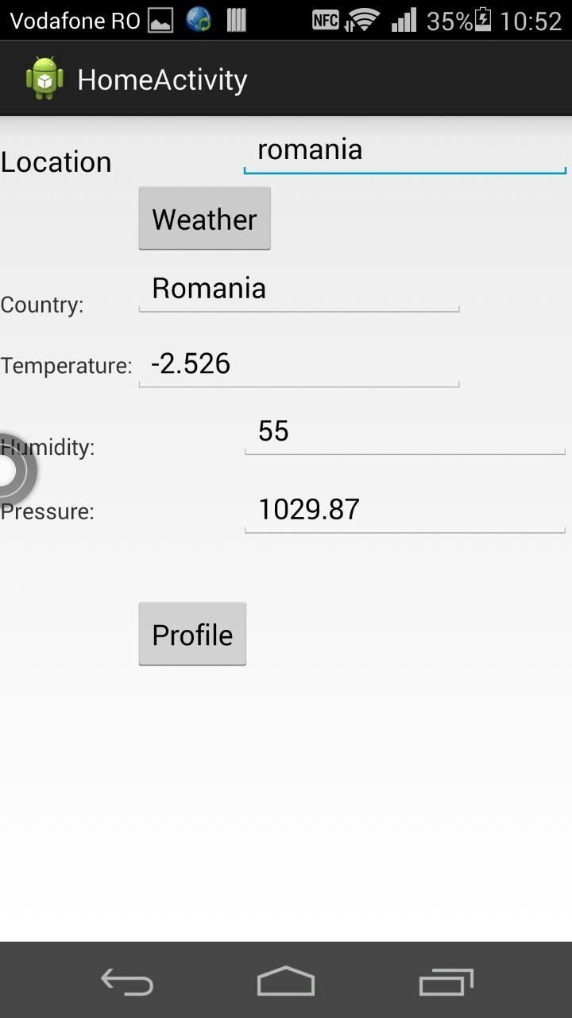

And after getting details about the weather, you also have to option to change and modify your profile, just in case you wrote something wrong at the registration point. For this, just tap the "Profile" button, after the weather information.