LOCAL AREA NETWORK DESIGN

A Project
Presented to the
Faculty of College of Engineering and Digital Technology
ICCT Colleges Foundation Inc.
V.V. Soliven Avenue II Cainta Rizal
Bachelor of Science Major in Computer Engineering
BY.
GROUP 8E
BRANDON ASHLEY P. (N060)
CADIMAS JULLIANA E. (E063)
DELOS SANTOS EMMANUEL B. (E063)
ESCOBAL RUBEN III M. (E063)
ESTARIS KRISTINE YVONNE F. (E063)
FRANCISCO JENNICA HAZEL V. (N060)
HERRADURA LAMECH UZ R. (E063)
MACABUDBOD CLYDE L. (E063)
VALDEZ KENNETH JAMES M. (N060)

CHAPTER 1

DESIGN OVERVIEW AND INTRODUCTION

1.0 OVERVIEW OF THE DESIGN

The proposed network infrastructure design is intended for a modern three-storey Office, Condominium, Hotel or Dormitory building composed of multiple room workspaces, dedicated server facilities, and interconnected communication systems designed to support efficient data transmission, resource sharing, and secure network operations. The building layout follows a centralized and structured networking architecture wherein each floor contains several Router stations connected whether through a hierarchical, star or bus network topology. to ensure reliability, scalability, and high-speed communication across all end users and for easy expansion in the future and simplify troubleshooting. The floor plan consists of organized rooms positioned along common hallways with a designated server room strategically located within the ground floor of the building. The server room functions as the core of the network infrastructure, housing essential networking devices such as routers, managed switches, patch panels, servers, and backbone distribution equipment. Each network within the rooms is connected through structured cabling systems using Ethernet LAN technology, allowing stable communication between computers, printers, servers, and internet resources. The proposed design accommodates more than thirty 30 computer workstations for office style workstations distributed across the three floors. Each floor is interconnected using a high-speed backbone network to provide seamless communication between each room and maintain centralized network management. The implementation of managed switches enables efficient traffic handling and improved overall performance of the system.

The network design emphasizes Structured cabling pathways are carefully planned to minimize signal interference and allow future expansion of additional devices and workspaces. The design also incorporates proper placement of networking equipment to ensure balanced network distribution and efficient utilization of resources throughout the building. Furthermore, the proposed infrastructure supports various organizational operations including file sharing, centralized database access, internet connectivity, communication services, and internal data management. Security considerations such as controlled server access, organized cable management, and network segmentation are also integrated into the overall system design to enhance operational safety and protect network resources from unauthorized access. Overall, this project presents a comprehensive network infrastructure solution for a three-storey office building that integrates functionality, efficiency, and future-ready scalability.
Today’s digital environment, computer networking has become an essential component in the operation of businesses, institutions, and corporate establishments. Organizations rely heavily on efficient communication systems to facilitate data exchange, resource sharing, internet connectivity, and centralized information management. As technology continues to evolve, the demand for reliable and scalable network infrastructures also increases, particularly in three-storey buildings where numerous devices and users operate simultaneously. This project focuses on the design and development of a structured network infrastructure for a three-storey building.

The proposed setup aims to establish an organized and efficient communication system capable of supporting multiple end users, centralized server operations, and interconnected networking devices across all floors of the building. The design utilizes Ethernet-based Local Area Network (LAN) technology integrated with routers, managed switches, servers, and structured cabling systems. Each floor contains several room workspaces connected to a centralized network system through backbone cabling infrastructure. The server room serves as the primary control center for network management, data storage, monitoring, and communication services throughout the building.

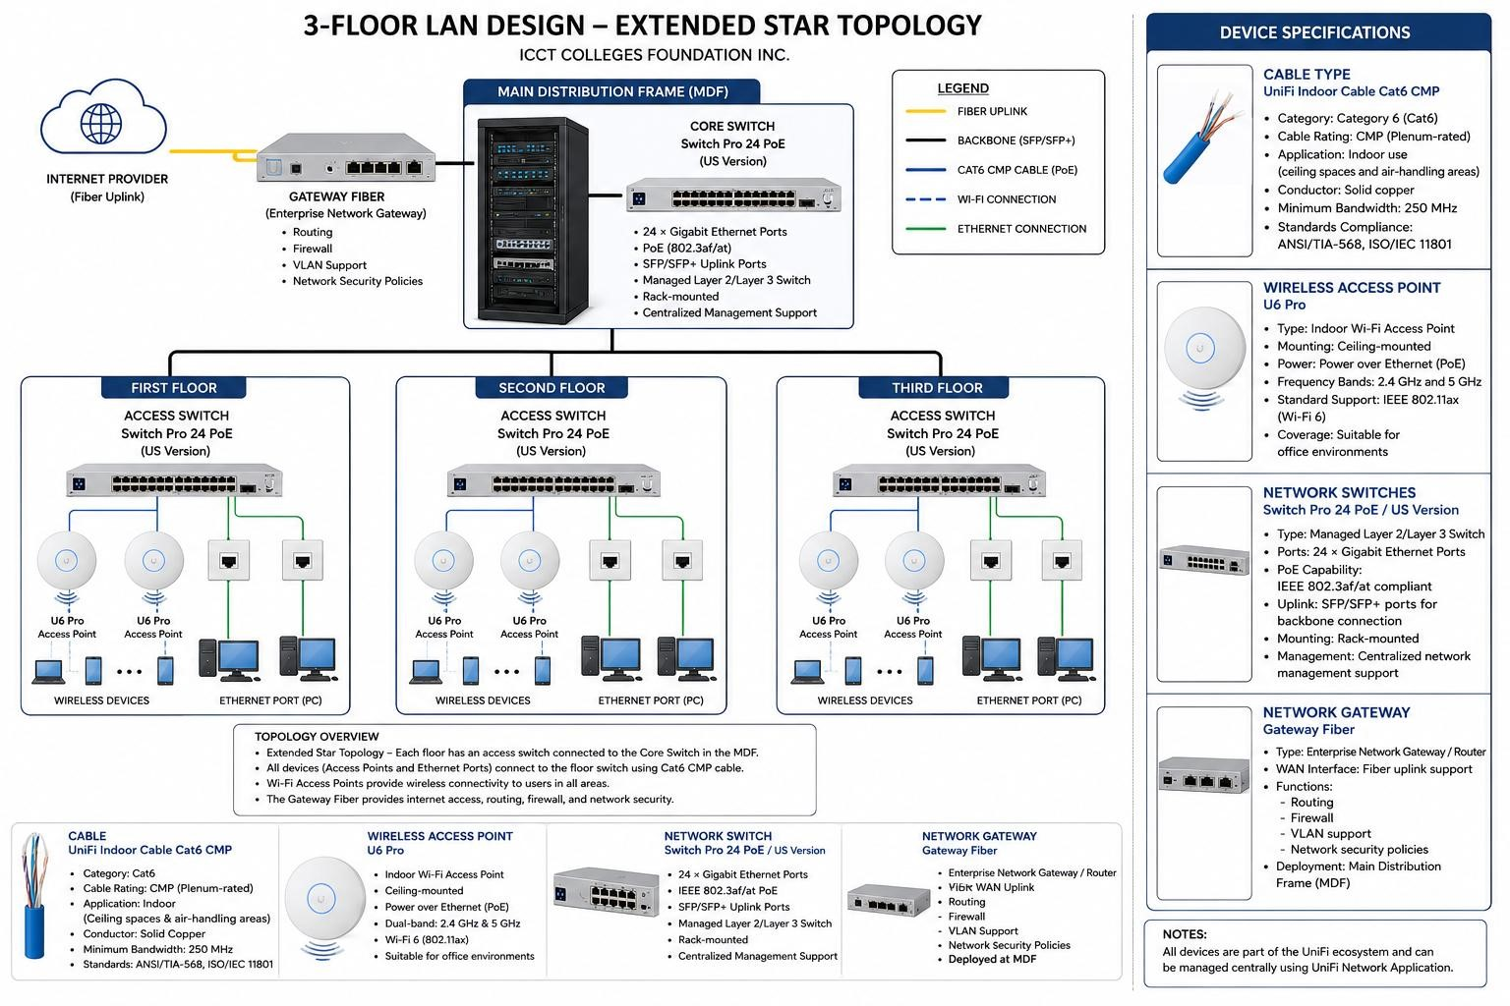

This study serves as a practical application of data communication and networking principles, demonstrating how modern network infrastructures are designed to meet the demands of contemporary office operations.

CHAPTER 2

2.1 STATEMENT OF THE PROBLEM

In today’s technology-driven environment, organizations rely on computer networks to support communication, data sharing, internet access, and centralized information management. However, many multi-storey buildings face network-related challenges such as unstable connections, slow data transfer, poor cable organization, limited scalability, weak security measures, and difficulties in managing multiple devices across different floors. These problems can reduce work efficiency, interrupt communication, and affect the overall productivity of the organization.

As the number of users and network-connected devices continues to increase in office buildings, condominiums, hotels, and dormitories, the need for a reliable, secure, and scalable network infrastructure becomes more important. Without a properly planned and structured network system, issues such as network congestion, connectivity failures, inefficient resource sharing, and complicated troubleshooting procedures may occur.

This study aims to develop a structured and centralized network infrastructure design for a three-storey building that can efficiently support multiple users and interconnected devices. Specifically, the study seeks to answer the following questions:

- How can a structured network infrastructure be designed to provide reliable communication and data transmission within a three-storey building?
- What networking devices, technologies, and cabling systems are most suitable for supporting centralized network operations and resource sharing?
- How can the proposed network design ensure scalability, efficient traffic management, and simplified troubleshooting for future expansion?
- What security measures can be integrated into the network infrastructure to protect network resources and prevent unauthorized access?
- How can the implementation of managed switches, routers, servers, and backbone cabling improve the overall performance and reliability of the network system?
- How can the proposed network infrastructure support organizational operations such as file sharing, database access, internet connectivity, communication services, and centralized management?

The study aims to provide a practical, efficient, secure, and scalable network infrastructure solution suitable for modern multi-storey establishments.

2.2 DESIGN AND OBJECTIVES

The main objective of the study is to design a reliable, organized, and efficient system of Local Area Network (LAN) for the three (3)-Storey building of ICCT Colleges Foundation Inc. that gives a strong connection to the internet, communication, and file sharing for academics and office use.

In particular, the study is specifically designed to:

- Design a structured LAN based on Extended Star Topology for a better network and communication management;
- Provide stable internet access to every room using the integrated Wi-Fi access points connected to the network switches;
- Create an organized network cabling system using CAT6 cables to support fast and reliable data transmission;
- Connect all floor switches to a center server rack and router for centralized network control and internet distribution;
- Improve communication and network sharing through all floors;
- Build an easy to maintain network infrastructure that can support future expansion;
- Ensure the proper placement of network devices such as access switches, PoE switches, routers, Ethernet ports, and Wi-Fi access points to maximize network connectivity, efficiency and coverage.

Overall, the proposed LAN design aims to create a dependable and efficient network environment that support the daily academic and administrative operations of the institution.

2.3 SCOPE AND DELIMITATION

This project is focused on the design and proposed implementation of Local Area Network (LAN) for the three (3)-Storey Building of ICCT Colleges Foundation Inc. This covers planning and organizing of communications, internet access, and sharing of files to the computers and network devices inside the building.

This includes:
- Designing of LAN using the Star Topology;
- Connecting of desktop computers to the switch installed in each floor;
- Connecting of all floor switches to a server to a central router for the internet and network management;
- Wireless network (Wi-Fi) design;
- Identifying and proposing networking devices such as routers, switches, hubs, Ethernet cables, and desktop computers;
- Providing a network layout and structured cabling design for the three (3)-floor building;
- Support academic and office operability through reliable and efficient network communication;
- Improving internal communication, data sharing, and internet accessibility within the school;

This study mainly focused on the network design, connections, and proper installation of equipment for networking to achieve a stable and organized LAN environment.

DELIMITATION OF THE STUDY

This project is limited only to the proposed LAN design within the the (3)-Storey Building of ICCT Colleges Foundation Inc.

This study does not include:
- Wide Area Network (WAN) or external branch networking;
- Actual installation, configuration, and maintenance of networking devices;
- Advanced network security systems such as firewalls, detection systems, and cybersecurity monitoring;
- Server administration, cloud services, and database management;
- Network performance testing in real-world operations;
- Cost analysis beyond the proposed networking materials and equipment;

