“LOCAL AREA NETWORK DESIGN”
A Project
Presented to the
Faculty of College of Engineering and Digital Technology
ICCT Colleges Foundation Inc.
V.V. Soliven Avenue II Cainta Rizal
In Partial Fulfillment
Of the requirements for the Degree of
Bachelor of Science Major in Computer Engineering
BY.
BRANDON ASHLEY P.
CADIMAS JULLIANA E.
DELOS SANTOS EMMANUEL B.
ESCOBAL RUBEN III M.
ESTARIS KRISTINE YVONNE F.
FRANCISCO JENNICA HAZEL V.
HERRADURA LAMECH UZ R.
VALDEZ KENNETH JAMES M.

1. AUTOCAD OF 3 FLOORS

Ground Floor
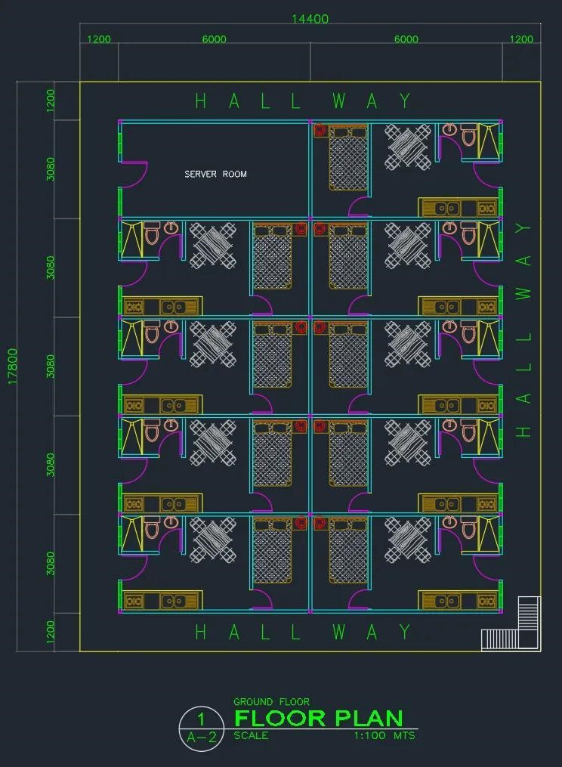

Second Floor

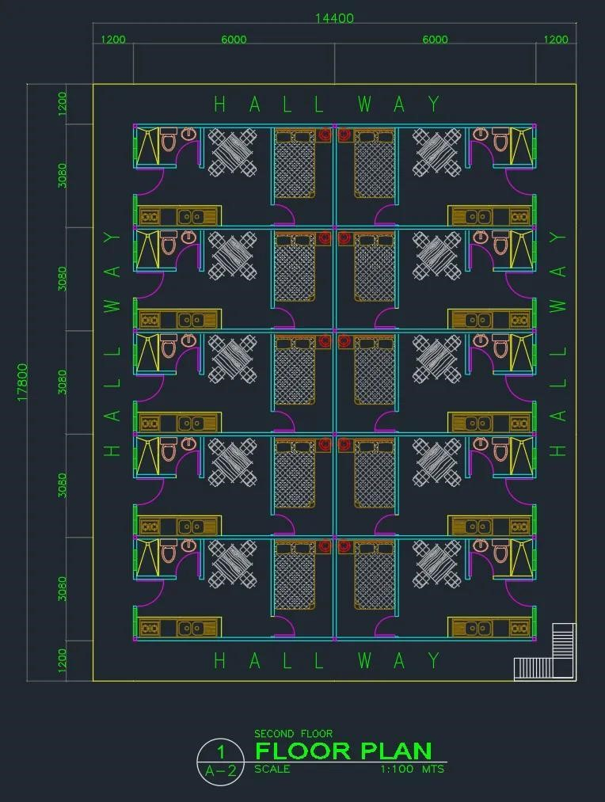

Third Floor
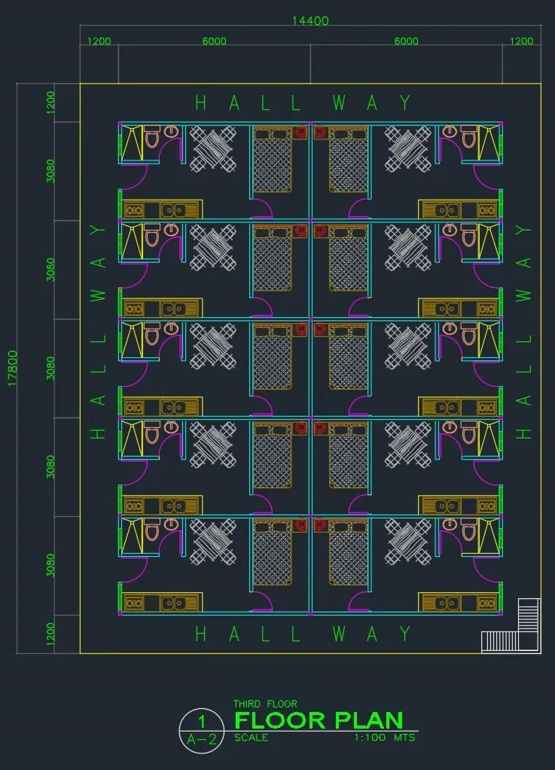
2. COMPUTER SPECIFICATION

Desktop Brand: Dell Model: 27 All-in-One EC27250

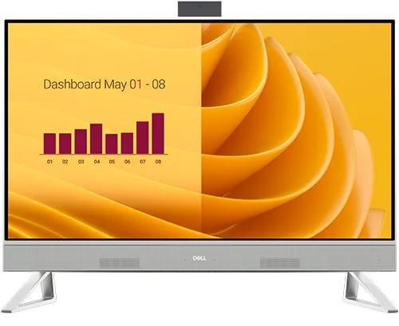

2.1 Electrical Specifications

Input Voltage | 100–240 VAC
Input Frequency | 50–60 Hz
Input Current | 1.5 A (max)
Power Supply Type | External AC Adapter
Output Voltage | 19.5 VDC
Output Current | 4.62 A (continuous)
Power Rating | 90 Watts

2.2 Computer Requirements

Processor | Intel® Core™ 5 processor 120U (12MB cache, 10 cores, 12 threads, up to 5.0 GHz)
Operating System | Windows 11 Home
Graphics Card | Intel® Graphics
Display | 27”, Non-Touch, FHD(1920×1080),  WVA
Memory | 32 GB: 2 x 16 GB, DDR5, 5200  MT/s
Storage | 1 TB, M.2, PCIe NVMe, SSD
Connectiviry & Ports | Rear:  3 USB 3.2 Gen 1 (5 Gbps) ports with Wake-up support (S3/Modern  Standby)  1 USB 3.2 Gen 2 (10 Gbps) port with PowerShare 1 HDMI-out 1.4b  1 HDMI-in 1.4  1 RJ45 Ethernet port 1 headset (headphone and microphone combo) port  1 power-adapter port  Side:  1 USB 3.2 Type-C® Gen 2 (10  Gbps) port  Slots  1 M.2 2230/2280 slot for PCIe soli”state drive  1 M.2 2230 slot for WiFi and  Bluetooth combo card  1 SD-card slot
Form Factors | All-in-One Desktop
Security | Kensington Lock support
Dimensions & Weight | Without stand:
Depth: 1.64 in. (41.80 mm)
Width: 24.20 in. (614.70 mm)
Rear Height: 15.73 in. (399.74 mm) Front Height: 15.54 in. (394.82 mm) Starting Weight (Touchscreen):
14.55 lb (6.60 kg)

With Isosceles stand (White):
Depth: 7.90 in. (200.70 mm)
Width: 23.76 in. (603.70 mm)
Rear height: 17.93 in. (455.50 mm) Front height: 17.93 in. (455.50 mm) Starting Weight (Touchscreen):
15.26 lb (6.92 kg)
Starting Weight (Non-Touchscreen):
14.26 lb (6.47 kg)

Wireless | Intel® Wi-Fi 6E AX211, 2x2,  802.11ax, Bluetooth® wireless card
Power | 90W AC adapter, 4.5 mm barrel for  Intel® Graphics

2.3 User’s Manual

https://dl.dell.com/content/manual32163823-dell-27-all-in-one-ec27250owner-s-manual.pdf?language=en-us

HUB AND SWITCHES
3.1 Hub Equipment Information
Brand: TP-Link
Model: TL-SF1008D

Unit / Type: 8-Port Fast Ethernet Hub / Desktop Type

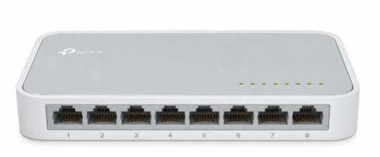

Specifications:
Standard | IEEE 802.3, IEEE 802.3i, IEEE  802.3u, IEEE 802.3x
Protocol | CSMA/CD
Interface | 5/8/16/24 10/100 Mbps Auto-  Negotiation RJ45 Ports
Network Media Cable | 10BASE-T: UTP category 3, 4, 5 cable (≤100 m) EIA/TIA-568 100Ω STP (≤100 m)  100BASE-TX: UTP category 5, 5e cable (≤100 m) EIA/TIA-568 100Ω  STP (≤100 m)
Led Indicators | Power, Link/Act LE‘s
Data Transfer Rate | Ethernet: 10 Mbps (Half Duplex), 20  Mbps (Full Duplex)  Fast Ethernet: 100 Mbps (Half  Duplex), 200 Mbps (Full Duplex)
Transfer Method | Store-and-Forward
MAC Address Learning | Automatically learning, automatically aging
Frame Forward Rate | 10Base-T: 14881 pps/Port  100Base-Tx: 148810 pps/Port
Wall Mountable | No
Distance between  Mounting Holes | TL-SF1016D: 157.2 mm  TL-SF1024M: 178 mm

User’s Manual
https://static.tp-
link.com/upload/manual/2022/202203/20220304/7106508781_Desktop%2 0Switch(UN)_IG.pdf

3.2 Switch Equipment Information
Brand: D-Link
Model: DGS-1210-24-Port 10/100/1000Mbps plus 4 Combo

Unit / Type: Smart Managed Gigabit Ethernet Switch

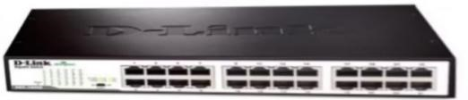

Specification:
Switching Capacity | DGS-1210-24P: 56Gbps
Max. Forwarding Rate | DGS-1210-24P: 41.7Mpps
Forwarding Mode | Store and Forward
Packet Buffer memory | DGS-1210-24P: 4.1Mbits
DDRIII for CPU | 128M bytes
Flash Memory | 32M bytes
Priority Queues | 8
Power Consumption | DGS-1210-48:  Maximum power consumption:  34.85 Watts
Standby power consumption: 13.9
Watts

Power Supply | AC input, 100~240 VAC, 50/60Hz, internal universal power supply  AC input, 100-240 VAC, 50/60Hz, DC 54V/1.574A external desktop power adapter (only DGS-1210-08P)
10/100/1000BASE-TX  Ethernet ports | 24 x 10/100/1000BaseT ports for DGS-1210-24/24P  1000Base-T ports compliant to following standards:  - IEEE 802.3 compliance  - IEEE 802.3u compliance  - IEEE 802.3ab compliance  Support Half/Full-Duplex operations  - IEEE 802.3x Flow Control support for Full-Duplex mode  - Back Pressure for Half-Duplex mode  - Head-of-line blocking prevention  Support manual/auto MDI/MDIX configuration  Support Auto-Negotiation for each port

Combo Ports | 4 combo 1000BASE-T/SFP ports for  DGS-1210-16/24/24P/48  SFP Transceivers Supported:  DGS-712 (1000Base-T)  - DEM-210 (100BASE-FX, 15km)  - DEM-211 (100BASE-FX, 2km)  - DEM-310GT (1000BASE-LX, 10km)  - DEM-311GT (1000BASE-SX, 550m)  - DEM-314GT (1000BASE-LH, 50km)  - DEM-315GT (1000BASE-ZX,  80km)  -DEM-312GT2 (1000BASE-SX, 2km  WDM Transceivers Supported:  - DEM-220T (100Base-BX,TX1550/RX-1310nm, 20km)  - DEM-220R (100Base-BX,TX-  1310/RX-1550nm, 20km)  - DEM-330T (1000Base-BX,TX-  1550/RX-1310nm, 10km)  DEM-331T (1000Base-BX,TX-  1550/RX-1310nm, 40km)  - DEM-331R (1000Base-BX,TX-  1310/RX-1550nm, 40km)

Fans | DGS-1210-24P: 2pcs Smart Fan
Operating Temperature | 5~50°C
Storage Temperature | 20~70°C
Humidity | Storage: 0%~95% non-condensing
Dimensions | DGS-1210-24P: 440mm x 250mm x  44mm
Weight | DGS-1210-24P: 3.75kg
EMI | CE, FCC/IC, VCCI, BSMI, C-Tick,  CCC
Safety | UL, CB, BSMI, CCC

User’s Manual
https://media.dlink.eu/support/products/dgs/dgs-1210/documentation/dgs1210_man_revg1_7-20_eu_multi_20210929.pdf

IMPORTANCE OF HUB AND SWITCHES
Hub and switches are important in networking because they allow communication between computers and devices. They help build a functioning local area network inside a building. Although both devices can connect computers, switches are more practical and efficient for modern network setups. A hub may still be discussed for educational purposes, but in actual modern network installations, the switch is more recommended because it provides better performance and more reliable communication between devices.

4. ROUTERS
Brand: TP-Link

Model: Archer BE230
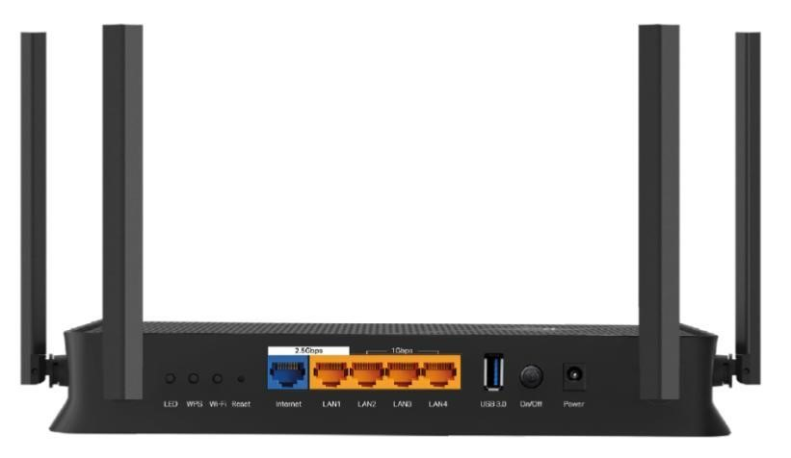

Specification
Product Name | TP-Link Archer BE230 BE3600 Wi-  Fi 7 Router
Brand | TP-Link
Device Type | Wireless Router (Wi-Fi 7)
Wi-Fi Standard | Wi-Fi 7 (802.11be)
Wi-Fi Speed | Up to 3.6 Gbps (Dual-Band)
2.4 GHz Speed | 688 Mbps
5 GHz Speed | 2882 Mbps
Frequency Bands | Dual-Band (2.4 GHz & 5 GHz)
Antennas | 4 External Antennas
Wi-Fi Range | Suitable for 3-bedroom houses
Wi-Fi Features | Beamforming, OFDMA, 2×2 MU-  MIMO, Airtime Fairness
Advanced Features | Multi-Link Operation (MLO), 4K-  QAM, Multi-RUs
Ethernet Ports | 1× 2.5 Gbps WAN, 1× 2.5 Gbps  LAN, ”× 1 Gbps LAN
Total LAN Ports | 5 ports
USB Functions | 1× USB 3.0
Network Modes | Router Mode, Access Point Mode
Mesh Compatibility | EasyMesh Compatible
Security Features | SPI Firewall, Access Control, IP &  MAC Binding
Home Security | TP-Link HomeShield (IoT  Protection, IPS, DDoS Prevention)
VPN Support | OpenVPN, PPTP, L2TP, WireGuard
Guest Network | 1× 2.4 ‘Hz, 1× 5 GHz
Wi-Fi Encryption | WPA, WPA2, WPA3, WPA/WPA2-  Enterprise
Parental Controls | HomeShield Parental Controls
QoS | QoS by Device
Power Supply | 12V ⎓ 2A (US), 12V ⎓ 1.5A (EU)
Management App | TP-Link Tether App
Smart Compatibility | Works with Alexa & google  Assistant

4.1 User’s Manual https://www.tp-link.com/us/document/107339/?app=t.

The network design follows a star topology where each floor has its own switch connecting all desktop computers. These switches are connected to a central router that manages internet connectivity. A hub is included for demonstration purposes, but switches are used as the primary networking device due to their efficiency and ability to reduce network collisions.

EQUIPMENT | BRAND | MODEL | QUANTITY
Desktop | Dell | 27 All-in-One  EC27250 | 29
Switch | D-Link | DGS-1210-24-  Port  10/100/1000Mbps plus 4 Combo | 3
Router | TP-Link | Archer BE230 | 1

5. FLOOR PLAN (Use Ruler Scale for Accuracy)
Each floor is equipped with one switch to connect all desktop computers. The switches are interconnected and linked to a central router to provide internet access throughout the building.
Ground Floor
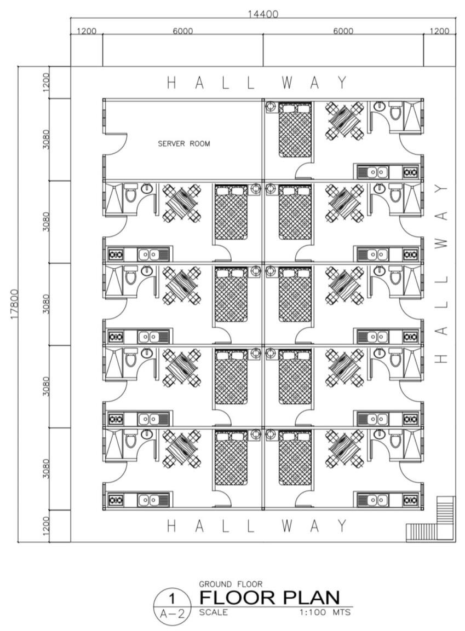

Second Floor

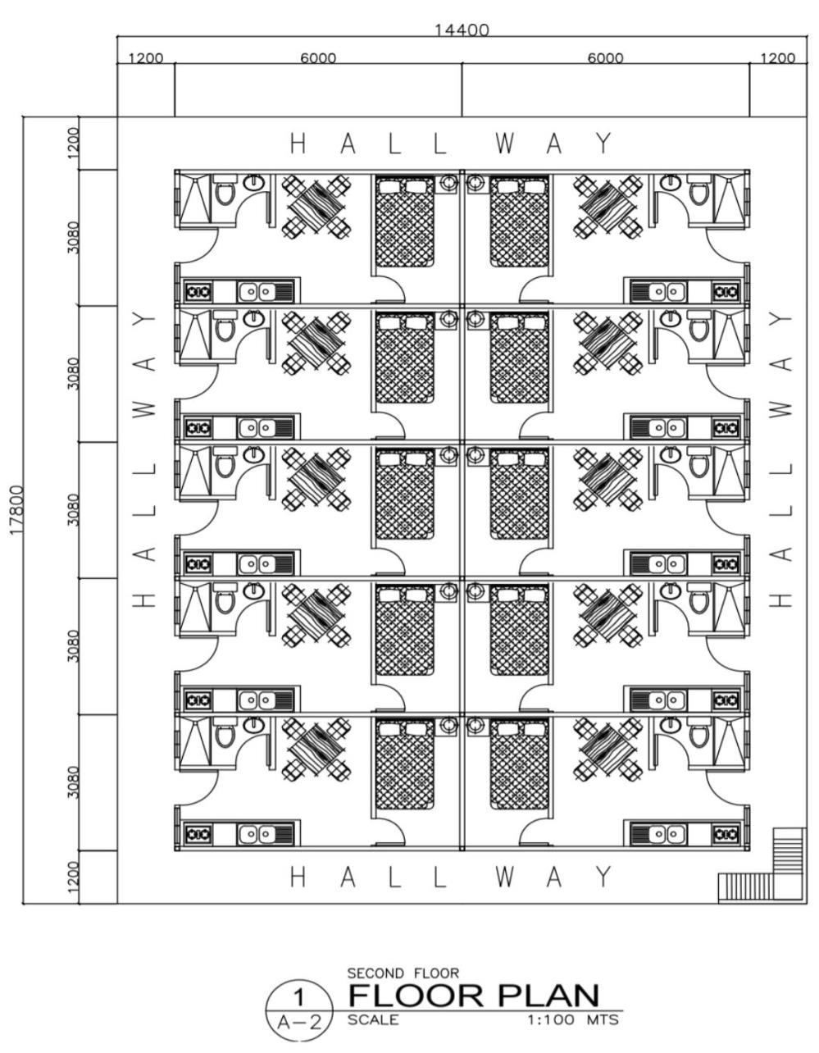
Third Floor
