LOCAL AREA NETWORK DESIGN

A Project
Presented to the
Faculty of College of Engineering and Digital Technology
ICCT Colleges Foundation Inc.
V.V. Soliven Avenue II Cainta Rizal
Bachelor of Science Major in Computer Engineering
BY.
GROUP 8E
BRANDON ASHLEY P.
CADIMAS JULLIANA E.
DELOS SANTOS EMMANUEL B.
ESCOBAL RUBEN III M.
ESTARIS KRISTINE YVONNE F.
FRANCISCO JENNICA HAZEL V.
HERRADURA LAMECH UZ R.
VALDEZ KENNETH JAMES M.

CHAPTER 4: Design Configuration

4.0 SERVER IP ADDRESS CONFIG

A. SERVER CONFIGURATION
Step 1: Open Control Panel
- Click on the Windows Search Bar.
- Type “Control Panel” and open it.

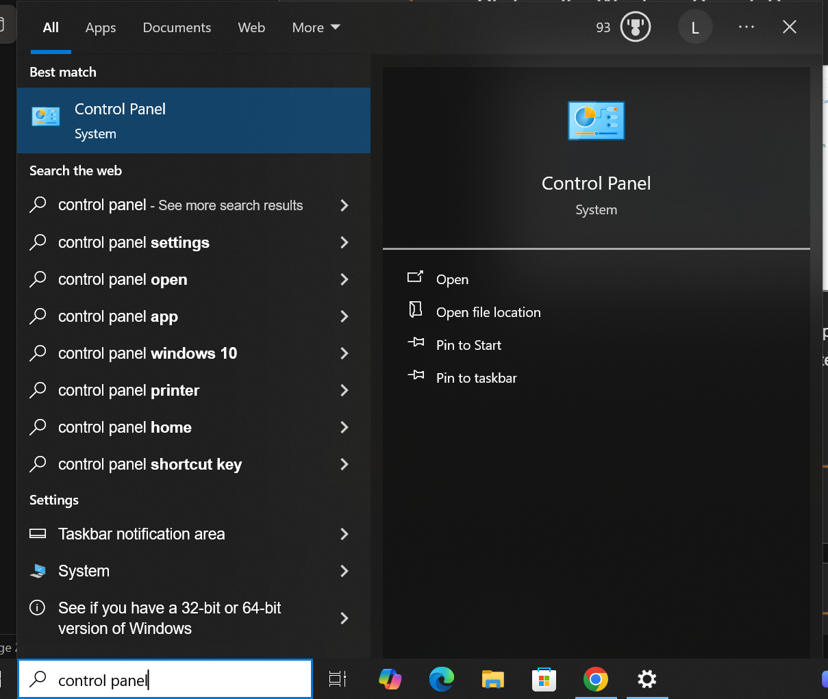

Step 2: Open Network and Sharing Center
- Click “Network and Internet”.
- Open “Network and Sharing Center”.
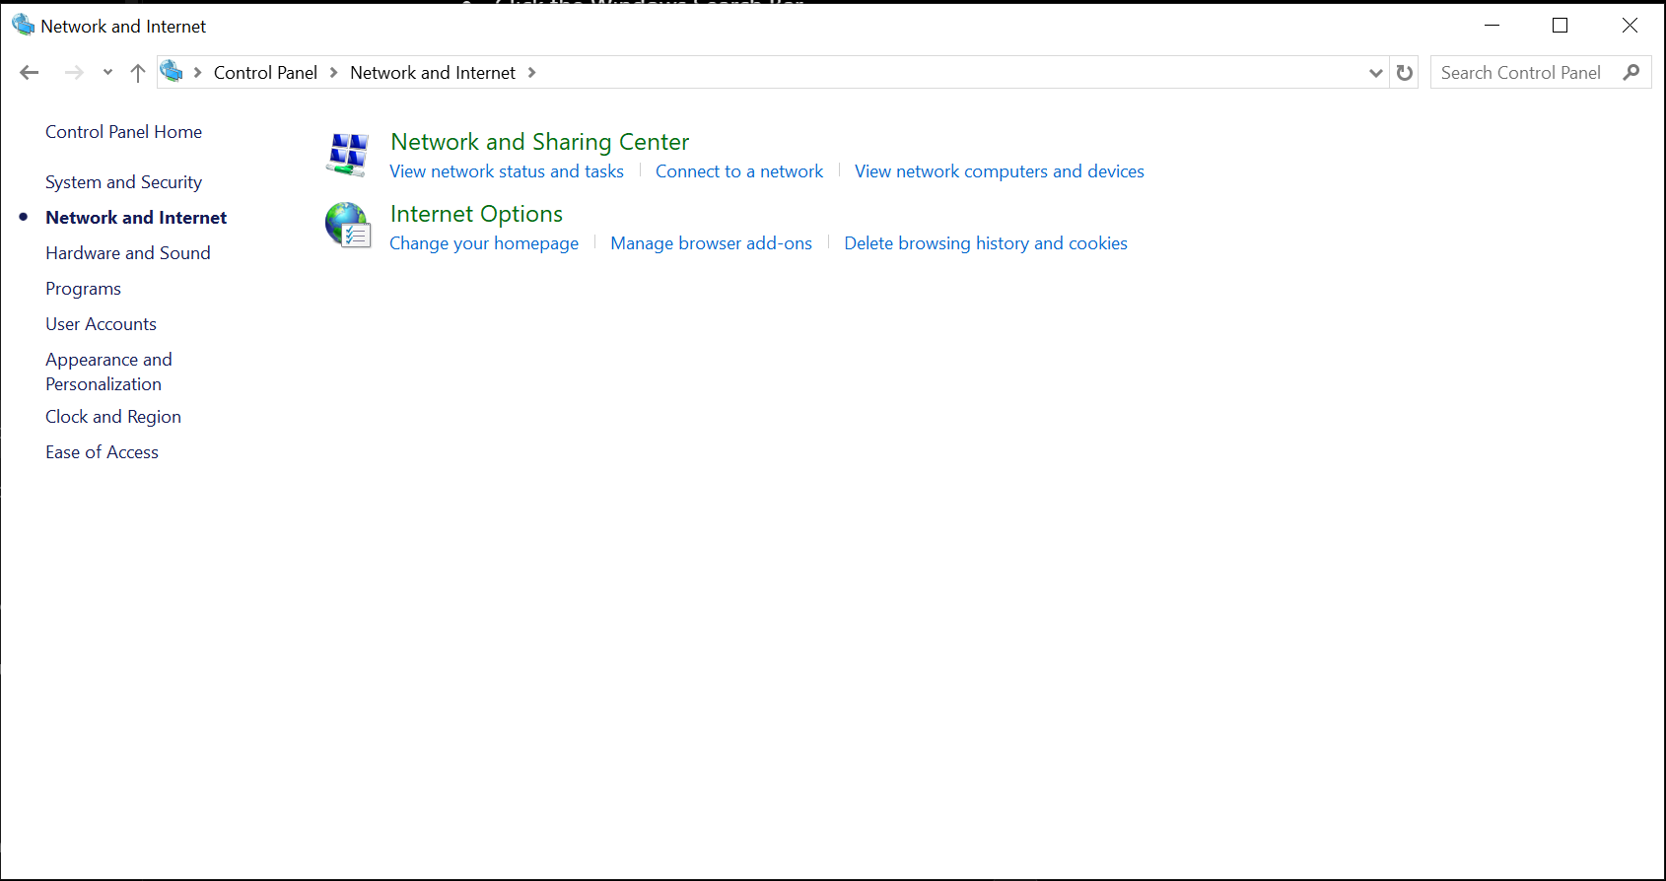
Figure 4.0.2 Network and Sharing Center
Step 3: Open Adapter Settings
- Click “Change Adapter Settings”.
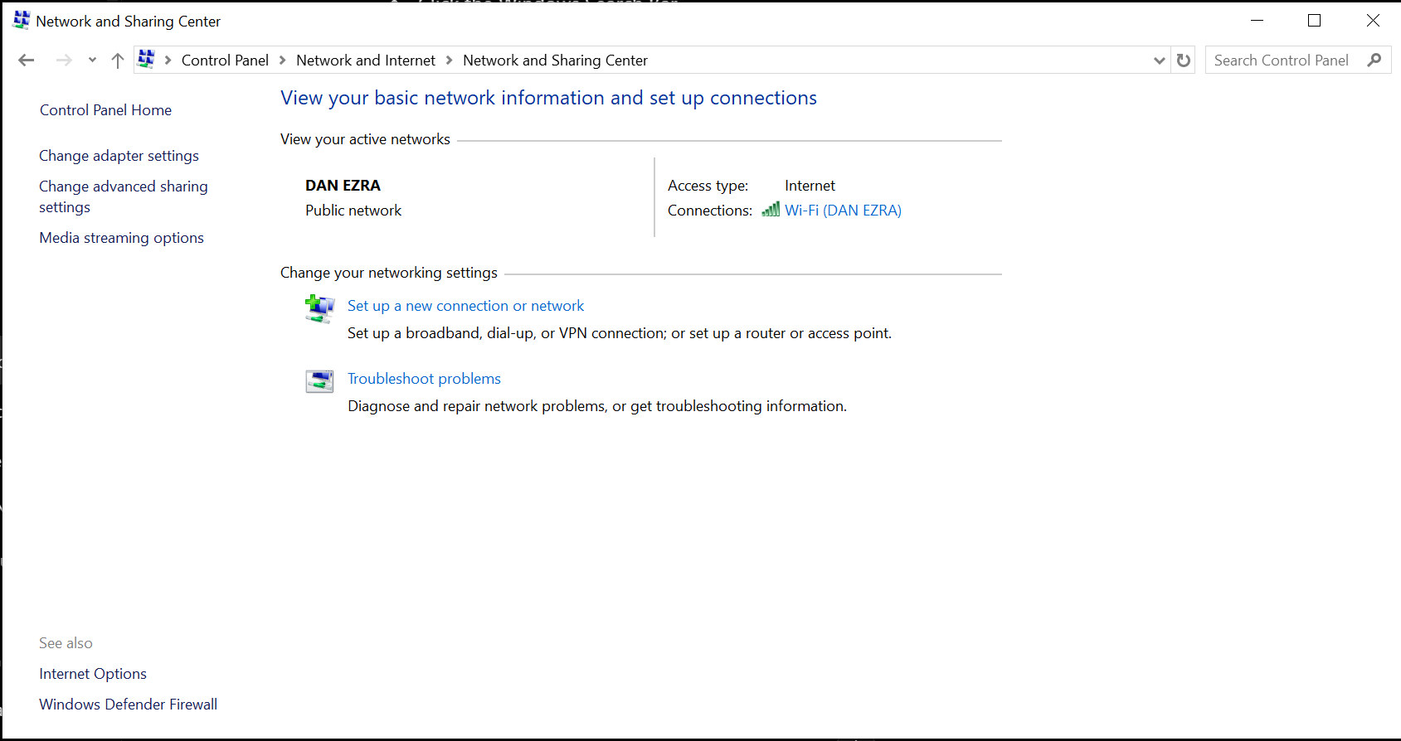
Figure 4.0.3 Adapter Settings

Step 4: Open Ethernet Properties
- Right click “Ethernet”.
- Select “Properties”.
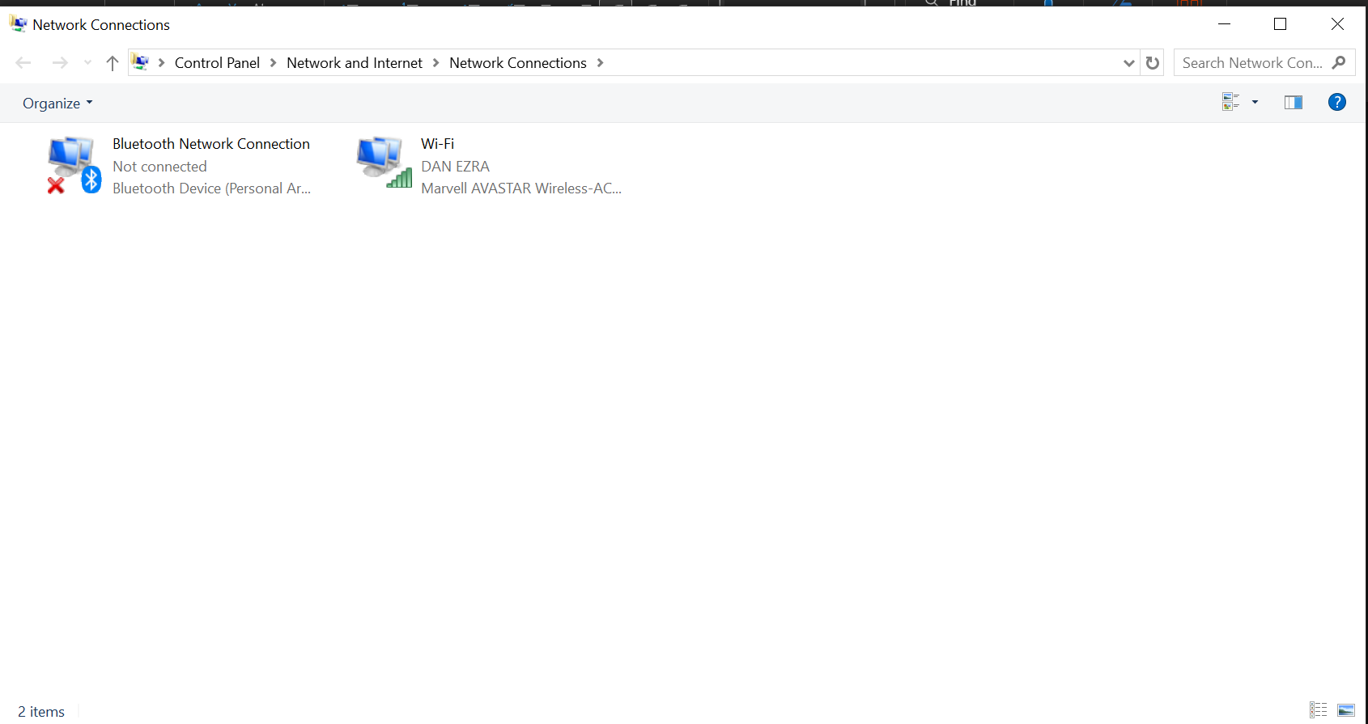

Figure 4.0.4 Ethernet Properties

Step 5: Configure IPv4
- Double click “Internet Protocol Version 4 (TCP/IPv4)”.
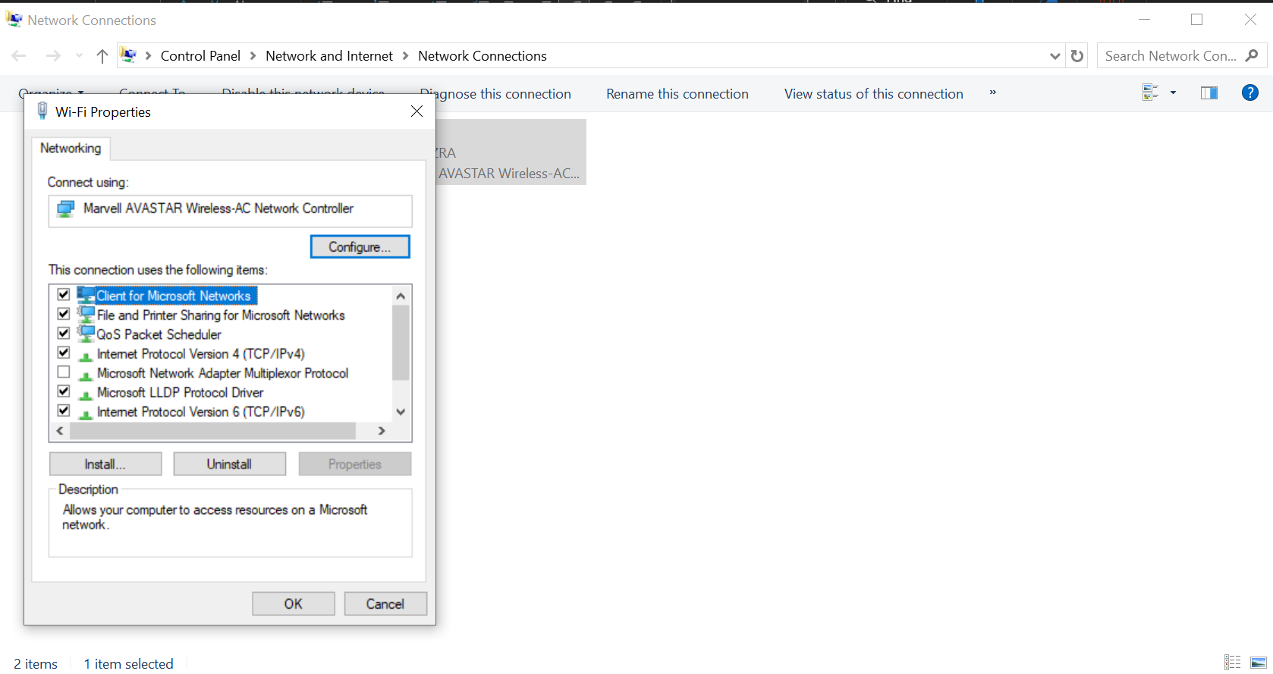
Figure 4.0.5 IPv4 Settings

Step 6: Configure Static IP Address
- Select “Use the following IP address”.
- Input the following configuration:
- SETTING VALUE
- IP ADRESS 10.0.10.10
- SUBNET MASK 255.255.255.0
- DEFAULT GATEWAY 10.0.010.1
- PREFERRED DNS SERVER 8.8.8.8
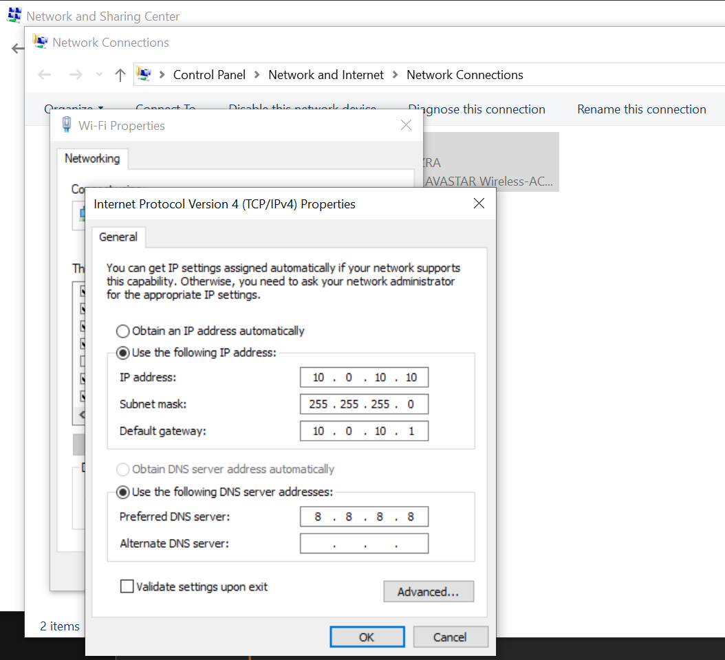
Figure 4.0.6 Server IP Configuration

Step 7: Save Configuration
- Click “OK” to save the configuration.

B. CLIENT CONFIGURATION
The client computers were configured using different IP addresses within the same network.

DEVICE IP ADDRESS SUBNET MASK DEFAULT GATEWAY DNS
Client PC 1 10.0.10.13 255.255.255.0 10.0.10.1 8.8.8.8
Client PC 2 10.0.10.14 255.255.255.0 10.0.10.1 8.8.8.8

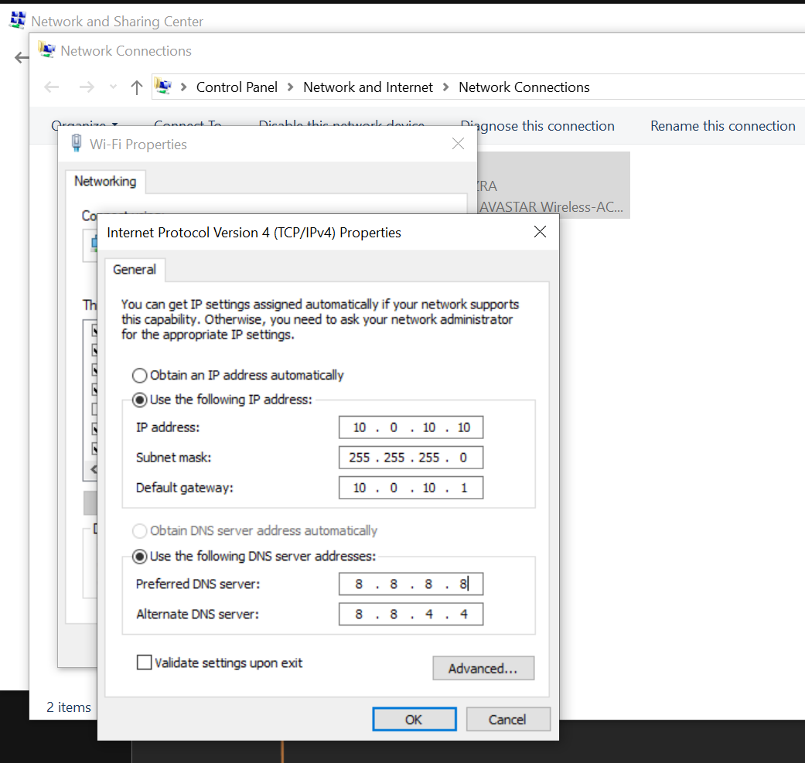

4.1 CLIENT PC CONFIGURATION 1ST FLOOR TO 3RD FLOOR (NEED PROCESS AND SS)

4.2 NETWORK CONFIGURATION SUMMARY

DEVICES | IP ADDRESS | SUBNET MASK | DEFAULT GATEWAY | DNS | REMARKS
ROUTER | 10.0.99.1 | 255.255.255.0 | N/A | 8.8.8.8 | CORE GATEWAY
MAIN SWITCH | 10.0.99.2 | 255.255.255.0 | 10.0.99.1 | 8.8.8.8 | MANAGED
ACCESS POINT | 10.0.99.3 | 255.255.255.0 | 10.0.99.1 | 8.8.8.8 | WIFI
NVR/DVR | 10.0.99.4 | 255.255.255.0 | 10.0.99.1 | 8.8.8.8 | RECORDER
CCTV1 | 10.0.40.101 | 255.255.255.0 | 10.0.40.1 | 8.8.8.8 | SERVER ROOM
CCTV2 | 10.0.40.102 | 255.255.255.0 | 10.0.40.1 | 8.8.8.8 | GUARD HOUSE
CCTV3 | 10.0.40.103 | 255.255.255.0 | 10.0.40.1 | 8.8.8.8 | GATE ENTRY
CCTV4 | 10.0.40.104 | 255.255.255.0 | 10.0.40.1 | 8.8.8.8 | GATE EXIT
CCTV5 | 10.0.40.105 | 255.255.255.0 | 10.0.40.1 | 8.8.8.8 | PARKING
CCTV6 | 10.0.40.106 | 255.255.255.0 | 10.0.40.1 | 8.8.8.8 | PARKING
CCTV7 | 10.0.40.107 | 255.255.255.0 | 10.0.40.1 | 8.8.8.8 | HALLWAY 1A
CCTV8 | 10.0.40.108 | 255.255.255.0 | 10.0.40.1 | 8.8.8.8 | HALLWAY 1B
CCTV9 | 10.0.40.109 | 255.255.255.0 | 10.0.40.1 | 8.8.8.8 | HALLWAY 2A
CCTV10 | 10.0.40.110 | 255.255.255.0 | 10.0.40.1 | 8.8.8.8 | HALLWAY 2B
CCTV11 | 10.0.40.111 | 255.255.255.0 | 10.0.40.1 | 8.8.8.8 | HALLWAY 3A
CCVTV12 | 10.0.40.112 | 255.255.255.0 | 10.0.40.1 | 8.8.8.8 | HALLWAY 3B
1ST FLR SWITCH | N/A | N/A | N/A | N/A | UNMANAGED
PC1 | 10.0.10.10 | 255.255.255.0 | 10.0.10.1 | 8.8.8.8 | SERVER
PC2 | 10.0.10.11 | 255.255.255.0 | 10.0.10.1 | 8.8.8.8 | SERVER
PC3 | 10.0.10.12 | 255.255.255.0 | 10.0.10.1 | 8.8.8.8 | SERVER
PC4 | 10.0.10.13 | 255.255.255.0 | 10.0.10.1 | 8.8.8.8 | CLIENT
PC5 | 10.0.10.14 | 255.255.255.0 | 10.0.10.1 | 8.8.8.8 | CLIENT
PC6 | 10.0.10.15 | 255.255.255.0 | 10.0.10.1 | 8.8.8.8 | CLIENT
PC7 | 10.0.10.16 | 255.255.255.0 | 10.0.10.1 | 8.8.8.8 | CLIENT
PC8 | 10.0.10.17 | 255.255.255.0 | 10.0.10.1 | 8.8.8.8 | CLIENT
PC9 | 10.0.10.18 | 255.255.255.0 | 10.0.10.1 | 8.8.8.8 | CLIENT
PC10 | 10.0.10.19 | 255.255.255.0 | 10.0.10.1 | 8.8.8.8 | CLIENT
2NDFLR SWITCH | N/A | N/A | N/A | N/A | UNMANAGED
PC11 | 10.0.20.10 | 255.255.255.0 | 10.0.20.1 | 8.8.8.8 | CLIENT
PC12 | 10.0.20.11 | 255.255.255.0 | 10.0.20.1 | 8.8.8.8 | CLIENT
PC13 | 10.0.20.12 | 255.255.255.0 | 10.0.20.1 | 8.8.8.8 | CLIENT
PC14 | 10.0.20.13 | 255.255.255.0 | 10.0.20.1 | 8.8.8.8 | CLIENT
PC15 | 10.0.20.14 | 255.255.255.0 | 10.0.20.1 | 8.8.8.8 | CLIENT
PC16 | 10.0.20.15 | 255.255.255.0 | 10.0.20.1 | 8.8.8.8 | CLIENT
PC17 | 10.0.20.16 | 255.255.255.0 | 10.0.20.1 | 8.8.8.8 | CLIENT
PC18 | 10.0.20.17 | 255.255.255.0 | 10.0.20.1 | 8.8.8.8 | CLIENT
PC19 | 10.0.20.18 | 255.255.255.0 | 10.0.20.1 | 8.8.8.8 | CLIENT
PC20 | 10.0.20.19 | 255.255.255.0 | 10.0.20.1 | 8.8.8.8 | CLIENT
3RD FLR SWITCH | N/A | N/A | N/A | N/A | UNMANAGED
PC21 | 10.0.30.10 | 255.255.255.0 | 10.0.30.1 | 8.8.8.8 | CLIENT
PC22 | 10.0.30.11 | 255.255.255.0 | 10.0.30.1 | 8.8.8.8 | CLIENT
PC23 | 10.0.30.12 | 255.255.255.0 | 10.0.30.1 | 8.8.8.8 | CLIENT
PC24 | 10.0.30.13 | 255.255.255.0 | 10.0.30.1 | 8.8.8.8 | CLIENT
PC25 | 10.0.30.14 | 255.255.255.0 | 10.0.30.1 | 8.8.8.8 | CLIENT
PC26 | 10.0.30.15 | 255.255.255.0 | 10.0.30.1 | 8.8.8.8 | CLIENT
PC27 | 10.0.30.16 | 255.255.255.0 | 10.0.30.1 | 8.8.8.8 | CLIENT
PC28 | 10.0.30.17 | 255.255.255.0 | 10.0.30.1 | 8.8.8.8 | CLIENT
PC29 | 10.0.30.18 | 255.255.255.0 | 10.0.30.1 | 8.8.8.8 | CLIENT
PC30 | 10.0.30.19 | 255.255.255.0 | 10.0.30.1 | 8.8.8.8 | CLIENT

CHAPTER 5: CENTRAL MONITORING

5.0 DIAGRAM

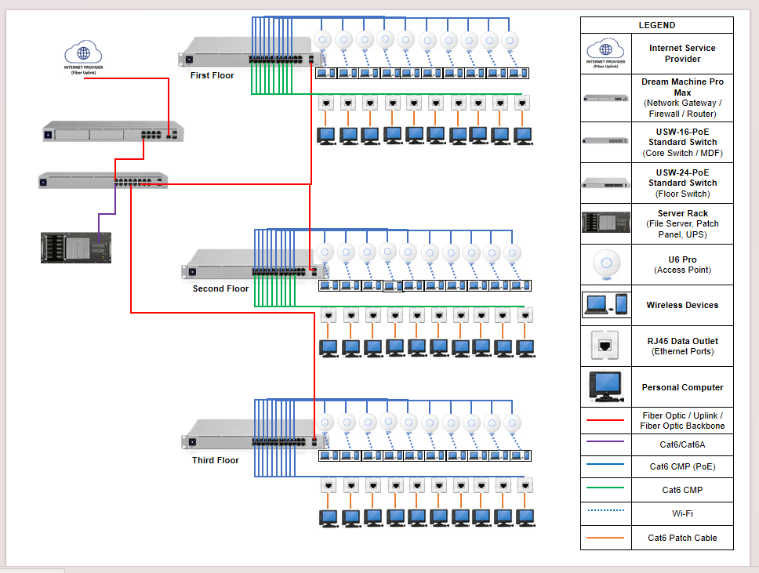

5.1 MAIN CENTRAL MONITORING EQUIPMENT USED

Internet Service Provider (ISP)

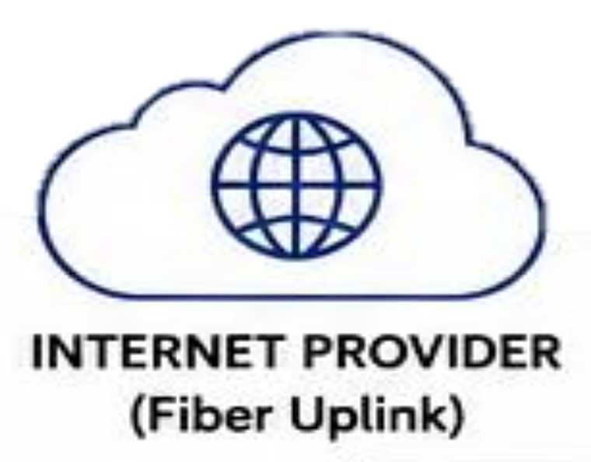
The Internet Service Provider supplies the external network connection that enables the entire LAN to access online services, global communication, and cloud-based resources. It serves as the entry point for all incoming and outgoing internet traffic and provides the public IP addressing and bandwidth needed for stable and reliable connectivity.

Dream Machine Pro Max (Gateway / Router / Firewall)
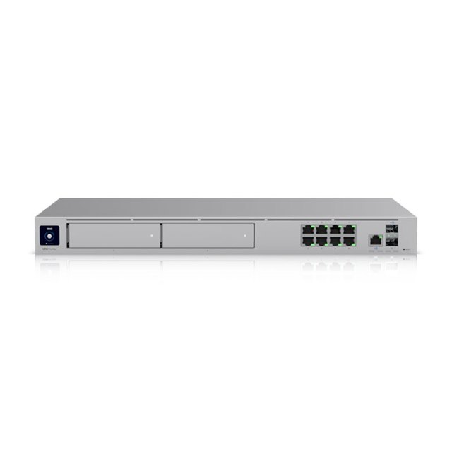

The Dream Machine Pro Max is an all-in-one device that acts as the main gateway router and firewall. It connects the internet service provider to the whole local network and fixes problems like unorganized traffic security risks and hard to monitor connections. It is very important because it controls where data goes blocks threats manages flow and lead administrators see all activity in real time. It keeps the entire network stable safe and properly connected.
USW-16-PoE Standard Switch (Core Switch / MDF)

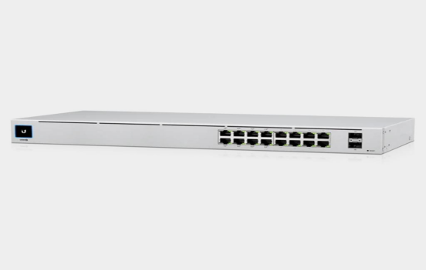

The USW-16-PoE Standard Switch (Core Switch / MDF layer) functions as the main distribution point of the network backbone. It connects the main gateway to different floor switches and server systems. Without it, network traffic would not be properly centralized, making communication between different floors unstable or inefficient.

USW-24-PoE Standard Switch (Floor Switch)

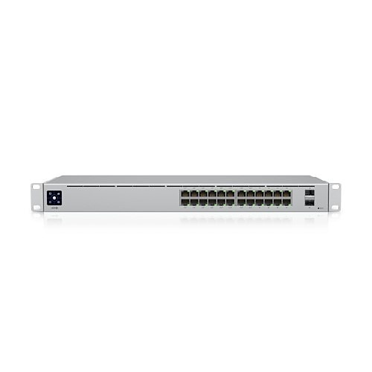
The USW-24-PoE is the floor-level distribution switch that connects all devices on a specific floor, including PCs and access points, and supplies PoE power where needed. It handles the switching of local data traffic, organizes wired connections through structured cabling, and sends the combined floor traffic to the core switch for routing and monitoring. This prevents overload on a single connection and ensures smooth and organized network access per area.
Server Rack (File Server, Patch Panel, UPS)

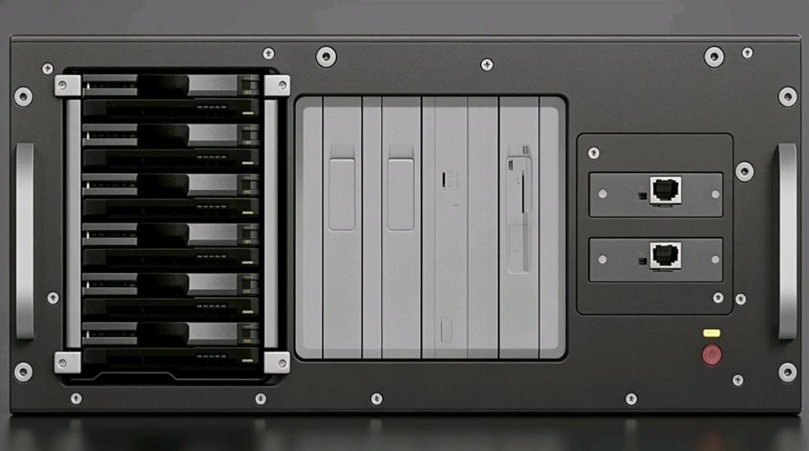

The server rack is a centralized physical enclosure designed to securely house and organize critical network and computing equipment such as the file server for data storage and backup, the patch panel for structured cable termination and management, and the UPS (Uninterruptible Power Supply) for power protection and backup. It solves the common problems of cable disorganization, equipment vulnerability, and inefficient space usage by consolidating all essential networking hardware into one structured and accessible location. Without a server rack, networks often suffer from messy cabling, difficult troubleshooting, higher risk of accidental disconnections, and increased chance of equipment damage. Its importance lies in its role as the main physical hub of the network infrastructure, ensuring proper cable management, stable power supply, and continuous data availability. It also improves maintenance efficiency, allows faster troubleshooting, enhances system reliability, and helps protect critical network resources from unexpected power failures or hardware issues.

U6 Pro (Access Point)
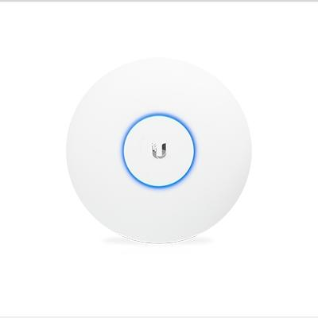
The U6 Pro access point is a wireless networking device that provides Wi-Fi coverage across each floor of the building, allowing mobile phones, laptops, and other wireless devices to connect to the network without the need for physical Ethernet cables. It solves the problem of limited mobility and weak or inconsistent wireless signals in large or multi-floor environments by extending strong and stable Wi-Fi coverage throughout the area. Without access points like the U6 Pro, users would experience dead zones, slow connectivity, and unreliable network access when moving around the building. Its importance is in providing reliable wireless connectivity, improving user mobility within the network, and supporting Power over Ethernet (PoE) for easier installation and reduced cabling requirements.

Wireless Devices

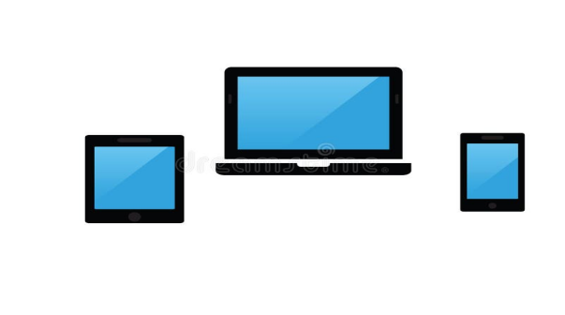

Wireless devices such as laptops, tablets, and smartphones connect through the access points to access internet services, internal servers, and shared resources. They rely on the wireless network for mobility and convenience, contributing to flexible and efficient communication within the LAN.

RJ45 Data Outlet
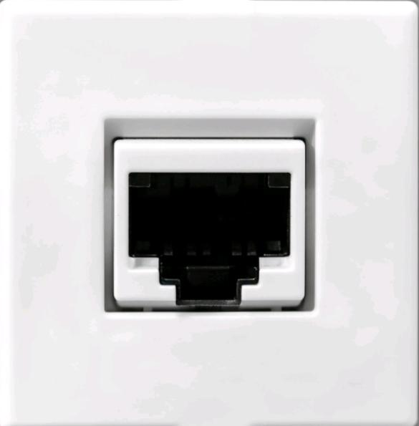

The RJ45 data outlet serves as the connection point for wired devices, providing a stable and secure interface between desktop computers and the structured cabling system. It helps maintain orderly cabling, ensures reliable data transmission, and supports the wired infrastructure used on each floor.

Personal Computer (End Device)
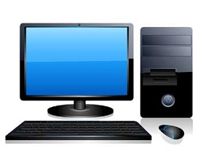
Personal computers act as end-user devices that access network resources such as internet connectivity, shared files, communication tools, and internal services. They generate and receive most of the data passing through the network, making them essential terminals in daily operations.

LAN Cables
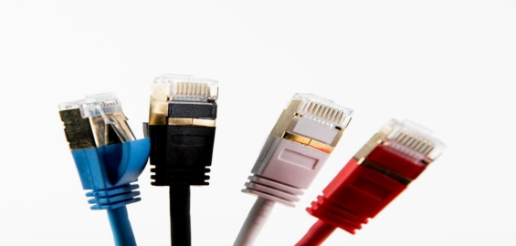

(Cat6/Cat6A, Cat6 CMP, Cat6 CMP PoE, and Cat6 patch cables) are responsible for carrying data signals between computers, switches, access points, and other network equipment. Each type has a specific role: patch cables connect switches to the patch panel, Cat6 CMP cables run through walls for workstation connections, and Cat6 CMP PoE cables deliver both power and data to devices like Wi-Fi access points. These cables form the wired infrastructure of the LAN, ensuring fast, stable, and low-latency communication across all devices in the network.

Fiber Optic Cable
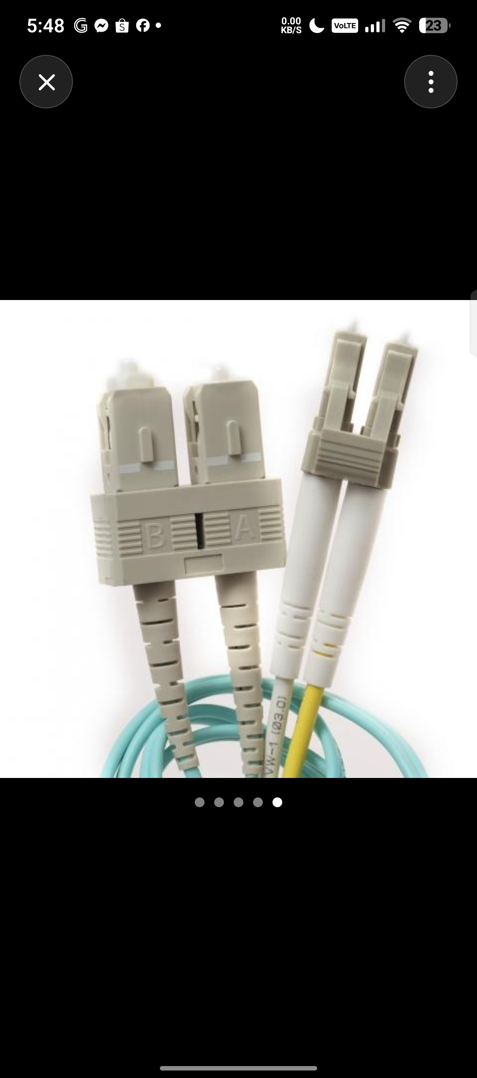

The fiber optic provides a high-speed backbone connecting the core switch, floor switches, and the main gateway. These cables use light instead of electrical signals, allowing them to transmit large amounts of data over long distances with minimal loss and maximum speed. The fiber uplink ensures that each floor receives strong and stable connectivity, prevents network bottlenecks, and supports gigabit or even multi-gigabit data transmission between key networking equipment.

