4.0 SERVER IP ADDRESS CONFIGURATION.
In this chapter we will configure the ip address of the network both for dynamic (dhcp) and static IPs
Note: the entire configuration process is done on a computer running windows 11. The entire process may be different on other version of windows.

Static IP configuration (GUI):
Step 1: Open the Start Menu and click Settings.
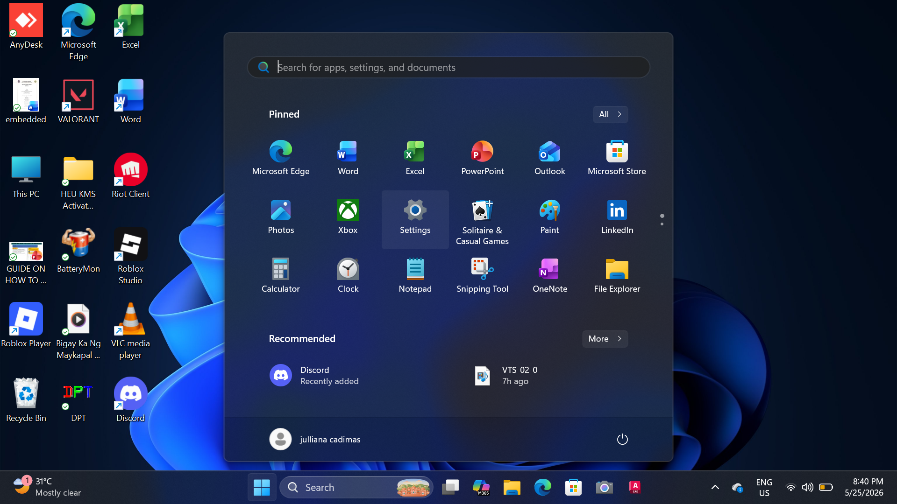

Step 2: Go on Network & Internet.

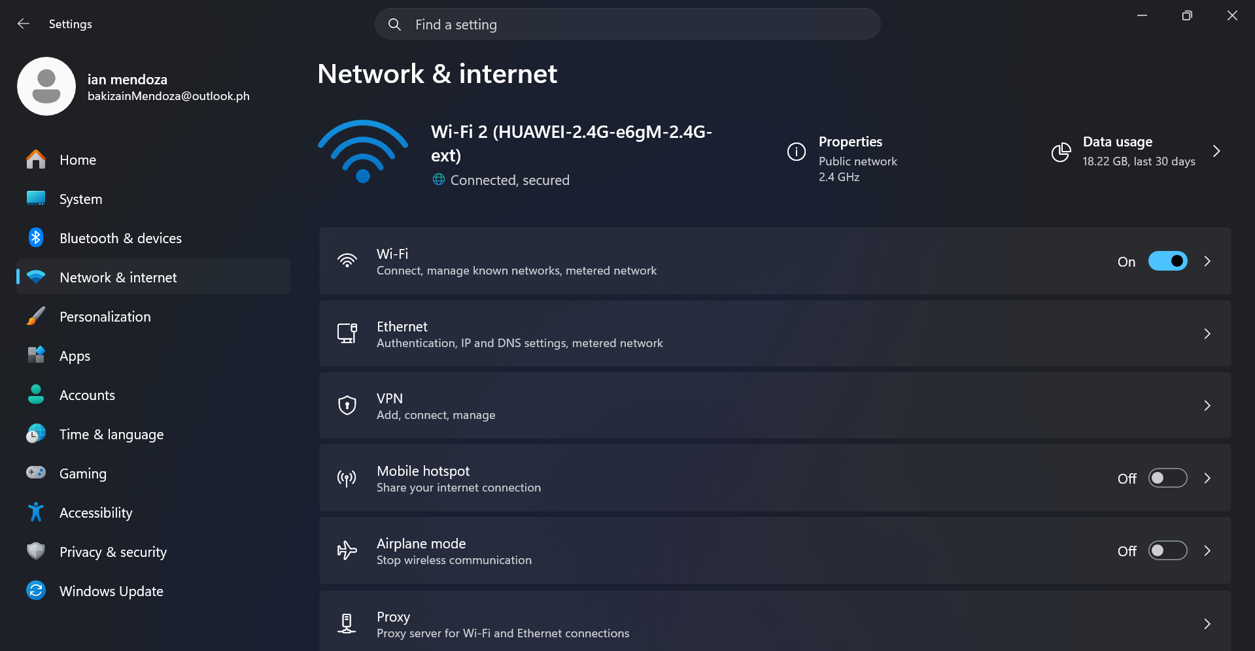

Step 3: Click your active network adapter (Ethernet) and Select the Edit button in the IP Settings.
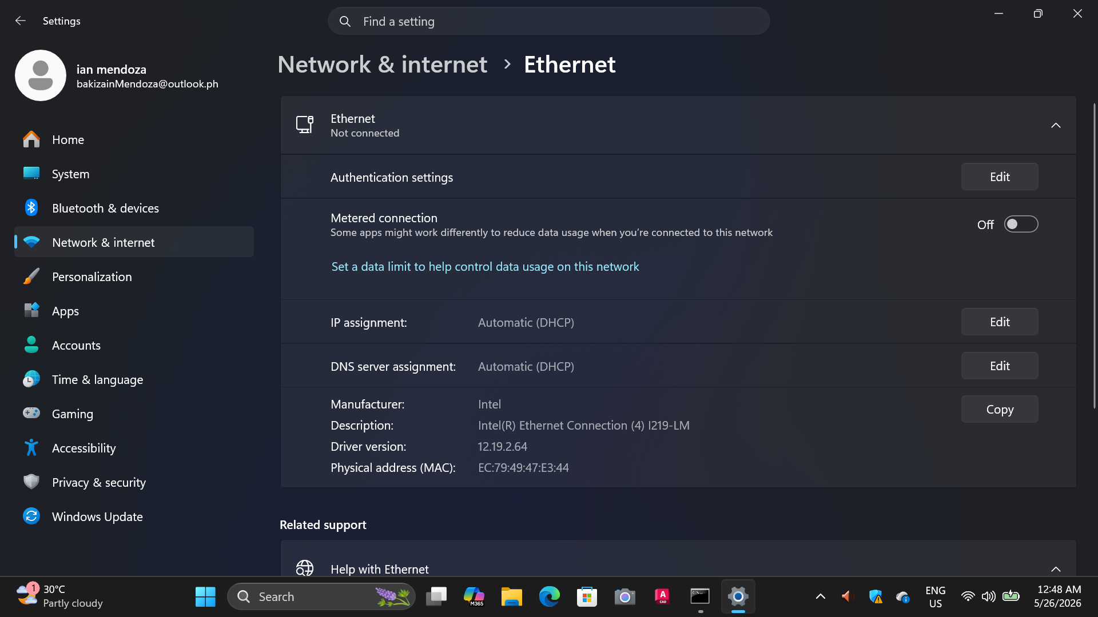

Step 4: In the Edit IP settings change it from Automatic to Manual.
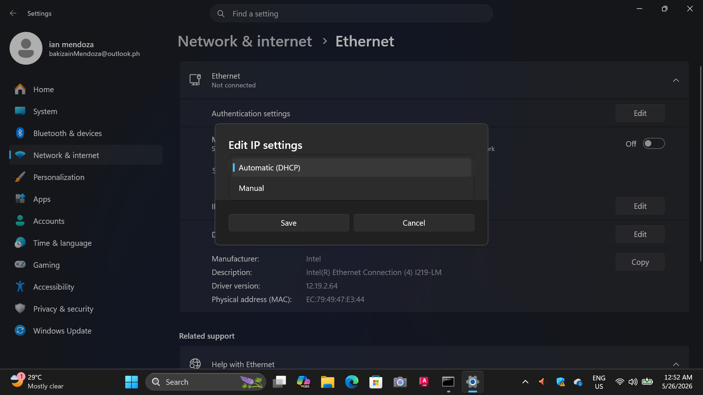

Step 5: Select the toggle on the IPV4, configure the IP address and the other requirements then click Save.

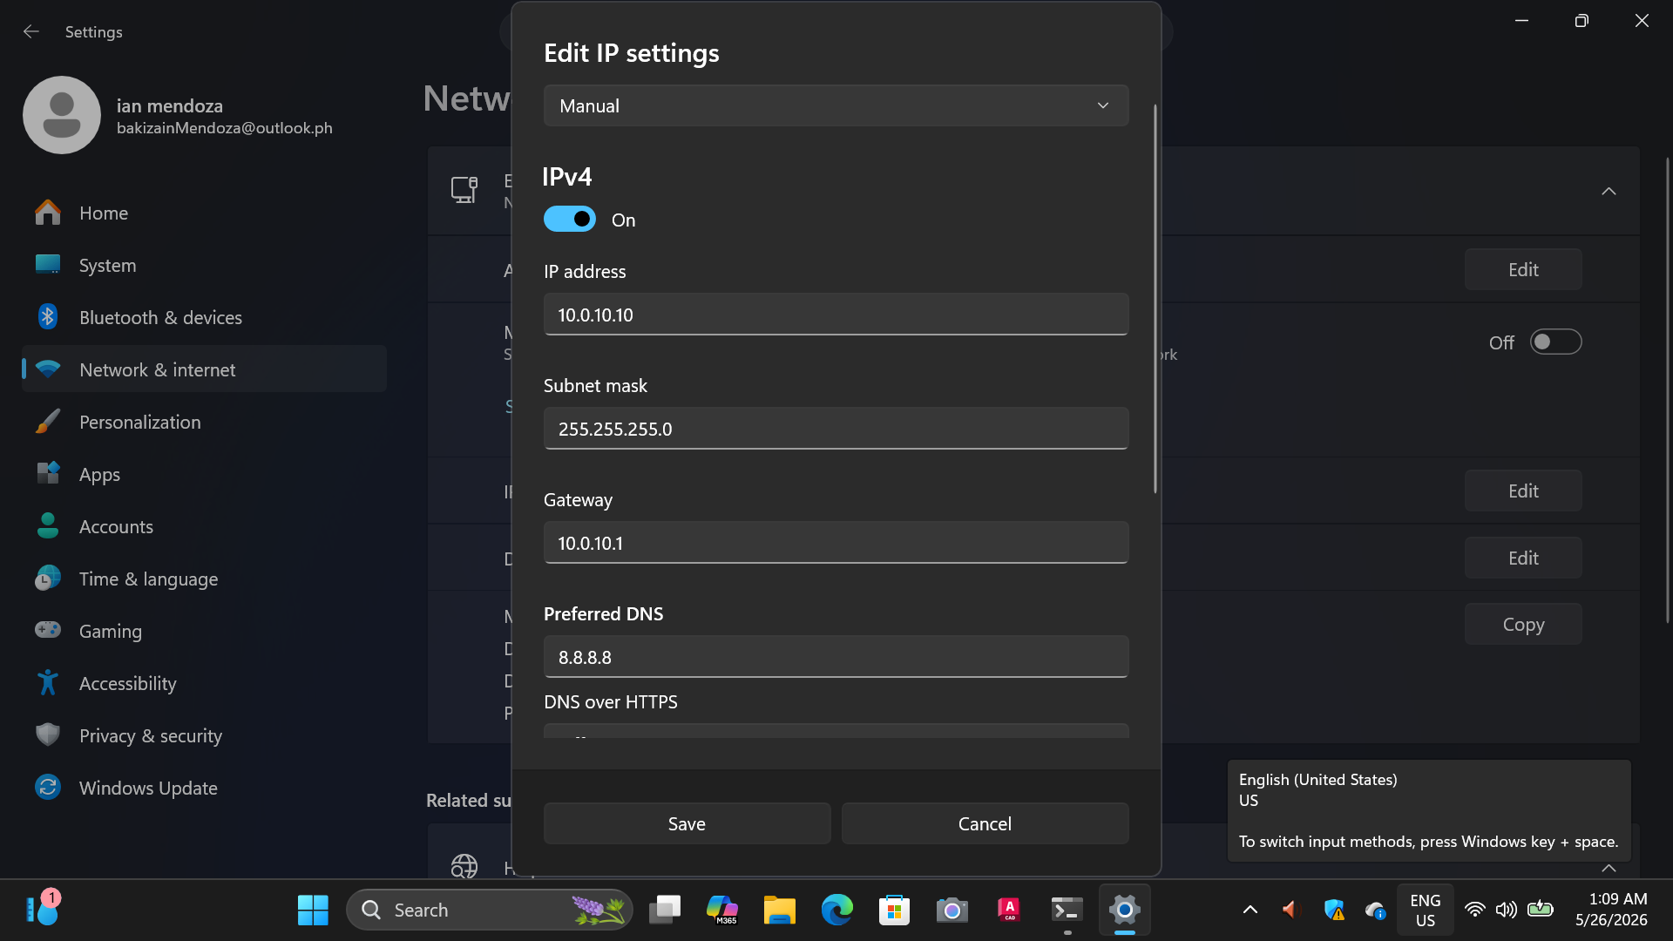

Static IP configuration (CLI):
Step 1: Go to the Start Menu and Search for the Command Prompt then select Run as Administrator.
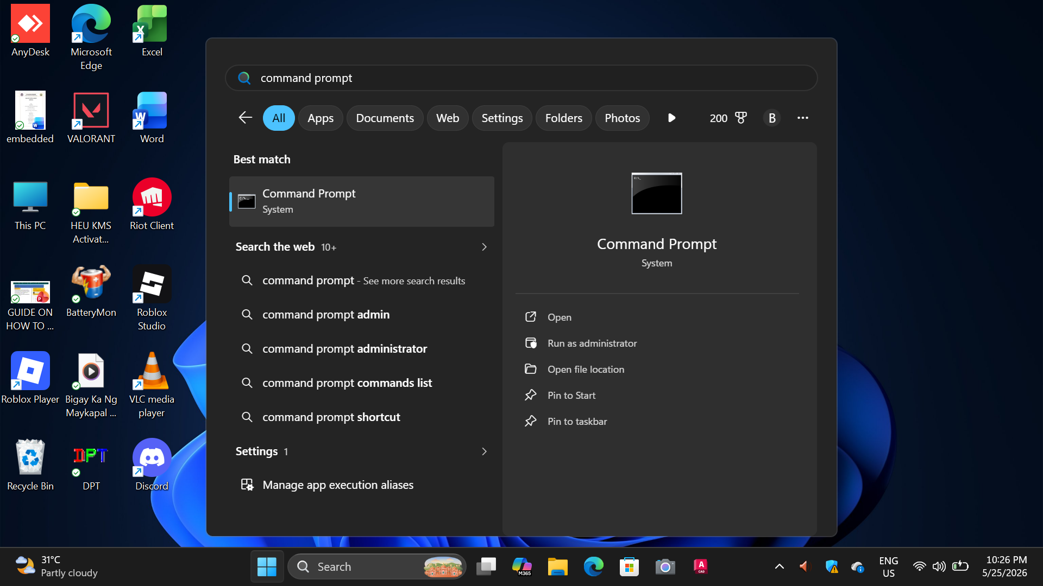

Step 2: In the command prompt type the ipconfig/all command and press Enter.
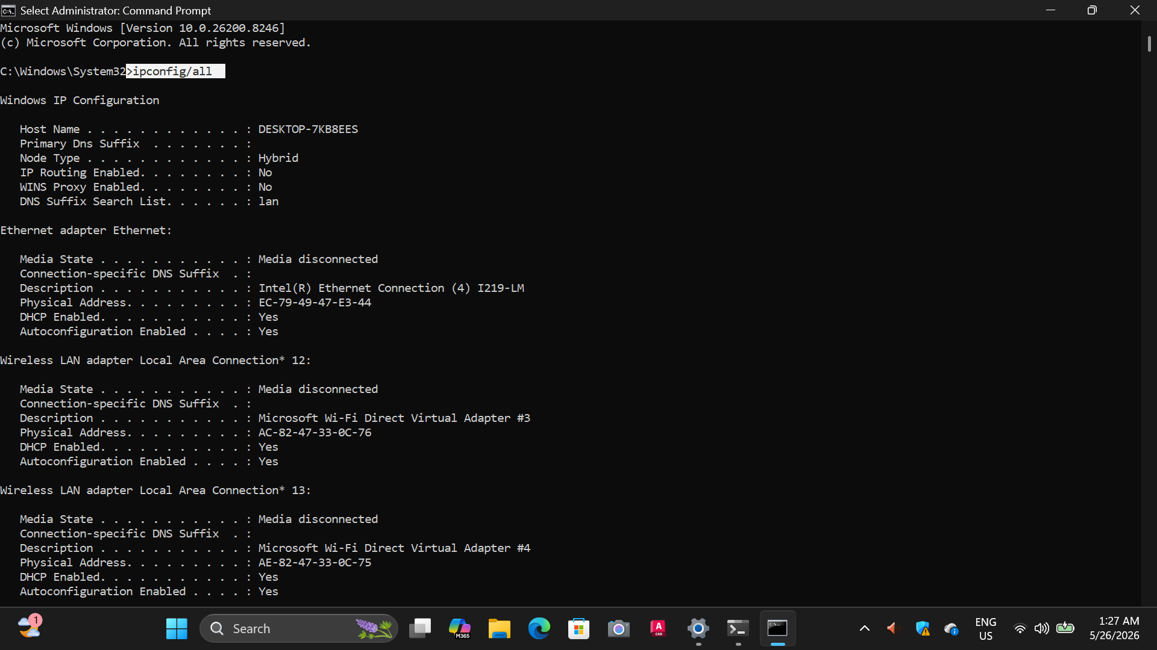

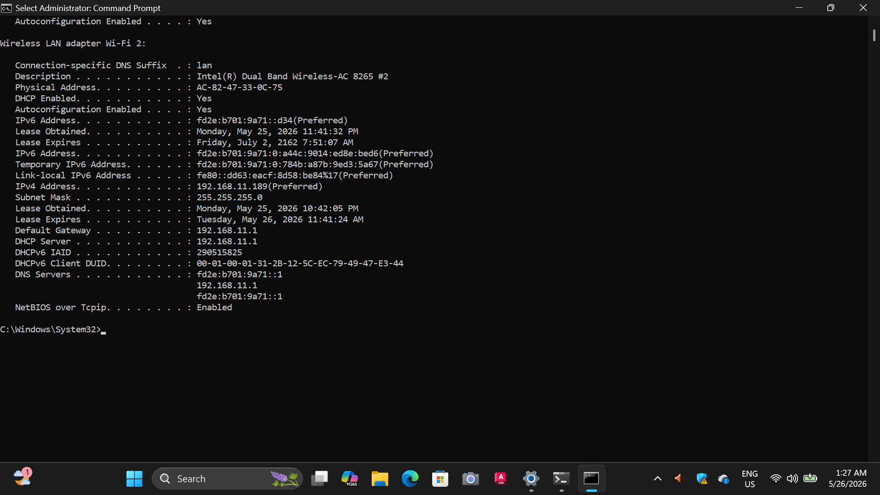
Step 3: Type the following command given below and press Enter:
netsh interface ip set address name=“name of your adapter” static IP address Subnet mask. Default gateway
netsh interface ip set address name=”Ethernet” static 10.0.10.10 255.255.255.0 10.0.10.1

This command is used to manually assign and configure a static IP address to the specific network adapter.
Step 4: To configure the DNS server address, type the following command and press Enter:
netsh interface ip set dns name=“name of your adapter” static 10.0.10.10
Once all required network configurations are entered, the static IP setup process is complete.

Note: The information above is just a given example, The information setup for Static IP address, Subnet mask, Default gateway as well as the Static DNS depends on the user’s network configurations.
4.1 CLIENT CONFIGURATION
Step 1: On the Start Menu, search the Control Panel and click Open.

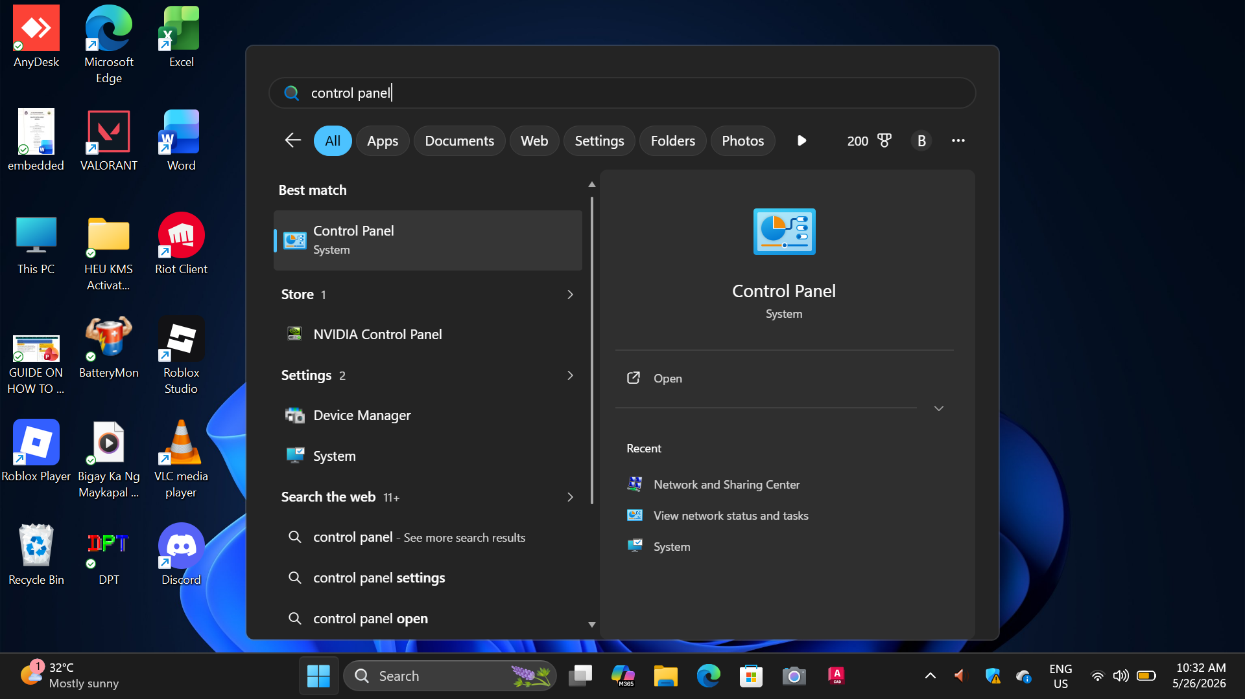

Step 2: Go to the Network and Internet then choose the Network and Sharing Center.
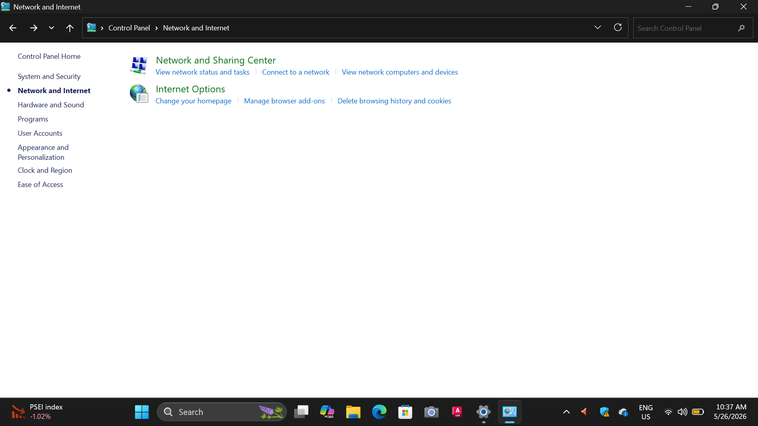

Step 3: Select your active connection name (Wi-Fi or Ethernet) to check the network. For the Ethernet, click “Change the Adapter Settings”.
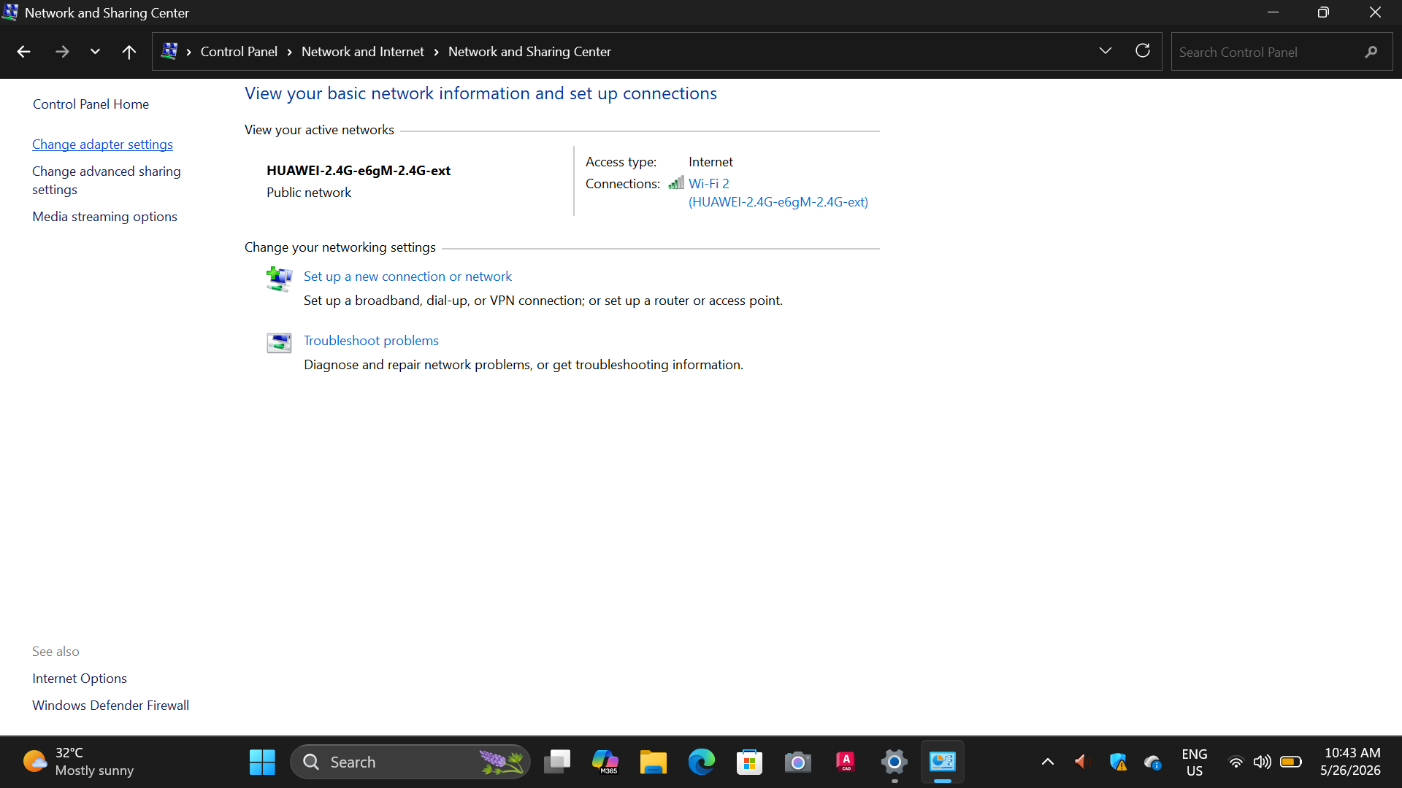

Step 4: Right click the Ethernet then click Properties.
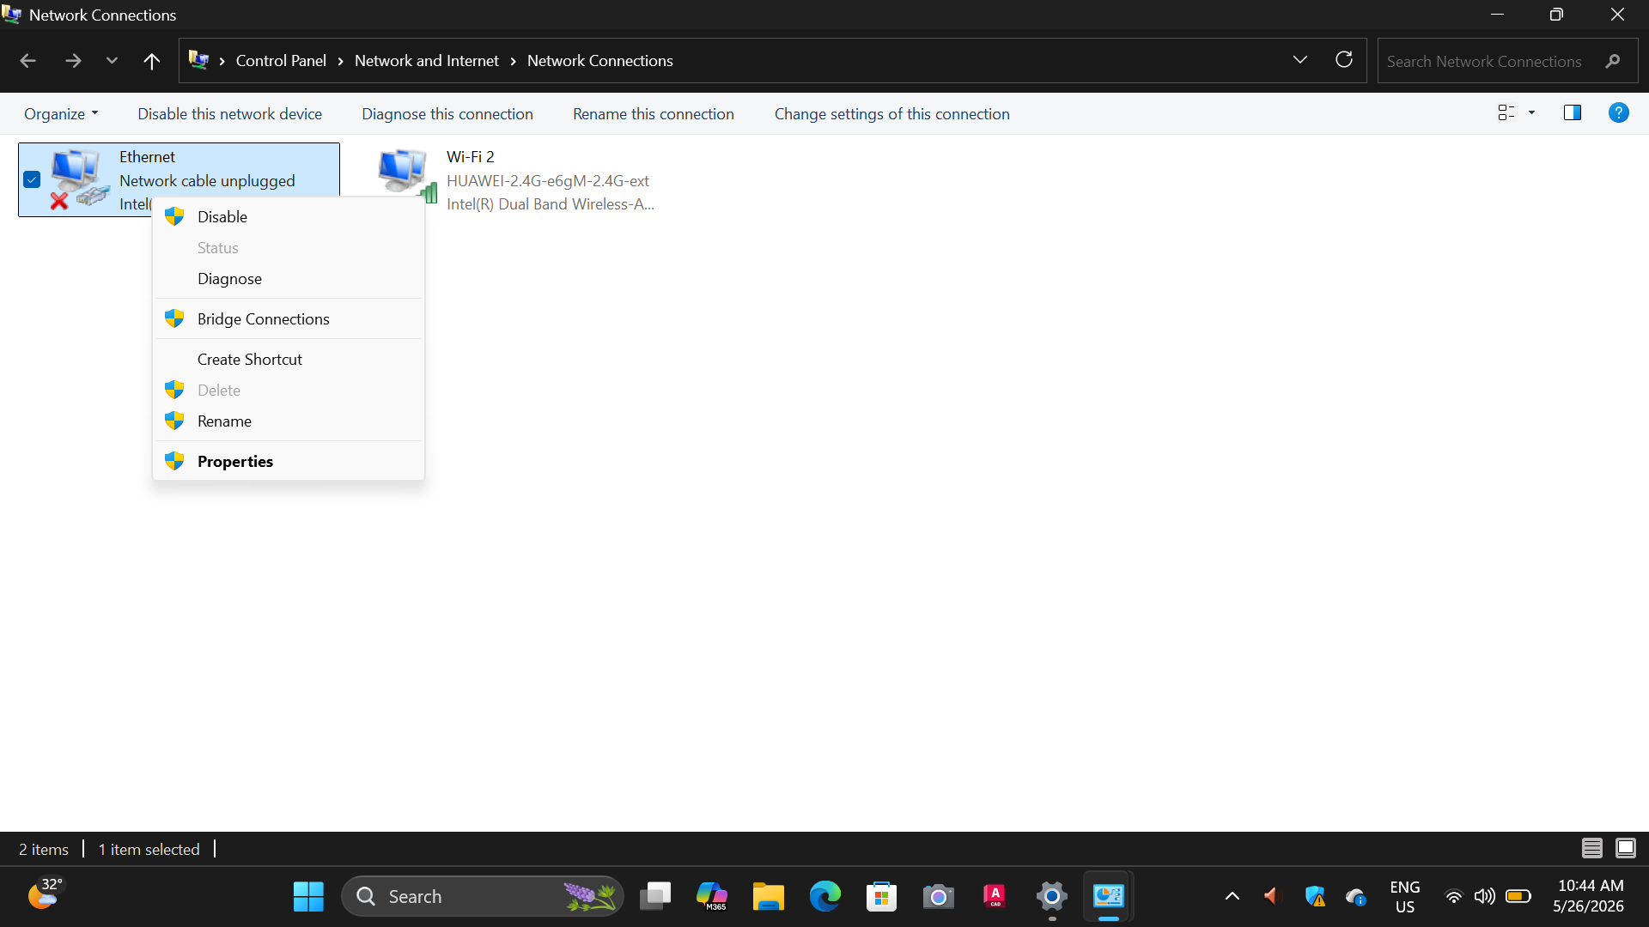

Step 5: Choose the Internet Protocol version 4(TCP/IPv4) or Internet Protocol version 6(TCP/IPV6) depending on the server’s IP preferences and click Properties.

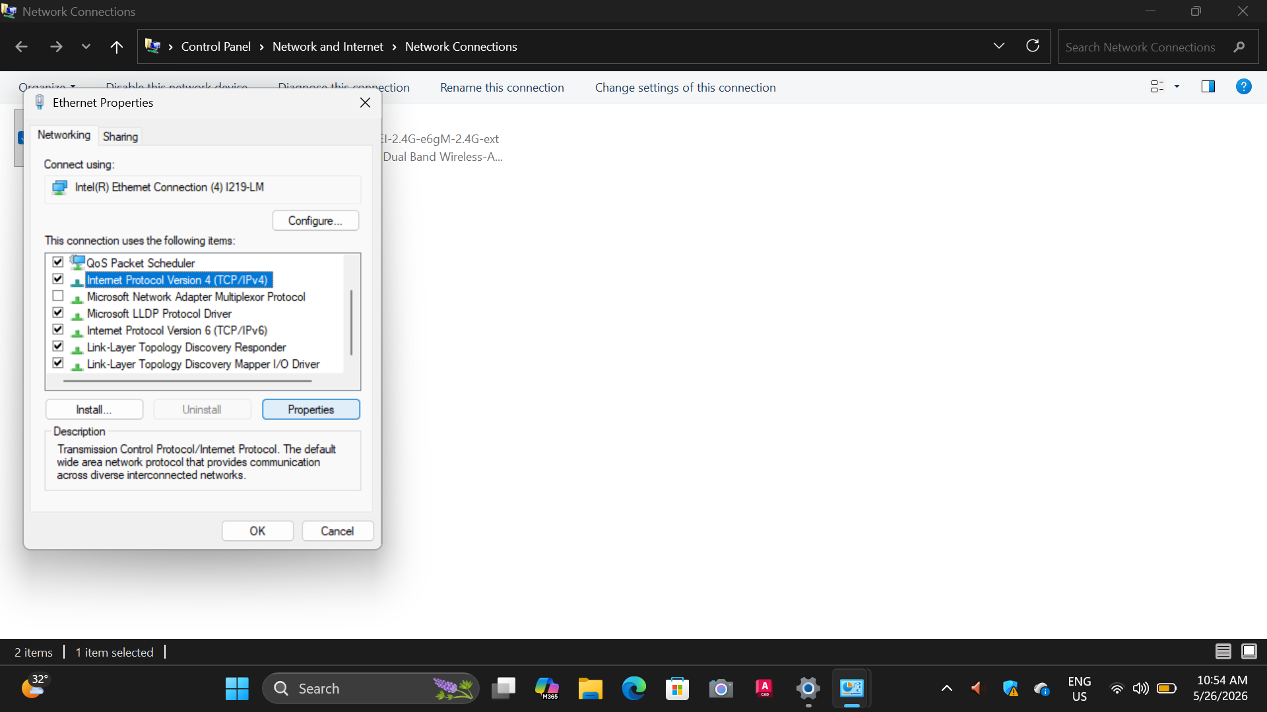

Step 6: Then click Advanced.
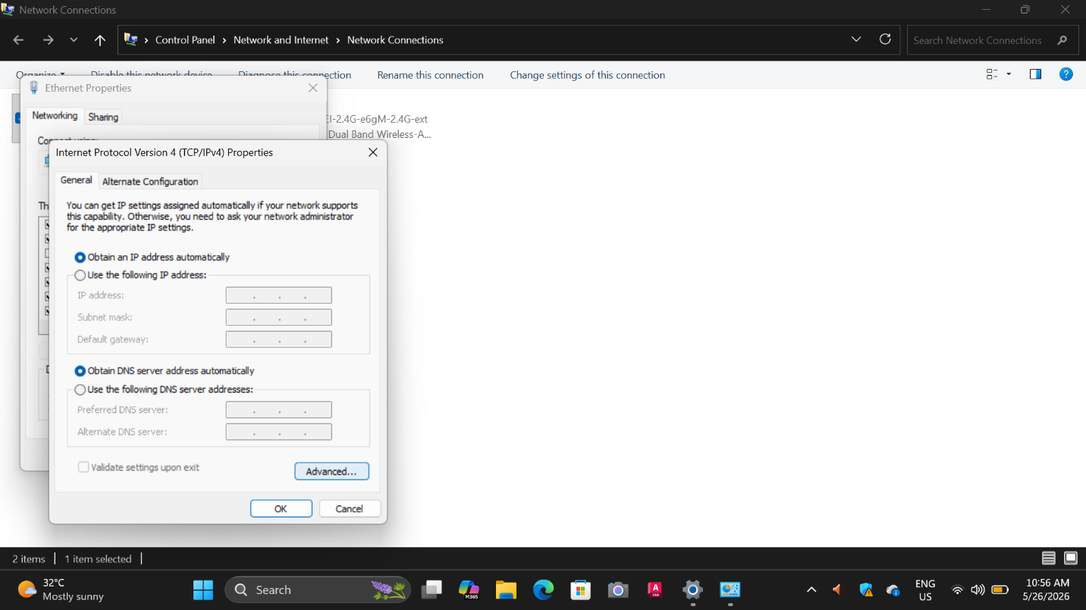

Step 7: Now click on the WINS tab above and click on Add then enter the exact WINS IP address of the designated server and press OK when done.
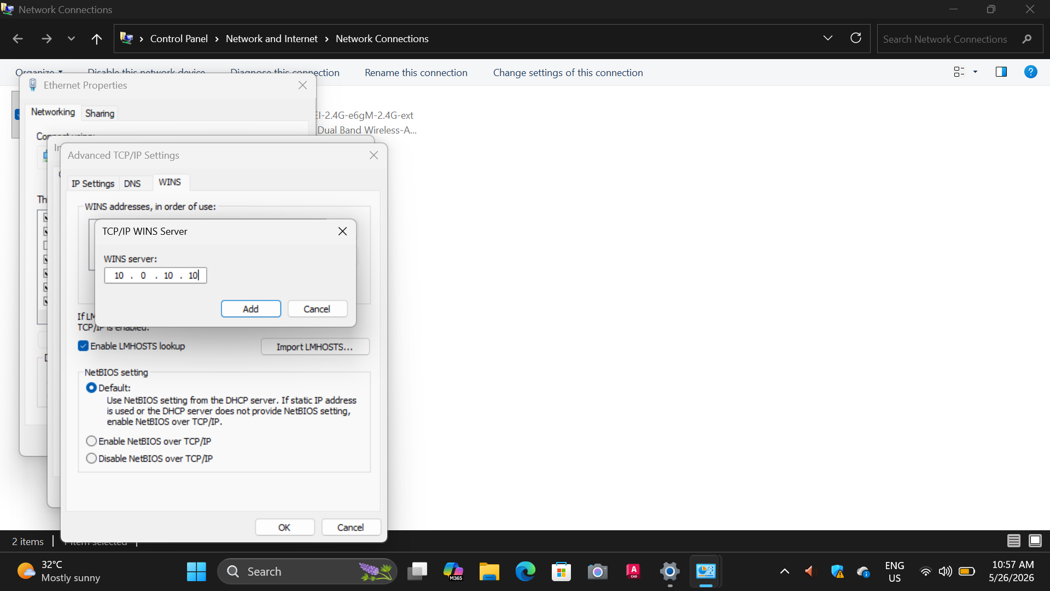

The PC is now assigned as a client.

