Julian Potter

Dr. Olenick

Computational Physics

December 10, 2018

Self-Organized Criticality

**Abstract**

The purpose of this project is to organize and measure partially chaotic systems in order to more accurately predict the outcomes based on a series of changes to the system. The method to find this will be to use simulations of sand falling in a grid in random locations, causing collapse after a certain threshold of sand is reached. This will also simulate a chain reaction by the domino effect.

**Introduction**

Self-Organized Criticality (SOC) was proposed by Bak, Tang and Wiesenfeld. It is a way to understand complex, chaotic, changing systems, especially those that build up to a certain state within a range and fluctuate within that range, such as with the sandpile experiment. As grains of sand are added to the sandpile, a new grain may cause a large avalanche.

**Theory**

Avalanches will frequently vary the height of the sand pile. Self-organized criticality shows that the number of avalanches of a size N(s) vary in proportion to the avalanche size s raised to the power b.

N(s) = Nosb

This is shown by the fractional occurrence of a range of avalanche sizes. The fractional occurrences is shown by F0=N(s)/((wb)(at), where N(s) is the number of avalanches in one part, and at is the total number of avalanches in the data set.

Self-organized criticality will also show a certain domino effect, in which the sand dropped in various points will often trigger multiple avalanches at different points.

**Computer Model**

The computer model used VPython in the Glowscript IDE to plot a simulation of the sand pile. It consists of color-varying cubes dropped at random points within a 20x20x20 3-dimensional range. The computer program showed highly varying and chaotic values.

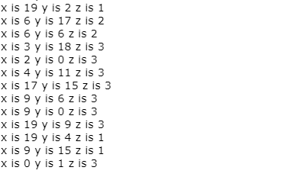

Data after program reaches a critical point

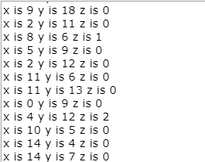

Data before program reaches a critical point

The program used several lists of size 20 to hold the data correlating with the simulation. It then uses the add_sand function, which contains the functionality of the avalanche, called recursively.

The sandpile will always collapse by a fixed amount 4, and will always set one cube in each of its adjacent north, east, south, and west sides. This function is called recursively to achieve the domino effect, and the adjacent sandpiles will also end up collapsing due to a single sand drop if the conditions are met.

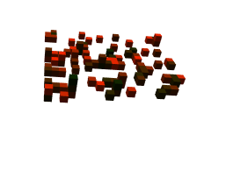

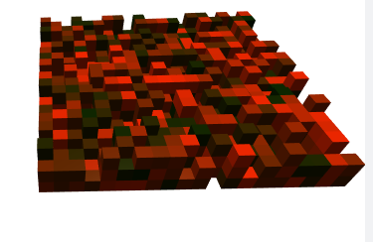

As the sandpile grows larger, there will be more grains of sand, and thus a greater chance for the domino effect to occur, and a greater chance for toppling sandpiles with it.

**ANALYSIS AND INTERPRETATION**

After some runtime, the sandpile reached the critical point in which it was constantly fluctuating. The domino effect occurred frequently, and sandpiles toppled over, toppling over adjacent sandpiles.

References

P. Bak, How Nature Works. Springer -Verlag, NY, 1986.

P.Bak, C. Tang, K. WiesenFeld. Self-Organized Criticality: An Explanation of 1/f Noise. Physical Review Letters. Volume 59, Number 4, July 1987.

P.Bak. C. Tang. Kurt Wiesenfeld. Self-Organized Criticality. A Physical Review. Volume 38, Number 1. July 1988.