CS210

Module 1 – Assignment
C++ Hello World

Java Hello World
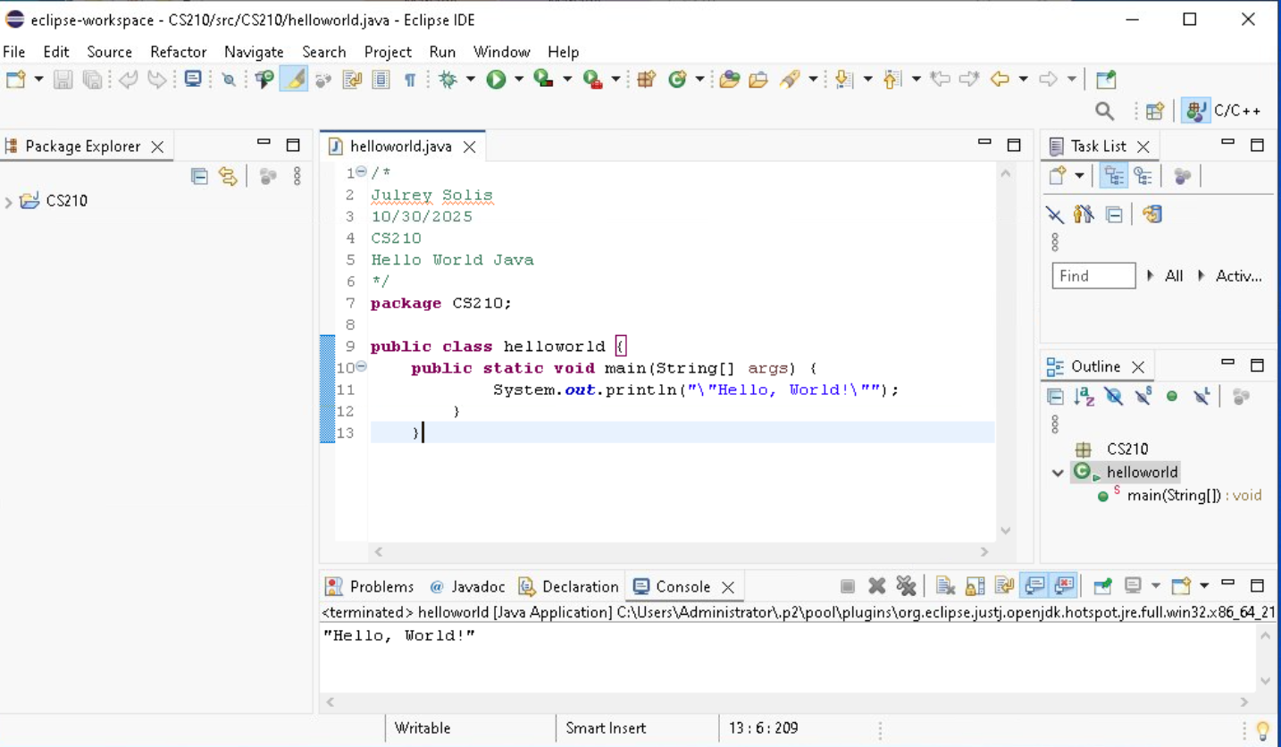

Reflection:
Both C++ and Java have very similar coding syntax.
For example, both have a class syntax. C++ having int main() {} while Java having public class helloworld {}. Even the comment syntaxes are the same for both. This is probably due to Java being an adaptation of the C language.

I’ve researched the advantages and disadvantages between C++ and Java and found this information:
- C++ offers speed and control while Java provides safety and portability.
- C++ is ideal for system-level programming while Java excels in cross-platform applications.
However, I am unable to fully absorb any of these benefits and drawbacks due to my lack of work experience or real-life application of using either language.

Being able to code in multiple languages allows you to be flexible in finding opportunities in real-life since there is not a universal language that the world uses for their systems and applications. Having knowledge and experience of multiple languages gives you an advantage of also creating your applications on different platforms as well.

