Installation Guide: How to install Git on your computer

In the Python workshop, new notebooks for each session will be uploaded on an online repository, hosted on Orsay’s BitBucket platform

Before each session, participants will be able to run a command to fetch the latest version of the notebooks and any additional material needed for the course.

1. Install Git

Go on this link: <https://git-scm.com/downloads>, and download the latest version of Git for Windows:

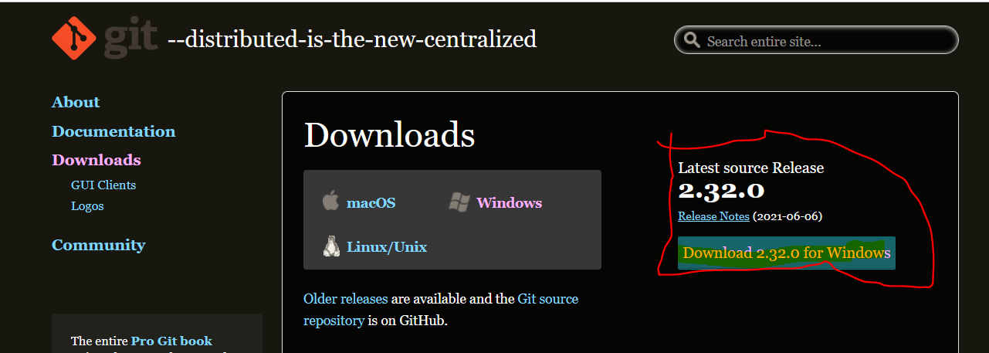

Follow the installation steps, by **always selecting the default selected option.**

The installation should end with this screen:

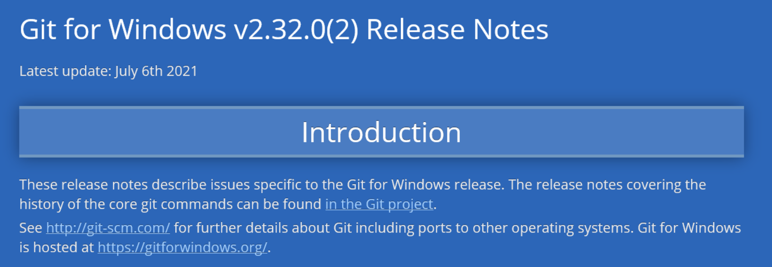

1. Launch Git Bash interface

Go in /Documents folder, and right click on it. You should see a `**Git Bash Here**` option, as showed below:

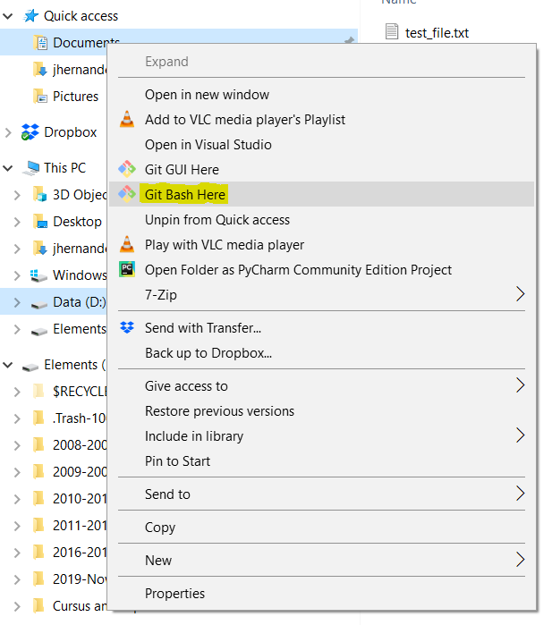

Which will launch the following shell:

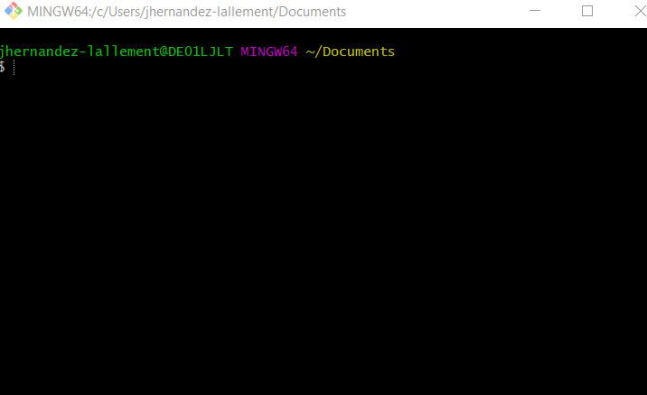

1. Clone repository

All material for the course is located on an online repository hosted on a platform called GitHub. We are now going go clone the repo. In the shell you opened above, enter the following command:

**git clone https://github.com/juls-dotcom/python_workshop.git**

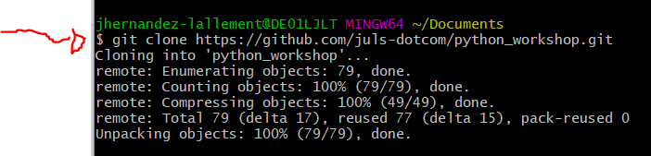

(since the shell is linux-based, if you want to CopyPaste, use Ctrl+Shift+V, not just Ctrl+V)

1. Clone repository

This command should have created a folder **Documents/python_workshop.** In there you will find the main library for the workshop, including a subfolder called **\notebooks**.

This subfolder will contain all material for the courses.

1. Update library before each session

Before each session, I will include the new notebooks for the coming session, together with any necessary material such as datafile and others. Please, before each session:

1. use a `**Git Bash Here**` in the **Documents/python_workshop** folder.
2. Run `**Git Pull**` in the shell
3. The folder **Documents/python_workshop** is now updated with the content from the following workshop, and any corrections made in already existing files on your computer.