# Coversheet

## System Design

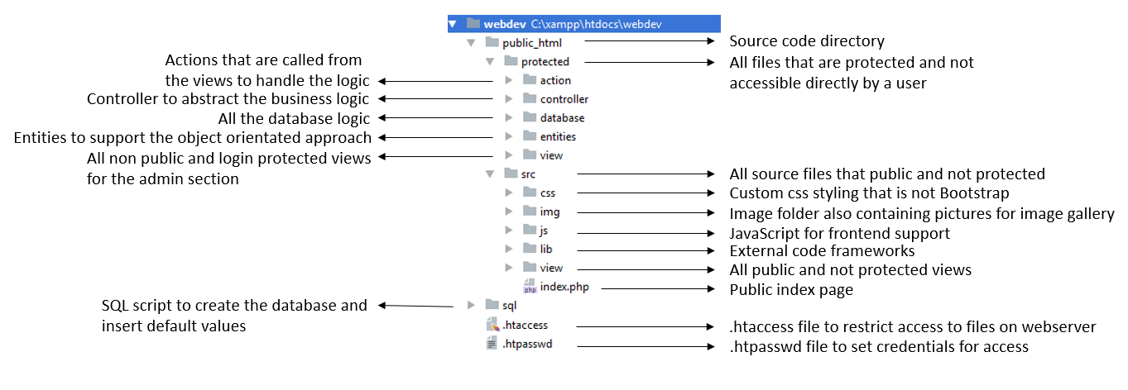

## Screenshots