Specification

Global navigation

The website will have a navigation bar at the very top of the site. This bar will be a global reference point that will be available on every page and always look the same. Users will be able to access different sections of the platform through this bar at all times, no matter how many levels deep they might have been navigating through sub-pages. The navigation bar will consist of the following elements:

* Button to browse categories
* Search bar (including a drop-down menu to narrow down the search to a specific category)
* Menu button that opens up a menu with the following sections:
  + Open Deals
  + Messages
  + Account Balance
  + My Listings
    - My offers
    - My requests
  + Profile
  + Settings
  + Sign Out
* Message icon that will take users to their inbox and will visually indicate whenever there are unread messages
* Handshake icon that will take users to their currently open deals
* Add icon that will allow users to quickly create a new offer or request
* Help link that opens a drop-down menu with links to global FAQs and some context-sensitive help, and finally
* Icons to maximize and minimze fonts and switch to black-white mode and back

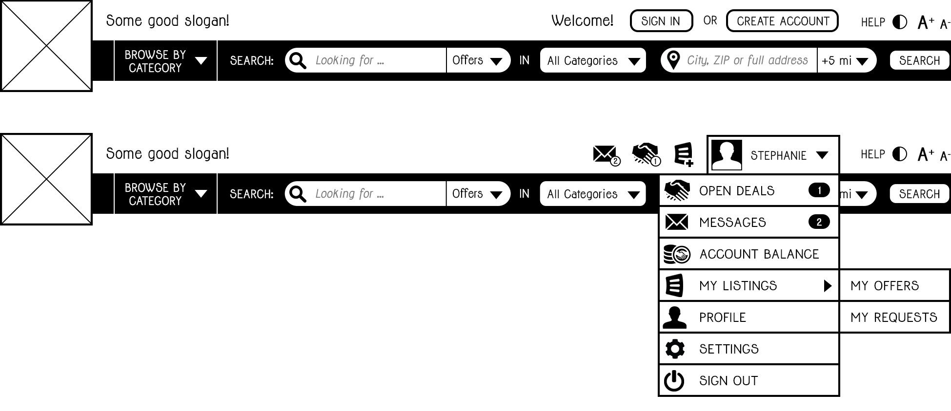

The icons for messages, open deals, adding offers/requests and help will have a tooltip-like mouseover effect indicating their respective functions.

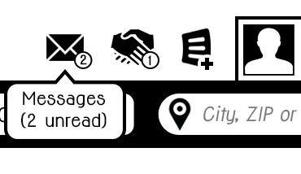 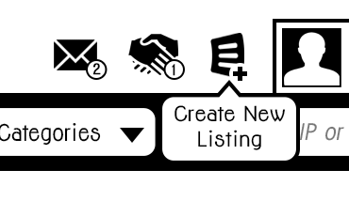 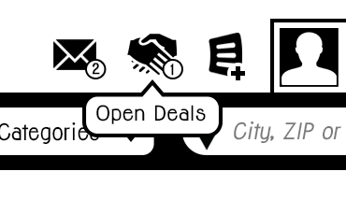

The mobile application will follow a different navigation approach. The global reference point will be a navigation bar at the top that lets users know where they currently are. In top-level screens, the navigation bar will display a menu button on the top left. Tapping this button will make the current view swipe to the right side until only about 1/3 of its original width are visible, revealing an underlying menu containing the same elements as the website's menu specified above, additionally a search and a browse element. Tapping the menu button again will make the current screen swipe back in, while tapping any of the elements in the menu will change the current screen according to the user's selection before automatically swiping it back in. In addition to the menu button on the top left, the menu can be opened and closed at any point by a simple swipe gesture anywhere on the screen. This will allow users to open the menu whenever they need it, even if the screen they're currently viewing is one or more levels down in the navigation hierachy, in which case the menu button will have been replaced by a back button to give users the opportunity to navigate back up in the hierachy.

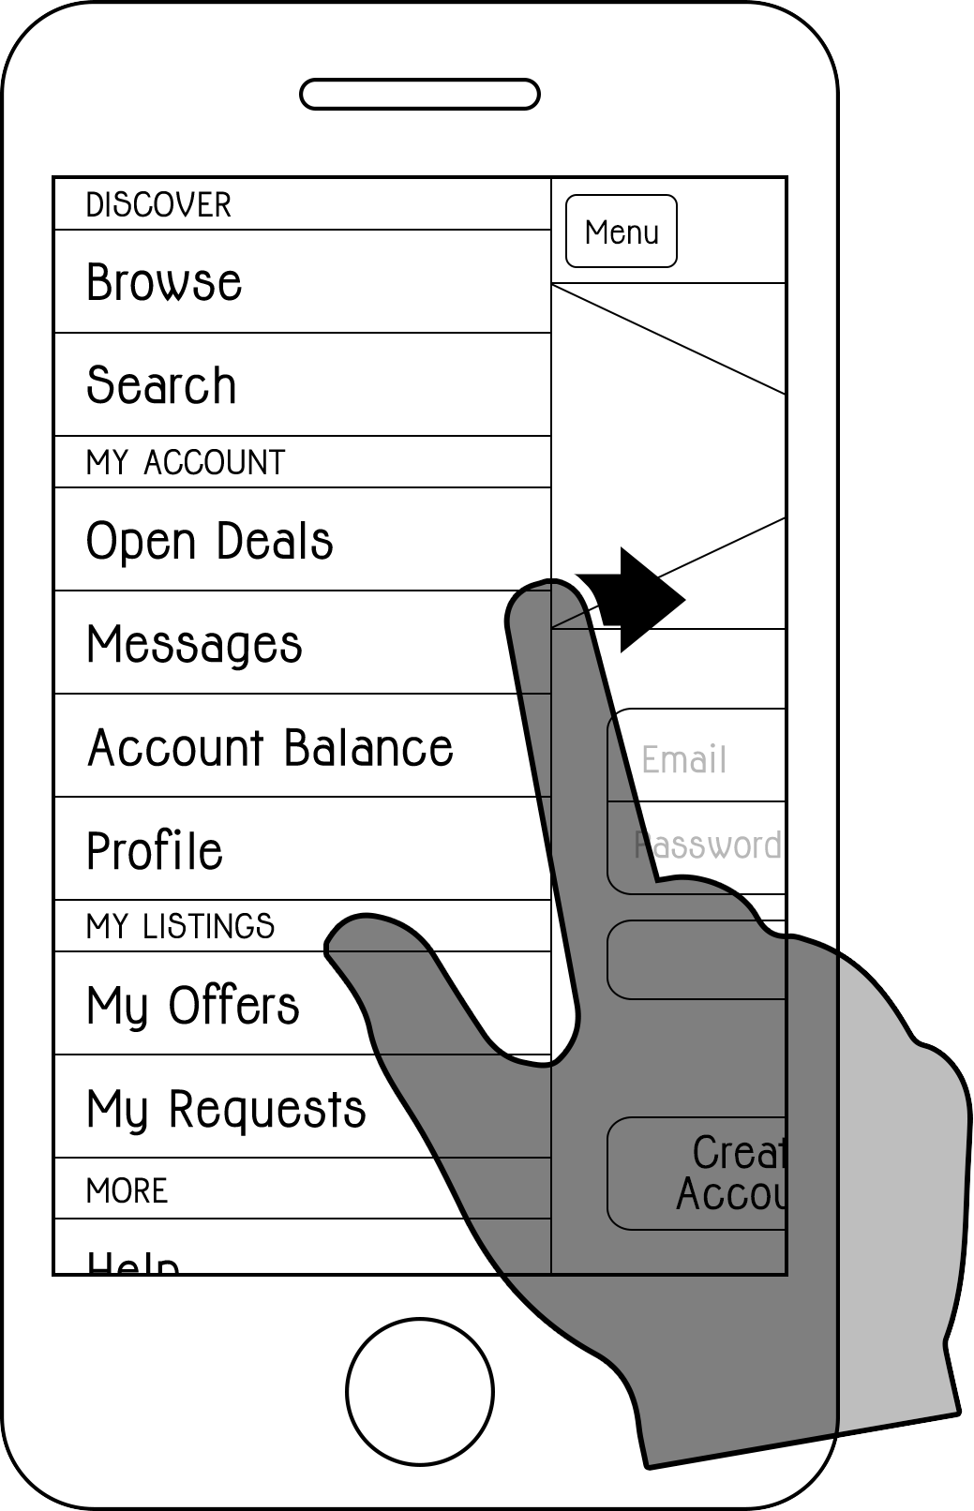 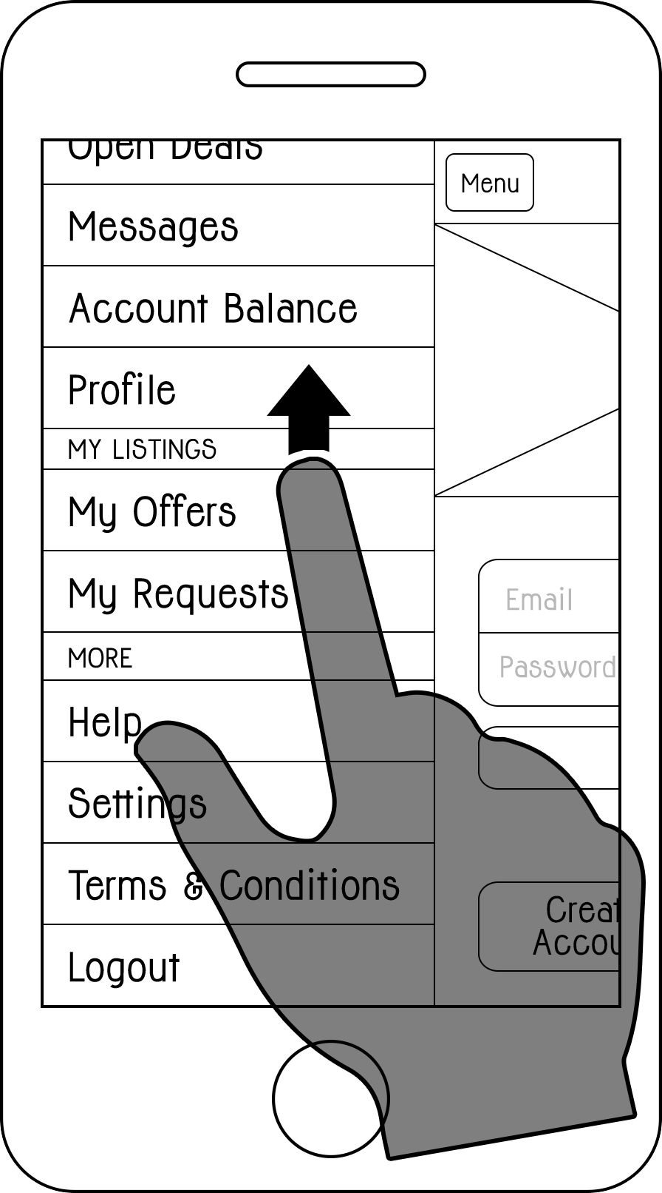

First-time users

People who visit the website or open the app for the first time will have the possibility to learn about the platform and find out what kind of offers and requests are listed without having to sign up. On the website, new users will be greeted with a welcome screen that concisely presents the platform's vision and includes two prominent buttons: one for creating an account and one that takes them to a section where they can read about how exactly the system works in greater detail.

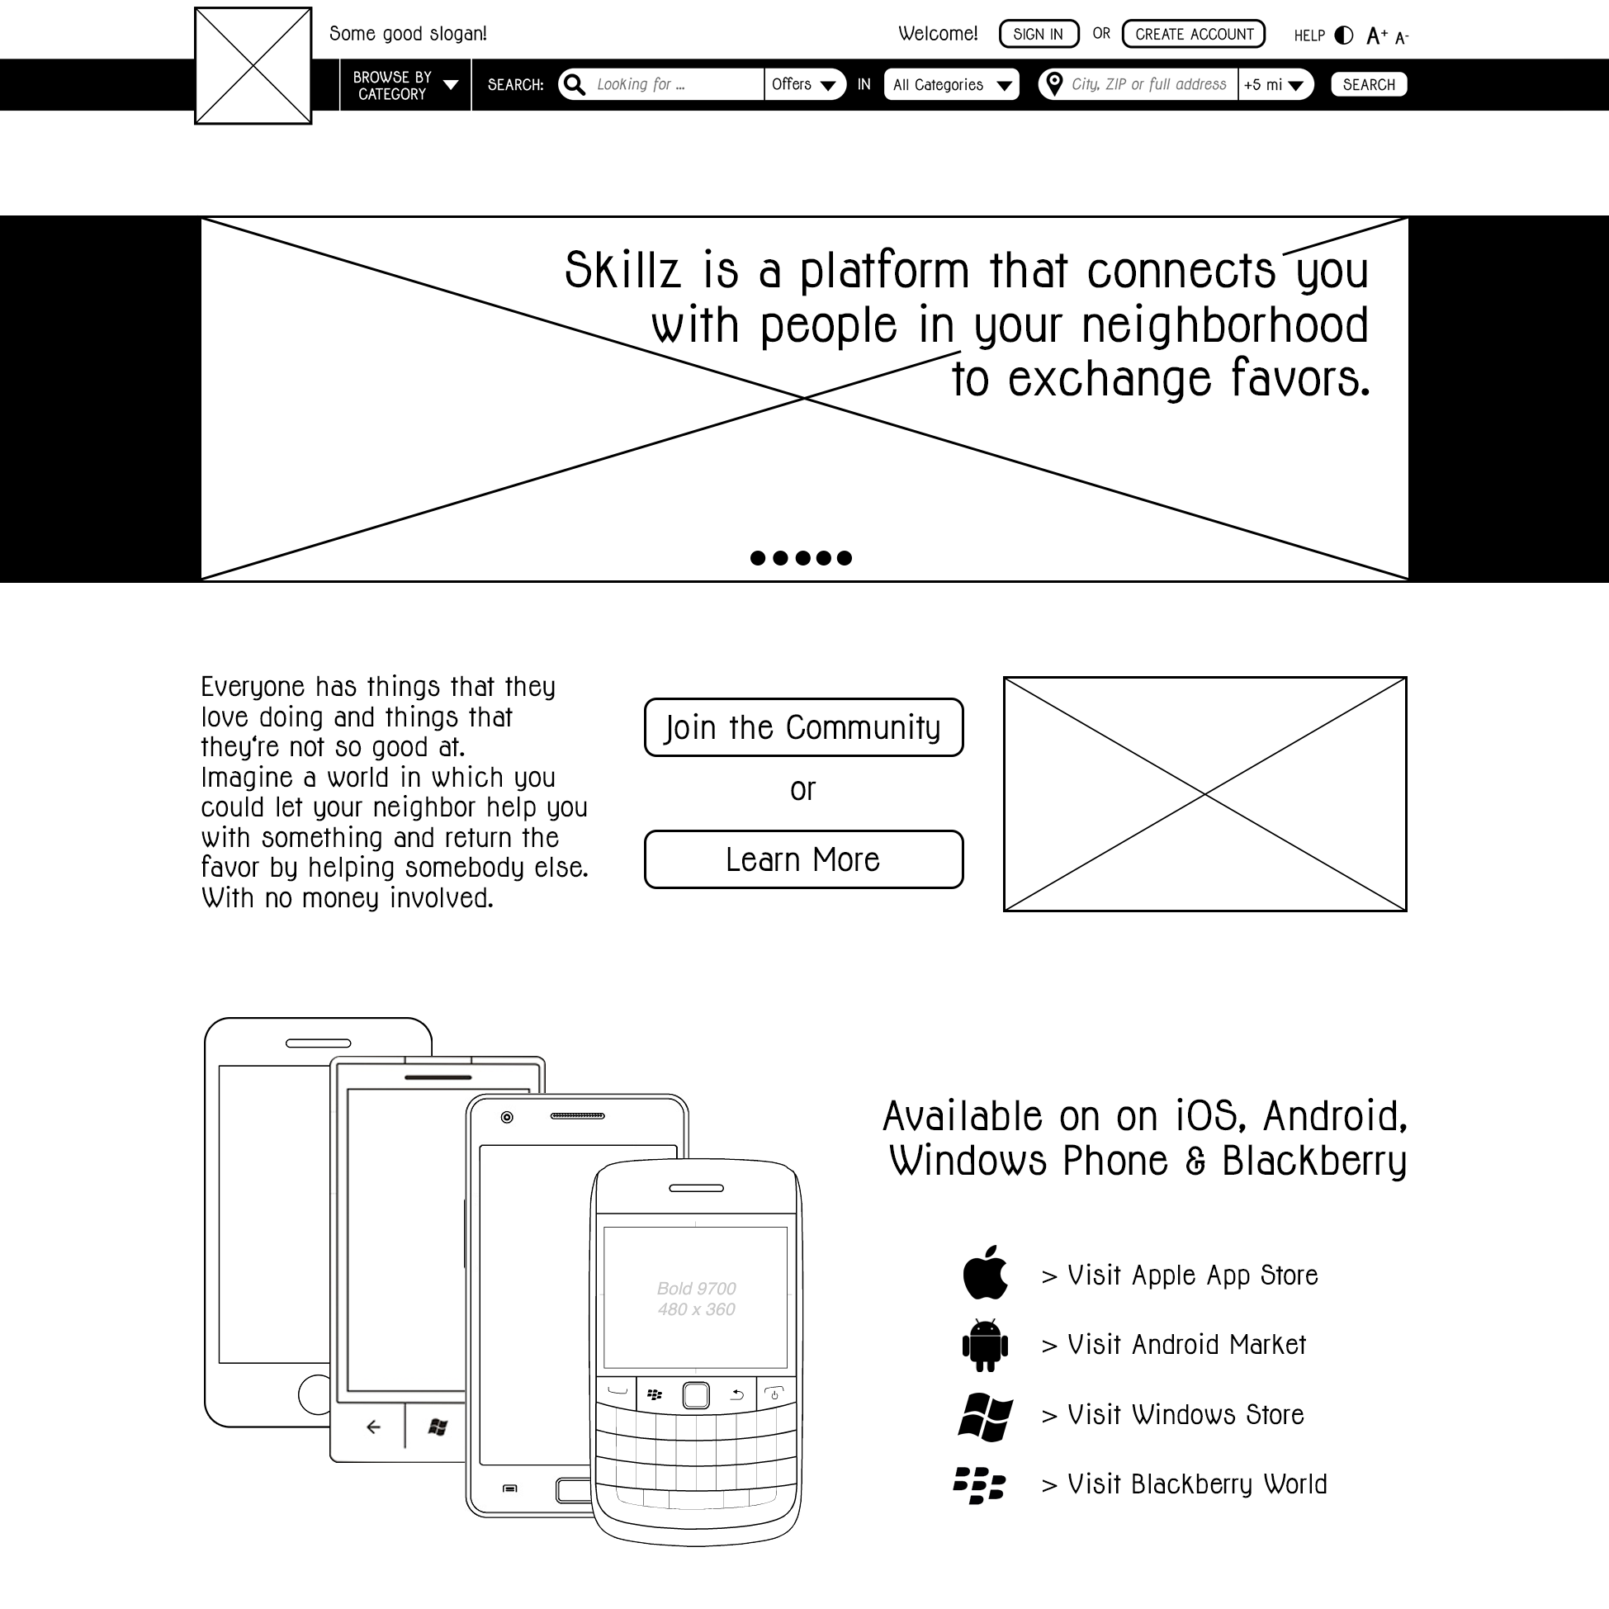

Even without having an account yet, people will be able to browse through offers and requests and make specific searches in order to decide if it's worth for them to sign up for the platform. While listings will be generally open to be viewed by non-members, any further actions – contacting another user, viewing somebody's profile or posting an offer or request of their own – will require them to become a member. A section within the global naviation element will give them the opportunity to create an account from whatever page on the website they might currently be viewing. In addition to that, the attempt to take certain actions like clicking on a user picture or clicking the button intended for contacting the user who belongs to a request or offer will prompt a screen overlay stating that they have to be a member in order to do this and give them the option of creating an account right on the spot or signing in if they already have one.

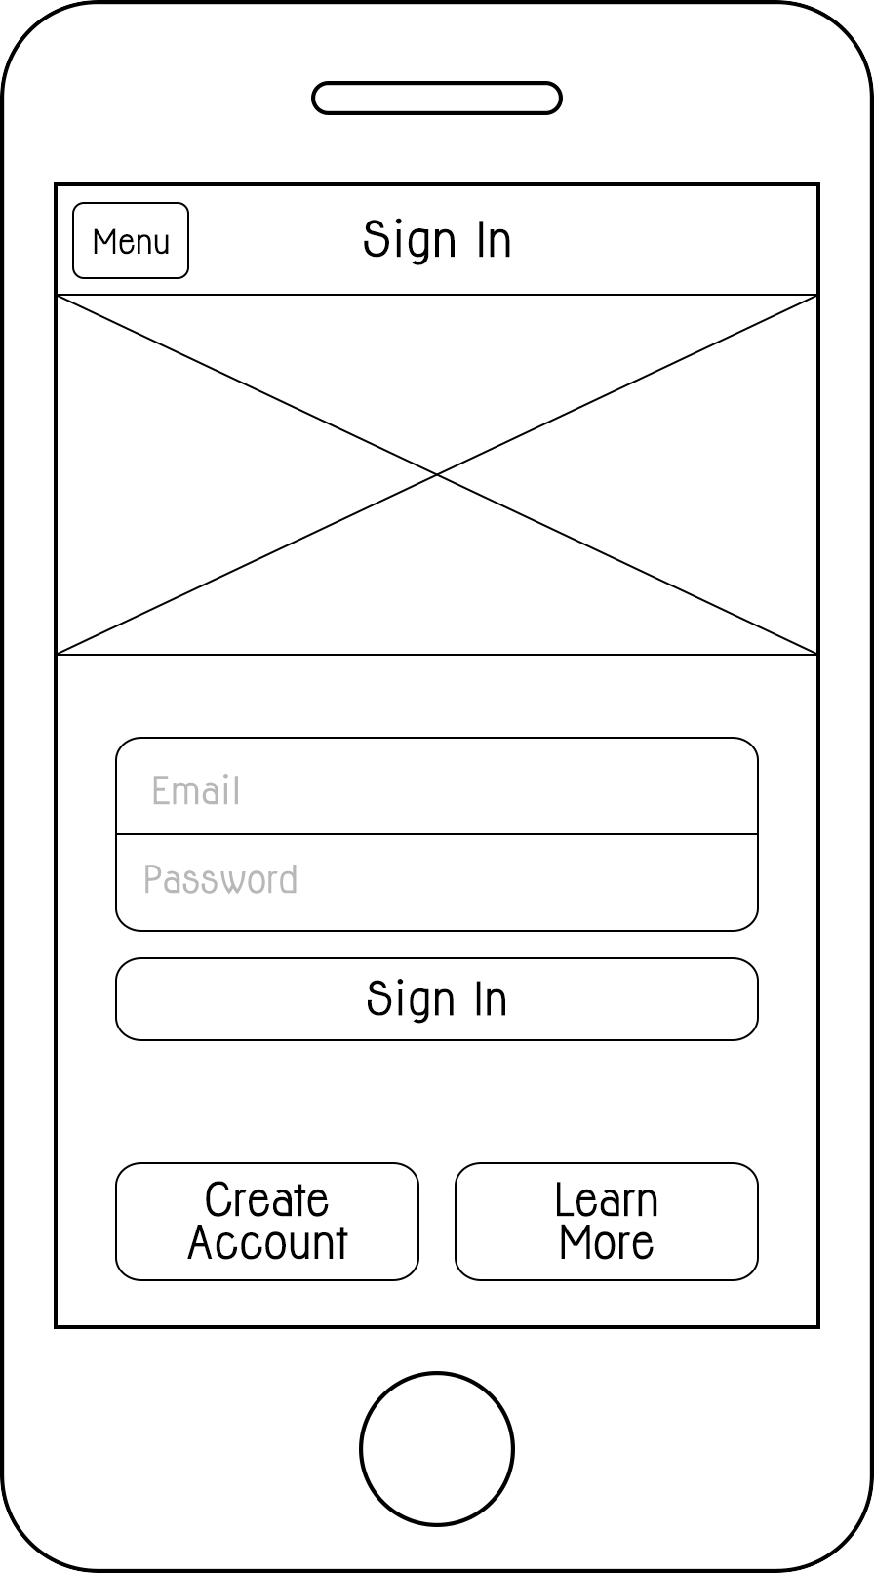

Users opening up the mobile app for the first time will be presented a sign-in screen. This screen will also include buttons to create an account and to learn more about the platform. People who use the app are not required to ever use the website. All features available on the website will be realized in the mobile application as well. A global menu will give first-timers access to browse and search functionality without signing in, while the attempt to tap on sections reserved for registered members will trigger a modal pop-up asking the user to create an account or sign in. Once a user successfully signed in, they will remain signed in on the device, even in they close and re-open the app. They may choose to sign out by selecting the "Sign Out" option in the menu.

Creating an account

To create an account, people have to enter their Email address and chose a password of 6 - 18 characters (allowed characters are upper and lower case letters, digits and any of the following special characters: . _ - ! ? @). Users will have to verify their password a second time to avoid typos. In addition to Email address and password, which will serve as their sign in credentials, users have to provide their first and last name, their ZIP code and the state they live in. There are no username aliases – users are identified by their Email address and will be displayed to other users with only their first name. To successfully create an account, users will have to accept the platform's terms and conditions, which will be available through a link on the create account page and also through a section in the menu (in the mobile app) and a link at the bottom of every page of the website.

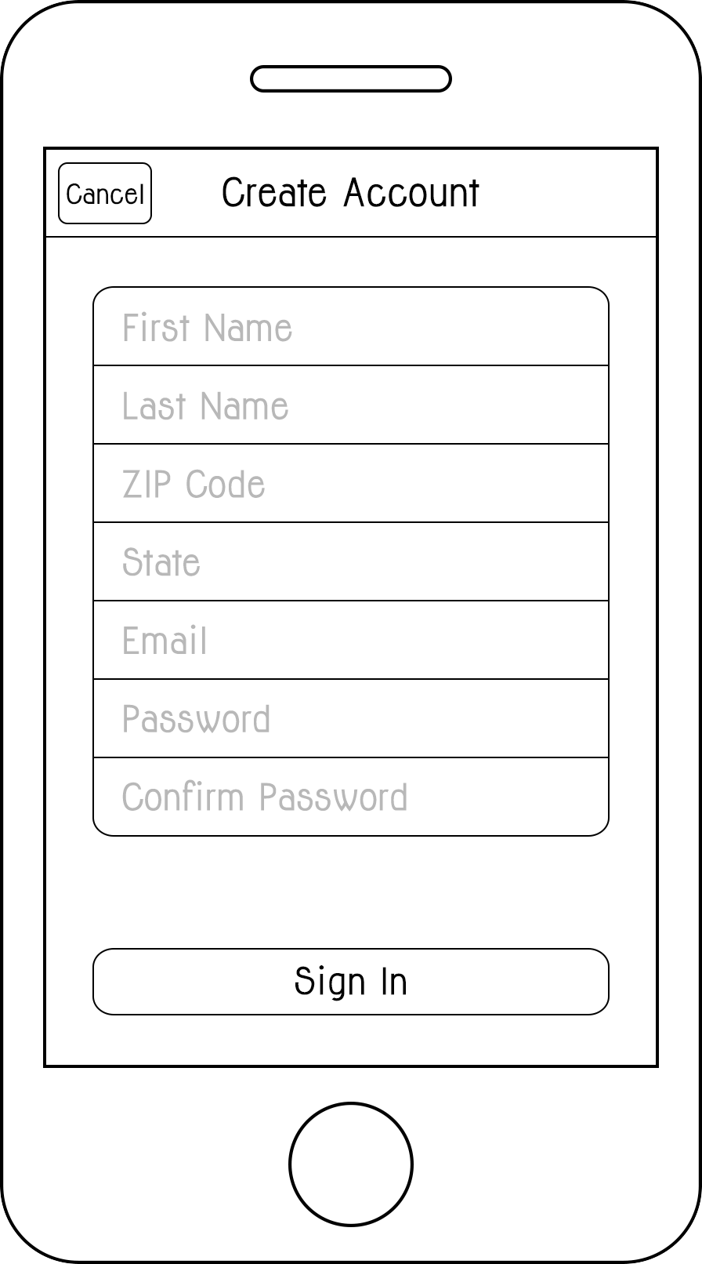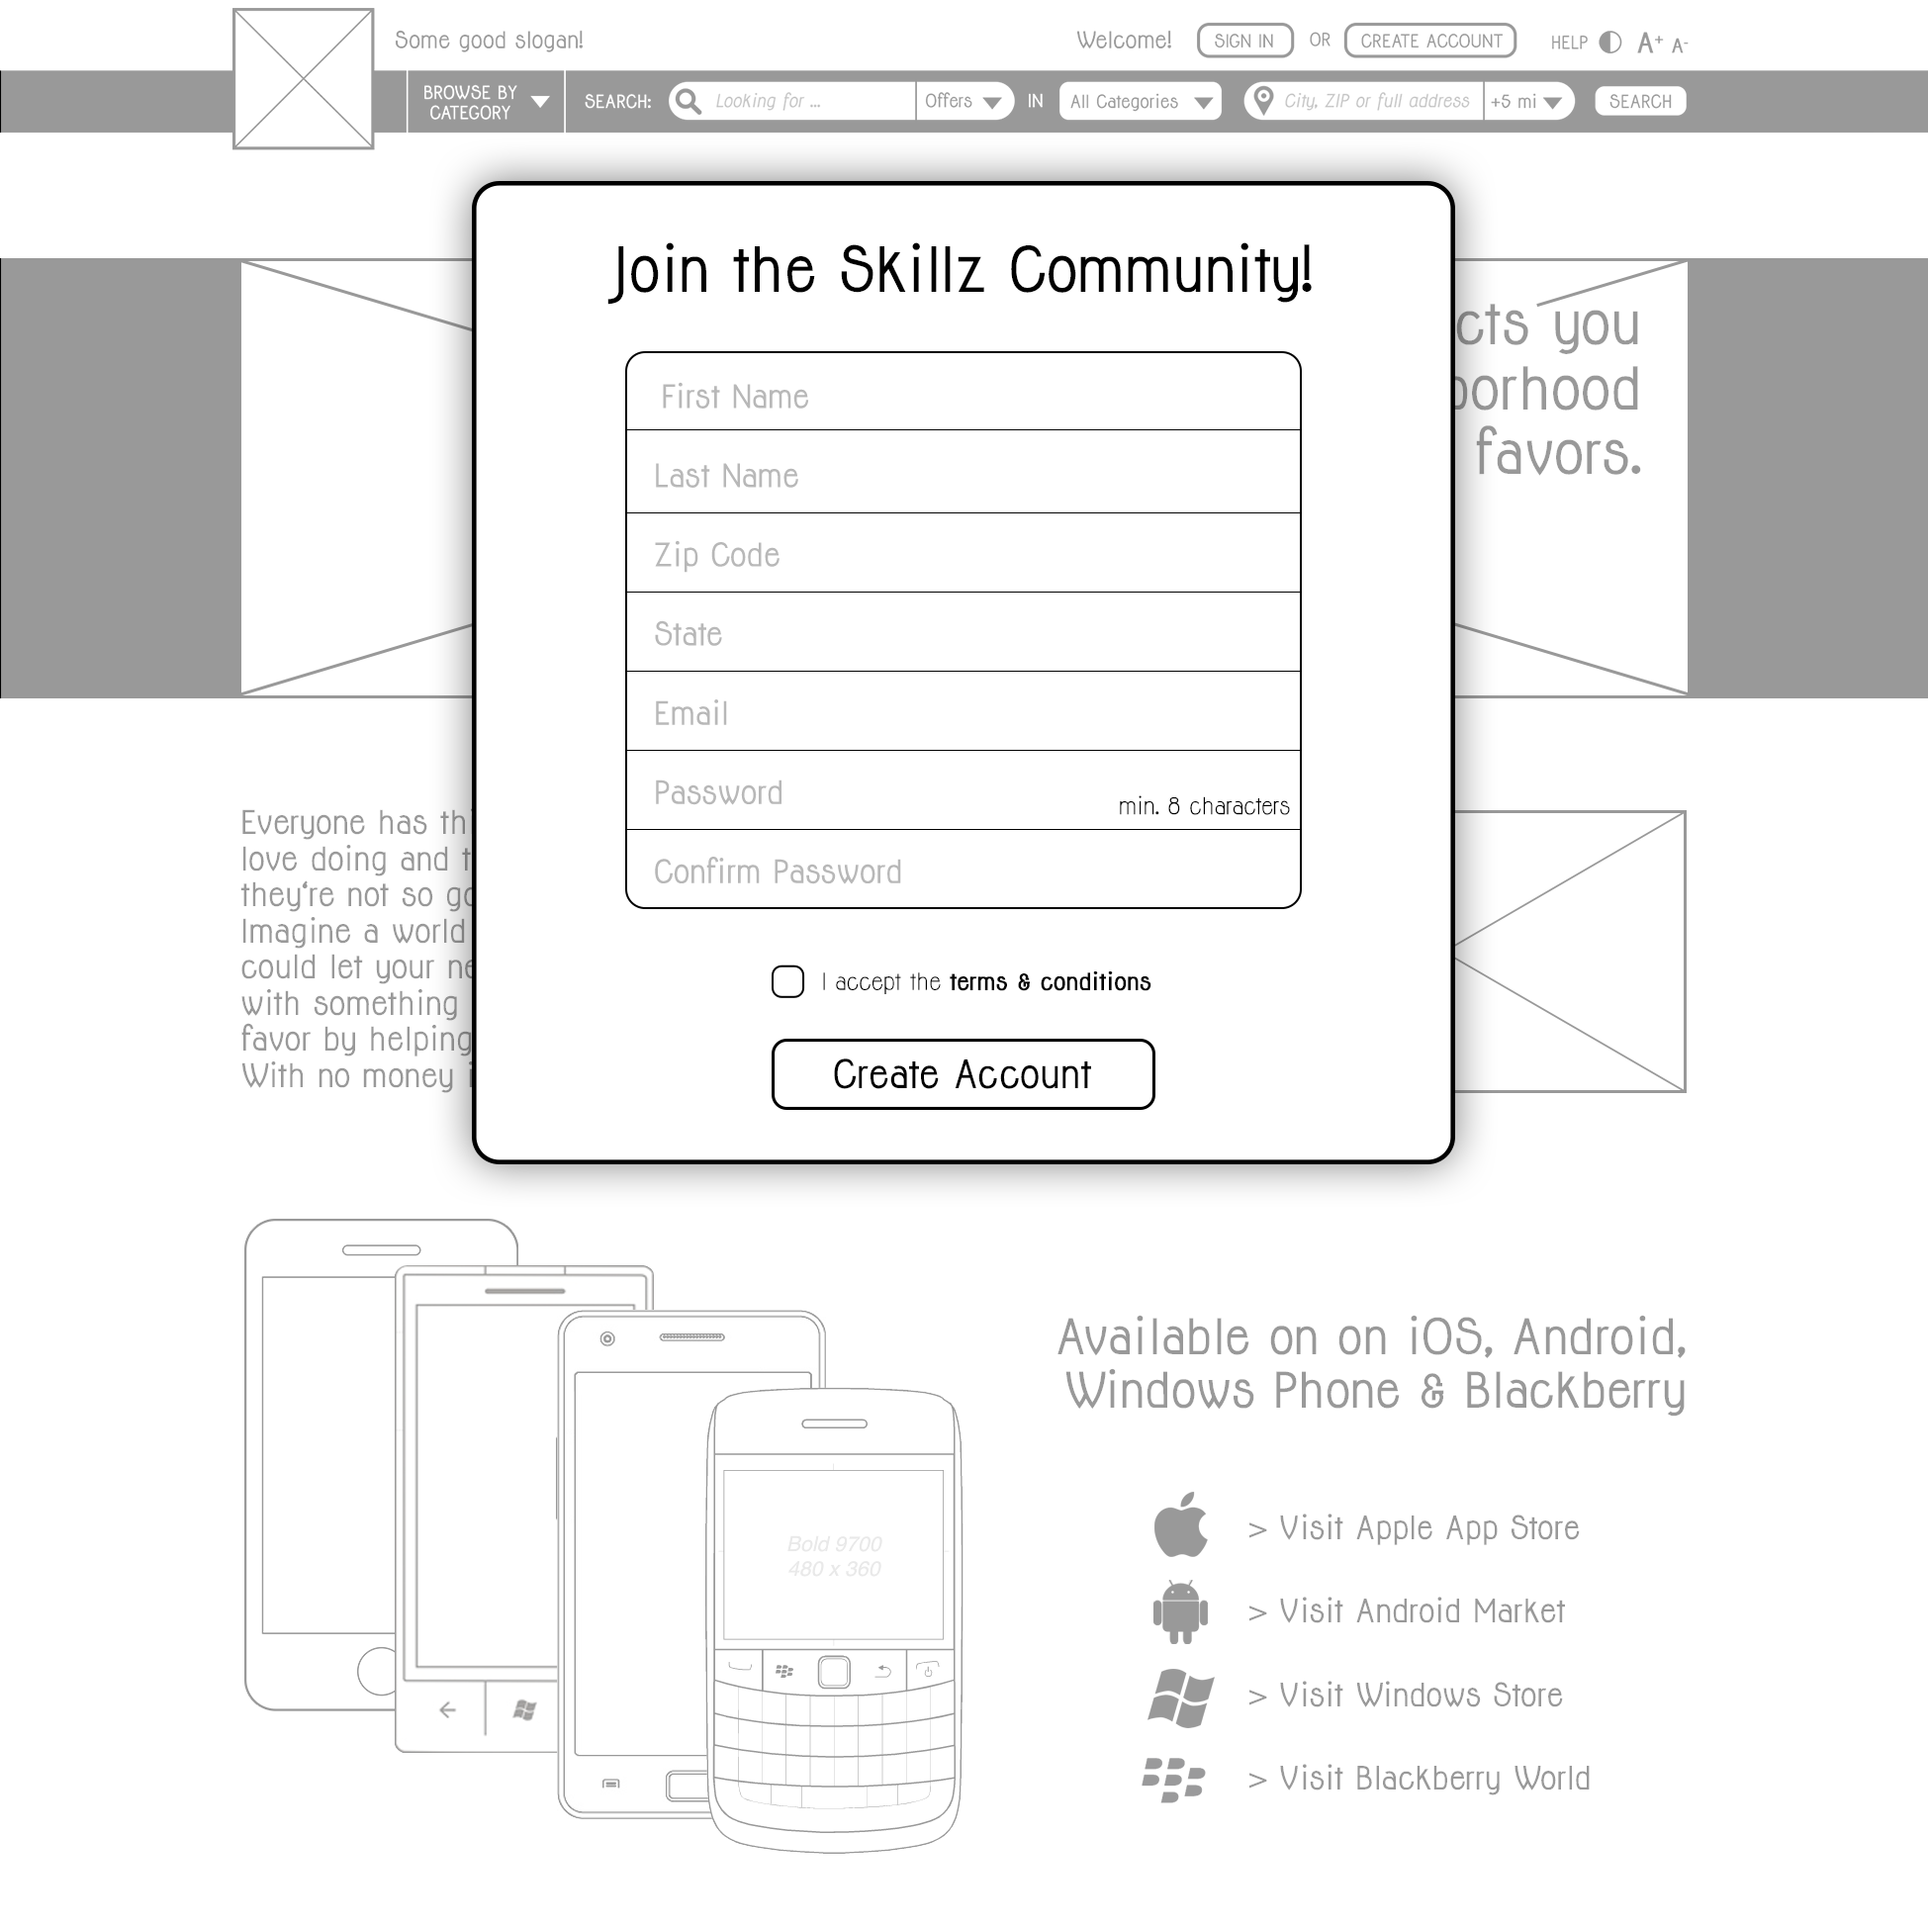

Start screen

Once users signs in, they will be presented with a dashboard-like start screen that displays key information and gives quick access to the most commonly used features. If there are any unread messages, this will be communicated in a prominent way along with a button to take users directly to their inbox. If there are any deals currently open, the start screen will list those deals and give the user the opportunity to mark them as done and review the other user involved in the deal.

The start screen will also display the user's account balance and offer some quick links depending on their balance. If the balance is significantly positive, the start screen will display links to create a request, browse offers or donate. If the balance is significantly negative, the screen will show links for creating an offer and browsing requests.

[WIREFRAMES START SCREEN WEB + MOBILE]

User profile

When users navigate to the profile section, they will see their personal profile the same way it will be displayed to other users. Additionally, they will have the option to edit and personalize their profile. Initially, their profile picture will be displayed with a placeholder image. A little plus icon within the placeholder will offer them the opportunity to upload a photo of themselves. Users may add a personalized description to their profile to tell other members a little bit about themselves. They will also be encouraged to list their personal skills and talents on their profile. Those listed skills will be used to display relevant members within search or browse results even if they don't have active offers listed. Users may opt out of this feature if they don't wish to be displayed to other users based on their skills. The "Browsing and Searching" section (page XX) will explain the feature in further detail.

Users may also chose to add their phone number to their profile information. Phone numbers will only be displayed to another user if the two users agreed to engange in a deal with each other.

Furthermore, the profile page will show a little review graphic displaying the user's average review score based on a star-system of 0 to 5 stars and also indicating the number of reviews. Initially, the 3 latest reviews will be displayed on the user profile with a "Show More" button that will expand the view and display all received reviews.

[WIREFRAMES PROFILE PAGE WEB + MOBILE]

Posting and managing offers and requests

Members can create their own offers and requests and post them on the platform. They will be guided through the process in a step-by-step dialogue.

In the first step, they have to select a category for their listing. A comprehensive list of categories will be offered to them, with some categories being split into more detailed sub-categories to choose from. In case users don't find a fitting category, they may choose the "Miscellaneous" category but will also be offered the option of suggesting a new category. If a category gets suggested several times by different users, it will be added to the list of categories.

In the second step, users will be asked to enter a title for their listing and add a text that describes the offer or request in greater detail.

The third step requires the user to specify location details about their listing. Initially, users may chose from 3 options: "I'm willing to go somewhere else", "People have to come to me" or "This can be done remotely". If they select the first option, they will be asked to specify how far they're willing to travel. They may choose to limit the listing to their own ZIP code area, specify a location and a maximum distance they would be willing to travel from this location or decide to keep the travel distance open to negotiation. If they select the second option ("People have to come to me"), they will be asked to specify their address. However, an annotation will ensure them that their address will only be used to display the listing's approximate location on a map and will only be disclosed to another user if both users have agreed to engage in a deal with each other.

In the next step, users have the option of specifying what they want to be paid to perform the task (if they're posting an offer) or what they're willing to pay someone to perform the task (if they're posting a request). They may choose from an hour-based rate or a task-based rate and also have the option to keep the compensation open for negotiation.

In the last step, users may specify a time frame for their listing. This would make sense for users who post requests like babysitting on a specific day or similar tasks that rely on a certain time frame. Instead of setting a complete time frame with start and end times, users may also just set an end time on their listing if the timing is generally flexible but the task will have to be done by a certain deadline. This will cause the listing to be automatically deactivated after the end time has passed. The timing specification is generally optional, so users may also choose to keep their task timing flexible.

There are two exceptions that will slightly change the user flow of posting a listing: Ride shares and accomodation. Users who choose the ride share category will not enter a title for their listing but instead specify the start and end location and the number of available seats for the ride they offer or need. If they're offering a ride, they will be asked to provide more detailed information about the exact start address (or may offer to pick up passengers) in the description section. Instead of choosing whether or not to specify a time frame, they will be asked to specify the take-off date time (if they're offering a ride) or take-off date and time frame (if they're looking for a ride). They have the option to set a fixed price on the ride or leave the compensation up for negotiation.

Similarly, users who choose to post an accommodation offer will be asked to specify the property's location and indicate how many people it can accommodate. They will have the opportunity to limit the availability to one or more time frames. Furthermore, they will be able to add photos of the property/room they offer. Users who post an accommodation offer will have to specify when, where and for how many people they are seeking accommodation.

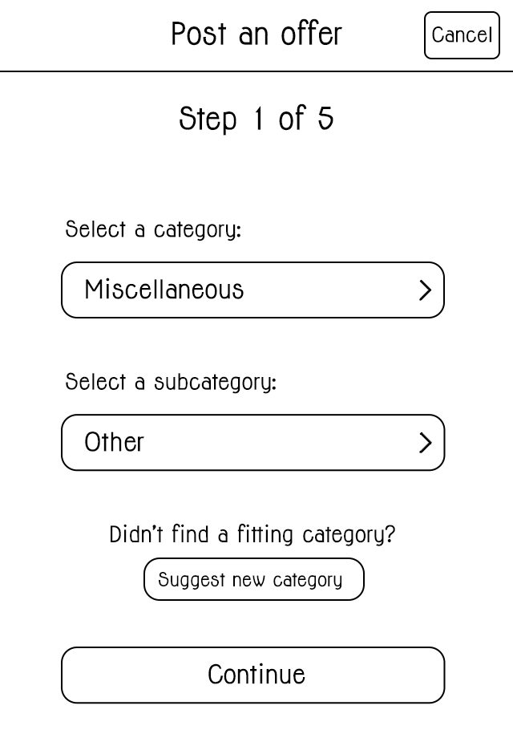 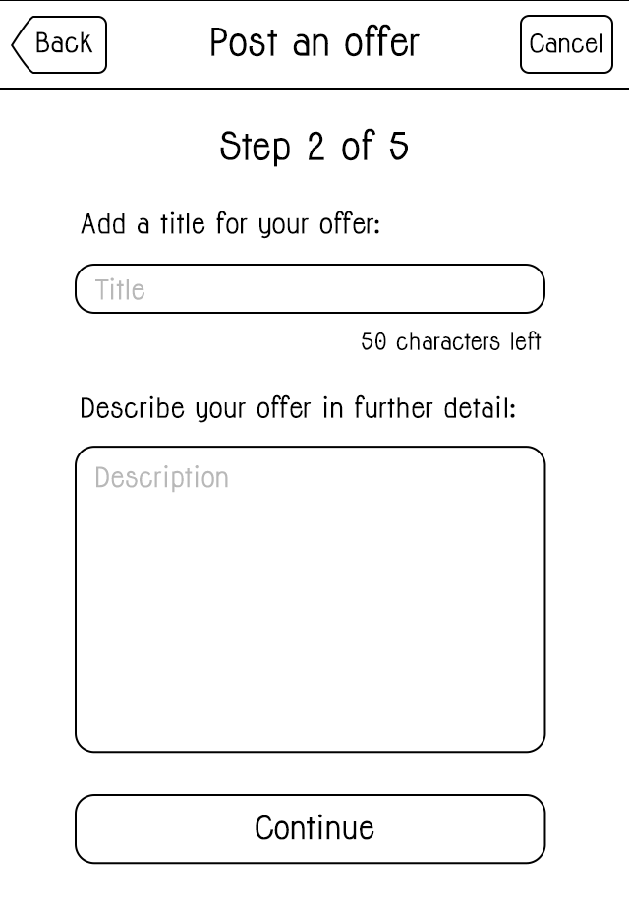 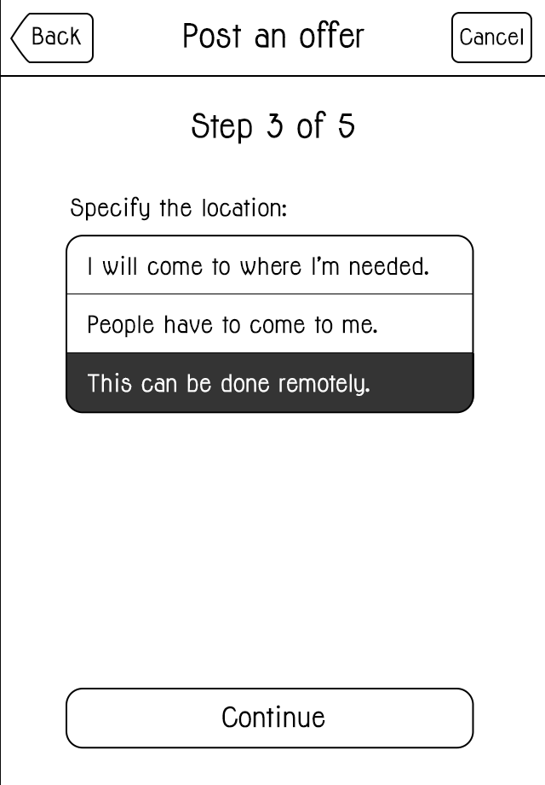

Step 1 Step 2 Step 3

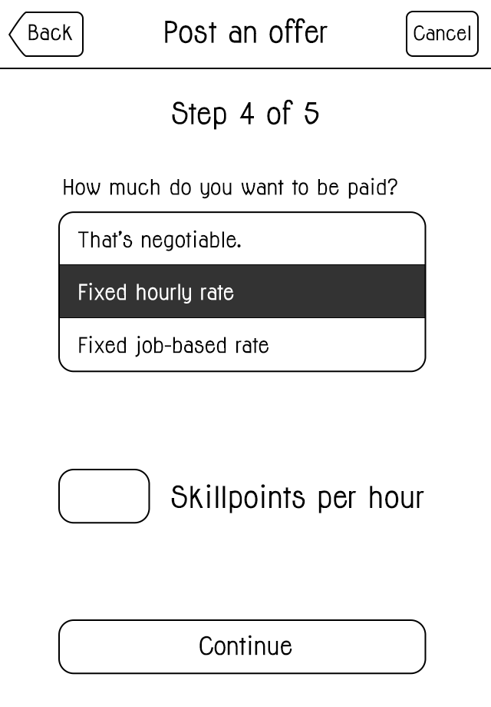 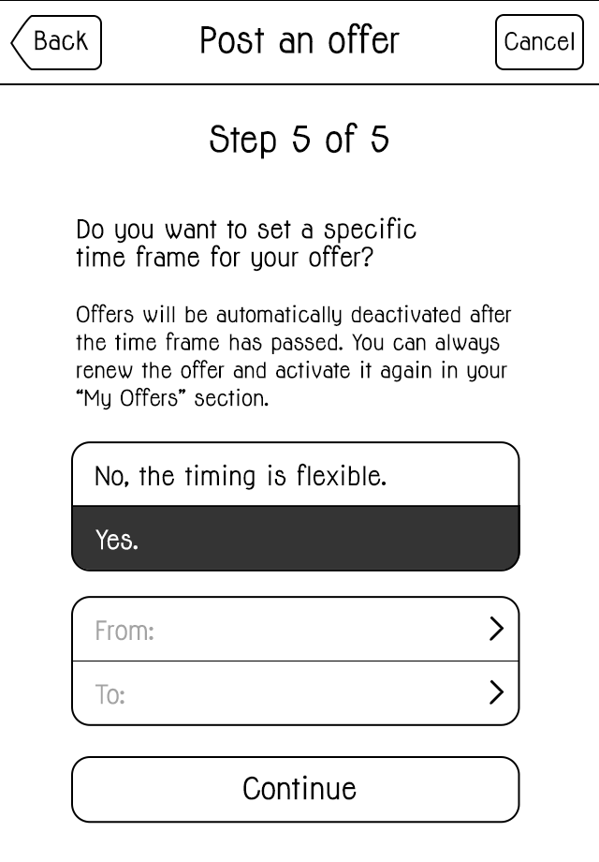 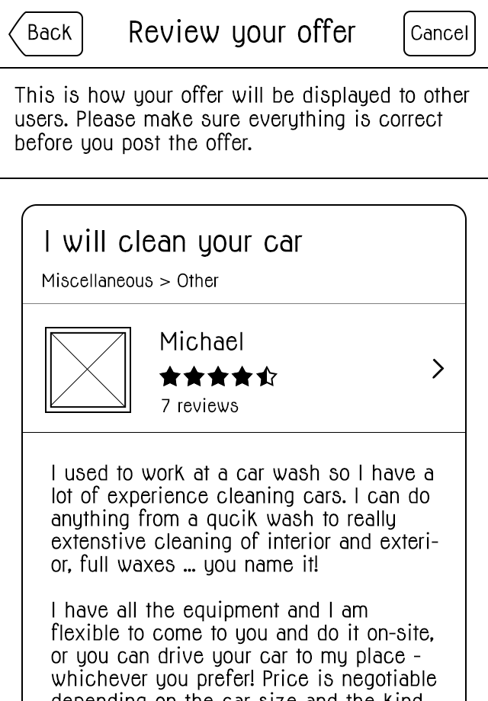

Step 4 Step 5 Review

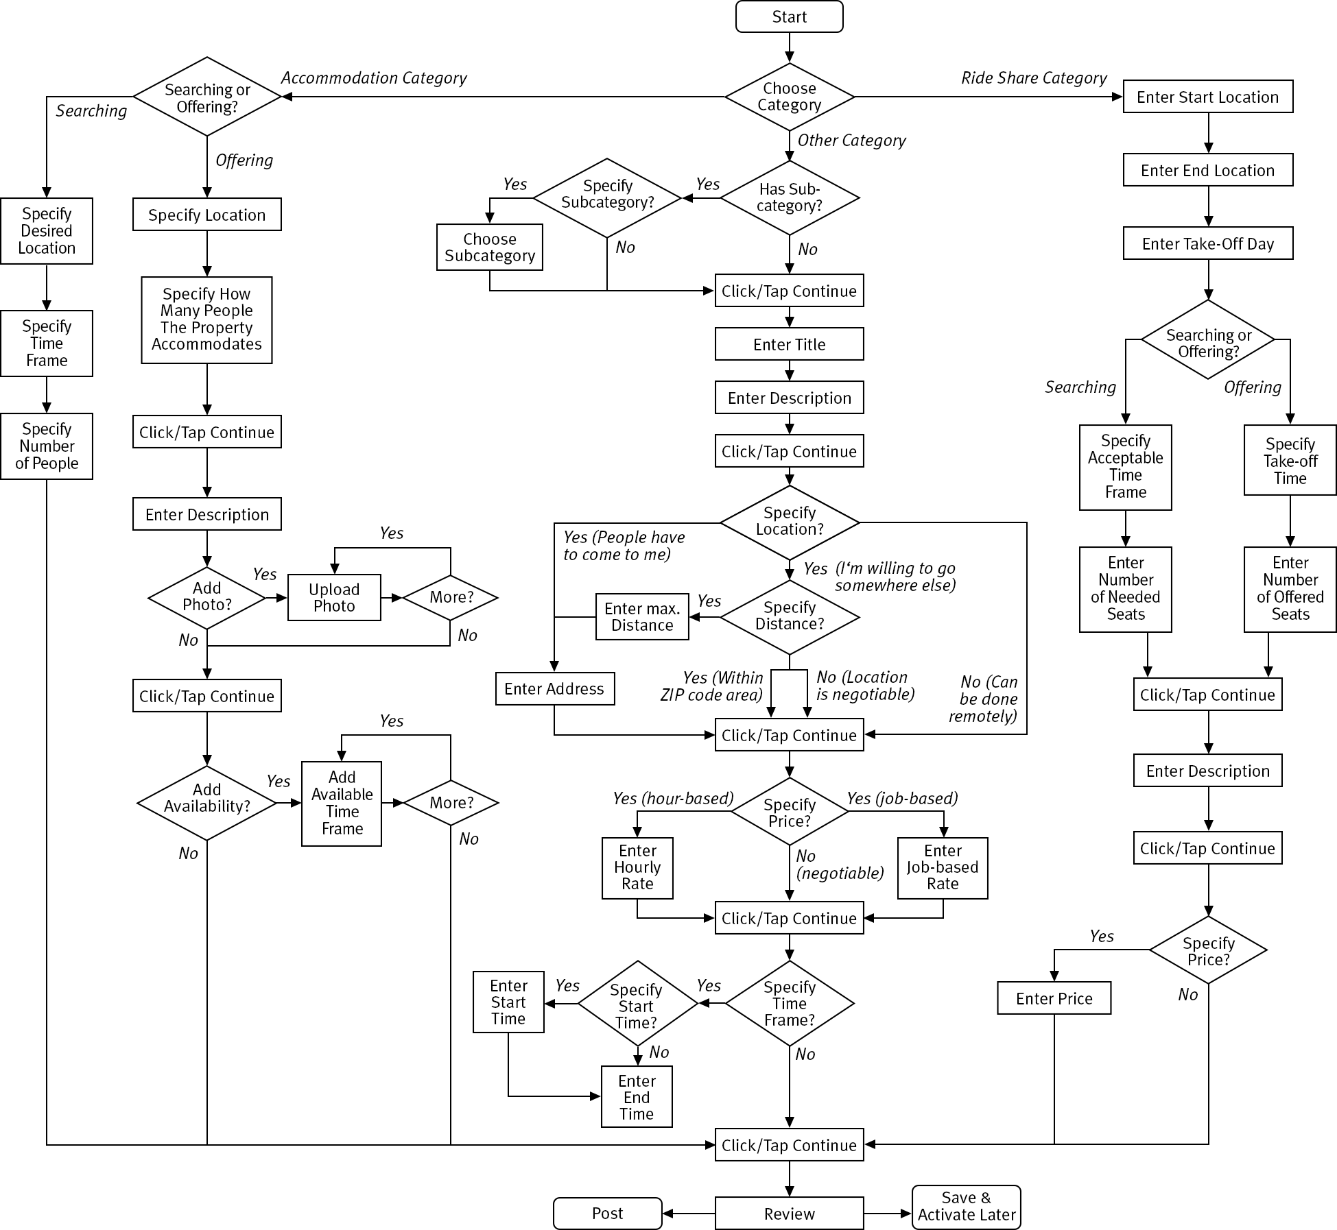

Postig a new listing – user flow

After having entered all necessary information, users will be presented a preview of the listing to see how it would be displayed to others and double-check all information. If they're happy with everything, they can post the listing right away or save it to be activated later.

The sections "My Offers" and "My Requests" shows users a list with all their current listings and gives them the option to edit or delete them. Listings also have a switch to deactivate/activate them, giving users the opportunity to temporarily pause a listing without having to delete and recreate it when they want that same listing back online.

On the mobile device, user's listings will be cached on the device, allowing for offline creation, modification and deletion of listings with the changes being updated on the server once the device is back online.

Browsing and Searching

Users have two different options of viewing active listings: Browsing through categories or making a concrete search. They can choose to view all currently open listings by selecting "All Categories" or narrow down the selection by choosing a specific category and, if existing, an associated subcategory. The search section on the website's top navigation bar as well as the search screen on the mobile device takes the following parameters:

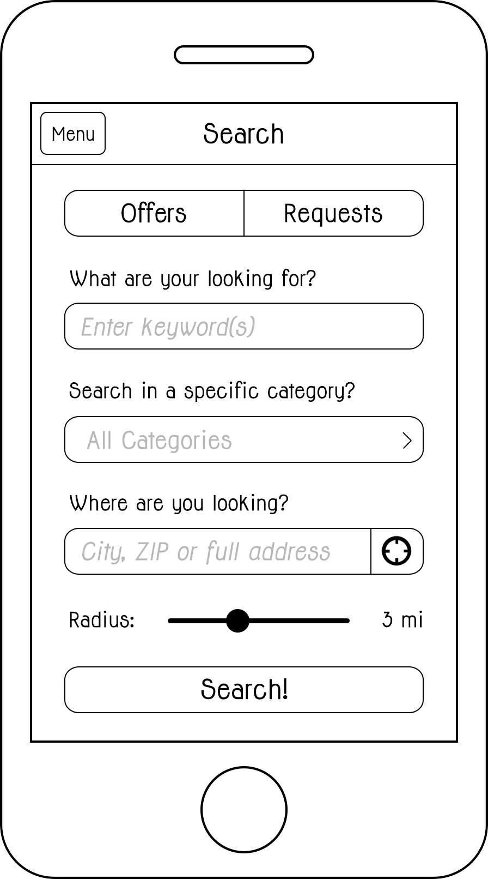

* What type of listing to search for (offers or requests)
* Search keywords – entered in a text field
* Category (optional) – drop-down menu on the website, picker view in the mobile app
* Location (optional) – entered in a text field, accepts cities, ZIP codes or full addresses, will suggest cities based on the first few letters entered by the user, for the mobile version it will include a button to choose the user's current GPS location
* Search radius (only active if location specified) – drop-down menu on the website, slider element in the mobile app

In the web version, all results will be displayed in a preview-style list. Each result will show the title of the listing, the picture, name and average rating of the user who belongs to the listing and the price (if specified). A menu offering sort and filter options will be displayed on the left side of the page. Sort options include sorting the results by user rating, by price or by distance from a location specified in the menu section. If the user's browser and computer support location services, the option of allowing the site to acces the user's current location will be available as well. Users will also have the opportunity to filter results by minimum user rating, price range and area radius, which will remove all listings that don't match the specified parameters from the results list. Listings that have don't have certain parameters specified (e.g. keeping the price or location negotiable) will be kept in the list but displayed at the very bottom. The filter menu will also include a small map view that shows the currently displayed listings as points on a map. Instead of filtering by a specified address and radius, users will also have the option of dragging and zooming the map area and having the result list updated according to the current map section.

Clicking on a listing will bring users to its detail view, where all information available about the listing will be presented to the user, along with the options to directly contact the user who posted the listing or to navigate to their profile in order to find out more about them and read their reviews.

[WIREFRAME SEARCH RESULT PAGE + LISTING DETAIL VIEW WEB]

In the mobile app, sort and filter menus will be available through buttons on the top right of the navigation bar. Similarly to the global menu on the left side, the sort and filter menus are hidden on the right side behind the result view and can be made visible by tapping the sort or filter button on the right side of the navigation bar abvoe the search result view.

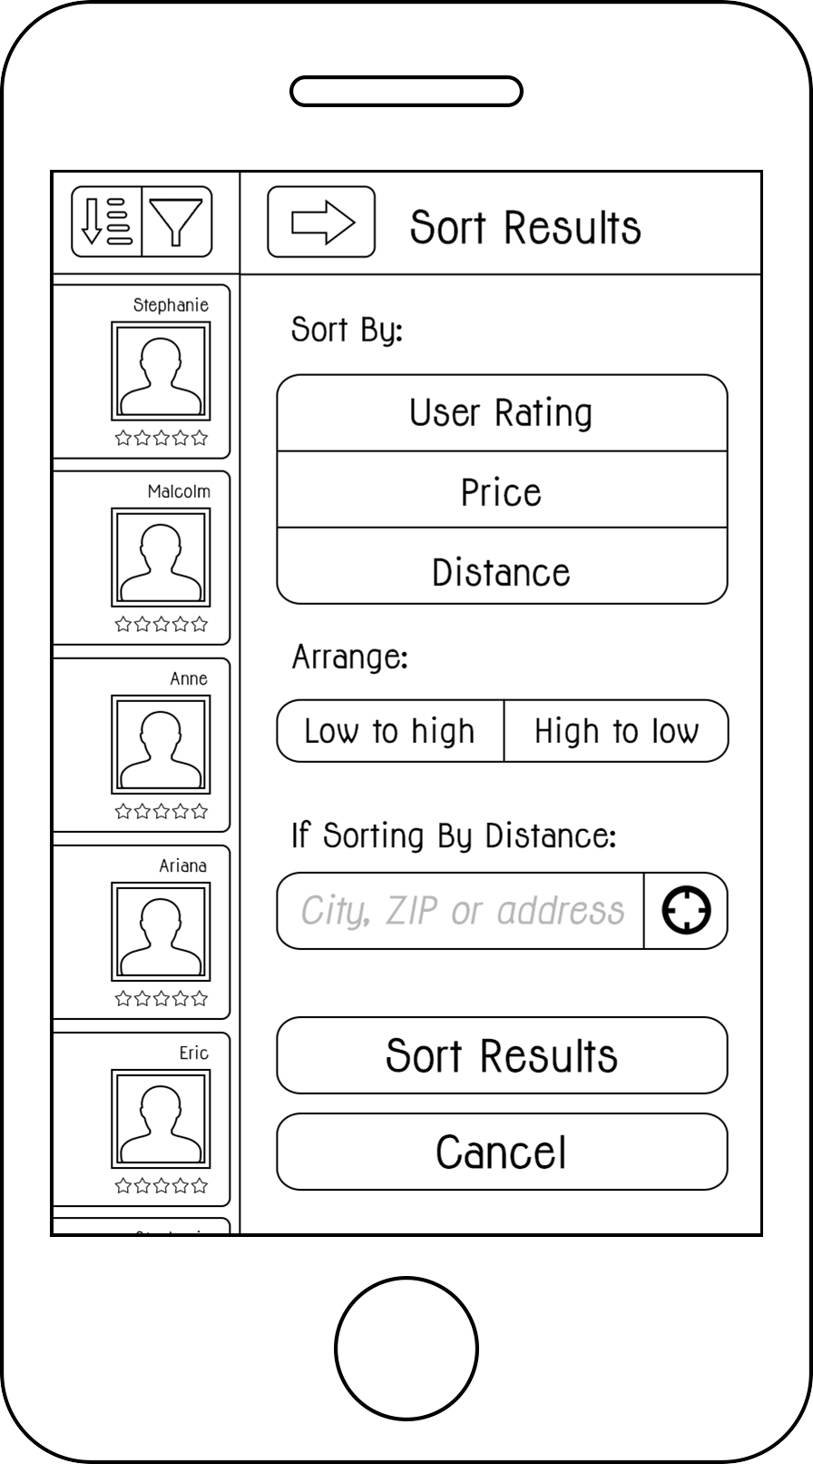 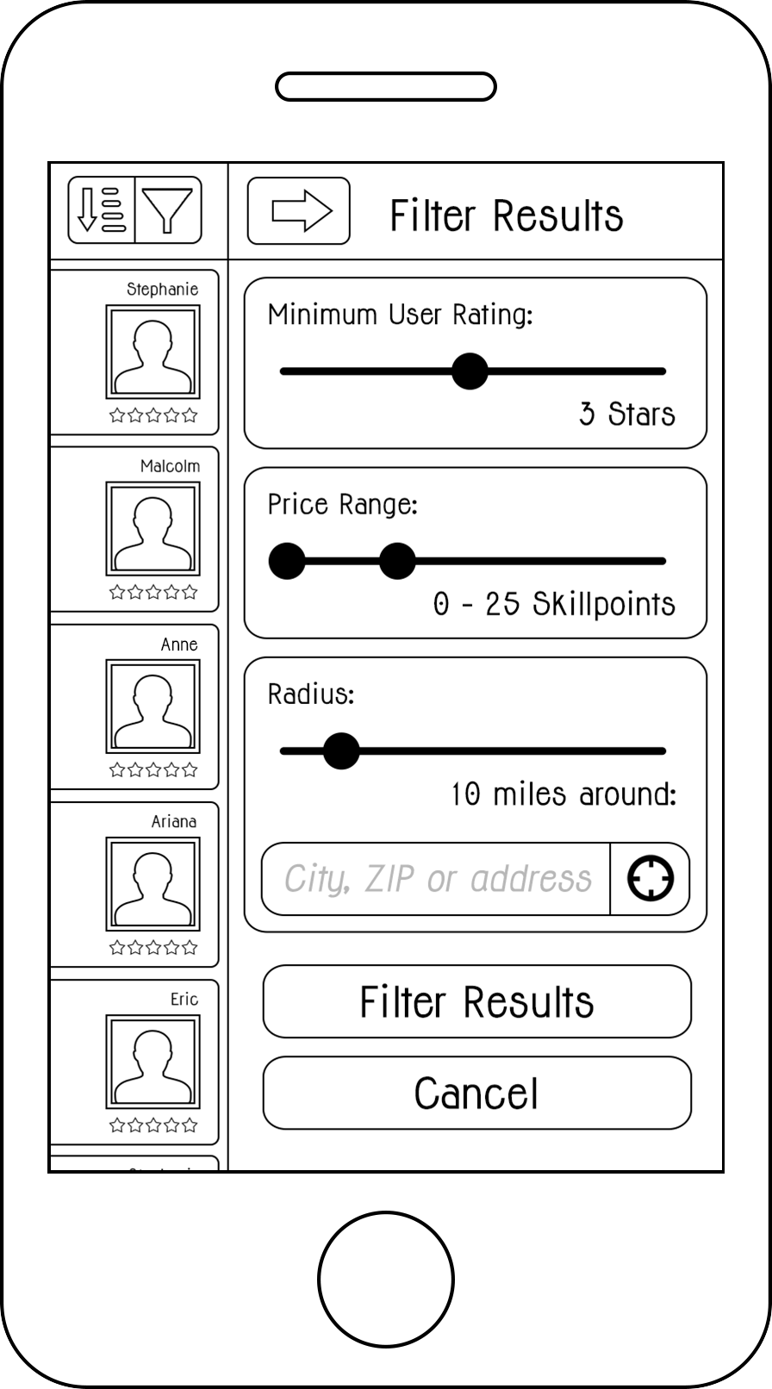

The menus offer the same sort and filter options as the version on the website. However, they will not include the map view. Instead, the user will be able to switch between map view and list view by tapping a segmented button control on the navigation bar above the search result view. Search results in the map view will be displayed as pins, which can be tapped to display a little info view displaying the listing's title, the user picture, name and rating and a button to open up the listing's detail page.

[WIREFRAME SEARCH RESULT PAGE + LISTING DETAIL VIEW MOBILE]

Users who search or browse offers will be presented an additional section at the end of their search results page, listing users whose skills and talents match the search parameters, even if those users currently have no active offers. For example, if a user searches for somebody to fix a flat tire on their bike but none of the search results seemed like the right fit (or there were no search results at all), this section will show them users in their specified area who have mechanical skills listed on their profile page. The user with the flat tire may choose to proactively contact one of these users and ask them for help, attaching a deal that the contacted user can choose to accept or decline.

Contacting members and engaging in deals

Users may get in touch with other members either through the detail page of the listing they're currently viewing or through another member's profile page. If they're contacting a member with the intention of engaging in a deal with them, they may attach a deal suggestion and "stretch out their hand" to the other user. A deal suggestion consits of a concrete offer regarding the compensation of the task. If the listing has a price specified, this will be the default setting for the attached deal. However, members can modify the deal's price and thereby try to bargain with the other user. If the listing doesn't have a price specified, users will have to come up with a price for the deal anyway. Attaching a deal suggestion to the contact message is optional – users may also choose to send a simple message to clarify details or make a non-binding suggestion.

A user receiving a deal suggestion may choose to make a counter-suggestion with a modified price specification or simply decline the suggestion. If they want to accept the suggested deal, they will virtually shake the hand that was stetched out to them, resulting in a binding agreement among both parties for the transaction to take place. The stretching out and shaking of hands are metaphors that will be visually incorporated into the user flow to illustrate the process of engaging in a deal. Once a deal is sealed, both members will have the option of making a donation for people in need (see page XX for more explanation about this).

[WIREFRAME OF EXAMPLE MESSAGE FLOW & DEAL AGREEMENT]

Open deals, payment flow and review process

When two people engange in a deal, the amount of points that both parties agreed on will be debited from the account of the user receiving the service. However, the user performing the services will not immediately receive those points. Instead, the points will be withheld by the system until the deal is marked as done.

Open deals will be available for reference in the "Open Deals" section for both parties. Through this section, users will be able to quickly view relevant details about those deals, for example the address of the other user (if applicable) or their phone number. They may contact the other person to clarify details and logistics in order to get the job done. Both parties will see a "Mark as Done" button, a "Cancel Deal" button and a "Report Problem" button. If the user who received the services marks it as done, this will automatically mark it as done for the other user and the points will be credited to their account. If the user who performed the service hits the "Done" button first, the other user will be notified about this and asked to confirm that the deal is done.

Once a deal is marked as done, both users will be asked to review each other. A review consists of a star-rating (0 to 5 stars), a public review text open to the community that will be displayed on the user's profile page and optionally a private message to the other user where further feedback or just a simple "Thank You" can be exchanged. Users will not be able to see the review they got before they haven't submitted their own review for the other user.

The "Cancel Deal" button allows users to cancel a deal if necessary. There could always be unforeseeable circumstances (for example illness) that require a deal to be cancelled. If one of both parties hits the cancel button, they will be asked to attach a message explaining the other user why they have to cancel. A notifiation including this message will be send to the other user, who has to accept the cancellation in order for the points to be booked back to the account that they were originally debited from.

There are various things that can potentially go wrong in the process: Somebody doesn't respond after a deal has been agreed on, delivers unacceptable work or doesn't show up at all, doesn't mark the deal as done or even tries to cancel the deal after the work has already been performed. That's what the "Report Problem" button is for. Users who hit this button will first be asked if they have already tried to solve the problem on their own by contacting the other user. If they haven't, they will be encouraged to first write a message to the other user to see if they can find an agreement. If they still want to report the problem, they will get the opportunity to contact customer service to explain the problem and seek assistance in solving it.

[WIREFRAMES OPEN DEAL PAGE WEB + MOBILE]

Security and trust

To avoid fake profiles, users will be required to verify their Email address before they are able to sign in. After a user successfully created a new account, an Email will be sent to the address they provided with a link to verify the address. After clicking this link, their account will be activated, giving them full access to all of the platform's features.

To build additional trust, users have the opportunity of verifying their phone number. If they provided a phone number in their personal profile settings, they will see a button labeled "Verify Phone Number". Upon clicking that button, a text message will be sent to their phone with a confirmation code. If they enter this code on their profile page, their phone number will be marked as verified. Through cooperation with a third-party service called Virtrue[1], users will also have the opportunity to have their identity verified through a link in their personal profile settings. Virtrue uses a set of algorithms that analyze user's online data to verify if they really are who they say they are. If a user has successfully verified their phone number and/or identity, this will be indicated on their public profile – the data itself will be kept private.

Notification settings and subscriptions

By default, users will be notified about incoming messages through an Email sent to the provided Email address. On the mobile device, people will also have the opportunity to enable push notifications in order to be instantly informed about messages.

Users will also have the opportunity to subscribe to newly posted offers and requests within their area. They may do so by specifying one or more categories and choosing to either subscribe to new listings matching those categories within their ZIP code area or providing a specific location and radius around this location. Whenever a new listing matching the critea is posted, they will be instantly notified via Email and, if they're using the mobile app and have the service activated, will receive a push notifcation on their device.

Accessibility

To help users who suffer from weak eyesight or visual impairment, both the website and the mobile app will offer the opportunity of enlarging fonts and switching to a black-white mode to support vision through increased contrast.

All elements, including pictures, buttons and icons, will be supplemented with metadata and accessibility labels to support blind users who rely on screen readers.

1. http://www.virtrue.us/