How to begin a new SSIS Project using SQL Server Data Tools for Visual Studio 2017 for IMT 577 for the Staging Project

1. Use run as your NetID account to open SQL Server Data Tools for Visual Studio 2017

STEP 1 Create New Project

1. Select File>New>Project

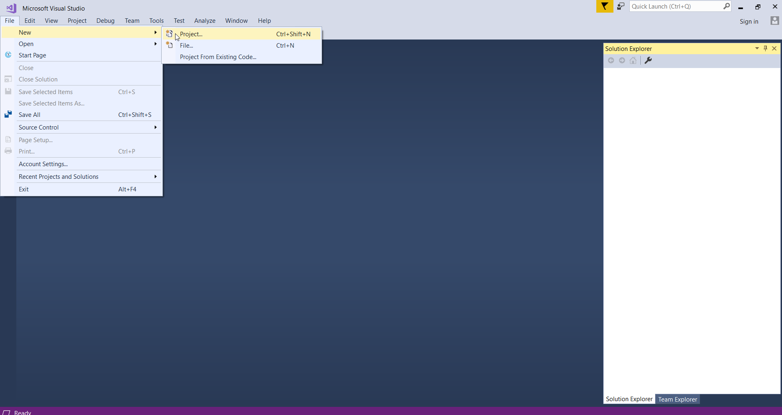

1. From the “New Project” pop-up screen choose “Integration Services Project”.

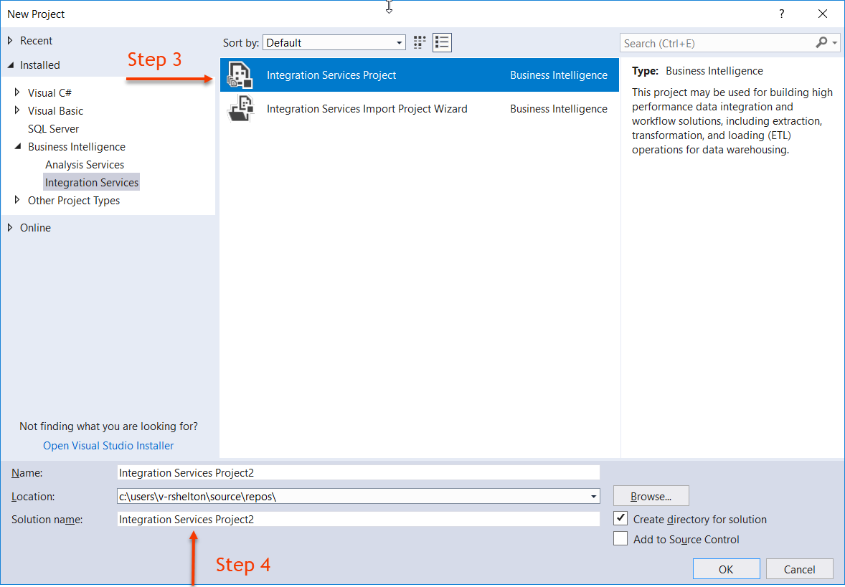

1. Give your new project a name, set the location the new project, and set the solution name (the solution name can be the same as the name).

STEP 2 Create New Data Sources

1. In Solution Explorer select “Connection Managers”, right click and choose New Connection Manager.

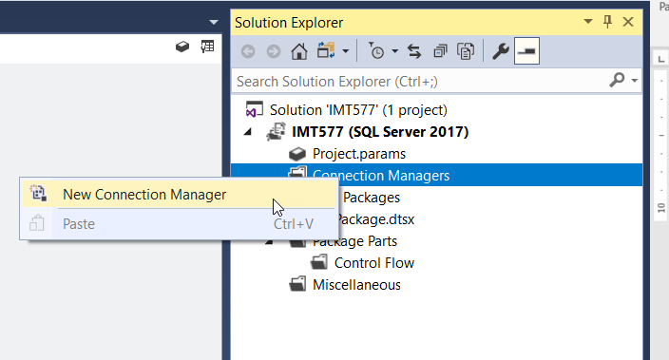

1. In the ensuing “Add SSIS Connection Manager” pop-up window, select OLEDB and click the Add… button.

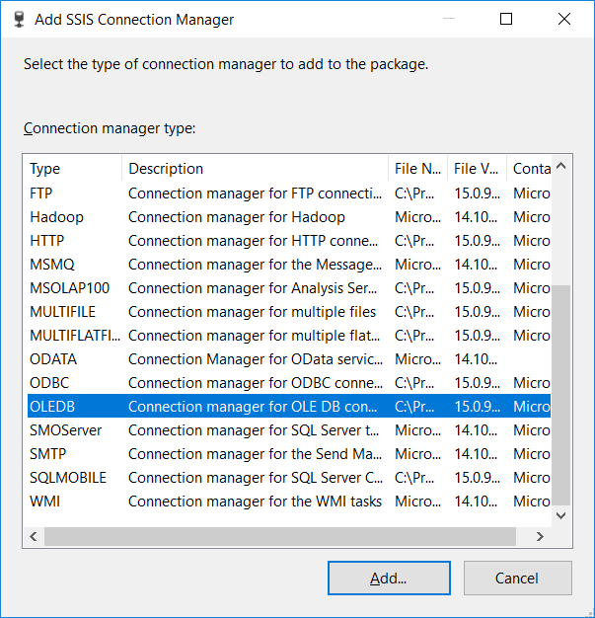

1. On the “Configure OLE DB Connection Manager” screen, click the New… button.

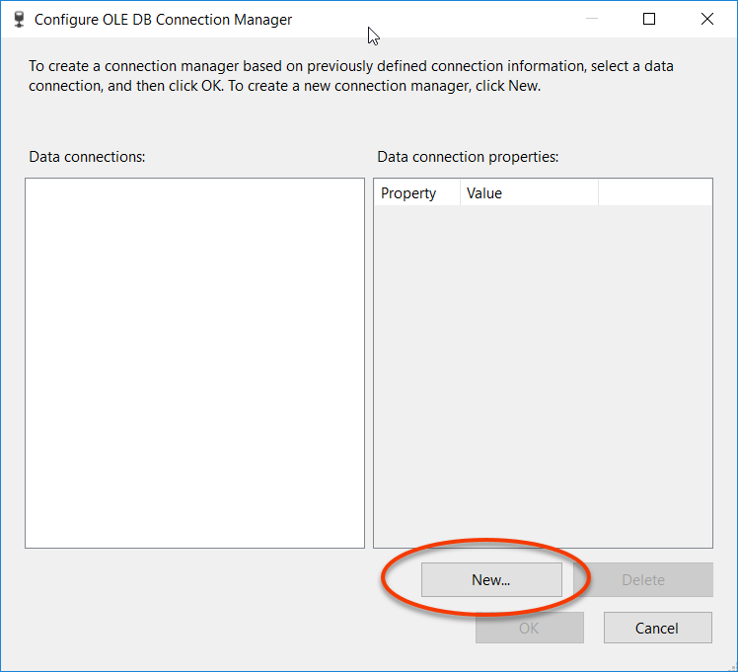

1. In the ensuing “Connection Manager” pop-up window. Change the “Provider” to Native OLE DB\SQL Server Native Client 11.0. Enter smith-bi1.ischool.uw.edu in the “Server name” box. Then select the database SourceSystem from the “Connect to a database” select list. Afterward, click the OK button.

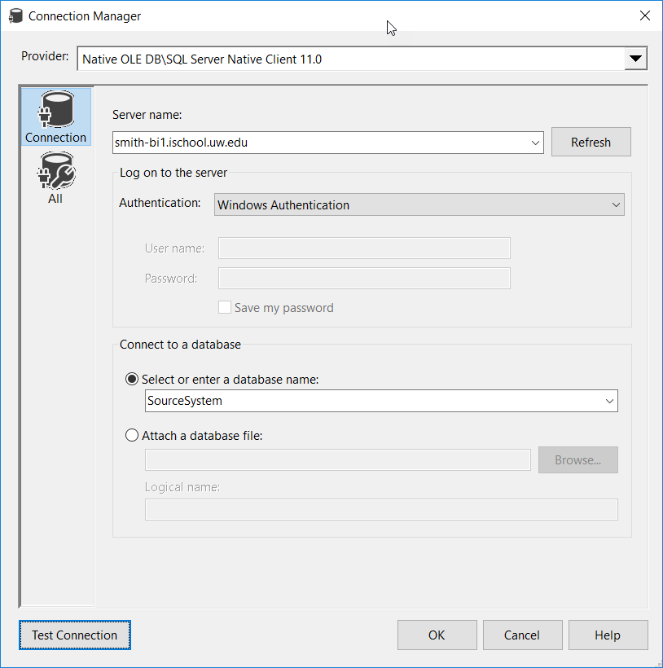

1. Back on the “Configure OLE DB Connection Manager” screen, ensure that the Data connection for Source System is highlighted, then click the OK button.

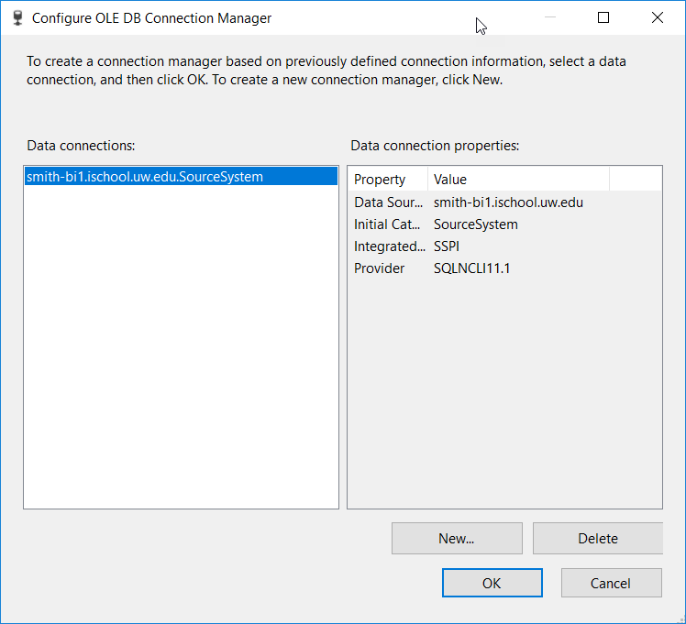

1. Repeat steps 7-9 to create a connection to your database (<NETID>DW).

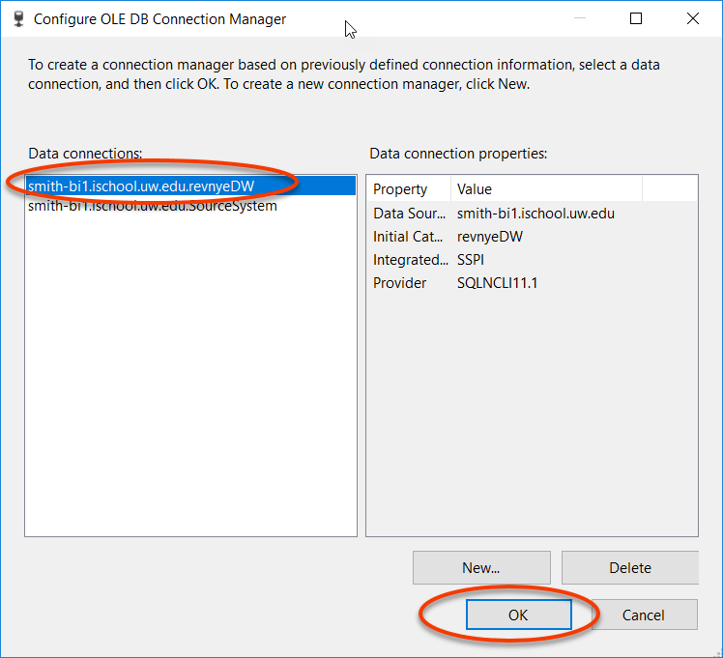

STEP 3 Create Staging Data Flows

1. In the SSIS package (Package.dtsx or another name if you rename it). Drag and Drop an Execute SQL Task onto the Control Flow tab. Right click on the new Execute SQL Task and choose Rename. Change the name to Create Destination Database Schema and Tables.

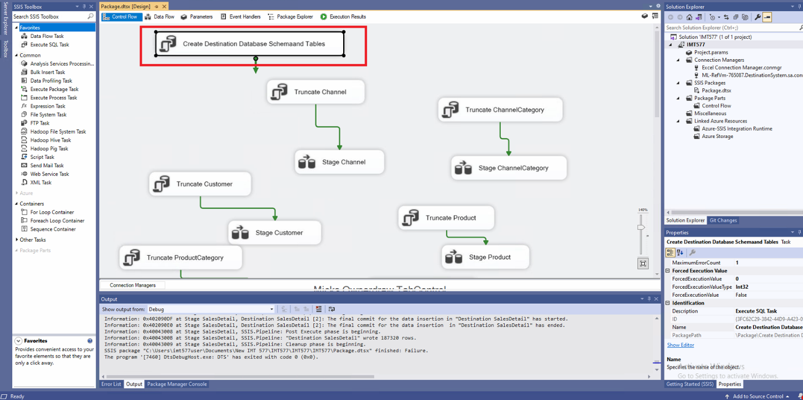

1. Double click on the task. In the ensuing “Execute SQL Task Editor” pop-up window, set the Connection to your database Connection Manager and the SQLStatement to “Create Destination Schema Script – (At the end of this document)” create DB table queries. Then click the OK button.

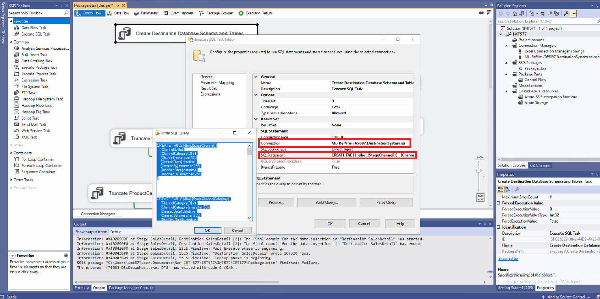

1. Drag and Drop an Execute SQL Task onto the Control Flow tab. Right click on the new Execute SQL Task and choose Rename. Change the name to Truncate Channel

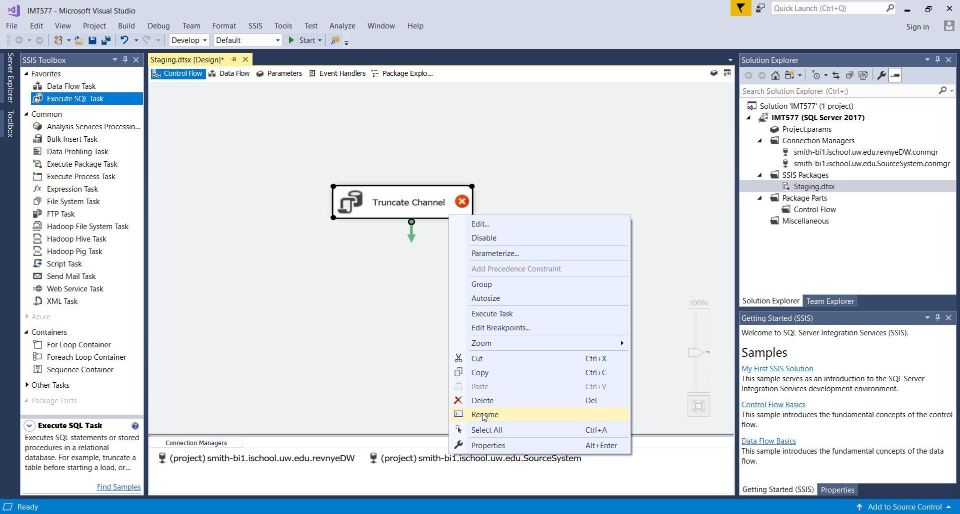

1. Double click on the task. In the ensuing “Execute SQL Task Editor” pop-up window, set the Connection to your database Connection Manager and the SQLStatement to “TRUNCATE TABLE dbo.StageChannel”. Then click the OK button.

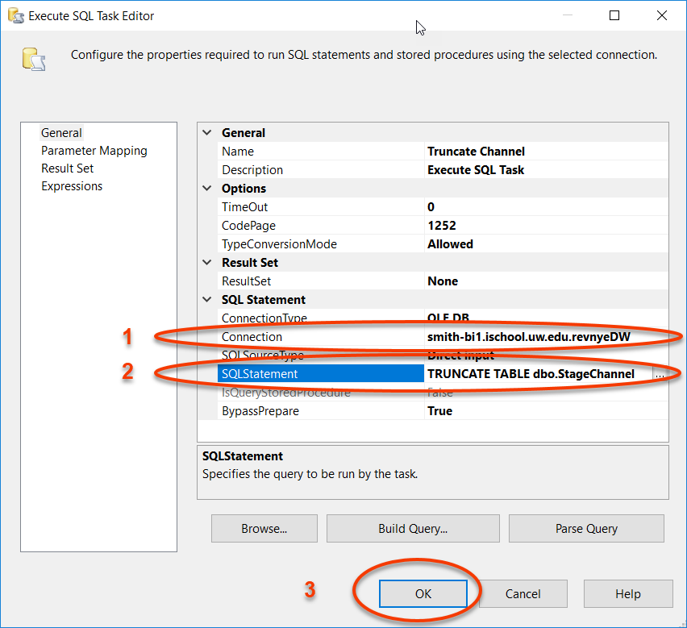

1. Next Drag and Drop a Data Flow Task onto the Control Flow tab. Right click on the new Data Flow Task and choose Rename. Change the name to Stage Channel.

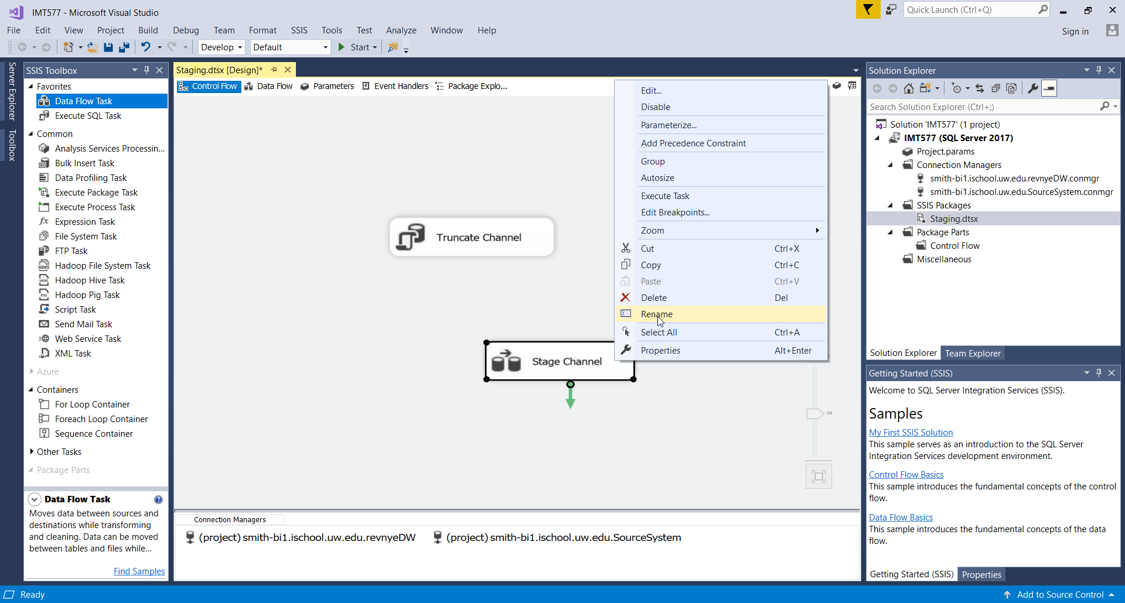

1. Double click on the task Stage Channel Task. This will take you to the Data Flow tab.
2. Drag and Drop a Source Assistant task onto the Data Flow tab.
3. In the ensuing “Source Assistant – Add New Source” pop-up window, select SQL Server. Then select the connection manager for the SourceSystem. Then click the OK button.

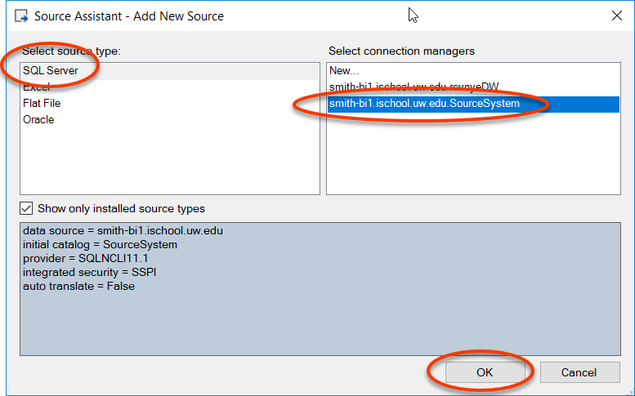

1. Right click on the new OLE DB Source Task and choose Rename. Change the name to Source Channel.
2. Double click on the Source Channel task. In the ensuing “OLE DB Source Editor” pop-up window, ensure that the “OLE DB connection manager” is set to the Source System database Connection Manager. Then select the Channel table in the “Name of the table or the view” select list. Then click the OK button.

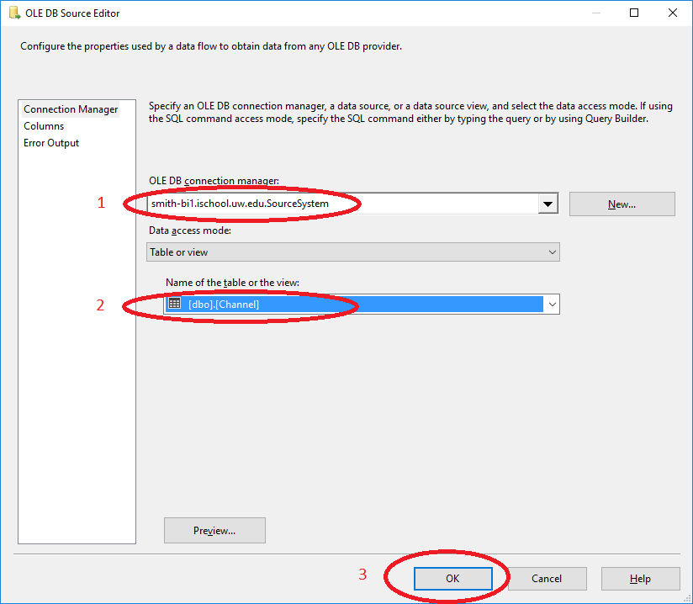

1. Drag and Drop a Destination Assistant task onto the Data Flow tab.
2. In the ensuing “Source Assistant – Add New Destination” pop-up window, select SQL Server. Then select the connection manager for your database Connection Manager. Then click the OK button.
3. Right click on the new OLE DB Destination Task and choose Rename. Change the name to Destination Channel.
4. Click on the Source Channel task, then select the blue arrow under the task. Stretch the blue arrow onto the Destination Channel task.

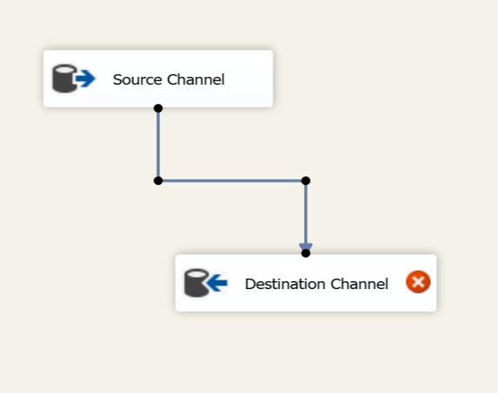

1. Double click on the Destination Channel task. In the ensuing “OLE DB Destination Editor” pop-up window, ensure that the “OLE DB connection manager” is set to your database Connection Manager. Then click the New… button next to the “Name of the table or the view” select list.

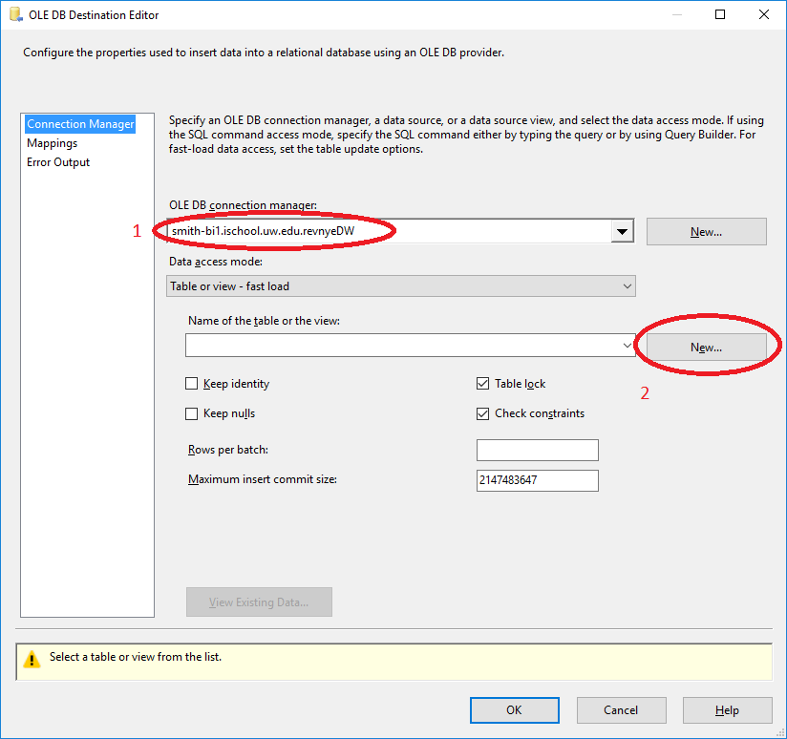

1. In the ensuing “OLE DB Destination Editor” pop-up window, change the name of the table to [dbo].[StageChannel] (to avoid using a space) and then click the OK button.

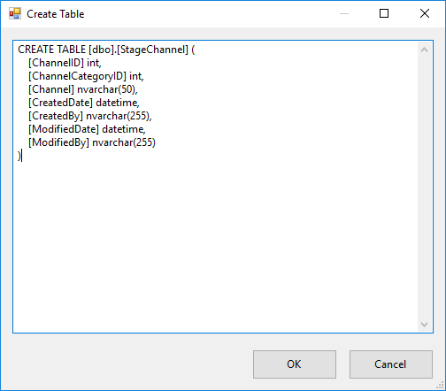

1. The new table name should appear in the “Name of the table or the view” select list. Click the Mappings in the left window. Verify that SSIS has mapped every Input Column to a Destination Column. Then click the OK button.

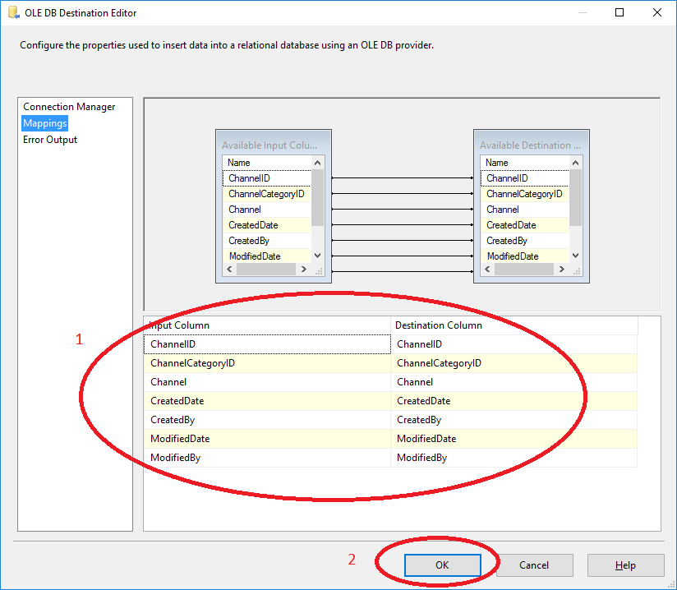

1. Click the Control Flow tab to return to the Control Flow.
2. Click on the Truncate Channel task, then select the green arrow under the task. Stretch the green arrow onto the Stage Channel task.

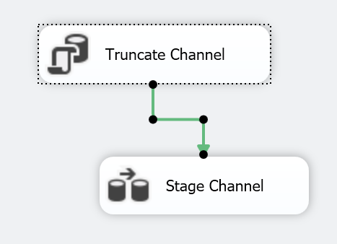

1. In the SSIS package (Package.dtsx or another name if you rename it). Drag and Drop an Execute SQL Task onto the Control Flow tab. Right click on the new Execute SQL Task and choose Rename. Change the name to Truncate ChannelCategory.

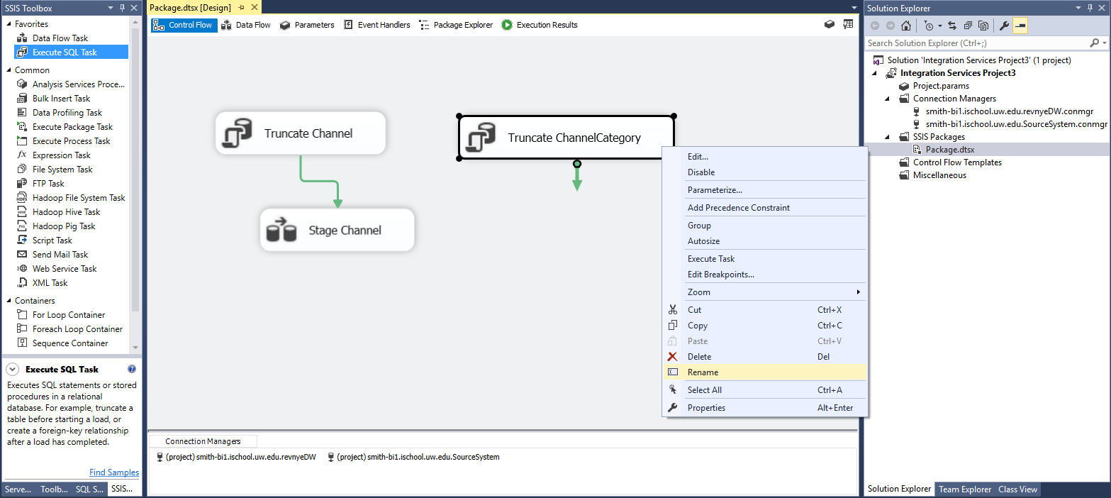

1. Double click on the task. In the ensuing “Execute SQL Task Editor” pop-up window, set the Connection to your database Connection Manager and the SQLStatement to “TRUNCATE TABLE dbo.StageChannelCategory”. Then click the OK button.

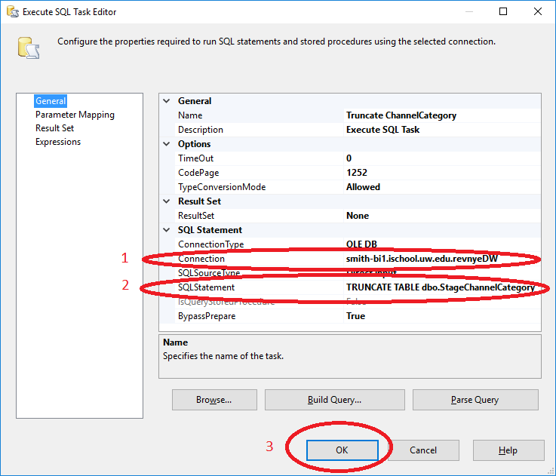

1. Next Drag and Drop a Data Flow Task onto the Control Flow tab. Right click on the new Data Flow Task and choose Rename. Change the name to Stage ChannelCategory.

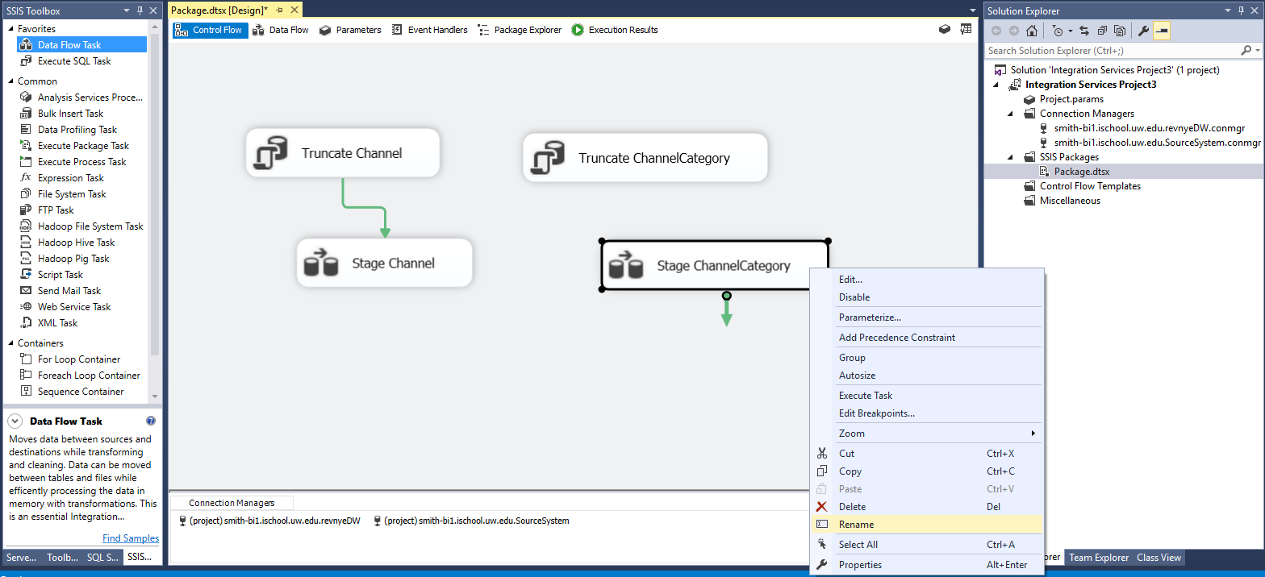

1. Double click on the task Stage ChannelCategory Task. This will take you to the Data Flow tab.
2. Drag and Drop a Source Assistant task onto the Data Flow tab. In the ensuing “Source Assistant – Add New Source” pop-up window, select SQL Server. Then select the connection manager for the SourceSystem. Then click the OK button.
3. Right click on the new OLE DB Source Task and choose Rename. Change the name to Source ChannelCategory.
4. Double click on the Source ChannelCategory task. In the ensuing “OLE DB Source Editor” pop-up window, ensure that the “OLE DB connection manager” is set to the Source System database Connection Manager. Then select the ChannelCategory table in the “Name of the table or the view” select list. Then click the OK button.

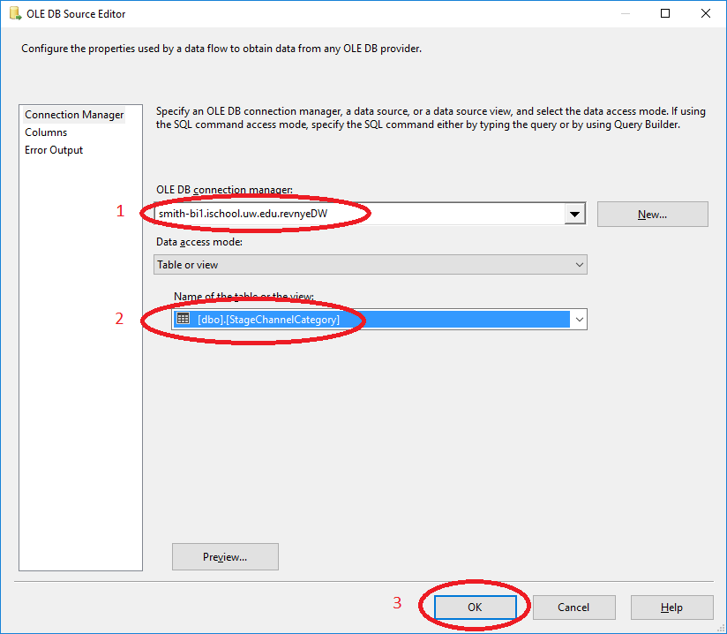

1. Drag and Drop an OLE DB Destination task onto the Data Flow tab. Right click on the new OLE DB Source Task and choose Rename. Change the name to Destination ChannelCategory.
2. Click on the Source ChannelCategory task, then select the blue arrow under the task. Stretch the blue arrow onto the Destination ChannelCategory task.

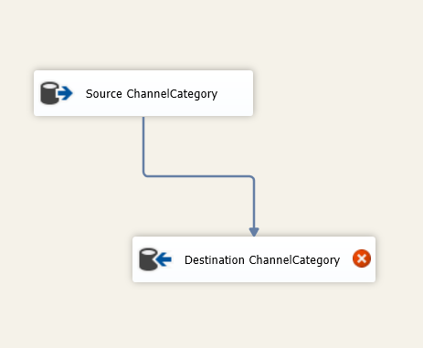

1. Double click on the Destination ChannelCategory task. In the ensuing “OLE DB Destination Editor” pop-up window, set the “OLE DB connection manager” to your database database Connection Manager. Then click the New… button next to the “Name of the table or the view” select list.



1. In the ensuing “OLE DB Destination Editor” pop-up window, change the name of the table to [dbo].[StageChannelCategory] (to avoid using a space) and then click the OK button.

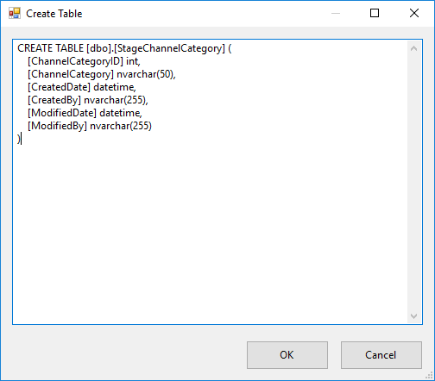

1. The new table name should appear in the “Name of the table or the view” select list. Click the Mappings in the left window. Verify that SSIS has mapped every Input Column to a Destination Column. Then click the OK button.

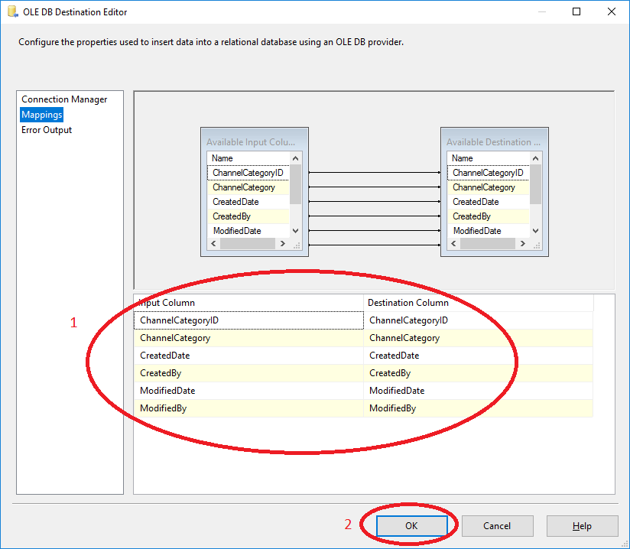

1. Click the Control Flow tab to return to the Control Flow.
2. Click on the Truncate Channel task, then select the green arrow under the task. Stretch the green arrow onto the Stage Channel task.

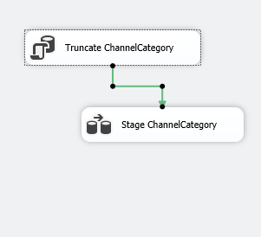

1. Repeat steps 11-27 for each table in the SourceSystem database.
2. Execute the “Create Destination Database Schema and Tables” task before project gets started.
3. Now Run the project again.

**SCRIPTS**

**Create Destination Schema Script**

CREATE TABLE [dbo].[StageChannel] (

[ChannelID] int,

[ChannelCategoryID] int,

[Channel] nvarchar(50),

[CreatedDate] datetime,

[CreatedBy] nvarchar(255),

[ModifiedDate] datetime,

[ModifiedBy] nvarchar(255)

)

CREATE TABLE [dbo].[StageChannelCategory] (

[ChannelCategoryID] int,

[ChannelCategory] nvarchar(50),

[CreatedDate] datetime,

[CreatedBy] nvarchar(255),

[ModifiedDate] datetime,

[ModifiedBy] nvarchar(255)

)

CREATE TABLE [dbo].[StageCustomer] (

[CustomerID] uniqueidentifier,

[SubSegmentID] int,

[FirstName] nvarchar(255),

[LastName] nvarchar(255),

[Gender] nvarchar(1),

[EmailAddress] nvarchar(255),

[Address] nvarchar(255),

[City] nvarchar(255),

[StateProvince] nvarchar(255),

[Country] nvarchar(255),

[PostalCode] nvarchar(255),

[PhoneNumber] nvarchar(20),

[CreatedDate] datetime,

[CreatedBy] nvarchar(255),

[ModifiedDate] datetime,

[ModifiedBy] nvarchar(255)

)

CREATE TABLE [dbo].[StageProduct] (

[ProductID] int,

[ProductTypeID] int,

[Product] nvarchar(50),

[Color] nvarchar(50),

[Style] nvarchar(50),

[UnitofMeasureID] int,

[Weight] numeric(18,4),

[Price] numeric(18,2),

[Cost] numeric(18,2),

[CreatedDate] datetime,

[CreatedBy] nvarchar(255),

[ModifiedDate] datetime,

[ModifiedBy] nvarchar(255),

[WholesalePrice] numeric(18,2)

)

CREATE TABLE [dbo].[StageProductCategory] (

[ProductCategoryID] int,

[ProductCategory] nvarchar(50),

[CreatedDate] datetime,

[CreatedBy] nvarchar(255),

[ModifiedDate] datetime,

[ModifiedBy] nvarchar(255)

)

CREATE TABLE [StageProductType] (

[ProductTypeID] int,

[ProductCategoryID] int,

[ProductType] nvarchar(50),

[CreatedDate] datetime,

[CreatedBy] nvarchar(255),

[ModifiedDate] datetime,

[ModifiedBy] nvarchar(255)

)

CREATE TABLE [dbo].[StageReseller] (

[ResellerID] uniqueidentifier,

[Contact] nvarchar(255),

[EmailAddress] nvarchar(255),

[Address] nvarchar(255),

[City] nvarchar(255),

[StateProvince] nvarchar(255),

[Country] nvarchar(255),

[PostalCode] nvarchar(255),

[PhoneNumber] nvarchar(20),

[CreatedDate] datetime,

[CreatedBy] nvarchar(255),

[ModifiedDate] datetime,

[ModifiedBy] nvarchar(255),

[ResellerName] nvarchar(255)

)

CREATE TABLE [dbo].[StageSalesDetail] (

[SalesDetailID] int,

[SalesHeaderID] int,

[ProductID] int,

[SalesQuantity] int,

[SalesAmount] numeric(18,2),

[CreatedDate] datetime,

[CreatedBy] nvarchar(255),

[ModifiedDate] datetime,

[ModifiedBy] nvarchar(255)

)

CREATE TABLE [dbo].[StageSalesHeader] (

[SalesHeaderID] int,

[Date] date,

[ChannelID] int,

[StoreID] int,

[CustomerID] uniqueidentifier,

[ResellerID] uniqueidentifier,

[CreatedDate] datetime,

[CreatedBy] nvarchar(255),

[ModifiedDate] datetime,

[ModifiedBy] nvarchar(255)

)

CREATE TABLE [dbo].[StageStore] (

[StoreID] int,

[SubSegmentID] int,

[StoreNumber] int,

[StoreManager] nvarchar(255),

[Address] nvarchar(255),

[City] nvarchar(255),

[StateProvince] nvarchar(255),

[Country] nvarchar(255),

[PostalCode] nvarchar(255),

[PhoneNumber] nvarchar(20),

[CreatedDate] datetime,

[CreatedBy] nvarchar(255),

[ModifiedDate] datetime,

[ModifiedBy] nvarchar(255)

)

CREATE TABLE [dbo].[StageTargetCRS] (

[Year] float,

[ChannelName] nvarchar(255),

[TargetName] nvarchar(255),

[ TargetSalesAmount ] float

)

CREATE TABLE [dbo].[StageTargetProduct] (

[ProductID] float,

[Product] nvarchar(255),

[Year] float,

[ SalesQuantityTarget ] float

)