Operation Analytics and Investigating Metric Spike
PROJECT DESCRIPTION:
Operational analytics is crucial for improving a company's operations by extracting valuable insights from collected data. As a lead Data Analyst at a company like Microsoft, I collaborated with the operations, support, and marketing teams. With the help of my advanced SQL skills, I examine their data to pinpoint areas for improvement and provided the company understand with insights into unexpected changes in key metrics.
My project focuses on two main case studies. The first, Job Data Analysis, aims to analyse operational metrics related to job reviews. The second, Investigating Metric Spike, seeks to understand user engagement and activity patterns. Both case studies leverage advanced SQL techniques to derive valuable insights and address specific business questions. This project will provide actionable recommendations to optimize operations and enhance user experience.
PROJECT APPROACH:
1.DATABASE SETUP:
- Create Database and Table: A database is created, and tables are defined according to the given structure. Also, import CSV files into MySQL Workbench.

2.ANALYSIS EXECUTION: In the analysis phase, I am going to use advanced SQL techniques to answer the questions asked for case studies.
- Job Data Analysis: In this part, using SQL aggregation functions and series analysis, I worked on calculating average scores, identification trends, and anomaly detection in job reviews.
- Investigating Metric Spike: User engagement trends are analyzed by aggregating activity data. Spikes are detected by comparing current data against historical averages.
3.REPORT PREPARATION:
- Compile Findings: The analysis results were summarized in a detailed report. This report, created in PDF format, summarized the key findings by charting trends and making actionable recommendations. The clear and crisp presentation of insights, driven by data, had to be given to the leadership team for meaningful decision-making and improvements in operations and user experience.

TECH-STACK USED
The Tech-stack used for the project is MySQL community server with version 8.0.34, for creating the database. Also used Microsoft Excel for import and export of data.
PROJECT INSIGHTS:
1) CASE STUDY 1: JOB DATA ANALYSIS
Creating a table named job-data with the following columns:
- Job_id: (unique identifier of jobs)
- Actor_id: (Unique identifier of actor)
- Event: (the type of event(decision/skip/transfer))
- Language: (The language of the content
- Time_spent: (time spent to review the job in seconds)
- Org: (the organization of the actor)
- Ds: (The date in the format yyyy/mm/dd -stored as text).
Query:
create database job;
use job;
Query for creating a table:
create table job_data (
ds Date,
job_id int not null,
actor_id int not null,
event varchar(20) not null,
language varchar(10) not null,
time_spent int not null,
org char(2)
);
select * from job_data;
Result: The result for creating table is given below
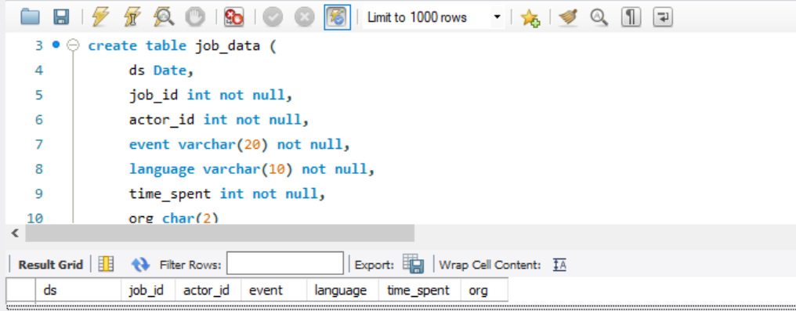
Query for inserting data into a table job_data:
insert into job_data (ds,job_id,actor_id,event,language,time_spent,org)
values('2020-11-30',21,1001,'skip','English',15,'A'),
('2020-11-30',22,1006,'transfer','Arabic',25,'B'),
('2020-11-29',23,1003,'decision','Persian',20,'C'),
('2020-11-28',23,1005,'transfer','Persian',22,'D'),
('2020-11-28',25,1002,'decision','Hindi',11,'B'),
('2020-11-27',11,1007,'decision','French',104,'D'),
('2020-11-26',23,1004,'skip','Persian',56,'A'),
('2020-11-25',20,1003,'transfer','Italian',45,'C');

Result: After inserting the values.
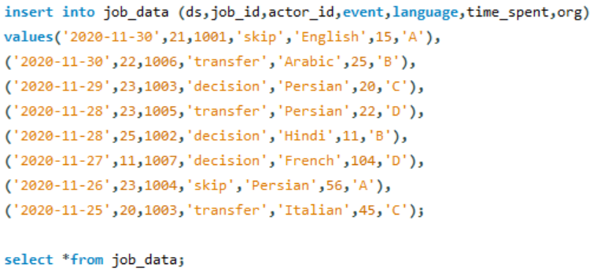
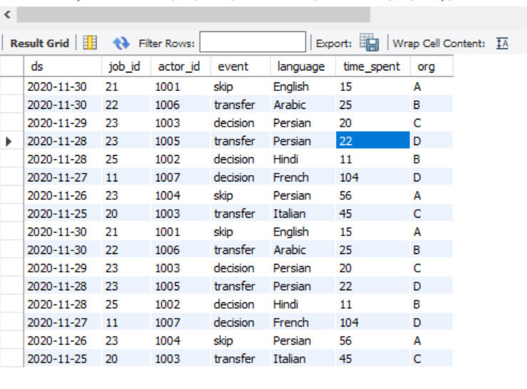
1.CASE STUDY-1:TASKS
A. Jobs Reviewed Over Time:
Task: Write an SQL query to calculate the number of jobs reviewed per hour for each day in November 2020.
SQL Query:
select ds as Data,
count(job_id) as joint_job_id,
round((sum(time_spent) / 3600),2) as total_time,
round((count(job_id) / (sum(time_spent) / 3600)),2) as job_review_pDay
from
job_data
where ds between '2020-11-01' and '2020-11-30'
group by ds
order by ds;
Result: The total number of jobs reviewed per hour for each day in November 2020 are given below table.
slno | Date | Count_Job_Id | Total_Time_Sp_Hr | Job_Rview_PHr_PDay
1. | 2020-11-25 | 1 | 0.01 | 80.00
2. | 2020-11-26 | 1 | 0.02 | 64.29
3. | 2020-11-27 | 1 | 0.03 | 34.62
4. | 2020-11-28 | 2 | 0.01 | 218.18
5. | 2020-11-29 | 1 | 0.01 | 180.00
6. | 2020-11-30 | 2 | 0.01 | 180.00

INSIGHT:
- From the table ,we can observe that 0.01 jobs reviewed per hour for each day in November 2020.
- The highest job reviewed on 28th November 2020 with 218.18 per hour.
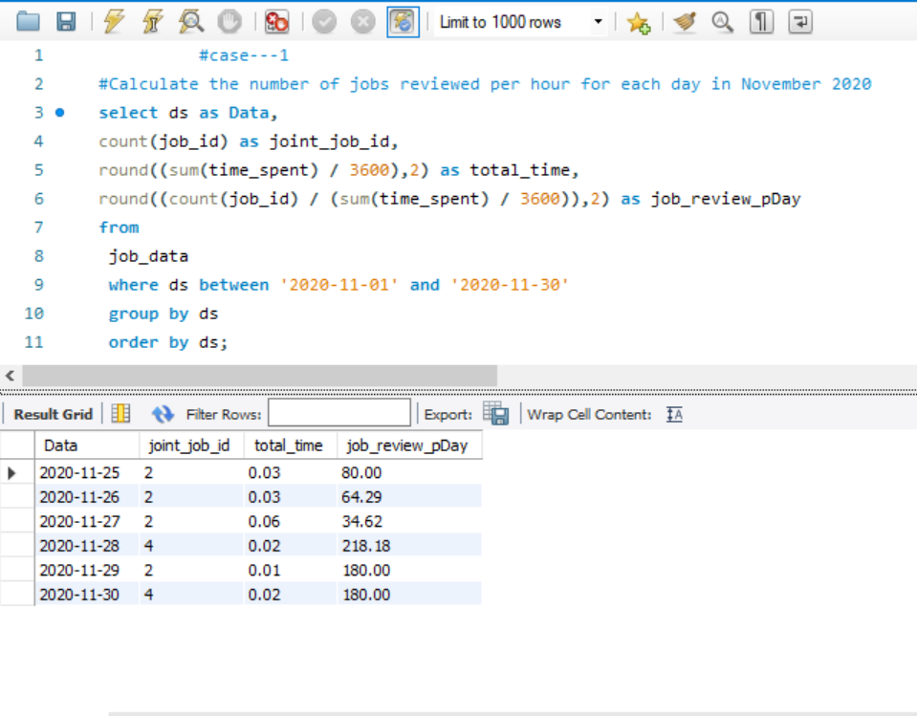
B. THROUGHPUT ANALYSIS:
Objective: Calculate the 7-day rolling average of throughput (number of events per second) Task: calculate the 7-day rolling average of throughput. Explain whether you prefer using the daily metric or the 7-day rolling average for throughput, and why?
SQL Query:
select
round(count(event) / sum(time_spent),2) as week_average_throughput
from
job_data;
slno | Week_average_throughtput
1 | 0.03
SQL Query:
# daily average throughput
select ds as dates,
round(count(event) / sum(time_spent),2) as daily_average_throughput
from job_data
group by ds
dates | daily_average_throughput
2020-11-25 | 0.02
2020-11-26 | 0.02
2020-11-27 | 0.01
2020-11-28 | 0.06
2020-11-29 | 0.05
2020-11-30 | 0.05
order by ds;

Insight:
- The 7-day rolling average of throughput is between 0.01 to 0.06;
- The weekly average throughput is 0.03 events per second.
- 7 day rolling average will normally preferable for analyzing throughput to avoid fluctuating trends.
Daily Metric Vs 7-day Rolling Average:The 7-day rolling average is generally preferable for analyzing throughput. Rolling average smooths out daily fluctuations and give a stable output on a trend over time. Daily metric can be highly fluctuating and influenced by short term events. But rolling average gives a clearer indication of overall performance. So 7-day rolling average is more comprehensive and stable measure of throughput for identify good patterns good patterns and long term trends in the data.
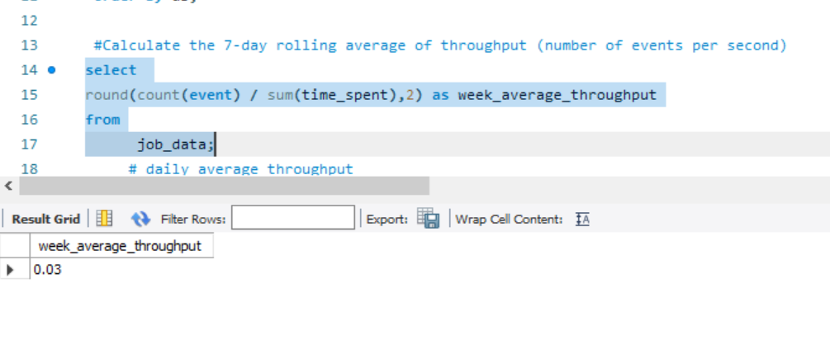
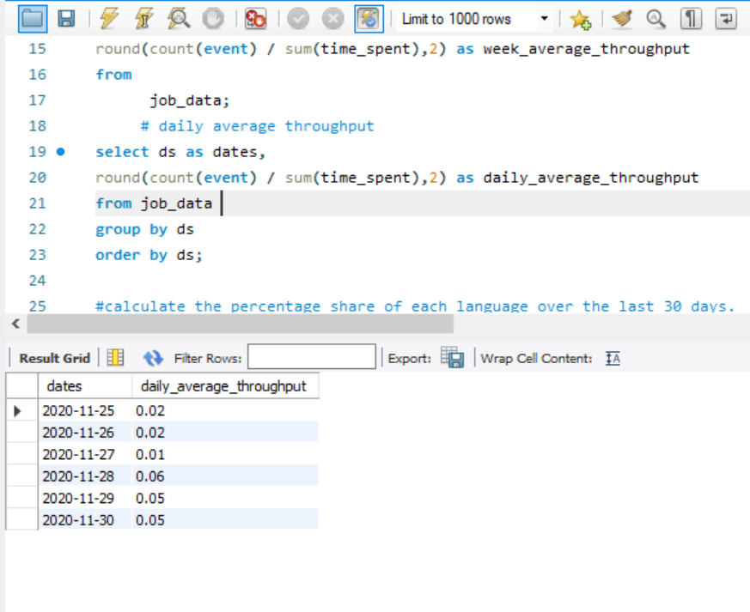

C.Language Share Analysis:
  - Objective: Calculate the percentage share of each language in the last 30 days.
  - Your Task: Write an SQL query to calculate the percentage share of each language over the last 30 days.
SQL Query:
SELECT
language,
ROUND(COUNT(*) * 100.0 / (SELECT COUNT(*) FROM job_data), 2) AS percentage_share
FROM job_data
GROUP BY language
ORDER BY percentage_share DESC;
slno | language | Percentage | total
1 | English | 12.50 | 8
2 | Arabic | 12.50 | 8
3 | Persian | 37.50 | 8
4 | Hindi | 12.50 | 8
5 | French | 12.50 | 8
6 | Italian | 12.50 | 8

Insight:
- From the table we can observe that Persian language is the most used language with the percentage share of 37.50 followed by other languages having a equal share of 12.50 percentage.
- The whole data is taken from total of 8 counts.
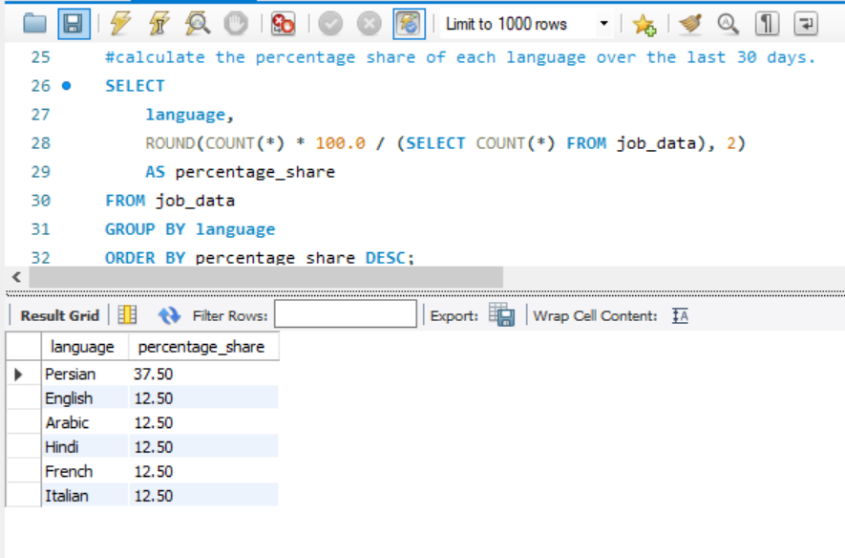

D.Duplicate Rows Detection:
Objective: Identify duplicate rows in the data.
Your Task: Write an SQL query to display duplicate rows from the job_data table.
SQL Query:
SELECT
actor_id,
COUNT(*) AS duplicate FROM job_data
GROUP BY actor_id
HAVING COUNT(*) > 1;
Result:
- The duplicate rows from the job_data tables are below
Insight:
- Out of those 8rows, we have 2 number of duplicate rows
- The actor_id 1003 is having duplicate

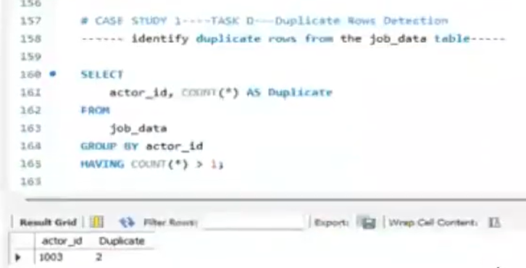

1)CASE STUDY-2 : INVESTIGATING METRIC SPIKE:
Creating table for investigating metric spike:
1.CREATING TABLE 1 USERS:
Contains one row per user, with descriptive about that users account.
- Step-1 : create database
Query : CREATE DATABASE job;

- Step-2: use database
Query: USE job;

- Step-3 : create table users
Query: create table users(
user_id int,
created_at varchar(100),
company_id int,
language varchar(50),
activated_at varchar(100),
state varchar(50));

- Step 4: After creating data, we need to load data to the table users:
QUERY: LOAD DATA INFILE "c:/Program Data/MySQL/MySQL Server 8.0/Uploads/users.csv"
INTO TABLE users
FIELDS TERMINATED BY ','
ENCLOSED BY '"'
LINES TERMINATED BY '\n'
IGNORE 1 ROWS;
• Step 5: For loading full data, we need to create a temporary column in users table:
Query: ALTER TABLE users ADD COLUMN temp_created_at datetime;
• Step 6: For temporarily disable safe updates:
Query: SET SQL_SAFE_UPDATES = 0
• Step 7: Next we need to load data in temp_created_at:
Query: UPDATE users SET temp_created_at = STR_TO_DATE(created_at,'%d-%m-%Y %H:%i');
• Step 8: Re-enable safe updates:
Query: SET SQL_SAFE_UPDATES = 1
• Step 9: Change column name from temp_created_at to created_at:
Query: ALTER TABLE users DROP COLUMN created_at;
Query: ALTER TABLE users CHANGE COLUMN temp_created_at created_at DATETIME;
• Step 10: show table users
Query: select * from users;
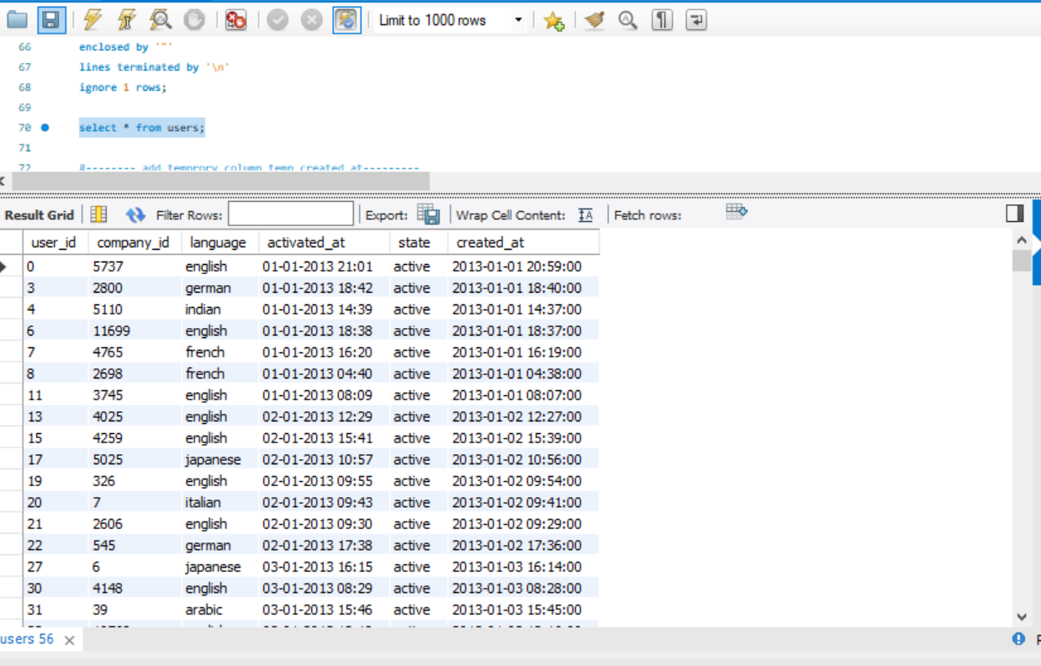
2.CREATING TABLE 2 EVENTS:
Contains one row per event, where an event is an action that a user has taken.
- Step-1 : create database
Query : CREATE DATABASE job;

- Step-2: use database
Query: USE job;

- Step-3 : create table events
Query: create table events(
user_id int,
occurred_at varchar(100),
event_type varchar(50),
event_name varchar(100),
location varchar(50),
device varchar(50),
user_type int );

- Step 4: After creating data, we need to load data to the table events:

QUERY: load data infile "C:/ProgramData/MySQL/MySQL Server 8.0/Uploads/events.csv"
into table events
fields terminated by ','
enclosed by '"'
lines terminated by '\n'
ignore 1 rows;
• Step 5: For loading full data, we need to create a temporary column in events table:
Query: ALTER TABLE events ADD COLUMN temp_occurred_at DATETIME;
• Step 6: For temporarily disable safe updates:
Query: SET SQL_SAFE_UPDATES = 0
• Step 7: Next we need to load data in temp_occurred_at:
Query: UPDATE events SET temp_occurred_at = STR_TO_DATE(occurred_at, '%d-%m-%Y %H:%i');
• Step 8: Re-enable safe updates:
Query: SET SQL_SAFE_UPDATES = 1
• Step 9: Change column name from temp_created_at to created_at:
Query: ALTER TABLE events DROP COLUMN occurred_at;
QUERY: ALTER TABLE EVENTS CHANGE COLUMN temp_occurred_at occurred_at datetime;
- Step-10 : show table events
QUERY: select *from events;
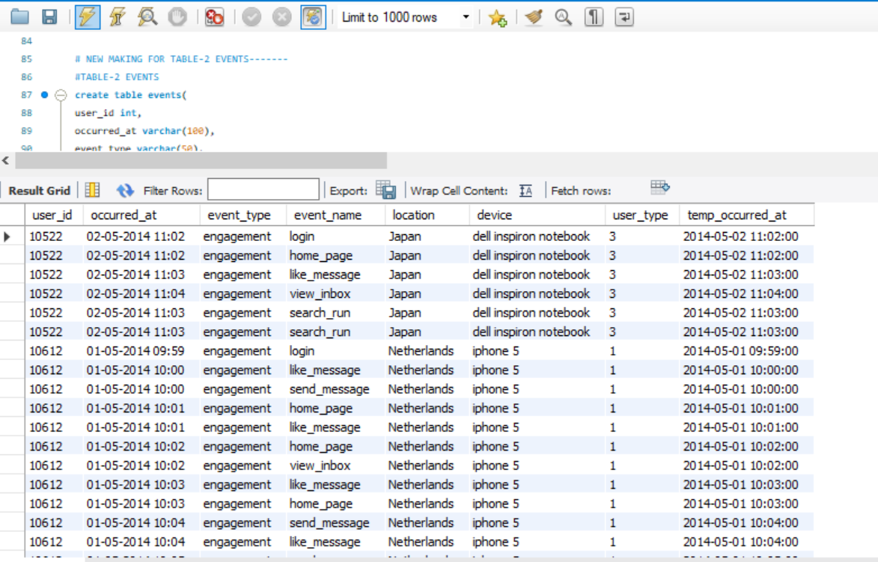

3.CREATING TABLE 3 EMAIL_EVENTS:
Contains one row per event, where an event is an action that a user has taken.
- Step-1 : create database
Query : CREATE DATABASE job;

- Step-2: use database
Query: USE job;

- Step-3 : create table events
Query : create table email_events(
user_id int,
occurred_at varchar(100),
action varchar(100),
user_type int );
- Step 4: After creating table, we need to load data to the table email_events:
Query: load data infile "C:/ProgramData/MySQL/MySQL Server 8.0/Uploads/email_events.csv"
into table email_events
fields terminated by ','
enclosed by '"'
lines terminated by '\n'
ignore 1 rows;
- Step-5 : show table events
Query: select * from email_events;
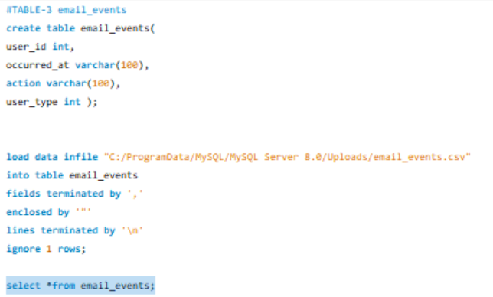
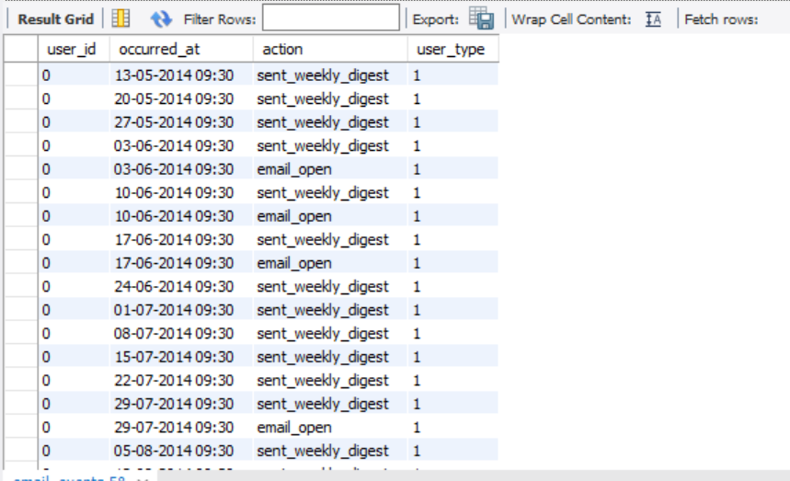
2.CASE STUDY 2: TASKS
A)WEEKLY USER ENGAGEMENT:
Objective: Measure the activeness of users on a weekly basis.
Your Task: Write an SQL query to calculate the weekly user engagement.
Query: select
extract(week from occurred_at) as week_num,
count(distinct user_id) as active_users
from
events
where
event_type = 'engagement'
group by week_num
order by week_num;
Result: The weekly user engagement as give below.
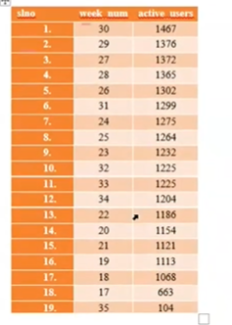
Insight:
- The Highest user week:30th week with 1467 users
- The minimum user week 35th week with 104 users
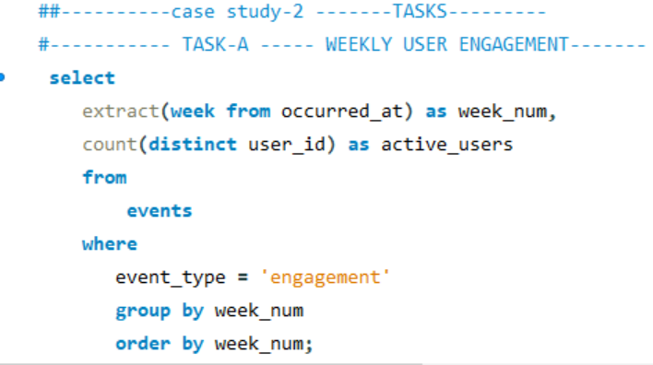
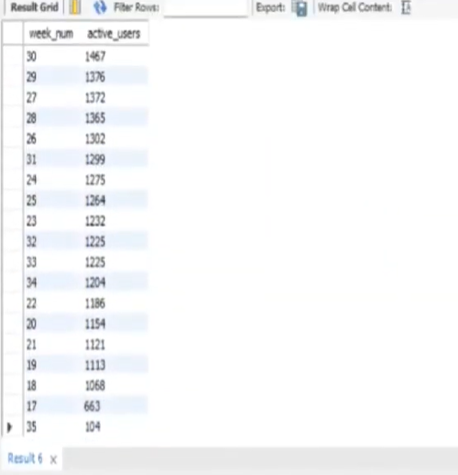
B)User Growth Analysis:
Objective: Analyze the growth of users over time for a product.
Your Task: Write an SQL query to calculate the user growth for the product.
Query:
select count(*) from users where state = 'active';
select distinct state from users;
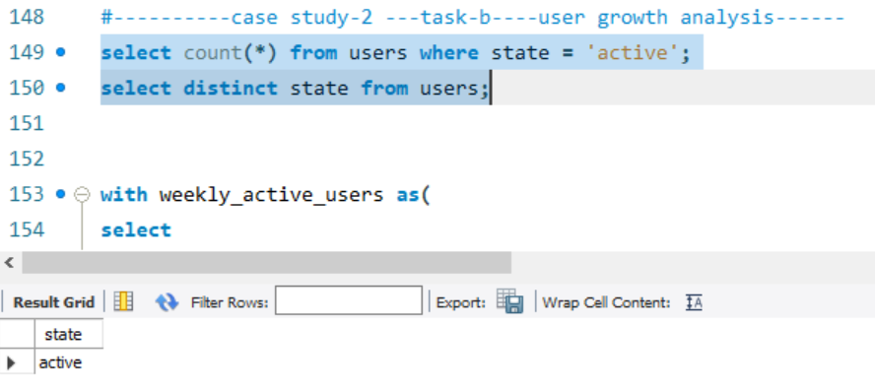
with weekly_active_users as(
select
extract(year from created_at) as year,
extract(week from created_at) as week_number,
count(distinct user_id) as num_of_users
from users
group by year, week_number
)
select
year,
week_number,
num_of_users,
sum(num_of_users) over (order by year,week_number) as cumulative_users
from weekly_active_users
order by year, week_number;
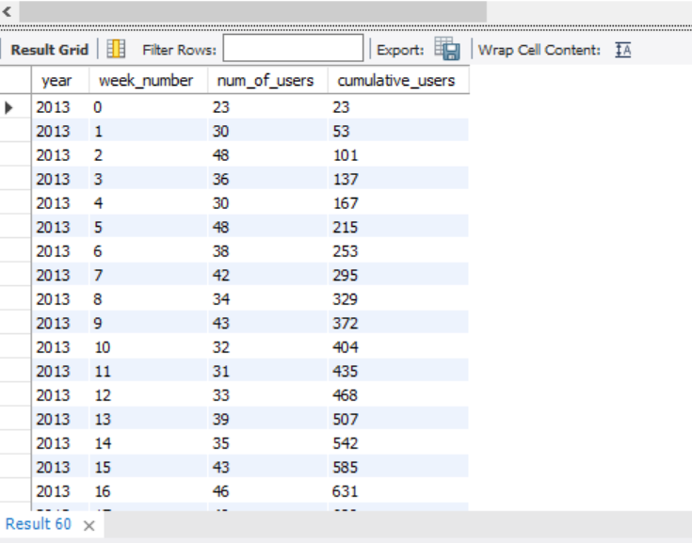
C)Weekly Retention Analysis:
Objective: Analyze the retention of users on a weekly basis after signing up for a product.
Your Task: Write an SQL query to calculate the weekly retention of users based on their sign-up cohort.
Query: SELECT first AS "week numbers",
SUM(CASE WHEN week_number=0 THEN 1 ELSE 0 END) AS "week_0",
SUM(CASE WHEN week_number=1 THEN 1 ELSE 0 END) AS "week_1",
SUM(CASE WHEN week_number=2 THEN 1 ELSE 0 END) AS "week_2",
SUM(CASE WHEN week_number=3 THEN 1 ELSE 0 END) AS "week_3",
SUM(CASE WHEN week_number=4 THEN 1 ELSE 0 END) AS "week_4",
SUM(CASE WHEN week_number=5 THEN 1 ELSE 0 END) AS "week_5",
SUM(CASE WHEN week_number=6 THEN 1 ELSE 0 END) AS "week_6",
SUM(CASE WHEN week_number=7 THEN 1 ELSE 0 END) AS "week 7",
SUM(CASE WHEN week_number=8 THEN 1 ELSE 0 END) AS "week_8",
SUM(CASE WHEN week_number=9 THEN 1 ELSE 0 END) AS "week_9",
SUM(CASE WHEN week_number=10 THEN 1 ELSE 0 END) AS "week_10",
SUM(CASE WHEN week_number=11 THEN 1 ELSE 0 END) AS "week_11",
SUM(CASE WHEN week_number=12 THEN 1 ELSE 0 END) AS "week_12",
SUM(CASE WHEN week_number=13 THEN 1 ELSE 0 END) AS "week_13",
SUM(CASE WHEN week_number=14 THEN 1 ELSE 0 END) AS "week_14",
SUM(CASE WHEN week_number=15 THEN 1 ELSE 0 END) AS "week 15",
SUM(CASE WHEN week_number=16 THEN 1 ELSE 0 END) AS "week_16",
SUM(CASE WHEN week_number=17 THEN 1 ELSE 0 END) AS "week_17",
SUM(CASE WHEN week_number=18 THEN 1 ELSE 0 END) AS "week_18"
from
(
select
m.user_id,
m.login_week,
n.first,
m.login_week-n.first as week_number
from
(
select user_id,
extract(week from occurred_at)as login_week
from events
group by user_id,login_week
)m
join
(select user_id,
min(extract(week from occurred_at))as first
from events
group by user_id
)n
on m.user_id=n.user_id
)sub
group by first
order by first;
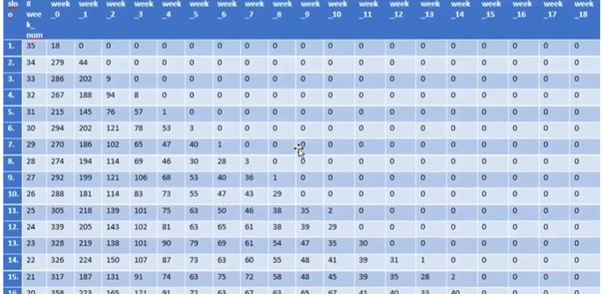
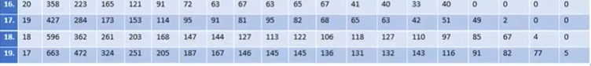
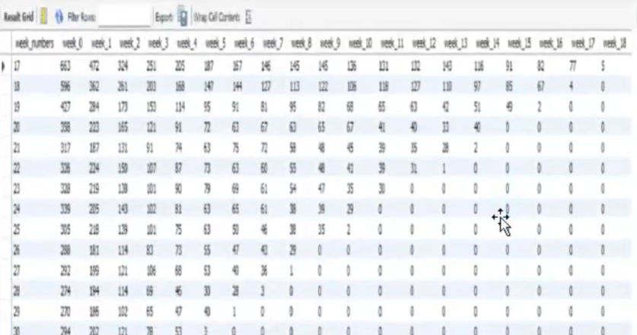
D)Weekly Engagement Per Device:
Objective: Measure the activeness of users on a weekly basis per device.
Your Task: Write an SQL query to calculate the weekly engagement per device.
Query: select
EXTRACT(Week FROM occurred_at) AS week_number,
COUNT(DISTINCT CASE WHEN device = 'dell inspiron notebook' then user_id else null end) as dell_inspiron_notebook,
COUNT(DISTINCT CASE WHEN device='Iphone 5' THEN user_id ELSE NULL END) AS iphone_5,
COUNT(DISTINCT CASE WHEN device='Iphone 4s' THEN user_id ELSE NULL END) AS iphone_4s,
COUNT(DISTINCT CASE WHEN device='Iphone 5s' THEN user_id ELSE NULL END) AS iphone_5s,
COUNT(DISTINCT CASE WHEN device='ipad air' THEN user_id ELSE NULL END) AS ipad_air,
COUNT(DISTINCT CASE WHEN device='windows surface'THEN user_id ELSE NULL END) AS windows_surface,
COUNT(DISTINCT CASE WHEN device='macbook air'THEN user_id ELSE NULL END) AS macbook_air,
COUNT(DISTINCT CASE WHEN device='macbook pro'THEN user_id ELSE NULL END) AS macbook_pro,
COUNT(DISTINCT CASE WHEN device='Ipad mini' THEN user_id ELSE NULL END) AS ipad_mini,
COUNT(DISTINCT CASE WHEN device='kindle fire' THEN user_id ELSE NULL END) AS kindle_fire,
COUNT(DISTINCT CASE WHEN device='amazon fire phone' THEN user_id ELSE NULL END) AS amazon_fire_phone,
COUNT(DISTINCT CASE WHEN device='nexus 5'THEN user_id ELSE NULL END) AS nexus_5,
COUNT(DISTINCT CASE WHEN device='nexus 7'THEN user_id ELSE NULL END) AS nexus_7,
COUNT(DISTINCT CASE WHEN device='nexus 10'THEN user_id ELSE NULL END) AS nexus_10,
COUNT(DISTINCT CASE WHEN device ='samsung galaxy s4'THEN user_id ELSE NULL END) AS samsung_galaxy_s4,
COUNT(DISTINCT CASE WHEN device = 'samsung galaxy tablet' THEN user_id ELSE NULL END) AS samsung_galaxy_tablet,
COUNT(DISTINCT CASE WHEN device = 'samsung galaxy note' THEN user_id ELSE NULL END) AS samsung_galaxy_note,
COUNT(DISTINCT CASE WHEN device = 'lenovo thinkpad' THEN user_id ELSE NULL END) AS lenovo_thinkpad,
COUNT(DISTINCT CASE WHEN device = 'acer aspire notebook' THEN user_id ELSE NULL END) AS acer_aspire_notebook,
COUNT(DISTINCT CASE WHEN device = 'asus chromebook' THEN user_id ELSE NULL END) AS asus_chromebook,
COUNT(DISTINCT CASE WHEN device = 'htc one' THEN user_id ELSE NULL END) AS htc_one,
COUNT(DISTINCT CASE WHEN device = 'nokia lumia 635' THEN user_id ELSE NULL END) AS nokia_lumia_635,
COUNT(DISTINCT CASE WHEN device = 'mac mini' THEN user_id ELSE NULL END) AS mac_mini,
COUNT(DISTINCT CASE WHEN device = 'hp pavilion desktop' THEN user_id ELSE NULL END) AS hp_pavilion_desktop,
COUNT(DISTINCT CASE WHEN device = 'dell inspiron desktop' THEN user_id ELSE NULL END) AS dell_inspiron_desktop
FROM
Events
WHERE
event_type = 'engagement'
group by week_number
order by week_number;
Insight:
from the table it is clear that most people uses macbook_pro(322 users on 30rd week ), followed by levnova_thinkpad (220 users 28th week) and iphone_5(163 users on 27th week).
Result:The result for weekly users’engagement per devices are given below.

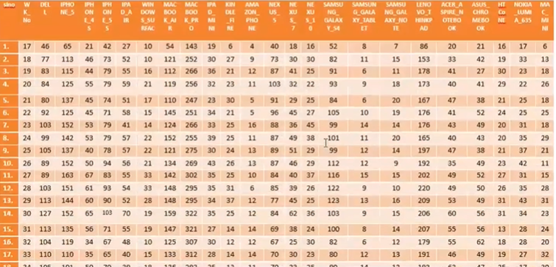
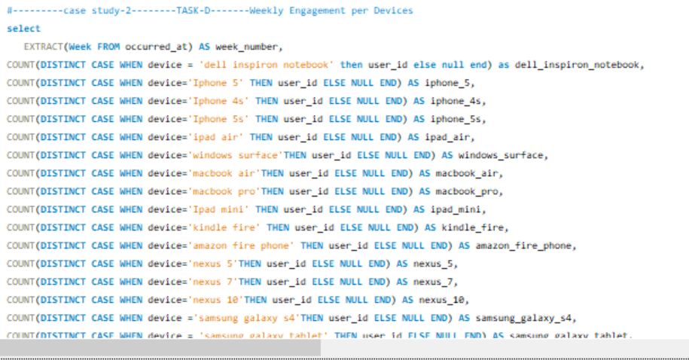
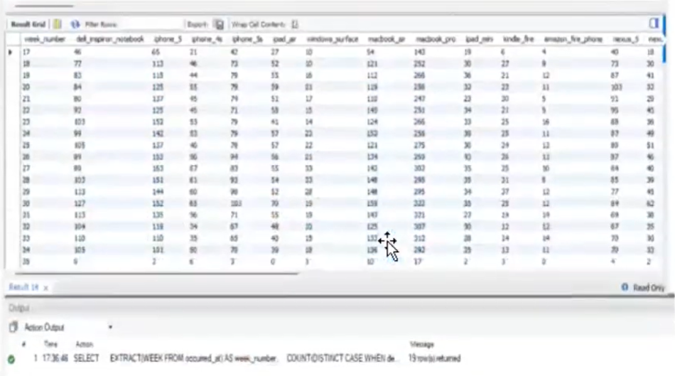
E)Email Engagement Analysis:
Objective: Analyze how users are engaging with the email service.
Your Task: Write an SQL query to calculate the email engagement metrics.
Query: SELECT
100.0 * SUM(CASE WHEN email_action='email_open' THEN 1 ELSE 0 END) /
SUM(CASE WHEN email_action = 'email_sent' THEN 1 ELSE 0 END) AS email_open_rate,
100.0 * SUM(CASE WHEN email_action= 'email_clicked' THEN 1 ELSE 0 END) /
SUM(CASE WHEN email_action = 'email_sent' THEN 1 ELSE 0 END) AS email_clicked_rate
from
(SELECT *,
CASE
WHEN action IN ('sent_weekly_digest', 'sent_reengagement_email') THEN 'email_sent'
WHEN action IN ('email_open') THEN 'email_open'
WHEN action IN ('email_clickthrough') THEN 'email_clicked'
ELSE NULL
end as email_action
from job.email_events
) a;
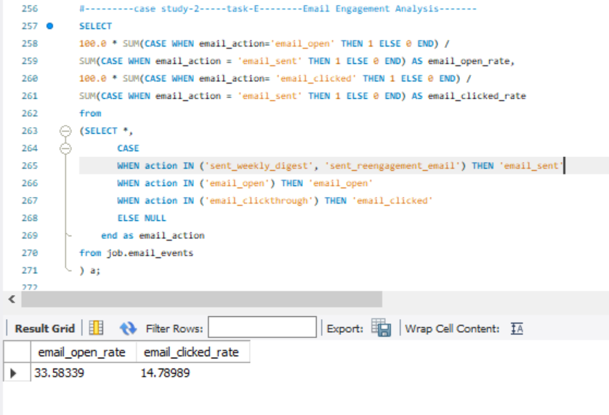
PROJECT RESULT:
- Less than 0.01 jobs were reviewed every hour of each day of the month of November.
- 7-day rolling average for throughput is about 0.03 event per second.
- The Persian language have the highest (37.50%) share among all languages.
- Actor_id have a duplicate row from the 8 rows.
- The weekly user engagement is the highest on 30th week and lowest on 35th week.
- The highest user growth rate on 33rd week and lowest among 35th week.
- The highest retained users who joined on 17th week which retained about 18 weeks.
- The maximum users using MacBook pro.
- Only 31.19% email are opened out of entire emails.
Conclusion:
This project helped me to gain insighgt

