1. STUDENTS INFORMATION
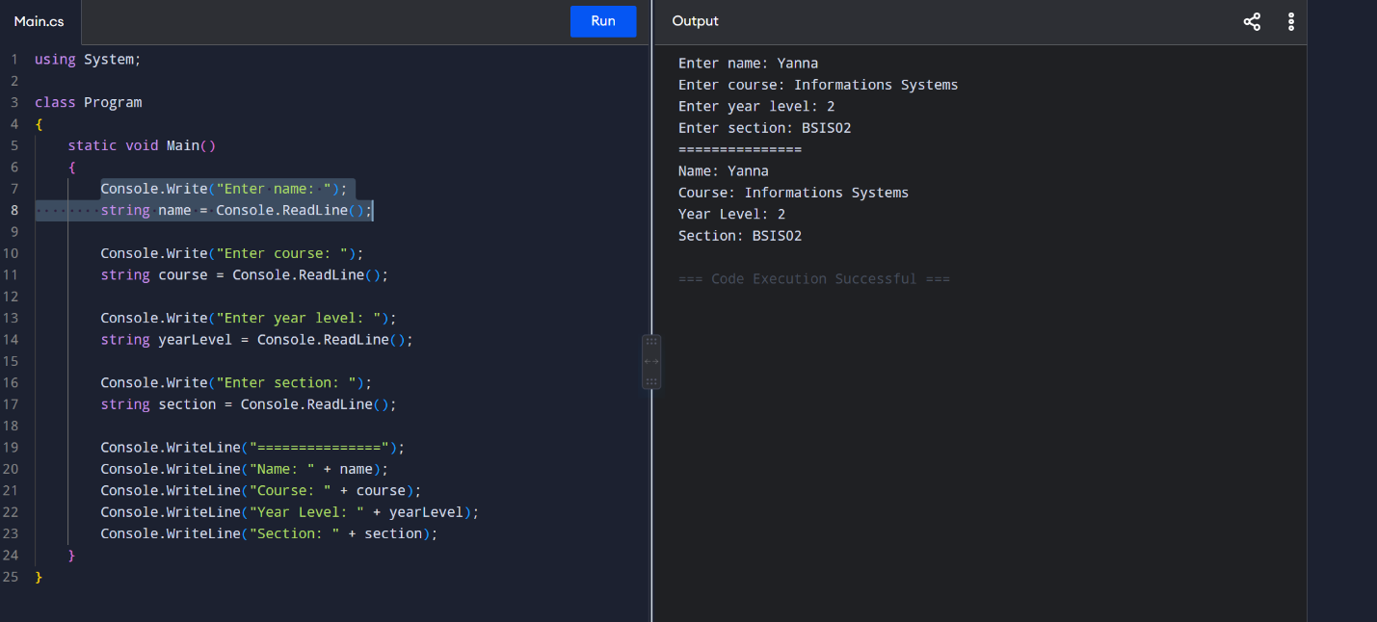

2. BASIC CALCULATOR
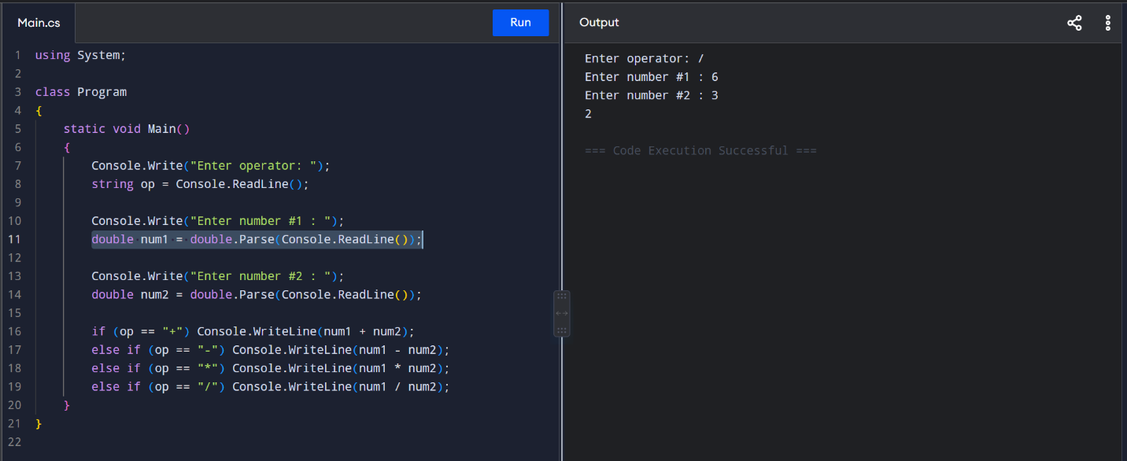

3. AREA OF RECTANGLE 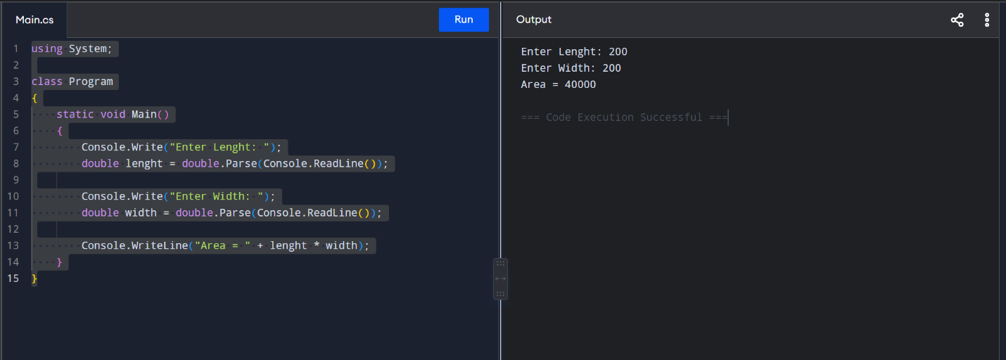

4. STUDENT GRADE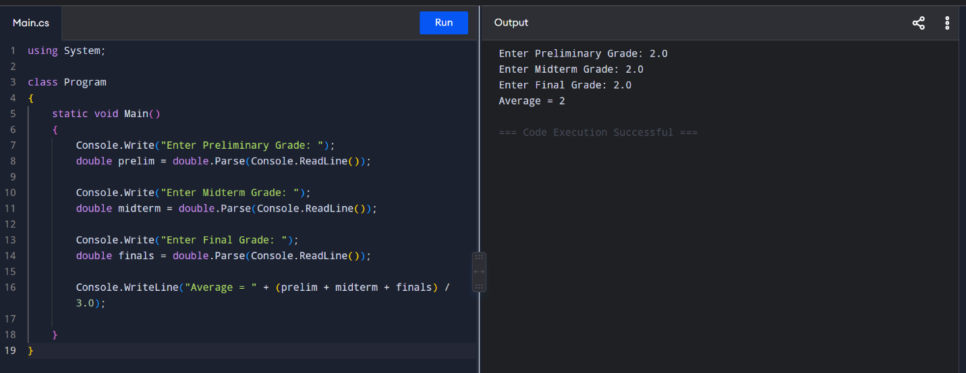

5. BOOLEAN INPUT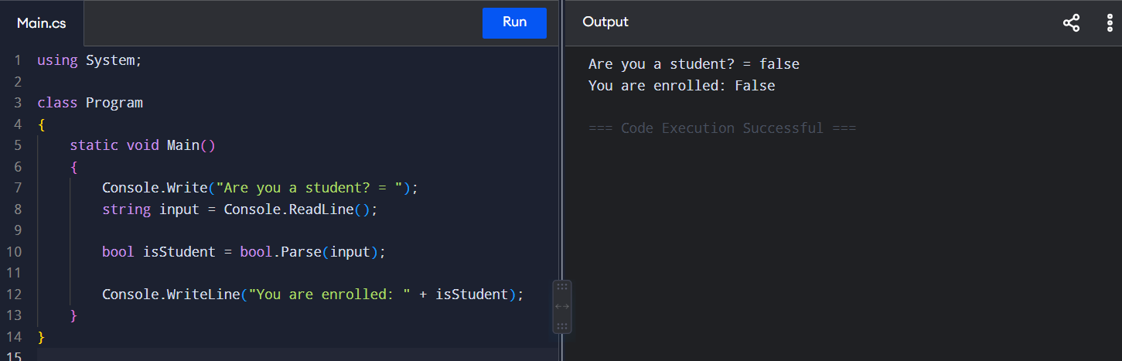

6. AGE VERIFICATION
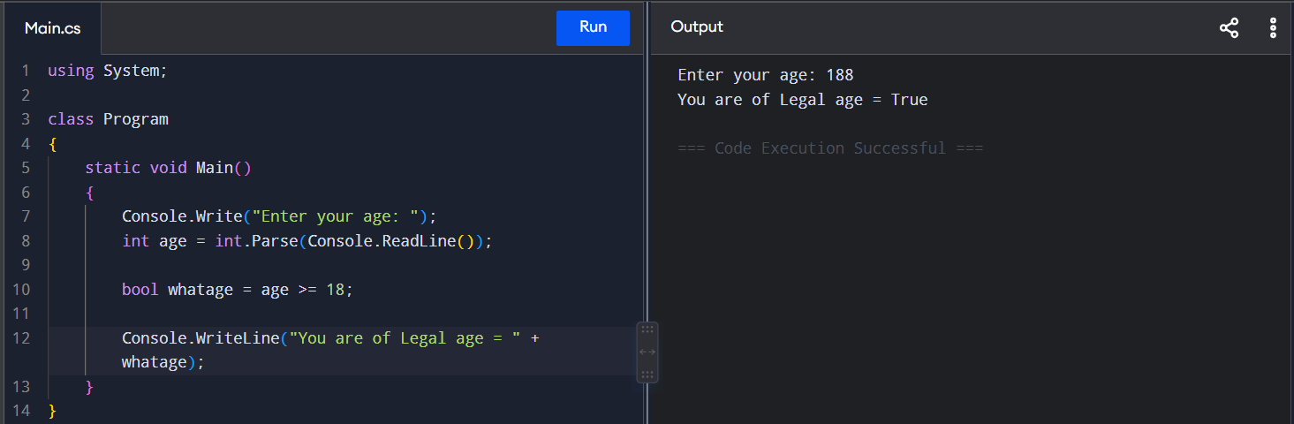

7. FULL NAME
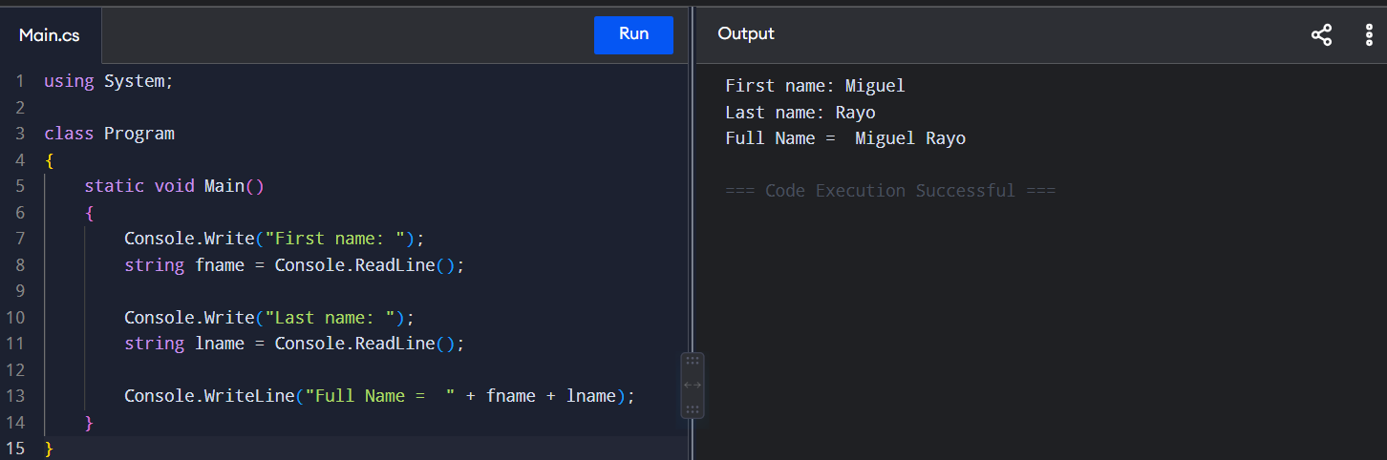

8. SHOPPING CALCULATOR
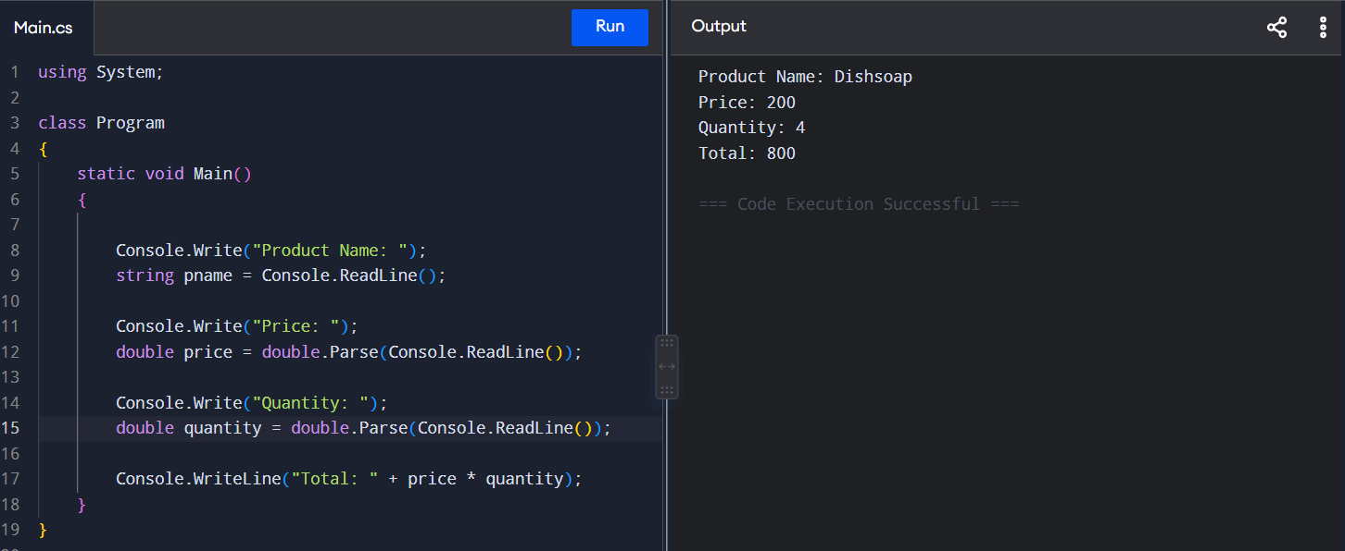
9. SALARY CALCULATOR
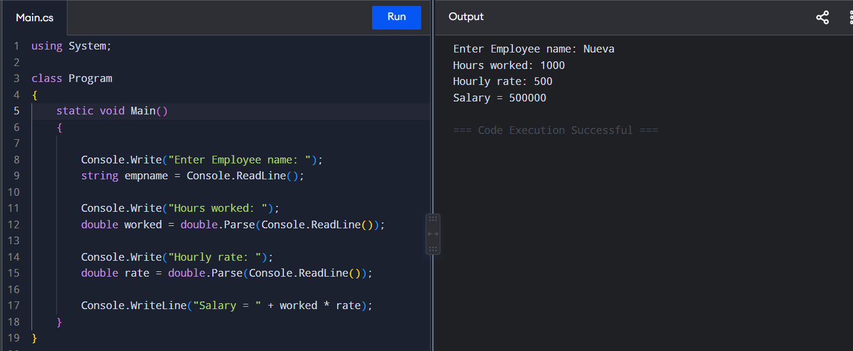

10. MINI STUDENT INFO SYSTEM
