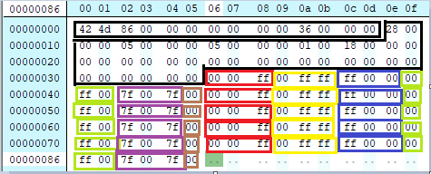

Black 14 – BITMAPHEADER

Next 40 – BITMAPINFOHEADER

Red – red pixels

Yellow – yellow pixels

Blue – blue pixels

Green – green pixels

Purple – purple pixels

Brown – padding bytes