%% Lab 4 – Augustus Crosby - MAT 275 Lab
% MATLAB solvers for First-Order IVP
%% EX1
%A 6 PTS
function LAB04ex1
t0 = 0; tf = 50; y0 = [-.5,.5];
[t,Y] = ode45(@f,[t0,tf],y0,[]);
y = Y(:,1); v = Y(:,2);
figure(1);
plot(t,y,'b-', 'LineWidth', 2);
grid on;
hold on;
plot(t,v,'r-', 'LineWidth', 2);
legend('y(t)', 'v(t)=y''(t)');
ylim([-1.2,1.2]); xlim([0,50]);
figure(2)
plot(y,v, 'k', 'LineWidth', 2); axis square; xlabel('y(t)');
ylabel('v(t)');
ylim([-1.2, 1.2]); xlim([-.5, 1]);
grid on;
ylabel('v=y''');
xlabel('y');

function dYdt= f(t,Y)
y=Y(1); v=Y(2);
dYdt = [v; sin(t)-7*v-5*y];
end
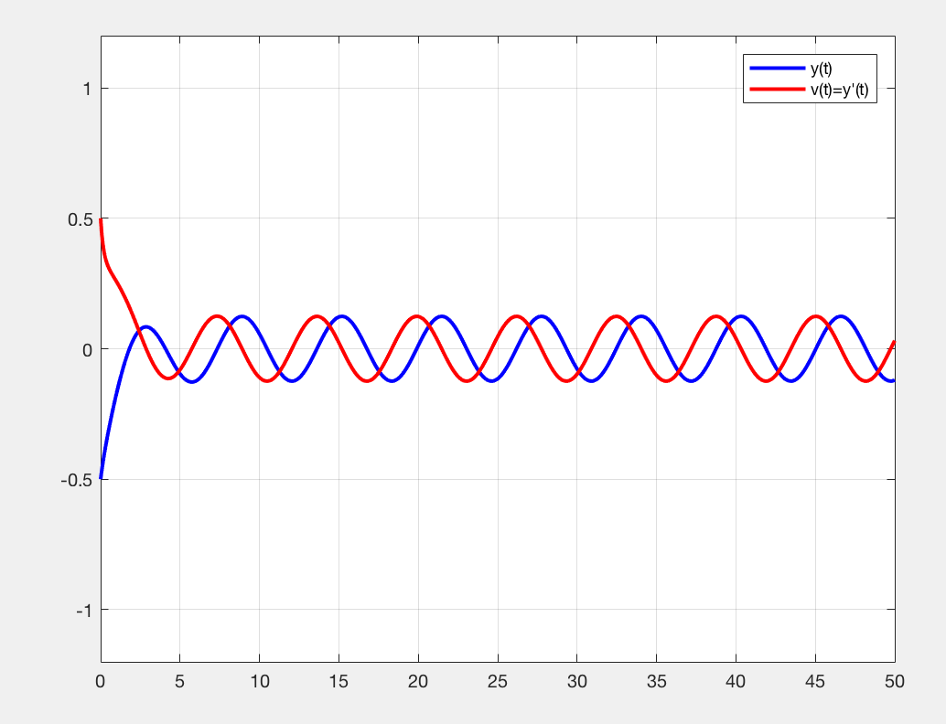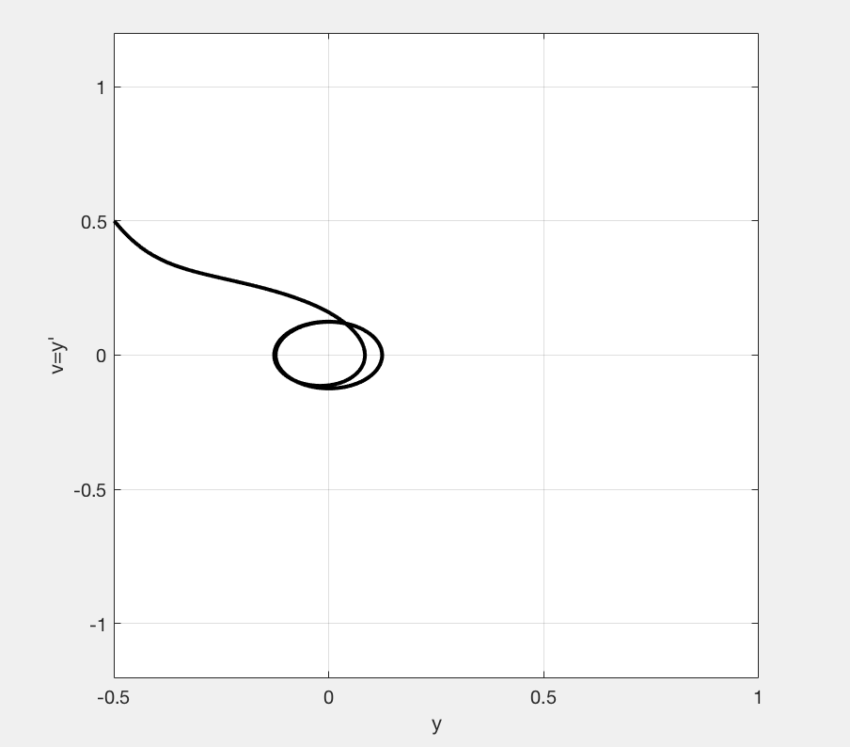

%B 2PTS
%It appears that local maximums for y are located at t values of 2.8435, %8.8861, 15.1567, 21.4665, 27.7283, 34.0250, 40.3136, and 46.5714.

%C 2 PTS
% It appears that the long term behavior is that of a typical sine curve.

%D 2 PTS
%create a function file "LAB04ex1d" which is a duplicate of LAB04ex1 but with
%the initial conditions for y and v changed.
%figure(1) and figure(2) also need to be
%changed to figure(3) and figure(4) (in order to plot part a and part d on separate figures).
function LAB04ex1d
t0 = 0; tf = 50; y0 = [2,3];
[t,Y] = ode45(@f,[t0,tf],y0,[]);
y = Y(:,1); v = Y(:,2);
figure(3);
plot(t,y,'b-', 'LineWidth', 2);
grid on;
hold on;
plot(t,v,'r-', 'LineWidth', 2);
legend('y(t)', 'v(t)=y''(t)');
ylim([-1.2,4]); xlim([0,50]);
figure(4)
plot(y,v, 'k', 'LineWidth', 2); axis square; xlabel('y(t)');
ylabel('v(t)');
ylim([-1.2,4]); xlim([-.5, 1]);
grid on;
ylabel('v=y''');
xlabel('y');

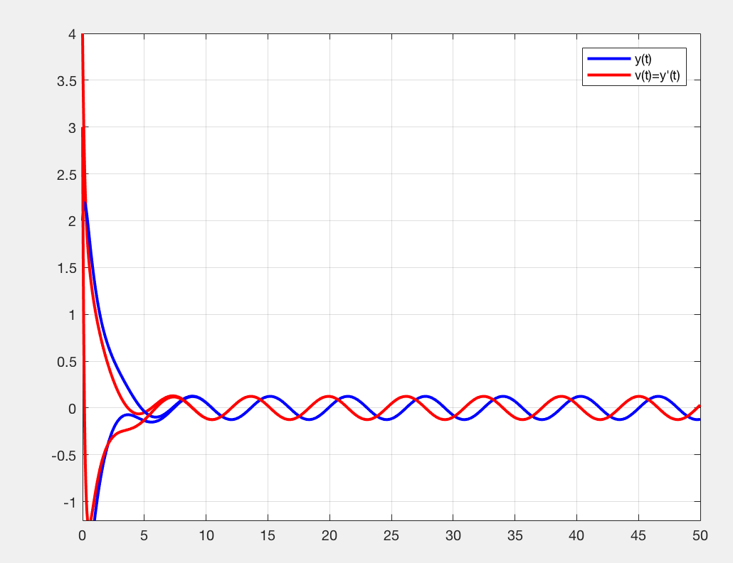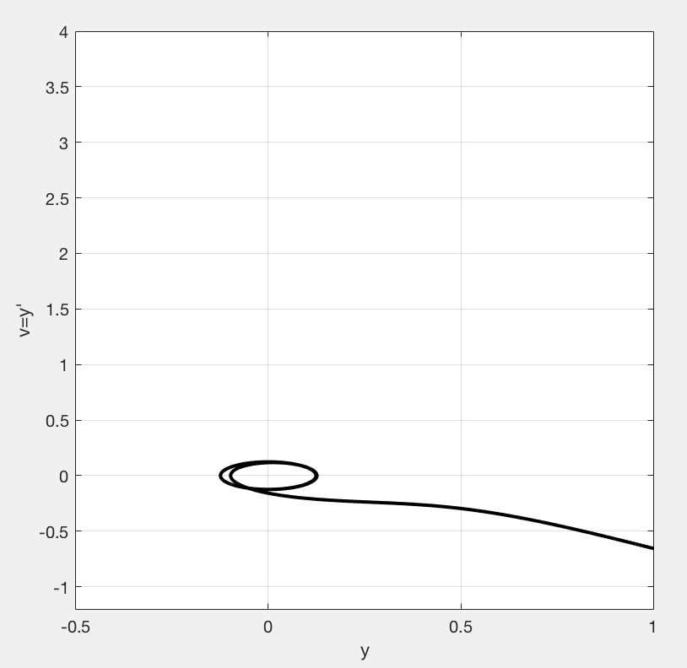

%% EX2

%A 5 PTS
%create a new mfile with the differential equation changed
type LAB04ex2
function LAB04ex2
t0 = 0; tf = 50; y0 = [-.5,.5];
[t,Y] = ode45(@f,[t0,tf],y0,[]);
y = Y(:,1); v = Y(:,2);
figure(1);
plot(t,y,'b-', 'LineWidth', 2);
grid on;
hold on;
plot(t,v,'r-', 'LineWidth', 2);
legend('y(t)', 'v(t)=y''(t)');
ylim([-1.2,1.2]); xlim([0,50]);
figure(2)
plot(y,v, 'k', 'LineWidth', 2); axis square; xlabel('y(t)');
ylabel('v(t)'); % plot the phase plot
ylim([-1.2, 1.2]); xlim([-.5, 1]);
grid on;
ylabel('v=y''');
xlabel('y');
end

function dYdt= f(t,Y)
y=Y(1); v=Y(2);
dYdt = [v; sin(t)-7*y^2*v-5*y];
end

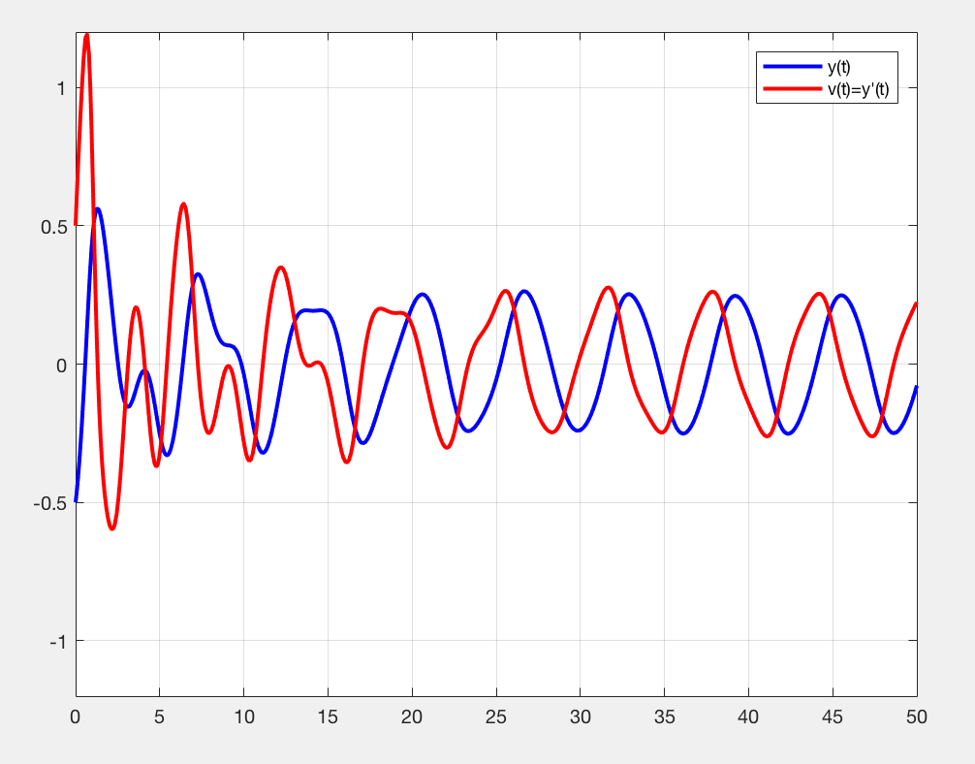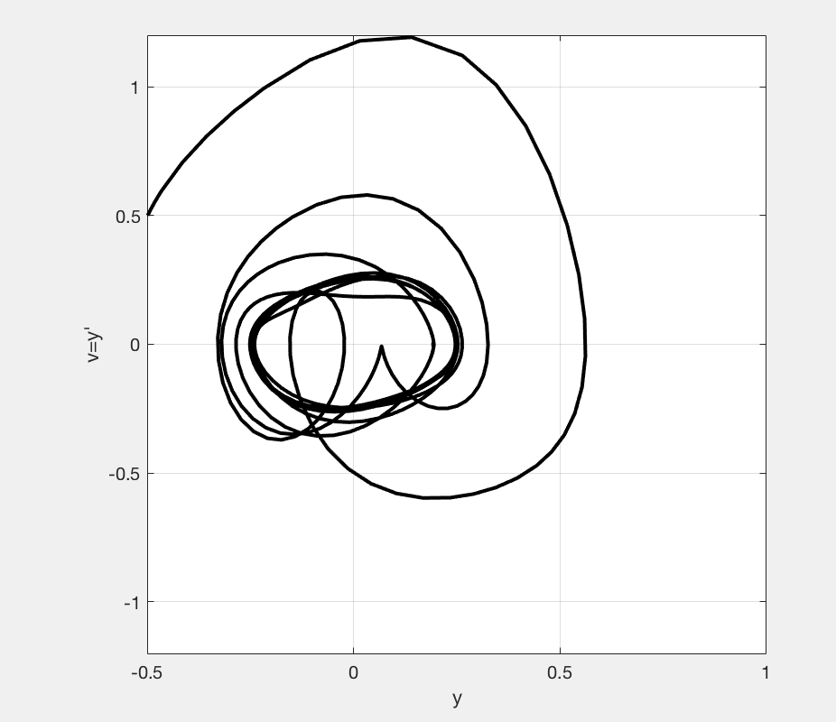
%B 1 PTS
% It appears more erratic at the beginning and takes more time to “correct” itself to a regular sine graph.

%C 1 PTS
% It appears that the local maximum and minimum have gotten higher and lower respectively.

%D 3 PTS
function LAB04ex2d
t0 = 0; tf = 50; y0 = [-.5,.5];
[t,Y] = ode45(@f,[t0,tf],y0,[]);
[te,Ye] = euler(@f,[t0,tf],y0, 1000);
y = Y(:,1);
ye = Ye(:,1);
figure(1);
plot(t,y,'k-', 'LineWidth', 2);
grid on;
hold on;
plot(te,ye,'r-', 'LineWidth', 2);
legend('y(t) ODE45', 'y(t) Euler');
ylim([-1.2,1.2]); xlim([0,50]);
end

function dYdt= f(t,Y)
y=Y(1); v=Y(2);
dYdt = [v; sin(t)-7*y^2*v-5*y];
end

%It appears that they are not identical, but they are close for approximation %purposes. If we increase the value of N Euler’s method gets more and more precise.

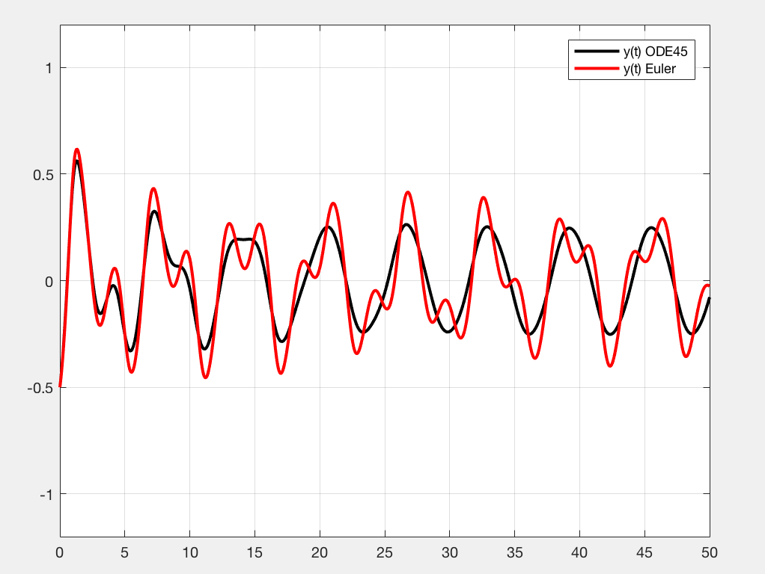

%% EX 3 6 PTS
function LAB04ex3
t0 = 0; tf = 50; y0 = [-.5,.5];
[t,Y] = ode45(@f,[t0,tf],y0,[]);
y = Y(:,1); v = Y(:,2);
figure(1);
plot(t,y,'b-', 'LineWidth', 2);
grid on;
hold on;
plot(t,v,'r-', 'LineWidth', 2);
legend('y(t)', 'v(t)=y''(t)');
ylim([-10,10]); xlim([0,50]);
end

function dYdt= f(t,Y)
y=Y(1); v=Y(2);
dYdt = [v; sin(t)-7*y*v-5*y];
end

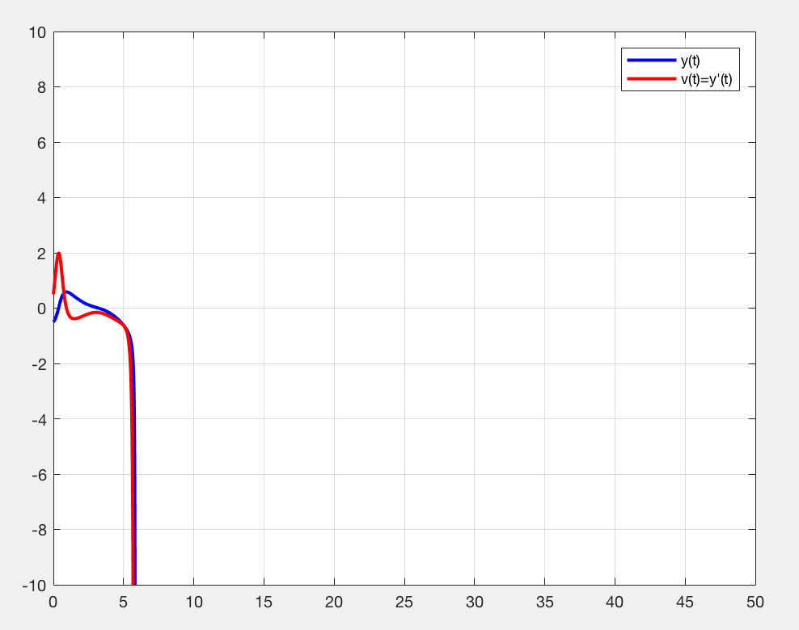

%Yes there was a warning and it said “Warning: Failure at t=5.840631e+00. %Unable to meet integration tolerances without reducing the
%step size below the smallest value allowed (1.421085e-14) at time t.” This %is because of the asymptote that is near to t=5.840631e+00.

%% EX4
%A 6 PTS
function LAB04ex4
t0 = 0; tf = 50; y0 = [-.5,.5, 1.625];
[t,Y] = ode45(@f,[t0,tf],y0,[]);
y = Y(:,1); v = Y(:,2); w = Y(:,3);
figure(1);
plot(t,y,'b-', 'LineWidth', 2);
grid on;
hold on;
plot(t,v,'r-', 'LineWidth', 2);
hold on;
plot(t,w,'m-', 'LineWidth', 2);
legend('y(t)', 'v(t)=y''(t)');
ylim([-1.2,1.2]); xlim([0,50]);
figure(2);
plot3(y,v,w,'k-');
grid on; view([-40,60])
xlabel('y'); ylabel('v=y'''); zlabel('w=y''''');
end

function dYdt= f(t,Y)
y=Y(1); v=Y(2); w=Y(3);
dYdt = [v; w; cos(t)-7*y^2*w-14*y*v^2-5*v];
end

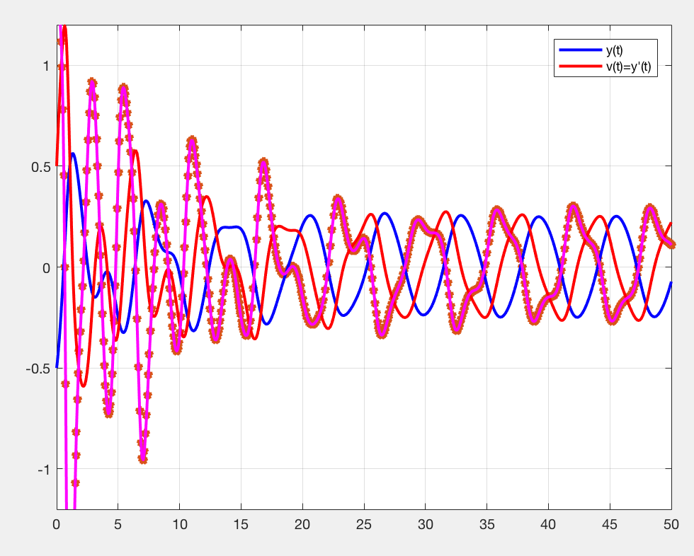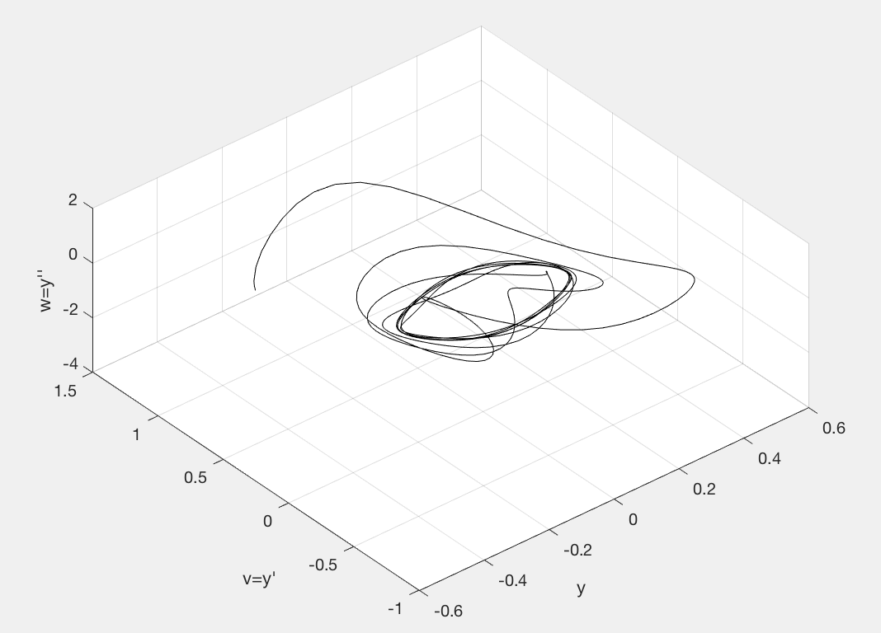

%B 2 PTS
% What appeared to have happened is that the y and v values turned out the same and the only thing that was added was the w or second derivative in the graph.

%C 2 PTS
%Using my learned math skills, I got that it turned out to be the equation that was found in L4.8 (and thus my previous answer is confirmed as well).
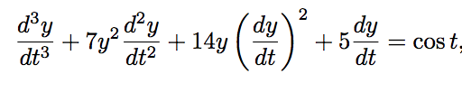

%D 2 PTS
%When evaluated at t=0, y =-.5 and v=.5. The L4.8 equation is also satisfied by these initial values. I’ve already found that L4.7 and L4.8 are related to one another when L4.7 is differentiated into L4.8, which is why this make sense.

