**Sitemap:**

* Contact form
  + url: /
  + Description: display contact form
* Thankyou page
  + url: /thankyou
  + Description: display data user submitted and send email

**Flow chart:**

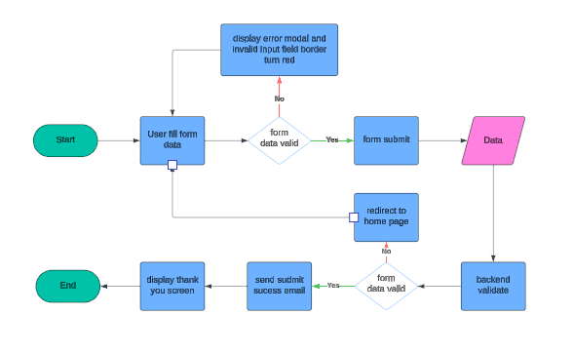

**Pseudo code of the form**

On form submit

If validateForm fail

errorModal show

return

form submit

function validateForm()

if any validateDetail fail

return fail

return success

function validateDetail()

if not valid

display error

return fail

remove error

return success

**Wireframing**

Contact form

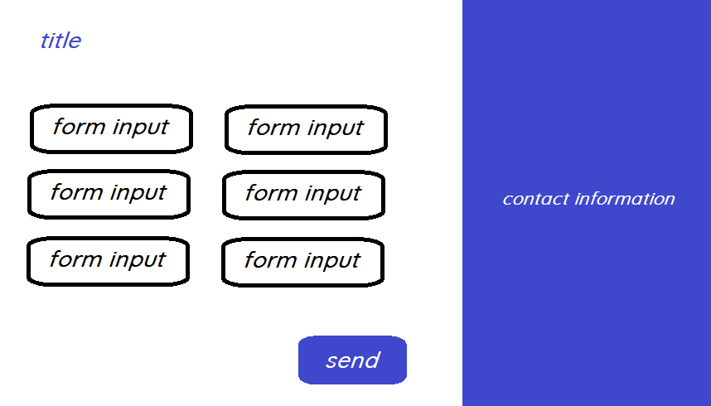

Thank you page

