CSCD 327 Lab #1 (16 points)

**Section 1 - Basic Concepts:**

* (3 points)
* Explain the following terms in the context of the relational data model. Use Employee-Department database from Appendix 1 (at the end of this lab) to provide examples of each term.
* Relation
* Attribute
* Domain
* Tuple
* Degree
* Cardinality
* (3 points)
* Explain the following terms in the context of the relational data model. Use the Employee-Department database from Appendix 1 to provide examples of each term.
* Candidate Key
* Primary Key
* Foreign Key

**Section 2 - Warm-up Exercise:**

Open up ***MySQL Workbench***, create a new connection, and fill in the form with the correct hostname, username, password, etc. You may want to save the connection for future use.

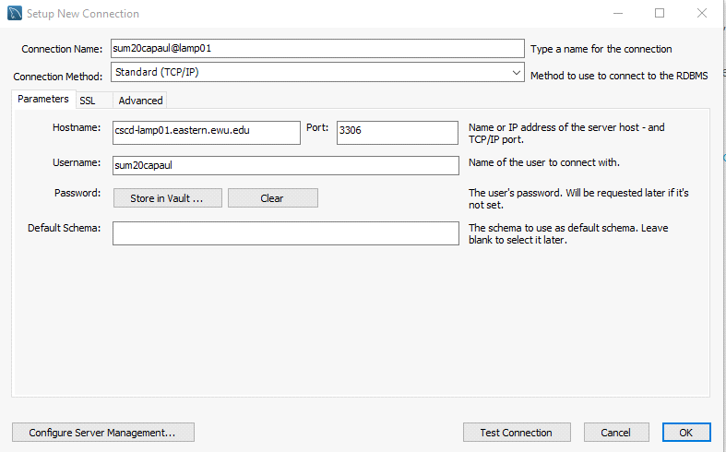

**DB Host:** cscd-lamp01.eastern.ewu.edu

**DB Username:** sum20y*ourlastname* (all in lower case; NOTE: if you have the same last name as someone else (2 of you have a last name of morris), the last name is followed by the first initial of your first name)

**DB Password:** 1234

**Port**: 3306 (the default number)

**Note**: To access the server off-campus, you need to first connect to Eastern student VPN network (<https://support.ewu.edu/support/solutions/articles/10000020118-how-do-i-connect-to-vpn>- )

Maybe the first thing you want to do is to change your password. In the SQL editor, enter the following statement (then click the lightning bolt, which executes your SQL code) to re-set your password:

**ALTER USER your_account_name IDENTIFIED BY 'new password goes here';**

Now, create your first database named as *YourUsername*_DDL (note, substitute your actual user name for *YourUserName* – if it were Tom it would be sum20capaul_DDL):

**create database *YourUsername*_DDL;**

**(don't forget to click lightning bolt to execute your code)**

**NOTE: The left portion of MySQL Workbench (Navigator) shows the schemas (databases) associated with your account under the Schemas tab. After you execute the above command, you can click on the (small) refresh button just below the Navigator frame and it should list your newly created database. Once you have the database created, you need to select this database (double click) to make sure the following operations will be applied to this database. Any time you add a database or tables to a database, clicking the refresh button should display the results of your operation.**

**NOTE 2: The second half of the Relational Model notes introduce most of the basic SQL you will need for the exercises below. Chapter 6 (6.5) of the text shows even more. It is also permissible (advisable?) to do a quick Google search as necessary.**

* (1 point) Use appropriate DDL to create a new table containing the category code and description for the categories of books sold by a bookstore. The table should be called *CATEGORY*, and the columns should be *CatCode* and *CatDesc*. The *CatCode* column should store a maximum of 2 characters, and the *CatDesc* column should store a maximum of 10 characters. **(Include your DDL statements in your submission.)**
* (1 point) Use appropriate DDL to create a new table containing these four columns: *Emp_num*, *Lastname*, *Firstname*, and *Job_class*. The table name should be *EMPLOYEES*. The *Job_class* column should be able to store character strings up to a maximum lenth of four. The *Emp_num* column contains a numeric ID and should allow a five-digit number. Use column sizes you consider suitable for the *Firstname* and *Lastname* columns. **(Include your DDL statements in your submission.)**
* (1 point) Use appropriate DDL to add two columns to the *EMPLOYEES* table. One column, named *EmpDate*, contains the date of employment for each employee. The second column, named *EndDate*, contains employees’ date of termination. **(Include your DDL statements in your submission.)**
* (1 point) Use appropriate DDL to modify the *Job_class* column of the *EMPLOYEES* table so that it allows storing a maximum width of two characters. **(Include your DDL statements in your submission.)**
* (1 point) Use appropriate DDL to delete the *EndDate* column from the *EMPLOYEES* table. **(Include your DDL statements in your submission.)**
* (1 point) Use appropriate DDL to rename the *EMPLOYEES* table as *JL_EMPS*. **(Include your DDL statements in your submission.)**

**Section 3 – More Exercises:**

Create a new database named as *YourUsername*_1:

**create database *YourUsername*_1;**

* (2 points) Use appropriate DDL to create two new tables *EMP* and *DEPT* (the info for these tables is in Appendix 1 at the end of this document). Please make sure to choose appropriate data type for each attribute, and **also add a primary key to each table**. **(Include your DDL statements in your submission.)**
* (1 point) Now you are ready to add new tuples into your tables.
* Insert all 14 tuples listed in Appendix 1 into *EMP* table.
* Insert all 4 tuples listed in Appendix 1 into *DEPT* table.  
  (**Include your DDL statements in your submission.**)

**Section 4 – Get Ready for Future Labs:**

* (1 point) Let’s create four more databases and tables for future use. Name these four databases as *YourUsername*_2, *YourUsername*_3, *YourUsername*_4, and *YourUsername*_5. Now open/load four databases from the script files posted on Canvas:
* Open/load ***database2.sql*** file into ***YourDatabase_2***. Five tables will be added to your *YourUsername*_2 database. Make sure you have selected ***YourDatabase_2*** before opening the sql file in the editor.
* Open/load ***database3.sql*** file into ***YourDatabase_3***.Eight tables will be added to your *YourUsername*_3 database. Make sure database is selected first.
* Open/load ***database4.sql*** file into ***YourDatabase_4***. Eleven tables will be added to your *YourUsername*_4 database. Make sure database is selected first.
* Open/load ***database5.sql*** file into ***YourDatabase_5***. Seven tables will be added to your *YourUsername*_5 database. Make sure database is selected first.

**Appendix 1**

**Employee - Department Database**

**EMP**

EMPNO ENAME JOB MGR HIREDATE SAL COMM DEPTNO

----- ------ --------- ---- ----------- ---- ---- -------

7369 SMITH CLERK 7902 1980-12-17 800 20

7499 ALLEN SALESMAN 7698 1981-02-20 1600 300 30

7521 WARD SALESMAN 7698 1981-02-22 1250 500 30

7566 JONES MANAGER 7839 1981-04-02 2975 20

7654 MARTIN SALESMAN 7698 1981-09-28 1250 1400 30

7698 BLAKE MANAGER 7839 1981-05-01 2850 30

7782 CLARK MANAGER 7839 1981-06-09 2450 10

7788 SCOTT ANALYST 7566 1982-12-09 3000 20

7839 KING PRESIDENT 1981-11-17 5000 10

7844 TURNER SALESMAN 7698 1981-09-08 1500 0 30

7876 ADAMS CLERK 7788 1983-01-12 1100 20

7900 JAMES CLERK 7698 1981-12-03 950 30

7902 FORD ANALYST 7566 1981-12-03 3000 20

7934 MILLER CLERK 7782 1982-01-23 1300 10

**DEPT**

DEPTNO DNAME LOC

------ -------------- ---------

10 ACCOUNTING NEW YORK

20 RESEARCH DALLAS

30 SALES CHICAGO

40 OPERATIONS BOSTON