**Acknowledgement**

I would like to acknowledge the people who have helped me to complete my 420 hrs OJT training at Philippine Airlines and In PhilSCa’s CAU Office Headed by Ms. Vista.

Thank you to Ms. Almond De Leon of PAL Ticketing Office for having my papers be processed right away in PAL, Ms. Vista for guiding us, My Bosses Mr. Gerry Rustia, Mrs. Elsa Yuson, Mr. JP Lagumbay, Mrs. Trisha for training with my skills in communication and always there for me when I needed someone to ask. Thank you for treating me like your own daughter Mrs. Elsa I will always be grateful. To all of you Thankyou for Appreciating my skills and knowledge and always acknowledge me with my strengths and uplift me with in my weakness.

And Also to my family for all the support and to my friends , classmate and some of my professors whom I seek for guidance and advice.

**Table of Contents**

Philippine Airlines In-Flights

* Tittle page
* Acknowledgement
* Table of Contents
* Introduction
* Resume
* Application Letter
* Certificate of Good Moral
* Previous Grades
* Waiver
* Acceptance Letter
* Accomplishment Report
* Daily Time Record
* Monthly Evaluation
* Final Evaluation
* Trainees Evaluation
* OJT Pictures
* Certificate of Completion

PhilSCA CAU Office

* Resume
* Application Letter
* Certificate of Good Moral
* Previous Grades
* Waiver
* Acceptance Letter
* Accomplishment report
* Daily Time Record
* Monthly Evaluation
* Final Evaluation
* Trainees Evaluation
* OJT Pictures
* Certificate of Completion

**Introduction**

One of the most important goals and mission of The Philippines State College of Aeronautics is to produce world-class aeronautic professionals and to produce graduates equipped with skills and knowledge needed to succeed in their chosen fields. This can be more enhanced and achieved through excellent instructions and provisions of quality programs.

For the Students , an OJT or internship program provides opportunities to go through at the actual methodologies of a specific job using the real tools, equipments and documents. In effect, the workspace becomes a development venue for a student trainee to learn more about his chosen field and practice what he/she has learn from college.

On the other hand, an effective OJT program also benefits the companies who accept trainees. Fist OJT or intern provides additional manpower for a lesser labor cost than a regular employee. Most of them eager to learn the ropes so chances are high that they will cooperate.





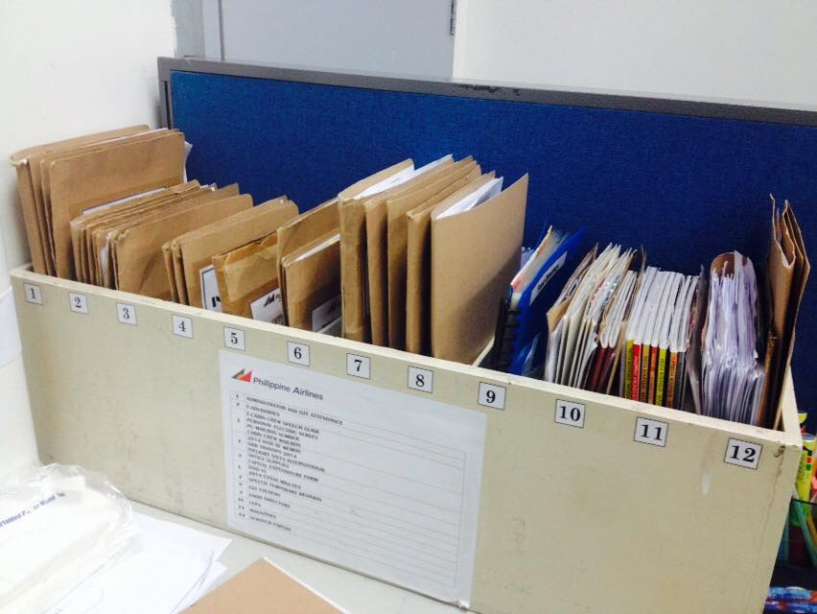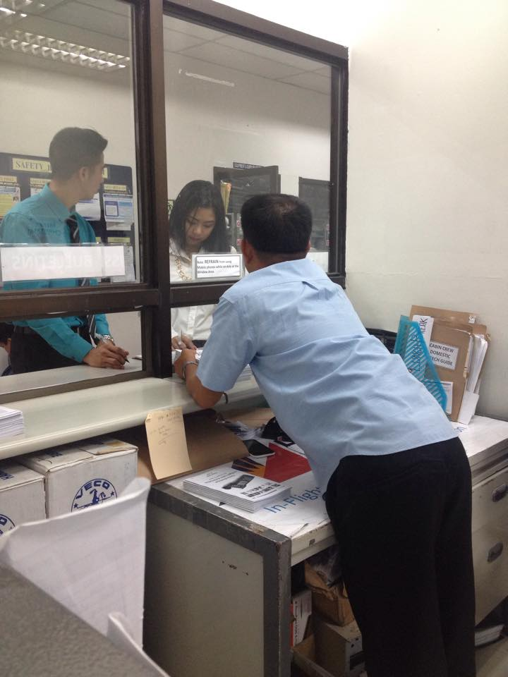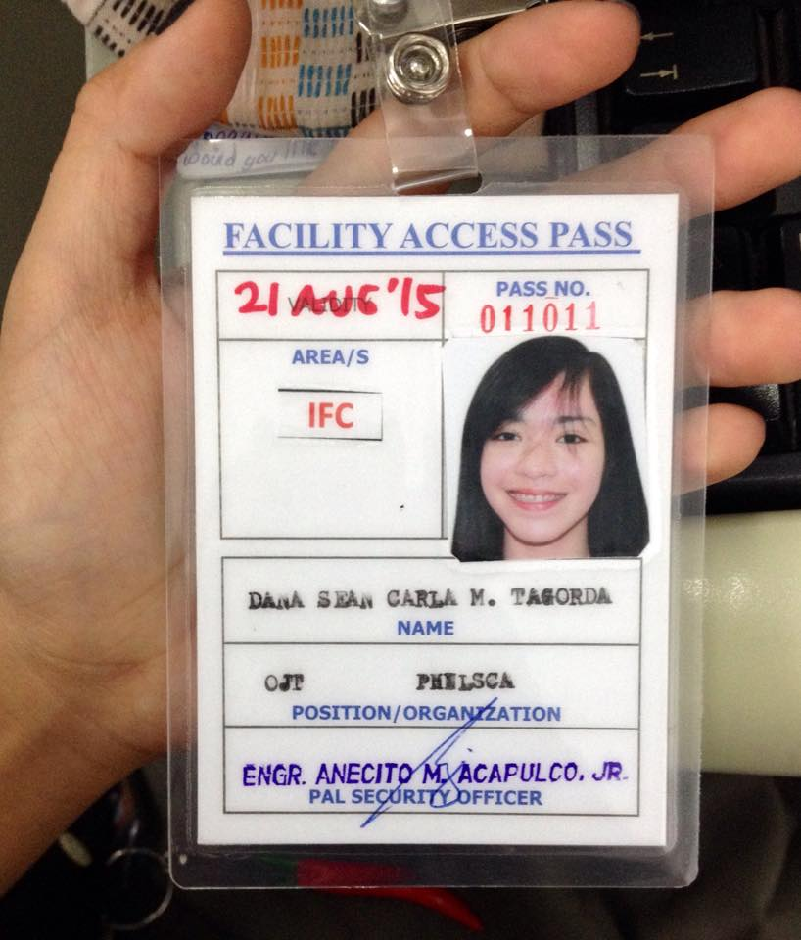

|  |  |  |  |
| --- | --- | --- | --- |
| **Department : CAU Office** | | | |
| Date | Time in | Time out | No. of Hours |
|  |  |  |  |
|  |  |  |  |
|  |  |  |  |
|  |  |  |  |
|  |  |  |  |
|  |  |  |  |