

Jose Rizal University

80 Shaw Boulevard, Mandaluyong City



Simbayanan ni Maria Multi-Purpose Cooperative

(SMMPC)

In Partial Fulfillment of the Requirements for the

Degree of Bachelor of Science in Business Administration

Major in Banking and Finance

By:

Chatte Lorraine Z. Serohijos

Members:

Bautista, Mack Aldrin I.

Basilio, Mark Jerome Q.

Clarito, Mark Ryan B.

Submitted to:

Dr. Ronaldo P. Poblete

September 2017

**Table of Contents**

**Title Page**

**Table of Contents**

**Abstract**

**Part I: History of Cooperative**

**Part II: Composition of Management**

**Board of Directors**

1. **HISTORY**

The provision of financial services to the poor started as part of the Parish Church’s ministry—worship, education, social services, temporalities, and youth development— under the social services arm. The Church workers believed that “We could not preach the Gospel to empty stomachs.” As the parish priest of Lower Bicutan, Fr. Anton first ventured into microcredit in 1989 when a benefactor granted him Php1 million to be given out to individuals as micro loans of Php5,000 each. However, only Php100,000 in repayments was collected. Mr. Edgardo Contreras, then a Church volunteer worker, recalled, We attributed this phenomenon to the members’ lack of value formation and sense of obligation to repay whatever they owed. Because of this experience, putting up a cooperative was conceived. We consulted the parish and participated in a cooperative seminar conducted by the San Dionisio Credit Cooperative in Paranaque. By establishing SMMPC in 1991, Fr. Anton formalized the extension of various services and the provision of loans to small-scale entrepreneurs. SMMPC had the following objectives:

1. To promote the cooperative among its members and create funds to be able to grant loans for productive and providential purposes;

2. To procure and distribute commodities to members and non-members;

3. To undertake joint agricultural or industrial production;

4. To supply production inputs to members and help market the product;

5. To promote an integrated cooperative system as a way of life so as to improve the social and economic well-being of the people;

6. To undertake any related activity leading to the members’ self-government and to improve the peoples’ social and/or economic well-being under a truly just and democratic society;

7. To work with the cooperative movement, non-government and government organizations in the promotion and development of cooperatives and in carrying out government policies; and

8. To undertake other activities for the effective and efficient implementation of the provisions of the Cooperative Code.

Its vision and mission were expressed thus:

**VISION** A self-reliant community in Lower Bicutan and the adjacent villages through its cooperative integrated development programs.

**MISSION SMMPC** shall develop and undertake socioeconomic programs and activities for the improvement of the quality of life of the residents.

Mr. Contreras, who became the cooperative’s first elected Chairman, recalled that Mt. Pinatubo erupted right after the cooperative was established, covering most parts of Central Luzon and Manila with ashes. He said that the resulting economic crisis from the disaster made it doubly difficult for a start-up cooperative like SMMPC to pursue its objectives. The cooperative had started with only 33 members and a capitalization of Php16,000. As Chairman, Mr. Contreras had to grapple with several issues. He recounted, I had to establish the credibility of the cooperative. The recruitment of members was done by promoting the newly-formed cooperative during Sunday mass and through the use of “guerilla tactics,” that is, we moved around the four nearby villages—Lower Bicutan, Bagumbayan, North Daang Hari, and Sitio de Asis. However, people were too afraid to put their resources into something that they feared was not stable. Since there were many fly-by-night cooperatives, people were afraid SMMPC might run off with their money. Aware of what it was up against, SMMPC thus hired managers whom the people could trust. These managers were existing volunteers in the cooperative. It issued its first loan of Php1,000 in September in 1991. Mr. Contreras said, “Initially, very few members wanted to avail of loans, which they found too small to begin with. Thus, SMMPC increased the minimum loan size to Php5,000 to make the service more marketable.” SMMPC also had to compete with the 5/6 operators who did not require any investment or membership to any one prior to granting a loan. According to Mr. Contreras,

These operators also did not require attendance in seminars during the loan term and neither did they impose any limit on the loan amount. The cooperative limited the allowable loan to three times the savings amount or share capital of the borrowing member. Moreover, these operators were able to release the loan within the day it was applied for. In contrast, since the SMMPC staff was composed of volunteers who did not necessarily have any banking experience and were thus not used to processing financial transactions, it took them two weeks to release the loans. Realizing the need to build the management capabilities of its officers, SMMPC used the cooperative education and training fund (CETF)6 for skills training and personal development seminars of the volunteer staff. Finally, Mr. Contreras had to deal with some “’very enterprising members’ who lent out the loans they obtained from SMMPC to non-members who were not subjected to a background investigation nor screening vis-à-vis the selection criteria, thus causing SMMPC’s past due account to rise.” Since SMMPC was a parish-based cooperative, its Board then was composed of members of the Parish Pastoral Council “who had good leadership because of instilled values of service and sincerity, but simply took directives from the parish priest. In a way, it was really the parish priest who ran the show,” Fr. Anton said, referring to himself. In 1992, Fr. Anton was assigned to Makati City. Believing that the cooperative would collapse if the next parish priest did not have social orientation, the Board decided to take SMMPC out of the jurisdiction of the parish church and transformed SMMPC into a community-based cooperative. The SMMPC Board-cum-Pastoral Council was maintained while a new set of officers was appointed to the Parish Pastoral Council. Though still in Makati in 1995, Fr. Anton was elected SMMPC Chairman

**SMMPC core values ;**

**CORE VALUES  *(Moral na*** ***Pamantayan)***

*God Centeredness (Maka* *Diyos)*

*Financial Intelligence ( Kaalamang* *Pangpinansyal)*

*Discipline of Entrepreneurship (Disiplina* *sa Pagnenegosyo)*

*Teamwork and Community (Pagkakaisa* *sa Komunidad)*

*Social Responsibility ( Panlipunan* *Pagpapakilos)*

And the SMMPC Principle;

1. Voluntary & Open-Membership
2. Democratic Member Control
3. Member's Economic Participation
4. Autonomy & Independence
5. Education, Training & Information
6. Cooperation among Cooperatives
7. Concern for Community

Then the Simbahayan ni Maria Multi-purpose cooperative is already helping others since 1989 and it place all started in lower bicutan taguig, by the desire of the owner and its employee they succeed in to achieve their goal. They have many more branches around metro manila for them to be able to help lot of people who need there help.

1. 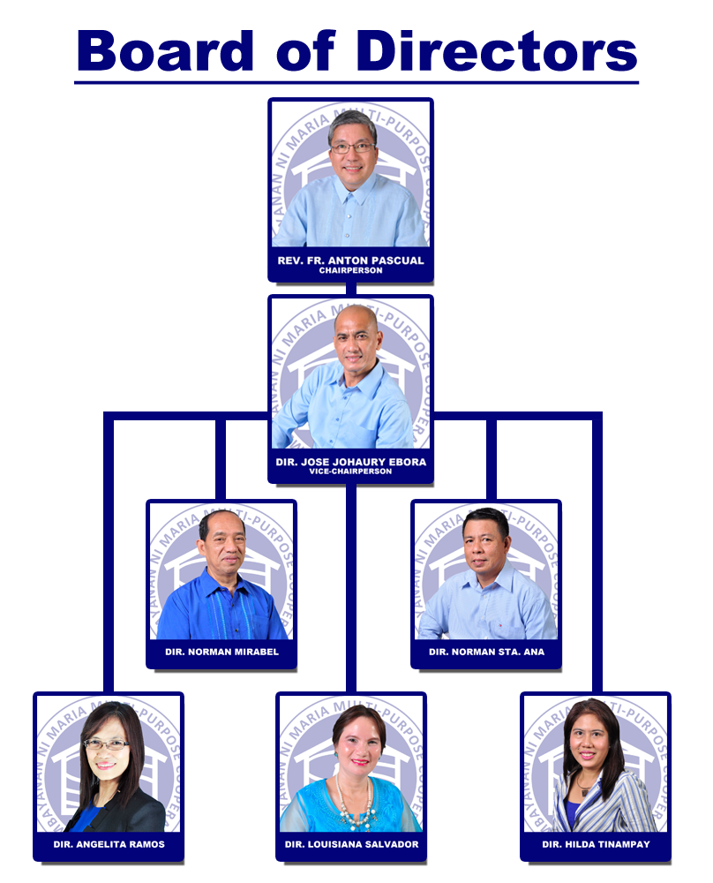**Composition of management.**
2. **Product and Services**

**Regular Saving Deposit**

Requirements:

* Open for regular and associate members of Simbayanan.
* Initial deposit to open an account is P1300.00 or P2500.00.

Characteristics

* Fixed Rate
* No withholding tax
* Savings Deposit can be used as Loan Collateral (back-to-back loan) with HOLD status. During HOLD status, the depositor cannot withdraw from the Savings Deposit if loan is not settled in full.

Interest Rate

* 3% per Annum
* Tax free

**Loan Services**

**6C’s of Credit/6C pamantayan sa PAGHIRAM**

CHARACTER = Willingness to Pay / Background

CAPACITY = Ability to pay

CONDITION = Condition of the borrower / business

COLLATERAL = Security Offered

CAPITAL = Assets minus Liabilities

CO-MAKER = Shared liability

**Regular Loan**

Interest 2% Per Month

Terms 3 mons. minimum; 2 years maximum

Loanable Amount P5,000.00 - P150,000.00

**Character Loan**

Interest 1% Per Month

Terms 3 years maximum

Loanable Amount Up to P200,000.00

**Real State Mortgage Loan**

Interest 1.1% Per Month

Terms 10 years Maximum

Loanable Amount Up to 60% of Appraised Value

Up to P10 Million

Collateral Land Title

Transfer Certificate of Title(TCT)

Original Certificate of Title(OCT)

**Enterprise Loan**

Interest 1.5% Per Month(Diminishing)

Terms 3 years maximum

Loanable Amount P50,000.00 - P300,000.00

**Appliance Loan**

Interest 1% per month

Terms 1 year maximum

loanable Amount Depends on the amount of the appliances and gadgets

**Motorcycle Loan**

Interest 2% Per Month

Terms 3 years maximum

Loanable Amount Based on the amount of motorcycle

**Vehicle/CAR Loan**

Interest 0.045%

Terms 3 years to 5yrs maximum

Loanable Amount 90% of the SRP

**Emergency Loan**

**Memorial Loan**

**General Requirements:**

PMES (Pre-Membership Education Seminar)

COS (Credit Orientation Seminar)

BRANCH TIME SCHEDULE

MAIN 2PM MONDAY-FRIDAY

CENTRAL 2PM MONDAY-FRIDAY

TUKTUKAN

WATERFUN/SIGNAL

PATEROS 8AM SATURDAY

WATERFUN/SIGNAL

PEMBO/RIZAL 1PM WEDNESDAY-FRIDAY

3. PMES (Pre-Membership Education Seminar)

4. Sketch of Residency

5. Proof of Income

1 Month current PAYSLIP

Employment Certificate with COMPENSATION

Remittance slip = (Cebuana, Palawan, Western Union, Mlhuiller, others)

Pension = Bank Statement or Updated Passbook

Business Permit or Brgy. Business permit (with record of daily sales)

Contract or list of tenant or Student for Room / house rental/ school Service

Copy of OR/CR with Franchise(PUJ, Tricycle, UV Express, Uber, Grab, Taxi Operators)

Copy of OR/CR with Driver license / ID of TODA (for Driver's)

**Services Offered:**

* Training Formation on Business Management Capacity Building Program and Skills training.
* Access to Capital. Offer Entrep Loan who finished Entrepreneurial Training Formation to wit.
* Business Advisory. Coop Bazaar, Product expo, Entrepreneurship symposium, focus Group Discussion
* Business Registration Assistance for Business name on DTI and BMBE Registration
* Business Information. Simbayanan Enterprise Directory and Coopreneurs magazine.

**Business Education Hub**

* To provide free entrepreneurial trainings and seminar to its members, through linkage partnership with the following:
* Technical Education and Skills Development Authority (TESDA)
* Coca-Cola Philippines (Sari-sari store Training and Access to Resources (S.T.A.R.) Program that caters women entrepreneurs to the whole nation.)

**Skills and Livelihood Program**

* Center conducts Skills Trainings to uplift the living conditions of people who lacks of skills and to build their own source of living and a business opportunity for none.

**WHAT ARE THE BENEFITS PROVIDED BY COOP HEALTH?**

1. **PREVENTIVE:**

**ANNUAL PHYSICAL EXAMINATION:**

* Chest X-Ray
* Complete Blood Count (CBC)
* Urine Test
* Stool Test
* Physical Examination

1. **OUTPATIENT CONSULTATION:**

* Free consultation to our accredited clinics
* Php 10,000.00 Annual Coverage for laboratories examination (no intense laboratory for out patient) e.g.: MRI, CT Scan etc.
* Follow-up check up
* Necessary medicine used inside the clinic

1. **EMERGENCY TREATMENT:**

* 24/7 COVERAGE to all emergency cases
* Nationwide coverage
* All medicolegal cases (reimbursement only) i.e. vehicular accident, mauling, gun shot wound, etc.
* First dose of anti-rabies and anti-venom

1. **IN PATIENT OR CONFINEMENT:**

* Php 30,000.00/single confinement
* Php 60,000.00 Maximum Benefit Limit/year (Note: All availment deductable to MBL)
* Net of PhilHealth
* Doctors fee, room accomodation, medicines, laboratories, and other diagnostic test deemed necessary.
* Nationwide coverage to all emergency confinement.

1. **DENTAL COVERAGE:**

* Simple tooth extraction
* Consultation to dentist

1. **FINANCIAL ASSISTANCE:**

**DEATH BENEFIT:**

* Natural Death - Php 10,000.00
* Accidental Death - Php 20,000.00

1. **Other Information of Cooperatives**

**What is Smec?**

The Simbayanan ni Maria Enterprise Center, whose main objective is to become an educational hub of the members that will focus on developing micro entrepreneurs amongst the cooperators of Simbayanan ni Maria Multi Purpose Cooperative in making their business sustainable and progressive and to value the principles of self-reliance.

**Characteristics of a Member**

* Filipino Citizen
* Nakatira o Namamasukan sa area ng Taguig
* May edad 18 pataas (legal age)
* Nasa tamang pag-iisip
* May panahon at oras para sa kooperatiba
* May mabuting katayuan sa komunidad at walang anumang kaso patungkol sa di pagbabayad ng inutang
* Mayroong malasakit sa komunidad at sa kooperatibang sasalihan

**CRITERIA OF MIGS** (Batayan ng Isang MIGS)

All members In Good Standing (MIGS) are obliged to attend the General Assembly, being the highest obligation of a member. For your guidance, enumerated below are the criteria of MIGS: (Ang lahat ng MIGS ay obligadong dumalo sa General Assembly na siyang itinuturing na pinakamahalagang obligasyon ng isang miyembro. Para sa inyong kabatiran, ang batayan ng isang MIGS ay ang mga sumusunod:)

* Fulfil all obligations to the Cooperative and must have physically attended at least one (1) of the two (2) General Assemblies immediately preceding the current GA. (Ginagampanan ang lahat ng kanyang obligasyon sa Kooperatiba at personal na dumadalo isa (1) sa dalawang (2) pangkalahatang pagtitipon bago ang kasalukuyang pangkalahatang pagtitipon);
* Patronize the services of the Cooperative.(Tinatangkilik ang mga serbisyo ng Kooperatiba);
* Have a Share Capital of Five Thousand pesos (Php5,000.00) and up. (May Saping Puhunan na Limang Libong piso (Php5,000.00) at pataas);
* Attend all activities of the Cooperative. (Nakikilahok sa mga aktibidades o pagtitipon ng Kooperatiba);
* No delinquent and past due account. (Hindi delingkwente o walang utang na hindi bayad o lagpas sa taning); and
* A member whose acts not inimical to the interest of the Cooperative. (Miyembro na hindi gumagawa ng bagay na nakakasama sa interes ng Kooperatiba)

**PROMO/PROGRAMS/LOANS FOR MIGS** (Mga Programa Para sa MIGS)

* Character Loan
* Share Capital Empowerment Program
* Deferred Payment option for HMO
* Member’s Summer Outing
* Pilgrimage (for members who are Senior Citizens)
* Free Bayad Center
* Christmas Party (for members who are Senior Citizens)
* Right to vote and be voted as an officer or Board Member of Simbayanan

1. **General Evaluation of Cooperatives**

SMMPC can expand its offerings to include microlending, manpower placement, and pawnshop services in response to the growing demand for credit in our area. The C-D population is indeed growing in Taguig. It can also expand in terms of membership, in effect saturating its current market; or expand by increasing the allowable loan amounts or by increasing its geographic area of coverage. SMMPC also needs to train and educate its staff at all levels to make its operations and internal control mechanisms more effective and efficient. It can also concentrate on promoting itself in the area as an intervention organization committed to poverty alleviation, microfinance, microenterprise development, and value formation. This way, SMMPC can generate support for all its services from different sectors in the community, whether groups or individuals. SMMPC may also opt to focus on financial services alone and to expand its reach to as many poor people as possible. Because of the current capital build-up requirement of the coop, many poor people lose interest right away as they could not afford to pay the fees. The challenge to SMMPC now is to help those who need help the most. Finally, it can link with government organizations and other NGOs to help promote its intervention services.