There is a small ruby script that deals with the reformatting from Scrivener to be compatible with Quarto. It allows you to pass a file name and a format, so you can edit the post-processing panel to change the output format (change <$Scr_Cs::0>html<!$Scr_Cs::0> to <$Scr_Cs::0>pdf<!$Scr_Cs::0> / <$Scr_Cs::0>docx<!$Scr_Cs::0> / <$Scr_Cs::0>epub<!$Scr_Cs::0> etc.). It is embedded in this project’s Compiler format:

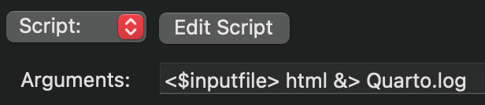

The script’s output is redirected <$Scr_Cs::0>&><!$Scr_Cs::0> to a <$Scr_Cs::0>Quarto.log<!$Scr_Cs::0> file and this log file will be opened after the compiler finishes so you can check any details or debug any errors…

