Cyber Range Lab Assignment 1

Introductory Linux Labs

Jon Mahoney

SRA 440W

# General Context and 10 Screenshots

The individual labs that comprise the overall lab assignment can be described as introductions to the Linux environment. The labs introduce the basic commands users will execute in the Linux command line and how to recognize the results of the commands. The first lab, “Basic Commands”, begins by teaching the user how to orient themselves within the directory structure of the Linux environment. The lab describes two essential commands, pwd and cd which is enough to get someone comfortable enough to poke around. The commands pwd and cd are used to **p**rint the **w**orking **d**irectory and **c**hange **d**irectory.

## Lab 1 Screenshot

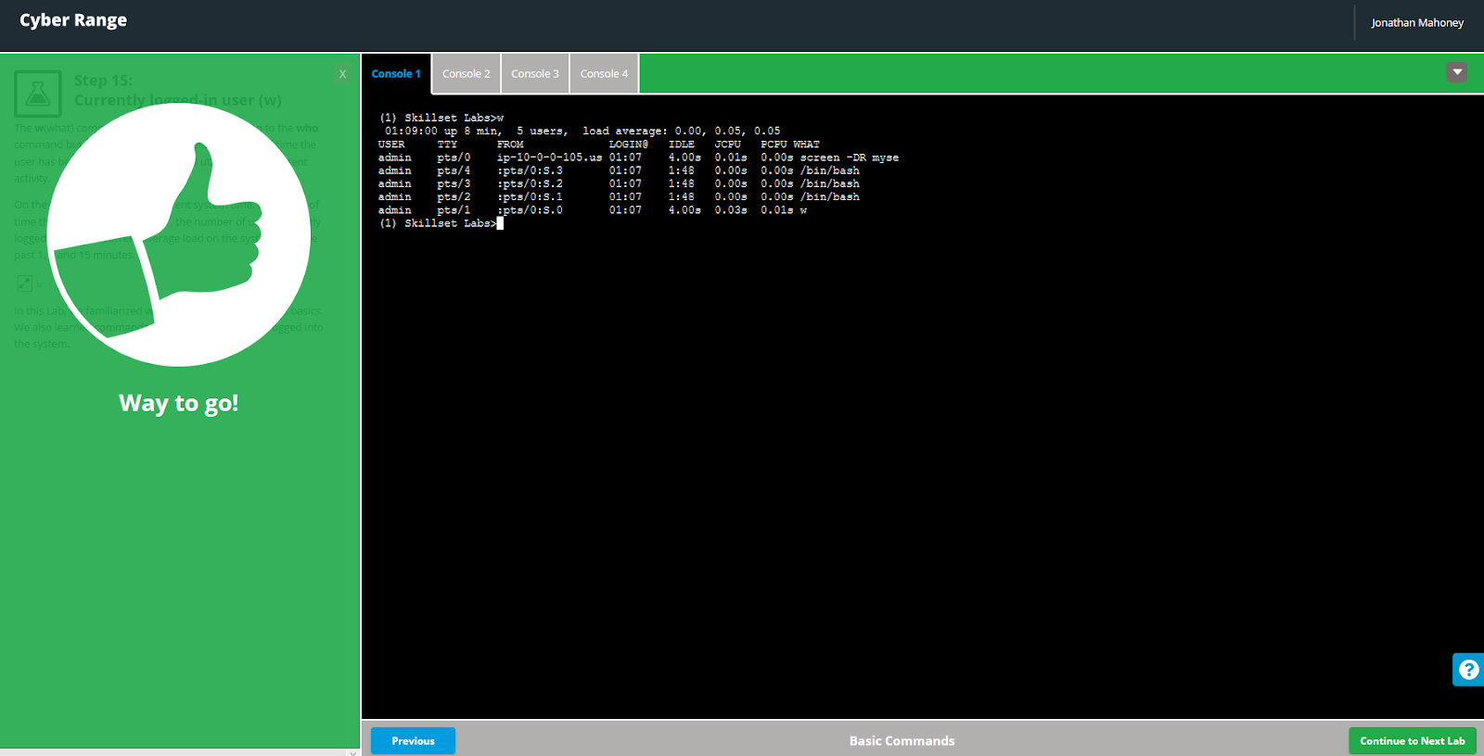

The following lab, “File Path and File Types”, elaborates on the file system of Linux and describes the types of files along with how to read the data that is presented from executing a command such as ‘cat /proc/cpuinfo’. An untrained user may be overwhelmed by the resulting wall of text but a user who has completed the lab will be able to pick out information such as the CPU model.

## Lab 2 Screenshot

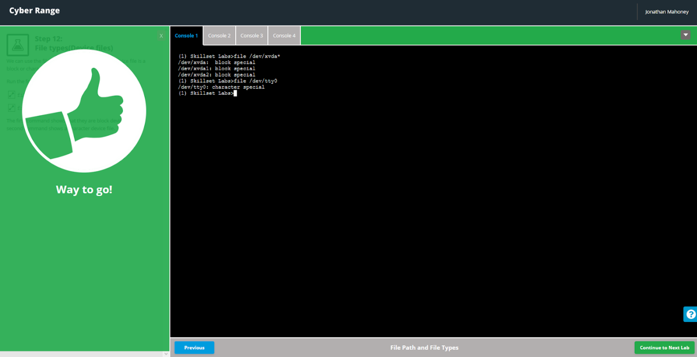The next lab, “File and Directory Permissions” builds on the previous lab by explaining file permissions and how to modify them. For instance, a user could begin the process of modifying permissions with the command ‘chmod’. The user would also have to include the group they want to modify along with the modification they would like to invoke. For example, chmod a-rw delivers read and write permissions to all users. The previous file system related labs set the cyber range user in a good place to understand the Linux Kernel which is the second to last lab in the assignment.

## Lab 3 Screenshots

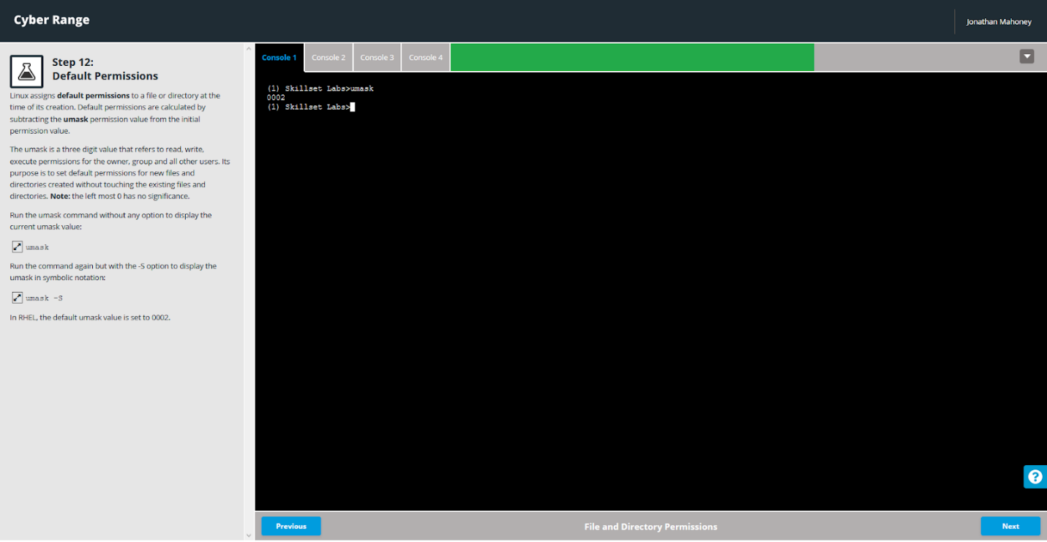

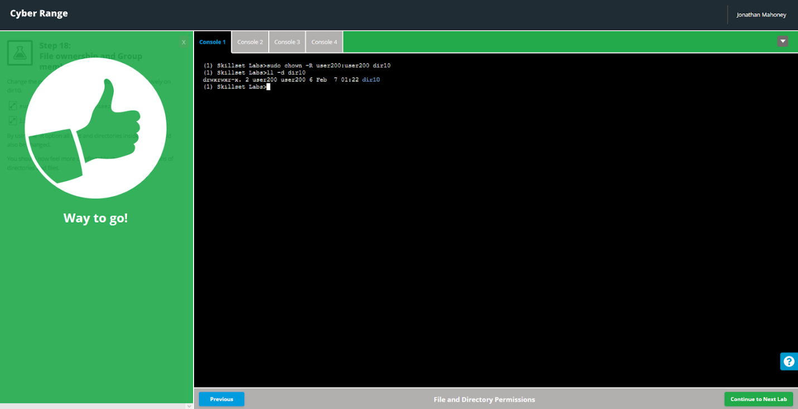

The Linux Kernel can be most basically described as the heart of the Linux operating system as it controls both hardware and software through a package of modules. Some of the modules present in the lab environment are amazon-id, rhui-lb, and search-disabled-repos. The last lab involves familiarization with the vi text editor.

## Lab 4 Screenshots

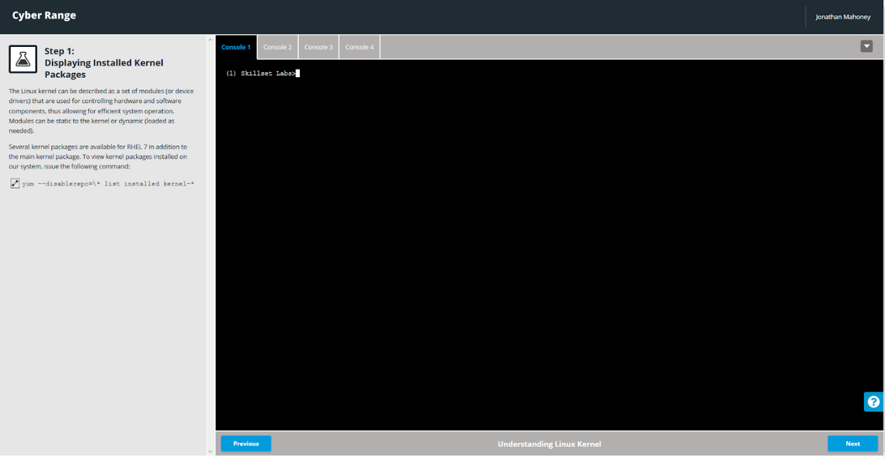

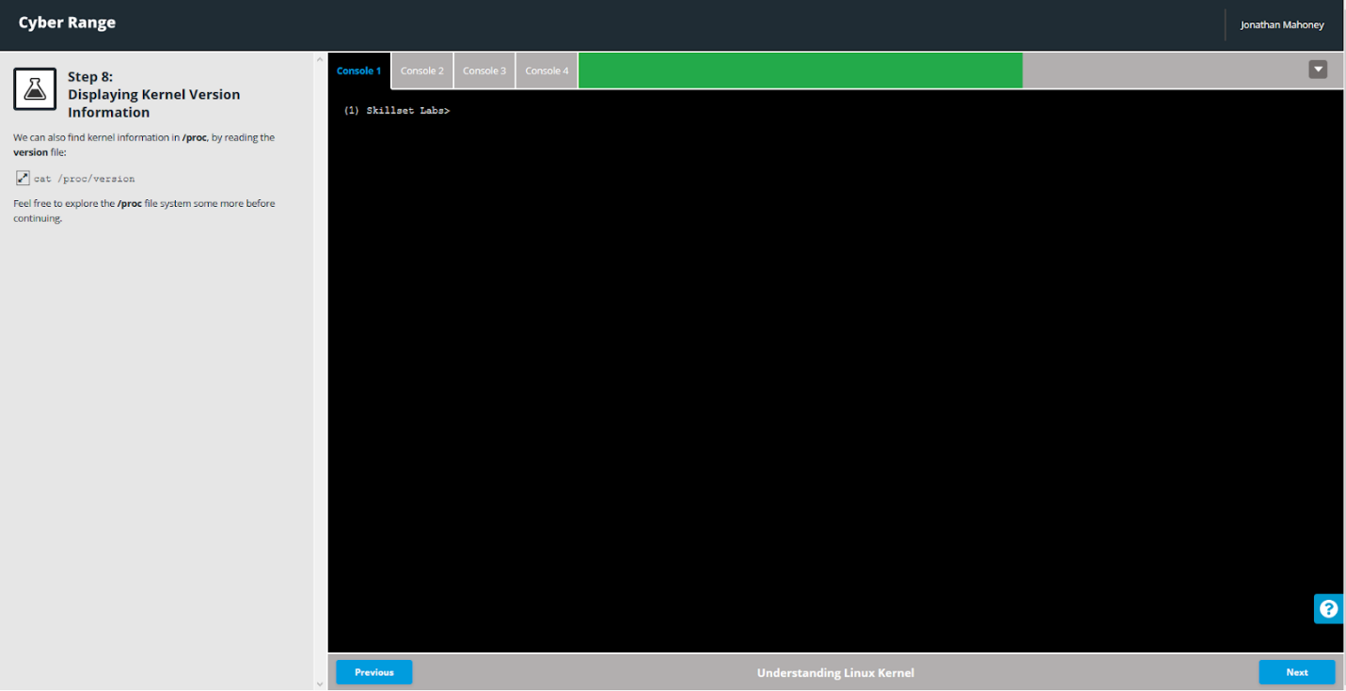

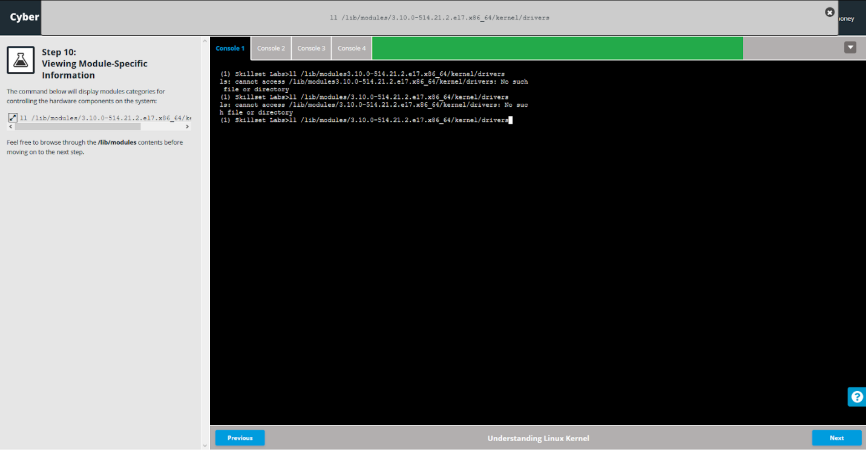

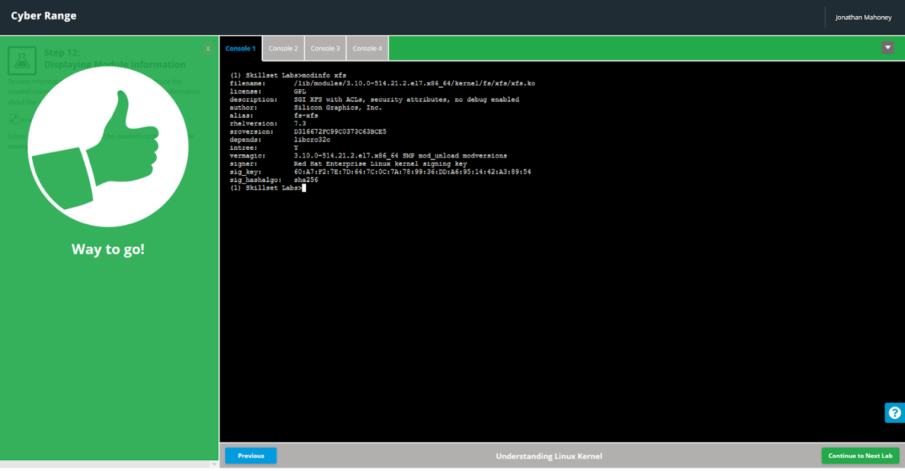

Text editors are an important piece in becoming proficient with Linux because of the importance of scripting. Shell scripts can be used in a number of ways. For instance, if someone had to complete a task in Linux regularly, they could write a shell script in the vi text editor and store the script to be executed as needed or even automate it.

## Lab 5 Screenshot

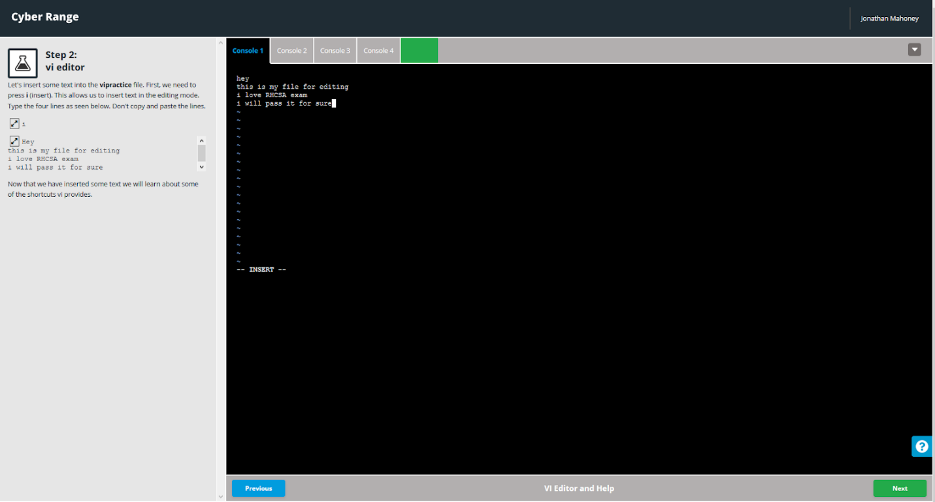

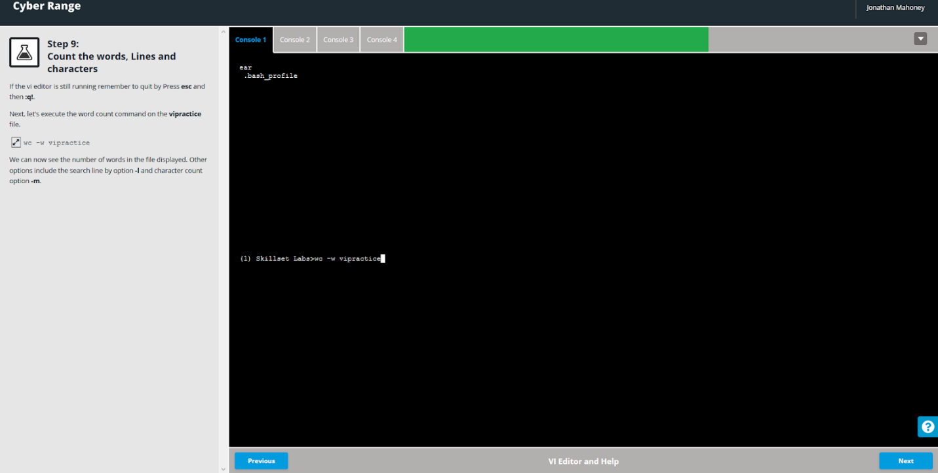

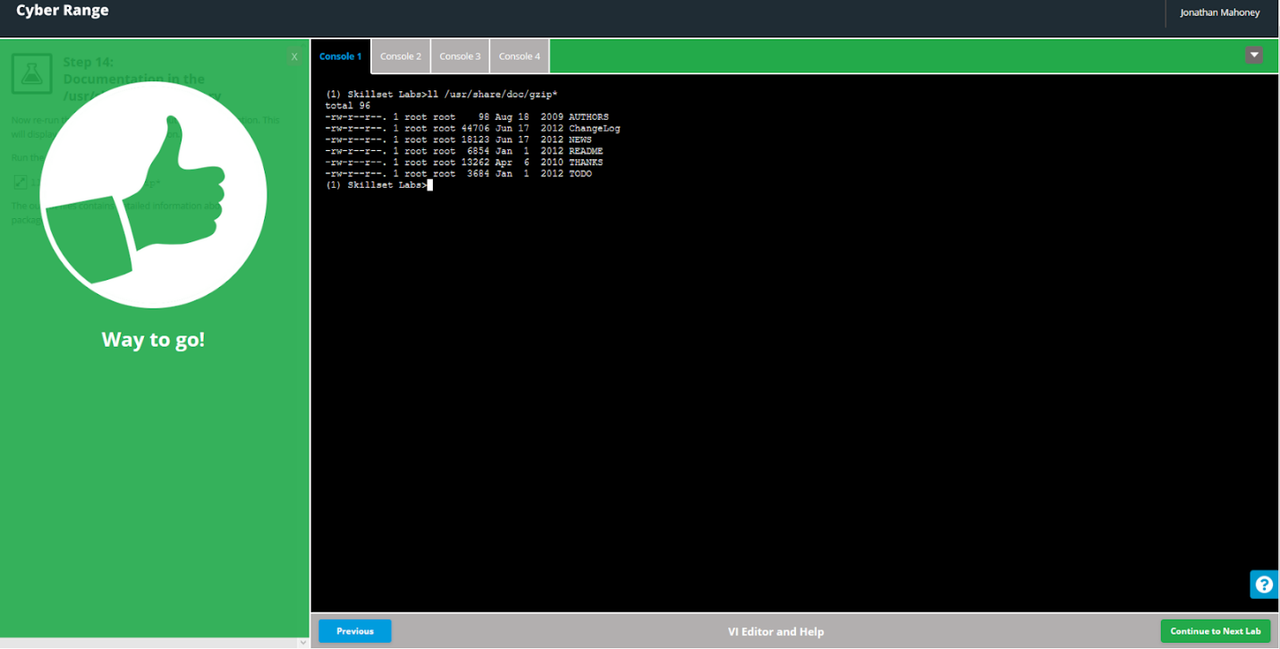

# Solution

I was well equipped to complete the lab assignment as I had taken Network Security with professor Nasereddin as well as Web and E-Commerce Security with professor Konak. Konak and Nasereddin both made sure to include plenty of Kali and BackTrack assignments in their curriculum, so I am very comfortable with basic Linux commands. For instance, the “File Path and File Types” lab involved a step of identifying the permissions of a file and entering a command to modify the permissions with the respective numbers as opposed to r,w,x. I was aware of the file permission notation before the lab explained it. That being said, I greatly appreciate the reinforcement of Linux basics as it is a platform I use very rarely compared to Windows.

In the last lab, “VI editor and Help”, I initially struggled with typing commands outside of the text editor. In the past, I used GNU nano and Gedit which I personally prefer to vi as they make use of GUIs. I also think their commands are more intuitive. For example, to save a text file in nano, you simply hold control and press o to “write out” whereas to save a text file in vi, you have to press escape and type “:wq!”. There were a few instances where I found myself stuck in the editor and I had to re-read the instructions but I managed to work through it.