Cyber Range Lab Assignment 11

Networking Cyber Range

Jon Mahoney

SRA 440W

# General Context

The four labs which comprised the assignment are the “Basic Router Interface Configuration”, “Basic Access Control Lists,” “Switch Learning”, and “Introduction to IP Routing.” The first lab required configuration of two cisco routers using telnet for connection to the routers, as well as various commands to test configurations. These commands are traceroute and ping. The second lab, “Basic Access Control Lists,” describes the information security administrative tool known as an access control list. ACL’s can be used in many different scenarios, but in the lab, an ACL is used to create rules which regulate communication between devices on a network. To summarize the second lab, access controls were established and then tested using the ping command.

The Third lab, “Switch Learning”, takes a look at switches on networks and uses many of the commands from the other labs to examine their properties. Network switches are devices that are used to relay packets to a separate destination network device. Part of the switch lab involved examination of switch MAC addresses. The fourth lab, “Introduction to IP Routing”, leads the user through the steps required to configure IP routes for three pre-configured routers. In doing so, static routing, dynamic routing, and routing tables were mentioned throughout the activity and will be further elaborated on in the solutions section.

# Solutions

An issue I ran into while completing the labs was that my screenshot program was exiting me out of telnet connections. This was occurring because I would take a screenshot, then my program would input ctrl+c to copy the image which would exit me out of the terminal. I avoided this issue by carefully choosing when to screenshot.

As for the commands that were used in the labs, a recurring command was “ping”. This is due to the fact that the command is the bread and butter of testing communication between devices on a network. Some other frequently used commands were “config t” and “enable”. These commands are part of the Cisco IOS. Config t is short for configuration terminal and it is used to access an elevated status which allows for global parameter alteration. Similarly, the enable command is used to access the elevated status directly below config t.

Two valuable concepts described in the labs are IP routing and Access Control Lists. When it comes to IP routing, static and dynamic routing can be equally useful depending on the needs of an organization. Static routing is known to support security at the cost of scalability, whereas dynamic routing can independently support complex topologies at a large scale.

# Screenshots

## Basic Router Interface Configuration

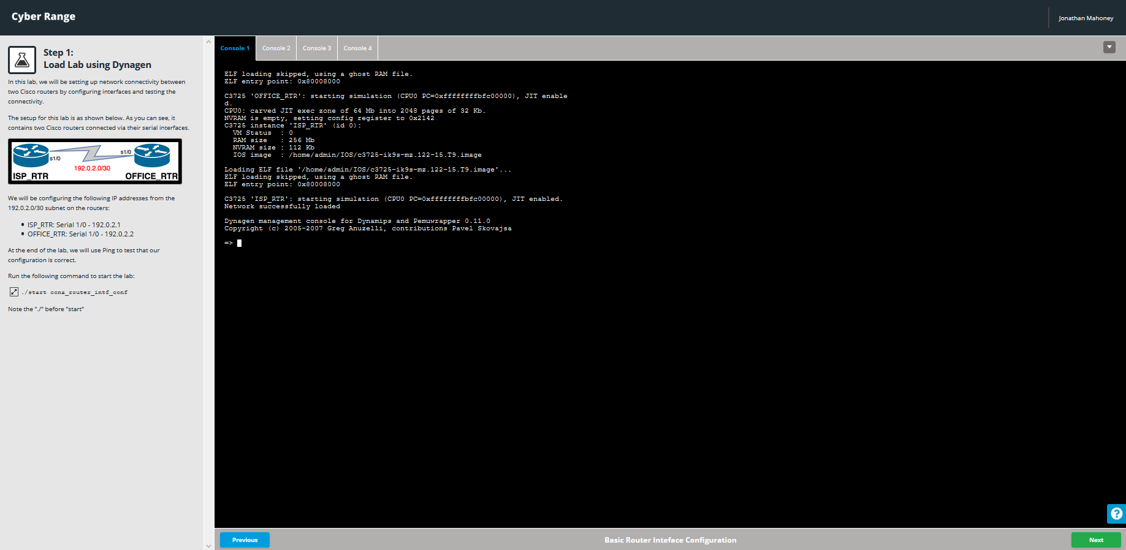 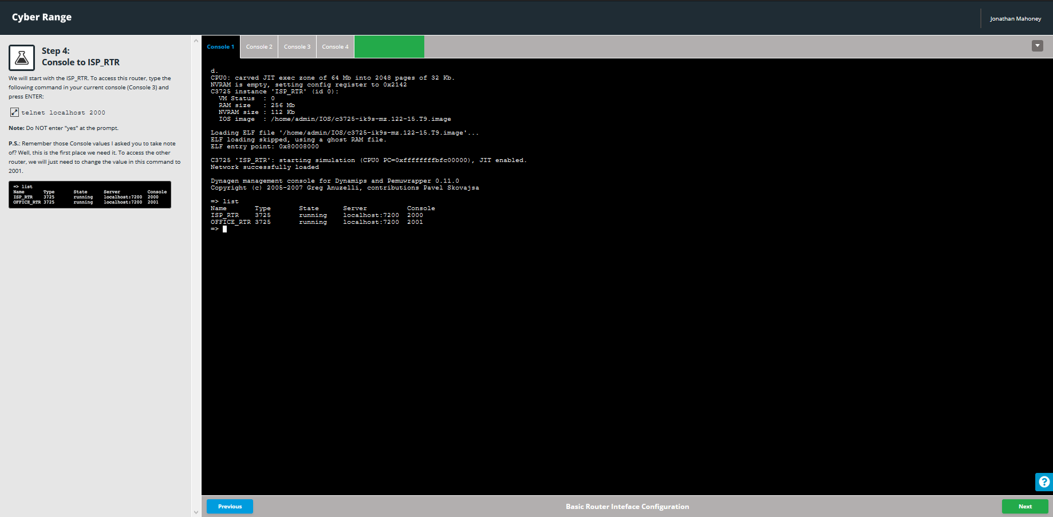 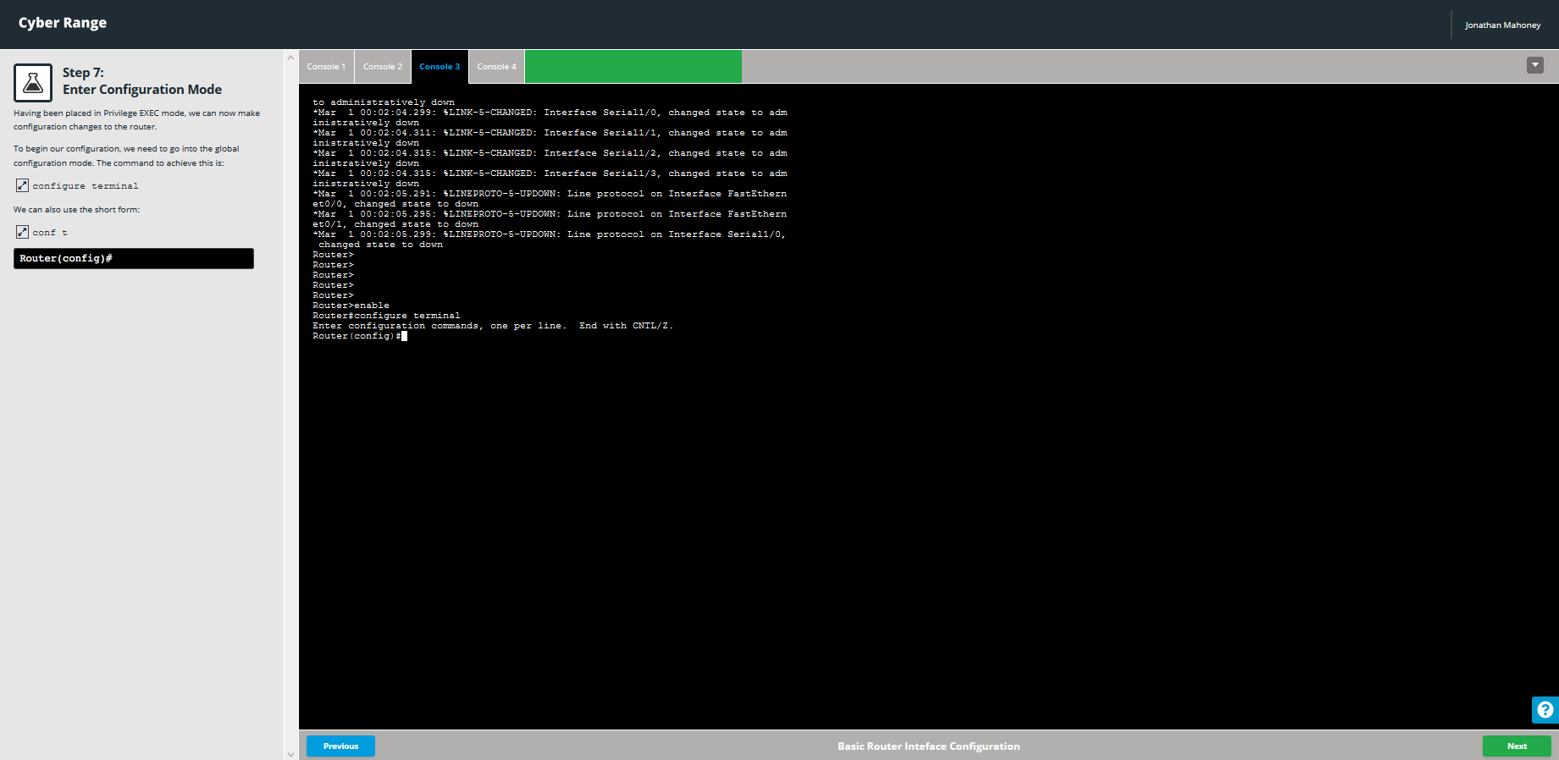 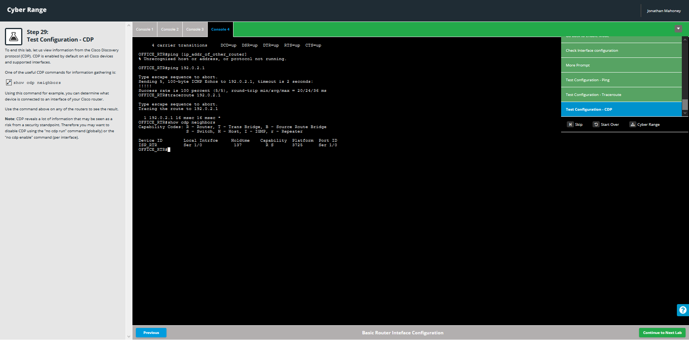

Basic Access Control Lists

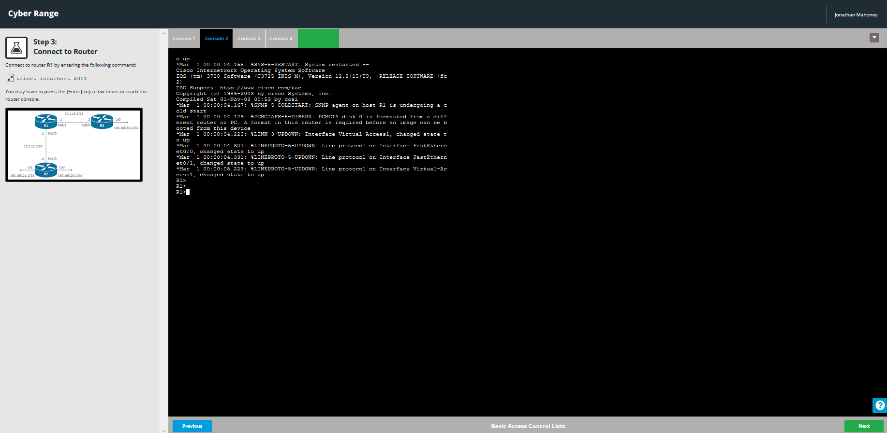 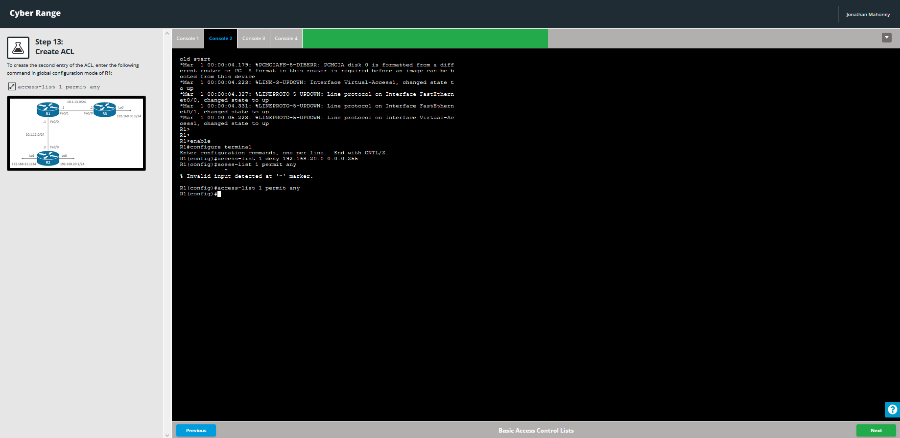 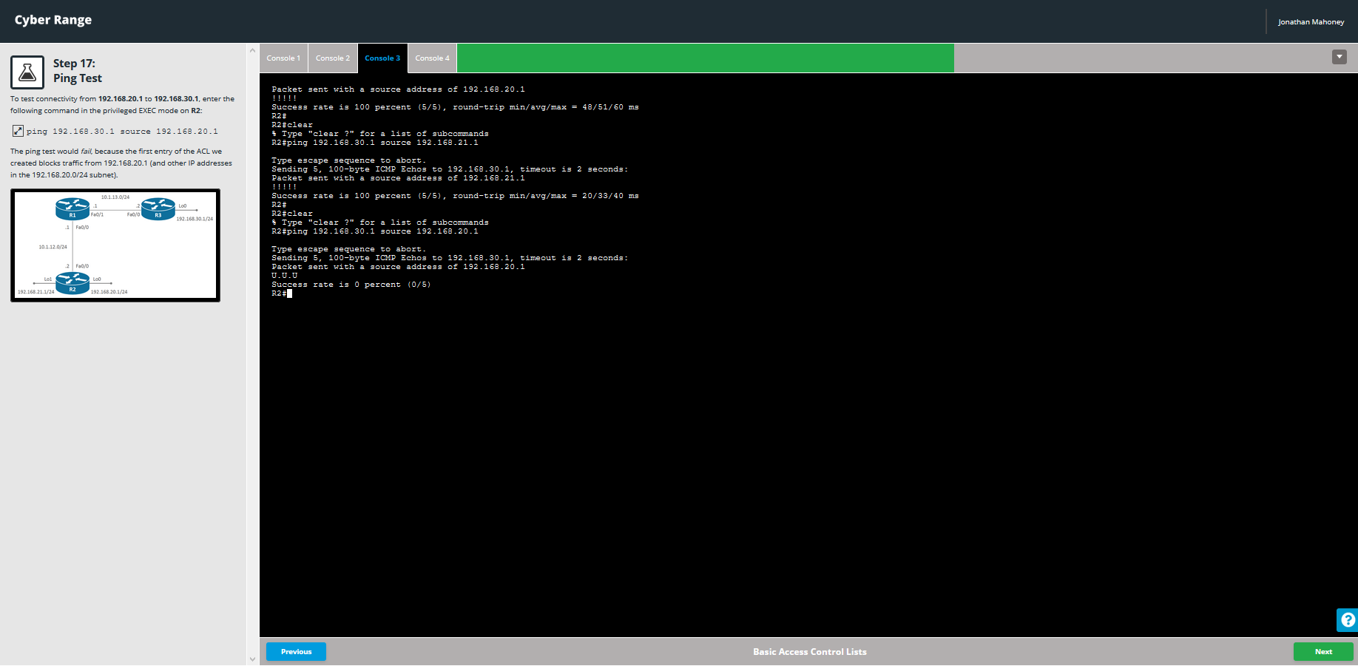 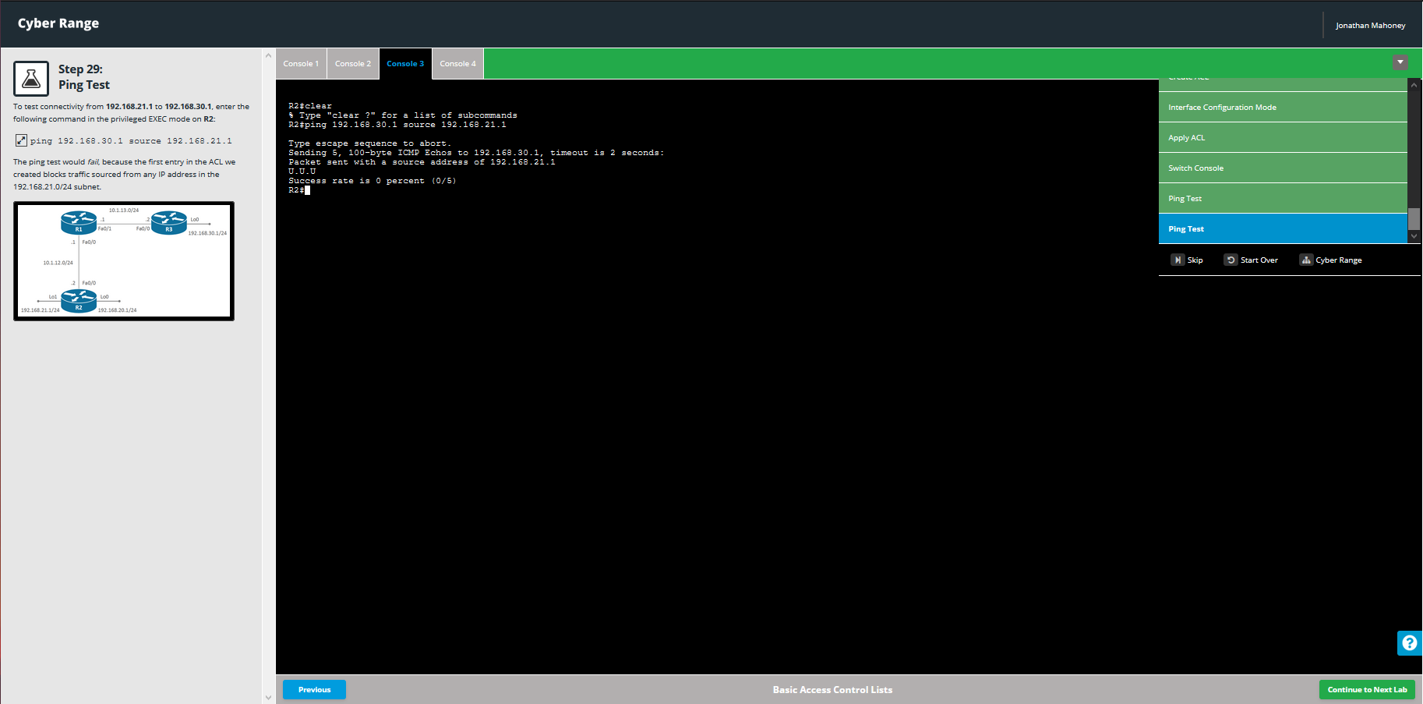

## Switch Learning

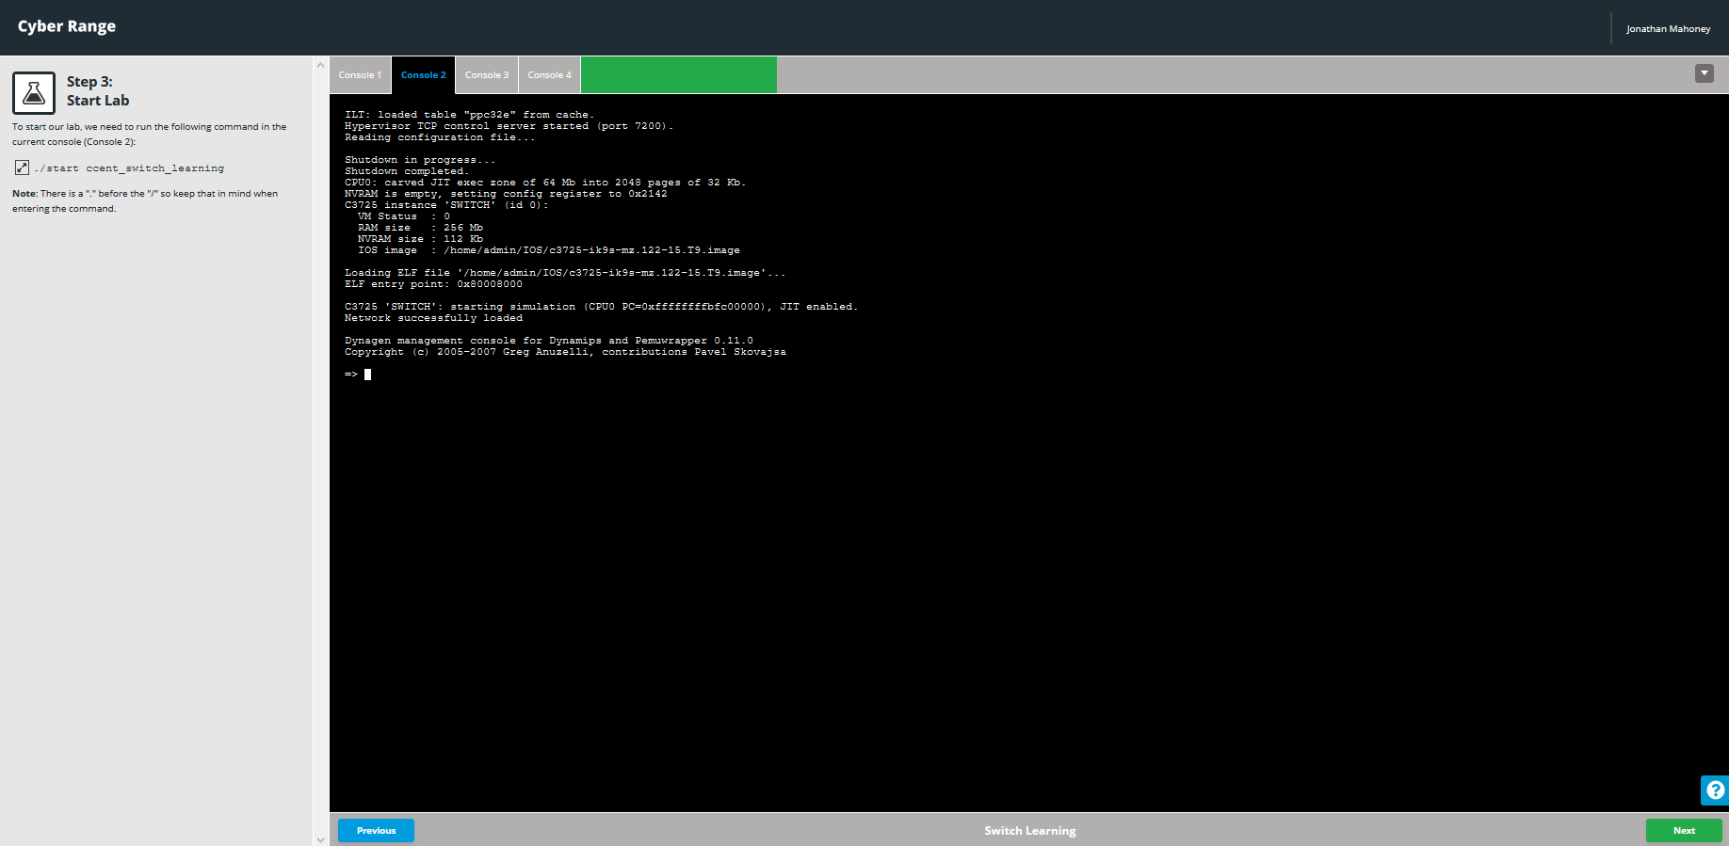 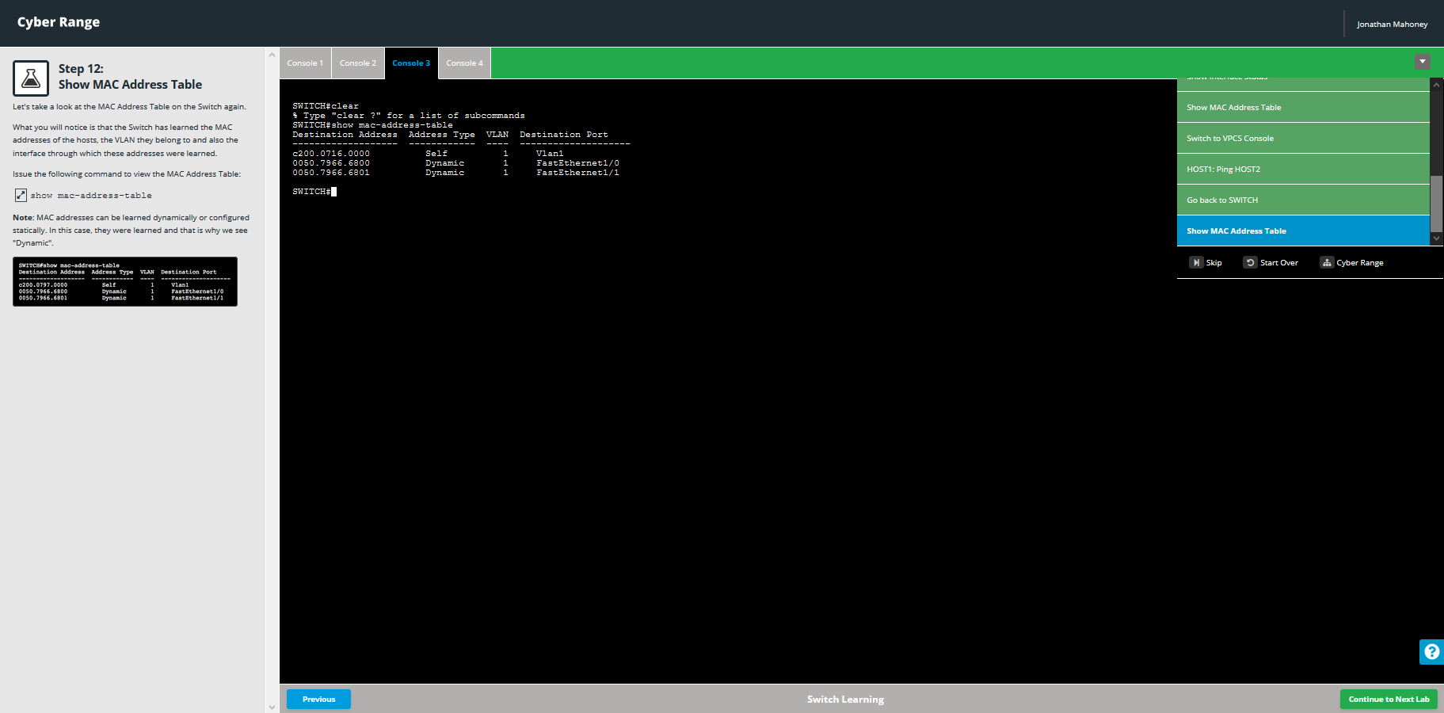

## Introduction to IP Routing

