Cyber Range Lab Assignment 12

Networking Cyber Range

Jon Mahoney

SRA 440W

# General Context

In the three labs that were assigned, utilities such as VPCs, VLANs, and hypervisors were used to cover some fundamentals on Cisco switches. Throughout all three labs, the Cisco IOS was used so the same few commands were frequently used. The first of the two VLAN labs start off by configuring a VLAN on one of two Cisco switches. The second VLAN lab deviates from the first as it has a specific issue where two devices cannot communicate with each other as they belong to different VLANs. This issue is circumvented through a process known as Inter-VLAN routing. The network management lab makes use of a Cisco tool referred to as Simple Network Management Protocol (SNMP) to simulate the duties of a network administrator. SNMP is used to collect information on devices on a given network for the purpose of modifying the devices or logging their activity.

# Solutions

The first of the two VLAN labs start off by configuring a VLAN on one of two Cisco switches. Before being able to configure the switches, the user must enable VPCS and then connect to the first switch using telnet. The method used to configure the VLAN is referred to as VLAN Database Mode. VLAN Database Mode is less than ideal due to the fact that it is old and can present issue for newer Cisco switches. The second VLAN lab covers a process called inter-VLAN routing which relies on an external router or a “router on a stick”. This router on a stick setup utilizes a physical link between a router and a switch in order to carry traffic between the VLANs. To make this possible, VLAN Trunking Protocol is used to pass traffic from SW1 to SW2. The network ­management lab makes use of SNMP and logging on a basic network of two preconfigured Cisco routers. As stated previously, SNMP can be used to modify devices. In the lab, several options are presented for modifying the login settings for one of the Cisco routers. One of the options is establishing a Syslog server which is an external server used to collect and store logs. The command to enable the Syslog server is “logging [ip for server]”. The Syslog server will generate logs with a severity rating on a scale of 0 to 7 where 0 is the most severe.

# Screenshots

## VLAN 1­

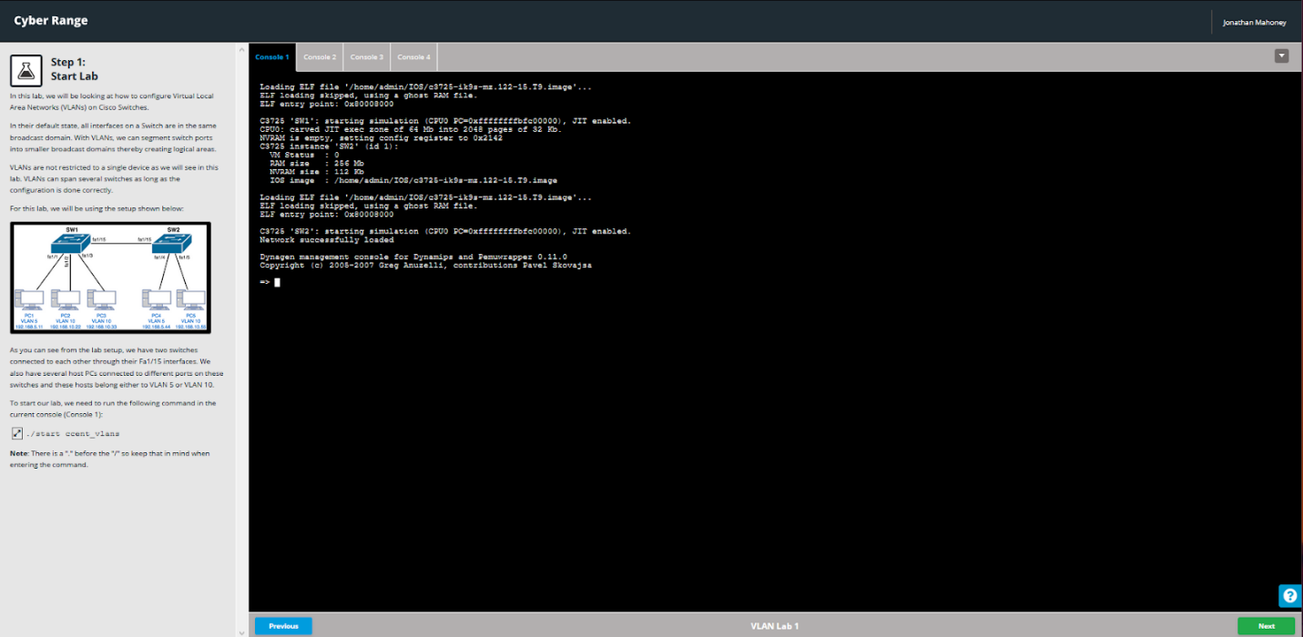

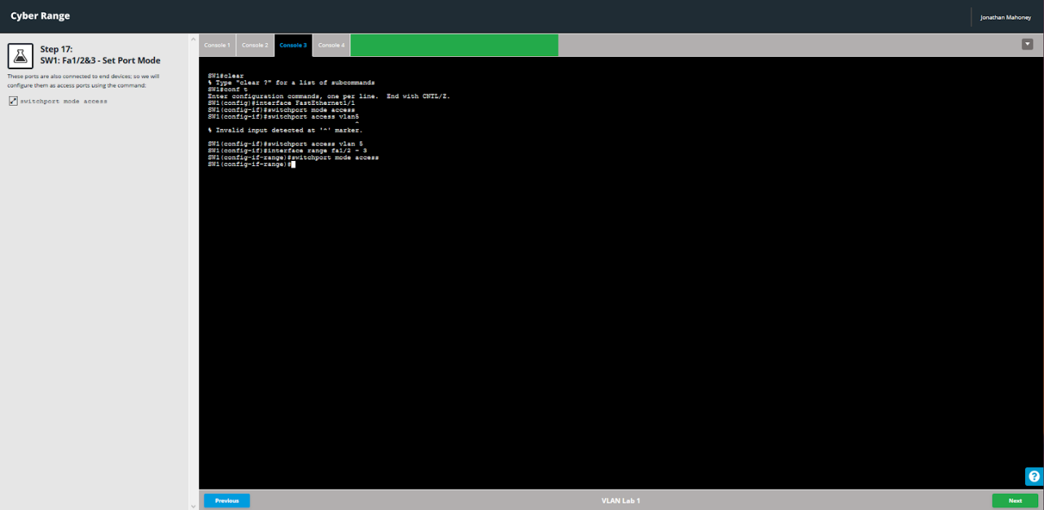

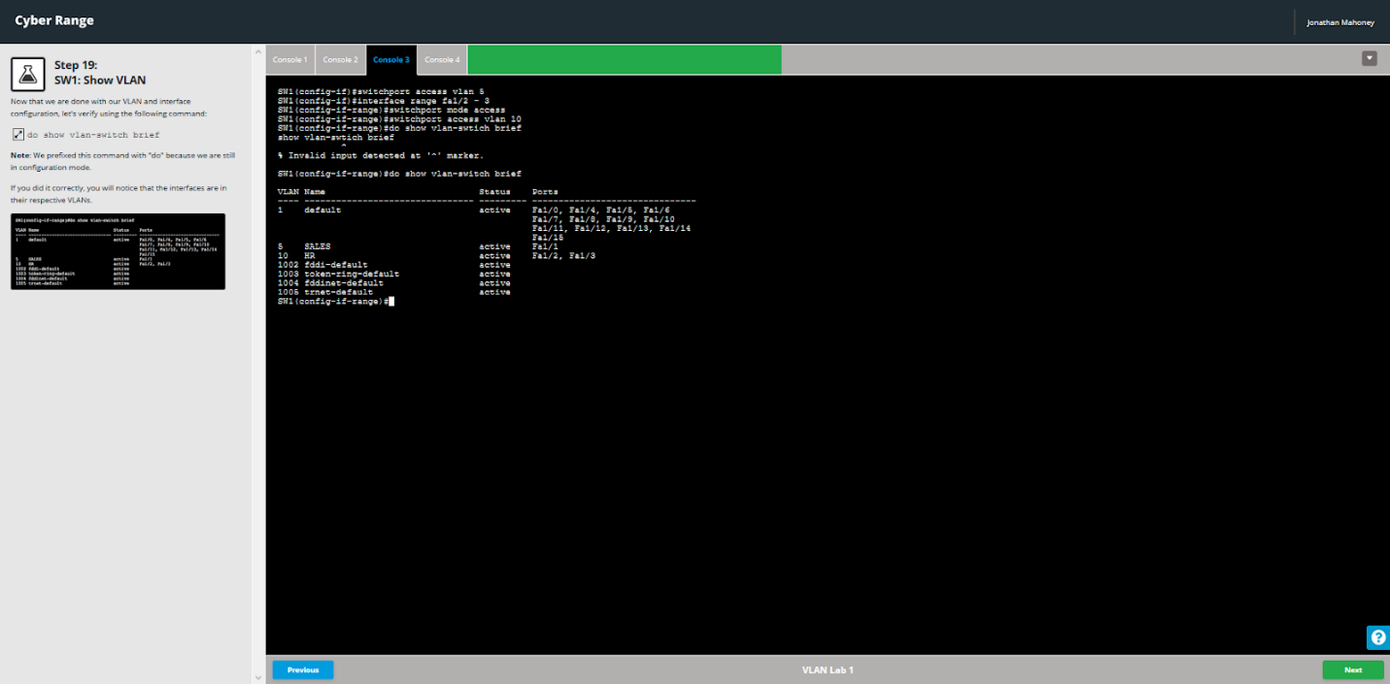



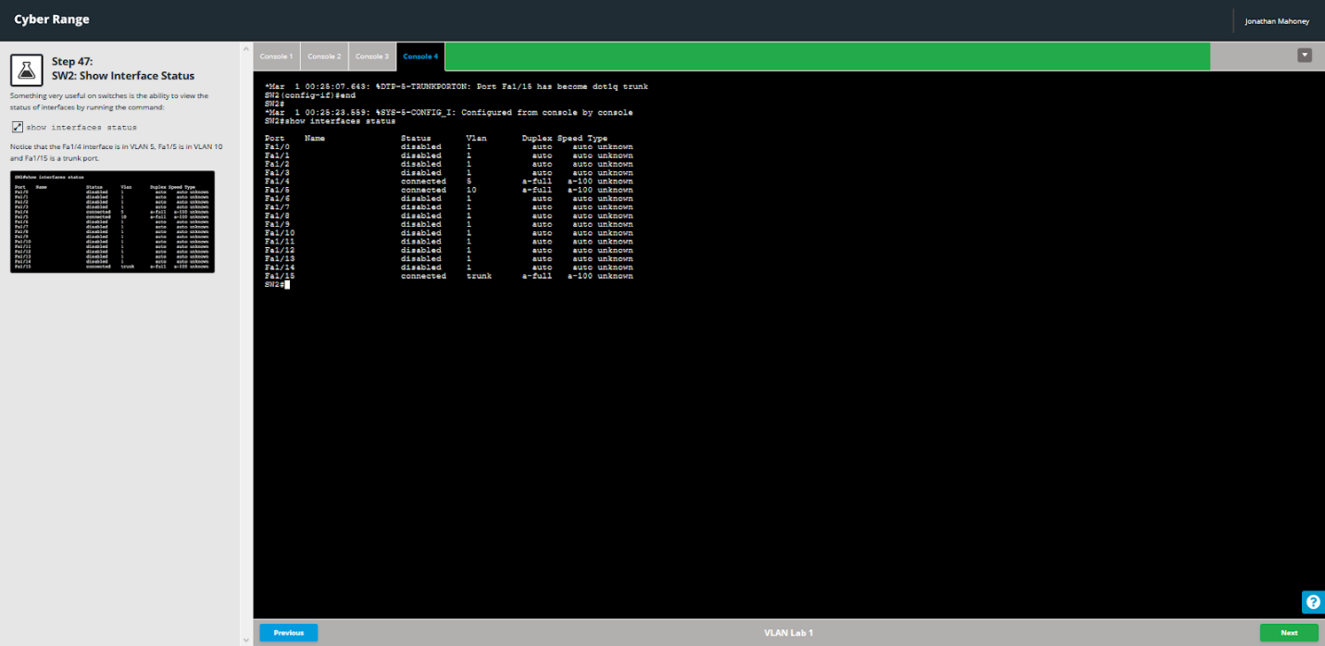

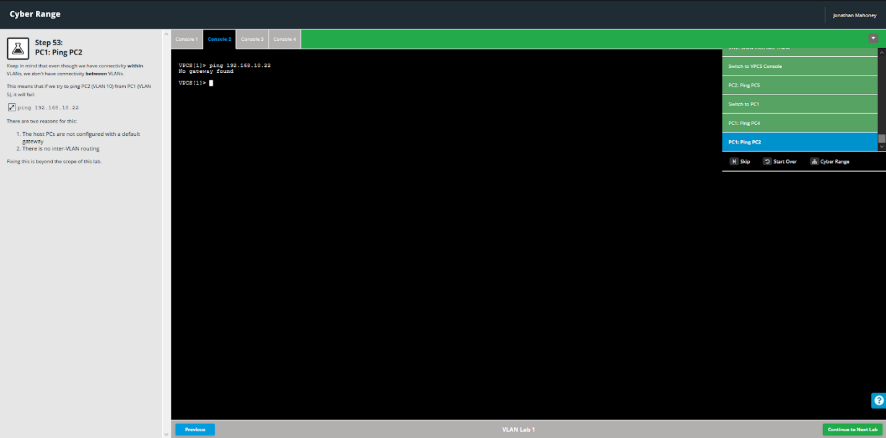

## VLAN 2

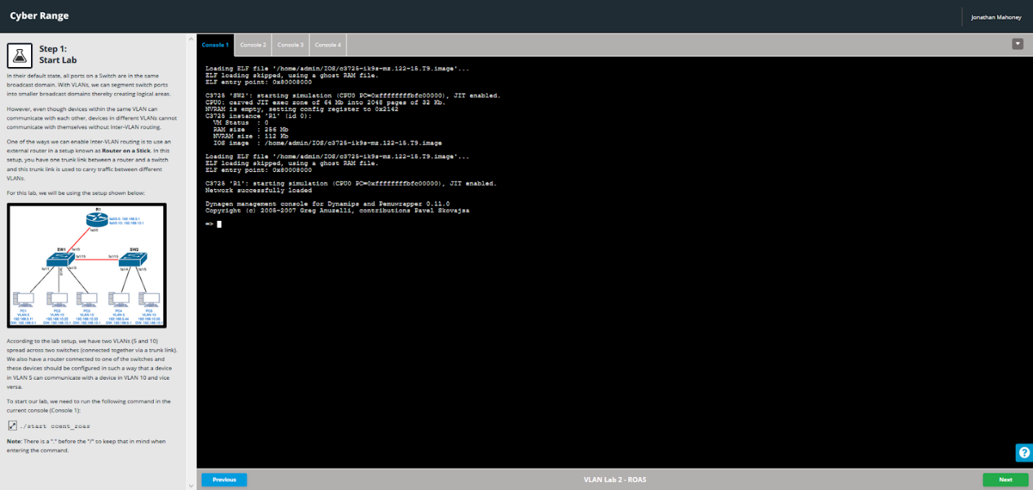

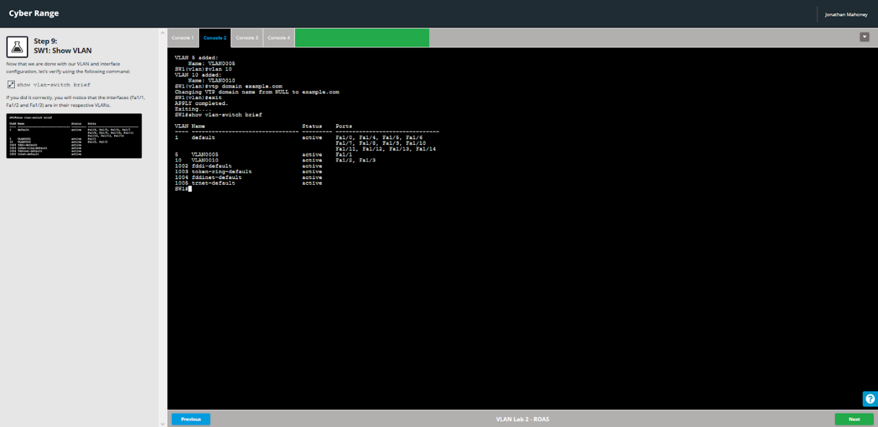

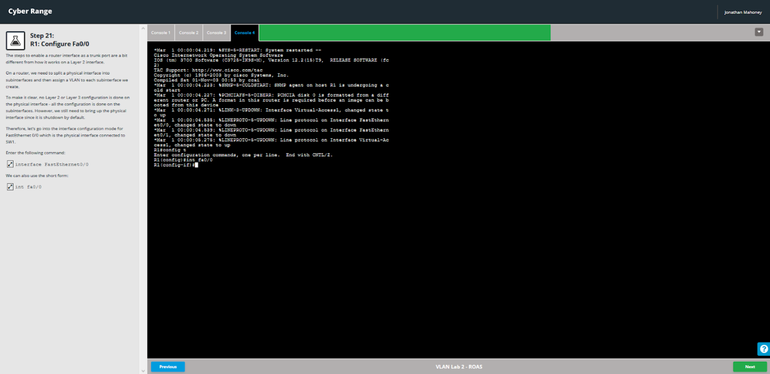

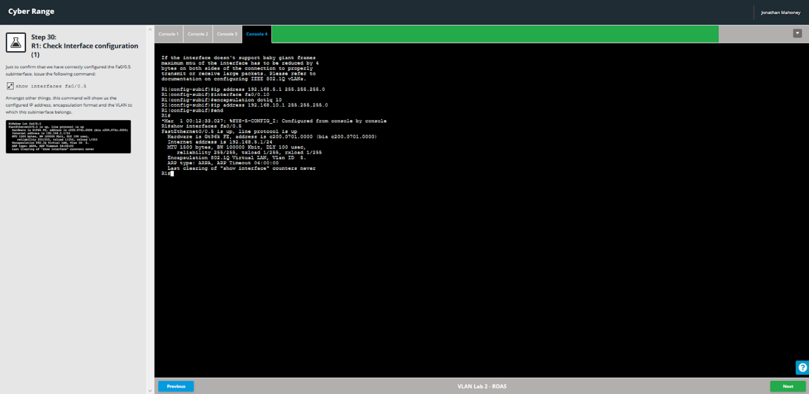

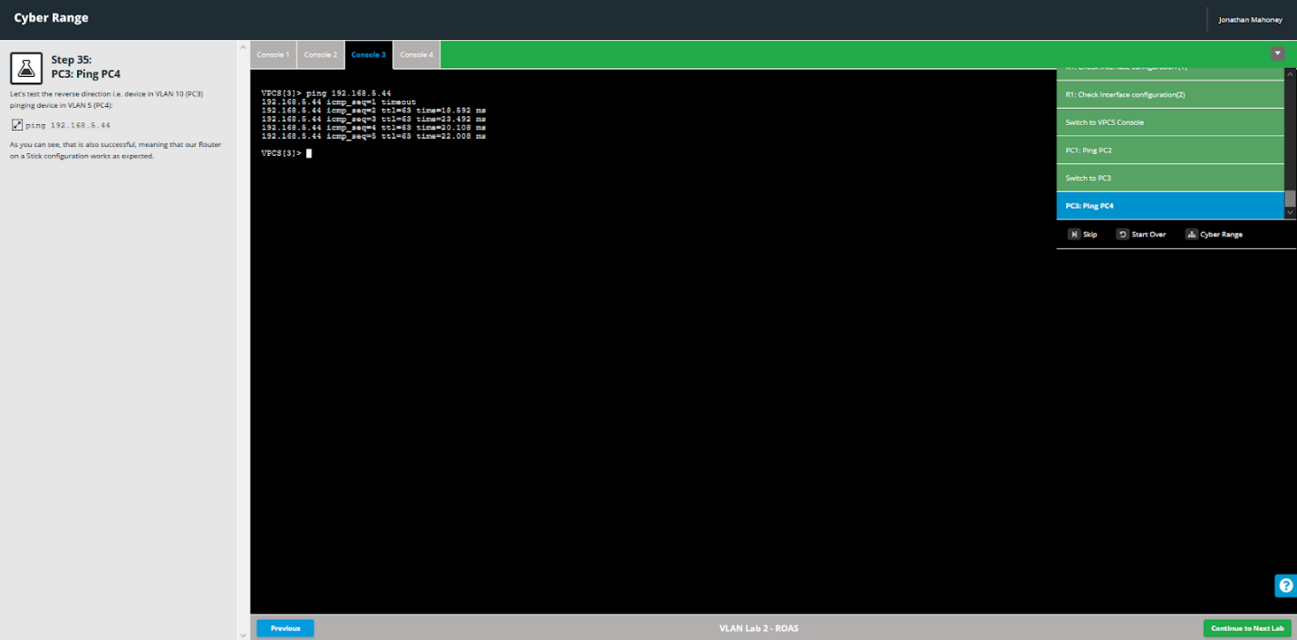

## Network Management

