Cyber Range Lab Assignment 9

RHCSA Cyber Range

Jon Mahoney

SRA 440W

# General Context

Red Hat Enterprise Linux is a Linux distribution which is known for supporting containerization, Kubernetes, and cloud computing. Since RHEL is a Linux distribution, many of the commands from the labs were familiar. I found this to be especially true for Basic Commands and Help as well as Using VI. Basic Commands and Help offered information on navigating directories in RHEL, commands like cd and pwd were used to navigate to a directory and output the current working directory. The next lab, Login History and Information provides information on system users such as permissions, users, groups, as well as information on the operating system. The lab made use of commands such as uname for finding system information, id for finding user and group information, as well as variations of the command last. The last command is used to find recent events such as lastlog which will display the most recent user logins.

The following lab, Using VI, focuses on familiarizing the user with the text editor VI. The lab walks the user through editing and saving a text file. For example, a user can save a file by using variations of the w command such as wq or w! to write then quit and overwrite respectively. The lab Finding and Linking files shows ways to search for files recursively based on attributes such as file size, date of last modification, permissions for the file, and name of the file. All these search methods begin with the command find and have a modifier such as -perm, -mtime, -size or -name. The final lab, File and Directory Operations, shows different commands for reading files. For instance, someone could use the more command to display a page of a text file at a time. The less command can instead be used to open a file without having to read it first. Later on in the lab, additional commands are provided for copying, moving, and deleting files.

# Solution

Due to previous lab activities, I felt sufficiently prepared to work in the RHCSA lab as many of the topics and commands were covered in previous assignments. Additionally, all the activities had clear instructions for instances where multiple inputs were needed. There were a couple instances where I mistyped a command and had to go back and correct the input. For example, when using the tilde key, I often pressed one of the neighboring keys. Whenever a typing error occurs, its often easiest to press the up-arrow key to show the most recent input. From there, the input can be modified and re-entered.

# Screenshots

## Basic Commands and Help

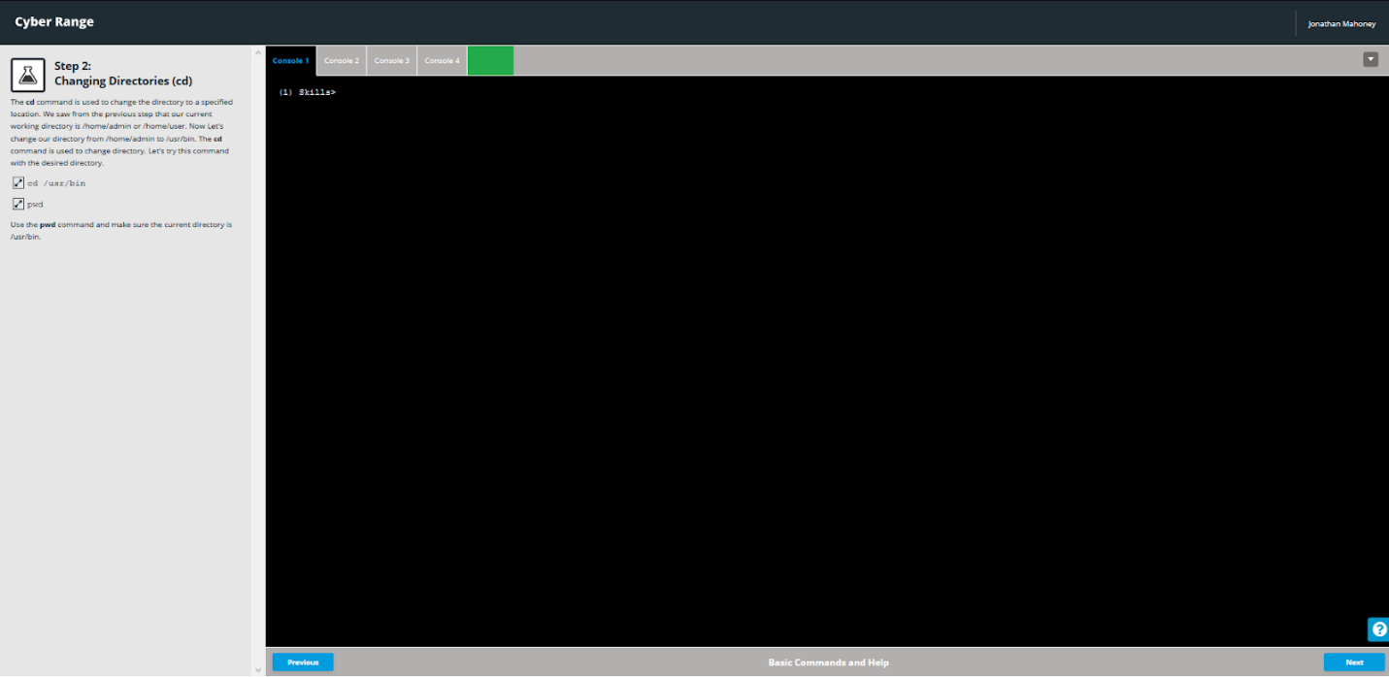

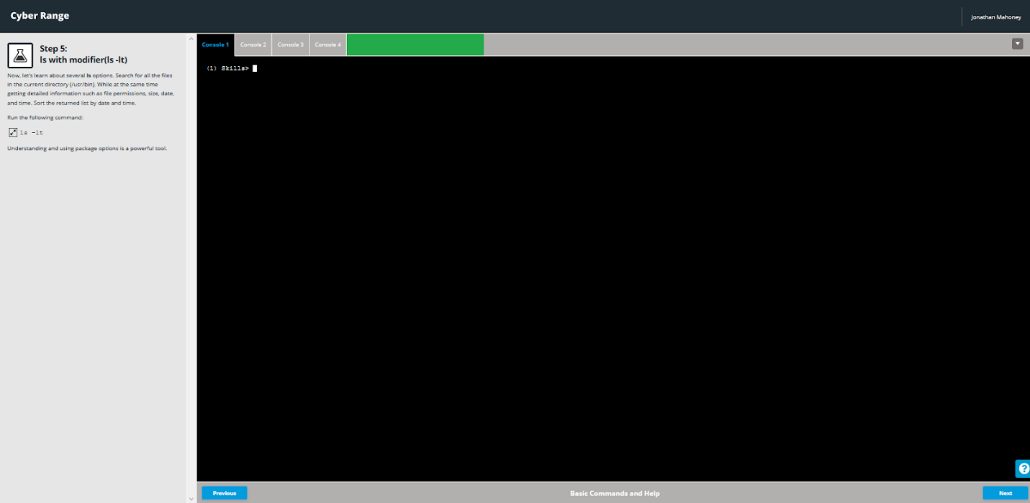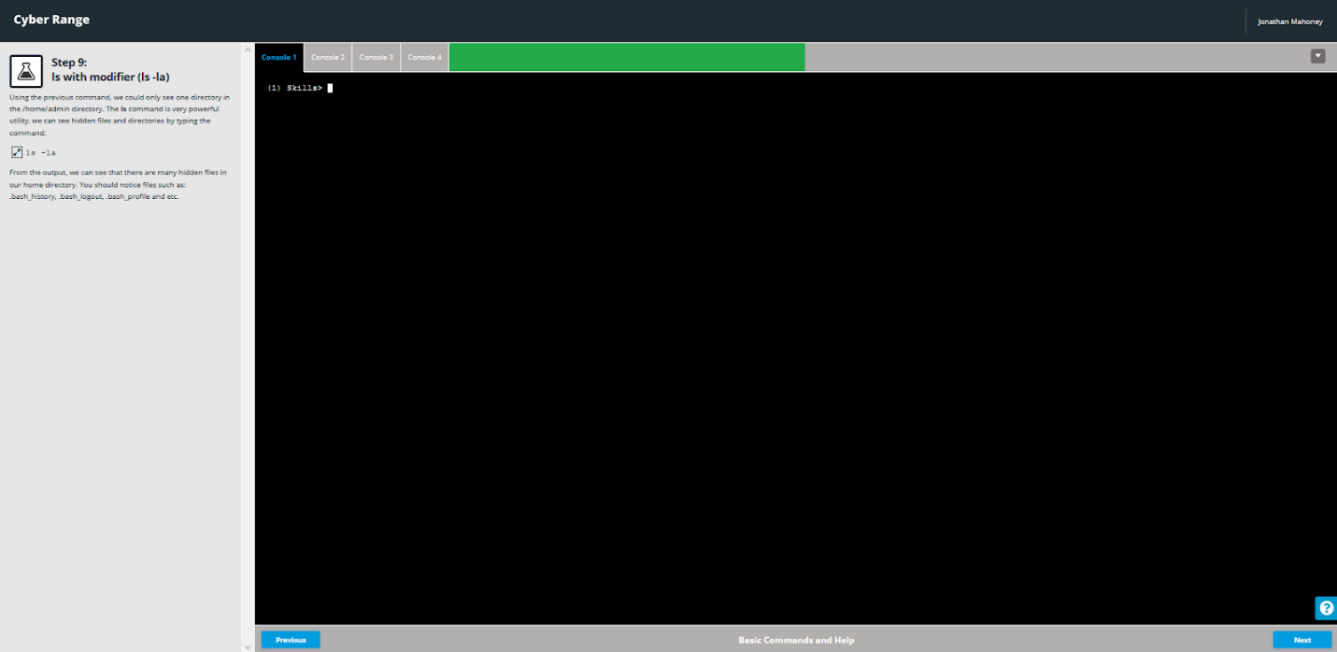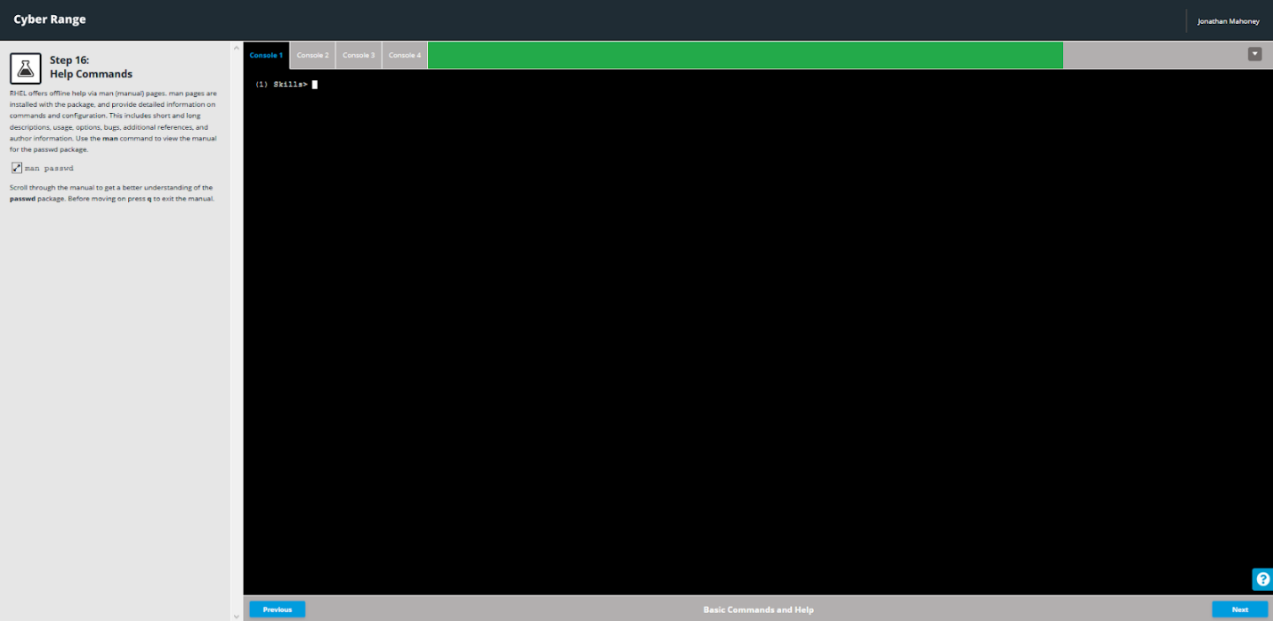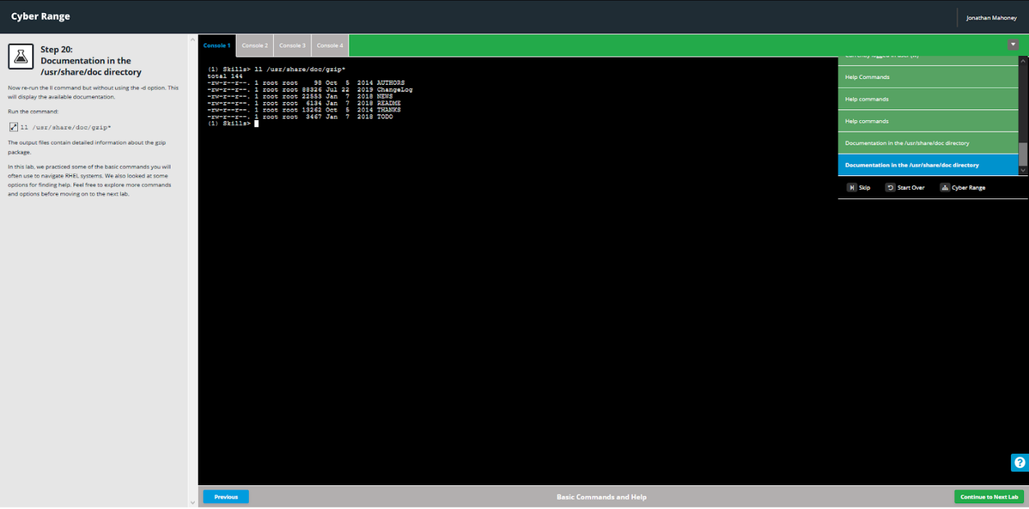

## Login History and Information

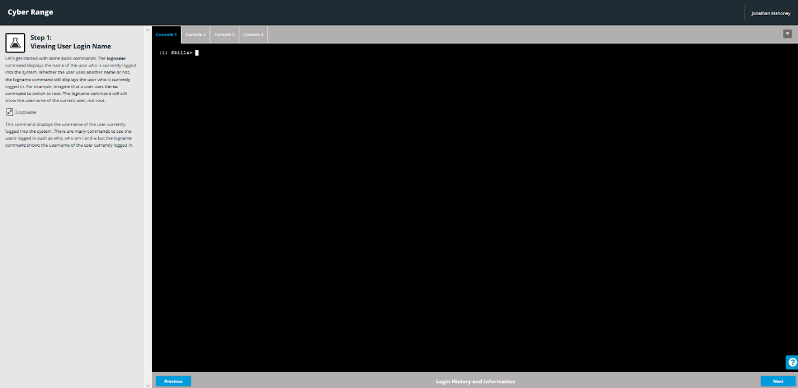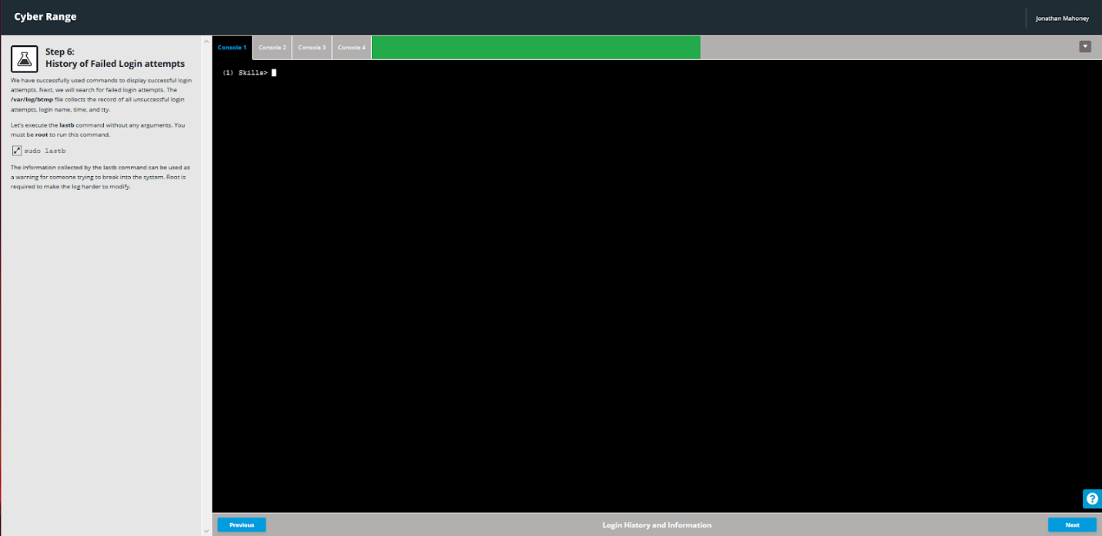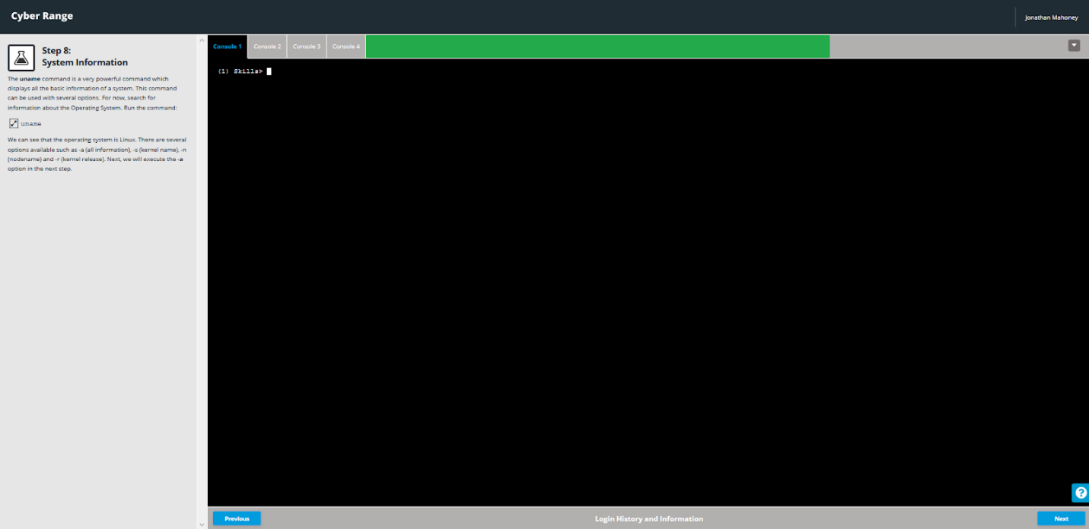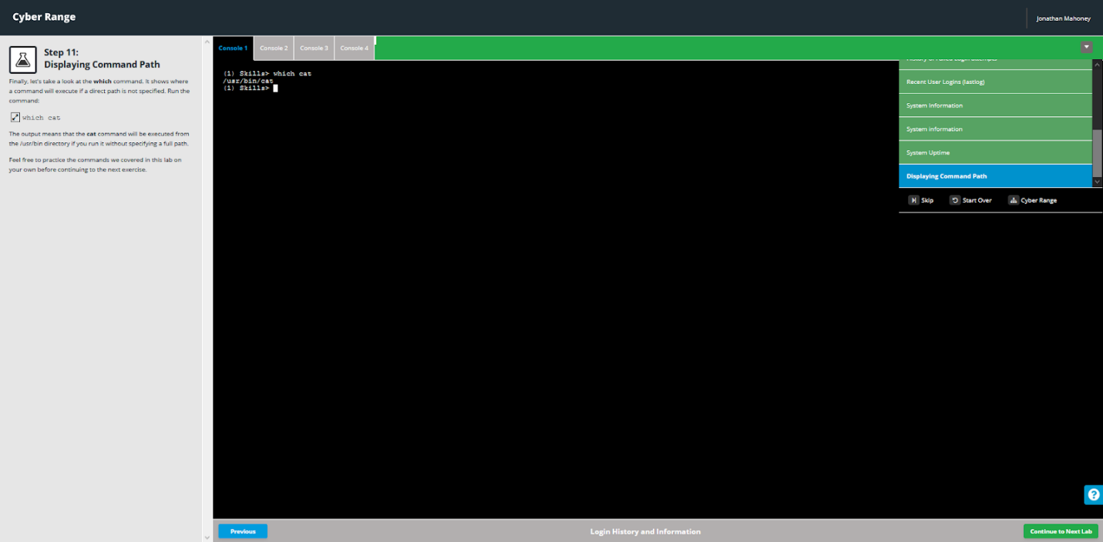

## Using vi

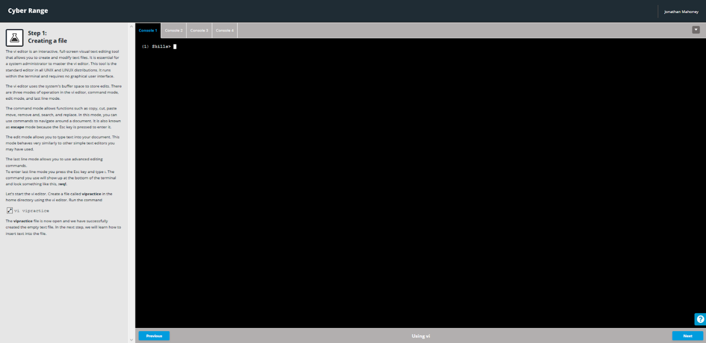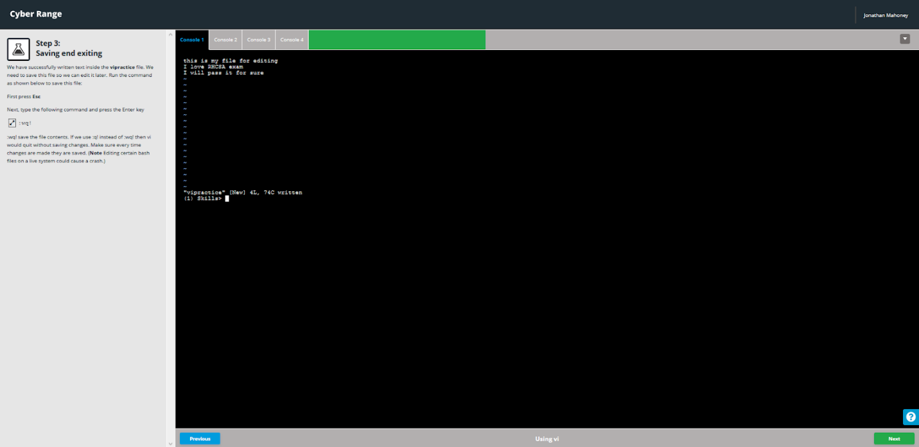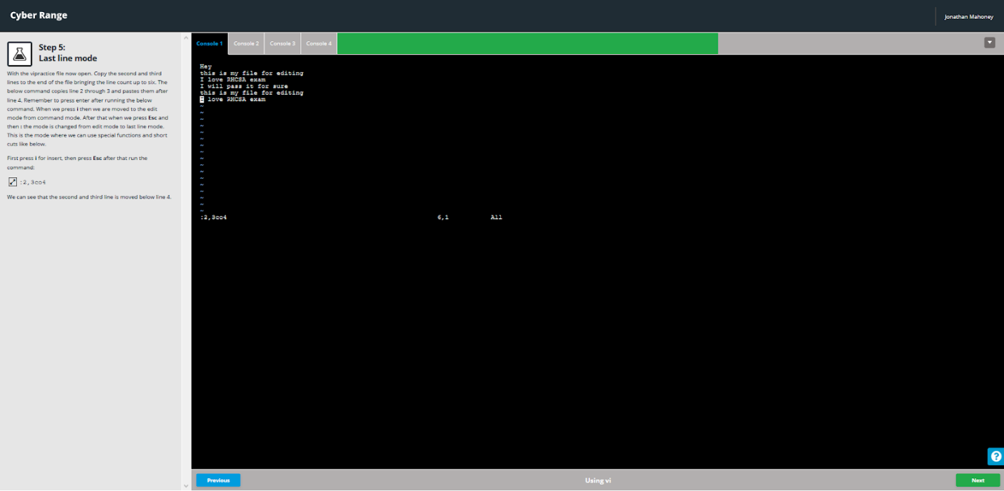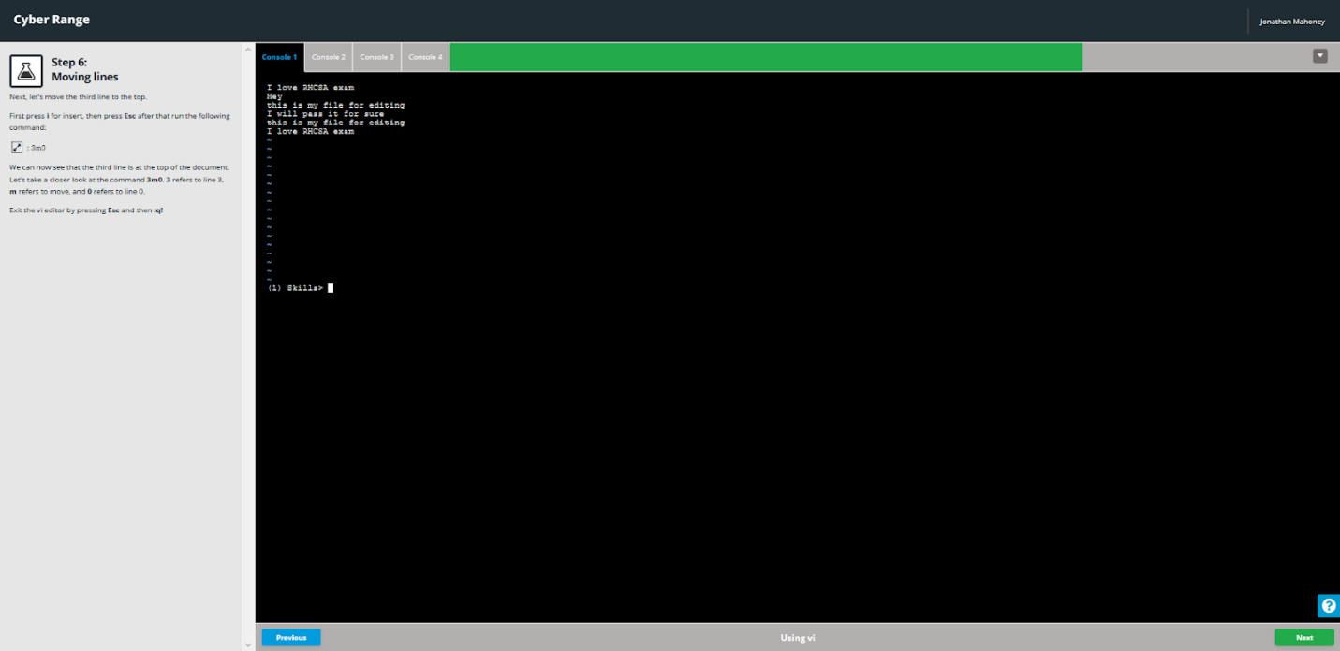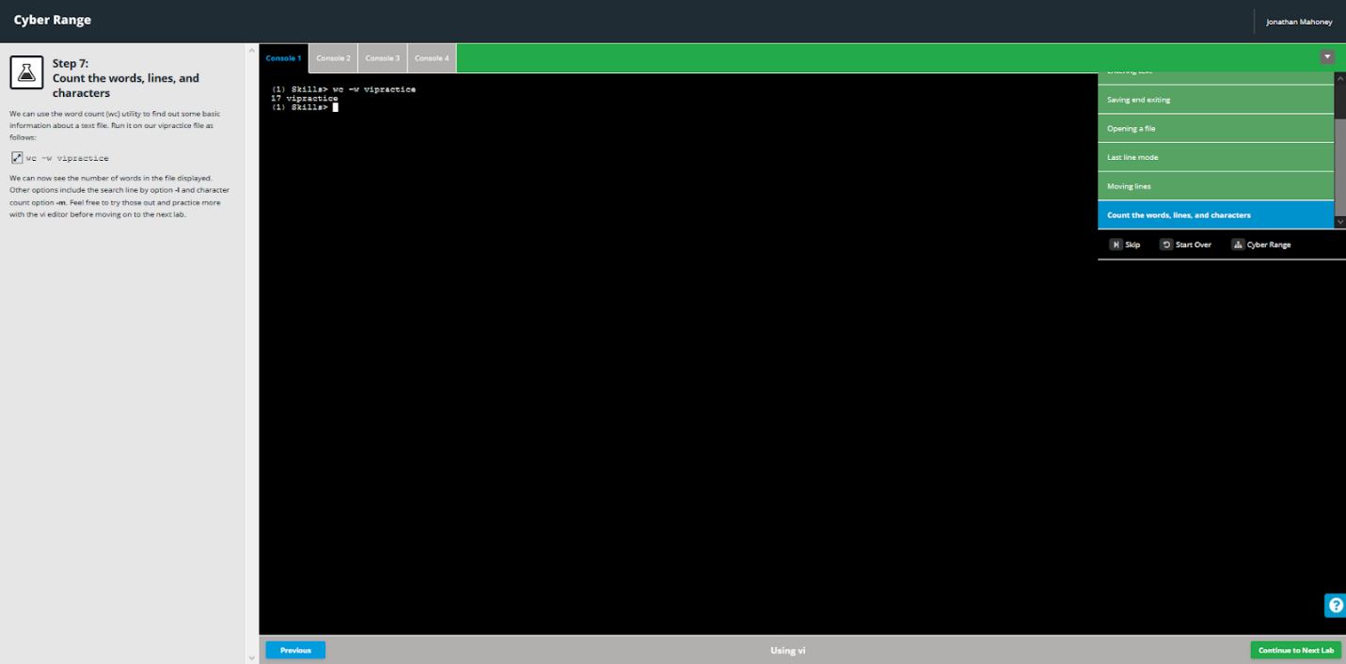

## Finding and Linking Files

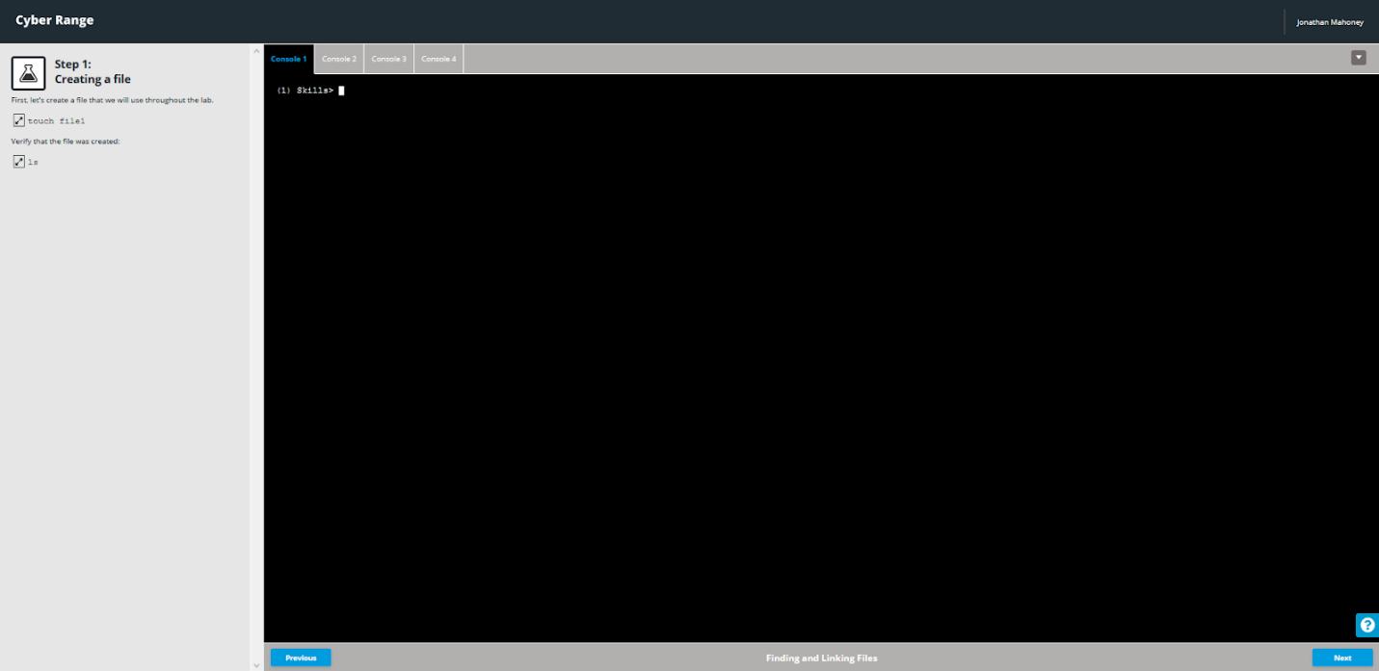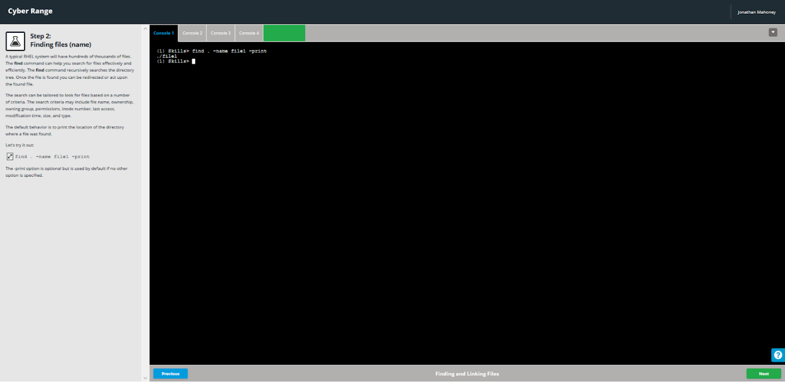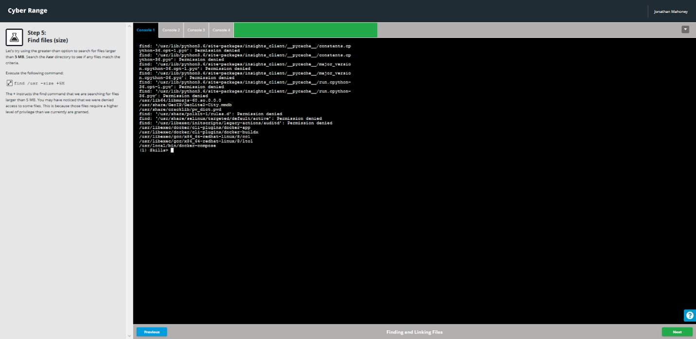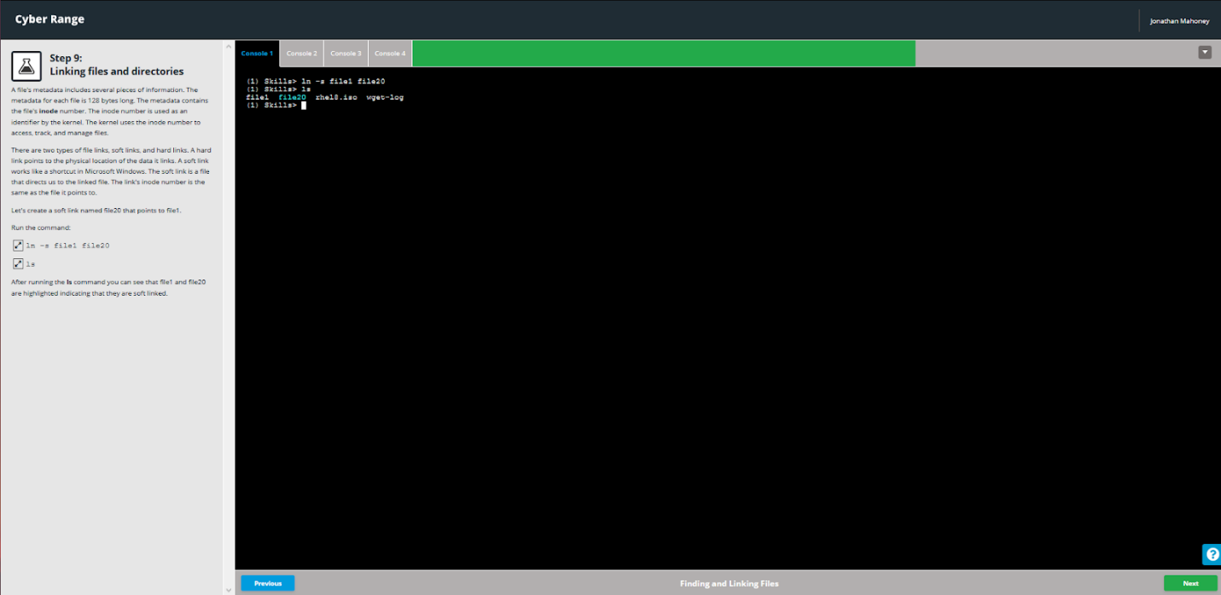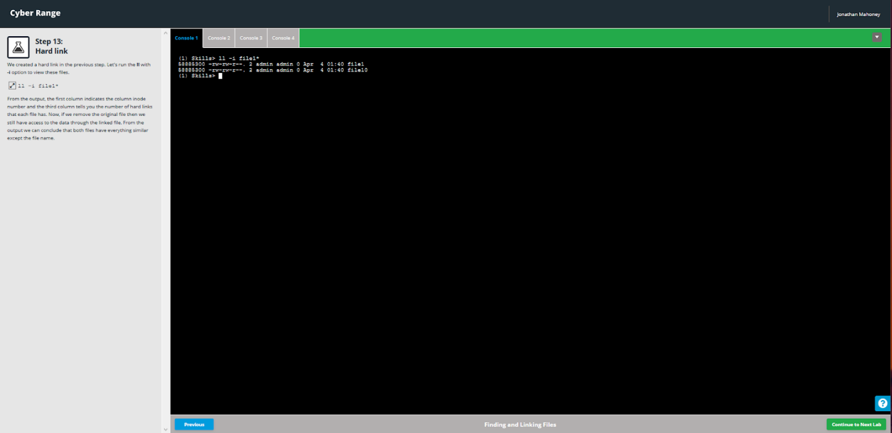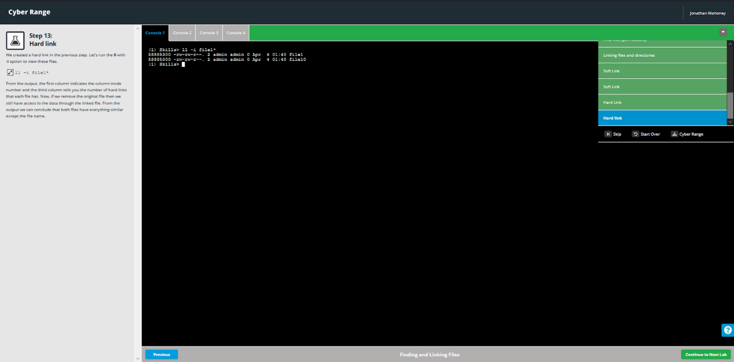

## File and Directory Operations

