Appliances Energy Prediction:
Nonlinear Regression with Ensemble Methods
Machine Learning – Final Project
[Your Name]

1. Introduction
This project develops a supervised machine-learning pipeline to predict the energy consumed by the appliances of a low-energy house. The target variable, Appliances, is measured in Wh every 10 minutes. The predictors are temperature and humidity sensors placed in different rooms, outdoor weather measurements (temperature, humidity, pressure, wind speed, visibility and dew point) and time information extracted from the timestamp.
The dataset comes from the UCI Machine Learning Repository (Candanedo et al., 2017) and contains 19,735 observations and 29 columns recorded over about 4.5 months in Belgium. The target is strongly right-skewed: the median consumption is 60 Wh, but it can reach 1080 Wh during short peaks.
Energy consumption in a house is mostly driven by human activity (when people are at home and use the appliances) and by comfort needs (heating or cooling). These effects are not linear: they involve thresholds (energy jumps when the house is occupied) and they depend on the time of day. For this reason a simple linear model is expected to underfit, while nonlinear and ensemble models should perform better. The goal of this project is to verify this by comparing a linear baseline with two nonlinear models and one ensemble model.

2. Methods

2.1 Exploratory Data Analysis
The dataset has no missing values, so no imputation was necessary. The histogram of the target (Figure 1) confirms the strong right skew. The correlation analysis shows that all features have a weak linear correlation with the target (all below 0.20 in absolute value, the strongest being lights with about 0.20). This already suggests that a linear model will struggle. On the other hand, the average consumption by hour of the day (Figure 2) shows a clear nonlinear daily pattern, with low consumption at night and a large peak in the evening — a typical occupancy effect.
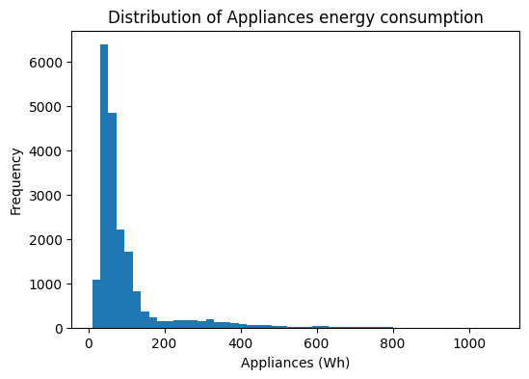
Figure 1. Distribution of the target (Appliances), strongly right-skewed.
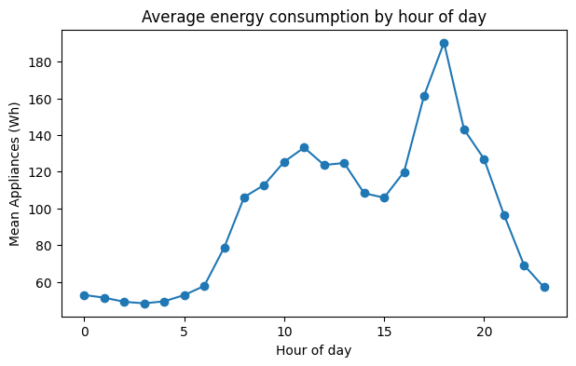
Figure 2. Average energy consumption by hour of day (nonlinear daily pattern).

2.2 Preprocessing
The columns rv1 and rv2 are random variables with no physical meaning and almost zero correlation with the target, so they were removed. The target has many high values, but I decided to keep these outliers (about 11% of the rows are above the IQR upper limit) because they represent real high-consumption events, not measurement errors, and they are exactly the cases the model should learn. From the date column I created four time features: hour, day of week, a weekend flag and month. This left 29 predictors.
Feature scaling was applied only to the models that need it. Linear and Polynomial Regression are sensitive to the scale of the features, so they were standardised with StandardScaler inside a Pipeline (fitted only on the training data to avoid leakage). The tree-based models split on thresholds and are scale-invariant, so they were left unscaled.

2.3 Models and Hyperparameter Tuning
The data was split into 80% training and 20% test with a fixed random seed. Four models were trained: Linear Regression (baseline), Polynomial Regression of degree 2 with Ridge regularisation, a Decision Tree, and a Random Forest (ensemble). For each model with hyperparameters I used GridSearchCV with 5-fold cross-validation and a small grid of 3–5 configurations (for example, tree depth from 5 to 20, and the Ridge penalty alpha from 1 to 100). Cross-validation gives a more stable estimate than a single split and makes the comparison between models fair.

3. Results
Table 1 reports the MAE, RMSE and R² of every model on the test set, together with the training R² to check overfitting.
Model | MAE (Wh) | RMSE (Wh) | R² test | R² train
Random Forest | 31.9 | 67.3 | 0.547 | 0.873
Decision Tree | 38.8 | 81.4 | 0.337 | 0.633
Polynomial (deg 2) | 48.6 | 82.7 | 0.317 | 0.368
Linear Regression | 52.6 | 91.1 | 0.171 | 0.169
Table 1. Test-set performance of all models (sorted by R²).
The Random Forest is clearly the best model, with a test R² of 0.55 and the lowest errors (RMSE 67 Wh, MAE 32 Wh). The Decision Tree and Polynomial models are in the middle (R² around 0.32–0.34), and the Linear Regression is the worst (R² 0.17). This ordering matches the expectation from the EDA: the more flexible nonlinear models capture the data much better than the linear baseline.
The training and test scores also show the typical overfitting/underfitting behaviour. The Linear model has a low R² on both train and test (about 0.17), which means it underfits. The Random Forest has a much higher training R² (0.87) than test R² (0.55), so it overfits the training data, but thanks to the averaging of many trees it still generalises best.
Figure 3 shows the predicted-vs-actual values and the residuals of the Random Forest. The predictions follow the diagonal well for low and medium consumption, but for high values the model predicts too low and the residuals grow. This heteroscedasticity is expected from the skewed target: the rare high peaks are the hardest to predict.
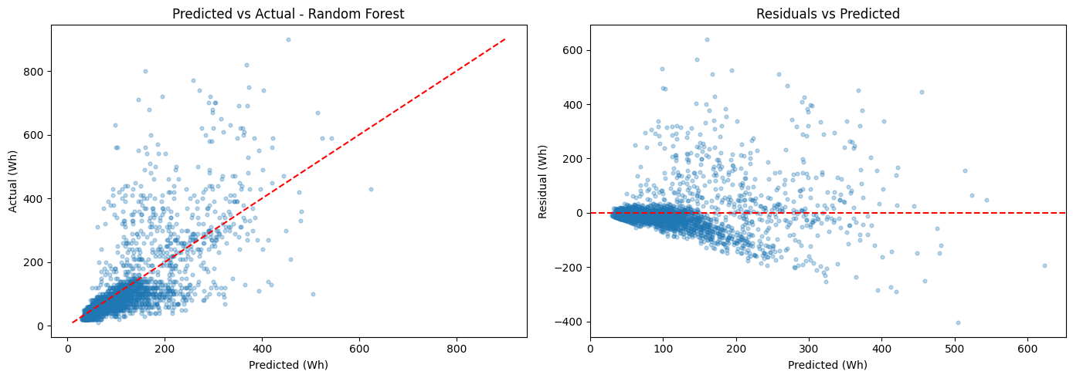
Figure 3. Predicted vs actual (left) and residuals vs predicted (right) for the Random Forest.

4. Discussion
Feature importance. Figure 4 shows the feature importances of the Random Forest. The most important variable by far is the hour of the day, followed by several indoor temperature and humidity sensors. This is consistent with domain knowledge: appliance use depends mostly on when people are active in the house and on the indoor conditions. Interestingly, lights had the strongest linear correlation with the target (about 0.2) but only a moderate importance in the random forest, because the hour feature already captures most of the time-of-day signal.
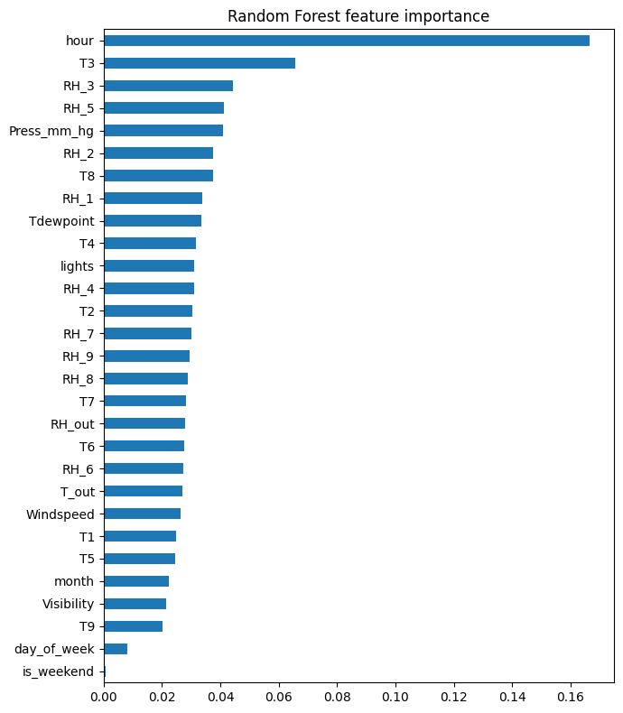
Figure 4. Random Forest feature importance.
Why nonlinear beats linear. The key result is that the Random Forest almost tripled the R² of the linear baseline (0.55 vs 0.17). Because no single feature has a strong linear correlation with the target, the useful information is in the interactions and thresholds between features (for example, energy is high only when it is evening and the house is occupied). Linear regression cannot represent this, while the trees and the ensemble can, which is why they perform much better.
Error analysis. The largest errors of the best model happen at high actual consumption, where the model under-predicts the peaks. With no information about the number of people in the house, these short bursts are partly unpredictable from the available sensors.
Limitations. The data is really a time series (one measurement every 10 minutes), but it was treated as a normal regression problem with a random split, so the temporal structure is not fully used. There is also no occupancy information, which is probably the main cause of the energy peaks. Finally, the data comes from a single house during about 4.5 months, so the model may not generalise to other houses or seasons.
Future work. The most promising improvement would be to add lag features (the consumption 10 minutes or 1 hour before) together with a time-based split, which usually helps a lot in time-series problems. Other options are gradient boosting, or a recurrent neural network (LSTM) to model the sequence directly, and using real occupancy data.

5. References
- Candanedo, L. M., Feldmann, A., & Degemmis, D. (2017). Data driven prediction models of energy use of appliances in a low-energy house. Energy and Buildings, 145, 13–25.
- UCI Machine Learning Repository — Appliances Energy Prediction (dataset 374).
- Scikit-learn documentation, https://scikit-learn.org.

AI Usage Statement
(Fill this in honestly before submission, as required by the course.)
- Did you use any generative AI tools? [Yes / No]
- If yes, for what purpose and how were they used: [...]

