Project : Predictive Maintenance for Machines

Data: Machine Predictive Maintenance Classification

Project Description: Develop a machine learning model to predict potential failures in industrial equipment based on sensor data and operational parameters. This project utilizes a synthetic dataset that mimics real-world predictive maintenance scenarios, focusing on early fault detection to minimize downtime and maintenance costs.

Key Components:

1. Data Exploration and Preprocessing:

a. Analyze the dataset, which includes features like air temperature, process temperature, rotational speed, torque, and tool wear.

b. Handle the class imbalance present in the target variable (812 positive cases out of 10,000 samples).

c. Investigate the relationship between failure types and other features.

2. Feature Engineering:

a. Create relevant features from the 'Date' column to capture temporal patterns.

b. Normalize numerical features and encode categorical variables (Type and Failure Type).

3. Model Development:

a. Implement and compare various classification algorithms, including Random Forest, Gradient Boosting, and Support Vector Machines.

b. Use techniques like SMOTE or class weighting to address the imbalanced nature of the dataset.

c. Perform hyperparameter tuning using cross-validation to optimize model performance.

4. Time-based Analysis:

a. Explore time series aspects of the data, particularly focusing on how tool wear and other parameters change over time.

b. Implement sliding window techniques to capture temporal dependencies in the data.

5. Anomaly Detection:

a. Develop anomaly detection models to identify unusual patterns in sensor readings that may indicate impending failures.

b. Compare traditional anomaly detection methods with machine learning-based approaches.

6. Model Evaluation:

a. Assess model performance using metrics suitable for imbalanced datasets, such as precision, recall, F1-score, and ROC-AUC.

b. Analyze feature importance to understand which factors contribute most to failure predictions.

7. Interpretability and Visualization:

a. Create a dashboard using tools like Plotly or Streamlit to visualize:

b. Predicted failure probabilities for each machine

c. Historical trends of key parameters

d. Feature importance and their impact on failure prediction

e. Implement model interpretability techniques (e.g., SHAP values) to explain individual predictions.

8. Deployment Strategy:

a. Design an API that could integrate the predictive model into an existing industrial monitoring system.

b. Outline a plan for continuous model monitoring and retraining to adapt to changing machine conditions over time.

This project will demonstrate your ability to handle imbalanced datasets, develop predictive models for industrial applications, and create actionable insights from machine learning predictions. It showcases skills in data preprocessing, advanced classification techniques, time series analysis, and data visualization, all crucial for a data scientist in the manufacturing and maintenance sectors.

I am a Researcher student who need to do a project in Machine Learning. The attached files are the portfolio project.pdf is the document where my project to be completed is there. Project2 has to be completed. Analyse the document and guide me to the project step by step. Another attached file is the predictive_maintanance.csv is the data set I ama using here for my project. kindly analyse both files and generate the code step by step and give me the explanation for the same step by step so that I can document the same.

**Step 1: Understand the Dataset**

The dataset includes features such as:

* **Air temperature**
* **Process temperature**
* **Rotational speed**
* **Torque**
* **Tool wear**
* **Failure type** (target variable).

We'll analyze it for:

* Data distribution.
* Correlations between features and failure types.
* Missing data and inconsistencies.

**Step 2: Data Exploration**

Load the dataset and:

1. Display basic information (.info() and .describe()).
2. Check for missing values or duplicates.
3. Understand class imbalance for the target variable.

**Step 3: Preprocessing**

1. Handle missing values and duplicates.
2. Encode categorical variables (e.g., failure types).
3. Normalize/scale numerical variables for uniformity.

**Step 4: Exploratory Data Analysis (EDA)**

1. Visualize data distribution using histograms and box plots.
2. Plot correlations using a heatmap.
3. Investigate failure distributions and their relationships with operational features.

**Step 5: Feature Engineering**

1. Create new features, e.g., capturing temporal patterns from timestamps.
2. Derive interaction features if they improve the model.

**Step 6: Handle Imbalanced Classes**

Use techniques such as:

* **Oversampling** (e.g., SMOTE).
* **Class weighting** in models.

**Step 7: Model Development**

1. Experiment with algorithms like Random Forest, Gradient Boosting, and SVM.
2. Implement hyperparameter tuning via GridSearchCV or RandomizedSearchCV.

**Step 8: Model Evaluation**

1. Use metrics such as precision, recall, F1-score, and ROC-AUC to evaluate.
2. Analyze feature importance.

**Step 9: Time-Based Analysis**

1. Conduct time-series analysis for tools' operational metrics.
2. Employ sliding windows for capturing temporal dependencies.

**Step 10: Visualization and Deployment**

1. Create visualizations for EDA insights and predictions.
2. Design a dashboard or API for real-time predictions.

Let’s start with **data loading and exploration**. I’ll write and explain the Python code to load and explore the dataset.

**Data Exploration Summary**

1. **Dataset Overview**:
   * The dataset has **10,000 entries** and **10 columns**.
   * Columns include numerical (e.g., Air temperature [K], Torque [Nm]), categorical (e.g., Type, Failure Type), and identifier variables (e.g., UDI, Product ID).
2. **Key Findings**:
   * No missing values in any column.
   * No duplicates detected.
   * Target variable (Target) is binary:
     + Value 1: Machine failure.
     + Value 0: No failure.
   * The Failure Type has six categories but is highly imbalanced, with "No Failure" being the most frequent.
3. **Summary Statistics**:
   * Air temperature ranges from **295.3 K** to **304.5 K**.
   * Process temperature ranges from **305.7 K** to **313.8 K**.
   * Rotational speed ranges from **1168 rpm** to **2886 rpm**.
   * Torque ranges from **3.8 Nm** to **76.6 Nm**.
   * Tool wear ranges from **0 min** to **253 min**.

**Next Steps: Preprocessing**

**Key Tasks**

1. **Handle Categorical Variables**:
   * Encode Type and Failure Type for machine learning.
2. **Normalize Numerical Variables**:
   * Scale features such as temperatures, speed, torque, and tool wear.
3. **Address Class Imbalance**:
   * Analyze and prepare techniques to balance classes.

Let’s preprocess the dataset by encoding categorical variables and normalizing numerical ones. ​​

**Preprocessing Summary**

1. **Encoding**:
   * Type and Failure Type were label-encoded into numeric values.
     + Example: Type → Type_encoded, Failure Type → Failure_Type_encoded.
2. **Normalization**:
   * Numerical features (Air temperature [K], Process temperature [K], Rotational speed [rpm], Torque [Nm], Tool wear [min]) were scaled to a range of [0, 1] using Min-Max Scaler.
3. **Target Distribution**:
   * **9661 samples** belong to the "No Failure" class.
   * **339 samples** represent "Failure" cases.
   * The dataset exhibits significant class imbalance.

**Next Steps: Exploratory Data Analysis (EDA)**

We'll:

1. Visualize the distribution of numerical features.
2. Investigate relationships between features and the target variable.
3. Explore the imbalance in the target variable.

Let’s start with some visualizations. ​​

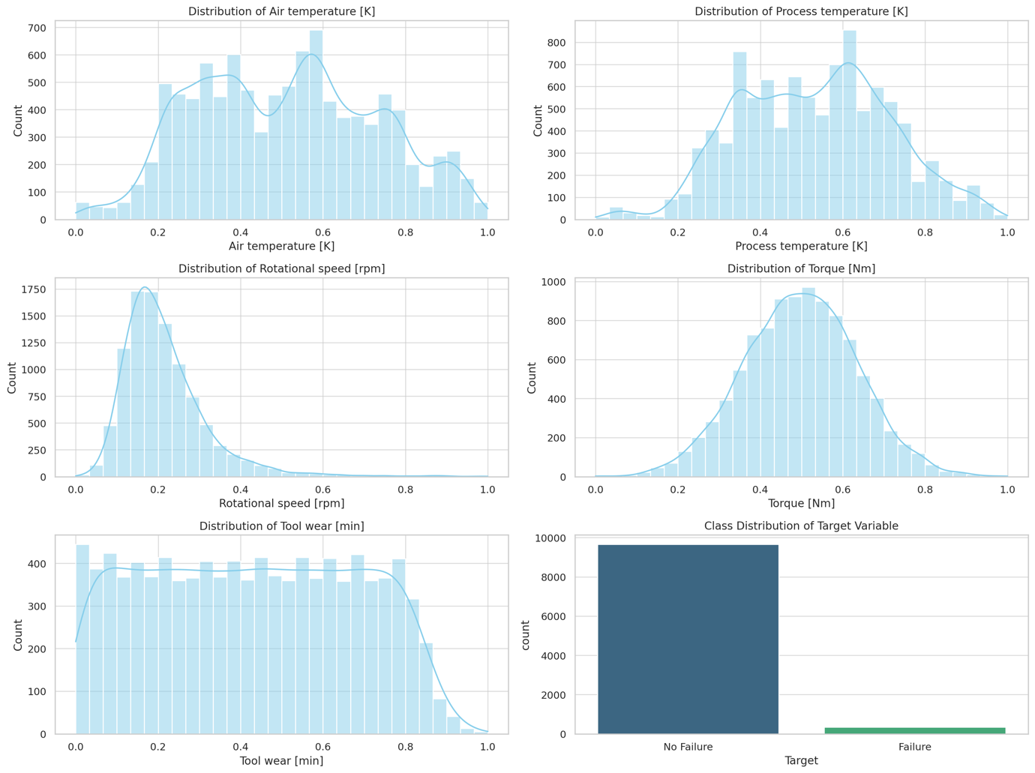

**Exploratory Data Analysis (EDA) Insights**

1. **Numerical Features**:
   * Most features, after normalization, show varied distributions:
     + Air temperature and Process temperature have tighter ranges.
     + Rotational speed and Torque exhibit broader distributions.
     + Tool wear appears more uniform, with notable peaks near the edges.
2. **Target Class Distribution**:
   * Imbalanced dataset:
     + "No Failure" cases dominate the data (~96.6% of samples).
     + "Failure" cases are rare (~3.4% of samples).

**Next Steps**

1. **Correlations**:
   * Use a heatmap to identify correlations between features.
2. **Feature-Target Relationships**:
   * Explore the relationship of each feature with the Target variable.
3. **Class Imbalance Handling**:
   * Discuss oversampling or other techniques to manage imbalance.

Let’s calculate and visualize correlations first. ​​

It seems like I can’t do more advanced data analysis right now. Please try again later. However, I can guide you on how to compute and visualize the correlation matrix on your end.

Here’s how you can do it in Python:

python

Copy code

# Compute correlation matrix

correlation_matrix = data[numerical_features + ['Target']].corr()

# Plot the heatmap

import matplotlib.pyplot as plt

import seaborn as sns

plt.figure(figsize=(10, 8))

sns.heatmap(correlation_matrix, annot=True, cmap="coolwarm", fmt=".2f")

plt.title("Correlation Matrix of Numerical Features and Target")

plt.show()

This code will display a heatmap showing the relationships between numerical features and the target variable. Strong correlations (positive or negative) can help in selecting features for the predictive model. Let me know if you’d like more guidance!