Building an Epigenetic Classifier for Breast Cancer from DNA Methylation Data
Juman Abu Rmeleh || | Github repository

Abstract
DNA methylation is a chemical mark carried by the DNA molecule, and it is known to be altered in cancer. This project uses TCGA breast cancer data (Illumina 450K array) to classify 721 tumor and 97 healthy biopsies based on DNA methylation. After filtering the raw beta values, I ran a Welch t-test and found 41,639 significantly altered CpG sites. I trained logistic regression, random forest, and k-nearest neighbors models using 5-fold cross-validation, selecting the top 500 features inside each fold to avoid data leakage. Logistic regression performed best, hitting a 0.970 balanced accuracy and 0.9995 ROC AUC.

Introduction

DNA methylation is a chemical tag on the DNA molecule. In humans, it almost always happens when a C is right next to a G, which is called a CpG site. It acts like a regulatory switch: heavy methylation near the start of a gene usually turns it off. In cancer, this normal pattern gets messed up. Tumors lose methylation across huge chunks of the genome, but randomly gain it at specific promoters to stop cells from controlling their division.

The data comes from the Illumina HumanMethylation450 array in the TCGA BRCA dataset, which gives a beta value between 0 and 1 for about 485,000 sites. This presents a challenging machine learning problem for two reasons, the feature dimension is massive compared to the 818 samples (guaranteed overfitting if we don't reduce features), and the classes are super imbalanced at 88% tumor to 12% healthy.

Results
I joined the two class matrices by their CpG IDs to avoid pairing unrelated sites. After dropping CpGs missing more than 20% of their values and mean-imputing the rest, I had 453,526 features left.
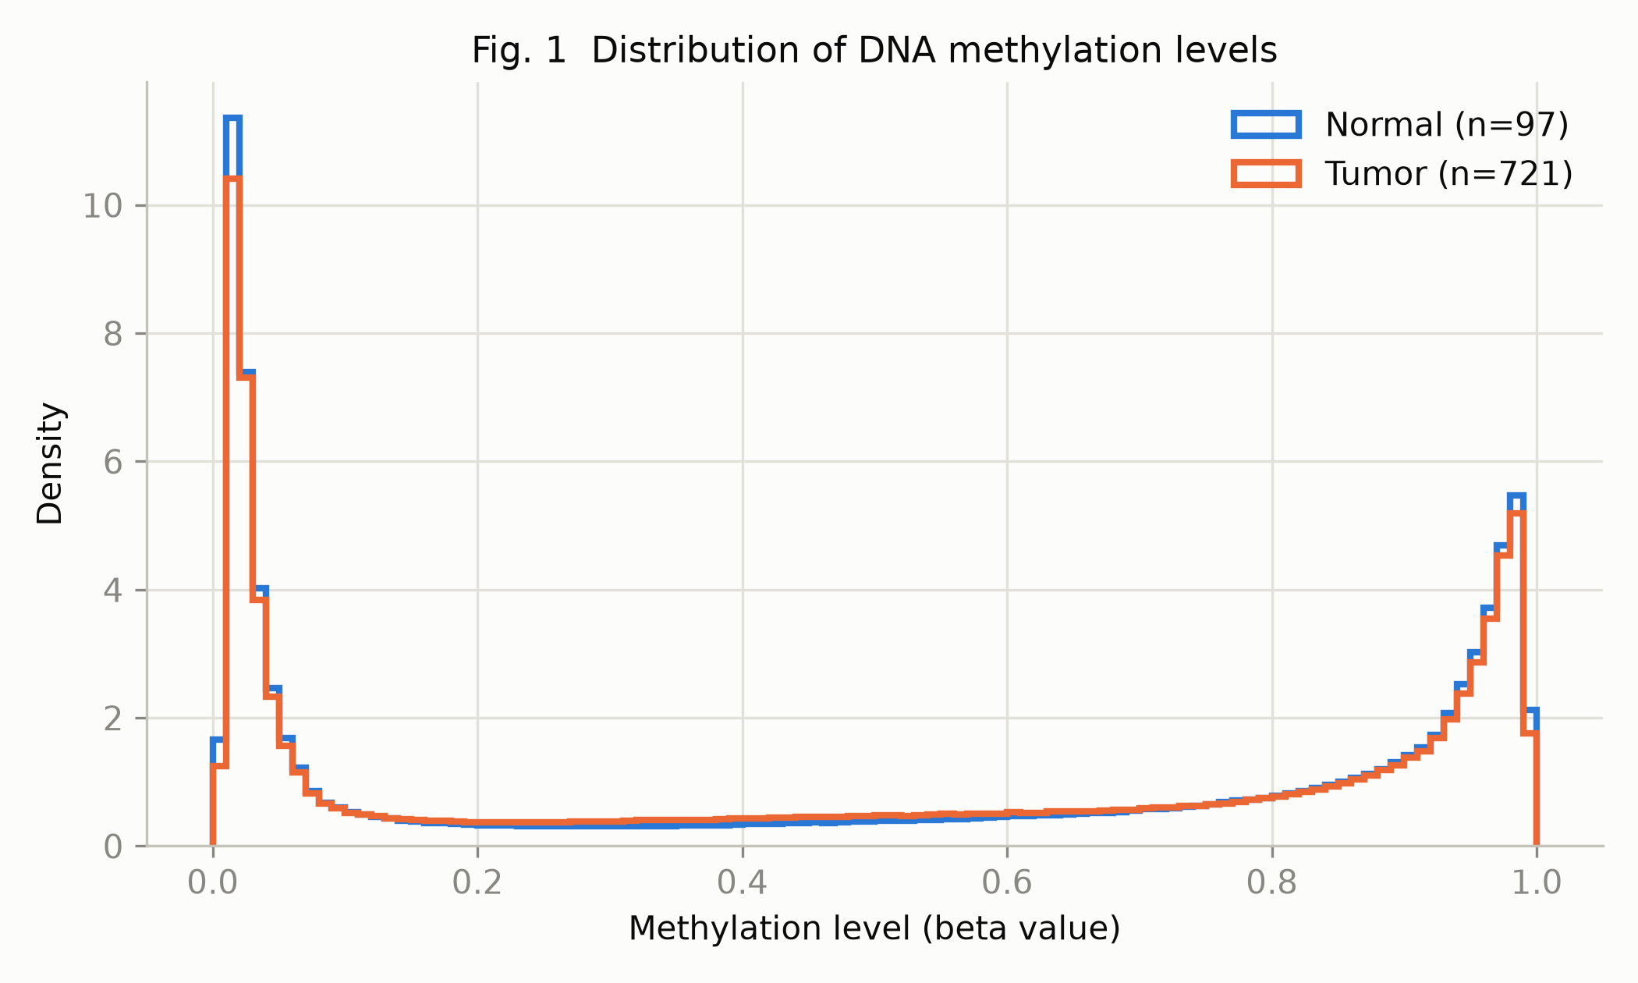
Fig. 1. Distribution of beta values in the two groups, pooled over all CpGs and samples. The peaks near 0 and 1 are the expected shape: most CpG sites are either almost fully unmethylated or almost fully methylated.
Looking at Figure 1, the bimodal shape is a good sanity check to make sure rescaling by 999 worked. The tumors carry slightly more weight in the middle values, which makes sense since a biopsy is a messy mix of cell populations rather than one clean tissue.
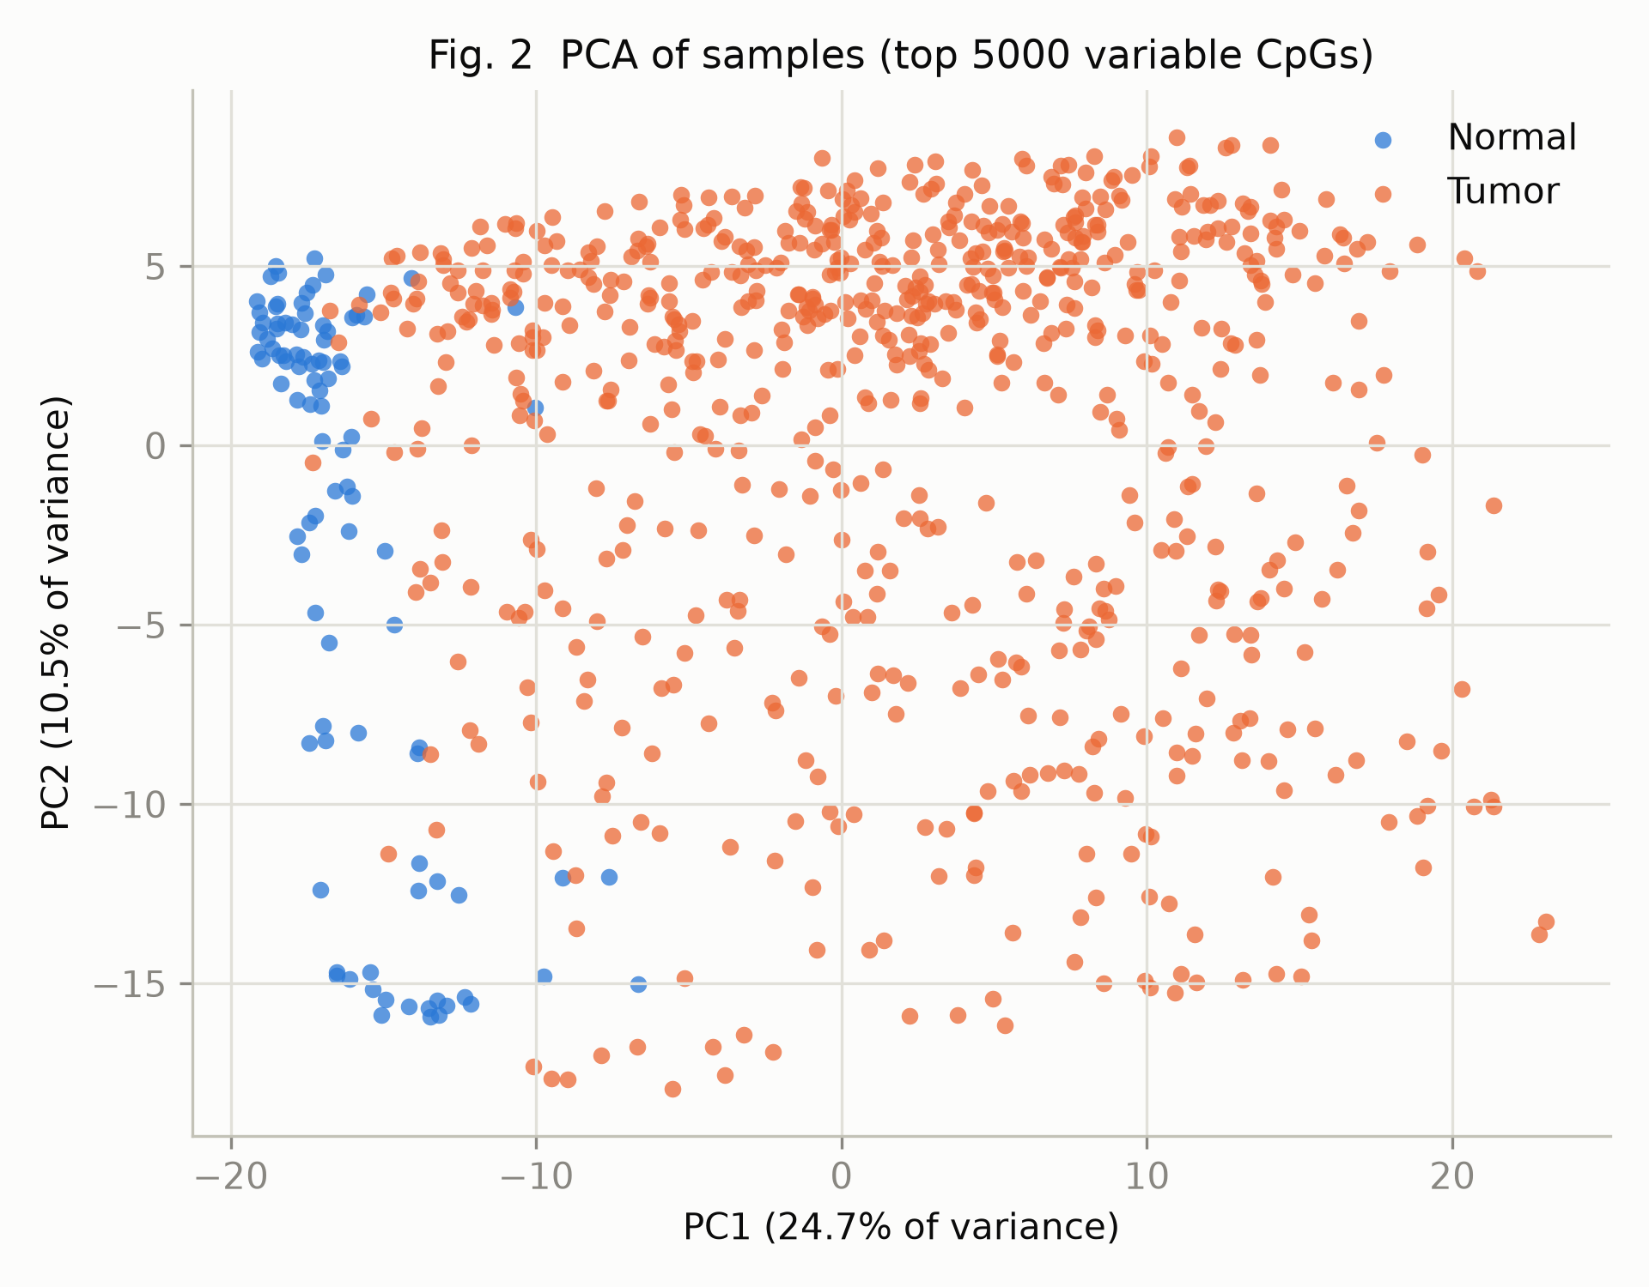
Fig. 2. PCA of the 818 samples using the 5,000 most variable CpGs. Blue = healthy, orange = tumor. PC1 accounts for 24.7% of the variance and PC2 for 10.5%.
Figure 2 shows a quick PCA. Even though it's unsupervised, it grouped the healthy samples on the left side of PC1 and spread the tumors out to the right. This shows the tumor/healthy split is one of the biggest sources of variation. The tumors are way more scattered since breast cancer has lots of molecular subtypes, while healthy tissue is mostly uniform.

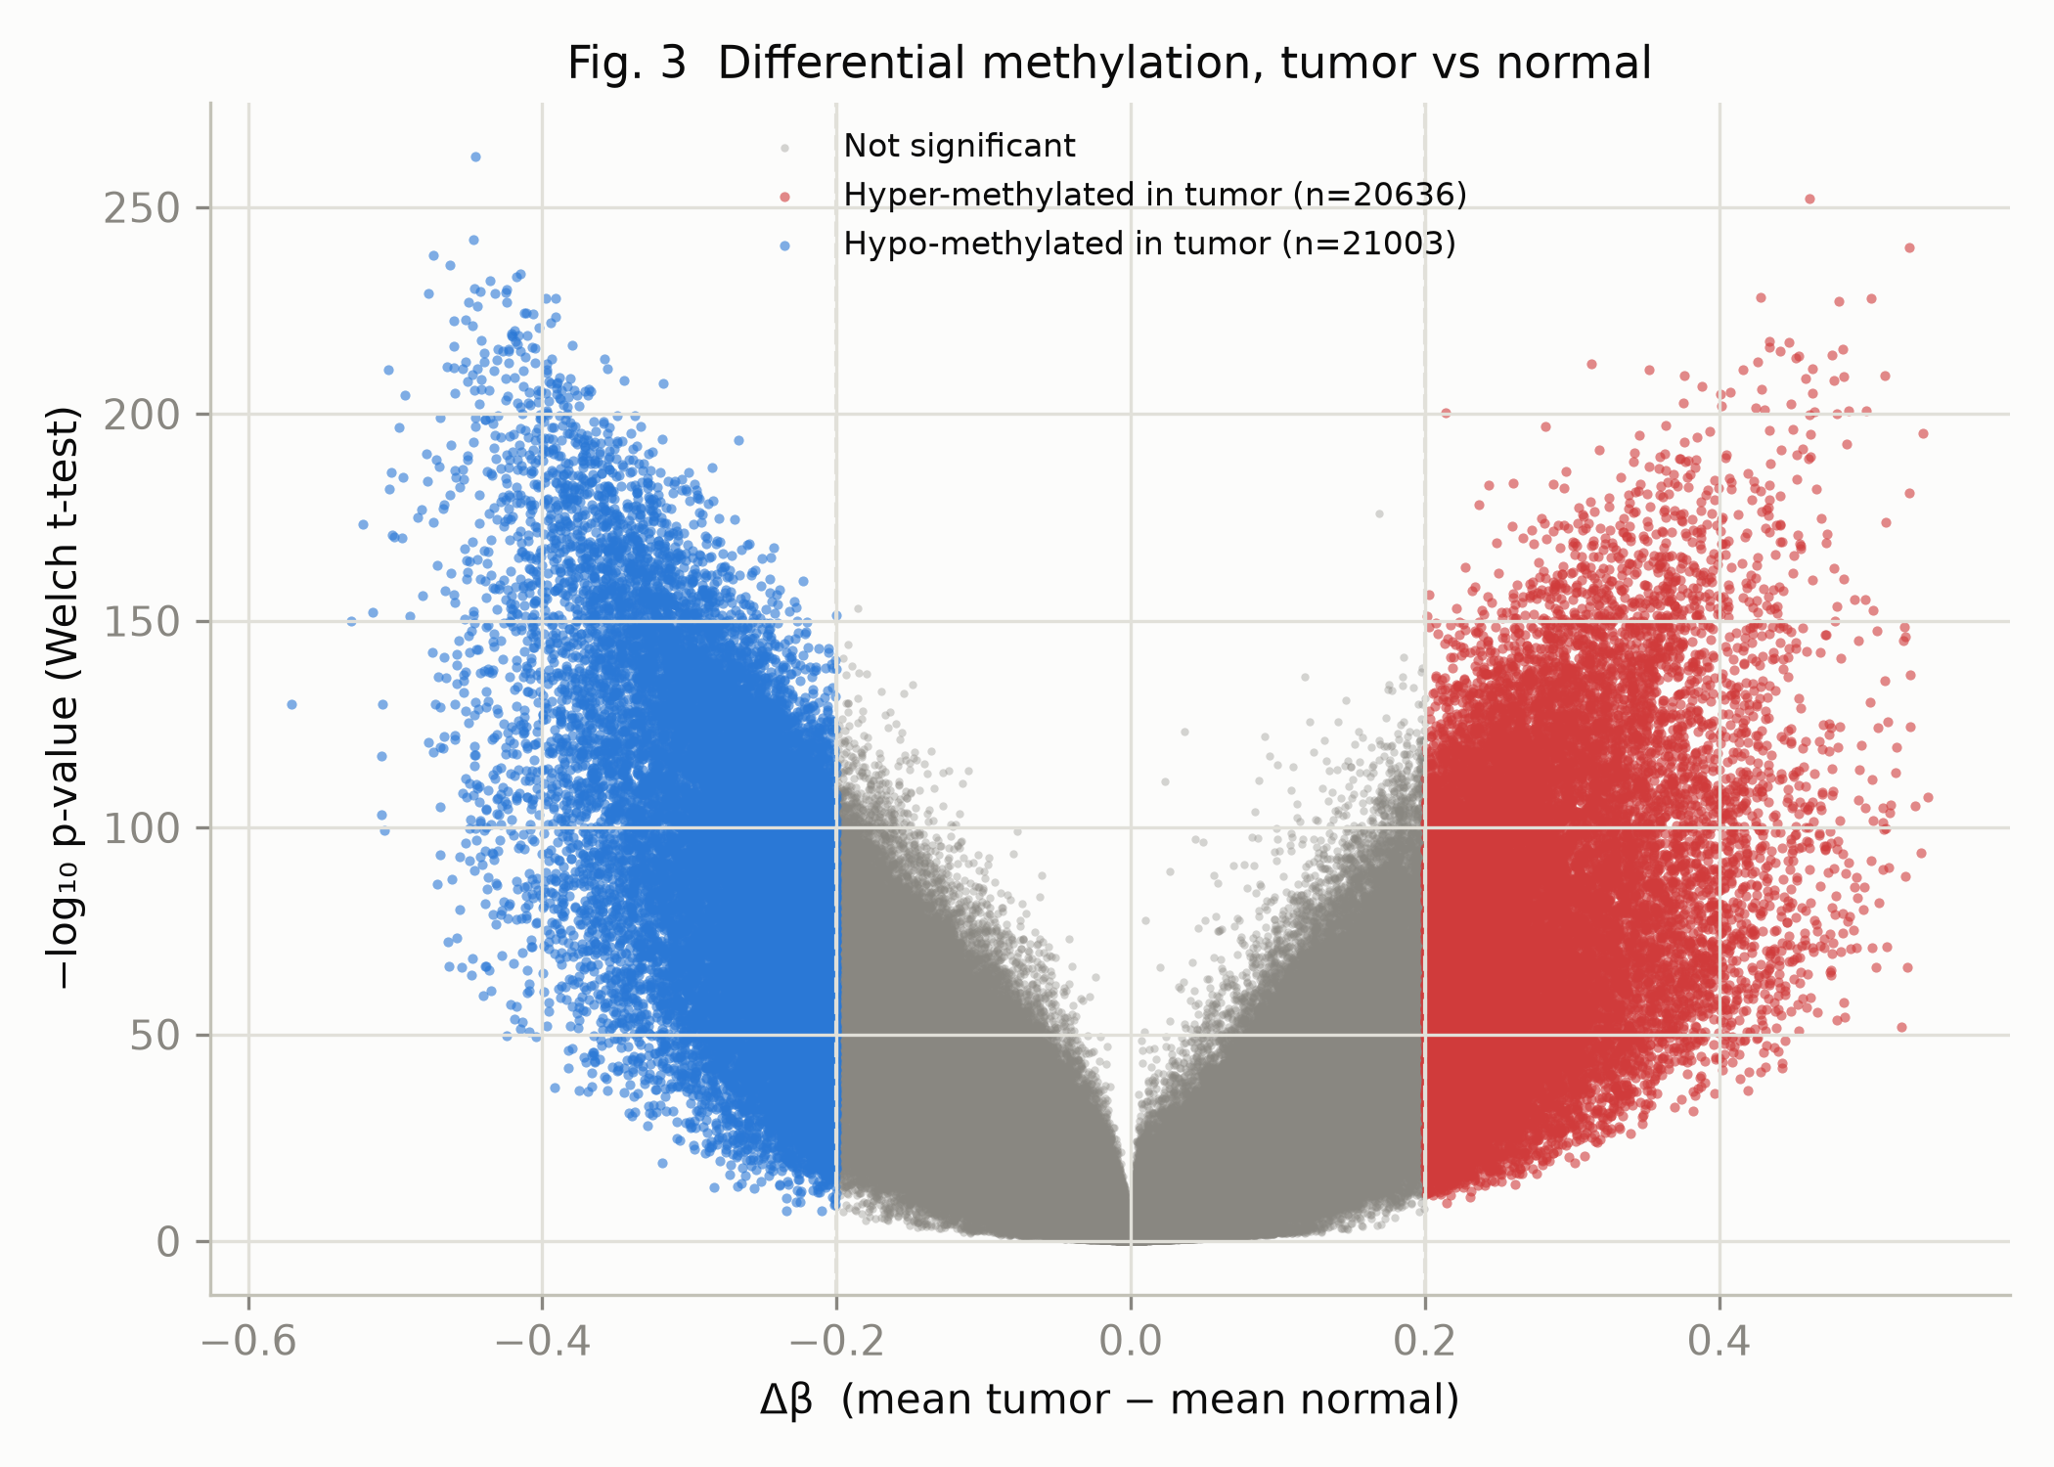
Fig. 3. Volcano plot of the per-CpG comparison. The x-axis is Δβ (mean beta in tumors minus mean beta in healthy samples) and the y-axis is −log₁₀ of the Welch t-test p-value. Red = gain of methylation in tumor, blue = loss, grey = failed at least one threshold.

I ran a Welch t-test with Bonferroni correction on every CpG. 41,639 sites passed (corrected p < 0.05 and |Δβ| > 0.2). It was a near-symmetric split: 20,636 gained methylation in tumors and 21,003 lost it. In Figure 3, we can see that because of the large sample size of 818, some points have insanely low p-values (like 10⁻²⁶⁰) but still fail the Δβ threshold.
For classification, I compared logistic regression, random forest, and k-NN (k=5). I put a feature selector (keeping the 500 CpGs with the highest ANOVA F score) inside a scikit-learn CV pipeline. Doing this selection inside the pipeline is critical so the model doesn't cheat using the test data.
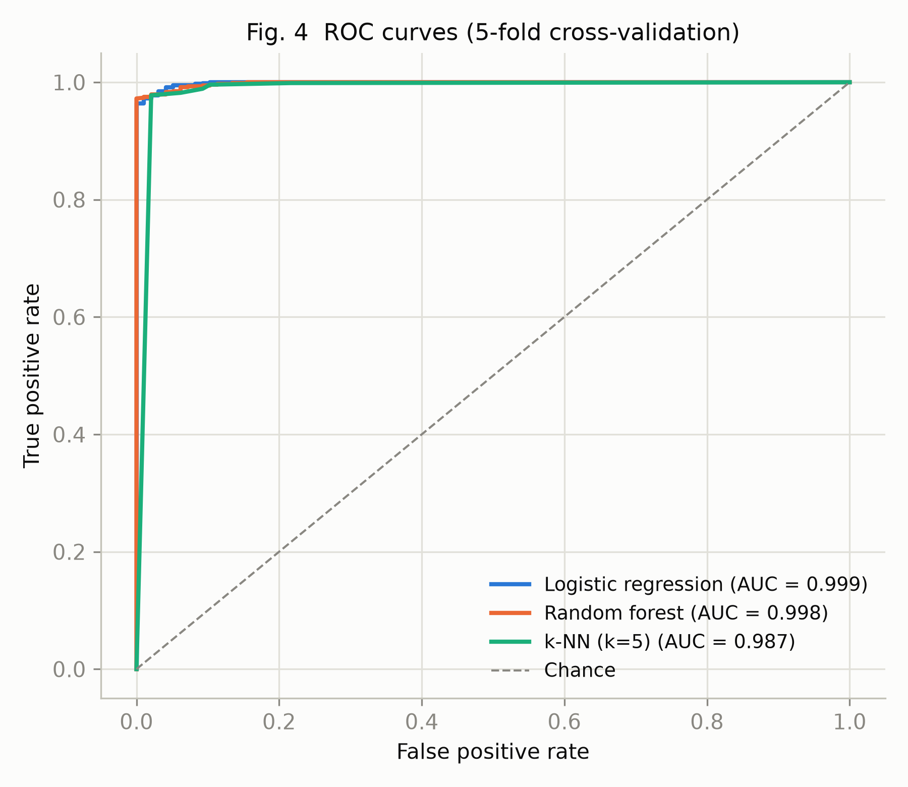
Fig. 4. ROC curves from the 5-fold cross-validation. The dashed diagonal marks a random classifier.

Model | Accuracy | Balanced acc. | Sensitivity | Specificity | ROC AUC
Logistic regression | 0.987 | 0.970 ± 0.021 | 0.992 | 0.949 | 0.9995
Random forest | 0.980 | 0.962 ± 0.018 | 0.986 | 0.938 | 0.9986
k-NN (k = 5) | 0.979 | 0.948 ± 0.018 | 0.989 | 0.907 | 0.9874
Majority-class baseline | 0.881 | 0.500 | 1.000 | 0.000 | 0.500
Table 1. Cross-validated performance of the three classifiers, with the trivial baseline in the last row. Sensitivity is the fraction of tumors classified correctly, specificity the fraction of healthy samples.

Regular accuracy is totally useless here since a dumb classifier that just guesses "tumor" gets 0.881. Balanced accuracy is much better, and logistic regression hits 0.970.
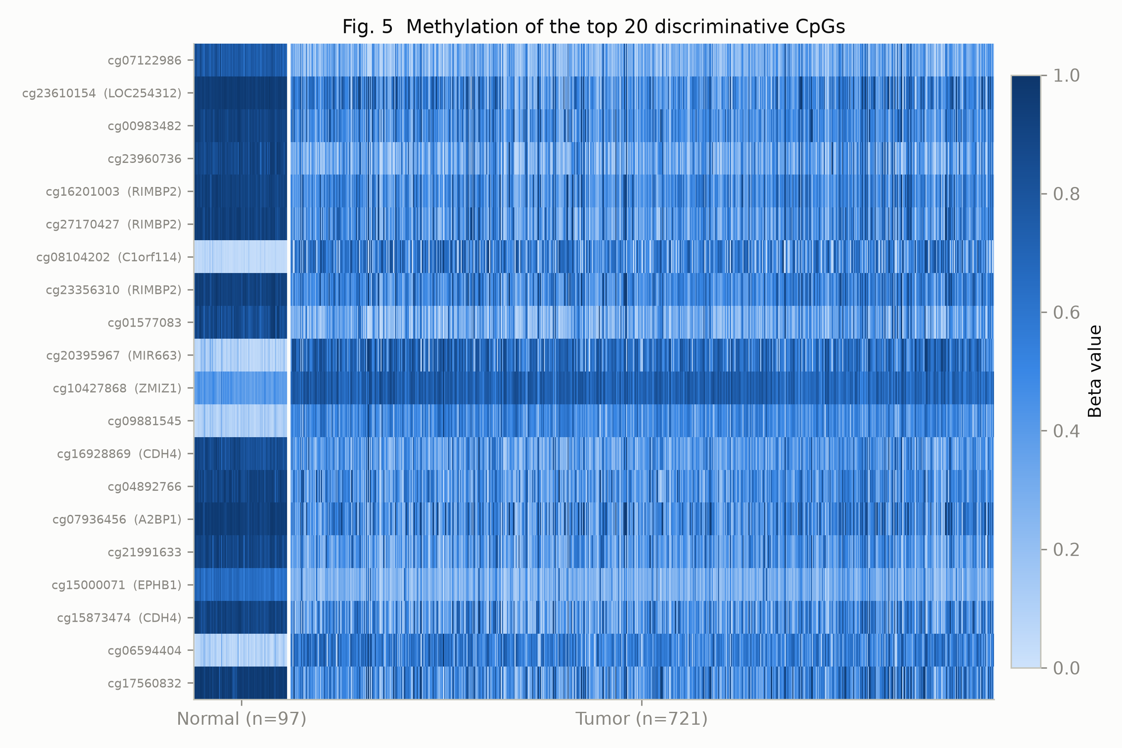
Fig. 5. Beta values of the 20 most discriminative CpGs. Columns are samples (healthy left, tumors right), rows are CpGs, dark blue = methylated and light blue = unmethylated. Gene names are given where the CpG falls inside an annotated gene.
Looking at the top 20 discriminative CpGs in Figure 5, we can see why the models had an easy time. The healthy block looks nearly uniform across all the columns, while the tumor block is super patchy. Healthy tissue follows a tight pattern, whereas each tumor breaks the rules in its own weird way. I noticed sites in gene bodies mostly lost methylation, while transcription start sites gained it, which matches the literature. Genes like C1orf114, RIMBP2, CDH4, and A2BP1 had multiple sites flag together, proving these are real biological regions shifting.

Discussion
The high performance metrics indicate that methylation profiles provide a remarkably clear and separable signal for distinguishing a cancerous breast biopsy from a healthy one. All three algorithms scored over 0.94 in balanced accuracy. The signal is incredibly redundant, just 500 features maxed out the metrics, so there's no single "indispensable" marker set.
The biggest limitation is that this model just separates already-surgically-removed tumor tissue from normal tissue, which is way easier than detecting cancer from a blood sample. A 0.999 AUC isn't a realistic screening result. Also, the "normal" samples are usually pulled from the same breast, meaning they might already have early methylation changes. A good next step would be plotting a precision-recall curve to handle the extreme 88/12 split better, and trying L1-regularized logistic regression to aggressively shrink the feature set to the absolute minimum

References
- Bibikova, M., Barnes, B., Tsan, C., Ho, V., Klotzle, B., Le, J. M., … Shen, R. (2011). High density DNA methylation array with single CpG site resolution. Genomics, 98(4), 288–295.
- Ehrlich, M. (2002). DNA methylation in cancer: Too much, but also too little. Oncogene, 21(35), 5400–5413.
- Jones, P. A. (2012). Functions of DNA methylation: Islands, start sites, gene bodies and beyond. Nature Reviews Genetics, 13(7), 484–492.
- Pedregosa, F., Varoquaux, G., Gramfort, A., Michel, V., Thirion, B., Grisel, O., … Duchesnay, É. (2011). Scikit-learn: Machine learning in Python. Journal of Machine Learning Research, 12, 2825–2830.
- The Cancer Genome Atlas Network. (2012). Comprehensive molecular portraits of human breast tumours. Nature, 490(7418), 61–70.

