

**Faculty of Engineering and Technology**

**Electrical and Computer Engineering Department**

**ENCS3340**

**Artificial Intelligence**

**______________________________________________**

**Project #2**

**Prepared by: Jumana Ajaj**

**Instructor’s Name :Dr.** [**Samah Alaydi**](https://ritaj.birzeit.edu/bzu-msgs/type?mttid=104&classid=225693)

**Section:3**

## **Introduction & Dataset Description**

Here in this project, we attempt to observe how well different machine learning algorithms can distinguish images into simple classes. Here, we focus on recognizing images of airplanes, cars, and birds using three popular algorithms: Naive Bayes, Decision Tree, and Multi-Layer Perceptron (MLP).

To perform this experiment, we used a small, well-balanced dataset of 500 images from the widely used CIFAR-10 dataset. The images were all resized to one-dimensional feature vectors for them to be used in standard machine learning models.

The data were divided randomly into 70% for training and 30% for testing to have a proper representation for every class. The main goal here is to compare the performance of these models on the same problem and to further distinguish between their strengths and weaknesses using measures of accuracy, confusion matrices, and visualizations.

## **Model Explanations**

In this project, three different machine learning models are used to classify images of airplanes, cars, and birds. The models differ in complexity, learning process, and ability to handle image data.

Naive Bayes is the first one. It is a simple probabilistic classifier which relies on Bayes' theorem under the assumption that all of the features are independent. Even though this assumption is unrealistic in the case of image data whose pixel values are tightly correlated, Naive Bayes usually acts as a quick and effective baseline. It's computationally inexpensive, and it's capable of handling high-dimensional data with ease. A Gaussian Naive Bayes model was utilized in this project, which assumes that features are distributed normally.

The second model is a Decision Tree, which is a very popular traditional machine learning algorithm that builds a decision rule hierarchy from the input attributes. The model splits the data in every node so that it can gain maximum information to learn non-linear interactions among features. Decision Trees are easy to visualize and understand but overfit the training data, especially for raw pixel features from images. Overfitting was avoided by keeping the maximum depth of the tree to 15 in this project.

The third model is a Multi-Layer Perceptron (MLP) or a feedforward artificial neural network made up of many layers of connected neurons. Unlike Naive Bayes and Decision Trees, the MLP has the ability to learn more complex, non-linear relationships in the data. The network used here is a single hidden layer with 100 neurons and early stopping to prevent overfitting. The input features were scaled using a Standard Scaler before training the MLP to encourage stable and efficient learning.

## **Evaluation results:**

The MLP classifier achieved a best validation accuracy of 82.86% after 10 iterations, with early stopping triggered due to no significant improvement over 10 consecutive epochs.

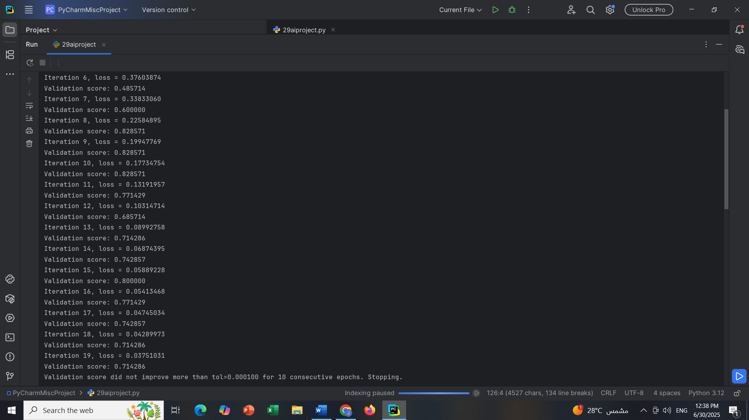

### **Evaluation for Naive Bayes:**

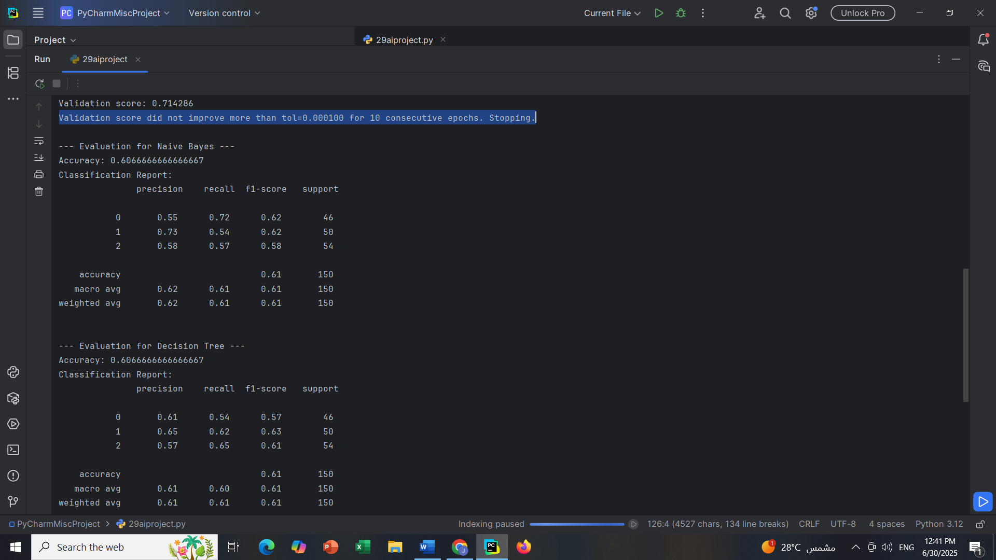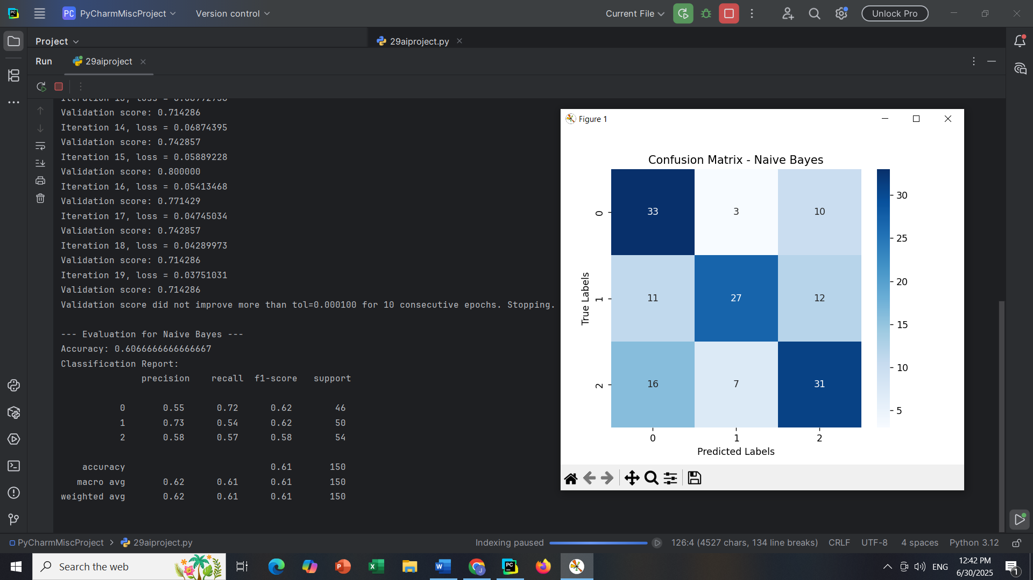

### **Evaluation for Decision Tree:**

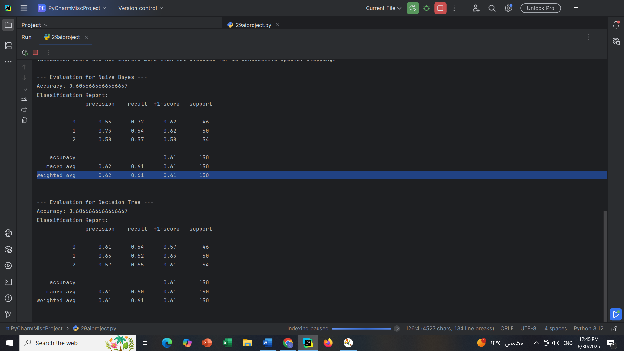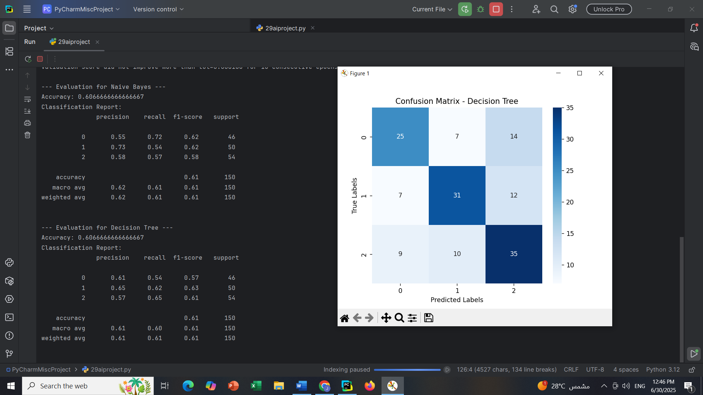

### **Evaluation for MLP Classifier:**

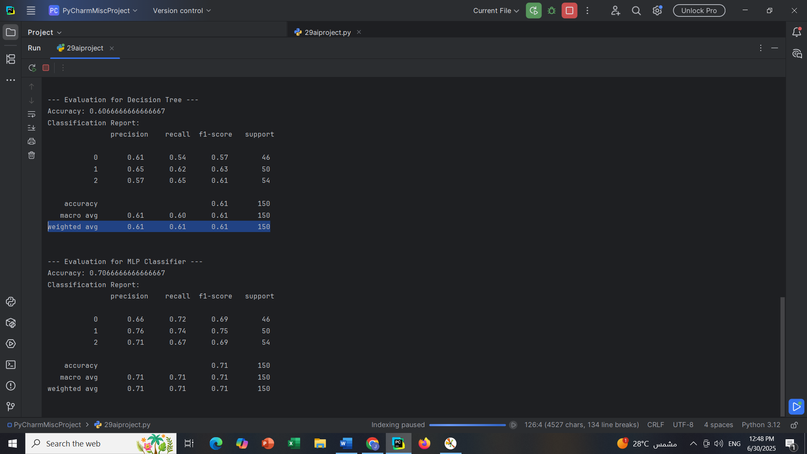

## 

## **Comparative Analysis and Discussion**

The final accuracy scores of the three models—Naive Bayes, Decision Tree, and MLPClassifier—are summarized below.

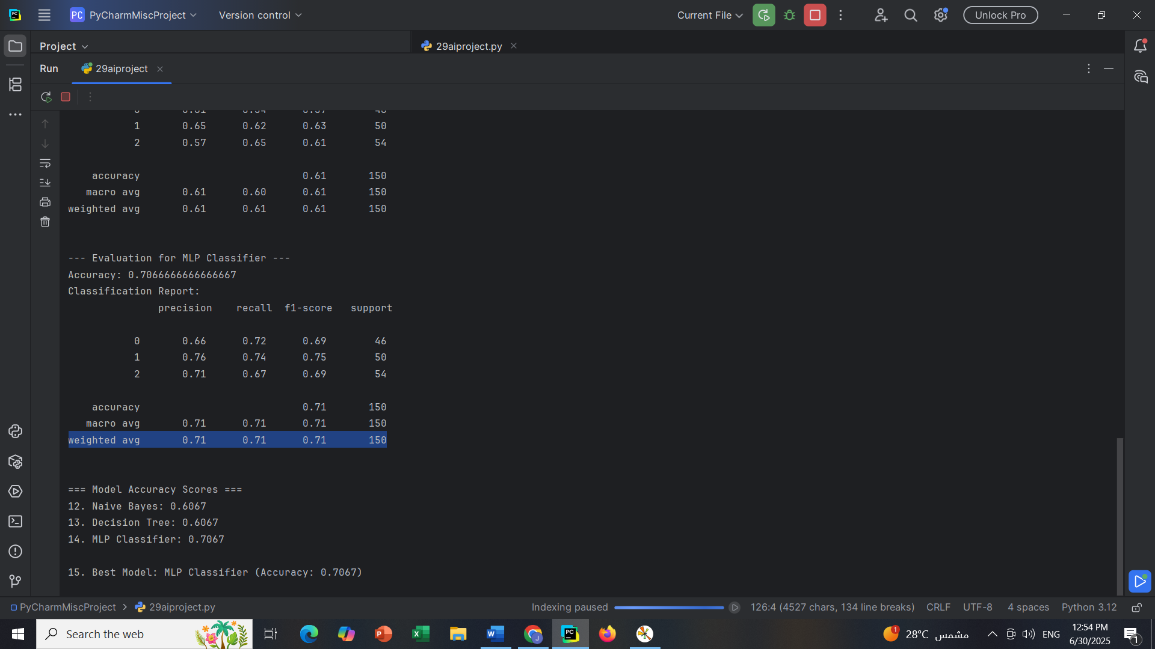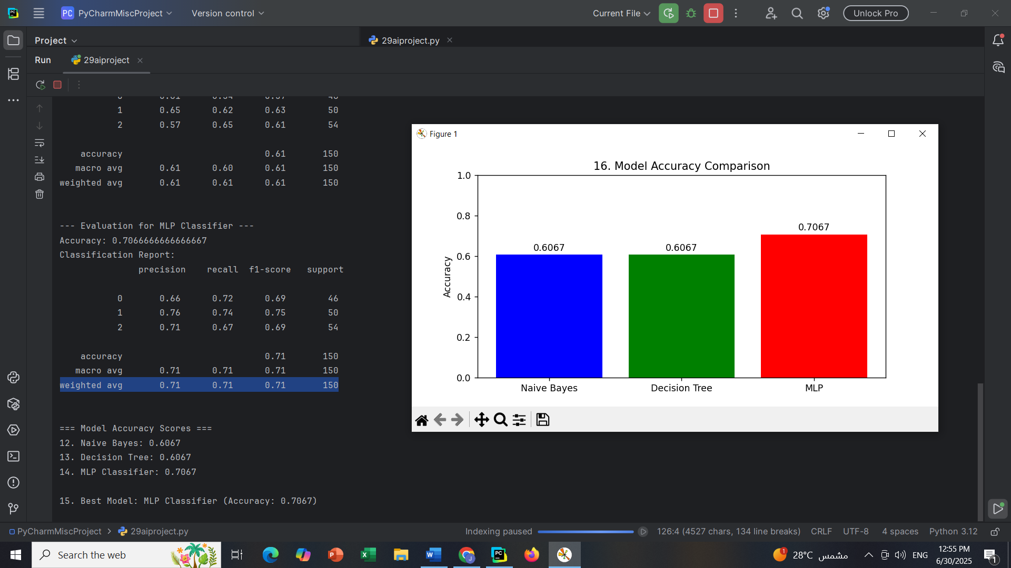

This project compared three classifiers—Naive Bayes, Decision Tree, and Feedforward Neural Network (MLPClassifier)—on an image dataset of airplanes, cars, and birds. All models were trained on the same flattened image features and compared on accuracy, precision, recall, and F1-score.

Naive Bayes classifier achieved 60.67% accuracy. Although fast and simple to apply, it was unable to capture complex patterns due to the assumption of feature independence, meaning it did worse on visually similar classes.

Decision Tree also attained 60.67% accuracy. It performed better than Naive Bayes in non-linear relationships but was very likely to overfit quickly on high-dimensional image data, which limited its generalization ability.

The most performant was the MLPClassifier with an accuracy of 70.67%. Being multi-layered helped it capture more complex relationships in the data that improved overall and class-wise accuracy. The model also achieved a peak validation accuracy of 82.86% during training.

Generally, the MLPClassifier outperformed the other models.