Global EV Market Analysis
Business Question and Visualization Report
Team ID: [Enter Team ID] | Prepared by: Nilamber Singh Hada | Date: 6 November 2026
Dataset note: ev_market_test.csv provided by Skill Wallet, 100,000 rows x 37 columns. The data is synthetic, so totals are relative measures, not real-world figures.

Purpose
This report lists the business questions answered by the Global EV Market Analysis dashboard and maps each question to a Tableau worksheet and a suitable visual. The findings come from the SQL queries run on the ev_market table and from the published Tableau workbook. Because the data is synthetic, totals are relative measures and not real-world market figures.
Worksheet set (12): Sales by Category, Sales by Year, Top Manufacturers, Country Map, Average Price by Region, Battery Share, Battery Durability, Price vs Range, Drivetrain Heat Map, Recommended Use Case, CO2 Saved, Customer Rating. Filters (6): Model Year, Market Region, Category, Battery Type, Price Segment, Manufacturer.

Business Questions and Visualizations
No. | Business question | Worksheet | Visual | Metric / calculation | Verified finding
1 | Which vehicle categories lead annual sales? | Sales by Category | Bar chart | SUM(Annual Sales Units) by Category, sorted descending | Two-wheeler scooters lead (about 85.0M), then sedans (78.3M) and compact SUVs (76.1M). Electric trucks, pickups and buses sell about 5 to 7M each.
2 | Is the market growing year by year? | Sales by Year | Line chart | SUM(Annual Sales Units) by Model Year (2018 to 2026) | Models per year stay near 11,000 and average price (about $65k) and range (about 324 km) are flat, so the trend is stable, not rising.
3 | Which manufacturers lead sales? | Top Manufacturers | Bar chart with Top N filter | SUM(Annual Sales Units) by Manufacturer; Top N used because there are 200 manufacturers | SurgeWorks (4.88M), CurrentMobility (4.78M) and ElektraMobility (4.75M) lead; the top five sit between 4.6M and 4.9M, so the market is balanced.
4 | Where are EV models manufactured? | Country Map | Filled map | COUNT of models by Manufacturing Country (geographic role assigned) | The data covers 10 manufacturing countries; read the country values from the filled map.
5 | How do market regions compare on price and rating? | Average Price by Region | Bar chart | AVG(Price Usd) and AVG(Customer Rating) by Market Region | Average price is $64.6k to $65.3k and rating is 4.07 to 4.09 across seven regions, so regions are evenly split.
6 | Which battery chemistry is most common? | Battery Share | Pie chart | COUNT of models by Battery Type (5 chemistries) | Five chemistries are compared; read the shares from the pie chart (values not recorded in the project report).
7 | Which battery type lasts longest with the lowest degradation? | Battery Durability | Bar chart | AVG(Battery Cycle Life) and AVG(Battery Degradation Pct 5yr) by Battery Type | Solid-State: 2,999 cycles, 7.36% degradation. LFP: 2,498 and 10.11%. NMC, Sodium-Ion and NCA: 1,598 to 1,799 cycles and about 14%.
8 | Does more money buy more range? | Price vs Range | Scatter plot | Price Usd (x) vs Range Km (y), one mark per model | Price correlates 0.84 with battery capacity but only 0.28 with range. Range rises up to about $50k to $150k, then does not keep rising.
9 | Where do FWD, RWD and AWD drivetrains concentrate? | Drivetrain Heat Map | Heat map | COUNT of models by Drivetrain and Category | Shows drivetrain concentration by category; read the values from the heat map.
10 | What are EVs recommended for? | Recommended Use Case | Treemap | COUNT of models by Recommended Use Case (7 values) | Shows the share of each of the seven use cases; read the values from the treemap.
11 | Where is the climate impact highest? | CO2 Saved | Stacked bar chart | SUM(Co2 Saved Tons Per Year) by Category, coloured by Market Region | Pickup trucks, electric trucks and electric buses save the most CO2 (about 48k, 47k and 39k tons per year in the sample chart); sedans, hatchbacks and compact SUVs are near 26k.
12 | How satisfied are owners? | Customer Rating | Histogram | Distribution of Customer Rating (1,931 values missing, ignored in averages) | Average rating is about 4.09 out of 5 in every region.

Calculated fields used by the questions
Range per 1000 USD = [Range Km] / [Price Usd] * 1000
Price Segment = IF [Price Usd] < 20000 THEN "Budget" ELSEIF [Price Usd] < 60000 THEN "Mid-range"
ELSEIF [Price Usd] < 120000 THEN "Premium" ELSE "Luxury" END
Range Class = IF [Range Km] >= 450 THEN "Long" ELSEIF [Range Km] >= 250 THEN "Medium" ELSE "Short" END
Fast Charge Rating = IF [Charging Dc Fast Time Min] <= 15 THEN "Ultra-fast"
ELSEIF [Charging Dc Fast Time Min] <= 25 THEN "Fast" ELSE "Standard" END
Revenue (Est.) = [Price Usd] * [Annual Sales Units]
Sales Share = SUM([Annual Sales Units]) / TOTAL(SUM([Annual Sales Units]))

Filter and presentation requirements
- Six filters (Model Year range slider, Market Region, Category, Battery Type, Price Segment, Manufacturer) are applied to all worksheets that use the data source and are shown on the dashboard.
- Charts that show 200 manufacturers are limited with a Top N filter.
- Buses, trucks and scooters are compared within their own category instead of being removed as outliers.
- Missing values (under 3.1% per column) are left blank so averages ignore them.
- The synthetic-data limitation is stated in the project report.

Evidence: sample visual outputs
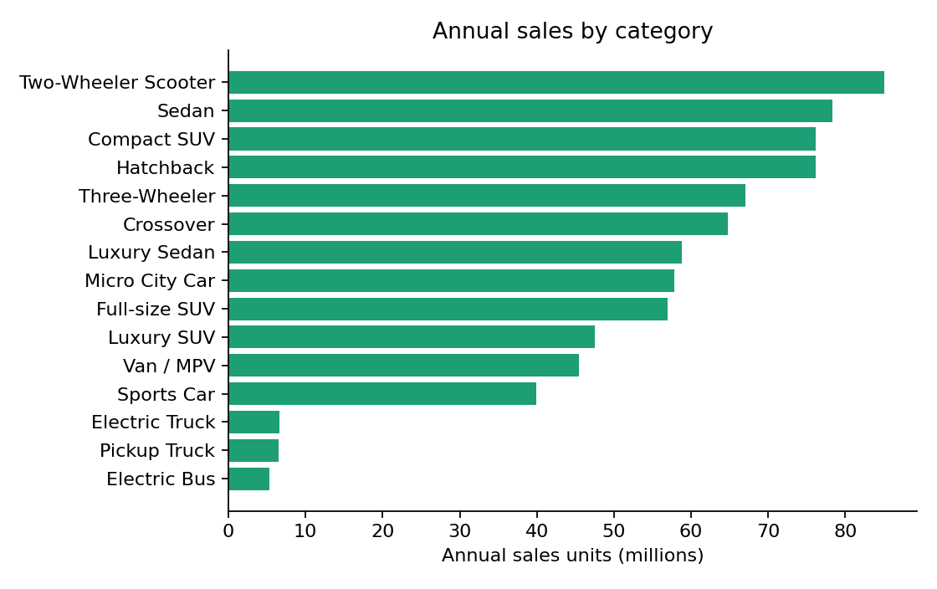
Figure 1. Annual sales by category (business question 1).
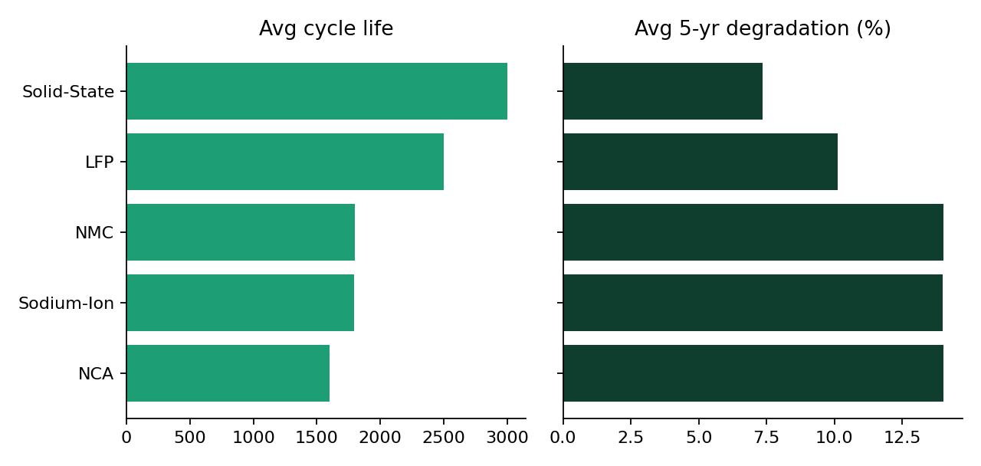
Figure 2. Average cycle life and 5-year degradation by battery type (question 7).
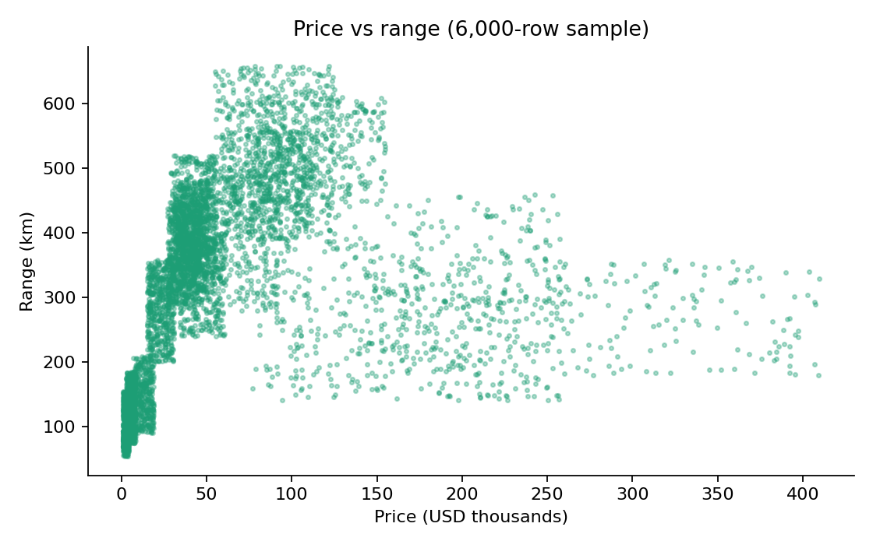
Figure 3. Price vs range, 6,000-row sample (question 8).
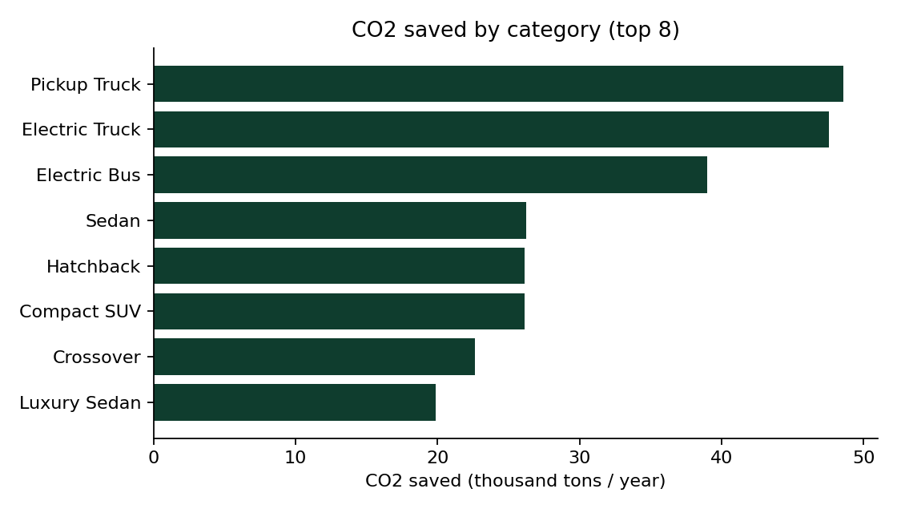
Figure 4. CO2 saved by category, top 8 (question 11).

Findings / outcomes
- Volume is led by scooters, sedans and compact SUVs; trucks, pickups and buses are low-volume categories (about 5 to 7M units each).
- Price follows battery size (correlation 0.84), not range (0.28); electric buses (about $274k) and trucks (about $169k) are the most expensive categories.
- Solid-State and LFP batteries are the most durable; all five chemistries average about 21 minutes of DC fast charging and 320 to 325 km of range.
- Manufacturers and regions are evenly balanced, with the top five manufacturers selling 4.6M to 4.9M units each.
- Heavy vehicles save the most CO2 per category even though they sell far fewer units.
Note: the dataset is synthetic. Models per year, regional totals and average range by battery type are almost uniform, so the analysis focuses on fields with real variation.

