Global EV Market Analysis
Code & Solution: Implementation Notes
Team ID: [Enter Team ID] | Prepared by: Nilamber Singh Hada | Date: 6 November 2026
Dataset note: ev_market_test.csv provided by Skill Wallet, 100,000 rows x 37 columns. The data is synthetic, so totals are relative measures, not real-world figures.

Solution Summary
Field | Project details
Project / repository link | https://github.com/NilamberHada/ev-market-tableau
Data source | ev_market_test.csv provided by Skill Wallet; 100,000 rows x 37 columns, model years 2018 to 2026
BI tool | Tableau Public (dashboard and story)
Database | SQLite file ev_market.db (a MySQL version of the loader and queries is in the repository)
Table / view | Table ev_market (100,000 rows, 37 columns); view vw_ev_clean
Web integration | Flask app with four pages (Home, Dashboard, Story, About) using the Tableau Embedding API
Transformations | Load with pandas; SQL aggregation; view with range_per_1000usd and price_segment; 6 Tableau calculated fields
KPIs | Annual sales units, average price, average range, battery cycle life and degradation, CO2 saved, customer rating
Key insights | Scooters lead volume; price follows battery size (0.84) not range (0.28); Solid-State and LFP last longest; market is balanced

1. Load the data
import sqlite3
import pandas as pd

df = pd.read_csv("ev_market_test.csv")
con = sqlite3.connect("ev_market.db")
df.to_sql("ev_market", con, if_exists="replace", index=False)
print("Stored", len(df), "rows in table ev_market (database file: ev_market.db)")

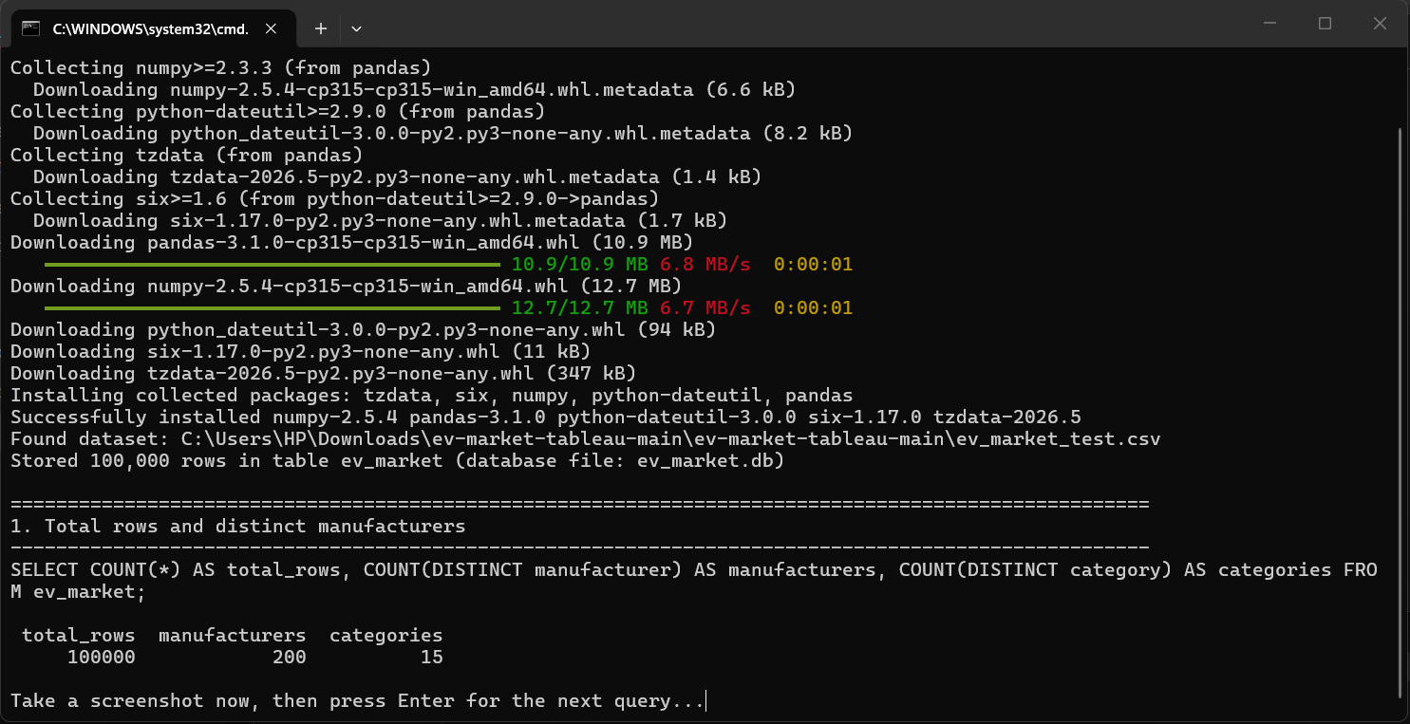
Figure 1. Output of the load step and query 1.

2. SQL operations with output
Six queries are shown with their output. They cover counting, aggregation, grouping, sorting and data checks. The full set of eight queries is in sql/queries.sql in the repository.

Query 1: Total rows and distinct manufacturers
SELECT COUNT(*) AS total_rows, COUNT(DISTINCT manufacturer) AS manufacturers,
COUNT(DISTINCT category) AS categories
FROM ev_market;

Output: 100000 rows, 200 manufacturers, 15 categories (see Figure 1).

Query 2: Top 10 manufacturers by total annual sales
SELECT manufacturer, CAST(SUM(annual_sales_units) AS INTEGER) AS total_sales
FROM ev_market GROUP BY manufacturer ORDER BY total_sales DESC LIMIT 10;

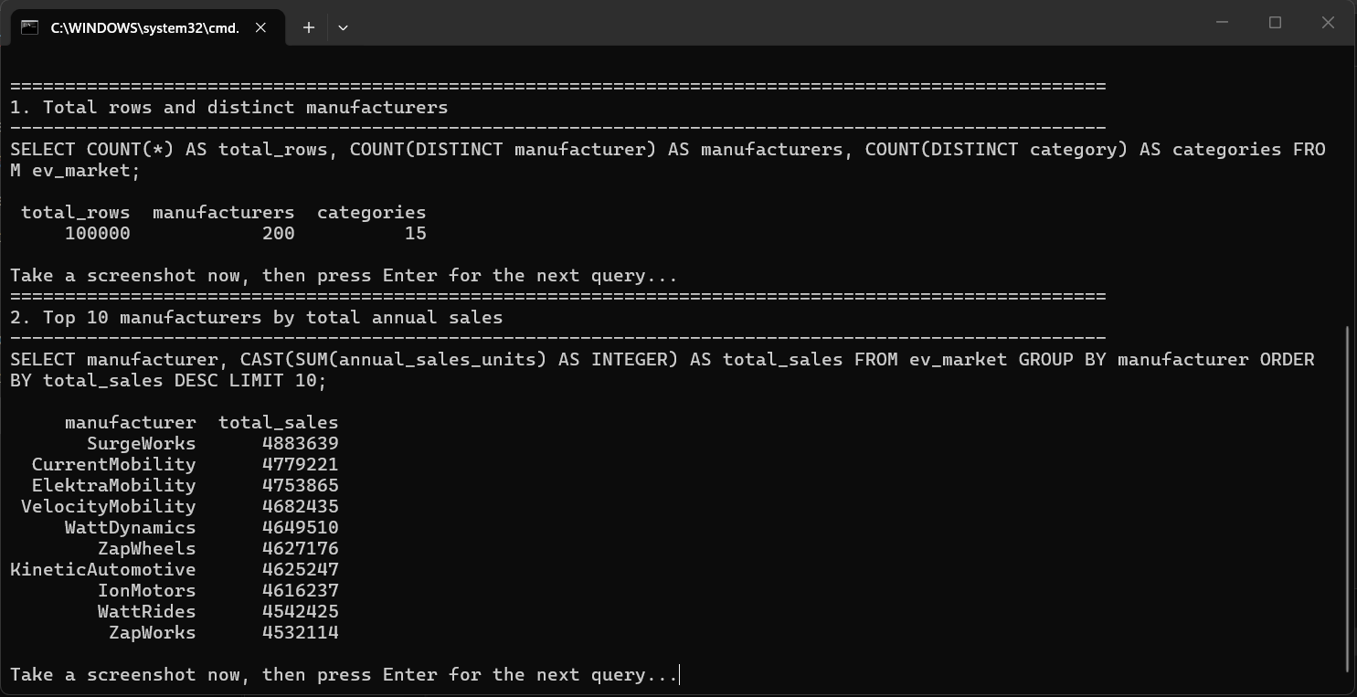
Figure 2. Query 2 output: SurgeWorks leads with 4,883,639 units.

Query 3: Sales and average price by category
SELECT category, COUNT(*) AS models,
CAST(SUM(annual_sales_units) AS INTEGER) AS total_sales,
ROUND(AVG(price_usd),2) AS avg_price
FROM ev_market GROUP BY category ORDER BY total_sales DESC;

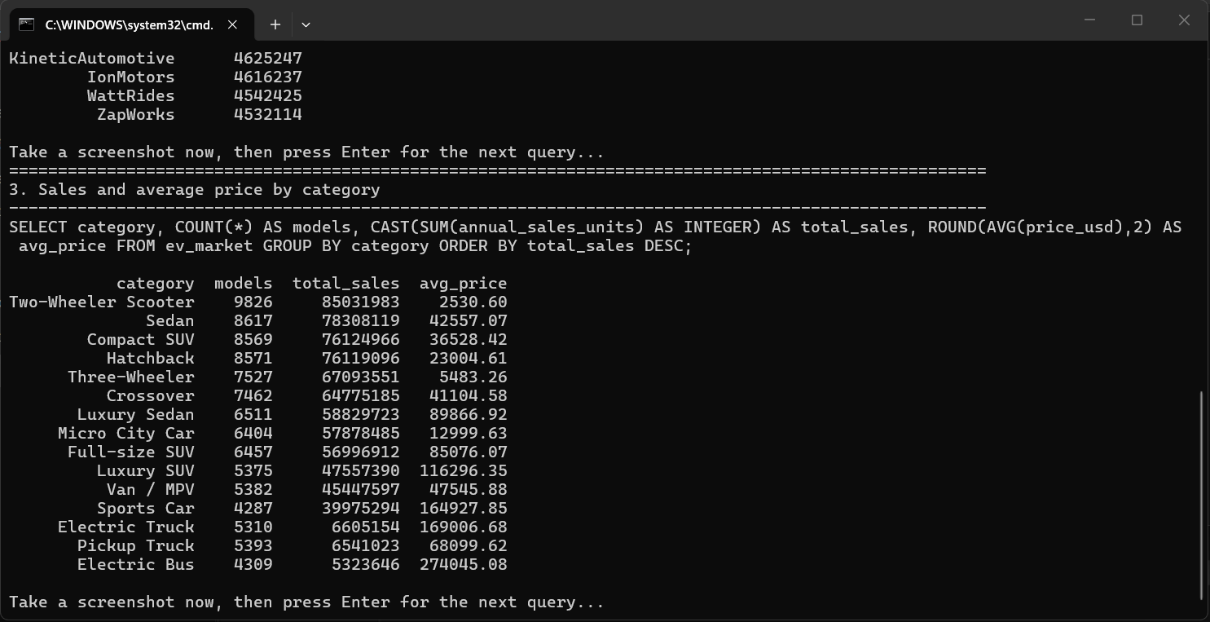
Figure 3. Query 3 output: models, total sales and average price by category.
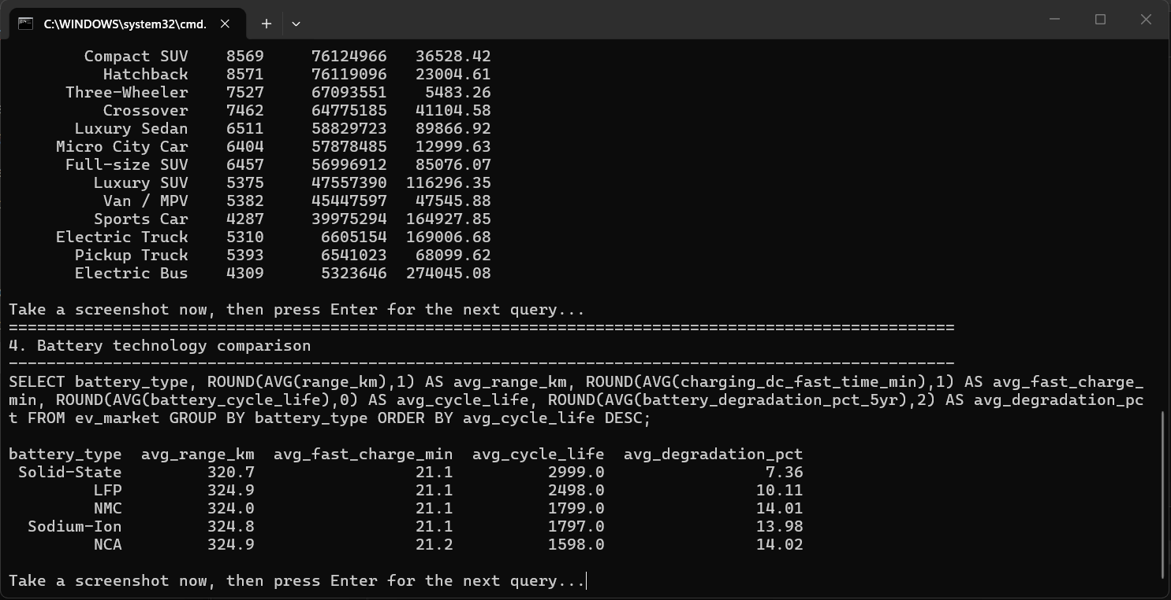
Figure 4. Query 4 output: battery technology comparison (the end of query 3 is visible above it).

Query 4: Battery technology comparison
SELECT battery_type, ROUND(AVG(range_km),1) AS avg_range_km,
ROUND(AVG(charging_dc_fast_time_min),1) AS avg_fast_charge_min,
ROUND(AVG(battery_cycle_life),0) AS avg_cycle_life,
ROUND(AVG(battery_degradation_pct_5yr),2) AS avg_degradation_pct
FROM ev_market GROUP BY battery_type ORDER BY avg_cycle_life DESC;

Battery type | Avg range (km) | Avg fast charge (min) | Avg cycle life | Avg degradation (%)
Solid-State | 320.7 | 21.1 | 2,999 | 7.36
LFP | 324.9 | 21.1 | 2,498 | 10.11
NMC | 324.0 | 21.1 | 1,799 | 14.01
Sodium-Ion | 324.8 | 21.1 | 1,797 | 13.98
NCA | 324.9 | 21.2 | 1,598 | 14.02

Query 5: Region-wise performance
SELECT market_region, COUNT(*) AS models, ROUND(AVG(price_usd),0) AS avg_price,
ROUND(AVG(customer_rating),2) AS avg_rating
FROM ev_market GROUP BY market_region ORDER BY models DESC;

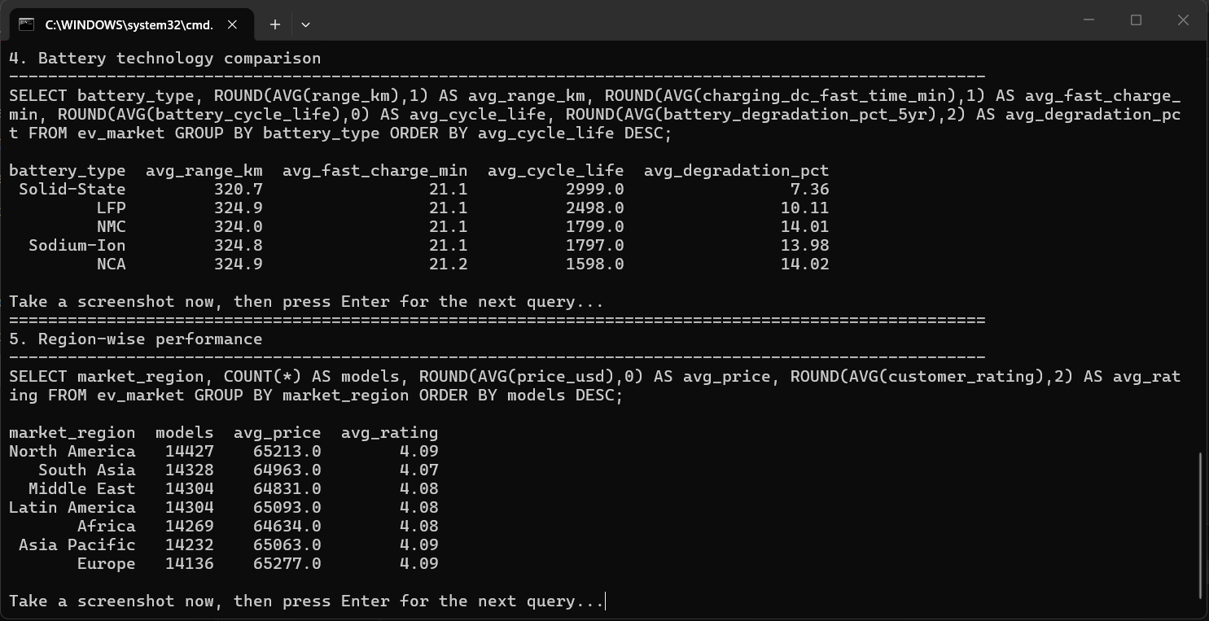
Figure 5. Query 5 output: seven regions with almost identical average price and rating.

Query 6: Year-wise trend
SELECT model_year, COUNT(*) AS models, ROUND(AVG(range_km),1) AS avg_range_km,
ROUND(AVG(price_usd),0) AS avg_price
FROM ev_market GROUP BY model_year ORDER BY model_year;

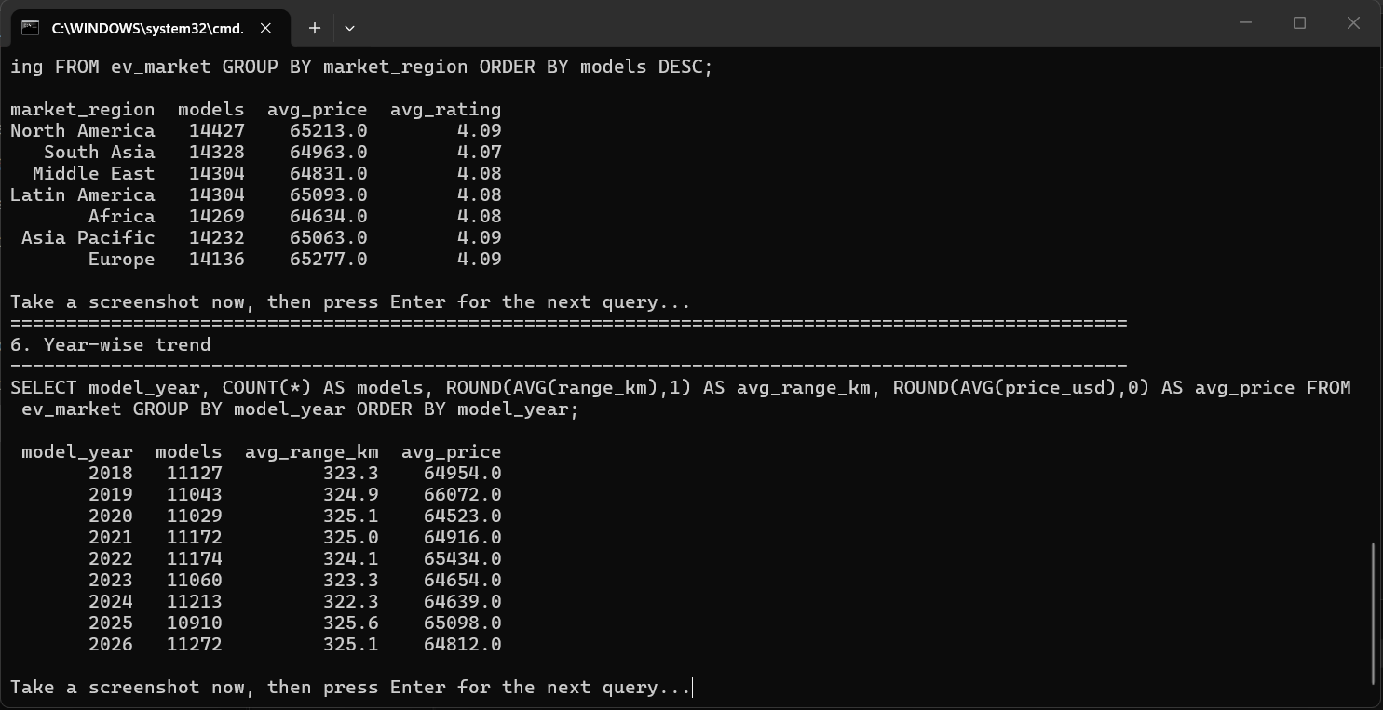
Figure 6. Query 6 output: models, average range and average price from 2018 to 2026.

View for Tableau (vw_ev_clean)
CREATE VIEW vw_ev_clean AS
SELECT *, ROUND(range_km*1.0/price_usd*1000,2) AS range_per_1000usd,
CASE WHEN price_usd < 20000 THEN 'Budget' WHEN price_usd < 60000 THEN 'Mid-range'
WHEN price_usd < 120000 THEN 'Premium' ELSE 'Luxury' END AS price_segment
FROM ev_market WHERE price_usd > 0 AND range_km > 0;

3. Tableau calculated fields
Range per 1000 USD = [Range Km] / [Price Usd] * 1000
Price Segment = IF [Price Usd] < 20000 THEN "Budget" ELSEIF [Price Usd] < 60000 THEN "Mid-range"
ELSEIF [Price Usd] < 120000 THEN "Premium" ELSE "Luxury" END
Range Class = IF [Range Km] >= 450 THEN "Long" ELSEIF [Range Km] >= 250 THEN "Medium" ELSE "Short" END
Fast Charge Rating = IF [Charging Dc Fast Time Min] <= 15 THEN "Ultra-fast"
ELSEIF [Charging Dc Fast Time Min] <= 25 THEN "Fast" ELSE "Standard" END
Revenue (Est.) = [Price Usd] * [Annual Sales Units]
Sales Share = SUM([Annual Sales Units]) / TOTAL(SUM([Annual Sales Units]))

4. Flask web integration
The dashboard and story are embedded with the Tableau Embedding API. The links are read from a configuration file, so no code change is needed to update them.
@app.route("/dashboard")
def dashboard():
return render_template("dashboard.html", viz_url=DASHBOARD_URL)

<script type="module" src="https://public.tableau.com/javascripts/api/tableau.embedding.3.latest.min.js"></script>
<tableau-viz src="{{ viz_url }}" toolbar="bottom" hide-tabs></tableau-viz>

5. Key insights
- Scooters sell about 85.0M units, then sedans (78.3M) and compact SUVs (76.1M); electric trucks, pickups and buses sell about 5 to 7M each.
- Price correlates 0.84 with battery capacity but only 0.28 with range; electric buses (about $274k) and trucks (about $169k) cost the most.
- Solid-State averages 2,999 cycles with 7.36% degradation; LFP follows with 2,498 cycles and 10.11%.
- Every battery type averages about 21 minutes for DC fast charging and 320 to 325 km of range.
- The top five manufacturers sell 4.6M to 4.9M units each and regions are evenly split.
Limitation: the dataset is synthetic, so summed sales (about 773 million units) and estimated revenue are relative measures, not real-world totals.

