Global EV Market Analysis
Dashboard Design
Team ID: [Enter Team ID] | Prepared by: Nilamber Singh Hada | Date: 6 November 2026
Dataset note: ev_market_test.csv provided by Skill Wallet, 100,000 rows x 37 columns. The data is synthetic, so totals are relative measures, not real-world figures.

Activity 1: Interactive and visually appealing dashboard
The aim is to present the EV market data in a clear, consistent, interactive Tableau dashboard that answers the business questions at a glance. The dashboards combine the 12 worksheets and share six filters. Dashboard size is set to Automatic so the layout adjusts to the browser window, and Phone layouts are available through Device Preview.

Dashboard structure
Area | Content | Design choice
Header | Global EV Market Analysis | Short title; add a one-line note that the data is synthetic.
Filter panel | Model Year slider, Category, Price Segment, Manufacturer, Market Region, Battery Type | Shown on the right of the dashboard; shared across all worksheets that use the data source.
Primary analysis | Sales by Category (bar) and Sales by Year (line) | Sorted horizontal bars for 15 categories; line for the 2018 to 2026 trend.
Secondary analysis | Top Manufacturers and Average Price by Market Region | Top N filter keeps 200 manufacturers readable; region table shows price per region.
Supporting analysis | Battery Share, Battery Durability, Price vs Range, Drivetrain Heat Map, Use Case Treemap, CO2 Saved, Customer Rating, Country Map | Each chart type matches the field: map for country, scatter for two numeric fields, heat map for two categories.
Interaction | Clicking a bar or region | Filters the other charts on the dashboard (drill-down by selection).

Design checklist
- Clear and intuitive layout: title first, filters grouped on one side, high-value charts at the top.
- Appropriate visualizations: bars for categories, line for years, filled map for countries, pie for share, scatter for price vs range, heat map for drivetrain, treemap for use cases, stacked bar for CO2, histogram for ratings.
- Color and theming: one consistent palette; blue bars on the dashboard and region colours only where the legend explains them.
- Interactive filters: six filters shared across worksheets; Model Year uses a range slider.
- Drill-down: click-to-filter on bars and regions.
- Responsive design: Automatic dashboard size plus Phone layout through Device Preview; the Flask page is also responsive.
- Tooltips: show the measure and the unit; sales are in units, price in USD, range in km.
- Performance: Top N on manufacturers, shared filters and a single mark per model only where needed.
- Data ethics: the synthetic-data limitation is stated and totals are described as relative measures.

Dashboard in the web app
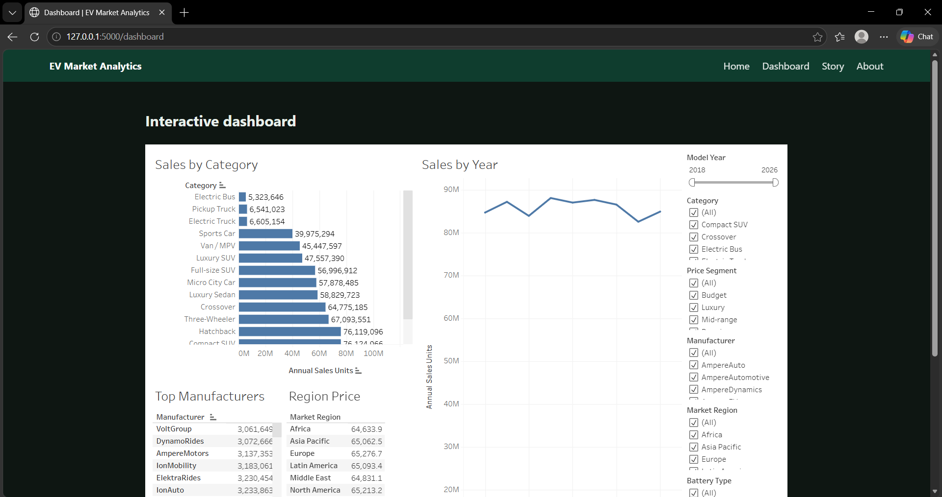
Figure 1. Dashboard page of the Flask app with the embedded Tableau dashboard and filters.

Activity 2: Tableau Public publication
Published dashboard: https://public.tableau.com/views/EVMarketAnalysis_17926786113420/MarketOverview
Published story: https://public.tableau.com/views/EVMarketAnalysis_17926786113420/Story1
GitHub repository: https://github.com/NilamberHada/ev-market-tableau

Major outcomes
- Scooters lead volume with about 85.0M units, followed by sedans (78.3M) and compact SUVs (76.1M); electric trucks, pickups and buses sell about 5 to 7M each.
- Price correlates 0.84 with battery capacity but only 0.28 with range, so a bigger battery explains price better than longer range does.
- Solid-State batteries average 2,999 cycles with 7.36% five-year degradation, ahead of LFP (2,498 cycles, 10.11%).
- Regions are balanced: average price is $64.6k to $65.3k and rating is 4.07 to 4.09 in all seven regions.
- The top five manufacturers each sell 4.6M to 4.9M units, so no single manufacturer dominates.

