Global EV Market Analysis
Dashboard Design (Version 2)
Team ID: [Enter Team ID] | Prepared by: Nilamber Singh Hada | Date: 6 November 2026
Dataset note: ev_market_test.csv provided by Skill Wallet, 100,000 rows x 37 columns. The data is synthetic, so totals are relative measures, not real-world figures.

Activity 1: Interactive and visually appealing dashboard
Design objective: present the EV market summaries in a single readable Tableau dashboard with clear charts, a consistent theme and six usable filters, then embed it in a Flask web page.

Recommended layout
Dashboard area | Content | Design guidance
Header | Global EV Market Analysis | Short title; add a note that the data is synthetic.
Filter panel | Model Year, Category, Price Segment, Manufacturer, Market Region, Battery Type | Placed on the right; shared by all worksheets.
Primary analysis | Sales by Category and Sales by Year | Sorted bars for categories; line for the 2018 to 2026 trend.
Secondary analysis | Top Manufacturers and Average Price by Market Region | Top N keeps 200 manufacturers readable.
Supporting analysis | Battery Share, Battery Durability, Price vs Range, Drivetrain Heat Map, Use Case Treemap, CO2 Saved, Customer Rating, Country Map | Pick the chart type by field type.
Footer / note | Data source and limitation | State that totals are relative measures.

Design checklist
- Clear layout with a visual hierarchy: title, filters, then the main charts.
- Appropriate visualizations: bars for categories, line for years, map for countries, scatter for price vs range.
- A restrained, consistent colour palette with legends where colour carries meaning.
- Filters connected to all worksheets; clicking a bar or region filters the other charts.
- Automatic dashboard size and a phone layout through Device Preview.
- Top N and shared filters to keep 100,000 rows responsive.
- Synthetic-data limitation stated.
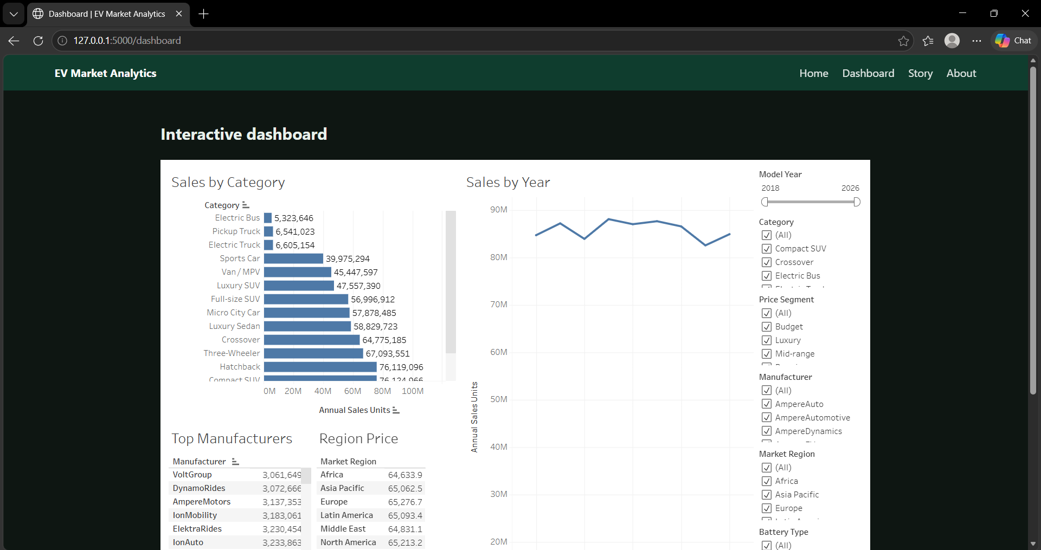
Figure 1. Dashboard page of the Flask app with the embedded Tableau dashboard and filters.

Major outcomes
- Scooters lead with about 85.0M units; sedans (78.3M) and compact SUVs (76.1M) follow.
- Price follows battery capacity (0.84) far more than range (0.28).
- Solid-State: 2,999 cycles and 7.36% degradation; LFP: 2,498 cycles and 10.11%.
- Average price is $64.6k to $65.3k and rating 4.07 to 4.09 in all seven regions.
- The top five manufacturers each sell 4.6M to 4.9M units.
Tableau Dashboard Link: https://public.tableau.com/views/EVMarketAnalysis_17926786113420/MarketOverview

