Global EV Market Analysis
Data Preparation: SQL and Tableau Workflow
Team ID: [Enter Team ID] | Prepared by: Nilamber Singh Hada | Date: 6 November 2026
Dataset note: ev_market_test.csv provided by Skill Wallet, 100,000 rows x 37 columns. The data is synthetic, so totals are relative measures, not real-world figures.

Data preparation scope
The Skill Wallet template describes Snowflake RAW, STAGING and CURATED layers. This project uses a SQLite database (ev_market.db) instead, loaded with Python and pandas, queried with SQL, and then connected to Tableau Public as a text file. This document follows the template activities using that real workflow. Tableau Public connects to files rather than database servers, so the same 100,000 rows were used in both places. The repository also holds a MySQL version of the loader and queries (scripts/load_to_db.py, sql/queries.sql).

Activity 0: Load the data into a database
ev_market_test.csv (100,000 rows, 37 columns) was loaded into a table named ev_market.
import sqlite3
import pandas as pd

df = pd.read_csv("ev_market_test.csv")
con = sqlite3.connect("ev_market.db")
df.to_sql("ev_market", con, if_exists="replace", index=False)
print("Stored", len(df), "rows in table ev_market (database file: ev_market.db)")

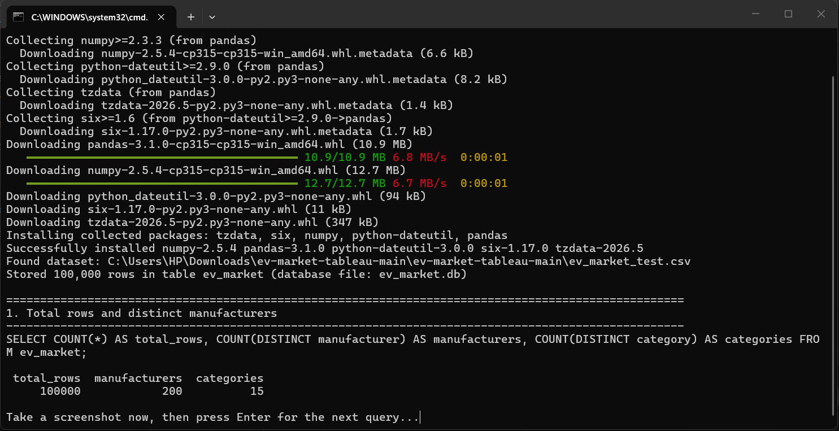
Figure 1. 100,000 rows stored in table ev_market; query 1 shows 100,000 rows, 200 manufacturers and 15 categories.

Activity 1: Identify and handle null values
Five columns contain missing values; all other columns are complete. Missing values are under 3.1% per column.
Column | Missing values | % of 100,000 rows | Treatment
resale_value_pct_3yr | 3,057 | 3.06% | Left blank; averages ignore nulls
battery_cycle_life | 2,028 | 2.03% | Left blank; averages ignore nulls
customer_rating | 1,931 | 1.93% | Left blank; averages ignore nulls
infotainment_screen_inch | 1,506 | 1.51% | Left blank; averages ignore nulls
annual_sales_units | 989 | 0.99% | Left blank; sums ignore nulls

Missing values were not replaced with zero, because a zero would pull averages down and misstate battery life, rating and sales.

Activity 2: Duplicate record handling
Each row is one EV model or variant. vehicle_id is unique and the dataset has no duplicate records, so no rows were removed.
Check | Result
Rows before cleaning | 100,000
Duplicate vehicle_id values | None (vehicle_id is unique)
Rows after duplicate handling | 100,000

Activity 3: Data cleaning and standardization
- Data types: model_year kept numeric (2018 to 2026); manufacturing_country given a geographic role for the map.
- Categorical fields: category (15 values), market_region (7), battery_type (5), manufacturing_country (10) and recommended_use_case (7) were checked and used as they are.
- High cardinality: 200 manufacturers are handled with a Top N filter in Tableau.
- Outliers: buses and trucks have very high efficiency values, seats go up to 65 and price goes up to about $410k. These exist by design, so they are kept and vehicles are compared within their own category.
- Valid ranges: the clean view keeps only rows with price_usd > 0 and range_km > 0.
- Source preserved: the original CSV is not edited; all changes are done in SQL views and Tableau calculated fields.

Activity 4: Data transformation and validation

SQL view for Tableau
CREATE VIEW vw_ev_clean AS
SELECT *, ROUND(range_km*1.0/price_usd*1000,2) AS range_per_1000usd,
CASE WHEN price_usd < 20000 THEN 'Budget' WHEN price_usd < 60000 THEN 'Mid-range'
WHEN price_usd < 120000 THEN 'Premium' ELSE 'Luxury' END AS price_segment
FROM ev_market WHERE price_usd > 0 AND range_km > 0;

Tableau calculated fields
Range per 1000 USD = [Range Km] / [Price Usd] * 1000
Price Segment = IF [Price Usd] < 20000 THEN "Budget" ELSEIF [Price Usd] < 60000 THEN "Mid-range"
ELSEIF [Price Usd] < 120000 THEN "Premium" ELSE "Luxury" END
Range Class = IF [Range Km] >= 450 THEN "Long" ELSEIF [Range Km] >= 250 THEN "Medium" ELSE "Short" END
Fast Charge Rating = IF [Charging Dc Fast Time Min] <= 15 THEN "Ultra-fast"
ELSEIF [Charging Dc Fast Time Min] <= 25 THEN "Fast" ELSE "Standard" END
Revenue (Est.) = [Price Usd] * [Annual Sales Units]
Sales Share = SUM([Annual Sales Units]) / TOTAL(SUM([Annual Sales Units]))

Validation checks
Check | How it was validated | Result
Row and column count | Query 1 and the pandas load message | 100,000 rows, 37 columns confirmed
Manufacturers and categories | Query 1 (COUNT DISTINCT) | 200 manufacturers, 15 categories
Null values | Profiled each column | 5 columns with gaps, each under 3.1%
Duplicate records | Checked vehicle_id | None
Sales totals | Sum of the 15 category totals from Query 3 compared with the reported total | About 773 million units; the two agree
Filters | Six filters shared on the dashboard | Applied to every worksheet that uses the data source

Evidence to attach
- Figure 1 above (rows stored in ev_market).
- Screenshot of the Tableau data source and field types.
- Screenshot of the dashboard with the six filters (see the Dashboard Design document).
- Repository link: https://github.com/NilamberHada/ev-market-tableau

